BRIEFING

Benefit Sanctions Statistics

February 2026 release

There was no Briefing in November 2025. This is the last regular quarterly Briefing. As explained on page 3 below, it is expected that there will continue to be occasional issues when appropriate.

3 March 2026

Dr David Webster
Honorary Senior Research Fellow
Urban Studies
University of Glasgow

Email david.webster@glasgow.ac.uk

Webpages: http://www.gla.ac.uk/schools/socialpolitical/staff/davidwebster/
https://cpag.org.uk/policy-and-research/latest-policy-briefings-and-reports/david-webster-briefings
http://www.cpag.org.uk/david-webster

SUMMARY

This is the last regular quarterly issue of the Briefing. On the next page there is a statement about its future.

This Briefing reports on the DWP’s latest quarterly sanctions statistics for Universal Credit (UC) which were released on 17 February.
The main news is that there is no significant news. The Labour government does not appear to have made any significant changes to the sanctions regime, which has settled into a stable pattern although with a slight rise in the latest quarter. It has simply carried on the regime inherited from the Conservative government. It has also excluded consideration of sanctions from the current review of Universal Credit, and has confirmed that sanctions in their present form will be included in the new employment support package for young people.
In January 2026 there were 2.04m UC claimants in the conditionality groups subject to sanctions. As a proportion of total UC claimants this was 24%, almost the lowest to date.

The latest quarterly average number of sanctions per month was 58,003, the highest since this particular measure began. The proportion of claimants sanctioned each month has been roughly constant since early 2022, at around 2.5%, but there has been an uptick in the latest quarter, to 2.85%. This is the highest since the pandemic.

In the year to end-October 2025, a total of 629,249 sanctions were imposed on 472,983 claimants. Of these, 112,164 received more than one sanction, and 30,921 received more than two. These figures are much higher than in the last full 12 months before the pandemic, to January 2020, when there were 230,720 UC sanctions and 178,476 sanctioned individual UC claimants.

In the latest quarter the percentage of UC claimants subject to conditionality who were serving a sanction at a point in time was 5.86% overall, lower than in the last full quarter under the Conservative government, when it was 6.22%. There has been a downward trend in this figure since Autumn 2023, but there has been an uptick in the latest quarter. The proportion of claimants under sanction is much higher for the unemployed (‘Searching for work’), at 6.84%, than for other claimants subject to conditionality. The total number of claimants under sanction at November 2025 was 120,477, of whom 106,911 were ‘Searcning for work’ and 8,035 were in conditionality groups not liable to sanction but will have transferred from a group with conditionality while still under sanction.

The DWP statistics show that 90% of sanctions are imposed for missing or not participating in an interview, but as explained below this appears to be misleading.

Over the last couple of years there has been an increase in the proportion of completed sanctions in the shortest category of 4 weeks or less, with falls in all the longer categories.

The News section reports in particular on a very useful study of the problems of the Universal Credit sanctions regime by the Public Law Project and Central England Law Centre.

Future of the Briefing

I have decided to cease regular publication of the Briefing after the present issue. This is partly for personal reasons including other research priorities, and partly because the picture has become very stable at least for the moment and regular briefing is therefore less valuable.

The Briefing has been running for 12 years, since November 2013, and has gone through 47 quarterly issues plus several additional issues on particular topics. It started as an evidence submission to the House of Commons Work and Pensions Committee entitled ‘The DWP’s Updated Statistics on JSA Sanctions: What do they show?’ which aimed to explain what was a particularly complicated set of official statistics. It became apparent that there was a continuing need for this kind of explanation, and the Child Poverty Action Group kindly agreed to host it on their website. The sanctions system since then has been through a host of changes, including the rollout of Universal Credit, which has largely replaced Jobseekers Allowance and Employment and Support Allowance and fully replaced Income Support; suspensions from time to time of various of the statistics and introduction of new measures; introduction of Mandatory Reconsideration; modest reform under Amber Rudd; extension of sanctions to new groups of claimants; and very large changes in the scale of sanctioning, both up and down. There have been four Parliamentary inquiries and an inquiry by the National Audit Office as well as the DWP’s own Oakley Review. However the sanctions system has currently settled down into a regular pattern and has shown little change between the new Labour and previous Conservative governments, while media coverage has dwindled. It is of course a matter of great regret to me that we have yet to see major reform of the system, and that numbers of sanctions remain relatively high by historical standards.

Although the regular quarterly Briefing will not be appearing I will maintain the mailing list and hope to produce occasional ad hoc briefings as developments occur that call for them.

The DWP meanwhile publishes its own quarterly commentary on the statistics in the publication Benefit Sanctions Statistics, with accompanying spreadsheets, at https://www.gov.uk/government/collections/jobseekers-allowance-sanctions This obviously takes a less critical approach than the Briefing, but it does cover some of the same topics. In particular it has the number of sanctions per month, the number of claimants in the conditionality groups subject to sanction and the proportion of claimants under sanction at a point in time. It also has rather full coverage of ethnicity. The accompanying spreadsheets give duration, age, gender, level, and repeat sanctions and benefit and earnings destinations, all in tabular form. The DWP’s Stat-Xplore tool has a range of variables and can be used to produce additional analyses, and there is a User Guide at https://www.gov.uk/government/publications/universal-credit-official-statistics-stat-xplore-user-guide

I would particularly like to thank the Child Poverty Action Group for hosting the Briefing on its website and Kelly Smith of CPAG for facilitating this.

Finally, if there is anyone out there who would like to take over the job of briefing on the benefit sanctions statistics then I would be very pleased to hear from them and to provide copies of my suite of labour-saving spreadsheets containing calculation formulas and long runs of data including material not available on the DWP website.

David Webster – 3 March 2026
BRIEFING: Benefit Sanctions Statistics
February 2026

The DWP released its latest quarterly sanctions statistics for Universal Credit (UC) on 17 February, covering statistics up to October or November 2025. There was no Briefing on the statistics published in November 2025, but this Briefing brings the commentary up to date.

The newly published data are summarised by DWP in the online publication Benefit Sanctions Statistics, available along with methodological notes at https://www.gov.uk/government/collections/jobseekers-allowance-sanctions together with a spreadsheet with summary tables. There is now a lot of sanctions data on Stat-Xplore at https://stat-xplore.dwp.gov.uk/webapi/jsf/login.xhtml .

All statistics presented here relate to Great Britain. All previous Briefings are available at https://cpag.org.uk/policy-and-research/latest-policy-briefings-and-reports/david-webster-briefings. The Briefings can also be readily found through a web search. The Briefing does not cover all topics in every issue. Previous Briefings include many analyses that are not repeated here but remain valid, and if a topic is not dealt with here it is likely to have been covered in an earlier Briefing. However it should be remembered that the DWP may have made subsequent revisions to the data reported in earlier Briefings. These revisions will generally not be major although there are exceptions. There may also often be substantial changes in some figures for the most recent few months.

DWP no longer publishes updates to statistics on sanctions for Jobseekers Allowance (JSA), Employment and Support Allowance (ESA) and Income Support (IS) for any date after April 2022. Nor has it ever published data on the appeal system for UC Full Service, which has included all UC claimants since April 2019. This is a serious gap. In its publication Universal Credit sanctions statistics: background information and methodology ,at https://www.gov.uk/government/publications/universal-credit-sanctions-statistics-background-information-and-methodology/a, DWP states that it does not currently have reliable statistics on the appeal system, but hopes to produce them shortly.

No. of claimants on Universal Credit and nos. subject to sanctions

There were a provisional 8.4m claimants of UC at January 2026. The proportion of claimants who were in the conditionality regimes where sanctions can be applied (‘Searching for work’, ‘Planning for work’ and ‘Preparing for work’) continues to fall, to 24% in the latest quarter (2.04m in January). Claimants on JSA, ESA and IS continue to be liable to sanctions but there are currently no data on whether they are being applied.

Monthly no. of UC sanctions imposed

Figure 1 shows the monthly number of UC sanctions imposed since August 2015. The quarterly moving average is also shown, to make it clearer what is happening. The latest quarterly average is the highest since this particular measure began, at 58,003 per month. This is far higher than in the three years preceding the pandemic, when it was generally under 20,000 per month.

Monthly sanctions as a percentage of claimants

Figure 2 shows the monthly number of UC sanctions as a percentage of UC claimants in the conditionality regimes where sanctions may be imposed, also with the quarterly moving average. The proportion of claimants sanctioned each month has been roughly constant since early 2022, at around 2.5%, but there has been an uptick in the latest quarter, to 2.85%. This is the highest since the pandemic. (Higher levels in the early years of UC were due to the confinement of claims to single people without dependants, who were generally younger and more liable to be sanctioned.)

Annual no. of UC sanctions imposed and no. of sanctioned individuals

In the year to end-October 2025, a total of 629,249 sanctions were imposed on 472,983 claimants. Of these, 112,164 received more than one sanction, and 30,921 received more than two. These figures are much higher than in the last full 12 months before the pandemic, to January 2020, when there were 230,720 UC sanctions and 178,476 sanctioned individual UC claimants.

UC claimants subject to conditionality who were serving a sanction at a point in time

Figure 3 shows the percentage of UC claimants subject to conditionality who were serving a sanction at a point in time, with the quarterly moving average. In the latest quarter the average was 5.86%, lower than in the last full quarter under the Conservative government, when it was 6.22%. There has been a downward trend in this figure since Autumn 2023, but there has been an uptick in the latest quarter.

The proportion of claimants under sanction is much higher for the unemployed (‘Searching for work’) than for other claimants subject to conditionality (‘Planning for work’ and ‘Preparing for work’) (Figure 4). In the latest quarter it was 6.84% for the unemployed, 1.39% for the ‘Planning for Work’ group and 1.09% for the ‘Preparing for Work’ group.

The total number of claimants under sanction at November 2025 was 120,477. Of these, 106,911 were ‘Searcning for work’, 1,309 ‘Planning for work’ and 4,217 ‘Preparing for Work’. There were 8,035 in conditionality groups not liable to sanction but who will have transferred from a group with conditionality while still under sanction.

Reasons for sanctions

When UC was introduced, the proportion of sanctions recorded as being to penalise missing or not participating in an interview was around 70%. But after a gradual rise up to late 2018, there was a very big jump over only two months, from 72.7% in September 2018 to 94.8% in November. After the pandemic the proportion increased further, reaching almost 100% (99.3%) by July 2021. Since then there has been a very slow decline (Figure 5). The proportion has now fallen to 90.1% in October 2025.

As noted in earlier editions of the Briefing, it appears that the figures are misleading and that other reasons are more significant in triggering sanctions than is being shown by the official figures. This issue was previously discussed in the February 2024 Briefing and the following is an addition to what was said there.

It could be that the big jump in the proportion of sanctions imposed for missed interviews in late 2018 coincided with the introduction of the Sanctions Assurance Framework (see the February 2021 Briefing, pp.6-7), with DWP staff switching to missed interviews as a reason in order to save time because the Framework was taking extra time and it is simpler to evidence a missed interview than other reasons. Unfortunately although the existence of the Assurance Framework was disclosed in November 2020, DWP has never publicly indicated exactly when it was introduced in Jobcentres. So this must remain only a hypothesis.

Duration of sanctions

Figure 6 shows that over the last couple of years there has been an increase in the proportion of completed sanctions in the shortest category of 4 weeks or less, with falls in all the longer categories.

Published DWP data do not show the duration of sanctions by ‘level’. This is serious because the terms ‘low’ and ‘lowest’ level are misleading. These sanctions have a fixed period of sanction which however is preceded by an ‘until compliance’ period. This means that these supposedly brief sanctions often end up being longer than ‘high’ or ‘medium’ level sanctions.

There were discussions of the sanctions duration data in the November 2017 Briefing, pp.6-10, and in the February 2024 Briefing, pp.7-8.

Ethnicity analysis

The DWP now updates ethnicity data every quarter. These were fully analysed in the February 2025 Briefing and the analysis is not repeated here.

SANCTIONS –DEVELOPMENTS IN POLICY AND RESEARCH
Sanctions to be included in new employment support package for young people
On 8 December the new Secretary of State for Work and Pensions, Pat McFadden, announced an expanded package of employment support for young people. He made it clear that sanctions will be part of the package: ‘The Youth Guarantee is part of a new social contract with young people – opportunity matched by responsibility. Young people who can work will be expected to engage with the support offered. If the support is declined without good reasons, existing benefit sanction rules will apply.’
The full statement is at https://hansard.parliament.uk/commons/2025-12-08/debates/25120819000011/SupportForYoungPeople
and there is an accompanying press release at https://www.gov.uk/government/news/almost-a-million-young-people-to-benefit-from-expanded-support-new-training-and-work-experience-opportunities

Sanctions are not being considered in the review of Universal Credit

The DWP Minister of State Stephen Timms confirmed in a Parliamentary Written Answer on 20 October that conditionality and sanctions are not within the scope of the current review of Universal Credit.

Crisis and Resilience Fund – exclusion of need arising from sanctions

Discretionary Housing Payments will come to an end in England on 31 March 2026, to be replaced by the Housing Payment strand of the Crisis and Resilience Fund. Para.59 of the government Guidance for local authorities on this fund, at https://www.gov.uk/government/publications/crisis-and-resilience-fund-guidance-for-local-authorities-in-england-1-april-2026-to-31-march-2029/the-crisis-and-resilience-fund-guidance-for-local-authorities-in-england-1-april-2026-to-31-march-2029 makes it clear that no housing assistance can be given where the requirement for assistance arises from a benefit sanction.

Investigation into the causes of young people being NEET

The former Labour minister Alan Milburn is conducting an investigation into the scale of young people being NEET (Not in Education, Employment or Training). A DWP press release explaining the arrangements for the investigation is at https://www.gov.uk/government/news/alan-milburn-calls-for-a-movement-to-address-lost-generation-of-young-people-not-earning-or-learning-as-investigation-opens

DWP research on Additional Jobcentre Support

Under the Additional Jobcentre Support pilot scheme, which was scrapped by the incoming Labour government, claimants in the Intensive Work Search regime were required to attend the Jobcentre every day for two weeks at weeks 14 and 27 of their claim, and later also at week 7. A DWP research report published on 29 January (DWP 2026a) is based on interviews with claimants and work coaches, and on observation of the scheme sessions. Daily attendance at the Jobcentre has often been suggested as a punitive measure, for instance as a substitute for financial sanctions, so this research is interesting as throwing light on the practicalities. Claimants and work coaches both turned out to have a generally positive view of the scheme, no doubt because it was able to deliver much more tailored support than in routine interviews. The report highlights a range of problems and suggestions. It notes that work coaches applied failure-to-attend guidance inconsistently and were sometimes reluctant to sanction. The report does not say so, but the latter finding will no doubt have been because serious employment support depends on a good relationship between claimant and work coach.

DWP research on In-Work Progression Support

On 26 February DWP published a research report on the experience of in-work progression support, both voluntary and mandatory (DWP 2026b). It is based on interviews with claimants and work coaches. It is called an evaluation but does not consider key issues such as success in increasing working hours or costs of delivery. Nevertheless it does contain useful findings about the issues involved in running a programme of this type.

Highly critical report on UC sanctions by PLP and the Central England Law Centre

On 12 November the Public Law Project and Central England Law Centre published a very important report (Selman 2025) on the UC sanctions regime. It is based on casework records relating to 119 sanctions in Birmingham and Coventry together with semi-structured interviews with 14 sanctioned claimants. Funding was by the Lloyds Bank Foundation. The report finds that all the familiar problems of the sanctions regime still apply. It calls in particular for sanctions to be applied only in exceptional circumstances, for safeguards to be strengthened and for the severity of sanctions to be reduced. It has a particularly useful comparison of the severity of benefit sanctions with court fines, finding a median for sanctions of £524 in its sample for a single claimant over 25 compared with £283 for a court fine. Although the sample is small, it also has analysis on the appeal system and the duration of sanctions of different ‘levels’, about both of which there is otherwise a dearth of published information. Of the 36 cases which had progressed beyond ‘mandatory reconsideration’ stage and which had concluded, the sanction was upheld on Tribunal appeal in only 5. Of the 75 cases where sanction length is known, the median length of a sanction was 35 days. 80% of these were ‘low-level’ sanctions. The median length of ‘low-level’ and ‘lowest-level’ sanctions was 36 days. This is eight days longer than the fixed-term period applied for ‘medium-level’ sanctions. The longest ‘low-level’ sanction recorded lasted for around five months. The length of the compliance period (the period until the claimant is accepted by DWP as having done whatever it was that they had not done before) varied from 0 days to 132 days, with a median of 26 days.

Treatment of a neurodiverse claimant

An example of the failure of safeguards within the sanctions regime to protect a neurodiverse claimant was raised by Josh Babarinde MP (Lib Dem – Eastbourne) in a parliamentary question on 27 October, c16-17.

Migrant sanctions

An organization called the Centre for Migration Control on 16 December at https://www.migrationcentral.co.uk/p/benefit-claiming-migrants-failed published what it said were figures showing that ‘Benefit claiming migrants failed to meet basic job-search requirements 198,000 times since 2023’ and that ‘Between January 2023 and April 2025, the DWP issued 198,771 “adverse sanctions” against migrants claiming UC….. or more than 200 a day.’. This story was reported by the Telegraph the same day at https://www.yahoo.com/news/articles/migrants-break-benefits-rules-200-175604859.html?guccounter=1 , with an added quotation from the Reform UK MP Lee Anderson saying ‘We are continually being told that mass migration is a good thing but these figures show that too many people are coming here for a payday by taking benefits and refusing to play by the rules.’
The Centre for Migration Control story went on to quote more detailed figures: Between January 2023 and April 2025 there were 99,269 sanctions against EEA nationals, 73,134 against non-EEA nationals, and 26,368 sanctions against migrants whose nationality could not be determined. There were 118,563 sanctions against those on the EU Settlement Scheme, 8,092 sanctions against those on humanitarian routes, 29,182 against refugees, 27,737 against those with Indefinite Leave to Remain, 12,732 against those with Limited Leave to Remain, and 2,465 on other or undeterminable immigration statuses. This means that 14.6% of all sanctions applied over the time period were on migrants.
The Centre for Migration Control did not say what was the source of these figures, which as far as I know have not been published elsewhere, although it appears that they most likely came from a Freedom of Information request. Nor did it provide any information about its own funding or governance.

The Oxford University-based Migration Observatory offers a more balanced view of migrants in the UK labour market, although nothing specifically on sanctions, at
https://migrationobservatory.ox.ac.uk/resources/briefings/migrants-in-the-uk-labour-market-an-overview/ As a very rough comparison it reports that in March 2025, 15% of individuals in receipt of a Universal Credit payment were neither UK nor Irish nationals, so at first sight migrants appear to be treated the same as other claimants.

REFERENCES

DWP (2026a) Summary: Additional Jobcentre Support pilot: qualitative research, 29 January, at
https://www.gov.uk/government/publications/additional-jobcentre-support-pilot-qualitative-research/summary-additional-jobcentre-support-pilot-qualitative-research

DWP (2026b) Universal Credit: In-Work Progression Support Research, IPSOS’ report, DWP Reearch Report No.1126, February, at
https://assets.publishing.service.gov.uk/media/6994a7350b6fa0acfdaaf12a/universal-credit-in-work-progression-support-research.pdf

Selman, Caroline (2025) Sanctionable Failures: Universal Credit’s failing sanctions regime and the harm it causes: A report by PLP and the Central England Law Centre (CELC), at https://publiclawproject.org.uk/resources/sanctionable-failures/

Figure 1
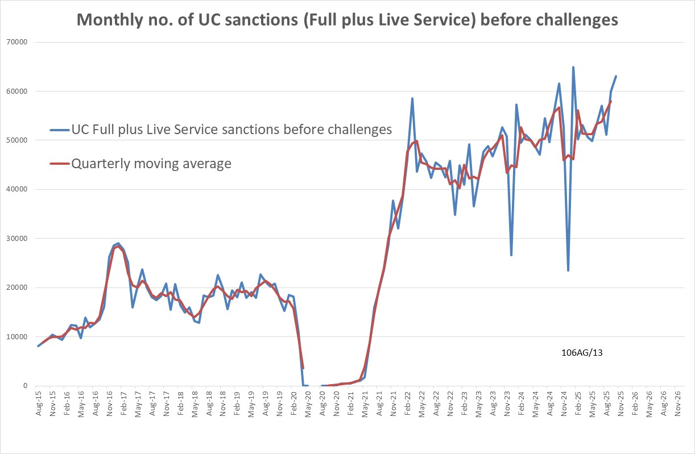

Figure 2
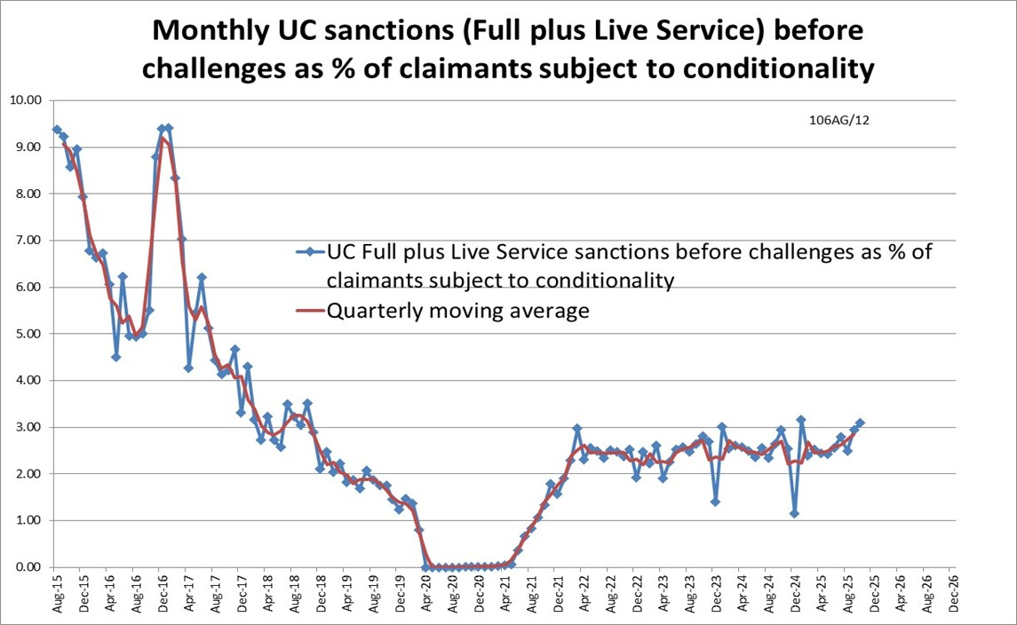

Figure 3
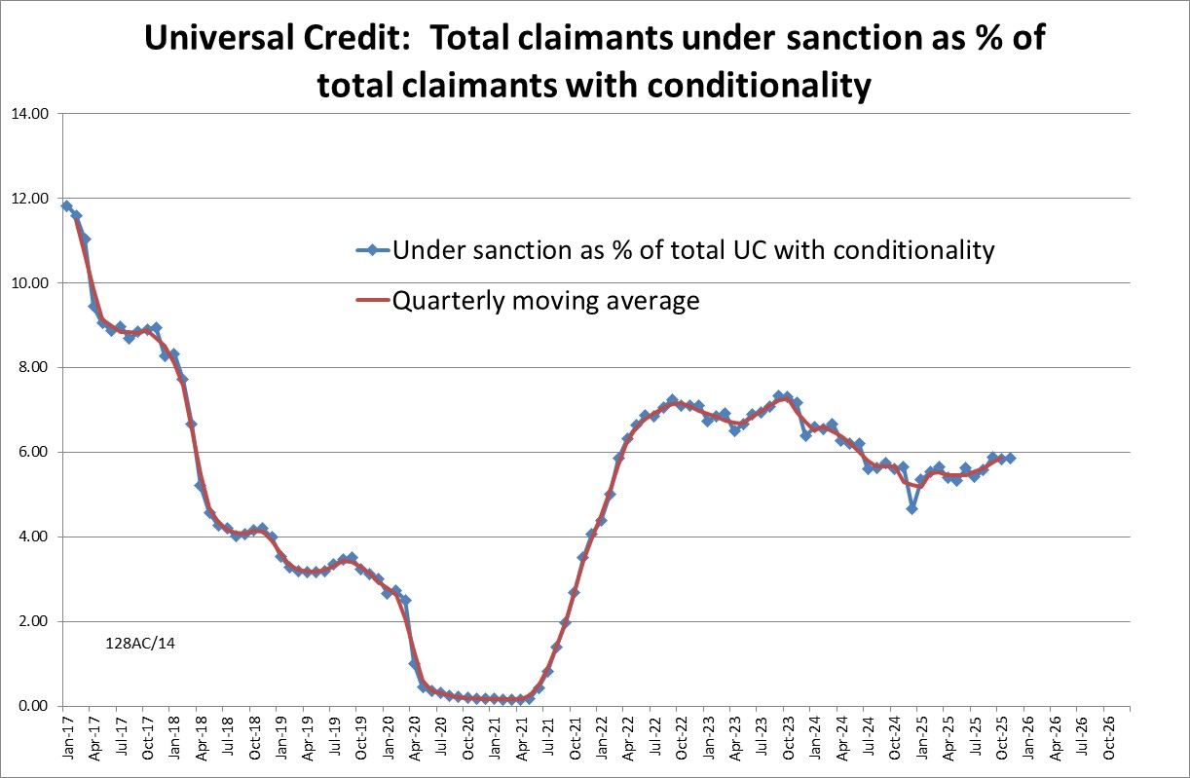

Figure 4
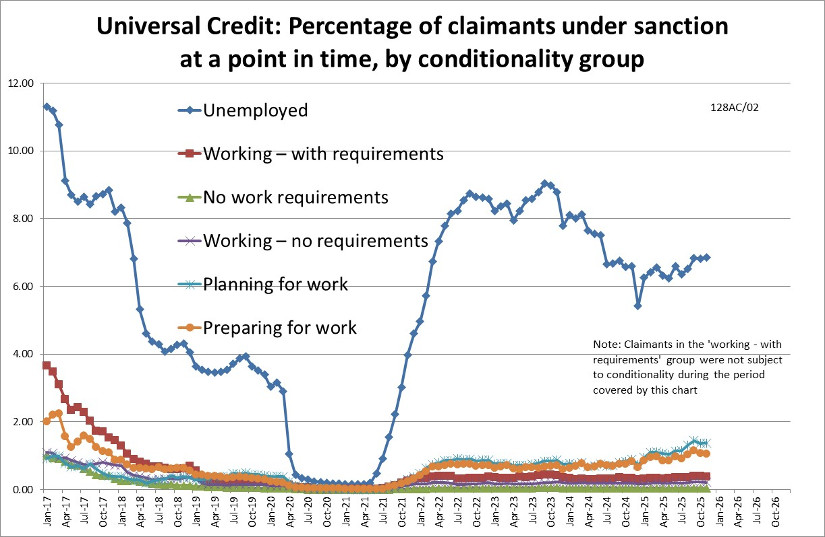

Figure 5
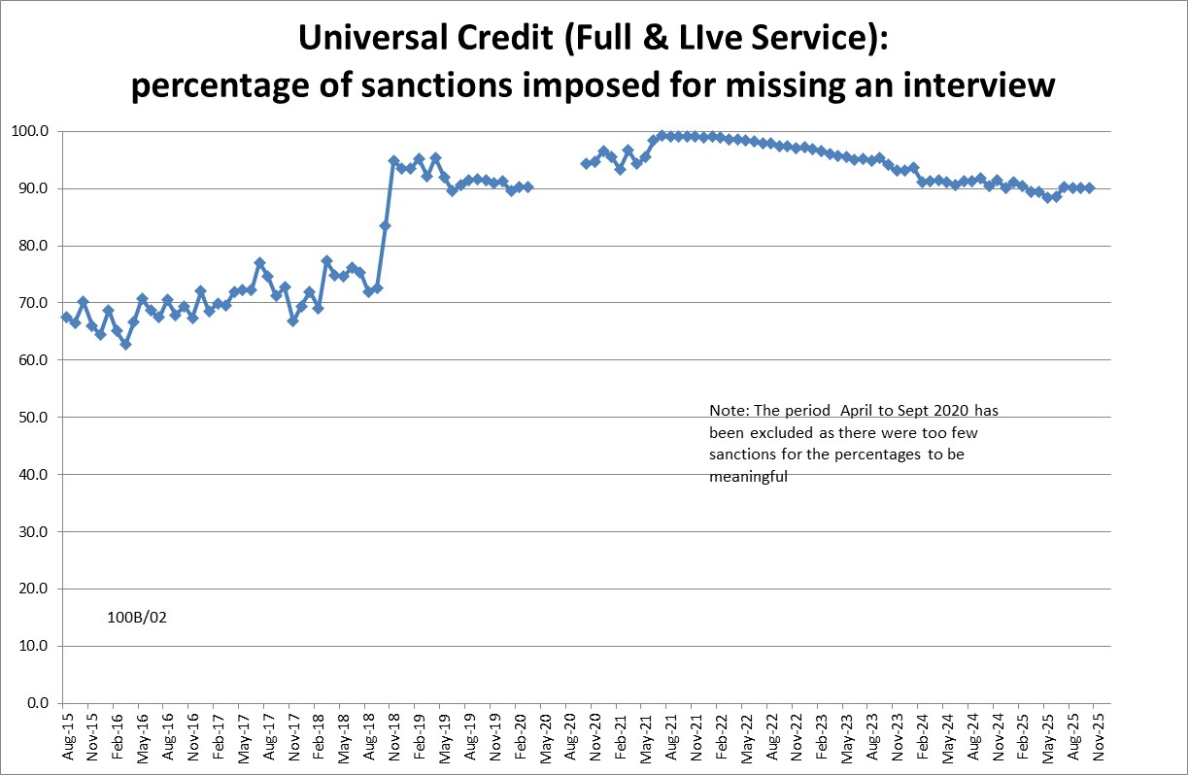

Figure 6
