Dear [name of politician or candidate],
We are [name of children/group] from [add in school]. We are sending you this [poster/drawing] to let you know about the School Shouldn’t Cost manifesto, organised by Child Poverty Action Group (CPAG) in Scotland.
Our manifesto contains the views of thousands of children and young people across Scotland. We are asking all parties running in the Scottish election to take action on our calls and include them in your manifestos.
- End child poverty. Make sure our families have what they need so we can come to school ready to learn.
- Fund every school to fully remove cost pressures from our families and help us overcome poverty-related barriers to learning.
- Help us with the basics we need to learn, take part and feel included at school. Free school meals, uniform support, devices and resources for all and continued funding for curriculum costs.
- Make sure there are opportunities for all. Help all of us benefit from life changing school trips and from activities in our communities.
- Involve us! Young people can help make our schools and Scotland better.
The calls in this manifesto are important to us because we believe that no child in Scotland should be living in poverty. Every school pupil deserves to feel included, be treated equally and learn without stress.
Our artwork shows [add in description of what you have drawn/what it represents]
We want to see the calls in our manifesto featured in yours, and action from the next government on them. Show us that you truly care about young people in Scotland.
Yours sincerely,
[name of children/school group]
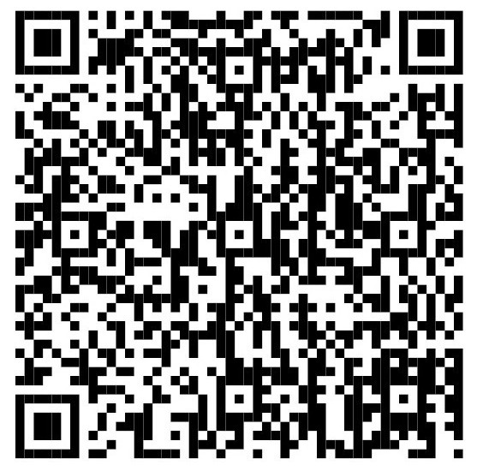
Please use this QR code to view the School Shouldn’t Cost manifesto.

