Dear [name of politician or candidate]
We are [name of children/group] from [add in school]. We are writing to tell you about the School Shouldn’t Cost manifesto, organised by Child Poverty Action Group (CPAG) in Scotland.
Our manifesto contains the views of thousands of children and young people across Scotland. We are asking all parties running in the Scottish election to take action on our calls and include them in your manifestos.
- End child poverty. Make sure our families have what they need so we can come to school ready to learn.
- Fund every school to fully remove cost pressures from our families and help us overcome poverty-related barriers to learning.
- Help us with the basics we need to learn, take part and feel included at school. Free school meals, uniform support, devices and resources for all and continued funding for curriculum costs.
- Make sure there are opportunities for all. Help all of us benefit from life changing school trips and from activities in our communities.
- Involve us! Young people can help make our schools and Scotland better.
The calls in this manifesto are important to us because we believe that no child in Scotland should be living in poverty. Every school pupil deserves to feel included, be treated equally and learn without stress.
Poverty and the cost of the school day are issues we must keep talking about, and we need people like you, who have a big platform, to listen and do more. Many schools work hard to make sure no pupils misses out due to costs, but we think more can be done to make sure families are not worried and children can thrive.
Taking action on our calls will help improve everyone’s life at school, and our future.
We want to see the calls in our manifesto featured in yours, and see action from the next government on them. Show us that you truly care about the young people in Scotland.
Please get back in touch with us and let us know how you will be supporting our future.
Yours sincerely
[your names and school]
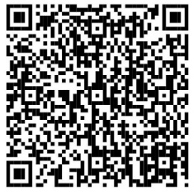
Please use this QR code to view the School Shouldn’t Cost manifesto.

