Dear [name of school/name of Head Teacher],
We are [names of children/name of group] from [name of your school].
We are getting in touch with you to tell you about the School Shouldn’t Cost manifesto, organised by Child Poverty Action Group (CPAG) in Scotland.
The manifesto contains the views of thousands of children and young people across Scotland. It calls for action to end child poverty, remove cost barriers to learning, help us with what we need to learn and make sure everybody can benefit from life changing trips and opportunities.
These calls are important to us because we believe that no child in Scotland should be living in poverty. Every school pupil deserves to feel included, be treated equally and learn without stress.
We are getting in touch with politicians on the run up to the Scottish elections in May to tell them all about the manifesto and ask them to include these calls in their manifestos. If you agree that these calls are important, your school can do this too using activities on the CPAG in Scotland website - you can use the QR code below to find them.
In our school we do [if you like, add in any cost of the school day work you are proud of] to help make sure no one is left out. What do you do? It would be great to share ideas with one another. [optional line if you would like to meet with the school] We would be really happy to meet with you, either in person or online to talk about this manifesto and our Cost of the School Day work.
We would love it if you could write back and let us know more about your school and what you are doing to tell more people about the School Shouldn’t Cost manifesto.
Yours sincerely
[name of children/school]
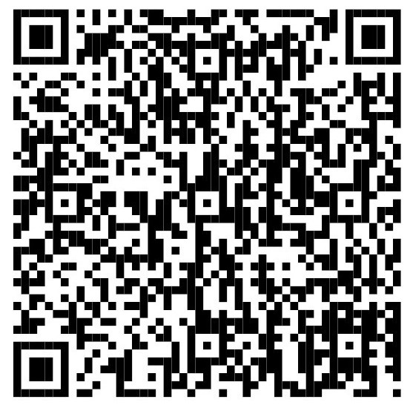
Use this QR code to read the School Shouldn’t Cost manifesto.

