Dear [name of MSP or candidate]
We are [name of children/group] from [name of school] in your constituency.
We are sending you this [letter/email] to let you know about the School Shouldn’t Cost manifesto, organised by Child Poverty Action Group (CPAG) in Scotland.
Our manifesto contains the views of thousands of children and young people across Scotland. We are asking all parties running in the Scottish election to take action on our calls and include them in your manifestos.
- End child poverty. Make sure our families have what they need so we can come to school ready to learn.
- Fund every school to fully remove cost pressures from our families and help us overcome poverty-related barriers to learning.
- Help us with the basics we need to learn, take part and feel included at school. Free school meals, uniform support, devices and resources for all and continued funding for curriculum costs.
- Make sure there are opportunities for all. Help all of us benefit from life changing school trips and activities in our communities.
- Involve us! Young people can help make our schools and Scotland better.
The calls in this manifesto are important to us because we believe that no child in Scotland should be living in poverty. Every school pupil deserves to feel included, be treated equally and learn without stress.
We are inviting you to meet us to discuss what we do in our school right now to reduce the cost of the school day, and how you can take action on the calls in this manifesto to help more children in Scotland.
Please let us know if you are available to visit us.
Yours sincerely
[your names and school]
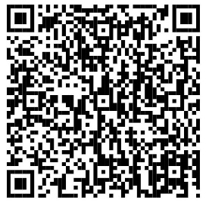
Please use this QR code to view the School Shouldn’t Cost manifesto.

