**BRIEFING**

**Benefit Sanctions Statistics**

**August 2025 release**

***Please note that due to expected family responsibilities, there will be no Briefing in November 2025. The next Briefing will be in February 2026.***

21 August 2025

Dr David Webster

Honorary Senior Research Fellow

Urban Studies

University of Glasgow

Email [david.webster@glasgow.ac.uk](mailto:david.webster@glasgow.ac.uk)

Webpages: <http://www.gla.ac.uk/schools/socialpolitical/staff/davidwebster/>

<https://cpag.org.uk/policy-and-research/latest-policy-briefings-and-reports/david-webster-briefings>

http://www.cpag.org.uk/david-webster

***SUMMARY***

This Briefing reports on the DWP’s latest quarterly sanctions statistics for Universal Credit (UC) which were released on 12 August. Its coverage includes the sanctions data which were missing from the May release.

**A divergence of trend has emerged between the number of sanctions imposed during each month, and the number of claimants serving a sanction at the measurement date in each month. The number of sanctions imposed has remained high and stable, while the number of claimants serving a sanction has fallen. The divergence is due to sanctions becoming shorter.**

There is no sign that the Labour government has reduced the numbers of sanctions. The monthly average number of sanctions imposed in the ten months since Labour took office in July 2024 has been 51,607. This compares with the average for the preceding ten months of 48,332. In the same period since July 2024 the monthly number of sanctions as a percentage of claimants in the conditionality regimes where sanctions may be imposed has been 2.46%. This is negligibly lower than the average in the preceding ten months of 2.51%.

In the year to end-April 2025, a total of 611,822 sanctions were imposed on 468,195 claimants. Of these, 104,740 received more than one sanction, and 27,693 reeived more than two. These figures are much higher than in the last full 12 months before the pandemic, to January 2020, when there were 230,720 UC sanctions and 178,476 sanctioned individual UC claimants.

It is possible to compare the total number of sanctions on all benefits for each of the 24 calendar years 2021-24, on the assumption that the number of sanctions other than for UC has been negligible since April 2022. On this basis, the total number of sanctions imposed in 2024, at 601,103, was the sixth highest out of the 24 years.

In the latest quarter, the percentage of UC claimants subject to conditionality who were serving a sanction at a point in time averaged 5.47%, lower than in the last full quarter under the Conservative government, when it was 6.22%. There has been a downward trend in this figure since Autumn 2023 and this is continuing under the Labour government, albeit the pace of decline is slow. However, the overall decline is composed of a fall from 7.57% to 6.38% in the proportion under sanction in the ‘Searching for work’, i.e. unemployed, group, with rises for the ‘Planning for Work’ and ‘Preparing for Work’ groups from 0.72% to 1.08% and from 0.70% to 0.90% respectively.

The actual total number of UC claimants serving a sanction in May 2025 was 109,570, a considerable reduction on the 124,109 in June 2024. Of these, 6,829 were in conditionality groups not liable to sanction but will have transferred from a group with conditionality while still under sanction.

The very slow decline in the proportion of sanctions imposed for missing an interview has continued. For April 2025 it was 89.5%. In the latest quarter, 93.0% of sanctions imposed were ‘low’ level, and 1.3% were ‘lowest’.

There is a short ‘news’ section at the end of the Briefing.

**BRIEFING: Benefit Sanctions Statistics**

**August 2025**

The DWP released its latest quarterly sanctions statistics for Universal Credit (UC) on 12 August. Its previous (May) release did not include data on numbers of sanctions and related figures, due to changes to the methods used to produce the statistics. The missing figures were restored by DWP in an update on 24 June. I did not think it worth producing a special issue of the Briefing to consider these, but they are included in the new August release and in the present Briefing.

The newly published data are summarised by DWP in the online publication *Benefit Sanctions Statistics*, available along with methodological notes at <https://www.gov.uk/government/collections/jobseekers-allowance-sanctions> together with a spreadsheet with summary tables. There is now a lot of sanctions data on Stat-Xplore at <https://stat-xplore.dwp.gov.uk/webapi/jsf/login.xhtml> .

All statistics presented here relate to Great Britain. All previous Briefings are available at <https://cpag.org.uk/policy-and-research/latest-policy-briefings-and-reports/david-webster-briefings>. The Briefings can also be readily found through a web search. The Briefing does not cover all topics in every issue. Previous Briefings include many analyses that are not repeated here but remain valid, and if a topic is not dealt with here it is likely to have been covered in an earlier Briefing. However it should be remembered that the DWP may have made subsequent revisions to the data reported in earlier Briefings. These revisions will generally not be major although there are exceptions. There may also often be substantial changes in some figures for the most recent few months.

DWP no longer publishes updates to statistics on sanctions for Jobseekers Allowance (JSA), Employment and Support Allowance (ESA) and Income Support (IS) for any date after April 2022. Nor has it ever published data on the appeal system for UC Full Service, which has included all UC claimants since April 2019. This is a serious gap.

**No. of claimants on Universal Credit and nos. subject to sanctions**

With the continuation of ‘managed migration’ of claimants on ‘legacy’ benefits, the number of UC claimants has topped 8 million for the first time, in the provisional figure for July. The increase of 322,000 between April and July was almost entirely due to an increase of 312,000 in the number with ‘no work requirements’. Consequently the proportion of claimants who were in the conditionality regimes where sanctions can be applied continued to fall, to 26.1% (2.09m) in July. Claimants on JSA, ESA and IS continued to be liable to sanctions but there are currently no data on whether they are being applied.

**Divergence between nos. of sanctions imposed and no. of claimants under sanction at a point in time**

**A divergence of trend has emerged between the numbers of sanctions imposed during each month, and the number of claimants serving a sanction at the measurement date in each month (the second Thursday). The number of sanctions imposed has remained high and** **stable, while the number of claimants serving a sanction has fallen. This is due to the length of sanctions becoming shorter.**

**Monthly no. of UC sanctions imposed**

**Figure 1** shows the monthly number of UC sanctions imposed since August 2015. The quarterly moving average is also shown, to make it clearer what is happening. The current level of sanctions is the highest since this particular measure began, and there is no sign that the Labour government has reduced the numbers of sanctions. The monthly average number of sanctions in the ten months since Labour took office in July 2024 has been 51,607. This compares with the average for the preceding ten months of 48,332.

**Monthly sanctions as a percentage of claimants**

**Figure 2** shows the monthly number of UC sanctions as a percentage of claimants in the conditionality regimes where sanctions may be imposed, also with the quarterly moving average. Once again it is apparent that the arrival of a Labour government has made no material difference. The monthly average percentage in the ten months since Labour took office in July 2024 has been 2.46%, negligibly lower than the average in the preceding ten months of 2.51%.

**No. of UC sanctions imposed and no. of sanctioned individuals**

In the year to end-April 2025, a total of 611,822 sanctions were imposed on 468,195 claimants. Of these, 104,740 received more than one sanction, and 27,693 reeived more than two. These figures are much higher than in the last full 12 months before the pandemic, to January 2020, when there were 230,720 UC sanctions and 178,476 sanctioned individual UC claimants.

**Figure 3** shows the total number of sanctions on all benefits for each calendar year since 2001, on the assumption that the number of sanctions other than for UC has been negligible since April 2022. DWP has not published any non-UC sanctions data since then, but such sanctions had already fallen to negligible levels since the beginning of the Covid-19 pandemic in March 2020.

The total number of sanctions for 2024, at 601,103, was the sixth highest out of the 24 years covered by the data.

**UC claimants subject to conditionality who were serving a sanction at a point in time**

**Figure 4** shows the percentage of UC claimants subject to conditionality who were serving a sanction at a point in time, with the quarterly moving average. In the latest quarter this averaged 5.47%, lower than in the last full quarter under the Conservative government, when it was 6.22%. There has been a downward trend in this figure since Autumn 2023 and this is continuing under the Labour government, albeit the pace of decline is slow. However, the overall decline is composed of a fall from 7.57% to 6.38% in the proportion under sanction in the ‘Searching for work’, i.e. unemployed, group, with rises for the ‘Planning for Work’ and ‘Preparing for Work’ groups from 0.72% to 1.08% and from 0.70% to 0.90% respectively. For the latter groups the numbers under sanction are small - 1,038 ‘Planning for Work’ and 3,224 ‘Preparing for Work’ in May 2025. By contrast, there were 98,466 ‘Searching for work’ claimants serving a sanction in April 2025.

The actual total number of UC claimants serving a sanction in May 2025 was 109,570, a considerable reduction on the 124,109 in June 2024. Of these, 6,829 were in conditionality groups not liable to sanction but will have transferred from a group with conditionality while still under sanction.

**Reasons for and ‘levels’ of sanctions**

The very slow decline in the proportion of sanctions imposed for missing an interview has continued. When this was last reported on in the Briefing, the latest figure was 94.2% for October 2023. For April 2025 it was 89.5%. As noted in the discussion of this topic in the February 2024 Briefing, there is a very close relationship between the reasons for sanctions and their ‘levels’. In the latest quarter, 93.0% of sanctions imposed were ‘low’ level, and 1.3% were ‘lowest’. As also previously noted, these terms can be a misnomer since both ‘low’ and ‘lowest’ sanctions have an indefinite ‘until compliance’ component, which can mean that they last longer than supposedly higher level sanctions.

**Duration of sanctions**

The fact that the proportion of UC claimants serving a sanction at a point in time has gone down while the proportion having a sanction imposed each month has scarcely changed implies that there has been a reduction in the duration of sanctions. This is indeed confirmed by **Figure 6**, which shows the median length of the sanctions completed in each month since January 2017. There has clearly been a reduction since July 2024 albeit there has been a slight uptick in the most recent quarter. **Figure 7** confirms this picture. There has been a reduction in the numbers of completed sanctions in the longest categories, namely 14 to 26 weeks and 27 weeks or more, and an accompanying rise in the shorter categories of 4 weeks or less and 5 to 13 weeks.

There were full discussions of the sanctions duration data in the November 2017 Briefing, pp.6-10, and in the February 2024 Briefing, pp.7-8.

**Ethnicity analysis**

The DWP has updated the ethnicity data first published in February 2025. These were fully analysed in the February Briefing and the analysis is not repeated here.

**SANCTIONS –DEVELOPMENTS IN POLICY AND RESEARCH**

**End of ‘any job’ policy**

The *Guardian* on 29 May published an interview with the Employment Minister Alison McGovern in which she said that Jobcentres will no longer force people into “any job” available, and also that the DWP will use AI for form-filling to free up the workloads of job coaches, giving them more time to provide “human” support to those with complex needs and long-term unemployment. The full interview is at

<https://www.theguardian.com/society/2025/may/29/jobcentres-alison-mcgovern-employment-support-policy>

**Jobs and careers service Pathfinder in Wakefield**

On 5 June the government announced the launch of a new model Jobcentre service in Wakefield, intended as a pathfinder for further rollout across the country. Elements of the new service will include a new Coaching Academy for work coaches, careers events focused on local growth sectors, more personalised Jobcentre appointments, better working with employers, and involvement of local areas in the design of services. It is partly a response to the fact that only 9% of employers currently recruit through Jobcentres.

The Wakefield Pathfinder is being co-designed with local leaders from the West Yorkshire Combined Authority and Wakefield Council. It builds on wider investment in West Yorkshire, including £18m for an ‘inactivity trailblazer’ and an NHS Accelerator. The inactivity trailblazer, launched in April 2025, is intended to boost employment in areas with the highest levels of economic inactivity. The NHS Accelerator will help to prevent people from falling out of work completely due to ill health.

Further Pathfinders, including ones that are focused on support for young people and those with health conditions, will be launched later this year.

More details are in a DWP press release at

<https://www.gov.uk/government/news/biggest-shake-up-of-jobcentres-in-decades-gets-underway>

**Unlocking the potential of young people furthest from the labour market**

On 6 May the Joseph Rowntree Foundation published a report on policies to help young people who are furthest from the labour market (Casey & Elliott 2025). Among the points it makes are that ‘extending conditionality to young people on LCWRA without any

clarification about who will be protected from the changes could push young people with a health condition or disability further away from employment, not closer to it, as they already fear punitive conditionality and benefit sanctions. It is unclear why programmes outlined in the white and green papers, such as the new supported employment programme, Connect to Work, are ‘voluntary’ (in recognition of the complexity of people’s lives, health conditions and disabilities) but the Youth Guarantee is not, despite recognising that young people may have similar barriers to participation, such as homelessness, drug and alcohol dependency, and being a care leaver.’

**REFERENCES**

Casey, Rachel and Joseph Elliott (2025) *Unlocking the potential of young people*

*furthest from the labour market*, Joseph Rowntree Foundation, 6 May, at

<https://www.jrf.org.uk/work/unlocking-the-potential-of-young-people-furthest-from-the-labour-market>

**Figure 1**

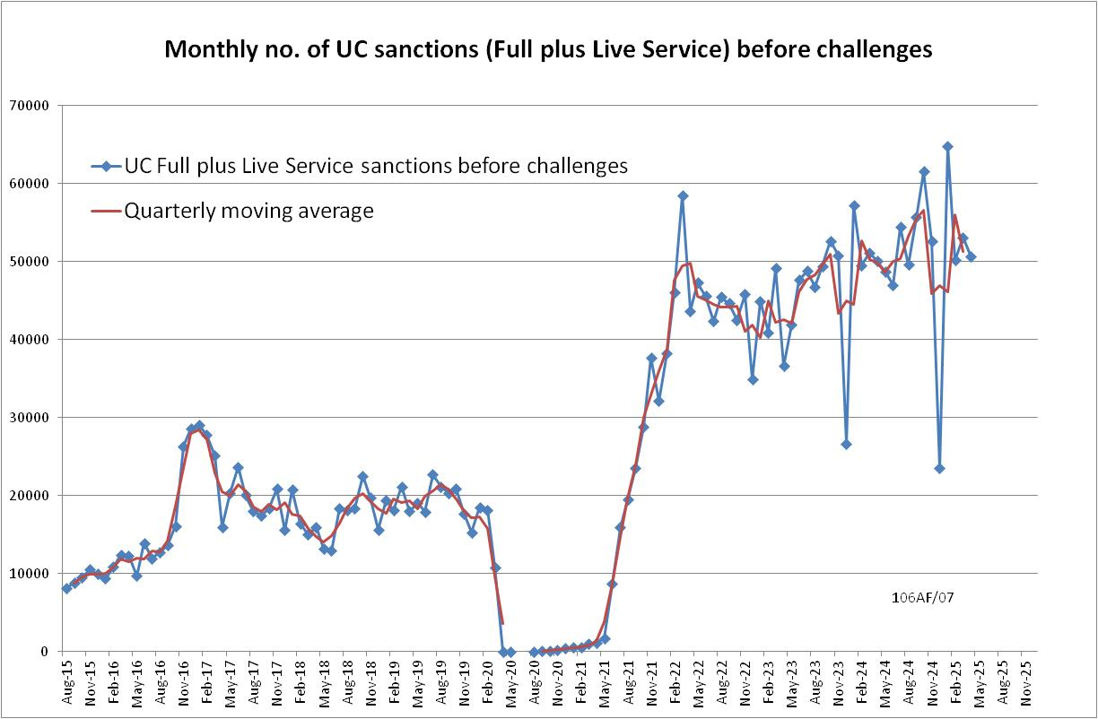

**Figure 2**

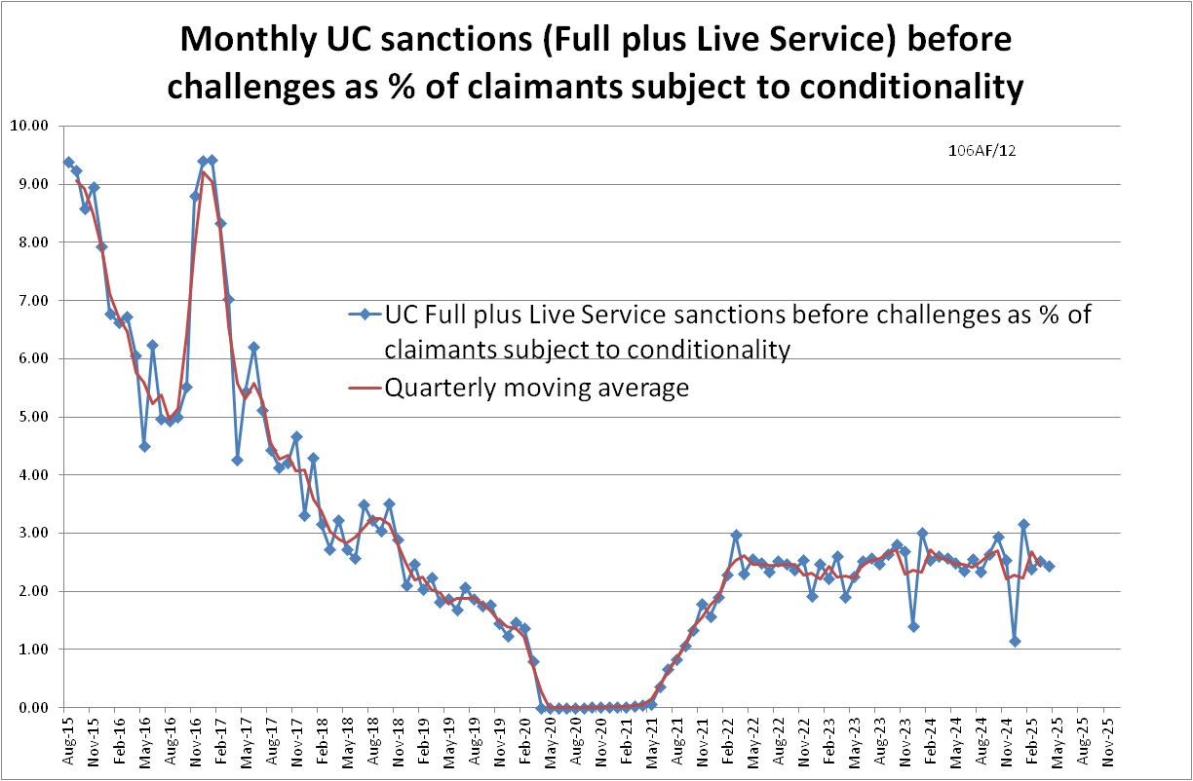

**Figure 3**

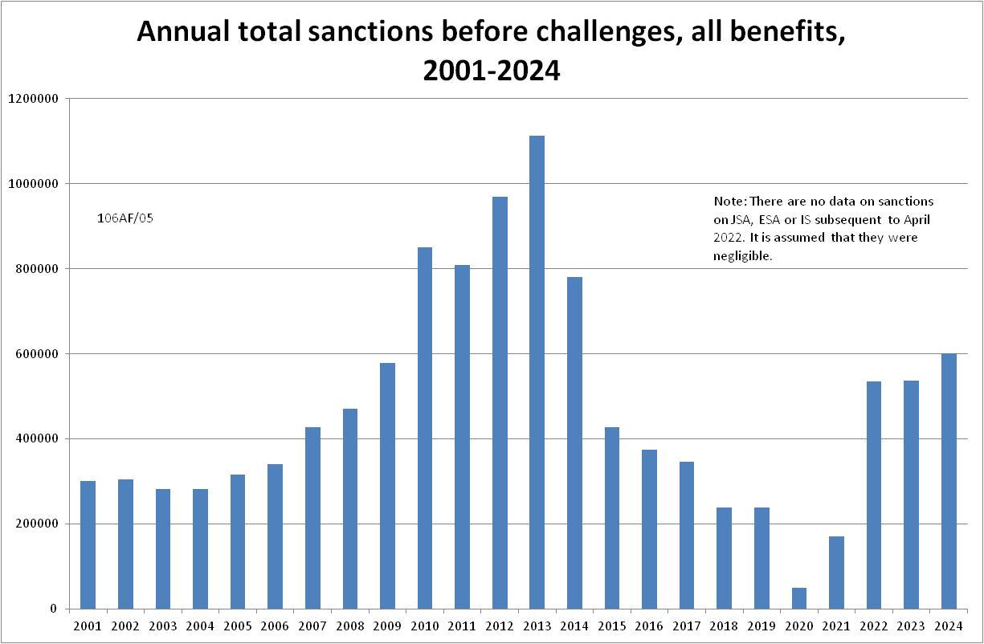

**Figure 4**

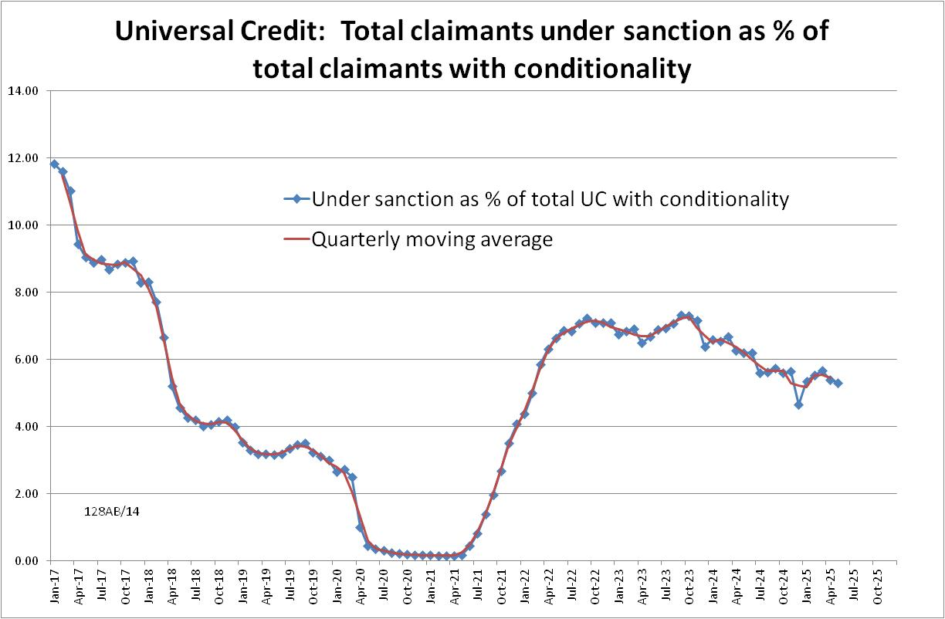

**Figure 5**

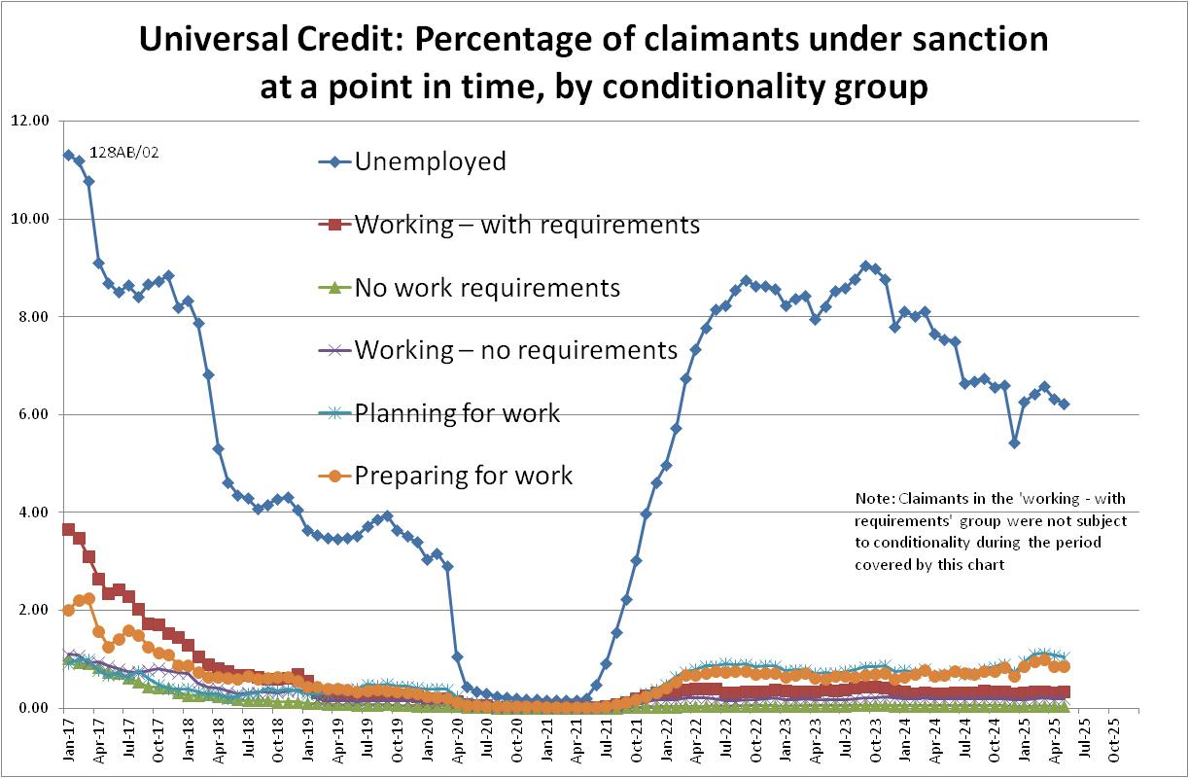

**Figure 6**

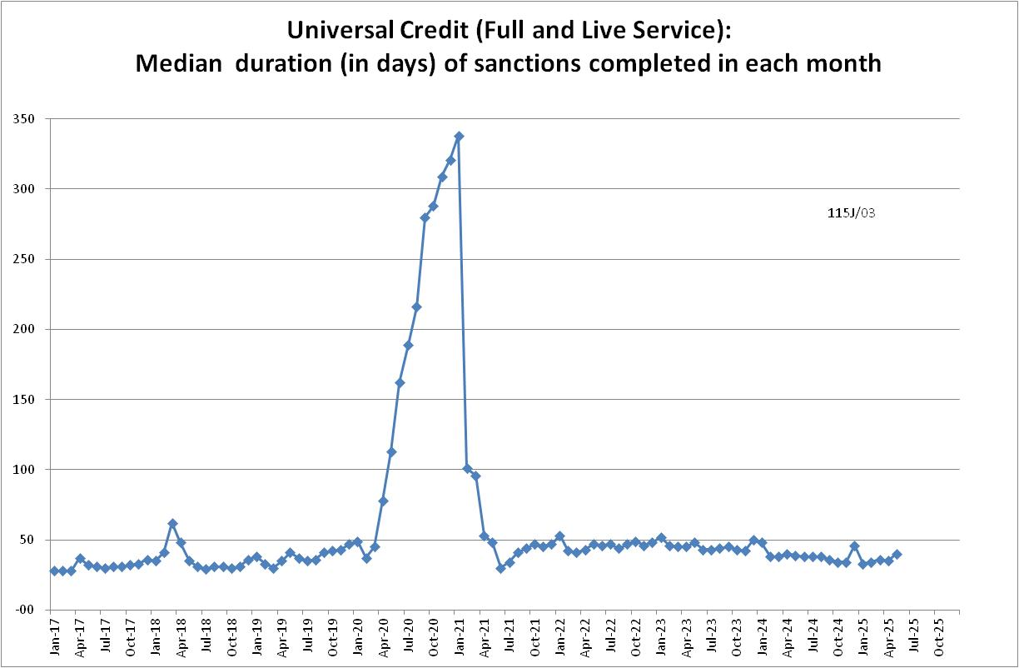

**Figure 7**

