, Picture

### **Cost of the School Day Voice Meet-up, summary of meeting**

**Tuesday 20th May 2025**

It was great to have a variety of primary schools across Scotland join us online to hear what we have all been up to. This session pupils from Bridgend Primary school in the Highlands came online and shared what they have been up to including their Bridgend Helpers initiative which offers P6 and P7 pupils leadership opportunities in the school where they can earn and save up points to exchange for rewards from the Bridgend ‘shop’

## **Bridgend Primary School Pupils, Highlands**

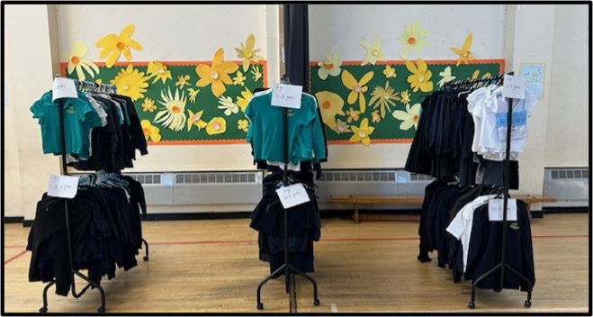 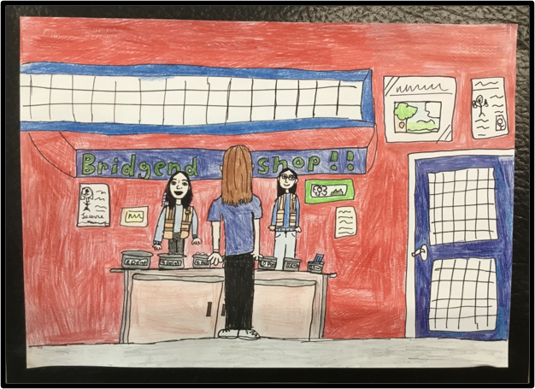

**Alfie, Emily, Noah, and Gracie** shared what they are doing in their school Cost of the School Day group to help make things more affordable for everyone at their school. The group has attended Parent Council sessions to tell them who they are and what they do in the school

They have also run assemblies for the whole school telling pupils what they are doing to reduce costs and include everyone.

### **Uniform Swap Shop**

**Emily** shared that they have a very successful free uniform swap shop that pupils and families can access ***“We made our uniform shop... It’s quite big. We’ve got different selections of jumpers for people that need them.*”** Emily also shared how they worked with their parent council to get funds for clothes rails on wheels, so uniforms can be easily moved around during events like open afternoons and parents' evenings so parents can access items easily.

### **Reintroducing toast in the mornings**

**Noah** told us during Covid pupils really liked having free toast in their classrooms and missed it and wanted to bring it back ***“We introduced toast again because lots of people were asking for it. It helps you feel fuller, we know it’s hard to focus with an empty stomach.****”* The group worked with their canteen to understand the cost of buying equipment and are in the trial phase where toast is offered one day a week to different classes. Noah says *“It has been really good. Some classes eat the toast in the class, and some classes go outside to eat it in the playground because some teachers are worried about crumbs”*

### **Bridgend Helpers Programme – helping everyone earn school rewards**

**Gracie** explained that all P6 and P7 pupils can apply for leadership jobs to help around the school, ***“anyone can be one. In August you can fill in an application form. You have to say what skills you have, like resilient, respectful or good working with little children.”***

Types of jobs include playground helpers, office assistants, paper recyclers, post helpers, litter pickers and lunch time helpers

Helpers earn **points** which can be spent at the Bridgend school shop. Pupils are given a payment card and each time they complete a task a staff signs it. Each signature equates to 2 points. Gracie told us **“Each *Thursday, the shop opens. You can trade your points — 2 points for pencils or rubbers, or you can save up to 30 points for a big art set”***

Gracie and Emily both agreed that bouncy balls and erasers were most popular

### **Upcoming cost of the school day work**

**Alfie** shared that their next project is to work with their school leaders and pupils to provide extra food and snacks for pupils ***“We want to set up snack boxes so people can help themselves if they don’t have a snack at break time.”*** Alfie also shared that they want to look at providing more play equipment in the playground and relaunch their Toughie Trail, an assault course in their playground.

### **What does it mean to pupils to be part of their Cost of the School group**

**Emily said** *“We get to help other people with doing new things. It’s really fun to be in the group because you get to meet new people.”*

**Noah said** *“You get to help parents who don’t have enough money to buy essentials for school. Our group helps with school stuff so families can save money for things outside school.”*

**Top Tip for Other Schools**

**Gracie** spoke about how it was important to consult with everybody at the school ***“You want to make sure the whole school wants the idea. We asked people if they wanted toast and they said yes.”***

## **What would you do if you had a magic money tree?**

As a quick activity to hear children’s views pupils shared what they thought extra investment in schools should be spent on to make sure all children can learn and be happy, here are just some of the great suggestions.

**Chyrnside primary pupils in Glasgow want**

Every pupil gets a free uniform, trips paid by school and free snacks available for hungry pupils

#### **Newton primary pupils in South Ayrshire want**

More music lessons offering a variety of instruments including the drums.

#### **Linlithgow Bridge Primary pupils in West Lothian want**

iPads for every pupil, therapy dog in school and more playground equipment

#### **St Mary’s primary pupils in West Lothian want**

Free school dinners for P6 & P7 and devices for all pupils

#### **Fintry primary pupils in Stirling**

Said they felt inspired by the Bridgend primary helper’s programme and would also, fix their woodlands area and, provide wet weather gear (boots, overalls) for outdoor access

## **Wee reminder to schools**

Check out the short video featuring pupils from the Voice Network who spoke to Jenny Gilruth MSP about the importance of the Cost of the School Day. Please do share this with your groups and help them hear from other young people what they thought about sharing their views and being listened to by decision makers. <https://youtu.be/mXct42k6Q_o>

## **Next school session**

We love hearing from your pupils, if there is anything your pupils would like to come online and share with us, please get in touch with Kirsty at [kcampbell@cpagscotland.org.uk](mailto:kcampbell@cpagscotland.org.uk)

Support available to help young people prepare for online meetings.