### A yellow and black sign with white text AI-generated content may be incorrect., Picture, Picture

### **Cost of the School Day Voice, leader’s meeting summary**

### **4th June 2025**

Input from Irvine Royal Academy pupil group

This session we heard from Cost of the School Day Voice pupils at **Irvine Royal Academy** in North Ayrshire. **Leo, Jayden, Savannah, Evie, Mollie and Jacob** gave an inspiring presentation on their school's approach to reducing the cost of the school day showcasing multiple practical initiatives:

  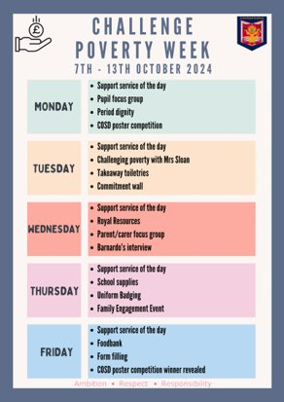

* **Royal Resources**: A walk-in closet-style space offering clothes, jackets, shoes, and school uniforms—open to the whole community. ***“We’ve got everything—trousers, skirts, cardigans, shorts—full sets of school uniform.”***
* **Free Badging Service**: A heat-press system available in the school allows families to badge school uniforms for free. Pupils told us ***“You can bring in anything—joggers, polo shirts—and we’ll badge it for free. We even get parents helping—it’s a real community thing.”*** The school badging service is available at the start of terms and through the school holidays to help pupils prepare for school.
* **Prom Wear Lending**: Access to suits, dresses, shoes, and accessories to make prom inclusive for all. Savannah shared how this resource is being used throughout the school community for other celebrations ***“We’ve even had families come in and use prom outfits for bridesmaids—we think everyone deserves a chance to go to prom no matter what they can afford.”***
* **Flexible Trip Payments**: School trips supported by fundraising efforts and extended payment plans for families. Jacob said, ***"Every young person deserves a chance to go on one of these school trips, no matter how much they cost."***
* **Family Engagement Days**: Pupils also highlighted the important role their Family Engagement Officer provides which includes termly free family fun days such as summer BBQs and Christmas celebrations offering information services like welfare rights, local community support groups accompanied with hot food. Pupils felt this was a way of making support services accessible in a fun, non-stigmatising way.
* **Free Period Products**: Widely available to all pupils and families.
* **Challenge Poverty Week**: The group uses this week to raise awareness with pupils and families about what they are doing. Last challenge poverty week they ran a whole week of awareness raising and activities they also took part in [Cost of the School Day pupil group interview their Headteacher](https://cpag.org.uk/what-we-do/project-work/cost-school-day/resources/ideas-bank/learners/interview-head-teacher)

**Scottish Government Insight – Pupil Equity Funding (PEF)**  
**Tom McKenna** from the Scottish Government PEF policy unit shared highlights from the recently published **Pupil Equity Funding (PEF) Report** <https://education.gov.scot/learning-in-scotland/scottish-attainment-challenge/pupil-equity-fund-report/>

* £130 million annually is invested directly into schools to reduce the poverty-related attainment gap.
* The report has case studies and videos from 15 schools developed to promote peer learning. Some useful for youth groups and school staff to watch together to explore the impact of PEF
* The report highlights the many creative approaches to reducing costs, such as free breakfast clubs and tackling uniform expenses.

**3. Having your say**

**Cost of the School Day Toolkit Survey**

Welcome feedback from teachers and Voice Leaders <https://www.surveymonkey.com/r/8CH5YJH> open until 26th June 2025

* + What works well?
  + What needs added or improved?

Aims to ensure the toolkit is practical, updated, and easy to use.

**Voice Network Feedback Survey** <https://forms.office.com/e/3FaSY4sxeT>

* + What has been useful this year?
  + What support, training, or themes would help next year?