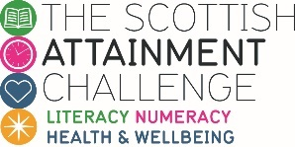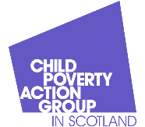
Cost of the School Day Voice Network
Primary and secondary meet ups – 18th September 2024

Primary school session
It was great to have 160 young people and group leaders online to share and listen to updates!
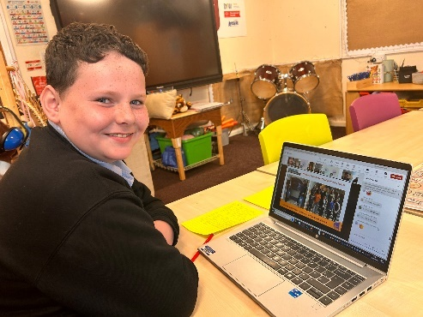
Leland from Newton Primary School in South Ayrshire told everyone about his trip to the Scottish Parliament before the summer holidays. Leland attended a round table with stakeholders and politicians, including Jenny Gilruth Cabinet Secretary for Education and Skills, to discuss the importance of Universal Free School Meals. He described the discussion, and what he told the politicians:
“If you don't get enough food, you get, like, really hungry and you can't focus, and it just makes school even worse. I’m pretty sure every school has to take part in 2 hours of PE. Could you do that if you were hungry?”
Leland asked politicians to extend universal free school meals “Instead of just doing it for P1-P5, do it for all including S1 to S6"
In the Meet up Leland had some tips on speaking in meetings and to decision makers: “I knew if I pushed myself out of my comfort zone I could do it. I learned this technique from a friend where I stared at one person, and I didn’t get nervous and if you mess up just try to play it off”
Leland thinks that it’s important that children are part of decision-making: “I don’t think they should make decisions without us, especially if it’s about us. I think we deserve a say in a lot of decisions”
There was lots of praise for Leland from Voice members, including: “Wow Leland! What a brilliant message to campaign and share with our elected members. Your school team and you must be very proud. Well done, keep it up!”
We also heard from St Joseph’s Primary School who told us about their uniform swap shop, and learners from Linlithgow Primary School, who are getting ready to deliver their Cost of the School Day assembly.
There was a shout out to any Voice members who would like to chat at the next meet up or work with us to come up with a warm-up game for the meeting. To get your group involved in either, please contact kcampbell@cpagscotland.org.uk
Secondary school session
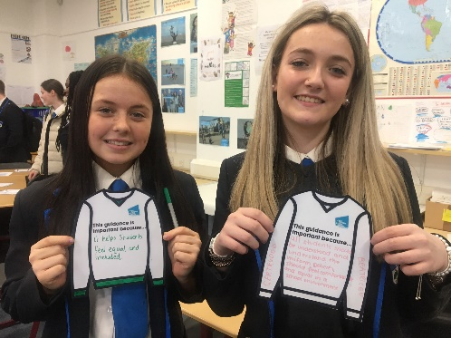
We heard from the Cost of the School Day group at Holyrood Secondary School in Glasgow who shared their work to create ‘take what you need’ trollies throughout the school. Abbie from Holyrood Secondary said she got involved with cost of the school day work because “we do know people can directly be struggling with costs at school and we wanted to be part of solving the issues”
The group shared their experience of filming the Cost of the School Day Big Question film and being involved in creating the children and young person’s version of the National Uniform Guidance for Schools.
Voice members shared some of the ways they are already addressing uniform costs Equity Ambassadors at Carluke High School, South Lanarkshire shared the uniformly app that they use in their school they told us “It’s an anonymous app that parents can download and go on to and select whatever pieces of clothing or uniform. They just go on press what they want and It's all packaged up anonymously put into our office and people can come in and take it as they need, and it's all free. It really takes a bit of the stigma away. People can access it at home in a time that suits them, and it's really simple. We've found this really been beneficial to our school community”
Voice members from Irvine Royal Academy in North Ayrshire shared their in-house initiative to brand plain clothing “we do a kind of re-badging here; you can bring stuff from your house like jumpers and t-shirts, and we stamp them [with the school logo] here. Means you can go to any shop and bring stuff in.”
During the session Voice members began looking at one of the Challenge Poverty Week activities and started thinking about the Talking to politcians activity: What would you like to ask or tell the politicians in charge of schools and education? Here are some of the questions we heard during the meeting:
- Irvine Royal Academy pupils had a focus on eating at school: “Please give meals for everyone, because some people in this school don't have enough money to pay for their school meals, and it's hard for other people to eat.”
- Carluke High School discussed the cost of trips and the need for additional support, especially with educational trips: “How can we make sure that our pupils can get these enriching experiences, without having that high price tag and is there a way around it”
- Holyrood Secondary pupils asked to: “increase the funding that schools would get for things like cost of the school day”
We hope that groups will continue this activity in the next few weeks, and maybe help run it with more pupils in their schools. Look forward to seeing what you all come up with during Challenge Poverty Week.
Finally, Kirsty asked Voice members their thoughts on what can we do to support your cost of the school day group? Please do chat to your group about what they would like to discuss or explore in future online meet ups and contact kcampbell@cpagscotland.org.uk with suggestions.
Finally, a huge thank you to everyone for joining us and sharing your news, ideas and updates.

Thanks for coming along, it was great to hear from you all! See you at the next meet up,
Kirsty

