**BRIEFING**

**Benefit Sanctions Statistics**

**February 2025 release**

24 February 2025

Dr David Webster

Honorary Senior Research Fellow

Urban Studies

University of Glasgow

Email [david.webster@glasgow.ac.uk](mailto:david.webster@glasgow.ac.uk)

Webpages: <http://www.gla.ac.uk/schools/socialpolitical/staff/davidwebster/>

<https://cpag.org.uk/policy-and-research/latest-policy-briefings-and-reports/david-webster-briefings>

http://www.cpag.org.uk/david-webster

***SUMMARY***

The DWP released its latest quarterly sanctions statistics for Universal Credit (UC) on 18 February. The sanctions figures for the latest quarter are the first for which the new Labour government is wholly responsible.

There is no sign that the Labour government has taken any steps to alter the sanctions regime. The average monthly number of sanctions for the latest quarter to November 2025 was 55,585. There has effectively been no change in the monthly rate of sanctions imposed as a percentage of claimants subject to conditionality since April 2022. It remains at about 2.5% of claimants per month (2.63% in the latest quarter).

A total of 601,999 UC sanctions were imposed in the year to end-October 2024, which straddles both Conservative and Labour governments. The total number of individual UC claimants who received at least one sanction during the year was 463,700.

In the latest quarter the percentage of UC claimants subject to conditionality who were serving a sanction at a point in time averaged 5.6%. The actual number of UC claimants serving a sanction in November 2024 was 116,536.

**DWP has published greatly improved data on ethnicity, which substantially changes the picture of ethnic disparities in sanctions.** For September to November 2024, DWP gives the results of an ethnic group analysis of the proportion of UC claimants in the conditionality groups subject to sanction who are serving a sanction at a point in time. This indicates that:

* There is no meaningful difference in the proportions for Black/Black British/African/Caribbean claimants compared to White claimants. Black claimants were only 6%, 4% and 3% more likely to be under sanction compared to White respectively in September, October and November 2024.
* Claimants in the Mixed/Multiple ethnic group were 27%, 29% and 29% more likely to be under sanction than the White group.
* The Asian/Asian British ehtnic group were 25%, 29% and 29% *less* likely to be under sanction than the White ethnic group.
* The Other ethnic group were 17%, 23% and 26% *less* likely to be under sanction than the White ethnic group.

**The figures on ethnicity published in the August 2024 Briefing should be disregarded, as they showed sanctions as proportions of all UC claimants, rather than just those subject to sanctions.**

Among a number of items in the news section are five more studies on the increase in health-related out of work benefit claims. They are additional to the two studies from the Institute for Fiscal Studies and the Resolution Foundation reported in the November 2024 Briefing. This is clearly an area of very active analysis, and associated policy debate and development.

**BRIEFING: Benefit Sanctions Statistics**

**February 2025**

The DWP released its latest quarterly sanctions statistics for Universal Credit (UC) on 18 February. Theese sanctions figures are the first for which the new Labour government is wholly responsible. The newly published data are summarised by DWP in the online publication *Benefit Sanctions Statistics*, available along with methodological notes at <https://www.gov.uk/government/collections/jobseekers-allowance-sanctions> together with a spreadsheet with summary tables. There is now a lot of data on Stat-Xplore at <https://stat-xplore.dwp.gov.uk/webapi/jsf/login.xhtml> . There is also an important new edition of *Universal Credit Sanctions Statistics: Background information and methodology.*

All statistics presented here relate to Great Britain. All previous Briefings are available at <https://cpag.org.uk/policy-and-research/latest-policy-briefings-and-reports/david-webster-briefings>. The Briefings can also be readily found through a web search. Previous Briefings include many analyses that are not repeated here but remain valid. However it should be remembered that the DWP may have made subsequent revisions to the data reported in earlier Briefings. These revisions will generally not be major although there are exceptions. There may also often be substantial changes in some figures for the most recent few months.

DWP no longer publishes updates to statistics on sanctions for Jobseekers Allowance (JSA), Employment and Support Allowance (ESA) and Income Support (IS). Nor has it ever published data on the appeal system for UC Full Service, which has included all UC claimants since April 2019.

**No. of claimants on Universal Credit and nos. subject to sanctions**

In January 2025 there were a provisional 7.46m claimants of UC. This number has been creeping up by around 80,000 to 100,000 per month due to ‘managed migration’ of claimants on ‘legacy’ benefits. Of the total, 2.08m or 27.9% of UC claimants were in the conditionality regimes where sanctions can be applied.

**Monthly no. of UC sanctions**

**Figure 1** shows the monthly number of UC sanctions imposed since August 2015. There is no sign that the Labour government has taken any steps to alter the sanctions regime. The average monthly number of sanctions for the latest quarter to November 2025 was 55,585. The number in November, at 61,527, was actually the highest to date for UC sanctions for a single month.

**Monthly sanctions as a percentage of claimants**

**Figure 2** shows monthly sanctions imposed as a percentage of claimants subject to conditionality, i.e. in the conditionality groups ‘searching for work’, ‘planning for work’ or ‘preparing for work’). There has effectively been no change in the monthly rate of sanctions imposed since April 2022. It remains at about 2.5% of claimants per month (2.63% in the latest quarter).

**No. of UC sanctions and no. of UC claimants sanctioned during the year to 31 October 2024**

A total of 601,999 UC sanctions were imposed in the year to end-October 2024, which straddles both Conservative and Labour governments. Of these, 138,299 were repeat sanctions on individuals who had already received at least one sanction during the year. Therefore the total number of individual UC claimants who received at least one sanction during the year was 463,700. Of these, 102,458 (22.1%) received more than one sanction, and 25,953 (5.6%) received more than two. These figures are much higher than in the last full 12 months before the pandemic, to January 2020, when there were 230,720 UC sanctions and 178,476 sanctioned individual claimants.

**Figure 3** shows the two series for the number of sanctions imposed and the number of claimants sanctioned, for the 12-month periods ending in each quarter since January 2020 (just before the pandemic).

**UC claimants subject to conditionality who were serving a sanction at a point in time**

**Figure 4** shows the percentage of UC claimants subject to conditionality who were serving a sanction at a point in time. In the latest quarter this averaged 5.6%. There has been a downward trend in this figure. It is too early to say whether this is continuing under the Labour government. The actual number of UC claimants serving a sanction in November 2024 was 116,536. Of these, 6,656 were in conditionality groups not liable to sanction but will have transferred from a group with conditionality.

**ETHNICITY ANALYSIS**

The DWP has now published important new data on sanctions and ethnicity. This improves the analysis by enabling calculation of sanction rates for UC claimants subject to conditionality, rather than for all UC claimants. This leads to strikingly different results.

In its August 2024 release, the DWP for the first time published data on UC sanctions by ethnicity. These were for the period April 2023 to April 2024, They were reported in the August 2024 Briefing, pp.7-8. Using the data on numbers of UC claimants by ethnicity separately published by DWP in its *Universal Credit Ethnicity Statistics*, the Briefing (Figures 8 and 9) calculated the monthly rates of sanction for the different ethnic groups. This analysis showed that for most of the time, all the minority ethnic groups have higher sanction rates than Whites. But while the sanction rate for Asian claimants was only around 5% above that for whites, and the rate for ‘other’ ethnic groups around 10% above, the rate for Black claimants was about 60% higher, and for Mixed ethnicities about 70% higher. As mentioned in the August 2024 Briefing*, a limitation in these figures is that they showed the sanction rate for all UC claimants, not just claimants in the conditionality groups subject to sanction*.

In its February 2025 release, **DWP has now published analyses of UC sanctions by ethnicity which give very different results**.These analyses are specifically for claimants in the conditionality groups subject to sanction (‘searching for work’, ‘planning for work’ and ‘preparing for work’), for varying time periods. They are in *Benefit Sanctions Statistics*, section 5, and there are some additional data in the accompanying spreadsheet tables. There is also a methodological discussion in an updated edition of *Universal Credit Sanctions Statistics: Background information and methodology*, at <https://www.gov.uk/government/publications/universal-credit-sanctions-statistics-background-information-and-methodology> However the ethnicity data are not on Stat-Xplore, nor are they published for the dates of the particular analyses which DWP has carried out. For this reason it is not possible for the Briefing to draw charts.

For September to November 2024, DWP gives the results of an ethnic group analysis of the proportion of UC claimants in the conditionality groups subject to sanction who are serving a sanction at a point in time. This indicates that:

* There is no meaningful difference in the proportions for Black/Black British/African/Caribbean claimants compared to white claimants, i.e. Black claimants in the conditionality groups subject to sanction were only 6%, 4% and 3% more likely to be under sanction compared to White respectively in September, October and November 2024.
* There is a meaningful difference in the proportions for claimants in the Mixed/Multiple ethnic group compared to White claimants. They were 27%, 29% and 29% more likely to be under sanction than the White group.
* There is a meaningful difference in the proportions for the Asian/Asian British ehtnic group compared to White claimants. They were 25%, 29% and 29% *less* likely to be under sanction than the White ethnic group.
* There is a meaningful difference in the proportions for the Other ethnic group compared to White claimants. They were 17%, 23% and 26% *less* likely to be under sanction than the White ethnic group.

**These findings are substantially different from those reported in the August 2024 Briefing. In particular, whereas in the earlier figures the Black group had a sanction rate much higher than the White group, the new figures suggest that they have only about the same rate. Also, whereas the earlier figures showed all the ethnic minorities with a higher sanction rate than Whites, the new figures suggest that the Asian and Other groups have substantially lower rates of sanction.** Of course the two sets of figures are not measuring the same thing. The August 2024 Briefing showed the number of sanctions imposed per month, whereas the latest release shows the number of claimants under sanction at a point in time. But these two meaasures are closely related and this does not seem likely to account for the differences in the figures. One key reason which certainly does account for it, at least in part, is that the proportions of UC claimants who are subject to sanctions are different for the different ethnic groups. In January 2025 for example, this proportion was 24.8% for White claimants, but 34.5% for the Mixed group, 34.8% for Asian, 37.7% for Other, and 37.8% for Black claimants.

In the latest edition of *Benefit Sanctions Statistics*, section 5, DWP also provides a comparison of the percentage of total sanctions imposed in October 2024 which were imposed on each ethnic group, with the percentage which that group formed of total UC claimants subject to sanctions. This showed the White group with 69% of claimants and 72% of sanctions; Asians with 13% of claimants but 10% of sanctions; the Black group with 8% of claimants and 8% of sanctions; Mixed with 4% of claimants and 5% of sanctions; and Other with 6% of claimants and 5% of sanctions. Allowing for rounding, these figures are obviously in line with the newly published figures for the proportion of claimants subject to sanction who were under sanction at a point in time.

**The new data on ethnicity presented here are clearly superior to those published in the August 2024 Briefing and the earlier figures should be disregarded.** It is very welcome that the improved data now show that ethnic disparities are much smaller than previously appeared. It remains puzzling that the Mixed ethnicity group is still showing a substantially higher sanction rate than the other groups, albeit the apparent disparity is now smaller. Some information about the composition of the Mixed group was provided in the August 2024 Briefing, Table 1. It should also be borne in mind that these figures are still not entirely satisfactory, since data are missing due to non-response for some 20%-30% of claimants and there has been no reweighting, so there may be significant non-response bias.

**SANCTIONS –DEVELOPMENTS IN POLICY AND RESEARCH**

**Guide to the Universal Credit ‘claimant commitment’**

DWP on 12 February published an updated guide to the ‘claimant commitment’, at <https://www.gov.uk/government/publications/universal-credit-and-your-claimant-commitment-quick-guide/universal-credit-and-your-claimant-commitment> . It has a useful listing and explanation of the various ‘easements’.

**Universal Credit Full Service Omnibus Survey – Lack of knowledge of sanctions**

DWP published results of its UC Full Service Omnibus Survey in October (DWP 2024), showing extensive lack of knowledge by claimants about sanctions. Section 5 concluded that ‘Overall knowledge about sanctions remained low and unchanged over time, with only one in ten (10%) claimants aware of both the impact on their benefits and their rights to appeal under any circumstance’.

**Updated DWP analysis of variations in the UC sanctions rate between Jobcentres**

On 6 February DWP published an update to its analysis of variations in the sanctions rate between Jobcentres. The new report (DWP 2024b) covers January 2017 to August 2024, while the previous report (DWP 2020) covered January 2017 to August 2019. The November 2020 Briefing reported on the earlier study. Like the earlier study, the new one finds that the degree of variation between Jobcentres has fallen over time. It does not consider the question whether there are Jobcentres that have consistently high or low rates of sanction over time.

**DWP report on work aspitations and support needs of health and disability customers**

This important report (DWP 2025c) was published on 6 February. It is based on 3,401 responses to a survey of a random stratified sample of 15,900 claimants, supplemented by 61 qualitative interviews with a quota sample. The survey response rate was only 21% but the results have been reweighted, Among the key findings are that:

* Nearly half (49%) ofcustomers felt they would never be able to work, or return to work, because of their health, while 27% felt they might be able to work in future but only if their health improved.
* Nearly half (44%) of people with a mental health condition felt they might be able to work in future if their health improved.
* Two in five customers (41%) were on a waiting list for treatment for their health condition(s), and half (50%) felt their ability to work was dependent on receiving treatment.
* One in twenty 5%) felt they could work right now, if only the right job or support were available, and many of the 19% of customers who were already in work wanted to increase their hours.
* Of those customers not in work who did not rule out work permanently, 60% were worried that DWP would make them look for unsuitable work, and 50% were worried they would not get their benefits back if they tried working, including some who were not receiving any means-tested benefits.
* Those in work often felt the financial return from additional hours worked was not worth it, given the way the UC taper works, and given that working longer hours could affect their health.
* Most customers (69%) were open to receiving contact from DWP/JCP about offers of support for employment, benefits or disability services. Customers wanted help to develop skills, including emotional, social and communication skills. They wanted help finding and applying for jobs, and help to stay in work, including engaging with employers to ensure their needs were met. Customers wanted help from DWP to be personal, with genuine attempts to understand their unique needs and circumstances. They wanted to feel supported rather than coerced, monitored or blamed.

**DWP statistical release on reasons for the increase in the number of sickness/disability UC claimants not subject to conditionality**

On 29 January DWP published a statistical release (DWP 2025a) examining factors behind the increase in the number of sick/disabled UC claimants in the Limited Capability for Work and Work Related Activity (LCWRA) group or the Employment and Support Allowance Support Group. These groups are not subject to conditionality. Its conclusion is that 30% of the increase of just over 800,000 over the five years 2018 to 2023 was due to technical factors or to population ageing, and not to an increase in the propensity to claim. This leaves a real increase of 560,000.

**Office for Budget Responsibility Welfare Trends Report**

On 10 October the Office for Budget Responsibility published its biennial report onWelfare Trends (OBR 2025). This edition focuses particularly on working age incapacity benefits. It offers detailed analysis of the benefit system and its interaction with population health and the state of the labour market, but does not reach any firm conclusions.

**House of Lords Economic Affairs Committee on sickness benefits, 20 January**

The House of Lords Economic Affairs Committee set out the findings of its inquiry into economic inactivity in a letter dated 20 January to the Secretary of State for Work and Pensions, at <https://committees.parliament.uk/publications/46296/documents/232987/default/>

It thinks that the lower level of conditionality attached to health-related benefits creates an incentive to apply for these benefits, and that the Work Capability Assessment (WCA) is not rigorous enough.

**Ben Geiger’s *Inequalities* blog**

Ben Geiger of King’s College London publishes a blog *Inequalities* at <https://inequalities.substack.com/> which is a valuable source of insights into sanctions-related issues. Particularly useful posts last year were on 13 and 23 February, which contested alarmist estimates on the apparent rise in out of work benefit claimants, concluding that there have been **barely fewer out-of-work benefit claimants for most of the past 40 years than there are today, and sometimes many more. Also significant is a post on 16 September on the way intensification of work has pushed people on to sickness benefits who would previously have been employed on ‘light duties’. The latest post on 24 January analyses competing claims about the true extent of conditionality.**

***Financial Times* on health-related economic inactivity**

The August 2022 Briefing (p.10) reported on an article in the *Financial Times* (Burn-Murdoch 2022) which argued that the UK was the only developed country where the share of working age people outside the labour force had kept rising after the initial pandemic shock, and that the most plausible explnation was the collapse of the NHS. The author has now published a further article, on 7 December (Burn-Murdoch 2024) which repudiates both propositions. Like other commentators such as the House of Lords Economic Affairs Committee, he now thinks that the rise in out of work health-related benefits is due to changing incentives in the social security system, including the fact that conditionality requirements are less stringent for claimants on grounds of sickness or disability.

**International comparisons on work and health –**

**Commission for Healthier Working Lives**

A report for the Commission for Healthier Working Lives (Litsardopoulos et al. 2025), sponsored by the Health Foundation and the Institute for Employment Studies, investigates how the UK compares with 14 other European countries in the employment of workers with long-term ill health or disabilities. It finds that:

* Between 2018 and 2022 there was a reduction in the employment rate of people with health limitations in most European countries. The UK ‘employment gap’ between those with and without health limitations is shown by available data to be among the highest in the EU15.
* The rise in worklessness among young UK adults with health limitations is especially pronounced. People aged 16-24 with health limitations were more than twice as likely to be out of work in 2022 than they had been pre-pandemic.
* For older workers with health limitations, employment chances are declining in the UK, but improving elsewhere. Between 2018 and 2022, the likelihood of being out of work due to ill health decreased for people aged 55–64 in most EU15 countries but increased in the UK. While the UK is still only slightly worse than average in this regard, it appears to be headed in the wrong direction.

The report makes various policy suggestions.

**National Statistician – Oral evidence to the House of Commons Treasury Committee**

On 4 February Sir Ian Diamond, National Statistician, gave evidence to the House of Commons Treasury Committee. The transcript at <https://committees.parliament.uk/oralevidence/15338/pdf/> gives useful insights into the troubles that the Office for National Statistics has had with the Labour Force Survey, leading to the current lack of reliable figures on the UK labour market.

**Joseph Rowntree Foundation: UK Poverty 2025**

The latest in the Joseph Rowntree Foundation series on UK Poverty was published on 29 January. It comments (p.127): ‘the various features of the social security system that actively contribute to food insecurity – such as the 5-week wait for UC, deductions and sanctions – remain in place.’

**New Danish study finds that active labour market programmes have negative effects on people with pre-existing mental health problems**

This new study (Baekgaard et al 2024, reported on by Ben Geiger on 20 January in his *Inequalities* blog), using evidence from randomized trials, demonstrates that Active Labour Market Programmes (ALMPs) increase employment among more resourceful clients even 10 years after the original interventions. However, for the least resourceful clients, it finds no employment effects. For this group of clients, it identifies a lasting increase in the use of antidepressants, suggesting negative long-run effects on their mental health. The results suggest that a one-size-fits-all approach to ALMPs is undesirable. To obtain positive employment effects and to avoid permanent unintended negative health effects, ALMPs should be carefully designed to fit with the resources of the unemployed.

**REFERENCES**

Baekgaard. Martin , Søren Albeck Nielsen, Michael Rosholm, and Michael Svarer ‘Long-term employment and health effects of active labor market programs’*, Proceedings of the National Academy of Sciences*, 121 (50) December 5, 2024 at <https://doi.org/10.1073/pnas.2411439121>

Burn-Murdoch, John (2022) ‘Chronic illness makes UK workers sickest in developed world’, *Financial Times*, 22 July p.22

Burn-Murdoch, John (2024) ‘What if the UK isn’t actually the sick man of Europe?’, *Financial Times*, 7 December, p.8

DWP (2020) *Variation in the Universal Credit sanction rate between jobcentres from August 2017 to August 2019* (HTML only), at

<https://www.gov.uk/government/publications/variation-in-the-universal-credit-sanction-rate-between-jobcentres-from-august-2017-to-august-2019/variation-in-the-universal-credit-sanction-rate-between-jobcentres-from-august-2017-to-august-2019>

DWP (2024) *Universal Credit Full Service Omnibus Survey: Findings from four waves of tracking research with recent Universal Credit full service claimants*, Research Report No.RR1078, October, at <https://assets.publishing.service.gov.uk/media/66fa7612a31f45a9c765ee68/universal_credit_full_service_omnibus_survey.pdf>

DWP (2025a) *Decomposition of growth in the number of claimants of Universal Credit with Limited Capability for Work and Work-Related Activity, or in the Employment and Support Allowance Support Group*, 29 January, at <https://www.gov.uk/government/statistics/growth-in-numbers-of-employment-and-support-allowance-support-group-or-universal-credit-limited-capability-for-work-and-work-related-activity/decomposition-of-growth-in-the-number-of-claimants-of-universal-credit-with-limited-capability-for-work-and-work-related-activity-or-in-the-employmen>

# DWP (2025b) *Variation in the Universal Credit sanction rate between jobcentres from January 2017 to August 2024*, February (HTML only), at

<https://www.gov.uk/government/publications/variation-in-the-universal-credit-sanction-rate-between-jobcentres-from-january-2017-to-august-2024>

DWP (2025c) *Work aspirations and support needs of health and disability customers: Interim findings report*, DWP ad hoc research report No. 112, at

<https://www.gov.uk/government/publications/work-aspirations-and-support-needs-of-health-and-disability-customers>

Joseph Rowntree Foundation (2025) *UK Poverty 2025*, at

<https://www.jrf.org.uk/uk-poverty-2025-the-essential-guide-to-understanding-poverty-in-the-uk>

Litsardopoulos, Nick et al. (2025) *Work and health: international comparisons with the UK*, A report for the Commission for Healthier Working Lives, Health Foundation and Institute for Employment Studies, at <https://www.employment-studies.co.uk/system/files/resources/files/CHWL%20international%20report%20-%20final.pdf>

Office for Budget Responsibility (2024) *Welfare Trends Report October 2024*, with separate Charts and Tables, at <https://obr.uk/wtr/welfare-trends-report-october-2024/>

**Figure 1**

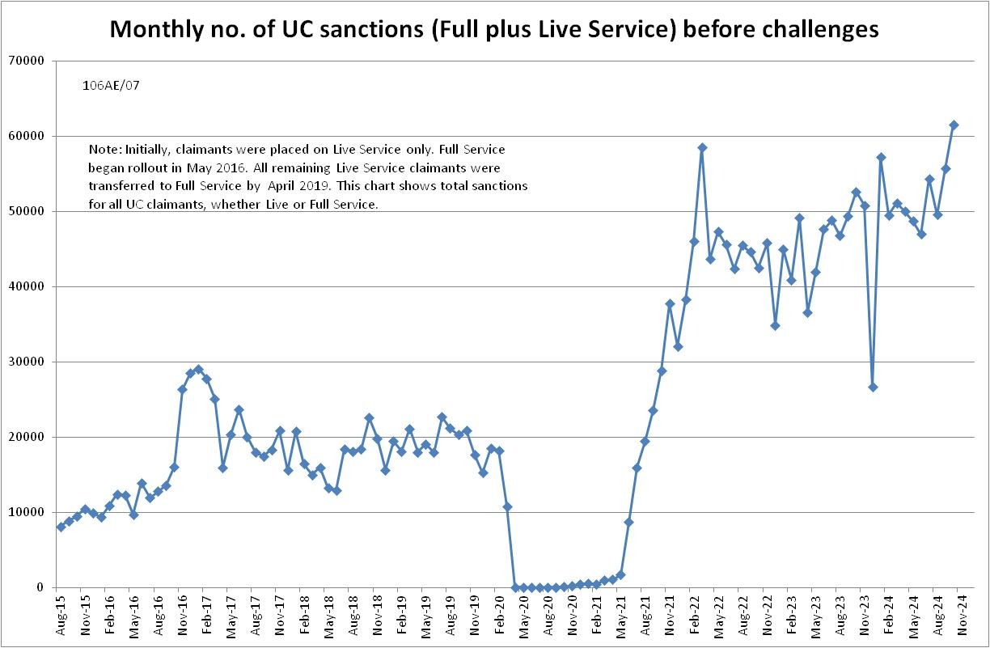

**Figure 2**

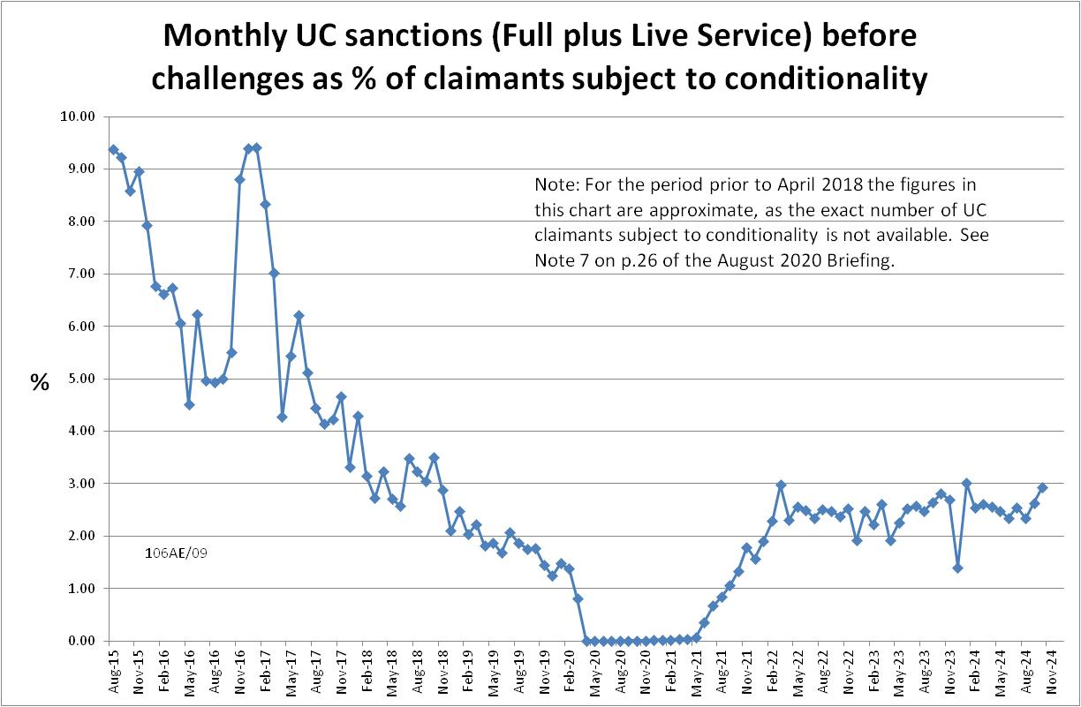

**Figure 3**

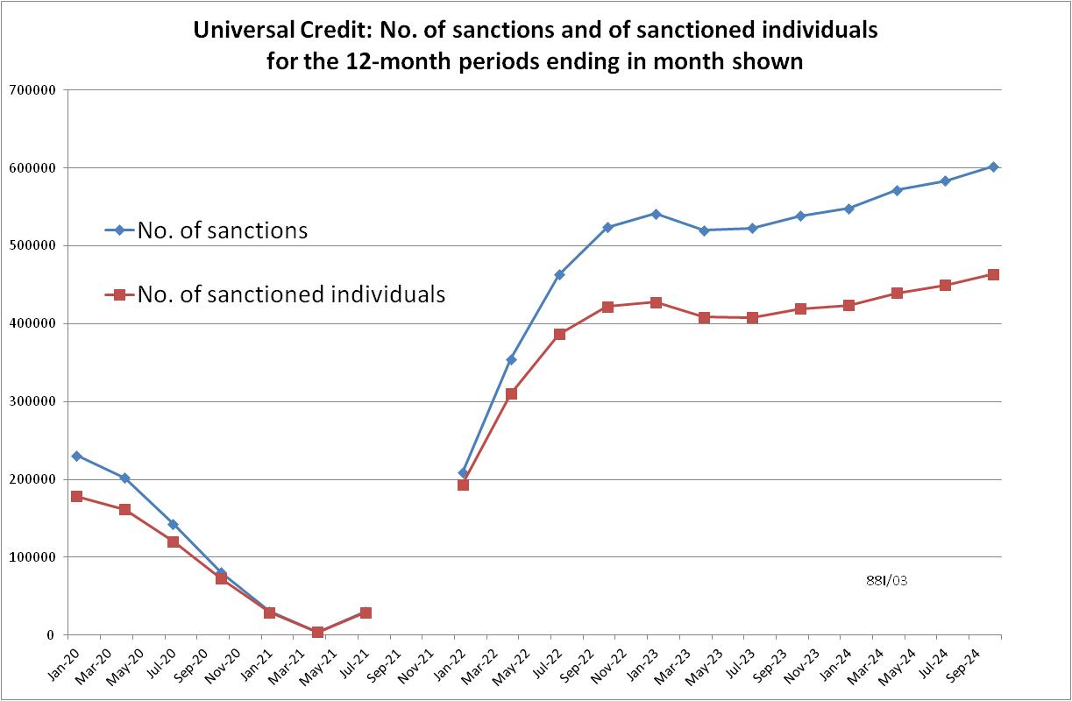

**Figure 4**

