**BRIEFING**

**Benefit Sanctions Statistics**

**November 2024 release**

2 December 2024

Dr David Webster

Honorary Senior Research Fellow

Urban Studies

University of Glasgow

Email [david.webster@glasgow.ac.uk](mailto:david.webster@glasgow.ac.uk)

Webpages: <http://www.gla.ac.uk/schools/socialpolitical/staff/davidwebster/>

<https://cpag.org.uk/policy-and-research/latest-policy-briefings-and-reports/david-webster-briefings>

http://www.cpag.org.uk/david-webster

***SUMMARY***

The DWP released its latest quarterly sanctions statistics for Universal Credit (UC) on 12 November. The sanctions figures are for May to July 2024, covering the last 10 weeks of the former Conservative government and the first three of the new Labour government. Attention is now focused on what the Labour government will do and there is likely to be little interest in the detail of these figures. On the other hand, a number of important policy and research reports have been published. **Therefore this Briefing does not update most of the usual statistical analyses, but focuses on the developments in sanctions policy and research.**

**Statistics Update**

A total of 583,780 UC sanctions were imposed in the year to end-July 2024. Of these, 133,963 were repeat sanctions on individuals who had already received at least one sanction during the year. Therefore the total number of individual UC claimants who received at least one sanction during the year was 449,817. Of these, 99,981 (22.9%) received more than one sanction, and 24,990 (5.6%) received more than two. These figures are much higher than in the last full 12 months before the pandemic, to January 2020, when there were 230,720 UC sanctions and 178,476 sanctioned individual claimants.

As a percentage of UC claimants subject to conditionality, monthly UC sanctions have been more or less stable for two and a half years, at about 2.5%, and there is no change in the latest quarter. However this is much higher than in the quarter immediately preceding the pandemic, i.e. December 2019 to February 2020, when it was 1.4% per month.

Tht downward trend in the percentage of UC claimants subject to conditionality who were serving a sanction at a point in time has continued, reaching 5.6% in both of the latest two months. This equates to one in 18 of UC claimants subject to conditionality and remains about double the immediate pre-pandemic level of around 3.0%.

**Policy and Research Update**

The White Paper ‘Get Britain Working’ published on 26 November has the fullest statement of the Labour government’s thinking and intentions to date. It maintains a commitment to conditionality and sanctions. It indicates an intention that employment services will shift focus from compliance with conditions towards positive support. But it does not propose any reform of the harsh features of the UC sanctions regime inherited from the Conservatives, such as the repayability of hardship payments, ‘until compliance’ sanctions, and serving of sanctions consecutively rather than concurrently. Ongoing monitoring of the sanctions regime is clearly required.

Reflecting recent debate, important research reports have emerged from the Resolution Foundation and Institute for Fiscal Studies on the increse in health-related benefit claims. The new DWP ministers have released hitherto unpublished reports on in-work conditionality, claimants’ debt and UC advances, and established a new Labour Market Advisory Board. There are also significant policy reports from the Institute for Employment Studies and Z2K. A report from the Resolution Foundation has raised serious doubts as to whether the increase in economic inactivity has been as large as estimated by ONS, due to problems with response to the Labour Force Survey. Numbers of claimants of sickness-related benefits are not affected by these problems.

**BRIEFING: Benefit Sanctions Statistics**

**November 2024**

The DWP released its latest quarterly sanctions statistics for Universal Credit (UC) on 12 November. The newly published data are summarised by DWP in the online publication *Benefit Sanctions Statistics*, available along with methodological notes at <https://www.gov.uk/government/collections/jobseekers-allowance-sanctions> together with a spreadsheet with summary tables. There is now a lot of data on Stat-Xplore at <https://stat-xplore.dwp.gov.uk/webapi/jsf/login.xhtml> .

All statistics presented here relate to Great Britain. All previous Briefings are available at <https://cpag.org.uk/policy-and-research/latest-policy-briefings-and-reports/david-webster-briefings>. The Briefings can also be readily found through a web search. Previous Briefings include many analyses that are not repeated here but remain valid. However it should be remembered that the DWP may have made subsequent revisions to the data reported in earlier Briefings. These revisions will generally not be major although there are exceptions. There may also often be substantial changes in some figures for the most recent few months.

DWP has created a new UC Stat-Xplore User Guide, at

<https://www.gov.uk/government/publications/universal-credit-official-statistics-stat-xplore-user-guide/universal-credit-official-statistics-stat-xplore-user-guide>

The latest months for which sanctions figures have now been released are May, June and July 2024. This period covers approximately the last 10 weeks of the former Conservative government and the first 3 weeks of the new Labour government. It seems likely therefore that there will be relatively little interest in these figures as attention is now focused on what the Labour government will do. On the other hand, a number of important policy and research reports have been published which together with other developments will be of interest to readers of the Briefing.

**I have therefore decided to limit this Briefing to a very basic look at the overall sanctions figures for the May-July quarter, and instead to focus on the other developments.**

**No. of UC sanctions and no. of UC claimants sanctioned during the year to 31 July 2024**

A total of 583,780 UC sanctions were imposed in the year to end-July 2024. Of these, 133,963 were repeat sanctions on individuals who had already received at least one sanction during the year. Therefore the total number of individual UC claimants who received at least one sanction during the year was 449,817. Of these, 99,981 (22.9%) received more than one sanction, and 24,990 (5.6%) received more than two. These figures are much higher than in the last full 12 months before the pandemic, to January 2020, when there were 230,720 UC sanctions and 178,476 sanctioned individual claimants.

**Figure 1** shows the two series for the number of sanctions imposed and the number of claimants sanctioned, for the 12-month periods ending in each quarter since January 2020 (just before the pandemic).

**Monthly UC sanctions as a percentage of UC claimants subject to conditionality**

As a percentage of UC claimants subject to conditionality, monthly UC sanctions have been more or less stable for two and a half years, at about 2.5%, and there is no change in the latest quarter (**Figure 2**). However this is much higher than in the quarter immediately preceding the pandemic, i.e. December 2019 to February 2020, when it was 1.4% per month.

**Percentage of UC claimants subject to conditionality who were serving a sanction at a point in time**

The downward trend in this figure noted in the previous Briefing has continued, reaching 5.6% in both of the latest two months (Figure 3). This percentage equates to one in 18 of UC claimants subject to conditionality and remains about double the immediate pre-pandemic level of around 3.0%.

**SANCTIONS –DEVELOPMENTS IN POLICY AND RESEARCH**

**‘Get Britain Working’ White Paper**

The White Paper was published on 26 November (HM Government 2024). It is actually a set of documents, with an Analytical Annex and data tables, Easy Read version and accessible formats as well as the main policy statement.

Main features of the policy package are:

* Merging the national Careers Service in England with Jobcentre Plus, to create a more positively focused and widely used employment service
* Creating a Youth Guarantee to give all 18-21 year olds the opportunity of employment, education, training or an apprenticeship
* Greater integration of employment services with local government and the health service
* An independent review into the role of employers in promoting health at work and enabling people with health or disability issues to work.

The White Peper has an explicit emphasis on the need to create good jobs – in other words on the labour demand side. There is also a welcome acceptance that local labour markets differ. Policy for the last 40 years has been focused on the role of the individual in creating their own unemployment, through alleged lack of motivation or skills, and has de-emphasised the role of variations in demand for labour over time and between areas. The White Paper accepts that employment conditions vary, and in fact in the Analytical Annex classifies local areas by the type of labour market they have. This is a very different narrative from the ‘workers and shirkers’ mantra that has previously been dominant.

The White Paper maintains a commitment to benefit sanctions (para.174): ‘Sanctions have an important place in our social security system when people refuse to meet reasonable requirements agreed with their work coaches, but there will be no targets – national or local – around the use of sanctions.’

Some mitigations are mentioned:

* **‘**Checking work-related requirements will move from the foreground to the background of the customer-work coach relationship’
* ‘We will also look at varying the frequency and mode of mandatory engagement for those claiming benefits based on what will work best for the individual ‘
* ‘We are launching an internal review of the Claimant Commitment to assess its appropriateness for customers on work-related benefits’
* And (para.129) The Government will ..... consider what changes to benefit rules might be necessary to support the intent and design of the Youth Guarantee.

However, there is no suggestion that any of the harsh features of the UC sanctions regime, introduced since the last Labour government, will be reformed – particularly the repayability of hardship payments and the consecutive rather than concurrent application of sanctions, or the ‘until compliance’ sanctions which are resulting in very lengthy deprivation of benefits. Nor are there any concrete proposals to reduce sanctions, such as restoration of the Santions Assurance Framework which resulted in a large reduction in the number of sanctions in the months preceding the pandemic (see the February 2021 Briefing, pp.6-7). Presumably such chnages may come, but they are not there yet.

Disability organizations have been critical of the White Paper, e.g. at <https://www.disabilitynewsservice.com/anger-and-concern-over-governments-hand-me-down-employment-white-paper/>

and at

<https://www.disabilitynewsservice.com/employment-white-paper-promises-fundamentally-different-approach-but-fails-to-answer-key-questions/>

The government says it intends to make similar savings on disability benefits to those planned by the previous government, but the White Paper does not say how. The previous plans involved extension of conditionality to several hundred thousand people (see November 2023 Briefing, p.9).

**Resolution Foundation suggests ONS has been overstating economic inactivity**

The difficulties for British official statistics caused by falling response rates to the Labour Force Survey were discussed in the November 2023, February 2024 and August 2024 Briefings. Adam Corlett of the Resolution Foundation (Corlett 2024), using the alternative data offered by HMRC and population estimates has produced a convincing case for arguing that the problems of the LFS may have led ONS to overestimate the rise in the numbers of people economically inactive by up to 930,000, and underestimate numbers in employment by a similar amount. The UK’s labour market performance would therefore have been a lot better than has been thought. This does not, however, do anything to affect the large increase of over half a million in people claiming out of work sickness or disability benefits, since figures on these are derived directly from administrative records. This will remain a policy concern. If it is true that economic inactivity has been overestimated, then there must have been a fall in other types of inactivity to offset the rise in sickness or disability.

The rather complicated statistical issues involved in the economic inactivity estimates were well explained by Heather Stewart in the *Guardian* on 20 November, at <https://www.theguardian.com/uk-news/2024/nov/20/ons-may-have-lost-a-million-workers-from-job-figures-since-pandemic>

**Backlog of 31 DWP research reports published**

The *Observer* on 13 October at <https://www.theguardian.com/society/2024/oct/13/two-thirds-of-uk-benefits-claimants-with-debts-have-gone-without-food> drew attention to the fact that the new government on 7 October published a clutch of 31 research reports which the previous government had commissioned but had decided not to publish. The full list is at <https://www.gov.uk/government/publications/list-of-upcoming-research-publications/list-of-upcoming-research-publications>

Of most interest to readers of the Briefing are probably the *International evidence review on in-work progression* (Rand Europe 2024), the two reports on impacts of external debt for indebted Universal Credit claimants (DWP/Government Social Research 2024 and Ipsos 2024) and the report on *Take up and use of the Universal Credit Advance Payments* (Ipsos MORI 2024).

The *Observer* majored on the findings that two-thirds of benefits claimants with **debts** have been unable to buy food, that some people had been driven into debt because they had not been able to access benefits, that 81% of UC claimants in debt ran out of money before their next payment “always” or “most of the time”, and that UC claimants with debts were less likely to be able to find work or a better paid job because they could not afford to travel.

The specific role of debt owed to public agencies in promoting child poverty was highlighted by the Aberlour Trust in an article in the Glasgow *Herald* on 27 October, at <https://www.heraldscotland.com/news/24679594.public-debt-forcing-scots-families-destitution/> In this context, the October Budget’s capping of deductions from Universal Credit at 15% of the standard allowance instead of 25% is important. It is expected to benefit about 1.2m households each month.

What is most striking about the international evidence review of **in-work progression** is that it shows that the UK is unusual is having such a narrow focus on job search, job search monitoring and sanctions. Other countries have broader approaches featuring for instance training and education.

Findings about the **UC Advance Payment** are much as would be expected.

**New Labour Market Advisory Board**

The new government has established a Labour Market Advisory Board chaired by Professor Paul Gregg of the University of Bath. Other members include Professor Stephen Machin of the London School of Economics, and Gavin Kelly, Executive Chair of the Resolution Foundation. Details are at <https://www.gov.uk/government/groups/labour-market-advisory-board> and at

<https://www.gov.uk/government/news/government-action-to-tackle-the-greatest-employment-challenge-for-a-generation>

Paul Gregg was the author of the Gregg report (2008) commissioned by the previous Labour government, which advocated a model of benefit sanctions, although not the Universal Credit regime which was only designed later. Stephen Machin has published a paper (Machin and Marie 2006) which showed that benefit sanctions have the effect of increasing crime. In 2015 Gavin Kelly criticised the extension of conditionality to people in work, at <https://www.resolutionfoundation.org/comment/credit-where-its-due-how-to-reform-and-make-the-most-out-of-universal-credit/> He commented ‘Let’s just say that there is little about the use of the sanctions regime in the last (2010-15) parliament that should make us feel sanguine about this prospect’. Web search has not produced any information about the views of the other members on conditionality and sanctions.

**Children in sanctioned households**

Since the general election there have been two parliamentary questions seeking to know the number of children in households where a claimant has been sanctioned. The answers by Alison McGovern, Minister of State in the DWP, on 9 September and 7 November, have been essentially the same as under the previous government, namely that data on children and data on sanctions are held separately and are not easy to relate to each other. Nevertheless one would expect that the new government’s Child Poverty Task Force, due to publish a Child Poverty Strategy in Spring 2025, would require this information.

<https://www.theyworkforyou.com/wrans/?id=2024-09-03.4014.h&s=universal+credit+sanction#g4014.q0>

<https://www.theyworkforyou.com/wrans/?id=2024-10-31.12240.h&s=universal+credit+sanction#g12240.r0>

**Easements for victims of domestic abuse**

On 16 September the Minister of State Stephen Timms answered a parliamentary question on easements for victims of domestic abuse. Details are at

<https://www.theyworkforyou.com/wrans/?id=2024-09-09.4809.h&s=universal+credit+sanction#g4809.r0>

**Ethnic disparities in sanction rates**

The August 2024 Briefing, pp.7-8 contained an analysis of the newly published statistics on the disparities in sanction rates between ethnic groups. Baroness Ruth Lister asked what assessment the government has made of the reasons for these disparities. In a written reply on 17 September, Baroness Sherlock, Parliamentary Under Secretary at the DWP, stated that the response rate to the ethnicity question in claimants’ records had not reached the required level. Details are at <https://questions-statements.parliament.uk/written-questions/detail/2024-09-03/HL721> This does not seem very convincing as the achieved response rate is not at all bad by present standards and the data could be reweighted.

**Institute for Employment Studies: Final report of the Commission on the Future of Employment Support**

On 18 September the Institute for Employment Studies published the final report of its Commission on the Future of Employment Support (Institute for Employment Studies 2024).

The report’s four main groups of recommendations are:

* **An ambitious approach to the government’s new Jobs and Careers Service:** underpinned by a new *online* employment service, an *on the high street* network of employment, skills and careers centres that are open to all, and *on the doorstep*integration of employment and careers advice within wider public, community and voluntary services; alongside a clear, joined up offer for employers
* **New Labour Market Partnerships within local areas** – so that ‘work, health and skills plans’ can enable areas to join up services, broaden access to support and tailor provision to local needs
* **Ending the ‘compliance culture’ in jobcentres** –including by ending the ‘35-hour rule’ for jobseekers and those in low paid work, having a clearer separation between benefits administration and employment support, and replacing the Claimant Commitment with forward-looking Action Plans
* **A clear framework for a reformed system, across national and local services** – underpinned by specific objectives on raising employment, tackling poverty at work and reducing inequalities; a guarantee that if you want help you will be able to get it; and common standards for the quality of services for individuals and employers.

The new Minister of State (Minister for Employment), Alison McGovern, signalled government approval for the report by attending and speaking at the launch. A press release is at

<https://www.gov.uk/government/news/lockdown-generation-consigned-to-the-scrapheap-will-get-life-changing-support-into-work-vows-minister--2>

and the full speech is at

<https://www.gov.uk/government/speeches/learning-from-the-past-to-deliver-the-future-getting-britains-labour-market-and-economy-working-again>

**Institute for Fiscal Studies report on health related benefit claims**

On 19 September the IFS published a valuable report comparing the UK experience of health-related benefit claims post-pandemic with that of other countries. ‘Health-related benefits’ comprise *incapacity benefits*, designed to support people with long-term conditions who are out of the labour market, and *disability benefits*, designed to help with the extra costs of disability or ill health. Key findings are:

The rapid growth in health-related benefits seems to be largely a UK phenomenon. The number of claimants of similar benefits in most similar countries with available data has slightly fallen over the same period. There have been small percentage increases in claims in France and Norway. Denmark was the only other country with available data that saw a significant increase and, at 13%, even that was considerably smaller than the over 30% in the UK.

The increase in UK disability benefit claimants is due to both more people beginning claims and fewer people ending claims. Before the pandemic, around 250,000 people in England and Wales would start getting working-age disability benefits each year. These figures started to rise in mid 2021, and in the latest data (year to November 2023) reached almost 500,000. At the same time, the share of claimants ending their claim has fallen, from 9.0% in 2019 to 7.4% in 2023. Overall, at least two-thirds of the rise in the caseload is explained by an increase in the number of people beginning claims.

The new claimants of disability benefits are youner than those who were beginning claims shortly before the pandemic: the number of new awards made to under-40s has grown by 150% compared to 82% for 40- to 64-year-olds. Current new claimants are more likely to claim due to mental health problems (including learning disabilities). In 2019–20, 28% of all new awards were primarily for these conditions, compared to 37% now. Only 2 percentage points of this rise is accounted for by the increasing rate of claims among younger individuals – there has been a marked rise in claiming for mental health reasons at all ages. New claimants are slightly more likely to be women, whose share of new claims has grown from 55% in 2019–20 to 58% in 2023–24.

Both prior to and since the pandemic, the share of new disability benefit claimants out of work was around 70%. There has been a slight increase in the share of new claimants who have worked within the last two years, from 37% to 40%, but it remains the case that most new disability benefit claimants have been out of work for more than two years.

Broadly, the growth in claims in absolute (not percentage) terms has been fastest in areas that already had a large number of claimants. For example, in Merthyr Tydfil and Blackpool, around 15% of 16- to 64-year-olds were in receipt of a health-related benefit before the pandemic. Now that figure is around 19%. Conversely, in Windsor & Maidenhead and Wokingham, around 3% were receiving one of these benefits but around 4% now.

**Resolution Foundation report on trends in working age disability and incapacity benefits**

A Resolution Foundation report published in June (Judge & Murphy 2024) analysed the reasons for the large increases in disability and incapacity benefit claims. Its key findings were:-

* Between 2013-14 and 2022-23, real spending on working-age incapacity benefits increased by 34 per cent, and on disability benefits by 89 per cent.
* A growing, ageing population and a rising State Pension Age have by themselves boosted the working-age disability benefits caseload by 272,000 between 2013 and 2023, one-quarter (25 per cent) of the increase over that time.
* In 2012-13, 5.9 million (16 per cent) working-age adults in Great Britain reported that they had a disability (defined as having a long-standing illness, disability or impairment which causes substantial difficulty with day-to-day activities); by 2022-23 this number was 8.9 million (23 per cent).
* There is little evidence to suggest it is ‘easier’ to be awarded disability benefits today, with award rates for new PIP claims broadly steady at around 45 per cent since 2015-16.
* Changes to the benefits system over the last decade have strengthened the incentive to claim incapacity and disability benefits. In April 2010, a single person claiming unemployment benefit received £98 a week (in 2024-25 prices); by April 2024, that figure has fallen to £91.
* Over the last 15 years, the share of GDP spent on all working-age benefits has barely changed, standing at 3.9 per cent in both the pre-recession year of 2007-08 and in 2022-23, although it is forecast to reach 4.6 per cent in 2028-29.

The analysis suggested that restricting eligibility for these benefits without fully understanding the complex set of underlying drivers is risky in the extreme. A serious strategy to control this expenditure requires government to understand the complex range of drivers that determine it.

**Z2K proposals on disability benefits**

The organization Z2K has a long history of contributing to the debate around sanctions. It has criticised the Autumn Budget’s confirmation of the changes to disability and sickness benefits proposed by the previous Conservative government, and has produced its own proposal aimed at identifying ways to make Universal Credit work better for seriously ill or disabled people and reduce economic inactivity. It has three core elements, which are designed to be taken together to take the risk out of the system, provide genuine security for everyone receiving Universal Credit, and enable people to move towards work without fear of a sudden and significant income drop:

* Increase the Standard Allowance in Universal Credit so that over time it reaches the level of the Standard Allowance plus the Limited Capability for Work and Work-Related Activity Element of Universal Credit
* Overhaul the Work Capability Assessment and eventually have it only determine the conditionality group you are in
* Introduce a floor into Universal Credit, below which someone’s Standard Allowance cannot fall.

**REFERENCES**

Corlett, Adam (2024) *Get Britain’s Stats Working: Exploring alternatives to Labour Force Survey estimates*, Resolution Foundation Briefing, 20 November, at

<https://www.resolutionfoundation.org/publications/get-britains-stats-working/>

DWP/Government Social Research (2024) *UC External Debt Research findings*, May 2022, at

<https://www.gov.uk/government/publications/impacts-of-external-debt-for-indebted-universal-credit-claimants>

Gregg, Paul (2008) *Realising Potential: A Vision for Personalised Conditionality and Support*. An independent report to the Department for Work and Pensions, TSO, December, at

<https://citeseerx.ist.psu.edu/document?repid=rep1&type=pdf&doi=2fe2bf93e616d593766af6ba21e5f84b3d581c45>

HM Government (2024) *Get Britain Working*, CP 1191, November, at

[https://www.gov.uk/government/publications/get-britain-working-white-paper](https://www.gov.uk/government/publications/get-britain-working-white-paper?utm_medium=email&utm_campaign=govuk-notifications-topic&utm_source=03dd1dd2-f999-4f15-86dc-039ab30f7891&utm_content=daily)

Institute for Employment Studies (2024) *Working for the future: Final report of the Commission on the Future of Employment Support*, 18 September, at

<https://www.employment-studies.co.uk/resource/working-future-0>

Ipsos (2024) *UC External Debt Research Technical report*, August 2022, at

<https://assets.publishing.service.gov.uk/media/66eae55a9975b7a980b3052d/external-debt-UC-claimants-technical-report.pdf>

Ipsos MORI (2024) *Take up and use of the Universal Credit Advance Payment: Qualitative research with Universal Credit Claimants*, DWP Research Report RR1076, at

<https://www.gov.uk/government/publications/take-up-and-use-of-the-universal-credit-advance-payment>

Judge , Lindsay and Louise Murphy (2024) *Under strain: Investigating trends in working-age disability and incapacity benefits*, Resolution Foundation Briefing, June, at

<https://www.resolutionfoundation.org/publications/under-strain/>

Latimer, Eduin, Freddie Pflanz and Tom Waters (2024) *Health-related benefit claims post-pandemic: UK trends and global context*, lnstitute for Fiscal Studies report R333, at

<https://ifs.org.uk/publications/health-related-benefit-claims-post-pandemic-uk-trends-and-global-context>

Machin, Stephen and Marie, Olivier (2006) ‘Crime and benefit sanctions’, *Portuguese Economic Journal* 5, 149–165. An earlier version of this paper is at

<https://core.ac.uk/download/pdf/204866009.pdf>

RAND Europe (2024) *International evidence review on in-work progression*, DWP Research Report 1074, at

<https://www.gov.uk/government/publications/international-evidence-review-on-in-work-progression>

Thunder, Jamie (2024) *Security not Sanctions: Making Universal Credit work for seriously ill and disabled people*. A co-produced proposal for a new government, Z2K, at

<https://z2k.org/wp-content/uploads/2024/05/Security-not-Sanctions-report-FINAL.pdf>

**Figure 1**

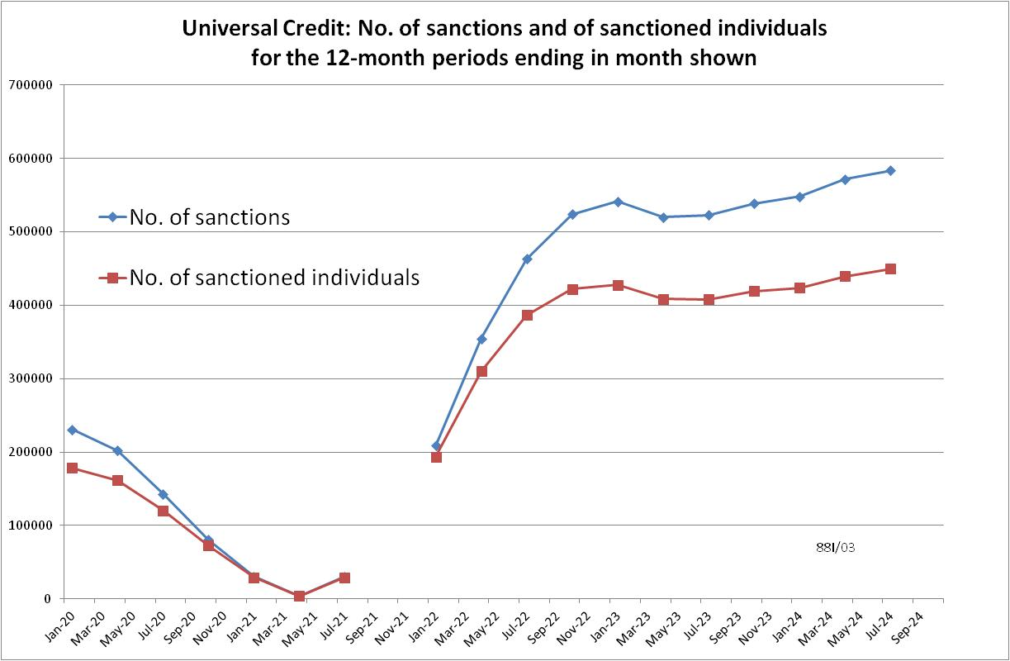

**Figure 2**

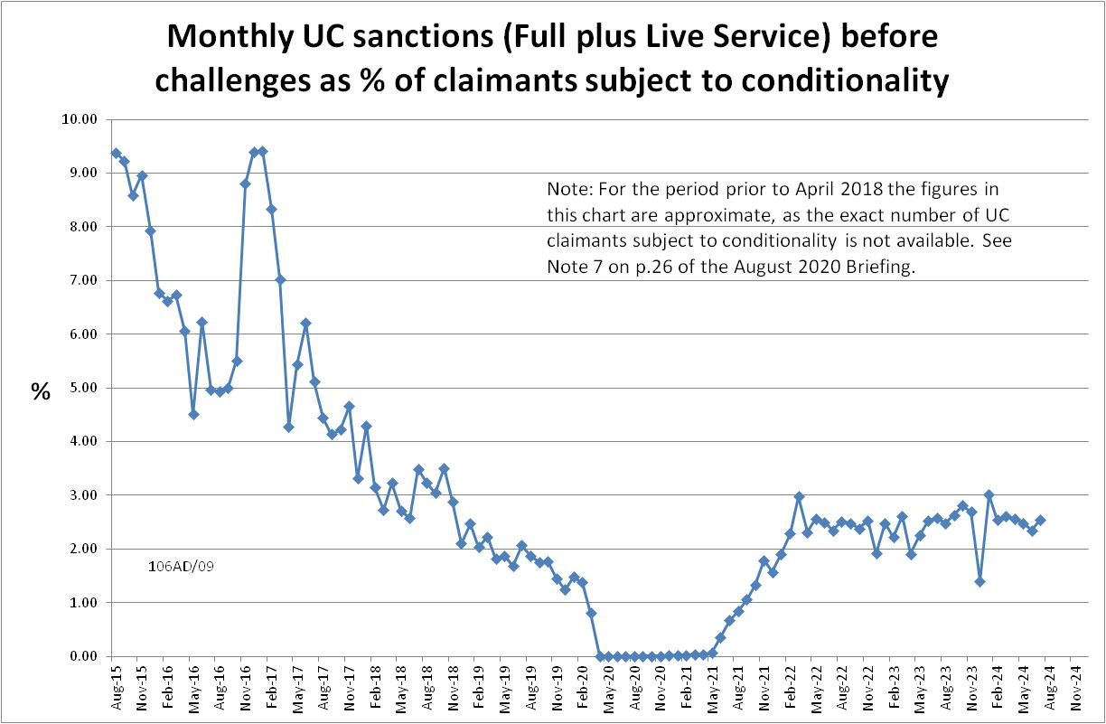

**Figure 3**

