**BRIEFING**

**Benefit Sanctions Statistics**

**August 2024 release**

27 August 2024

Dr David Webster

Honorary Senior Research Fellow

Urban Studies

University of Glasgow

Email [david.webster@glasgow.ac.uk](mailto:david.webster@glasgow.ac.uk)

Webpages: <http://www.gla.ac.uk/schools/socialpolitical/staff/davidwebster/>

<https://cpag.org.uk/policy-and-research/latest-policy-briefings-and-reports/david-webster-briefings>

http://www.cpag.org.uk/david-webster

***SUMMARY***

This Briefing reports on the quarterly Universal Credit (UC) sanctions statistics for Great Britain published by DWP on 13 August. All of these statistics relate to the period before the new Labour government was elected. Key findings are:

* There is clear evidence of the impact of recent raising of the Administrative Earnings Threshold (AET). Between June and July 2024 there was an increase of 158,668 in the number of claimants ‘searching for work’, with its ‘intensive work search regime’ and a corresponding decrease of 141,402 in those ‘working – with requirements’. This suggests increased vigour of enforcement of the raised AET by DWP this summer.
* There is also some evidence that the tightening of conditionality since the end of 2023 has impacted women more than men.
* For the first time, DWP has published statistics on the ethnicity of sanctioned UC claimants, for the period April 2023 to April 2024. These show that while the sanction rate for Asian claimants is only around 5% above that for whites, and the rate for ‘other’ ethnic groups around 10% above, the rate for Black claimants is about 60% higher, and for Mixed ethnicities about 70% higher. This confirms earlier findings by the author in 2013 and 2018. These ethnic disparities do not necessarily indicate racial discimination or structural racism, but their scale is a cause for concern. DWP should be asked to explain them and to say whether they can be justified.

At April 2024 there were an estimated total of 2.29m claimants on all benefits subject to conditionality. UC sanctions have continued to run at a high level of about 50,000 per month, almost three times the average just before the pandemic. As a percentage of UC claimants subject to conditionality, monthly UC sanctions have been more or less stable for over two years, at about 2.5% compared to 1.4% before the pandemic.

A total of 571,974 UC sanctions were imposed in the year to end-April 2024 and the total number of individual UC claimants who received at least one sanction was 439,768. Of these, 98,609 (22.4%) received more than one sanction, and 25,107 (5.6%) received more than two. These figures are much higher than in the last full 12 months before the pandemic, when there were 230,720 UC sanctions and 178,476 sanctioned individual claimants.

The number of UC claimants who were serving a sanction at a point in time has fluctuated between 121,000 and 137,000 over the past year. As a percentage of UC claimants subject to conditionality the average was 6.4% in the latest quarter. As usual, unemployed (‘searching for work’) claimants were far more likely to be sanctioned than others, with 111,113 or 7.5% under sanction in May 2024.

Updated gender analysis confirms that male claimants are far more likely to be sanctioned than female. The female rate for those subject to conditionality is around 1.5% per month, but the male rate is more than double at 3.0% to 3.5%. The disparity in the proportion of male and female claimants subject to conditionality who were serving a sanction at a point in time is similar, with about 3% of female claimants under sanction, and 10% of males. Reasons for sanctions do not differ significantly between male and female claimants. For both, almost all sanctions are ‘low’ level, which is the level imposed for non-attendance at an interview.

The Briefing has a short News section.

**BRIEFING: Benefit Sanctions Statistics**

**August 2024**

The DWP released its latest quarterly sanctions statistics for Universal Credit (UC) on 13 August. The newly published data are summarised by DWP in the online publication *Benefit Sanctions Statistics*, available along with methodological notes at <https://www.gov.uk/government/collections/jobseekers-allowance-sanctions> together with a spreadsheet with summary tables. There is now a lot of data on Stat-Xplore at <https://stat-xplore.dwp.gov.uk/webapi/jsf/login.xhtml> . All statistics presented here relate to Great Britain. All previous Briefings are available at <https://cpag.org.uk/policy-and-research/latest-policy-briefings-and-reports/david-webster-briefings>. The Briefings can also be readily found through a web search. Previous Briefings include many analyses that are not repeated here but remain valid. However it should be remembered that the DWP may have made subsequent revisions to the data reported in earlier Briefings. These revisions will generally not be major although there are exceptions. There may also often be substantial changes in some figures for the most recent few months.

DWP has created a new UC Stat-Xplore User Guide, at

<https://www.gov.uk/government/publications/universal-credit-official-statistics-stat-xplore-user-guide/universal-credit-official-statistics-stat-xplore-user-guide>

All the figuresin this Briefing show what was happening under the previous Conservative government. **The February 2025 release will be the first to show anything significant about the policy and practice of the new Labour government.**

**In the present release DWP has added some statistics on UC sanctions by ethnicity for 13 months from April 2023 to April 2024 inclusive**. This is the first time that DWP has published any ethnicity data for UC sanctions. DWP says this is happening now because there has been an increase to over 70% in the proportion of claimants stating their ethnicity, which has made the statistics viable. Contrary to what appeared to be stated previously by DWP, these statistics do include sanctions, not just sanction referrals. The ethnicity data are analysed below.

The most obvious remaining gap in the statistics is data on the UC appeal system for Full Service, which now covers all UC claimants. These statistics were published routinely for JSA, ESA and UC Live Service. Eight years on from the start of UC rollout in May 2016, DWP has still given no indication of when these might be published. There are also many gaps in the statistics on disability, ill-health and vulnerability.

DWP no longer publishes updates to statistics on sanctions for Jobseekers Allowance (JSA), Employment and Support Allowance (ESA) and Income Support (IS). JSA and ESA are not merely ‘legacy’ benefits since there are new claimants of the ‘New Style’ (contribution-based) versions of these benefits. But we will not know about any sanctions on these benefits except via Parliamentary Questions or FoI requests. Old-style JSA is already closed to new claimants so there are now very few if any JSA claimants other than on New Style. (A DWP report on the progress of managed migration stated that the final migration of claimants from old-style JSA to UC may not be completed before the end of 2024/25.)

**Number of people on Universal Credit (UC) and number of UC claimants subject to conditionality**

The total number of people on UC was a provisional 6.97m in July 2024, up from 6.84m in April. ‘Managed migration’ from ‘legacy benefits’ continues to increase the numbers on UC, particularly in the non-working groups (**Figure1**).

A major feature of the new statistics is that there is clear evidence of the impact of raising the Administrative Earnings Threshold (AET) in moving claimants from the ‘working – with requirements’ conditionality group (which currently effectively means no conditionality) into the ‘searching for work’ group and its ‘intensive work search regime’. Between June and July 2024 there was an increase of 158,668 in the number of claimants ‘searching for work’ and a corresponding decrease of 141,402 in those ‘working – with requirements’ (**Figure 1** – see the arrows on the chart). This should be treated with some caution as it is only one month’s figures, but it does suggest increased vigour of enforcement of the increased AET by DWP.

The AET was the equivalent of 9 hours’ work per week up to September 2022, when it was raised to 12 hours per week. It was then further increased to 15 hours per week in January 2023 and to 18 hours per week (£892 per calendar month for individual claimants or £1473 per calendar month for couples) on 13 May 2024. Claimants earning above the AET are effectively exempt from further work search requirements, whereas those below are required to look for work to increase their hours above the AET. Since October 2023, lead carers of children aged 3 to 12 in the ‘intensive work search’ regime are required to work or search for work for 30 hours per week. There was further discussion of the increases in AET in the May 2023 Briefing, pp.3-4 and Figure 1, in the August 2023 Briefing, p.4 and Figure 1, and in the May 2024 Briefing, p.4.

The Conservative government had been intending that people earning above the AET but below the ‘conditionality earnings threshold’ would become subject to conditionality in the form of a compulsory ‘In-work progression offer’. But this was delayed beyond the originally intended September 2023 start date.The August 2024 issue of DWP’s *Benefit Sanctions Statistics*, section 3.2,still does not list ‘Working – with requirements’ among the groups subject to conditionality. Therefore it appears that the ‘Working – with requirements’ group should continue to be excluded from the total of those subject to conditionality, at least for the time being. On this basis, there were 2.16m UC claimants subject to conditionality in July 2024, or 31% of all UC claimants. This represents an increase of 156,200 over the April 2024 figure, and reflects the impact of the increased AET discussed above.

The largest group of UC claimants subject to conditionality is those ‘searching for work’, i.e. unemployed. They were 1.67m in July 2024, accounting for 94.8% of all claimant unemployed. The other 5.2% of the claimant unemployed were the 90,842 claimants on JSA, all, or almost all, of whom will have been claiming the ‘New Style’ contribution based JSA.

**Total claimants on all benefits subject to conditionality**

Reporting on legacy benefits is less up-to-date than on UC. At April 2024 there were still an estimated 342,000 claimants on the legacy benefits subject to conditionality, comprising 137,000 in the ESA Work Related Activity Group, 112,400 on Income Support and 92,500 on JSA. Added to the 1.95m UC claimants subject to conditionality at that date, there were therefore an estimated total of 2.29m claimants on all benefits subject to conditionality. This is before the AET-related increase in UC ‘searching for work’ seen in July, which is discussed above.

**The monthly number of Universal Credit sanctions remains high and fairly stable**

The monthly number of sanctions imposed, and this number as a percentage of claimants subject to conditionality, are the most robust measures of the scale of sanctioning.

***Number of UC sanctions being imposed per month***

During the latest quarter, monthly UC sanctions continued to run at a high level of about 50,000 (**Figure 2**). This is almost three times the average in the last full three months before the pandemic (to February 2020), which was 17,290.

***Monthly UC sanctions as a percentage of UC claimants subject to conditionality***

As a percentage of UC claimants subject to conditionality, monthly UC sanctions have been more or less stable for over two years, at about 2.5% (**Figure 3**). However this is much higher than in the quarter immediately preceding the pandemic, i.e. December 2019 to February 2020, when it was 1.4% per month.

The reason for the very high initial rates of UC sanctions shown in **Figure 3** is that when UC was launched (as Live Service), it was only available to single people without dependants, and they tend to be young people, who have high rates of sanction.

As noted in previous Briefings, the overall sanction rate for UC puts together different categories of claimant with very different rates of sanctioning – unemployed, sick/disabled and those with caring responsibilities. The rate for *unemployed* claimants (‘searching for work’) is much higher than for the other conditionality groups, which have quite low rates of sanctioning. This is evident in the figures for claimants serving a sanction at a point in time (see below, **Figure 7**).

**No. of UC sanctions and no. of UC claimants sanctioned during the year to 30 April 2024**

A total of 571,974 UC sanctions were imposed in the year to end-April 2024. Of these, 132,206 were repeat sanctions on individuals who had already received at least one sanction during the year. Therefore the total number of individual UC claimants who received at least one sanction during the year was 439,768. Of these, 98,609 (22.4%) received more than one sanction, and 25,107 (5.6%) received more than two. These figures are much higher than in the last full 12 months before the pandemic, to January 2020, when there were 230,720 UC sanctions and 178,476 sanctioned individual claimants.

**Figure 4** shows the two series for the number of sanctions imposed and the number of claimants sanctioned, for the 12-month periods ending in each quarter since January 2020 (just before the pandemic).

As noted in the previous Briefing, the current annual number of sanctions is higher than at most times since the current recording system was introduced in 2000.

**Universal Credit claimants serving a sanction at a point in time**

***No. of UC claimants who were serving a sanction at a point in time***

The number of UC claimants who were serving a sanction at a point in time has fluctuated between 121,000 and 137,000 over the past year. This again is much higher than in the final quarter before the pandemic, when it was around 35,100. There is no obvious trend (**Figure 5**).

***Percentage of UC claimants subject to conditionality who were serving a sanction at a point in time***

**Figure 6** shows the same data as a percentage of UC claimants subject to conditionality. In the latest quarter this was an average of 6.4%. There is a slight downward trend in this figure. This percentage equates to one in 16 of UC claimants subject to conditionality and is over double the immediate pre-pandemic level of around 3.0%. Much higher percentages were seen for earlier months, going back to January 2017. As explained in relation to **Figure 3** above, this is because when UC was first introduced it was available only to single people without dependants, who tend to be young, and young people have much the highest rates of sanction.

***UC claimants serving a sanction at a point in time by conditionality group***

**Figure 7** shows the percentage of UC claimants subject to each individual conditionality regime who were serving a sanction at the measurement date in each month. As usual, unemployed (‘searching for work’) claimants were far more likely to be sanctioned than the other two groups subject to conditionality, with 111,113 or 7.5% under sanction in May 2024 compared to 0.70% for ‘planning for work’ and 0.68% for ‘preparing for work’. One in 13 unemployed UC claimants was under sanction in May 2024.

There are also people in the groups not subject to conditionality who are serving sanctions. That is because under UC, sanctioned claimants are made to serve out the whole of their sanction even if they move into a no-conditionality group, for instance because of illness. There were 6,518 of them in May 2024, almost half (3,012) of these in the ‘working – with requirements’ group. This group are the most likely to have recently been unemployed and therefore to have been sanctioned.

**Other analyses**

Analyses of recent data on duration, reasons for, and levels of sanctions, and deductions from benefit, can be found in the previous two issues of the Briefing.

**Ethnicity**

The data on UC sanctions by ethnicity newly published by DWP for April 2023 to April 2024 are shown in **Figure 8**. There are some considerable limitations to these figures. The data are simple numbers of sanctions, without any adjustment for different proportions of claimants reporting their ethnicitybetween ethnic groups or between months. The monthly response rate on ethnicity was 70.9% in April 2023 and rose almost continuously to 76.0% in April 2024. This is still not very good. Also, the figures show sanctions on claimants in all the conditionality groups taken together, but sanction rates vary drastically between groups, being high in the ‘searching for work’ group, much lower in the ‘planning for work’ and ‘preparing for work’ groups, and nil in the other groups except for claimants transferring from another group. The proportions of people in the different conditionality groups will vary between ethnic groups, and this will affect sanction rates. Also, sanction rates vary by age and gender and this again will affect the sanction rates shown for the different ethnic groups if they have different age/gender compositions,

Having said this, the easiest way to compare the sanction rates for the different ethnic groups is to show them as a ratio to the rate for white claimants, taken to be 100. This is done in **Figure 9**. The result is stark. For most of the time, all the minority ethnic groups have higher sanction rates than Whites. But while the sanction rate for Asian claimants is only around 5% above that for whites, and the rate for ‘other’ ethnic groups around 10% above, the rate for Black claimants is about 60% higher, and for Mixed ethnicities about 70% higher.

The author has analysed sanction rates by ethnicity on two previous occasions, in May 2013 for JSA (Webster 2014) and in July 2018 for JSA and ESA (Webster 2018). The data available for those analyses was more extensive and the reader is referred to them for the extra detail they contain. Here because of the limited data for 2023-24 it is only possible to makesimple comparisons.

**Figure 10** shows monthly JSA sanction rates for each ethnic group as a ratio to the White rate, for the period May 2005 to April 2018. JSA is the best comparator for UC, as the great majority of UC sanctions are on the ‘searching for work’ group. The JSA figures show sanctions after any reconsiderations and appeals, unlike the UC figures which show all sanctions imposed. Nevertheless the picture for JSA in 2005 to 2018 is remarkably similar to that for UC in 2023-24. Across the whole period sanction rates for the Other group are similar to those for Whites, though sometime lower and sometimes higher. Those for the Asian group are next highest. As for UC in 2023-24, the Mixed group has the highest sanction rates, and is closely followed by the Black group. The other striking feature of this comparison is that the ethnic disparities for Mixed and Black claimants compared to Whites for UC in 2023-24 are as great as the greatest disparities seen in the JSA figures, which were for the period around 2008 to 2010.

**Figure 11** shows sanction rates for ESA in 2010 to 2017. Once again, the rates for the minority ethnic groups are almost always higher than for Whites. Otherwise the picture is more confused, though it still shows roughly the same ordering of rates between ethnic groups as for UC and JSA (as shown by a crude average across the whole period).

One puzzle that arises is why the Mixed ethnic group has such consistently high sanction rates. One possibility would appear to be that it is really very similar to the Black group (though this would not explain why either group has such high rates). Inspection of the detailed composition of the Mixed group in the 2021 Census for England and Wales suggests that there might be something in this (**Table 1**). On a crude comparison with some rather arbitrary allocations, the percentage of Mixed people whose ethnicity is partly Black is 48.3%, whereas the percentage partly Asian is substantially less at 35.8%. Of course this could not explain why the Mixed group has higher rates than the Black group. Looking at **Table 1**, another possibility is that language difficulties might be greater for many people in the Mixed group.

The ethnic disparities shown here do not necessarily indicate racial discimination or structural racism. But their scale is surely cause for concern, and as advocated by the author in 2013 (Webster 2014, para.16), DWP should be asked to explain them and to say whether they can be justified.

In the present release DWP has also provided data on ethnicity of UC sanctions by age and gender. But the DWP’s UC Ethnicity Statistics do not provide the denominators (UC claimants by ethnic group by age and UC claimants by ethnic group by gender) which are required to calculate sanction rates. So these figures are not much use.

**Gender**

The Briefing last looked at sanctions by gender in July 2018. **Figure 12** shows monthly sanctions as a percentage of claimants subject to conditionality, for male and female claimants, since August 2021 when sanctions started rising to their present levels following the pandemic moratorium. The picture remains the well-known one, that male claimants are far more likely to be sanctioned than female. The female rate is around 1.5% per month, but the male rate is more than double at 3.0% to 3.5%.

It might be expected that the reasons for sanctions would differ between male and female claimants, but that is not the case. **Figure 13** shows that for both, almost all sanctions are ‘low’ level, which is the level imposed for non-attendance at an interview.

**Figure 14** shows the proportion of male and female claimants subject to conditionality who were serving a sanction at a point in time. The disparity is similar to that for monthly sanction rates, with about 3% of female claimants under sanction, and 10% of males. However the male rate appears to have fallen significantly since the end of 2023, to under 9%. Any such fall for females has been very slight indeed, suggesting that the recent tightening of conditionality may have been impacting more strongly on women than on men. This would make sense as the focus for tightening conditionality has been on part time workers, who are more likely to be women.

**SANCTIONS – OTHER DEVELOPMENTS**

**DWP – New Ministers’ responsibilities**

Following the elcction of the new Labour government, Stephen Timms who was Chair of the House of Commons Work and Pensions Committee has been appointed as a Minister of State in the DWP. However he will be Minister for Social Security and Disability. Conditionality and sanctions fall witin the remit of the other Minister of State, Alison McGovern, with Liz Kendall as Secretary of State in overall charge.

**Policies of the new Labour government**

There have been several statements on the new government’s policies by the Secretary of State:

The ‘Back to Work Plan’, 11 July

<https://www.gov.uk/government/news/back-to-work-plan-will-help-drive-economic-growth-in-every-region>

Speech at the launch of the Pathways to Work report, 23 July (see below)

<https://www.gov.uk/government/speeches/getting-britain-working>

Interview with the *Observer*, 18 August

<https://www.theguardian.com/politics/article/2024/aug/17/its-time-to-end-blame-culture-over-benefits-bill-says-labour-minister>

These statements indicate that there will be more delegation of policy and programmes to local areas; incapacity benefit claimants will be able to try out a job without losing benefits if it does not work out; Jobcentres will be merged with the National Careers Service; the emphasis in Jpbcentres wll be shifted towards promoting employment rather than policing benefits; there will be a Youth Guarantee of work, training or apprenticeship fpr 18-21 year olds; a Labour Market Advisory Board will be established, chaired by Professor Paul Gregg; and there will be an end to divisive Ministerial rhetoric that blames people and doesn’t support them.

A White Paper is intended in the autumn.

**Pathways to Work Commission report**

The Pathways to Work Commission was launched by Barnsley Council and South Yorkshire Mayoral Combined Authority in July 2023 to better understand how to support more people who would like to work in Barnsley and South Yorkshire, principally people who are economically inactive rather than unemployed. Its report was published on 23 July, with the Secretary of State making a speech at the launch (see above).

The Commission had twelve members, led by the former Labour cabinet minister Alan Milburn and including Torsten Bell of the Resolution Foundation, now Labour MP for Swansea West, Jennifer Dixon, Chief Executive of the Health Foundation, Ben Harrison, Director of the Work Foundation and Dan Jarvis, now a Minister of State at the Home Office,

Barnsley’s employment rate is 5% lower than the England average and Barnsley residents are one fifth more likely to be out of work than residents elsewhere. The Commission found that across South Yorkshire, 7 in 10 economically inactive people said they would take a job that aligned with their skills, interests and circumstances, and 40% said that they would do so 'now' or 'in the near future'. It found that 76% of economically inactive people had a health condition, and half cited illness as the reason for leaving their last job. Economic inactivity was mostly due to challenges around ill-health or disabilities, caring responsibilities and low qualifications.

The report concludes that the welfare and employment support system applies the wrong approaches to the wrong people. Those who are classified as officially seeking work are offered some support to do so but also face harsh conditionality and lower benefit payments than those who are classified as unable to work. By contrast, the economically inactive group get little support to find work but face no conditionality and receive higher payments than those actively seeking work. It pays to be classified as incapable of work rather than actively seeking it.

The report argues that public policy makers have relied on toughening benefits rules to deal with what is a largely health-related problem. They have been aiming at the wrong target. The primary challenge today is no longer to tackle high levels of unemployment but to deal with entrenched and growing levels of economic inactivity. Jobcentre Plus focusses on jobseekers who claim benefits, not the mass of people who are inactive. It supports job entry but not higher earnings or career progression. It has come to be dominated by its role in administering benefit rules, rather than being a place people want to go to help them find work or build their career.

The report makes 21 recommendations covering employment support, health services, job quality, education, childcare, social security benefits and governance arrangements. It argues that the priority groups who will benefit the most from support to move into work are those with ill-health or caring responsibilities, young adults with poor health and/or low qualifications at risk of not entering the labour market, and the over-50s already in work but at risk of leaving because of health problems.

A good summary was published in the *Guardian* on 22 July, at <https://www.theguardian.com/society/article/2024/jul/22/integrate-nhs-services-and-job-centres-to-get-more-people-working-report-says>

**Transition to ‘Transformed’ Labour Force Survey postponed for another 6 months**

The difficulties in tracking what is actually happening in the UK labour market due to falling response rates for the Labour Force Survey (LFS) were noted in the November 2023 Briefing (p.12) and the February 2024 Briefing (p.14). The LFS is the only source for data on economic inactivity and on ‘official’ (i.e. ILO-defined) as opposed to claimant unemployment. ONS announced on 18 July at

<https://www.ons.gov.uk/employmentandlabourmarket/peopleinwork/employmentandemployeetypes/articles/labourmarkettransformationupdateonprogressandplans/july2024>

that the difficulties continue. As a result the planned switch from the existing LFS to the new, larger ‘Transformed’ Labour Force Survey (TLFS) has been postponed again, for another 6 months from September. The latest reported responsse rate for the TLFS was a still poor 39% and there are other problems.

**John Pring’s new book**

John Pring of the Disability News Service has published a new book (Pring 2024) on deaths attributable to treatment of claimants with disabilities by DWP over the last 35 years since 1989, focusing on twelve individual case histories. There is more detail at <https://www.disabilitynewsservice.com/book-will-expose-how-dwps-decades-of-violent-bureaucracy-led-to-countless-deaths/>

**REFERENCES**

*Pathways to Work Commission Report* (2024), Barnsley Council, at

<https://www.barnsley.gov.uk/services/our-council/barnsley-2030/pathways-to-work-commission/>

Pring, John (2024) *The Department: How a Violent Government Bureaucracy Killed Hundreds and Hid the Evidence*, Pluto Press

Webster, David (2014) *JSA Sanctions and Disallowances*, Evidence submitted to the House of Commons Work and Pensions Committee Inquiry into the Role of Jobcentre Plus in the reformed welfare system, Second Report of Session 2013-14, Vol. II, pp. Ev w90-w101. House of Commons, London, at <https://eprints.gla.ac.uk/90147/>

Webster, David (2018) *Briefing: Benefit Sanctions Statistics, July 2018*, at

<https://cpag.org.uk/policy-and-research/latest-policy-briefings-and-reports/david-webster-briefings>

**Table 1**

**England and Wales Census 2021: All usual residents with a mixed ethnicity**

Ethnic group (detailed) All mixed ethnicity Mixed including Black Mixed including Asian

African unspecified 3,925 3,925

African Asian 4,071 4,071

African/Arab 1,924 1,924 1,924

Anglo Indian 2,473 2,473

Arab 7,777 7,777

Asian (unspecified) and European 2,805 2,805

Black and Asian 14,355 14,355 14,355

Black and European 2,185 2,185

Black and White (unspecified) 18,164 18,164

Black British 2,050 2,050

Brazilian 6,569

Caribbean 7,579 7,579

Caribbean Asian 7,516 7,516

Chinese 2,871 2,871

Chinese and other Asian 1,907 1,907

Chinese and White 7,642 7,642

English 3,803

English/Welsh/Scottish/N. Irish/British 11,880

European and Black African 3,450 3,450

European and Black Caribbean 2,266 2,266

European & N African or Middle Eastern 3,003 3,003

European Mixed, Euro unspec, other Euro 26,572

Greek Cypriot 1,968

Hispanic or Latin American 28,064

Indian or British Indian 3,515 3,515

Iranian 5,364 5,364

Italian 2,248

Jewish 2,595

Mauritian/Seych/Maldiv/S.Tom/St Helena 5,741 5,741 5,741

Mexican 2,655

Mixed Black 4,995 4,995

Mixed Irish 4,432

Mixed South Asian 1,999 1,999

Mixed White 6,389

Moroccan 1,879

Other Asian, Asian unspecified 2,849 2,849

Other Middle East 3,647 3,647

Other Mixed 107,957

Other White, White unspecified 11,092

Pakistani or British Pakistani 1,691 1,691

Polynesian/Micronesian/Melanesian 4,900

Portuguese 2,508

South African 1,620

South American 5,989

South Asian and European 2,965 2,965

Spanish 1,793

Turkish 5,149 5,149

Turkish Cypriot 1,985 1,985

White African 2,017

White and Arab 16,359 16,359

White and Asian (unspecified) 488,225 488,225

White and Black African 249,596 249,596

White and Black Caribbean 513,042 513,042

White and East Asian 3,111 3,111

White and North African or Middle Eastern 12,904 12,904

White and South Asian 3,886 3,886

White Caribbean 3,077

Any other ethnic group 54,986

TOTAL 1,717,979 829272 615734

Note: In order to protect against disclosure of personal information, counts have been perturbed by small amounts.

Source: ONS 2021 Census, Table TS022 Ethnic Group, from NOMIS

**Figure 1**

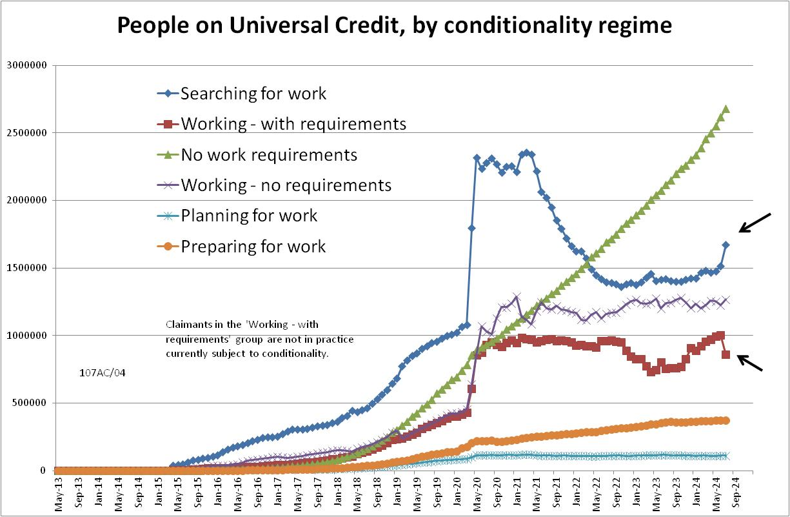

**Figure 2**

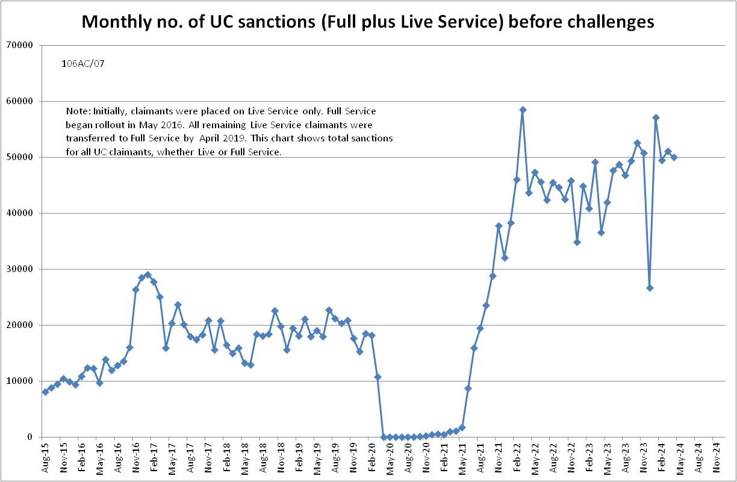

**Figure 3**

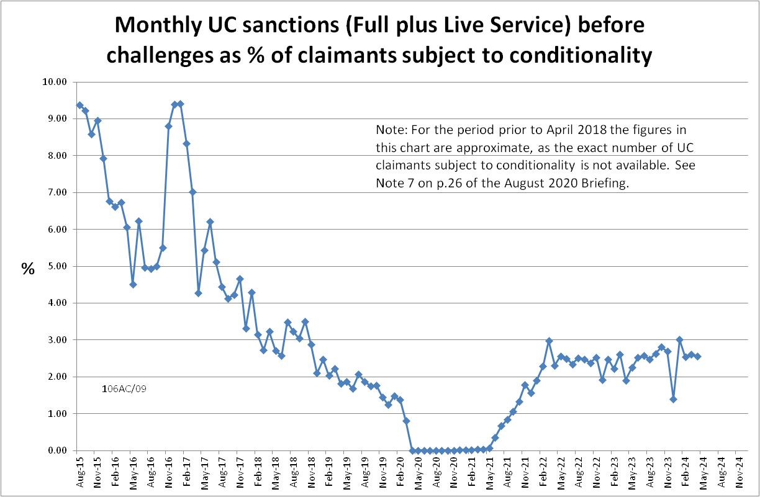

**Figure 4**

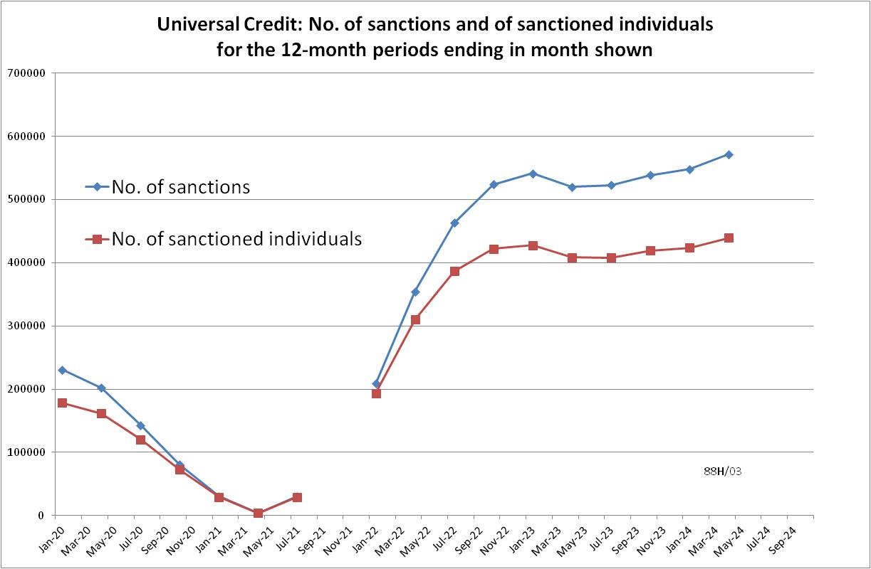

**Figure 5**

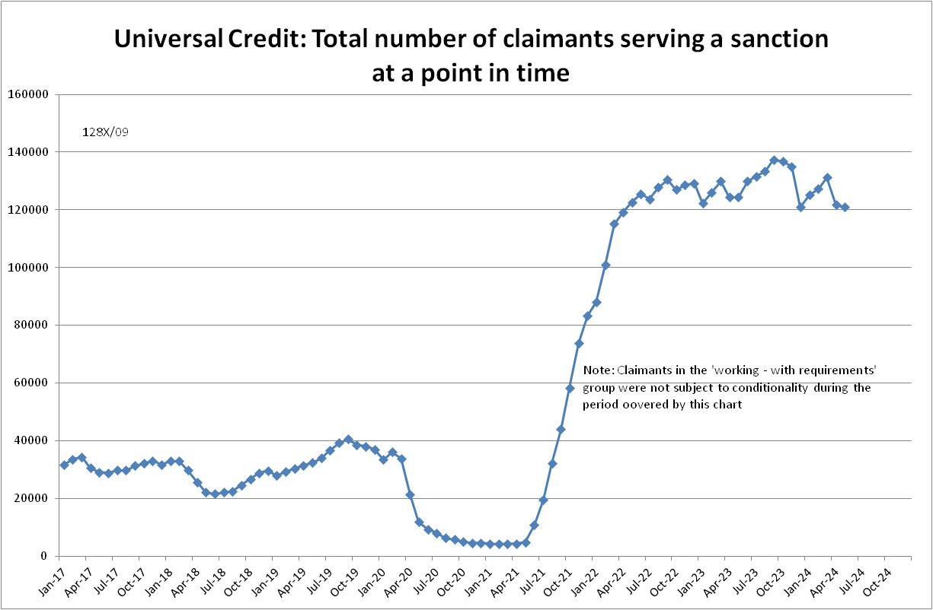

**Figure 6**

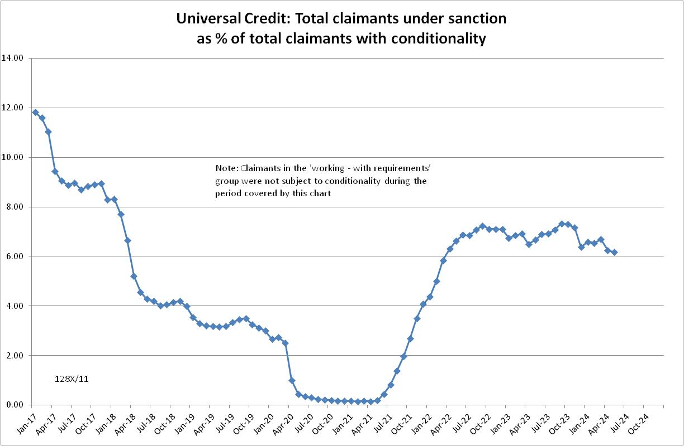

**Figure 7**

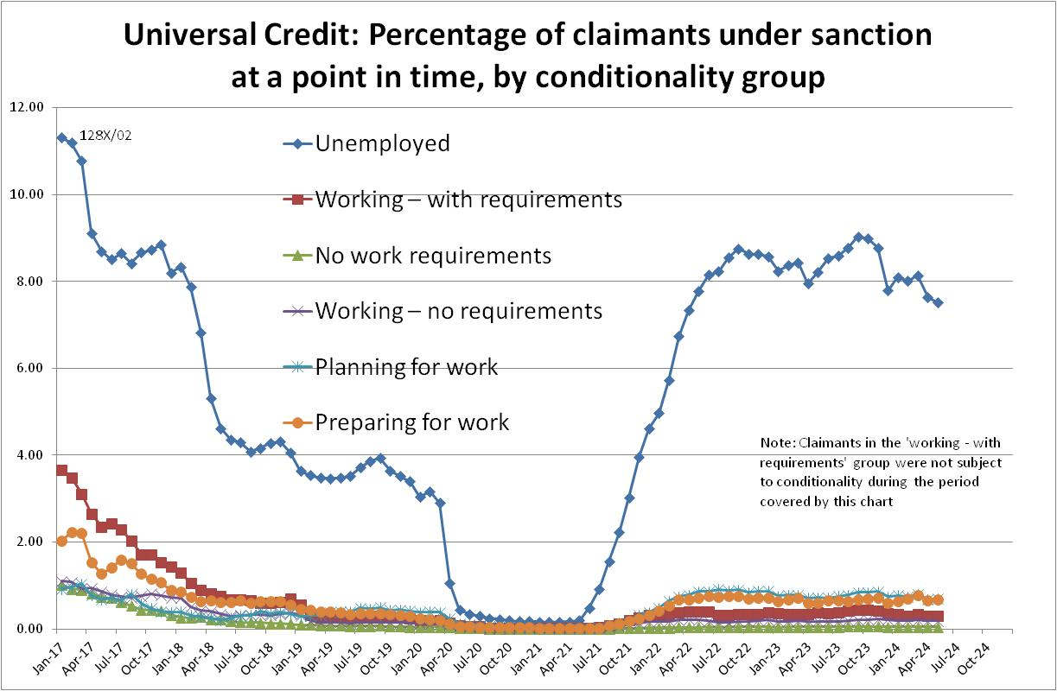

**Figure 8**

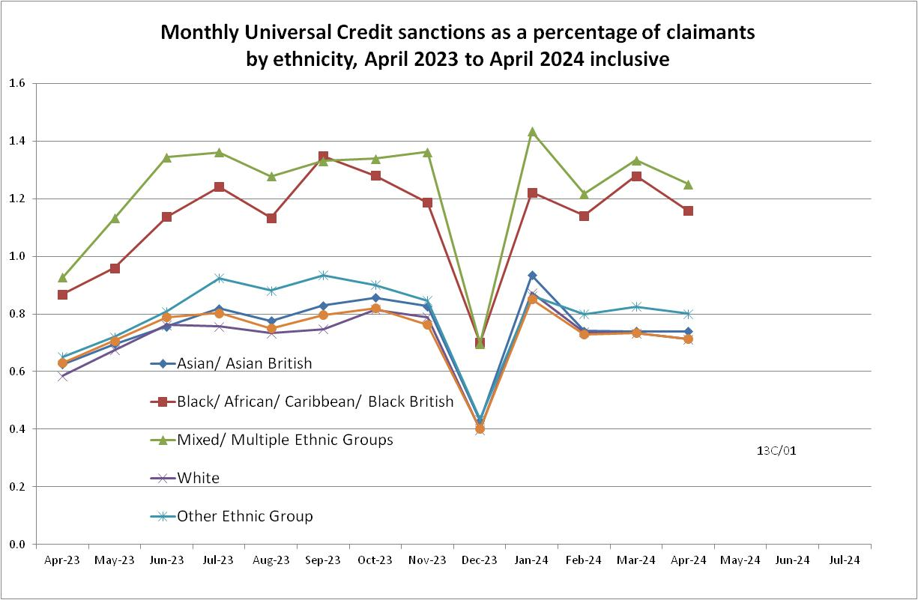

**Figure 9**

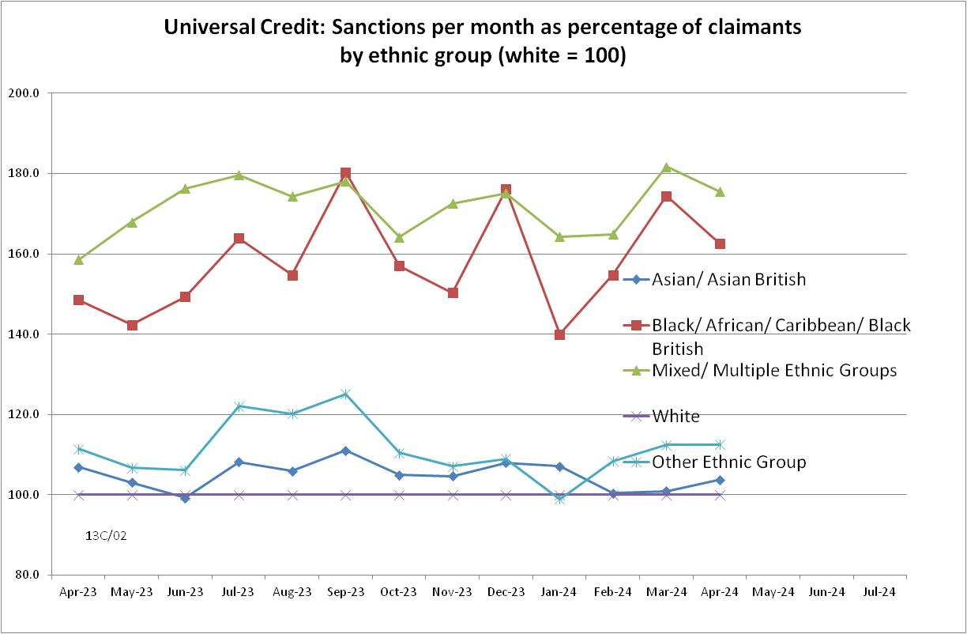

**Figure 10**

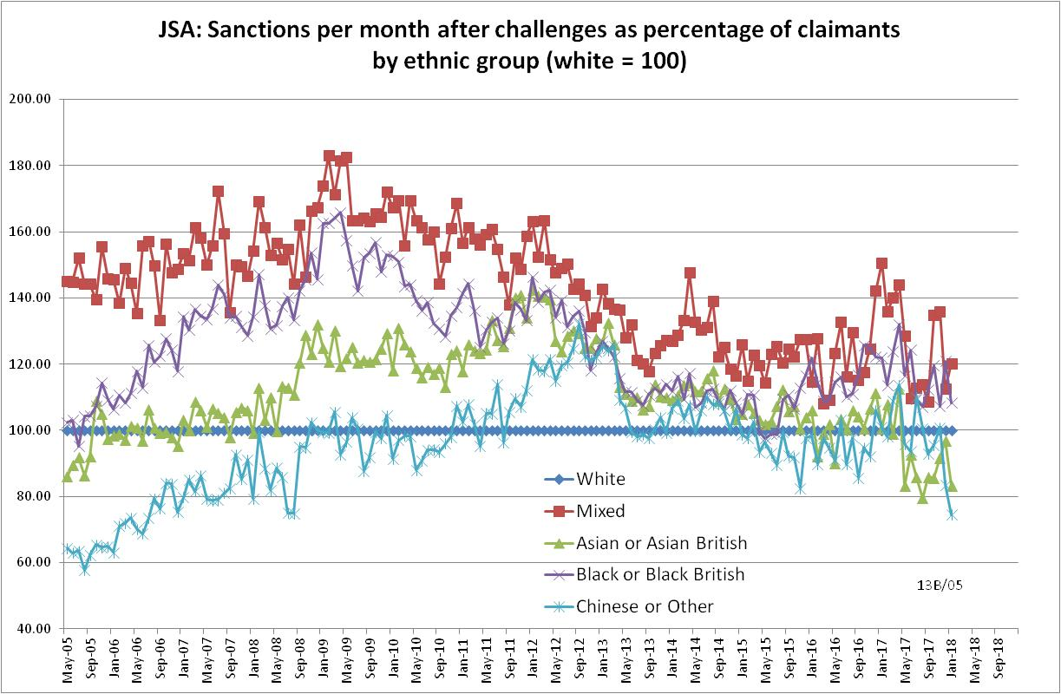

**Figure 11**

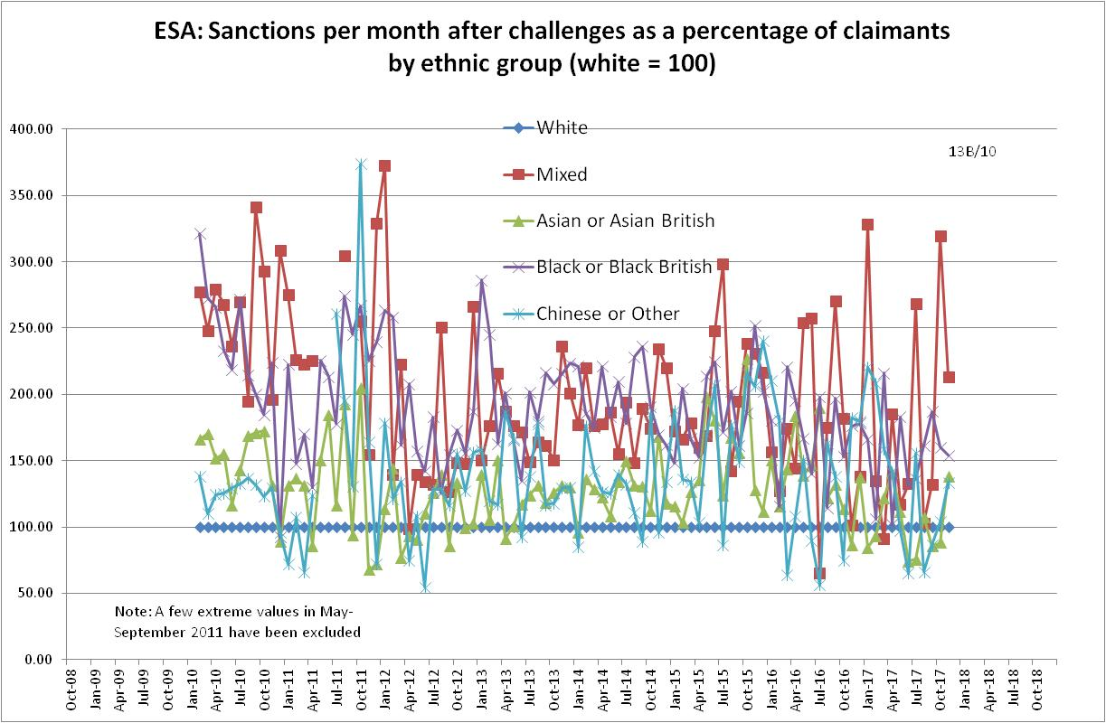

**Figure 12**

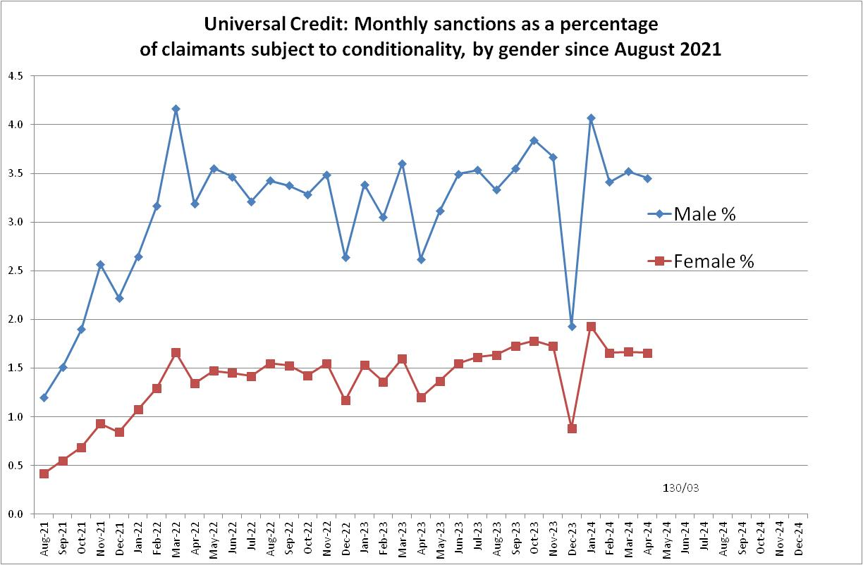

**Figure 13**

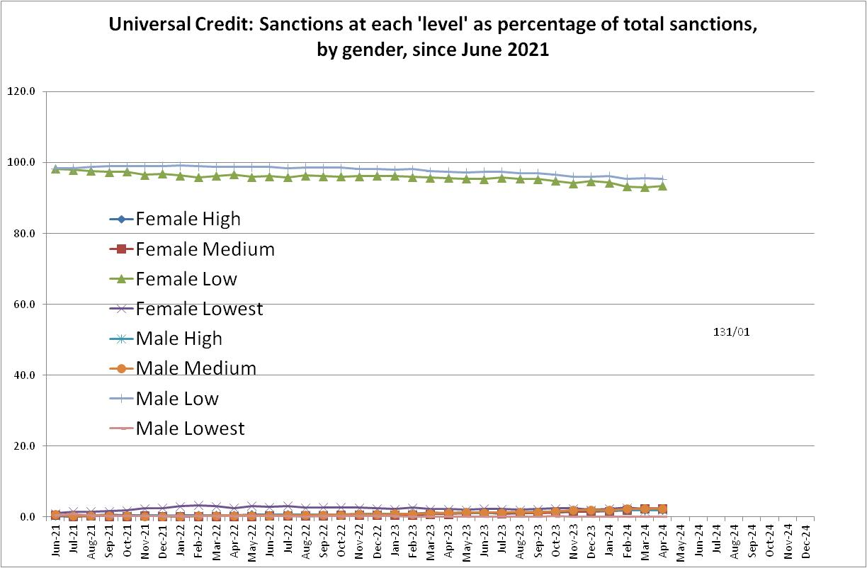

**Figure 14**

