BRIEFING

Benefit Sanctions Statistics

May 2024 release

5 June 2024

Dr David Webster
Honorary Senior Research Fellow
Urban Studies
University of Glasgow

Email david.webster@glasgow.ac.uk

Webpages: http://www.gla.ac.uk/schools/socialpolitical/staff/davidwebster/
https://cpag.org.uk/policy-and-research/latest-policy-briefings-and-reports/david-webster-briefings
http://www.cpag.org.uk/david-webster
SUMMARY

This Briefing reports on the quarterly Universal Credit (UC) sanctions statistics for Great Britain published by DWP on 14 May. This release contains no new series, only updating, but from the next release in August 2024, statistics on sanction referrals (not sanctions themselves) will be published by ethnicity.

The total number of people on UC was a provisional 6.74m in April 2024, of whom 1.97m or 29.2% were subject to conditionality. In the latest quarter there was a further large provisional increase in the number of people on UC, of 378,000, again partly due to ‘managed migration’. The largest group of UC claimants subject to conditionality is those ‘searching for work’, i.e. unemployed. At January 2024, if JSA, ESA and IS are added in, there were an estimated total of 2.26m claimants on all benefits subject to conditionality.

The AET was increased to the equivalent of 18 hours’ work a week on 13 May. This follows increases from 9 to 12 hours in September 2022 and from 12 to 15 hours in January 2023. About 180,000 people will be brought into the intensive work search regime by the further increase, and about 400,000 by the three increases taken together, with a further 80,000 if and when the separate Couples AET is abolished.

There were an average of 44,830 UC sanctions per month in the latest quarter, to January 2024, close to three times the average in the last three months before the pandemic. This
equates to 2.41% per month of UC claimants subject to conditionality, a slight fall compared to the previous quarter. In the three months immediately preceding the pandemic, i.e. December 2019 to February 2020, it was 1.4% per month.

A total of 547,692 UC sanctions were imposed in the 12 months to end-January 2024, and 424,006 claimants received at least one sanction, of whom 22.0% received more than one, and 5.4% more than two. These figures are much higher than in the last 12 months before the pandemic, when there were 230,720 UC sanctions and 178,476 sanctioned individuals.

On a calendar year basis, the annual total number of sanctions on all benefits in 2023 at 535,741 was very slightly higher than that for 2022, at 534,878. Both figures were higher than for any years since 2001, except for the period 2009 to 2014 inclusive.

On the basis of the figures as revised since the February 2024 release, the number of UC claimants who were serving a sanction at a point in time has seen a fall in the latest quarter, to an average of 124,422, (6.5% of claimants subject to conditionality), of whom 117,134 were unemployed. This is much higher than in the final quarter before the pandemic, when (again on the new basis) it was around 35,100 (3.0%). But there is no obvious trend.

DWP has published ‘ad hoc statistics’ showing how long UC claimants in the ‘Searching for work’ group have been out of work. Around 60% claim UC for 6 months or less, and only around one fifth claim for 18 months or more. These figures are a useful reminder that the potential gains from chivvying unemployed people into jobs faster are quite limited, even before taking account of the negative effects of conditionality.

While the statistics have shown little change, the latest quarter has seen a raft of new reports, announcements and analyses relating to sanctions and conditionality. These are reported in the news section at the end of the Briefing.
BRIEFING: Benefit Sanctions Statistics
May 2024

The DWP released its latest quarterly sanctions statistics for Universal Credit (UC) on 14 May. The newly published data are summarised by DWP in the online publication Benefit Sanctions Statistics, available along with methodological notes at https://www.gov.uk/government/collections/jobseekers-allowance-sanctions together with a spreadsheet with summary tables. Some data are on Stat-Xplore at https://stat-xplore.dwp.gov.uk/webapi/jsf/login.xhtml . All statistics presented here relate to Great Britain. All previous Briefings are available at https://cpag.org.uk/policy-and-research/latest-policy-briefings-and-reports/david-webster-briefings (note the change in URL, although www.cpag.org.uk/david-webster should also work). The Briefings can also be readily found through a web search.

The February 2024 release included new and reinstated statistical series. The present release by contrast contains no new series, only updating of existing ones. However DWP has announced that from the next release in August 2024, some very limited statistics will be published on ethnicity. This is because an increase to over 70% in the proportion of claimants stating their ethnicity has made the statistics viable. But the published statistics on sanctions will only relate to all decisions (in effect to sanction referrals), not to sanctions themselves.

The most important remaining gap is figures on the UC appeal system for Full Service, which now covers all UC claimants. Eight years on from the start of UC rollout in May 2016, DWP has still given no indication of when these might be published.

DWP no longer publishes updates to statistics on sanctions for Jobseekers Allowance (JSA), Employment and Support Allowance (ESA) and Income Support (IS). JSA and ESA are not merely ‘legacy’ benefits since there are new claimants of the ‘New Style’ (contribution-based) versions of these benefits. But we will not know about any sanctions on these benefits except via Parliamentary Questions or FoI requests. There are now very few if any JSA claimants other than on New Style.

Number of people on Universal Credit (UC) and number of UC claimants subject to conditionality

The total number of people on UC was a provisional 6.74m in April 2024. In the latest quarter there was a further large provisional increase in the number of people on UC, this time of 378,000. This was again partly due to ‘managed migration’. The House of Commons Library published a further briefing on the process of ‘managed migration’ on 11 March (Mockley et al. 2024). CPAG is also publishing reports on the experience of managed migration: https://cpag.org.uk/policy-and-research/findings-our-projects/managed-migration-research-project-findings

In principle, the number of UC claimants subject to conditionality might be about to increase dramatically. As noted in the May 2023 Briefing (p.9), the ‘In-work progression offer’ was to have been made compulsory from September 2023. This would have meant that all 761,000 claimants in the ‘Working – with requirements’ group would be added to the total of those subject to conditionality. But as noted in the November 2023 Briefing (pp. 9-10), staffing difficulties led to a delay. A Parliamentary answer on 13 October 2023 indicated that a start is intended for some time in 2024. The May 2024 issue of DWP’s Benefit Sanctions Statistics, section 3.2, does not list ‘Working – with requirements’ among the groups subject to conditionality. Therefore it appears that the ‘Working – with requirements’ group should continue to be excluded from the total of those subject to conditionality, at least for the time being. On this basis, there were 1.97m UC claimants subject to conditionality in April 2024, or 29.2% of all UC claimants. It may well be that, given the very weak case for in-work conditionality (see earlier Briefings), and with a change of government likely, it may never be introduced at all.

The largest group of UC claimants subject to conditionality is those ‘searching for work’, i.e. unemployed. They were 1.49m in April 2024, accounting for 94.1% of all claimant unemployed. The other 5.9% of the claimant unemployed were the 92,485 claimants on JSA, almost all of whom will have been claiming the ‘New Style’ contribution based JSA.

Total claimants on all benefits subject to conditionality

Reporting on legacy benefits is less up-to-date than on UC. At January 2024 there were still an estimated 357,000 claimants on the legacy benefits subject to conditionality, comprising 148,000 in the ESA Work Related Activity Group, 116,000 on Income Support and 93,000 on JSA. Added to the 1.90m UC claimants subject to conditionality at that date, there were therefore an estimated total of 2.26m claimants on all benefits subject to conditionality.

Further raising of the Administrative Earnings Threshold (AET)

The further increase in the AET to the equivalent of 18 hours’ work a week took place on 13 May. This follows increases from 9 to 12 hours in September 2022 and from 12 to 15 hours in January 2023. The May 2023 Briefing, pp.3-4 and Figure 1, and the August 2023 Briefing, p.4 and Figure 1, discussed the impact of the first two increases. Ministers state that the further increase will bring about 180,000 people into the intensive work search regime, and the total effect of the three increases will be to bring about 400,000 UC claimants into this regime (https://www.gov.uk/government/news/new-rules-require-180000-on-universal-credit-to-increase-working-hours) A further 80,000 will be brought into the regime when, as intended, the separate Couples AET is abolished. The Social Security Advisory Committee has published a critical report on these measures, raising many questions about them (see DWP (2024b) and SSAC (2024)).

The monthly number of Universal Credit sanctions remains fairly stable

The monthly number of sanctions imposed, and this number as a percentage of claimants subject to conditionality, are the most robust measures of the scale of sanctioning.

There was a very exaggerated occurrence of what is a usual fall in sanctions imposed in December, due to the Christmas/New Year holiday. But there has been no obvious change in trend.

Number of UC sanctions being imposed per month

Monthly UC sanctions reached a peak of 58,515 in March 2022 but since then have fallen back, to an average of 44,830 in the latest quarter, to January 2024 (Figure 1). However this latest quarterly average is close to three times the average in the last full three months before the pandemic (to February 2020), which was 17,290.

Monthly UC sanctions as a percentage of UC claimants subject to conditionality

UC sanctions are also more or less stable as a percentage of UC claimants subject to conditionality (Figure 2). The monthly average of 44,830 for the latest quarter to October 2023 equates to 2.41% per month of UC claimants subject to conditionality, a slight fall compared to the previous quarter. In the three months immediately preceding the pandemic, i.e. December 2019 to February 2020, it was 1.4% per month.

The reason for the very high initial rates of UC sanctions shown in Figure 2 is that when UC was launched (as Live Service), it was only available to single people without dependants, and they tend to be young people, who have high rates of sanction.

As noted in previous Briefings, the overall rate for UC puts together different categories of claimant with very different rates of sanctioning – unemployed, sick/disabled and those with caring responsibilities. The rate for unemployed claimants (‘searching for work’) is much higher than for the other conditionality groups, which have quite low rates of sanctioning. This is evident in the figures for claimants serving a sanction at a point in time (see below, Figure 8).

No. of UC sanctions and no. of UC claimants sanctioned during the year to 31 January 2024

Of the 547,692 UC sanctions imposed in the year to end-January 2024, 123,956 were repeat sanctions on individuals who had already received at least one sanction during the year. Therefore the total number of individual UC claimants who received at least one sanction during the year was 424,006. Of these, 93,127 (22.0%) received more than one sanction, and 23,058 (5.4%) received more than two. These figures are much higher than in the last full 12 months before the pandemic, to January 2020, when there were 230,720 UC sanctions and 178,476 sanctioned individual claimants.

Figure 3 shows the two series for the number of sanctions imposed and the number of claimants sanctioned, for the 12-month periods ending in each quarter since January 2020 (just before the pandemic).

Monthly total sanctions on all benefits since 2000

Figure 4 shows the monthly total number of sanctions on all benefits (UC, JSA, ESA and IS) since the start of the current recording system in April 2000, on the assumption that sanctions on JSA, ESA and IS have continued to be negligible after May 2022, when reporting on the latter three benefits stopped. Even if this assumption is incorrect, the monthly average for latest quarter, 44,830, is higher than at any time other than the coalition government’s sanctions campaign of 2010 to 2015, and the last year of the former Labour government in 2009 and 2010. (The previous three issues of the Briefing incorrectly stated that the recent figures were higher than those of the former Labour government in 2009 to 2010.)

Annual total sanctions on all benefits since 2001

Figure 5 shows the annual total number of sanctions on all benefits for calendar years since 2001. The total for 2023 at 535,741 was very slightly higher than that for 2022, at 534,878. Both figures were higher than for any years except 2009 to 2014 inclusive.

Reasons for, levels of, and durations of Universal Credit sanctions

The February 2024 issue of the Briefing had a very full analysis of the DWP’s newly published, reinstated or revised statistics on reasons for sanctions and of the closely related ‘levels’ and durations of sanctions. This analysis is not repeated here.

Universal Credit claimants serving a sanction at a point in time

On the basis of the figures as revised since the February 2024 release, the number of UC claimants who were serving a sanction at a point in time has seen a fall in the latest quarter, to an average of 124,422. This however is much higher than in the final quarter before the pandemic, when (again on the new basis) it was around 35,100. But there is no obvious trend (Figure 6).

Percentage of UC claimants subject to conditionality who were serving a sanction at a point in time

Figure 7 shows the same data as a percentage of UC claimants subject to conditionality. In the latest quarter this was an average of 6.5%, a slight fall from recent levels, though again there is no clear trend. This percentage equates to one in 15 of UC claimants subject to conditionality and is well over double the immediate pre-pandemic level of around 3.0%. Much higher percentages were seen for earlier months, going back to January 2017. As explained in relation to Figure 2 above, this is because when UC was first introduced it was available only to single people without dependants, who tend to be young, and young people have much the highest rates of sanction.

UC claimants serving a sanction at a point in time by conditionality group

Figure 8 shows the percentage of UC claimants subject to each individual conditionality regime who were serving a sanction at the measurement date in each month. As usual, unemployed (‘searching for work’) claimants were far more likely to be sanctioned than the other two groups subject to conditionality, with 117,134 or 8.0% under sanction in February 2024 compared to 0.74% for ‘planning for work’ and 0.70% for ‘preparing for work’. One in 12 or 13 unemployed UC claimants was under sanction in February 2024.

There are also people in the groups not subject to conditionality who are serving sanctions. That is because under UC, sanctioned claimants are made to serve out the whole of their sanction even if they move into a no-conditionality group, for instance because of illness. There were 6,325 of them in February 2024, almost half (2,839) of these in the ‘working – with requirements’ group. This group are the most likely to have recently been unemployed and therefore to have been sanctioned.

Universal Credit: Length of time out of work and in the ‘Searching for work’ group

DWP has published ‘ad hoc statistics’ (DWP 2024a) showing how long UC claimants in the ‘Searching for work’ group have been out of work. The presentation of the figures is unusual in that the categories used by DWP are not mutually exclusive. Figure 9 shows a more normal presentation, using percentages. It will be seen that the majority, around 60%, of unemployed claimants claim UC for 6 months or less. Almost three-quarters claim for a year or less. Only around one fifth claim for 18 months or more. The usual pattern is that these longer term unemployed people will be disproportionately concentrated in areas where demand for labour is low (Webster 2005) and where this is the case policy needs to focus on promoting employment rather than on influencing the behaviour of unemployed people.

These figures are a useful reminder that the potential gains from chivvying unemployed people into jobs faster are quite limited – in most cases just a few months of additional employment, if any. Moreover, against these potential gains have to be set the losses from pushing square pegs into the round holes of worse jobs, and the other damage done by conditionality.

SANCTIONS – OTHER DEVELOPMENTS

Extension of ‘Additional Jobcentre Support’

‘Additional Jobcentre Support’ (AJS) requires claimants in selected areas to attend the Jobcentre every day for a week or a fortnight. A FoI request by Gosia Banach of CPAG has elicited the following about the experience so far:
- 12,000 claimants participated in AJS Phase 1 (March to August 2023), of whom 5,000 (42%) had earnings recorded by November 2023.
- Up to 10 February 2024, 13,000 claimants had participated in AJS Phase 2 (this figure will increase as phase 2 is ongoing).
- Of 9,200 claimants who participated in AJS Phase 2 over the period September 2023 to January 2024, 2,700 (29%) had earnings recorded by February 2024.

It was announced in the Spring Budget that the AJS pilot is being extended across England and Scotland for a further 12 months. It will continue to test how intensive intervention at specific points in a UC claimant’s claim can move them into employment or higher earnings. As part of the pilot extension, claimants will be required to accept a new claimant commitment at 6, 13 and 26 weeks, agreeing to more work requirements, or have their claim closed. An additional 30 sites are being brought into the programme, bringing the total to 150.

Government failure to evaluate impact of the reduction in ‘permitted period’

The government has admitted that it has failed to carry out any evaluation of the reduction of the period during which jobseekers are permitted to confine job search to their own field from
12 weeks to 4 weeks:
https://www.theyworkforyou.com/wrans/?id=2024-02-20.HL2609.h&s=universal+credit+sanction#gHL2609.q0
This change took place in January 2022 and was discussed in the February 2022 Briefing, pp.6-7 and the May 2022 Briefing, pp.7-10. Pushing square pegs into round holes is one of the most serious criticisms of the conditionality regime.

‘Work Well’ pilots
On 7 May the government announced the launch of a new work and health support service which will be rolled out to 59,000 people across 15 areas of England from October 2024. It will provide tailored support for them in their local area to help them to stay and progress in work. The WorkWell service will provide a single, joined-up assessment and gateway into both employment support and health services locally to help people manage their conditions and to identify workplace adjustments or support that would enable them to stay in work or return sooner. The local support services will include physiotherapy and counselling. Participants will not need to be claiming any benefits. They will receive personalised support from a Work and Health Coach to understand their current health and social barriers to work and draw up a plan to help them overcome them. More detail including a list of the 15 areas is at https://www.gov.uk/government/news/new-64-million-plan-to-help-people-stay-in-work

Work Capability Assessment reform: estimated number of claimants affected

DWP on 18 April published updated statistics (DWP 2024c) on the estimated number of claimants affected by each of the WCA proposals announced in the Autumn Statement 2023.

House of Commons Work and Pensions Committee Inquiry on Safeguarding Vulnerable Claimants

As a result of the general election being called, the Committee has had to wind up its inquiry into Safeguarding Vulnerable Claimants without producing a report: https://committees.parliament.uk/publications/45115/documents/223499/default/.
The evidence remains available and the Committee published further documents on 24 May.

In a hearing on 26 March, Preeta Ramachandran, DWP’s Southern Area Director, Work and Health Services, told the Committee (Q.291): ‘We have a number of ways to ensure that
anyone who is vulnerable is not sanctioned. As soon as they come into the Jobcentre when they have their claimant commitment, if they have particular health conditions that stop them looking for work, we can put easements in at that stage. If it then goes into the actual claim and we decide to look at that process, the work coach has to do a pre-referral form, which is then discussed with the work coach team leader. They have to agree that there is no doubt there that we have considered vulnerability. It is important that that is considered before we send that to a decision maker. Then another pair of eyes looks at it. When the decision maker decides to put a sanction on, they have to consider another prereferral form. Vulnerability
is discussed again at that stage with someone at a higher grade. Only through all that process do we decide whether vulnerability has formulated doubt here before we put a sanction on’. However she also said (Q.290) that the sanctions data do not record whether a sanctioned claimant is vulnerable, and that therefore DWP cannot say how many vulnerable claimants are sanctioned.

The Committee carried out a survey of DWP staff who are members of the Public and Commercial Services Union (PCS), launched on 8 April, https://committees.parliament.uk/publications/45121/documents/223511/default/.
1,711 staff responded to the survey, of whom 80% had direct contact with claimants. Among the findings was that two thirds (67%) of those with direct contact said that they did not have enough time in their day to deal with safeguarding concerns carefully, correctly and in a timely manner. Half (51%) of the same group said that there is sufficient support from management and Advanced Customer Support Senior Leaders (ACSSLs) to help ensure that effective safeguards are in place for vulnerable claimants. More detail is available from the Disability News Service at https://www.disabilitynewsservice.com/dwp-staff-tell-mps-after-years-of-deaths-we-dont-have-time-to-deal-with-safeguarding-carefully-and-correctly/ These findings fit with the comments of PCS about Jobcentre understaffing discussed in the February 2024 Briefing, p.12 and November 2023 Briefing pp.9-10.

Conservatives and Labour on social security and employment

Recent speeches by Mel Stride (22 May) at https://www.gov.uk/government/speeches/breaking-new-ground-on-welfare-reform-growing-the-economy-and-changing-lives and by Liz Kendall (4 March) at
https://labourlist.org/2024/03/labour-party-work-budget-2024-workers-unemployed-young-people-plan-benefit-work/ have set out the two main parties’ views on labour market policy.

Unite campaign against in-work conditionality and the raised AET

The Unite union has published two YouTube videos Cut Sanctions, not Incomes, at https://www.youtube.com/watch?v=IkKqdxZYR-8 and at https://www.youtube.com/watch?v=KoS7zBLDvDA , criticising in-work conditionality including the raising of the AET. There is more information about the Unite campaign at
https://unitelive.org/cut-sanctions-not-incomes

New Economics Foundation on Universal Credit deductions

The New Economics Foundation has published a blog on the impact of benefit deductions on poverty (Tims & Wright 2024). It finds that in May 2023, 50% of households (2.3m people) in receipt of UC had a debt deduction automatically taken from their ​“standard allowance” – the portion of UC dedicated to adults’ basic living costs like food, utility bills and travel. On average, each household with a deduction lost £63 a month.

Financial Times on ‘sick note culture’

The Financial Times on 26 April (Strauss and Borrett 2024) carried a comprehensive critique of Richie Sunak’s argument that there is a ‘sick note culture’ in which young people are ‘over-medicalising’ everyday anxieties, disability benefits are being ‘misused’, and too many people offered cash instead of therapy.

Attempts to push people into longer hours are misplaced – FT

The Financial Times on 29 May (Strauss 2024) carried an article citing the European Central Bank and IMF to point out that there is a Europe-wide trend for people to work shorter hours. The IMF suggests that rather than attempting to cajole employed people into longer hours, a more promising approach is to promote better parental leave policies that could bring more people into work.

Adult learners fell by half between 2010-11 and 2022-23

The Learning and Work Institute on 27 May published a report (Evans & Egglestone 2024) showing that over the twelve years of Coalition or Conservative government, the number of adult learners fell by 47%, resulting in 7m fewer qualifications. Per capita adult skills funding has been cut by 28% in real terms and companies have cut their skills investment per employee by 20%. Combined with the ‘any old job’ employment policy under UC, this appears likely to contribute significantly to explaining the UK’s stagnant productivity.

Impact of increased UC conditionality on lone parents

The organization Single Parent Rights has published a study on the impact of increased UC conditionality on lone parents (Talbot 2024). It was based on a self-recruited online survey of 639 lone parents. It found that:
- 59% of respondents find their current work requirements unmanageable
- 81% of single parents said 30 hours a week is unmanageable for them
- 74% of respondents found work coach meetings were not useful and a further 20% weren’t sure if they were useful
- 98% of respondents face barriers to work including a lack of access to affordable childcare, a lack of flexible work and single parent employment discrimination
- The flexibility the DWP promised with the roll out of this policy is applied inconsistently
- The DWP has ignored the disproportionate impact of the changes on single parents.
Joseph Rowntree reform proposals

The Joseph Rowntree Trust on 19 February published a paper (Tomlinson 2024) making proposals for a comprehensive reform of employment support and social security. It points out that movements by unemployed people into work have halved since 2014/15, frorm 500-600,000 down to 250,000. The Jobcentre has become a UC monitoring service rather than an employment service. The report estimates that the department now spends £350m a year on monitoring claimants, the equivalent of over half of the annual spend on work coach salaries. The estimated 13m hours a year that work coaches spend monitoring claimants crowds out the opportunity for support. The paper argues that a better approach would be to reorientate Jobcentres around building productive, supportive, work-focused relationships between claimants and their work coaches.

IPPR study – associations between bad jobs and obesity and between obesity and economic inactivity

A study by IPPR (O’Halloran & Thomas 2024) finds an association between obesity and economic inactivity, and also some evidence that bad employment conditions promote obesity. This is one of many issues that a conditionality approach does not address.

Employer perspectives on in-work conditionality

A new paper (Jones & Carson 2024) explores employer perspectives on ‘in-work conditionality’. As policymakers across Europe and other developed nations have pursued increasingly interventionist approaches to activating the unemployed through conditionality, the UK has gone an unprecedented step further by requiring those in receipt of in-work benefits to demonstrate efforts to increase their working hours and/or pay. Employer perspectives on this policy development have been overlooked by policymakers and researchers. This paper addresses this omission through analysis of 84 semi-structured interviews with a diverse group of employers. It finds that this new approach may be a step too far. It contributes theoretically by identifying a potential role for employers as latent path disruptors in policy development, and challenges the assumption that employers are typically supportive of extensions of behavioural conditionality to social security claimants.

REFERENCES

DWP (2024a) Long-term out of work and “Searching for Work” claimants on Universal Credit, January 2023 to January 2024, 19 April, at
https://www.gov.uk/government/statistics/long-term-out-of-work-and-searching-for-work-claimants-on-universal-credit/long-term-out-of-work-and-searching-for-work-claimants-on-universal-credit-january-2023-to-january-2024

DWP (2024b) The Universal Credit (Administrative Earnings Threshold) (Amendment)
Regulations 2024 (SI 2024/****): Report by the Social Security Advisory Committee, April, at
https://assets.publishing.service.gov.uk/media/662b80caae7fb5d93ebf9327/universal-credit-transitional-provisions-amdt-regs-2024-accessible.pdf

DWP(2024c) Work Capability Assessment Reform: update to estimated number of claimants affected, 18 April, at
https://www.gov.uk/government/publications/work-capability-assessment-reform-estimated-number-of-claimants-affected

Evans, Stephen and Corin Egglestone (2024) The great skills divide: how learning inequalities risk holding the UK back, London, Learning and Work Institute, May, at
https://learningandwork.org.uk/news-and-policy/cuts-to-skills-funding-hit-poorest-areas-hardest-and-put-20-billion-economic-growth-at-risk/

Jones, Katy and Calum Carson (2024) ‘A step too far: Employer perspectives on in-work conditionality’, Journal of European Social Policy, OnlineFirst, 29 February

Mockley, Andrew, Steven Kennedy and Francis Hobson (2024) Managed migration: Completing Universal Credit rollout, House of Commons Library Research Briefing, 11 March, at
https://commonslibrary.parliament.uk/research-briefings/cbp-9984

O'Halloran, Jamie and Chris Thomas (2024) Scale of the Challenge: Obesity and the Labour Market, London, Institute for Public Policy Research, May, at
https://www.ippr.org/articles/scale-of-the-challenge

Social Security Advisory Committee (2024) The Universal Credit (Administrative Earnings Threshold) (Amendment) Regulations 2024, 8 March, at
https://www.gov.uk/government/publications/the-universal-credit-administrative-earnings-threshold-amendment-regulations-2024-si-2024

Strauss, Delphine (2024) ‘Efforts to cajole longer hours from European workers are misplaced’, Financial Times, 29 May, p.6

Strauss, Delphine and Amy Borrett (2024) ‘PM’s tough plan on ‘sick note culture’ is wrong prescription, warn experts’, Financial Times, 26 April, p.3

Talbot, Ruth (2024) Universal Credit Conditionality Changes and the Impact on Single Parent Families, Single Parent Rights, March, at https://www.singleparentrights.org/uc-conditionality-research

Tims, Sam & Hollie Wright (2024) Benefits debt deductions trapping people in poverty and debt, New Economics Foundation, 2 June, at
https://neweconomics.org/2024/06/benefits-debt-deductions-trapping-people-in-poverty-and-debt-1

Tomlinson, Don (2024) ‘Work first’ can work better: More people in employment is possible, with reforms to work and welfare policy, Joseph Rowntree Foundation Briefing, 19 February, at https://www.jrf.org.uk/work/work-first-can-work-better

Webster, D. (2005) ‘Long-Term Unemployment, the Invention of “Hysteresis” and the Misdiagnosis of Structural Unemployment in the UK’, Cambridge Journal of Economics, Vol.29 No.6, November, pp.975-95

Figure 1
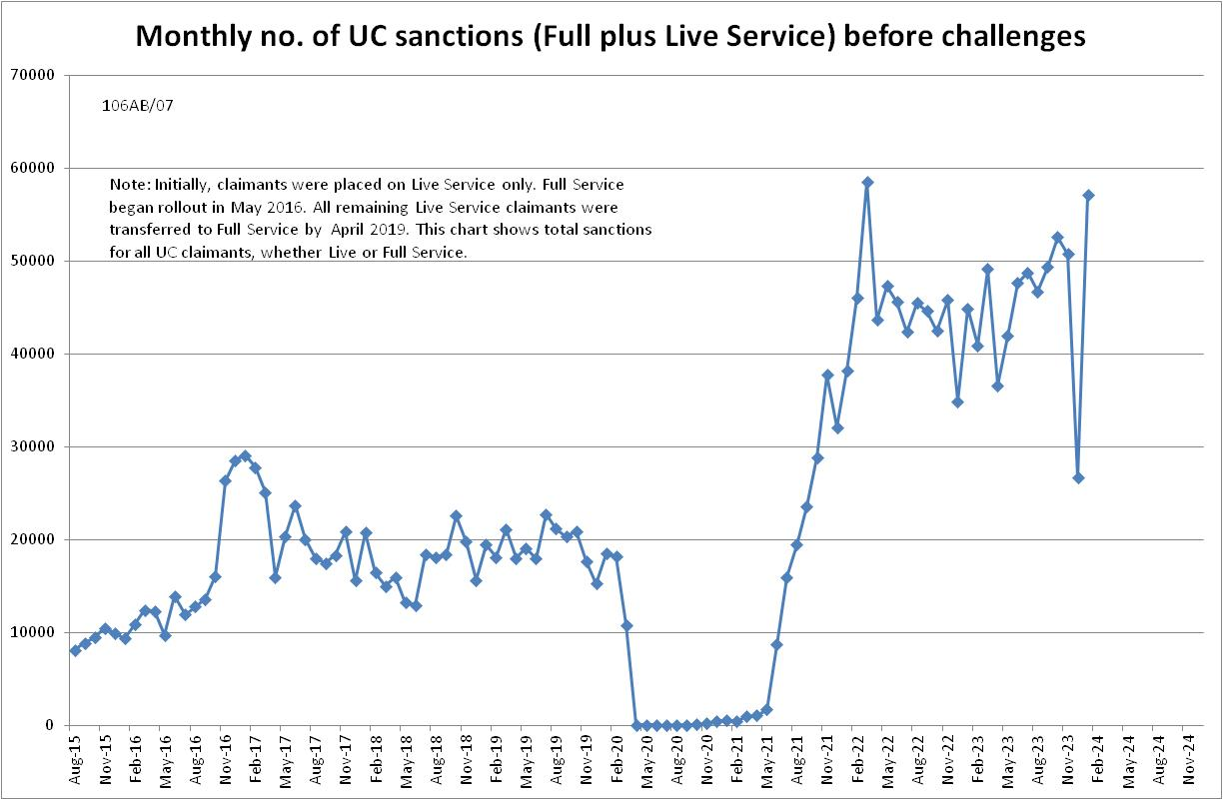

Figure 2
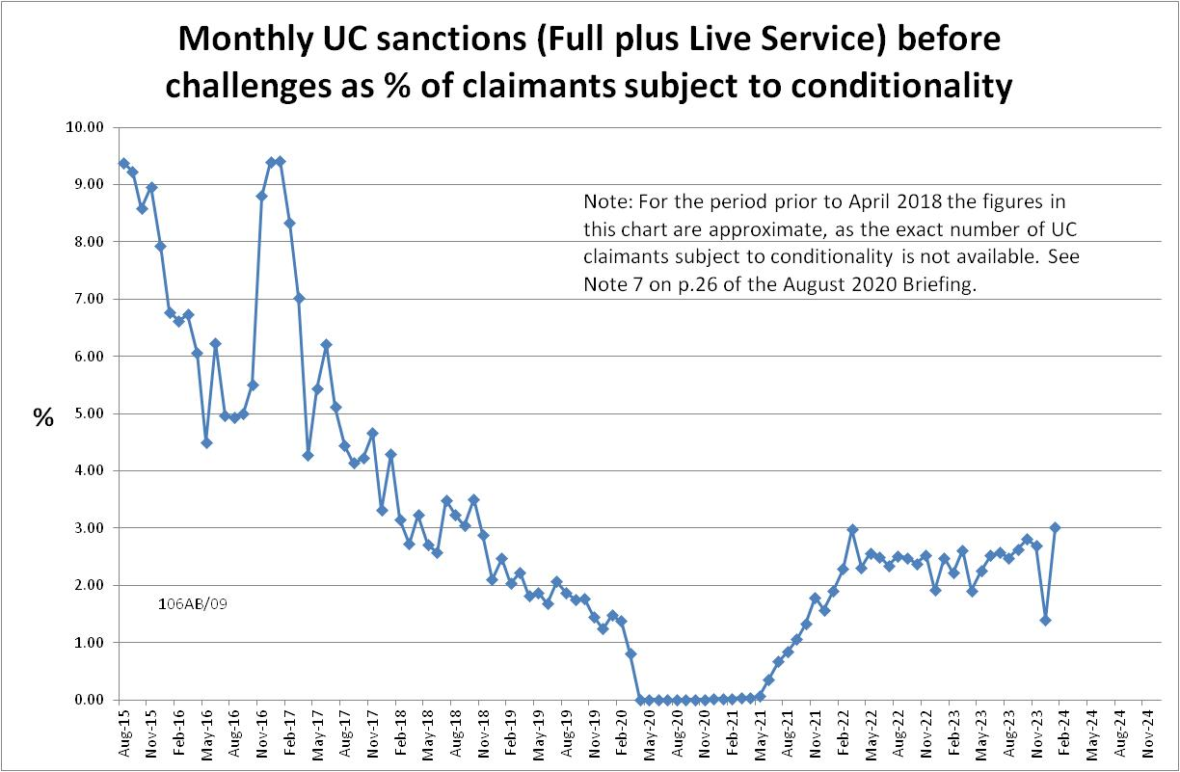

Figure 3
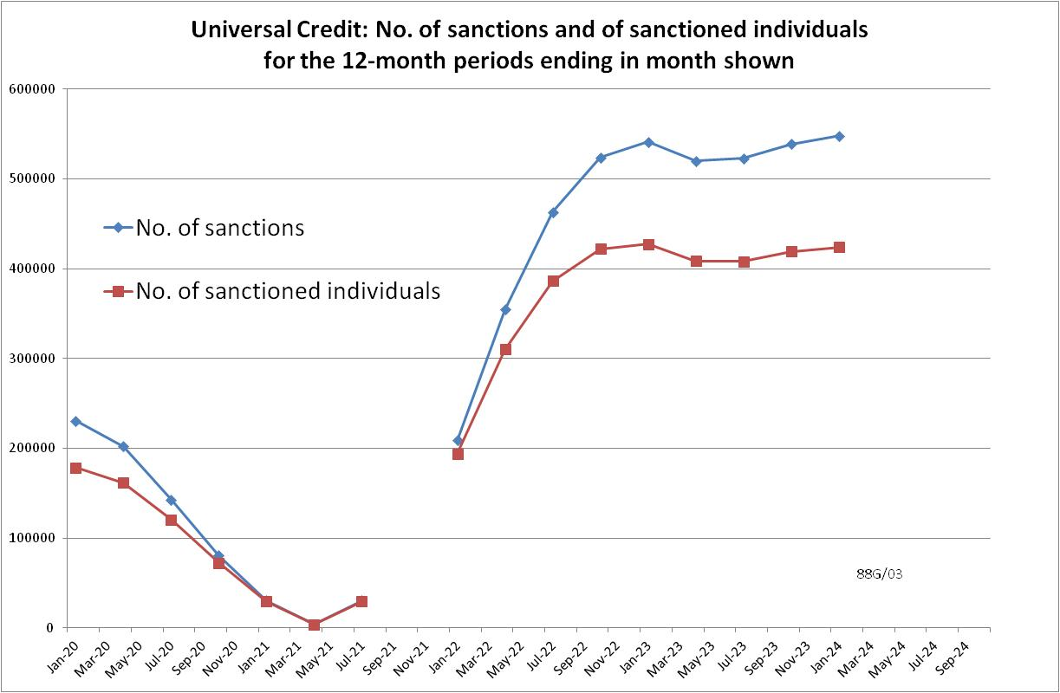

Figure 4
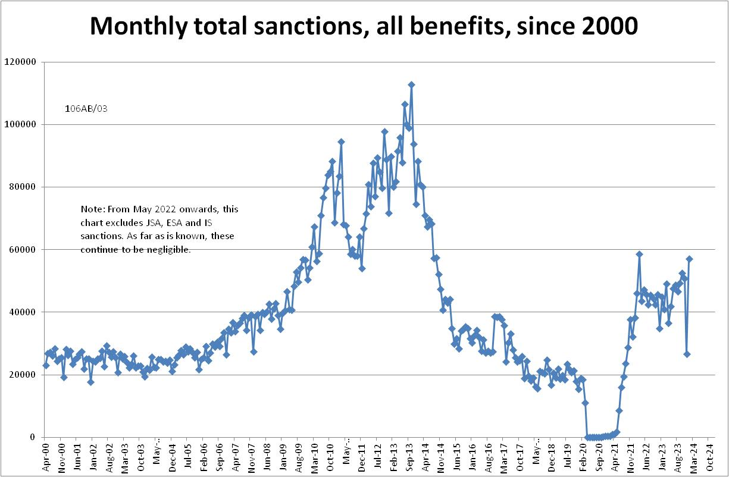

Figure 5
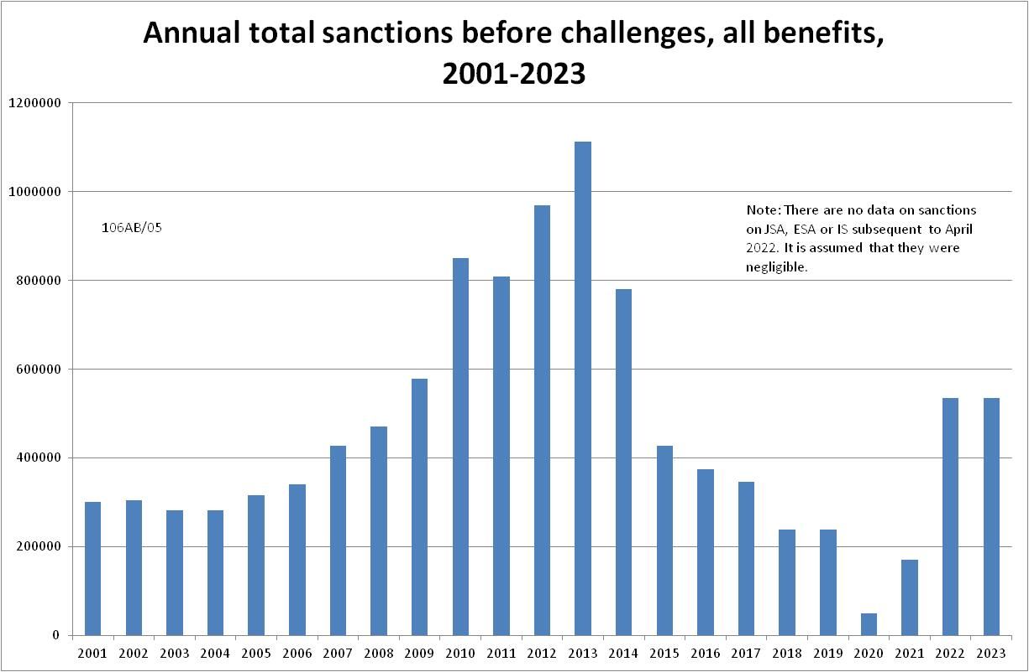

Figure 6
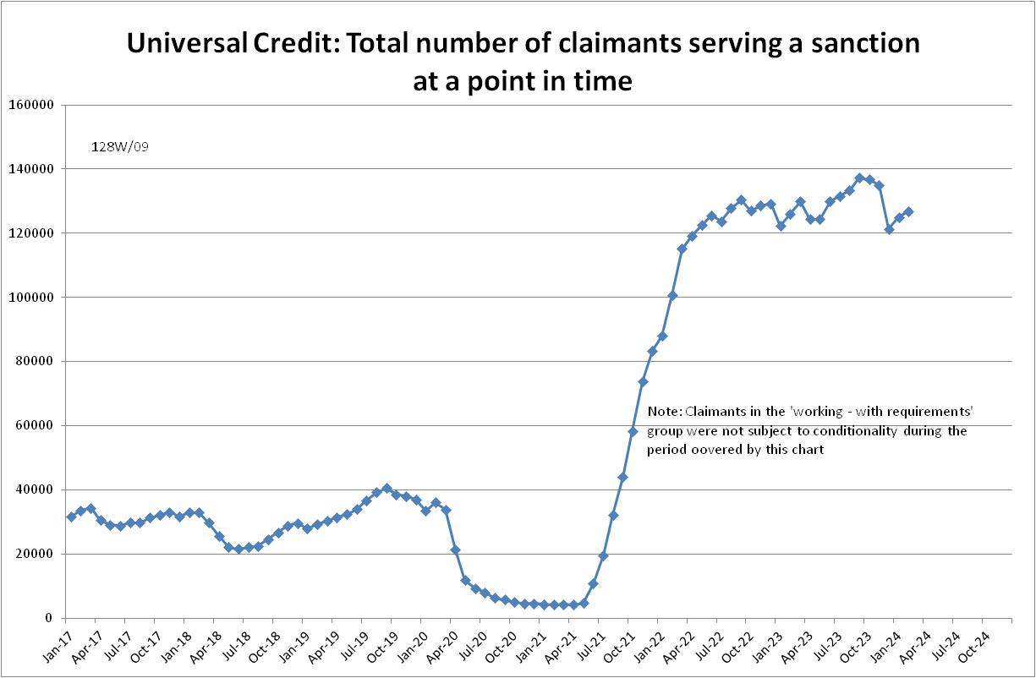

Figure 7
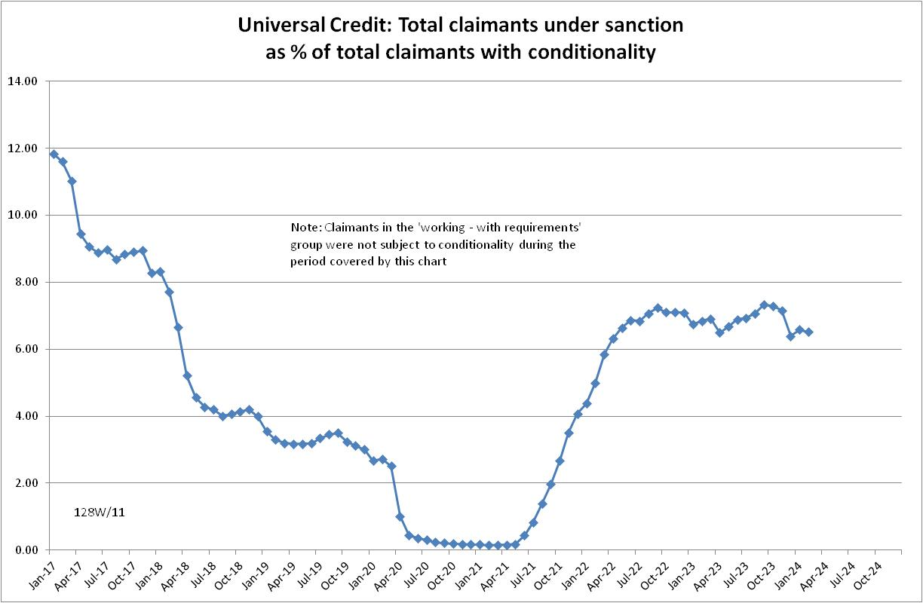

Figure 8
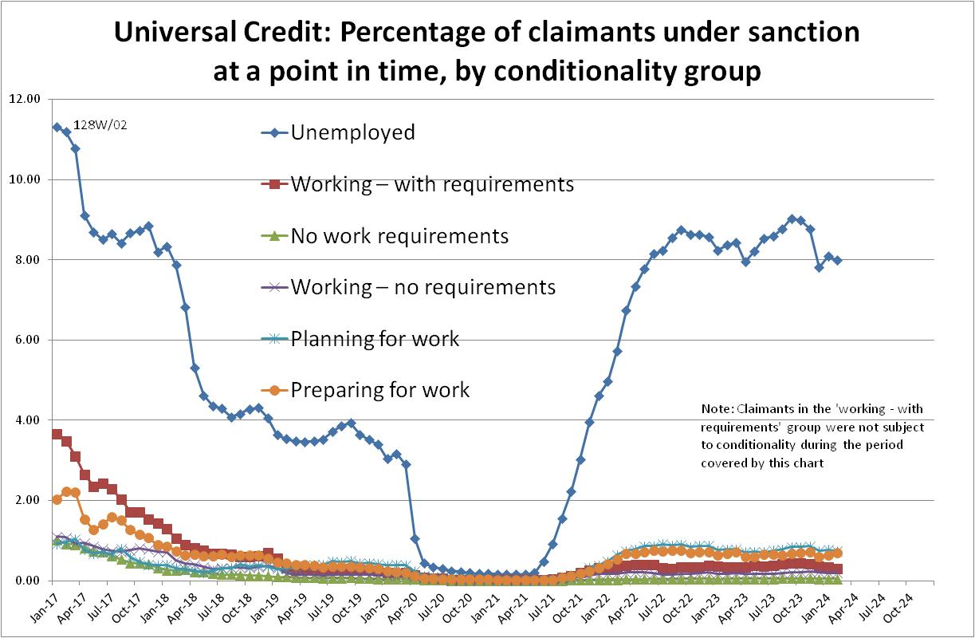

Figure 9
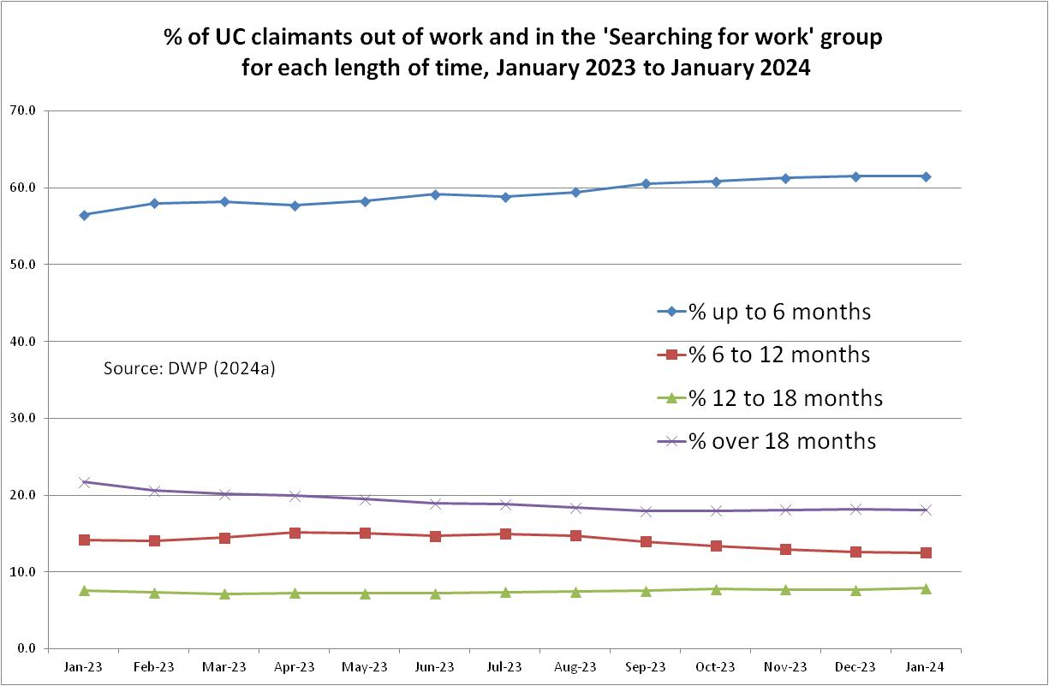

NOTES

Previous Briefings include many analyses that are not repeated here but remain valid. However it should be remembered that the DWP may have made subsequent revisions to the data reported in earlier Briefings. These revisions will generally not be major although there are exceptions. There may also often be substantial changes in some figures for the most recent few months.
A DWP report on the progress of managed migration stated that the final migration of claimants from old-style JSA to UC may not be completed before the end of 2024/25. Old-style JSA is already closed to new claimants.

