BRIEFING

Benefit Sanctions Statistics

February 2023

2 March 2023

Dr David Webster
Honorary Senior Research Fellow
Urban Studies
University of Glasgow

Email david.webster@glasgow.ac.uk

Webpages: http://www.gla.ac.uk/schools/socialpolitical/staff/davidwebster/
http://www.cpag.org.uk/david-webster

SUMMARY

This Briefing reports on the quarterly DWP Universal Credit sanctions statistics for Great Britain published on 14 February, and on important information that has come to light since the previous Briefing (November 2022).

The total number of people on UC was a provisional 5.85m in January 2023, of whom 1.83m, or 31.3% were subject to conditionality. The ‘working – with requirements’ group, 1.28m at January 2023, has not been subject to conditionality since March 2018 but reports indicate that a new ‘In Work Progression offer’ is now to start for them from the end of March.

Monthly UC sanctions were an average of 44,180 in the latest quarter, to October 2022, over two-and-a-half times the average in the last full three months before the pandemic. UC sanctions as a percentage of UC claimants subject to conditionality are 2.5% per month.

In the year to October 2022, 523,967 UC sanctions were imposed, and the total number of individuals who received at least one sanction during the year was 421,967. Of these, 80,258 (19.0%) received more than one sanction, and 17,084 (4.0%) received more than two. In the last full 12 months before the pandemic, to January 2020, there were 230,720 UC sanctions and 178,476 sanctioned individual UC claimants.

The number of UC claimants serving a sanction at a point in time reached a new peak of 122,759 in October 2022 before falling to 117,865 in November. This is higher than for any month before the pandemic, and more than three times the pre-pandemic peak of 36,771 in October 2019. The percentage of UC claimants subject to conditionality who were serving a sanction also peaked in October 2022 and fell in November, when it was 6.52%. This is more than double the pre-pandemic peak of 3.1% in October 2019. One in 13 (7.88%) of unemployed UC claimants were under sanction in November.

A Parliamentary question has revealed that the amount of money lost to UC claimants through sanctions is running at about £35m per month or about £420m per year, with an average sanction costing the claimant about £660. DWP has arranged that sanctioned claimants who are only entitled to the standard allowance are also disqualified from the Cost of Living Payment due during their sanction, bringing the average total financial penalty to almost £1000 for about 12,000 claimants in respect of each of the phased Payments.

A new analysis shows that the rate of sanctioning declines linearly with age. In the latest quarter, to October 2022, sanctions were 1.6% of claimants subject to conditionality for the 60 plus group but 13.8% for those aged 16-24.

DWP is expanding the pilot of a new programme called ‘Additional Jobcentre Support’ which requires unemployed UC claimants after 3 months and 6 months to attend the jobcentre every day for two weeks, on pain of sanctions, with staff competing for bonuses.

Among other developments, it has been revealed that Amber Rudd planned an independent review of sanctions policy which was scrapped by Therese Coffey; the thinktank Bright Blue has broken ranks with the Conservatives by proposing that sanctioned claimants should still be given a minimum income; the IFS has published a demolition of the ‘Lone Parent Obligation’; and Germany has enacted a major softening of its sanctions policy.

BRIEFING: Benefit Sanctions Statistics
February 2023

The DWP released its latest quarterly benefit sanctions statistics on 14 February. The newly published data are summarised by DWP in the online publication Benefit Sanctions Statistics, available along with methodological notes at https://www.gov.uk/government/collections/jobseekers-allowance-sanctions together with a spreadsheet with summary tables. Some data are on Stat-Xplore at https://stat-xplore.dwp.gov.uk/webapi/jsf/login.xhtml . All statistics presented here relate to Great Britain. All previous Briefings are available at http://www.cpag.org.uk/david-webster .

This Briefing relates only to Universal Credit (UC). DWP has ceased publishing updates to statistics on sanctions for Jobseekers Allowance (JSA), Employment and Support Allowance (ESA) and Income Support (IS). The latest published statistics on these sanctions are for April 2022 and were reported in the August 2022 Briefing. A recent Social Security Advisory Committee report (SSAC 2022, pp.37 & 70) includes the remarkable information that the computer system used to pay New Style JSA does not allow sanctions to be imposed. Instead there is a more cumbersome procedure under which every payment has to be specifically authorised, whether the claimant is sanctioned or not (SSAC recommends abolishing this requirement). The SSAC reports that there were no sanctions on New Style JSA or ESA until November 2021, following the introduction of the Jobseeker’s Allowance and Employment and Support Allowance (Amendment) Regulations 2021, about which there is correspondence on the SSAC website. Since there are now very few if any JSA claimants other than on New Style, this goes a long way to explaining why there have been so very few JSA sanctions in recent years. But it is disturbing that statistics on JSA and ESA sanctions have been dropped now that sanctions have been introduced for the ‘New Style’ versions of these benefits.

There is no improvement in the coverage of the UC sanctions statistics, which have never given any information on the appeal system or on the ‘levels’ of sanction for Full Service (which now covers all UC sanctions), DWP has also suspended data on duration of sanctions. However, DWP has announced that it will be publishing new quarterly statistics on the number of people on UC undergoing Work Capability Assessments (WCAs) by stage of process, giving monthly decisions and outcomes. The first release of these statistics will be on 8 June 2023.

Number of people on Universal Credit (UC) and number subject to conditionality

The total number of people on UC was a provisional 5.85m in January 2023. Within this, the number of claimants subject to conditionality was 1.83m, or 31.3%.

The largest group of UC claimants subject to conditionality is those ‘searching for work’, i.e. unemployed. They were 1.40m in January 2023 (Figure 1), accounting for 93.8% of all claimant unemployed; the other 6.2% of the claimant unemployed were the 92,116 claimants on JSA. The number in the UC ‘searching for work’ group has increased slightly in the latest few months, while the number of JSA claimants has stopped falling. Bottoming out of the number on JSA is to be expected at some point, when the only people left on JSA are those on ‘New Style JSA’. The other two UC groups subject to conditionality are those ‘preparing for work’, who are mainly the UC equivalent of the ESA Work-Related Activity Group (WRAG), accounting for 0.33m claimants in October 2022, and those ‘planning for work’, 0.11m.

Of the 4.02m UC claimants not subject to conditionality, the ‘no work requirements’ group, i.e. sick, disabled and some carers, was 1.90m in Jamuary 2023. It is continuing to rise strongly, partly due to ‘managed migration’ from legacy benefits, which restarted on 9 May 2022. The remaining groups not subject to conditionality are the ‘working – no requirements’ group, 1.28m at January 2023, and the ‘working – with requirements’ group, which has fallen from 0.95m in October to 0.84m in January. As explained in the November 2022 Briefing (p.4), a fall in ‘working - with requirements’ and rise in ‘searching for work’ is what would be expected as a result of the increase in the Administrative Earnings Threshold (AET) in September and a further similar effect can be expected to result from the further increase in the AET in January.

In spite of its name, in practice people in the ‘working – with requirements’ group are currently not subject to conditionality. However, the government has indicated an intention to introduce ‘in-work conditionality’ for them. This was to start on a phased basis from September 2023, but media reports now indicate that it will start in all jobcentres by the end of March.

The monthly number of Universal Credit sanctions appears to have stabilised

After rising rapidly and continuously following the pandemic, UC sanctions do now appear to have stabilised, at least for the time being, both in total numbers and as a percentage of UC claimants subject to sanctions. But they are running at a comparatively high level (Figures 2 and 3).

Number of UC sanctions being imposed per month – an annual rate of 530,000

Monthly UC sanctions reached a peak of 58,532 in March 2022 but since then have fallen back, to an average of 44,180 in the latest quarter, to October 2022 (Figure 2). This is a little lower than in the previous quarter, but still over two-and-a-half times the average in the last full three months before the pandemic (to February 2020), which was 17,293. It equates to a rate of over half a million (530,000) per year.

Monthly UC sanctions as a percentage of UC claimants subject to conditionality

UC sanctions have also stabilised as a percentage of UC claimants subject to conditionality (Figure 3). The monthly average of 44,180 for the latest quarter to October 2022 equates to 2.5% per month of UC claimants subject to conditionality, the same as in the previous quarter. In the three months immediately preceding the pandemic, i.e. December 2019 to February 2020, it was 1.4% per month.

As noted in previous Briefings, the overall rate for UC puts together different categories of claimant with very different rates of sanctioning – unemployed, sick/disabled and those with caring responsibilities. The rate for unemployed claimants (‘searching for work’) is much higher than for the other conditionality groups, which have quite low rates of sanctioning.

Number of Universal Credit claimants sanctioned during the year to 31 October 2022

The DWP’s Benefit Sanctions Statistics spreadsheet has a table showing the numbers of individuals who received two, three, four etc UC sanctions during the year to October 2022.
Since the total number of sanctions imposed is also shown, it is possible to calculate how many individual UC claimants were sanctioned during the year. Of the 523,967 UC sanctions imposed, exactly 102,000 were repeat sanctions on individuals who had already received one sanction during the year. Therefore the total number of individual UC claimants who received at least one sanction during the year was 421,967. Of these, 80,258 (19.0%) received more than one sanction, and 17,084 (4.0%) received more than two. In the last full 12 months before the pandemic, to January 2020, there were 230,720 UC sanctions and 178,476 sanctioned individual claimants.

Universal Credit claimants serving a sanction at a point in time

Number of UC claimants serving a sanction at a point in time

The number of UC claimants who were serving a sanction at a point in time has continued to rise, and reached a new peak of 122,759 in October 2022 before falling a little to 117,865 in November (Figure 4). This is still higher than for any month before the pandemic, and more than three times the pre-pandemic peak of 36,771 in October 2019.

Percentage of UC claimants subject to conditionality who were serving a sanction at a point in time

Figure 5 shows the same data as a percentage of UC claimants subject to conditionality. This measure also peaked in October 2022 but fell a little in November, when it was 6.52%. This percentage is more than double the pre-pandemic peak of 3.1% in October 2019 and equates to one in 15 of UC claimants subject to conditionality. The difference between pre- and post-pandemic levels is less spectacular than for the simple numbers because there are now many more UC claimants subject to conditionality.

UC claimants serving a sanction at a point in time by conditionality group

Figure 6 shows the percentage of UC claimants subject to each individual conditionality regime who were serving a sanction at the measurement date in each month. As usual, unemployed (‘searching for work’) claimants were far more likely to be sanctioned than the other two groups subject to conditionality, with 108,839 or 7.88% under sanction in November 2022 compared to 0.79% for ‘planning for work’ and 0.69% for ‘preparing for work’. One in 13 unemployed UC claimants was under sanction in November 2022.

There are also people in the groups not subject to conditionality who are serving sanctions. That is because under UC, sanctioned claimants are made to serve out the whole of their sanction even if they move into a no-conditionality group, for instance because of illness. There were 5,931 of them in November 2022, mainly (3,055) in the ‘working – with requirements’ group. This group are the most likely to have recently been unemployed and therefore to have been sanctioned.

Duration of Universal Credit sanctions

DWP is not currently publishing statistics on the duration of UC sanctions. But given that the proportion of UC claimants under sanction was 6.86% in July 2022, and the proportion being given a sanction each month was approximately 2.5% in the quarter to October, it follows that the average duration of a UC sanction must be around 2.7 months or around 11 or 12 weeks. This is obviously a very long time for a claimant to be without benefit income. This is only an approximate calculation because although the flow of sanctions has levelled off, it has not reached a steady state.

Amounts of money deducted through Universal Credit sanctions,
June-August 2022

A PQ by Chris Stephens MP (SNP, Glasgow SW) (88916, 22 November 2022), at https://www.theyworkforyou.com/wrans/?id=2022-11-16.88916.h, has produced data for the amounts of money deducted through UC sanctions in the most recent quarter, by parliamentary constitutency, to August 2022. The total amounts deducted in Great Britain were £34.074m in June, £34.927m in July and £36.397m in August, while the average amounts deducted per sanctioned claimant were £261, £259 and £262 respectively.

Since the current monthly number of UC sanctions is approximately stable (Figure 2), these figures imply that in a full year at current rates of benefit, approximately £420m (£35m x 12) would be denied to UC claimants through sanctions.

Since the average duration of a UC sanction is about 11 weeks, as shown earlier, and the average loss of benefit is about £260 per month, the average total financial penalty imposed by a UC sanction must be about £660.

Sanction penalties ramped up through denial of Cost of Living Payment

Part of the government’s response to the cost of living crisis is to make special one-off payments to recipients of means-tested benefits. The first of these payments, of £326, was made in summer 2022 to sll those receiving these benefits in the qualifying period. For UC this was the assessment period ending between 26th April and 25th May. A parliamentary answer on 22 September 2022 https://www.theyworkforyou.com/wrans/?id=2022-09-07.49154.h confirmed that 12,200 households containing 12,400 UC claimants did not receive the cost-of-living payment because they had a nil Universal Credit award in the qualifying assessment period due to a sanction. Of these, there were 6,600 households containing 6,600 claimants where the sanction was the only reason for the nil award.

A second cost of living payment of £324 was due to be made in late November. Further payments are due of £301 during spring 2023, £300 during autumn 2023 and £299 during spring 2024. It is assumed that the same procedure will apply to all these payments.

For the claimants unfortunate enough to lose their cost of living payment on top of a sanction, the average total financial penalty will be nearly £1,000 – a huge sum for someone on benefits.

Reasons for Universal Credit sanctions

According to DWP, almost all UC sanctions (97.6% in the latest quarter to October 2022) are now for ‘Failure to attend or participate in a Work-Focused Interview’. This contrasts with 87.5% in November 2019-January 2020 (the last full quarter before the pandemic). At the House of Commons Work and Pensions Committee oral hearing on 30 November last, the Permanent Under-Secretary Peter Schofield said (Q.51) ‘On average, I think we are
getting attendance rates at our best of around 75% of people attending when they should be attending.’ This suggests that DWP does have a problem with no-shows. However, as mentioned in both previous Briefings (May and August 2022), the figure of 97.6% of sanctions for interviews is difficult to credit as it implies that almost everyone complies with their Claimant Commitment. It seems likely that the reason ‘Failure to attend or participate in a Work-Focused Interview’ is now being used to include cases where claimants have not done the work search or other activities required by their Work Coach. However, categories of reason other than interviews have continued to increase slightly but steadily, while remaining very small, with a total of only 3,220 out of 132,560 sanctions imposed in the quarter to October 2022.

Universal Credit sanctions by age group

Each quarter DWP publishes a breakdown of new UC sanctions by age group, for the whole period since 1 May 2016. By deducting each new set of figures from the one before, it is possible to obtain approximate figures for each quarter. The results of this exercise are shown in Figure 7.

The picture is very clear. The rate of sanctioning declines linearly with age, with particularly high rates for those aged 16-24. In the latest quarter, to October 2022, sanctions were 1.6% of claimants subject to conditionality for the 60-plus group but 13.8% for those aged 16-24. The hierarchy of sanctioning rates by age was the same before the pandemic, although the one full quarter’s figures that we have for the earlier period are not reliable enough to be sure of the actual rates.

SANCTIONS - OTHER DEVELOPMENTS

FURTHER INCREASES IN CONDITIONALITY

Recent and forthcoming increases in UC conditionality were discussed in the November 2022 Briefing, pp. 6-11. At least one further increase is now taking place and it is likely that following the DWP’s current review of economic inactivity there will be further announcements in the Budget in March.
.
‘Additional Jobcentre Support’

LBC on 11 February and the Daily Record and Chronicle Live on 27 February have reported on the DWP pilot of a new programme called ‘Additional Jobcentre Support’. This requires claimants in the ‘intensive work search’ group, when they have been in this group for 3 months and 6 months, to attend the jobcentre every day for two weeks, on pain of sanctions. There they receive ‘additional one to one work search conversations with work coaches and ..... work search support sessions to help them overcome any challenges they may be experiencing. The Claimant Commitment ..... will be regularly reviewed and activity will be focused on specific steps to support people to move into work.’ As a result of the two increases in the AET, the ‘intensive work search group’ now includes part timers working less than 15 hours a week as well as those wholly unemployed. At the same time a jobcentre league table is being created and staff who get the most people into work each month will be given a £250 bonus, with the next best performers getting £125.

This programme has already been piloted in Crawley in West Sussex, Pontefract in West Yorkshire, Partick in Glasgow and Coalville in Leicestershire. It is now being expanded to 90 jobcentres in Central Scotland, Surrey and Sussex, West Yorkshire, Leicestershire and Northamptonshire.
- 30 sites will test ‘enhanced daily support’ only
- 30 sites will test ‘enhanced daily support’ and the rewards scheme
- 30 sites will test the rewards scheme only
None of the DWP’s comments on this initiative say anything about the cost of fares for the additional journeys to the jobcentre. It is worth recalling that compulsory daily jobcentre visits have been seen as a ‘non-financial’ penalty and touted as an alternative to financial sanctions, for instance by the Policy Exchange (Miscampbell 2014).

Earlier implementation of in-work conditionality

The Daily Record also reports that the new ‘In Work Progression offer’ described in the November 2022 Briefing (p.8), for claimants earning more than the equivalent of 15 hours a week on the national minimum wage but less than 35 hours, will now be rolled out to all jobcentres by the end of March, rather than starting in September.

Job coaches in GP surgeries

LBC also reported that plans are being considered to introduce job coaches in GP surgeries, to attempt to get economically inactive over-50s into work. This is similar to a Labour Party proposal (see below).

DISCLOSURES ABOUT DWP

Amber Rudd planned an independent review of sanctions policy which was scrapped by Therese Coffey

John Pring of the Disability News Service at https://www.disabilitynewsservice.com/coffey-scrapped-plan-for-independent-review-of-sanctions-dwp-admits/ reported on 26 January that under Amber Rudd as Secretary of State, the ‘Draft DWP Excellence Plan – Phase One activities' dated 19 September 2019 contained an item 'Independent review of sanctions policy’. In response to an FoI request (2022/95068), DWP stated: ‘In 2019, ideas on sanctions policy were discussed which resulted in a submission proposing an independent review of sanctions. The Secretary of State at that time’ (i.e. Amber Rudd) ‘was interested in taking this forward however the work was initially paused when they resigned shortly after, and then did not take place due to the emergence of the COVID-19 pandemic and differing priorities at that time.’ Amber Rudd resigned over Brexit on 7 September 2019 and was replaced the next day by Therese Coffey.

DWP claims there is no evidence that ‘appropriately used’ sanctions have a detrimental effect on vulnerable claimants

The minutes of the DWP Serious Case Panel, 12 October 2022 at https://assets.publishing.service.gov.uk/government/uploads/system/uploads/attachment_data/file/1116800/dwp-serious-case-panel-minutes-2022-10-12.pdf contain the following: ‘2.2 The discussion then moved on to the application of sanctions as part of efforts to help
customers into work. The Panel heard that there is no evidence so far that appropriate
use of sanctions is having a detrimental impact on vulnerable customers. However, the
Panel agreed there should be further collaborative work undertaken through the
appropriate governance routes to explore strengthening the mechanisms which protect
our most vulnerable customers in respect of sanctions.’

There is an obvious catch here. How much inappropriate use of sanctions is there? But even in relation to ‘appropriate’ use, the lack of evidence is the DWP’s own doing. As reported in the February 2022 Briefing (p.8), the DWP reneged on a long-standing promise to provide sanctions data for a Glasgow University study of the links between sanctions and claimant ill-health, including mental illness and suicide, despite recommendations by the National Audit Office and the House of Commons Work and Pensions Committee.

OTHER OFFICIAL NEWS

House of Commons Work and Pensions Committee oral hearing with the new Secretary of State, Mel Stride

This hearing took place on 30 November 2022. On sanctions (Q.51), Mel Stride argued that the big recent rise in sanctions has been due to relaxation of requirements during the pandemic leading to ‘people getting out of the habit of doing the kind of things that they were doing before’, and to raising of the AET in September 2022. These are not credible explanations. There is a high rate of turnover in the stock of unemployed people, so those being sanctioned in 2022 are largely not the same people who claimed UC without being exposed, or greatly exposed, to sanctions in 2020 or 2021; and a rise in AET in September 2022 cannot acoount for a rise in sanctions which took place well before that date.

Westminster Hall debate on benefit sanctions

Chris Stephens MP (SNP, Glasgow SW) was successful in obtaining a Westminster Hall debate on benefit sanctions, which took place on 13 December. A succession of Labour and SNP speakers criticised the sanctions system. The Employment Minister Guy Opperman replied to the debate but despite pressure from the MPs did not explain why sanctions have risen so much or provide any new information. However the House of Commons Library produced a most valuable briefing for the debate (Kennedy et al. 2022), summarising the history of the sanctions system and the debate around it over the last decade. There is a useful summary of the debate at https://www.disabilitynewsservice.com/dwps-aggressive-post-2010-attitude-to-sanctions-is-back-with-a-vengeance/

Social Security Advisory Committee report on New Style JSA and ESA

This report (SSAC 2022), dated July 2022 but published in October, makes various recommendations for the improvement of these benefits, and is also a generally valuable source of information about them, although some of the statements made about sanctions are not consistent with each other.

DEVELOPMENTS RELATING TO THE SHRINKAGE IN THE LABOUR FORCE

House of Lords Economic Affairs Committee report Where have all the workers gone?

This report (House of Lords 2022) offers what is probably the most rigorous analysis to date of the reasons for the shrinkage of the UK labour force over the past three years. It concludes that the shrinkage is due to four factors: retirement among those aged 50–64; increasing sickness; changes in the structure of migration; and the impact of an ageing UK population.

PIP claims have doubled in a year

A report from the Institute for Fiscal Studies (Joyce et al. 2022) highlights that monthly new claims for Personal Independence Payment, after staying constant for many years, doubled in the year to July 2022, across all age groups. It concludes that this is due to worsening health in the UK population. This has obvious implications for the labour market.

ONS on long covid and labour market outcomes

This updated analysis by ONS (2022) finds that working-age people are less likely to participate in the labour market after developing long covid symptoms than they were before being infected with coronavirus. This relationship between self-reported long covid and inactivity for reasons other than education or retirement is strongest among people aged 50 or above. Long covid may therefore have contributed to the decreasing levels of participation seen in the UK labour market during the coronavirus pandemic. However, the analysis finds that long covid has no apparent effect on retirement, which appears to be the most important reason for the fall in economic activity.

POLITICAL PARTY POLICY

Bright Blue on social security reform: people should receive a minimum income even if sanctioned

Unusually for a Conservative thinktank, Bright Blue has published a report (Sarygulov & Arslanagić-Wakefield 2022) pointing out the inadequacy of the current levels of social security payments, and advocating that ‘A benchmark should....... be set under which benefits cannot fall below even if a sanction was applied to their recipient’. This of course was the situation prior to the action of Michael Portillo in 1988.

Labour Party policy on conditionality

There have been some significant statements about the Labour Party’s proposals for employment support, in a statement by shadow employment minister Alison McGovern in the Guardian of 2 January at https://www.theguardian.com/money/2023/jan/02/labour-plans-overhaul-of-jobseeking-with-more-power-for-councils, and in a speech to the Centre for Social Justice (CSJ) by the Party’s shadow Work and Pensions Secretary Jonathan Ashworth on 10 January, at
https://labour.org.uk/press/jonathan-ashworth-speech-at-the-centre-for-social-justice/ and an interview with the Guardian of 11 January, also by Ashworth, at
https://www.theguardian.com/politics/2023/jan/11/labour-plans-to-embed-career-advisers-in-health-services-to-help-people-into-work The statements drew on earlier reports by Gordon Brown and David Blunkett. The emphasis in McGovern’s comments was on local authorities taking over responsibility for jobcentres’ employment support, and on making it easier for claimants to further their education and training while unemployed. Ashworth’s comments were focused on greater support for people with health-related conditions and making it easier for them to take a job without the fear of not being allowed back on benefits if it does not work out. He ruled out sanctions for this group. However, the report of his speech at the CSJ in the Huffington Post at https://www.huffingtonpost.co.uk/entry/benefits-sanctions-will-continue-under-labour-jonathan-ashworth-confirms_uk_63bd609fe4b0fe267cb3bfc0
included the following, which did not appear in the Labour Party version: ‘(Ashworth) confirmed that there would be “conditionality” — whereby people have to behave a certain way to access benefits — in any welfare system overseen by the party........ he said he wanted to be “clear” that sanctions would still apply to those who chose not to “engage sufficiently” in trying to find work......“I want to be clear, there will be a conditionality regime within the benefit system,” he said. ″[William] Beveridge was clear, in his white paper 80 years ago, that people who did not engage sufficiently with trying to find work, that would lead to consequences. It should not be surprising that there will be conditionality, there will be rights and responsibilities running through the heart of social security.”’ The Independent had a similar report at https://www.independent.co.uk/news/uk/jonathan-ashworth-labour-iain-duncan-smith-government-centre-for-social-justice-b2259447.html
Also in a question and answer session after his speech, reported at https://labourlist.org/2023/01/labour-will-fundamentally-reform-uc-to-simplify-the-system-ashworth-says/ , Ashworth said that Labour would not abolish Universal Credit but would reform it. At the Labour Party NEC on 24 January, Keir Starmer was asked why Labour had dropped its commitment to scrap UC. He agreed that ‘there were huge problems with timing and sanctions, but the principle of a single benefit rather than six separate benefits was, on balance, sensible’ - https://labourlist.org/2023/01/local-elections-and-the-next-manifesto-nec-and-joint-policy-committee-reports/
NEW PUBLICATIONS CRITICAL OF THE SANCTIONS SYSTEM

New reports by the Institute of Fiscal Studies criticise conditionality

A major new publication by the authoritative Institute for Fiscal Studies (Hoynes et al. 2023) is critical of the use of conditionality for claimants of out-of-work benefits. It concludes:

‘Imposing job-search conditions on claimants of out-of-work benefits ..... has become increasingly widespread. But the evidence suggests that the positive impacts of this, especially in the long term, are very arguable. Conditionality needs to be carefully justified with respect to clear goals, and carefully designed with those goals in mind. The extension of conditionality to many more single parents since 2008 has led many to move into paid work, but that work has been almost entirely part-time (fewer than 30 hours per week) and low-earning (in the bottom 40% of the overall earnings distribution). This is precisely the kind of work that tends to bring little or nothing in the way of longer-term benefits for skills, labour market attachment and wages. In combination with the fact that some lone parents have simply begun claims for health-related benefits instead (which come without the same conditions), this has meant that fiscal savings have been very minor. The jury is therefore still out on whether this kind of conditionality is achieving enough to be worth it, at least without effective schemes focused on human capital development running concurrently. Looking to the future, there is the additional issue that job-search requirements are focused on traditional employee work, and this may become increasingly outdated and hard to operationalise with continued increases in self-employment and the gig economy.’

In turn, this report draws on another new IFS report (Codreanu & Waters 2023) which delivers a damning assessment of the ‘Lone Parent Obligation’ introduced by the previous Labour government, which, between 2008 and 2012, introduced full-time work search requirements for single out-of-work parents caring for progressively younger children (and was ramped up further by the Conservative government in 2016). It concludes: ‘the reform reduced the number of single parents claiming welfare by a quarter, partly by discouraging eligible individuals from beginning a claim in the first place. However, only about half of the reduction in the number of claimants is explained by higher employment, and almost all of that is in part-time, low paid jobs – the median marginal job pays around the 13th percentile of the UK earnings distribution, so even those that get into work pay little in tax and receive significant (in-work) transfers. Most of the rest of the effect is accounted for by individuals substituting to – more generous – incapacity and disability benefits. As a result, the policy produces fiscal savings indistinguishable from zero. Furthermore, we find negative effects on the mental health of individuals who remained out-of-work, though positive effects for those pushed into work.’

Public Law Project report on the sanctions system

An important report (Selman 2022) published last July by the Public Law Project, funded by the Lloyds Bank Foundation, gives a thorough critical account of the impact of sanctions on claimants and of the difficulties of challenging them through the appeal system. It makes 20 recommendations for improving the process, while concluding that what is ultimately required is a complete review of the sanctions regime, with a shift from what is a primarily punitive system to one based on support and respect. The report is based on 63 responses to online surveys, including from 27 claimants, together with in-depth semi-structured interviews with 15 claimants, and 15 welfare rights advisers or others having experience of supporting sanctioned claimants. There was also a focus group of people who had received welfare advice, and a meeting with DWP’s policy and research team.

Mothers’ experience of conditionality within Universal Credit

A new book published on 23 January (Andersen 2023) looks at this topic. The findings demonstrate that the conditionality within Universal Credit devalues unpaid care, yet is largely ineffective in improving sustained moves into adequately paid work. It also constrains mothers’ agency regarding engagement in paid work and unpaid care. A policy briefing based on the book is available free at https://www.stisonbooks.com/media/How-does-the-conditionality-in-Universal-Credit-affect-women---policy-briefing.pdf

OTHER NEWS

More trouble with NHS prescription charge penalties in England

The Briefing has previously referred to problems with the NHS system of imposing penalties on people who are alleged to have wrongly claimed exemption from prescription charges, or have not succeeded in navigating the system correctly. This illustrrates the problems that arise when government tries to run what are in effect amateur penal systems. Now the Guardian on 4 February has reported scandalous incidents where pregnant women have for various reasons not obtained the special exemption certificate required, and have then been refused backdating in spite of the incontestable fact of their pregnancy. In 2022 the NHS Business Services Authority issued 38,191 letters questioning the eligibility of women who claimed a maternity exemption of whom more than 80% subsequently received a penalty charge notice. The Public Accounts Committee in 2019 (House of Commons 2019) investigated the system and was severely critical: ‘The Department (of Health) and NHS England have been shockingly complacent about the fundamental problems with the PCN (penalty charge notice) process, justifying their approach because most exemptions are claimed correctly and the system generates additional revenue for the NHS. But they seem to have lost sight of the undamental importance of helping people claim what they are entitled to.’ In spite of this, the Department of Health told the Guardian that it still has no plans to allow backdating of certificates by more than a month.

Softening of the unemployment benefit conditionality regime in Germany
In November 2022 the new SPD-Green- FDP coalition government reformed the German unemployment benefit conditionality regime, abolishing many of the harsh features introduced by the ‘Hartz IV’ reforms of Gerhard Schröder’s government in 2005. The reform has not gone as far as originally proposed but is a compromise with the upper house of parliament, the Bundesrat. Key features of the system as reformed are:
- Reductions in benefits are a maximum of 30% of the relevant monthly standard entitlement. Housing and heating costs are not reduced.
- There is no reduction if this would lead to exceptional hardship in a specific individual case.
- Reductions in benefits must be lifted if claimants subsequently fulfill their obligations to cooperate or credibly declare that they will do so.
- The previous stricter special regulations for claimants under 25 have been dropped. In the event of a reduction for this group of people the jobcentre is now obliged to offer advice and support.
- Claimants must have the opportunity to present the circumstances of their individual case personally.
- If claimants repeatedly breach their obligations or miss registration deadlines, the jobcentre should advise them.
Britain has not had stricter regulations for under 25s in recent times but apart from this, every feature of the new German system is now less harsh than the British equivalent.

There is a good critique of the Hartz reforms by Odendahl (2017). More information about the German system can be obtained by putting the words ‘sanktion arbeitslos’ (‘sanctions unemployed’) into Google, which will offer translations of sorts.

REFERENCES

Andersen, Kate (2023) Welfare That Works for Women? Mothers’ Experiences of the Conditionality within Universal Credit, Bristol, Policy Press

Codreanu, Mihai and Tom Waters (2023) Do work search requirements work? Evidence
from a UK reform targeting single parents, Working Paper 23/02, London, Institute for Fiscal Studies, at
https://ifs.org.uk/sites/default/files/2023-02/WP202302-Do-work-search-requirements-work-evidence-from-a-UK-reform-targeting-single-parents_1.pdf

DWP (2023) Completing the move to Universal Credit: Learning from the Discovery Phase,
at https://www.gov.uk/government/publications/completing-the-move-to-universal-credit-learning-from-the-discovery-phase/completing-the-move-to-universal-credit-learning-from-the-discovery-phase

House of Commons Committee of Public Accounts (2019) Penalty charge notices in healthcare, 115th Report of Session 2017–19, HC 2038, 20 September, at
https://publications.parliament.uk/pa/cm201719/cmselect/cmpubacc/2038/2038.pdf

House of Lords Economic Affairs Committee (2022) Where have all the workers gone?,
2nd Report of Session 2022–23, HL Paper 115, 20 December, at
https://committees.parliament.uk/publications/33305/documents/180390/default/

Hoynes, Hilary, Robert Joyce and Tom Waters (2023) Benefits and tax credits, The IFS Deaton Review of Inequalities, London, Institute for Fiscal Studies, 1 February, at
https://ifs.org.uk/publications/benefits-and-tax-credits

Joyce, Robert, Sam Ray-Chaudhuri and Tom Waters (2022) The number of new disability benefit claimants has doubled in a year, lnstitute for Fiscal Studies Report R233, 7 December, at https://ifs.org.uk/publications/number-new-disability-benefit-claimants-has-doubled-year

Kennedy, Steven, Frank Hobson, Andrew Mackley, Esme Kirk-Wade and Anastasia Lewis (2022) Department for Work and Pensions policy on benefit sanctions, House of Commons Library Debate Pack CDP-0230, 12 December, at https://commonslibrary.parliament.uk/research-briefings/cdp-2022-0230/

Miscampbell, Guy (2014) Smarter Sanctions: Sorting out the system, Policy Exchange, March, at https://policyexchange.org.uk/publication/smarter-sanctions-sorting-out-the-system/

Odendahl, Christian (2017) The Hartz myth: A closer look at Germany’s labour market reforms, Centre for European Reform, July, at
https://www.cer.eu/sites/default/files/pbrief_german_labour_19.7.17.pdf

Office for National Statistics (2022) Self-reported long COVID and labour market outcomes, UK: 2022, 5 December, at https://www.ons.gov.uk/peoplepopulationandcommunity/healthandsocialcare/conditionsanddiseases/bulletins/selfreportedlongcovidandlabourmarketoutcomesuk2022/selfreportedlongcovidandlabourmarketoutcomesuk2022

Sarygulov, Anvar and Arslanagić-Wakefield (2022) Building Up: The future of social security, Bright Blue Campaign, at http://www.brightblue.org.uk/portfolio/building-up-the-future-of-social-security/

Selman, Caroline (2022) Benefit Sanctions: A Presumption of Guilt, Public Law Project and Lloyds Bank Foundation, at
https://publiclawproject.org.uk/content/uploads/2022/10/Benefit-Sanctions-Research-Report-v0.7.1.pdf

Social Security Advisory Committee (2022) The future of working age contributory benefits for those not in paid work, Occasional Paper No. 26, July, at
https://assets.publishing.service.gov.uk/government/uploads/system/uploads/attachment_data/file/1110352/occ-paper-26-future-working-age-contributory-benefits-not-paid-work.pdf

Figure 1
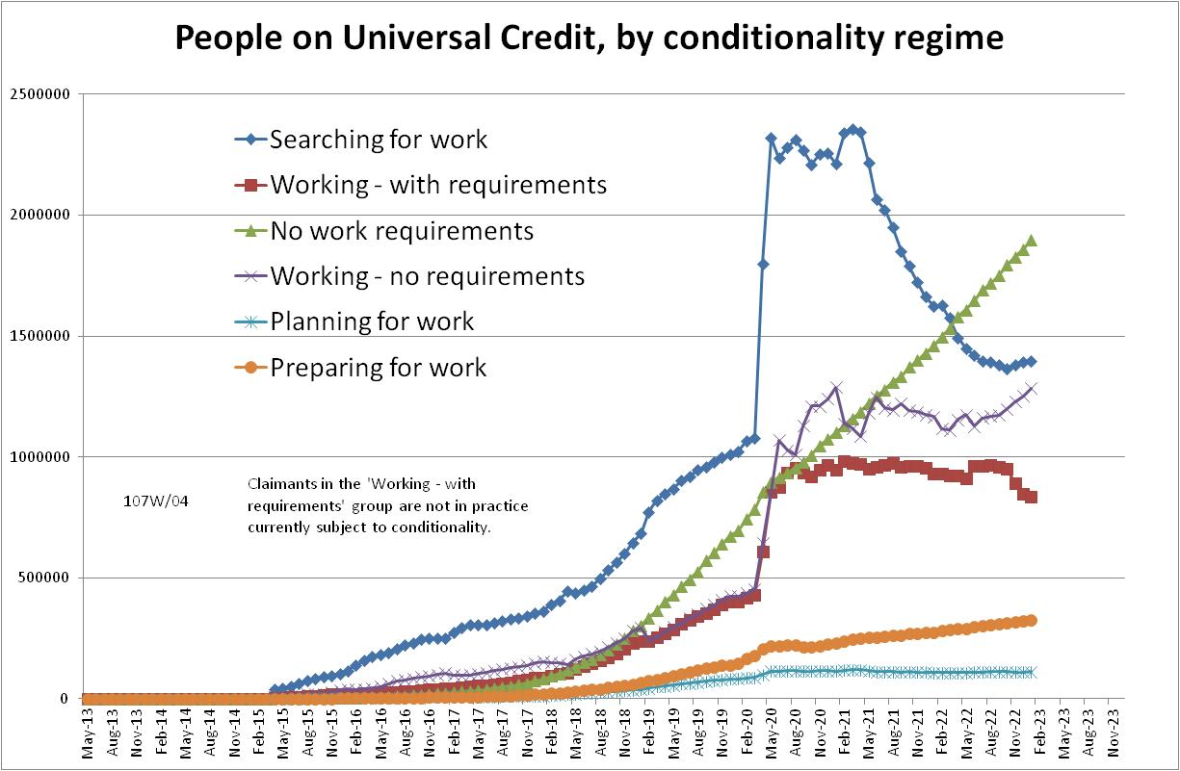

Figure 2
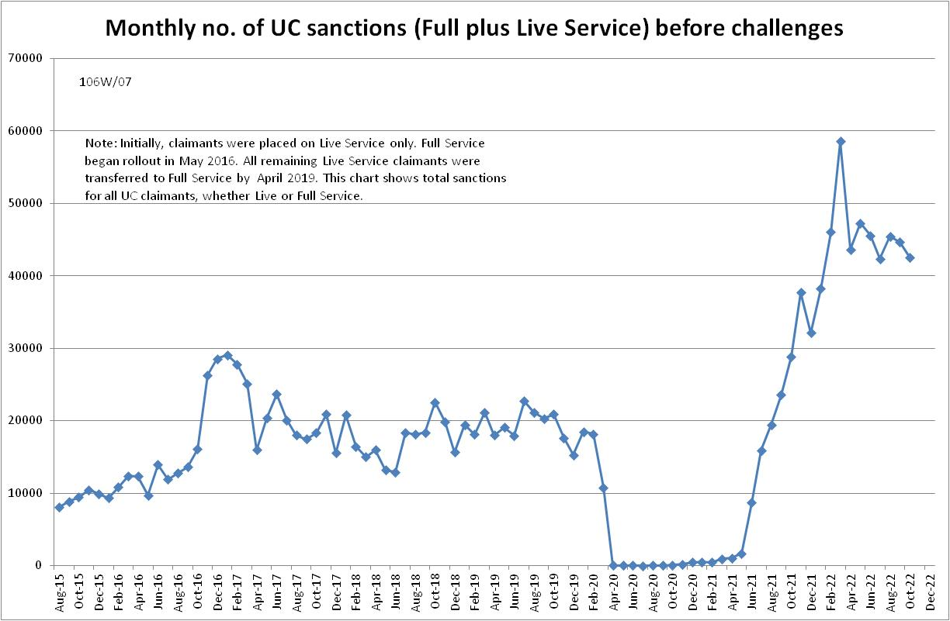

Figure 3
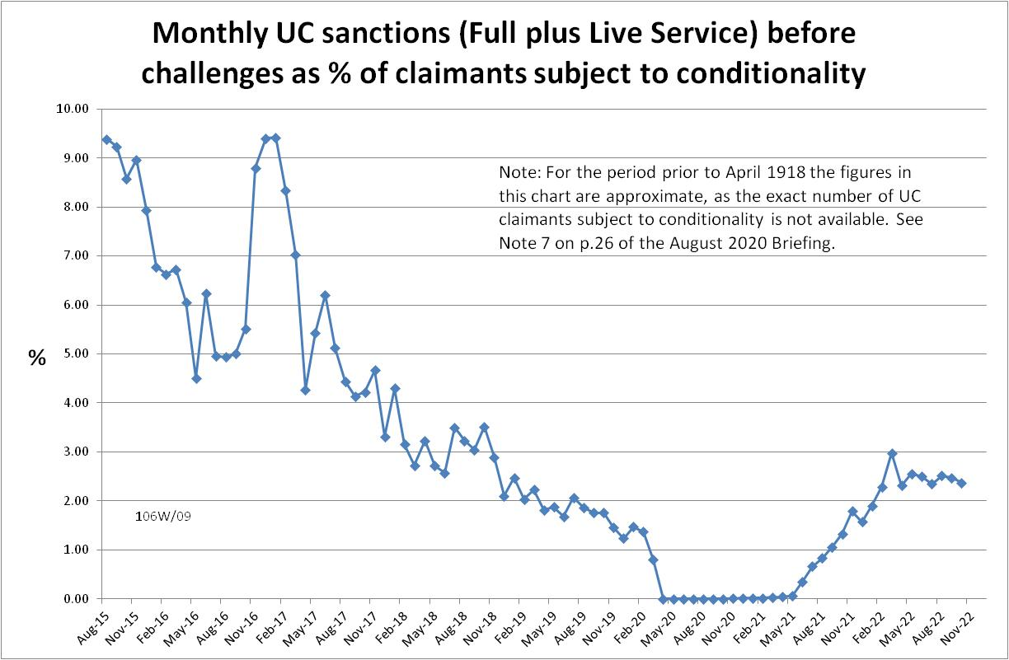
Figure 4
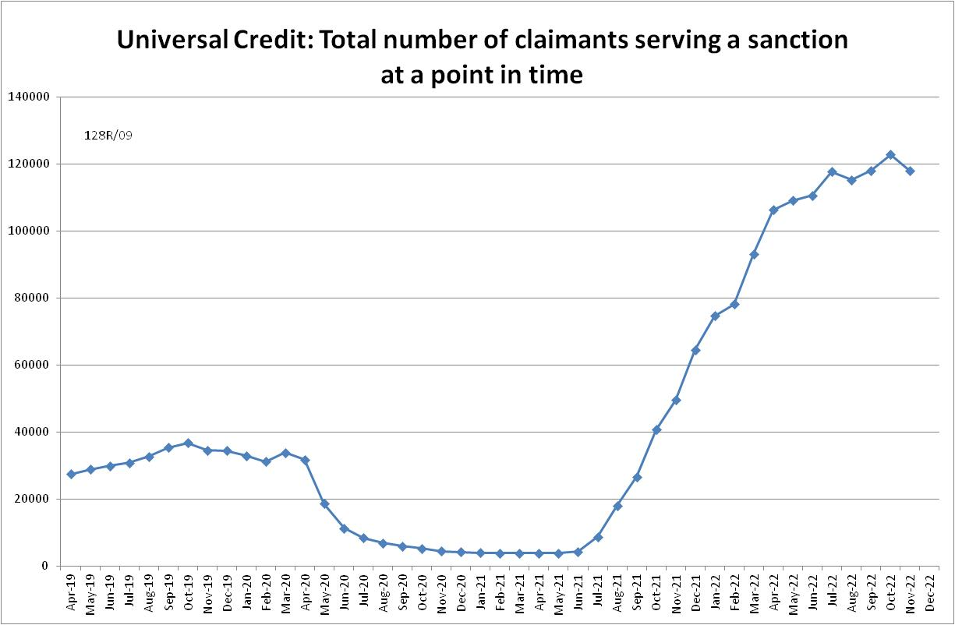

Figure 5
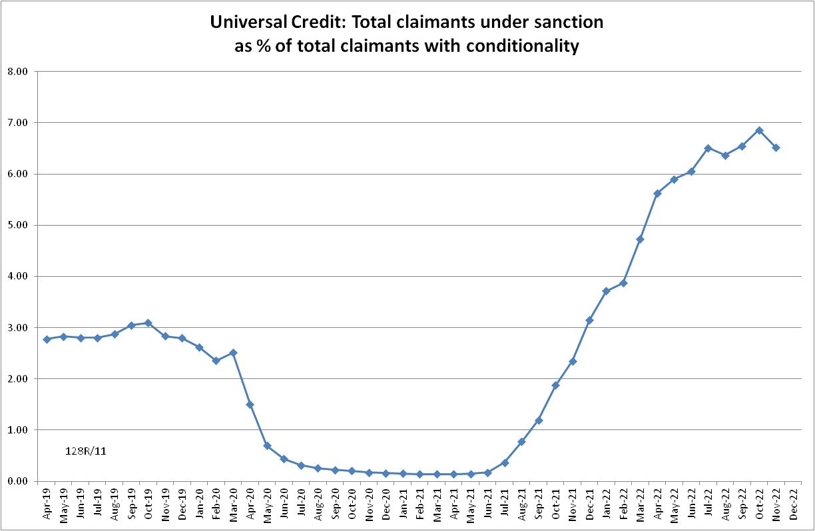

Figure 6
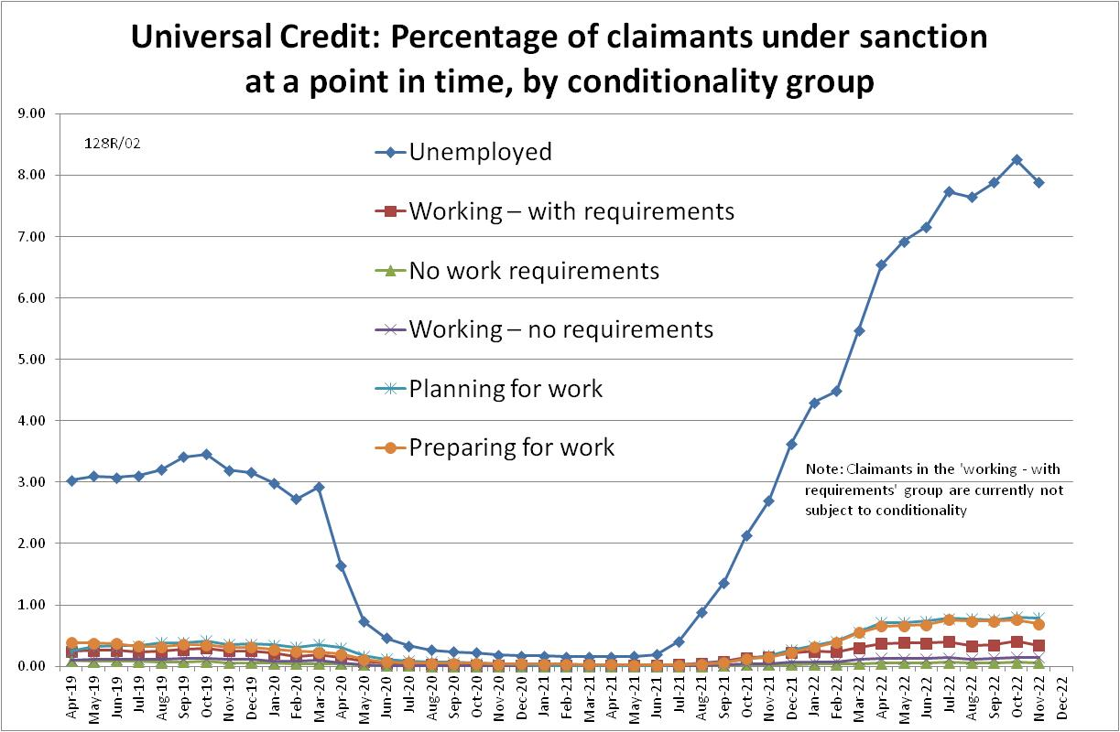

Figure 7
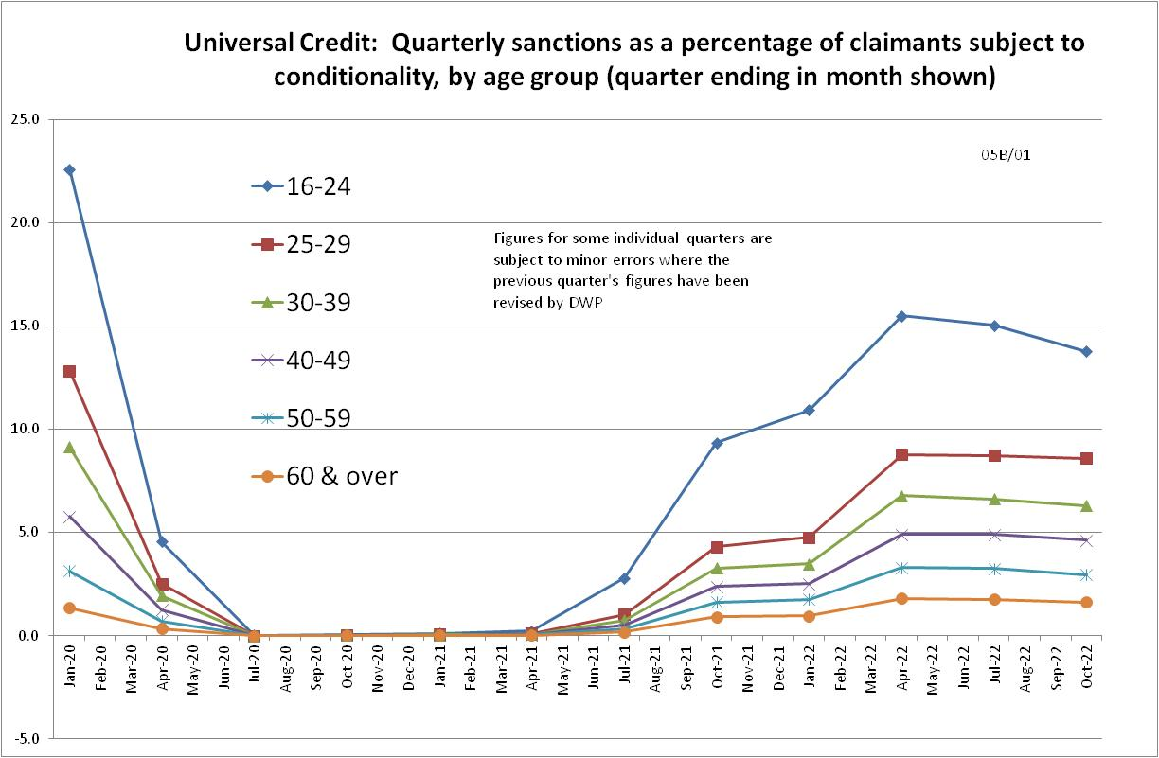

NOTES

Previous Briefings include many analyses that are not repeated here but remain valid. However it should be remembered that the DWP may have made subsequent revisions to the data reported in earlier Briefings. These revisions will generally not be major although there are exceptions. There may also often be substantial changes in some figures for the most recent few months.
A DWP report on the progress of managed migration (DWP 2023) states that the final migration of claimants from old-style JSA to UC may not be completed before the end of 2024/25. Old-style JSA is already closed to new claimants.
Throughout the Briefing, the term ‘claimants subject to conditionality’ refers only to those actually subject to conditionality, i.e. it currently excludes UC claimants in the ‘working-with requirements’ group, who according to the legislation are subject to conditionality but in practice are currently not. In its published statistics, DWP is now following the same practice. This position will change when ‘in-work conditionality’ is introduced, apparently from the end of March 2023.
The drawbacks of the ‘claimants under sanction at a point in time’ measure were discussed in the November 2017 issue of the Briefing, pp.6-10. In November 2020, DWP withdrew the UC ‘rate’ data for all months prior to April 2019, pending revision of the figures for the former ‘Live Service’. These figures remain withdrawn. In addition, in the February 2021 release DWP made significant revisions to the figures for April 2019 onwards (which are for Full Service only, there being no one left on the former Live Service). These were fully discussed in the February 2021 Briefing.
Currently available figures for the number of UC claimants under sanction only go back to April 2019 as DWP has withdrawn the figures for earlier dates. But the numbers previously published by DWP for the period before April 2019 are so far below those in 2022 that no conceivable revisions could made them higher than in 2022.
Welfare Reform and Work Act 2016

