BRIEFING

Benefit Sanctions Statistics

August 2022

24 August 2022

Dr David Webster
Honorary Senior Research Fellow
Urban Studies
University of Glasgow

Email david.webster@glasgow.ac.uk

Webpages: http://www.gla.ac.uk/schools/socialpolitical/staff/davidwebster/
http://www.cpag.org.uk/david-webster

SUMMARY

This Briefing reports on the benefit sanctions statistics released by DWP on 16 August. There has been no improvement in the coverage of the statistics and the figures for Universal Credit (UC) remain very inadequate. There is increasing evidence of a deliberate DWP policy of minimising the release of information.

UC sanctions have continued to rise rapidly. In the latest quarter, to end-April 2022, the average monthly number of UC sanctions imposed was almost 50,000 (49,449), up from 36,018 in the previous quarter. This is almost three times the average in the last full three months before the pandemic (to February 2020), which was 17,295. UC sanctions have also continued to rise as a percentage of UC claimants subject to conditionality, to an average of 2.5% per month in the quarter to April 2022. This compares with 1.75% in the previous quarter, and is the highest monthly rate since November 2018.

The number of UC claimants who were serving a sanction at a point in time also continues to rise rapidly. By May 2022 it reached 109,506. This is three times the pre-pandemic peak of 36,734 in October 2019. The percentage of UC claimants subject to conditionality who were serving a sanction at a point in time was also well above the pre-pandemic peak, at 5.93% in May 2022 compared to 3.1% in October 2019.

Unemployed (‘searching for work’) UC claimants were far more likely to be sanctioned than the other two groups subject to conditionality, with 100,735 or 6.95% (one in 14) under sanction in May 2022 compared to about 0.7% for the others. At this date an unemployed UC claimant was, roughly, more than three times as likely to be serving a benefit sanction as to have Covid. In May 2022 there were also over 6,000 (6,079) people in the UC groups not subject to conditionality who were still serving sanctions imposed on them previously.

Almost all UC sanctions (98.75% in the latest quarter to April 2022) are now said by DWP to be for ‘Failure to attend or participate in a Work-Focused Interview’. This contrasts with 87.5% in November 2019-January 2020 (the last full quarter before the pandemic). It seems likely that this category of reason is now being used to include cases where claimants have attended and participated in interviews but have not done the work search or other activities required by their Work Coach.

From the beginning of the pandemic and up to the end of April 2022, there continue to be very few sanctions on claimants of JSA, with a total of 29 in the latest quarter. There continue to be none at all on claimants of ESA or on non-lone parent claimants of Income Support. In the latest quarter there were also no sanctions on lone parent claimants of IS.

The latest reported rate of sanctioning would produce 593,000 sanctions on all benefits in a full year. This would be the highest number since 2014, and higher than in any year under the previous Labour government, as far back as statistics are available in their present form.

The government claims that its ‘Way to Work’ campaign has got 500,000 people into work in the five months February to June, but the available evidence suggests that this cannot be true. The Office for Statistics Regulation has reprimanded ministers and DWP over their claims.

The news section at the end of the Briefing reports on recent developments related to sanctions, including the planned increase in the UC AET on 26 September.
BRIEFING: Benefit Sanctions Statistics
August 2022

The DWP released its latest quarterly benefit sanctions statistics on 16 August. The newly published data are summarised by DWP in the online publication Benefit Sanctions Statistics, available along with methodological notes at https://www.gov.uk/government/collections/jobseekers-allowance-sanctions together with a spreadsheet with summary tables. Some data are on Stat-Xplore at https://stat-xplore.dwp.gov.uk/webapi/jsf/login.xhtml . All statistics presented here relate to Great Britain. All previous Briefings are available at http://www.cpag.org.uk/david-webster .

There has been no improvement in the coverage of the statistics and, six years on from the start and three years on from the completion of its full service rollout, the figures for Universal Credit (UC) remain very inadequate. Apart from the odd Freedom of Information response DWP has never published any data at all on UC mandatory reconsiderations and appeals. Figures on the duration of UC sanctions remain suspended due to methodological problems. Most data on UC sanctions are still being published in the form of ad hoc tables, rather than being available on Stat-Xplore. This means that analyses such as cross tabulations are not possible.

Previously the reason given for the delay in publishing a full suite of figures for UC was the need to validate them before release. But nothing has been said about the progress of validation and there is now increasing evidence of a deliberate DWP policy of minimising the release of information. In a response dated 15 July https://committees.parliament.uk/publications/23182/documents/169468/default/
to a letter from the Chair of the House of Commons Work and Pensions Committee dated 15 June https://committees.parliament.uk/publications/22665/documents/166571/default/, the Secretary of State stated her refusal to publish seven different reports or items of information. In relation to statistics on Work Capability Assessments for UC claimants, she specifically stated ‘While we will keep this position under review, I anticipate there will be fewer resources available and I am not committing to developing new statistics at this time’. The statement on WCA statistics was repeated by the junior minister Chloe Smith to the Work and Pensions Committee on 20 July, Q460-1. My own appeal against the Secretary of State’s refusal to release the DWP’s study on the effectiveness of benefit sanctions under Freedom of Information is still in the queue with the Information Commissioner (see the Briefing, February 2022 p.8 and May 2022 p.11). The Observer reported on DWP’s withholding of information on 14 August at https://www.theguardian.com/society/2022/aug/14/british-minister-accused-of-trying-to-hide-reports-on-impact-of-tory-welfare-reforms

In its publication Universal Credit statistics: background information and methodology, at https://www.gov.uk/government/publications/universal-credit-statistics-background-information-and-methodology/universal-credit-statistics-background-information-and-methodology , DWP now says ‘Only a limited range of statistics (on UC) is available. These will be added to as more claimants move onto Universal Credit, more is learned about the data, new methodologies developed and new data sources become available.’ This does not make any specific commitment at all.

Number of people on Universal Credit (UC) and ‘legacy’ benefits and number subject to conditionality

The total number of people on UC has changed little since the beginning of the pandemic. It was a provisional 5.67m in July 2022, almost exactly the same as in October 2020. But the composition in terms of conditionality regime has changed considerably (Figure 1). The ‘searching for work’, i.e. unemployed, group has fallen by 902,000 from its initial peak of 2.32m in May 2020, reaching 1.42m in July 2022. The ‘no work requirements’ group, i.e. sick, disabled and some carers, has risen by almost the same amount, 912,000, from 0.78m at the beginning of the pandemic in March 2020 to 1.69m in July 2022. The ‘preparing for work’ group, i.e. mainly the equivalent of the ESA Work-Related Activity Group (WRAG), has seen a modest rise of 124,000 between March 2020 and July 2022, while the other groups have seen little change. The net result has been a considerable fall in the number of UC claimants subject to conditionality, from 2.65m in May 2020 to 1.83m in July 2022. The proportion of UC claimants subject to conditionality was just under one third (32.3%) in July 2022, compared to one half (50.4%) in May 2020 and four-fifths (82.4%) when these statistics began in April 2015.

DWP announced on 25 April that ‘managed migration’ to UC of existing ‘legacy benefit’ claimants would restart on 9 May. Its plans are set out in DWP (2022a). The majority of the 2.6m claimants to be migrated are not currently subject to conditionality, so the effect is likely to be that the proportion of UC claimants subject to conditionality will continue to fall, unless offset by a rise in unemployment in the predicted forthcoming recession. The Child Poverty Action Group published a blog setting out some of the problems with managed migration on 4 July (Stevens 2022), and the Social Security Advisory Committee has also drawn attention to problems in its report on the migration (SSAC 2022).

The numbers of people claiming ‘legacy’ benefits and subject to conditionality are now relatively small. At July 2022 there were 94,670 claimants of JSA, and at February 2022 there were 181,064 people in the ESA WRAG, an estimated 75,500 lone parents on Income Support and subject to conditionality, and 96,040 other claimants of Income Support (IS). As a result, in April 2022 there were an estimated 450,000 claimants on legacy benefits and subject to conditionality, making a total estimated number of claimants on all benefits subject to conditionality in that month of 2.33m.

Universal Credit sanctions have continued to rise rapidly

Number of UC sanctions being imposed per month

UC sanctions have continued to rise rapidly from their lows during the pandemic. In the latest quarter, to end-April 2022, the average monthly number of UC sanctions imposed was almost 50,000 (49,449), up from 36,018 in the previous quarter. This is almost three times the average in the last full three months before the pandemic (to February 2020), which was 17,295.

Monthly UC sanctions as a percentage of UC claimants subject to conditionality

UC sanctions have also continued to rise as a percentage of UC claimants subject to conditionality (Figure 2). The monthly average of 49,449 for the latest quarter equates to 2.5% per month of UC claimants subject to conditionality. This compares with 1.75% in the previous quarter, and is the highest monthly rate since November 2018. In the three months immediately preceding the pandemic, i.e. December 2019 to February 2020, it was 1.4% per month.

However the overall rate for UC puts together different categories of claimant with very different rates of sanctioning – unemployed, sick/disabled and those with caring responsibilities. The rate for unemployed claimants (‘searching for work’) is higher than for the other conditionality groups. From the figures for the proportion of claimants serving a sanction at a point in time (see below), and on the assumption that the duration of sanctions is similar for the different categories, the monthly rate of sanction on unemployed claimants in April 2022 would be approximately 2.7%.

UC claimants serving a sanction at a point in time

Number of UC claimants serving a sanction at a point in time

The number of UC claimants who were serving a sanction at a point in time also continues to rise rapidly. Figure 3 shows the number of UC claimants who were serving a sanction at the measurement date in each month. By May 2022 it reached 109,506. This is three times the pre-pandemic peak of 36,734 in October 2019.

Percentage of UC claimants subject to conditionality who were serving a sanction at a point in time

Figure 4 shows the same data as a percentage of UC claimants subject to conditionality. This percentage is also well above the pre-pandemic peak, at 5.93% in May 2022 compared to 3.1% in October 2019. The difference is less spectacular than for the simple numbers because there are now many more UC claimants subject to conditionality. But the rate of increase is very fast – in February 2022 the percentage was 3.9%.

UC claimants serving a sanction at a point in time by conditionality group

Figure 5 shows the percentage of UC claimants subject to each individual conditionality regime who were serving a sanction at the measurement date in each month. As usual, unemployed (‘searching for work’) claimants were far more likely to be sanctioned than the other two groups subject to conditionality, with 100,735 or 6.95% under sanction in May 2022 compared to 0.72% for ‘planning for work’ and 0.66% for ‘preparing for work’. However, all three groups are showing rapid increases. One in 14 unemployed UC claimants was under sanction in May 2022. At this date about 2% or one in 50 of the GB population had Covid, so, roughly speaking, an unemployed UC claimant was more than three times as likely to be serving a benefit sanction as to have Covid.

There are also people in the groups not subject to conditionality who are serving sanctions. That is because under UC, sanctioned claimants are made to serve out the whole of their sanction even if they move into a no-conditionality group, for instance because of illness. Their numbers were over 6,000 (6,079) in May 2022, mainly (3,570) in the ‘working – with requirements’ group, who are the most likely to have recently been unemployed and therefore to have been sanctioned.

Reasons for UC sanctions

Almost all UC sanctions (98.75% in the latest quarter to April 2022) are now said by DWP to be for ‘Failure to attend or participate in a Work-Focused Interview’. This contrasts with 87.5% in November 2019-January 2020 (the last full quarter before the pandemic).
This does not seem to accurately reflect what is happening on the ground. ‘Way to Work’ was introduced at the end of January, involving greater restrictions on claimants’ choice of jobs to apply for, and a parliamentary answer on 25 May included the statement ‘We are providing more time for new claimants with their Work Coach and delivering a renewed focus on moving claimants into work through more rigorously applying agreements made in claimant commitments’ (see May 2022 Briefing, p.10). These changes would be expected to produce more sanctions in the category ‘availability’, since according to Stat-Xplore, ‘Fail to apply for a job’, ‘Fail to comply with a work preparation requirement’, ‘Fail to undertake all reasonable work search activity’ and ‘Fail to undertake particular, specified Work Search action’ are all classed under ‘availability’. But Figure 6 shows that virtually all sanctions continue to be in the ‘interview’ category.
I have attempted to get clarification from DWP on this point but without success. It seems likely that the reason ‘Failure to attend or participate in a Work-Focused Interview’ is now being used to include cases where claimants have not done the work search or other activities required by their Work Coach.

Sanctions – Other benefits

From the beginning of the pandemic and up to the end of April 2022, there continue to be very few sanctions on claimants of JSA, with a total of 29 in the latest quarter. There continue to be none at all on claimants of ESA or on non-lone parent claimants of Income Support. In the latest quarter there were also no sanctions on lone parent claimants of IS.

Sanctions – All benefits

Figure 7 compares what the total annual number of sanctions on all benefits would be if the April 2022 rate was to continue, with the annual numbers in earlier years. This shows that the latest reported rate of sanctioning would produce 593,000 sanctions in a full year. It also shows that this would be the highest number since 2014, and higher than in any year under the previous Labour government, as far back as statistics are available in their present form.

The ‘Way to Work’ campaign: what effect did it really have?

The government’s ‘Way to Work’ campaign was extensively discussed in the May 2022 Briefing, pp.7-10. As noted above, the statistics on reasons for UC sanctions do not suggest that ‘Way to Work’ has had any effect on the numbers of sanctions. Also, Figures 2 to 6 do not show any change of trend in numbers of sanctions that might be associated with the start of Way to Work at the end of January.
There has also been controversy about whether Way to Work has had any effect on the labour market. The government claimed on 30 June at https://www.gov.uk/government/news/half-a-million-benefit-claimants-get-jobs-in-under-6-months that ‘Over 500,000 jobseekers have been supported to find work through their jobcentre as government meets its target, helping to grow the economy. Benefit claimants moved into work at a record rate in April 2022 as part of the “Way to Work” drive....... Launched in January, ministers set the target of supporting 500,000 jobseekers through the jobcentre and into employment by the end of June’. Boris Johnson was quoted as saying ‘In less than six months we’ve helped half a million people - who have so far been struggling to find employment - into work. This is a massive success, especially in the context of some of the global economic pressures we’ve been facing’ and the Secretary of State for Work and Pensions, Thérèse Coffey said: ‘When people needed jobs and the economy needed workers, we stepped up our efforts to connect jobseekers with employers and have delivered on our target to get 500,000 more people into work in less than six months.’
The government has not produced any figures which would substantiate these claims, but asserts that they are based on unpublished management information. Published information casts doubt on them. For instance, Figure 1 shows a slackening of the rate of reduction in unemployed claimants of UC during the period covered by Way to Work.
There are specific ONS data on moves from unemployment into employment, both as defined by the Labour Force Survey (LFS). These were considered in an Observer article on 20 August by James Tapper, at https://www.theguardian.com/politics/2022/aug/20/boris-johnson-way-to-work-jobs-scheme-failure They also undermine the government claims.
Figure 8 shows the seasonally adjusted quarterly gross flow from unemployment to employment as recorded by the Labour Force Survey, back to 2001. This shows that flows for these 3-month periods are always in the region of 500,000, so 500,000 over a 5-month period is nothing special. Also, James Tapper points out that on these figures, 867,310 people moved from unemployment to employment from January to June, while in the previous six months, 1,015,954 people moved into work, and the average figure for January to June since records began in 2001 is 948,000.

Unemployment as defined by the LFS is not the same as claimant unemployment, since it includes people who are not claimants, for instance many married women moving into work, and who have no contact with the Jobcentre. But there is a very large overlap between the two measures: most people unemployed on the LFS definition are claimants, and vice versa. It is difficult to see how these LFS figures can be reconciled with the government claims about Way to Work. It is certain that nothing like 500,000 moves into employment can be attributed to Way to Work, and the programme may have had no effect at all.
Complaints were made to the Office for Statistics Regulation about the DWP’s claims, and the OSR’s response dated 28 July is at https://osr.statisticsauthority.gov.uk/correspondence/ed-humpherson-to-peter-schofield-department-for-work-and-pensions-dwp-way-to-work-target-and-use-of-figures-by-government/ It concluded ‘when management information is used publicly to inform Parliament, the media and the public, it should be published in an accessible form, with appropriate explanations of context and sources...... there is no clear explanation of how the Way to Work target was defined, how it would be measured, and the methods used to support claims ..... that the target has been reached..... Measuring government programmes in a robust and transparent way is important and the statistics/data underpinning any measurement should uphold principles of being trustworthy, of high quality and offer public value. The way the Department has communicated information in this case does not uphold these principles...... DWP should set out plans for more formal, structured reporting of statistics related to this programme in line with the Code of Practice for Statistics, for example, publishing a DWP ad hoc statistical release.’

SANCTIONS - OTHER DEVELOPMENTS

Raising of the Universal Credit Administrative Earnings Threshold from 26 September

The UC ‘administrative earnings threshold’ (AET) is the level of earnings below which a claimant without accepted limitations on their capacity for work is classed as ‘searching for work’ and put into the ‘intensive work search’ regime, and above which they are classed as ‘working – with requirements’ and are in the ‘Light Touch’ regime, which currently does not feature conditionality. The AET is currently set at a level equivalent to 9 hours’ work a week for an individual on the National Minimum Wage.

On 5 August DWP announced that the AET will be raised on 26 September to the equivalent of 12 hours’ work a week at the National Minimum Wage for a single person, and 19 hours for a couple. An ad hoc statistical release (DWP 2022b) gave a calculation that about 114,000 UC claimants will be moved into the intensive work search regime as a result. The Regulations legislating for the change were laid on 4 August: Statutory Instrument 2022 No. 886 Social Security: The Universal Credit (Administrative Earnings Threshold) (Amendment) Regulations 2022, at https://www.legislation.gov.uk/uksi/2022/886/made

On 26 July Rishi Sunak issued a press release saying that if he became Prime Minister he would raise the 12 hours’ work a week further, to 18 hours, thus doubling the present threshold. But this does not currently seem likely to happen. It would require additional Jobcentre staff.

In the statistical release, DWP states that ‘Since its introduction in 2013, the AET has not kept pace with the increases in the National Living Wage, with the result that the number of hours needed to work to earn the AET has fallen over time. The adjustment will bring the AET back to its original ‘parity’ with the National Living Wage.’ Some mechanism such as the AET is unavoidable if unemployed people are to be allowed to do any part time work, and there does not seem to be any particular reason to challenge DWP’s position on this, albeit it will bring more people under conditionality. It is the nature of the conditionality which is the key issue. The Regulations have been drafted in such a way that in future, the AET will automatically rise in line with the National Minimum Wage.

Following indifferent results from its ‘In-work progression trial’ (see Briefings, November 2019 p.10 and November 2018 pp.11-12), DWP has not to date pursued the idea of conditionality for people above the AET. A comment in the DWP statistical release suggests that this might be about to change. It states ‘From September this year, DWP will be developing a new labour market regime for Light Touch that will enable Light Touch claimants to access support through the Jobcentre Plus.’

Work & Pensions Committee calls for pause to deductions from benefits

In its Cost of Living report on 27 July (House of Commons 2022, pp.37-8) the Work and Pensions Committee notes the hardship being caused to already struggling households by deductions from benefits. It comments that ‘The Government has urged creditors to accept reduced monthly payments or write off debts, but isn’t following its own advice’. It recommends that deductions are paused, and then only restored gradually as the rate of inflation reduces, or when benefits have been uprated to reflect the current rate of inflation. The report does not list all types of deductions, but they include repayments of sanction hardship payments. Data on hardship payments and repayments were presented in the previous Briefing, May 2022 pp.5-6 and Figures 7-9.

Citizens Advice Scotland: Advice on UC sanctions has grown by 53% over 2021-22

A new report (Scott 2022) indicates that in the Scottish Citizens Advice network, advice on UC sanctions has grown by 53% over 2021-22. It comments that ‘Without access to the internet, people risk having their UC sanctioned, which can plunge them into real crisis. CAB often see clients who were sanctioned because they could not afford internet access to
update their UC journal or could not afford to pay to travel to their Jobcentre for an interview with their work coach. This leaves them with next to no income for the duration of the sanction, pushing them into poverty, debt, and mounting arrears’. It quotes the case of a claimant whose phone was damaged in an accident. He prioritised repairing the phone because he feared that his benefits would be sanctioned if he could not access his UC journal via his phone. This left him without food. CAS recommends suspending the use of sanctions until the cost of living crisis is over.

Institute for Fiscal Studies: Annual Report on Living Standards, Poverty and Inequality

This report, funded by the Joseph Rowntree Foundation, was published on 14 July. One of the findings is that in the year prior to the pandemic, nearly half (49%) of children in lone-parent families were in relative poverty – defined as having an income of less than 60% of median incomes adjusted for household size. This is almost double the rate among children living in two-parent families (25%).

The major role of sickness in shrinking the UK labour force

While ministers and the DWP choose to focus on getting unemployed but economically active people into work, two recent papers underline the major role played by sickness in the recent shrinkage of the labour force: Burn-Murdoch (2022) and Haskel and Martin (2022).

Burn-Murdoch points out that the UK is the only developed country in the world where the share of working-age people outside the labour force has kept rising after the initial pandemic shock. He argues that the most plausible explanation is the collapse of the NHS, as hundreds of thousands of patients, unable to access timely care, see their condition worsen to the point of being unable to work. The 332,000 people who have been waiting more than a year for hospital treatment in Britain is a close match for his estimate of 309,000 missing from the labour force due to long-term sickness.

Torsten Bell of the Resolution Foundation drew attention to the Haskel and Martin paper in the Observer of 31 July, at https://www.theguardian.com/commentisfree/2022/jul/31/britains-epidemic-of-long-term-sickness-can-only-lead-to-poor-outcomes-all-round. They
argue that if you look at the increase in who reports being long-term sick, whether or not they say it is their primary reason for being inactive, it explains almost all (88%) of the around half a million rise in inactivity since the pandemic.

New book: The Transformation of British Welfare Policy
A new book (O’Grady 2022) considers the reasons why UK social security policy has become so ungenerous and often punitive and why this has been popular with the public. It has been reviewed in an LSE blog by Orly Siow at

https://blogs.lse.ac.uk/lsereviewofbooks/2022/05/05/book-review-the-transformation-of-british-welfare-policy-politics-discourse-and-public-opinion-by-tom-ogrady/

REFERENCES

Burn-Murdoch, John (2022) ‘Chronic illness makes UK workers sickest in developed world’, Financial Times, 22 July p.22

Cribb, Jonathan, Tom Waters, Thomas Wernham and Xiaowei Xu (2022) Living standards, poverty and inequality in the UK: 2022 Report, Institute for Fiscal Studies, at
https://ifs.org.uk/publications/16124

DWP (2022a) Completing the Move to Universal Credit: Our 2022-24 strategy for implementing the final phase of Universal Credit, April, at
https://assets.publishing.service.gov.uk/government/uploads/system/uploads/attachment_data/file/1076130/completing-the-move-to-universal-credit.pdf

DWP (2022b) Numbers moved to Universal Credit’s Intensive Work Search Regime because of the increase in the Administrative Earnings Threshold, Ad hoc statistical release, 5 August, at https://www.gov.uk/government/publications/numbers-moved-to-universal-credits-intensive-work-search-regime-because-of-the-increase-in-the-administrative-earnings-threshold/numbers-moved-to-universal-credits-intensive-work-search-regime-because-of-the-increase-in-the-administrative-earnings-threshold

Haskel, Jonathan and Josh Martin (2022) Economic inactivity and the labour market experience of the long-term sick, draft Working Paper, at
https://haskelecon.blogspot.com/2022/07/the-rise-in-uk-inactivity-since.html

House of Commons Work and Pensions Committee (2022) The cost of living, Second Report of Session 2022–23, HC 129, 27 July, at
https://committees.parliament.uk/publications/23272/documents/169744/default/

O'Grady, Tom (2022) The Transformation of British Welfare Policy: Politics, Discourse, and Public Opinion, Oxford University Press

Scott, David (2022) The Perfect Storm: Living on Universal Credit during the Cost of Living Crisis, Citizens Advice Scotland, July, at
https://www.cas.org.uk/publications/perfect-storm-living-universal-credit-during-cost-living-crisis

Social Security Advisory Committee (2022) The Universal Credit (Transitional Provisions)
Amendment Regulations 2022 (SI 2022/****): Report by the Social Security Advisory
Committee under Sections 172(1) and Section 174(1) of the Social Security Administration Act 1992 and statement by the Secretary of State for Work and Pensions in accordance with
Section 174(2) of that Act, July, at
https://assets.publishing.service.gov.uk/government/uploads/system/uploads/attachment_data/file/1087706/universal-credit-transitional-provisions-amendment-regulations-2022-print.pdf

Stevens, Owen (2022) Managed migration to Universal Credit – an irresponsible gamble, Child Poverty Action Group, at
https://cpag.org.uk/news-blogs/news-listings/managed-migration-universal-credit-irresponsible-gamble

Figure 1
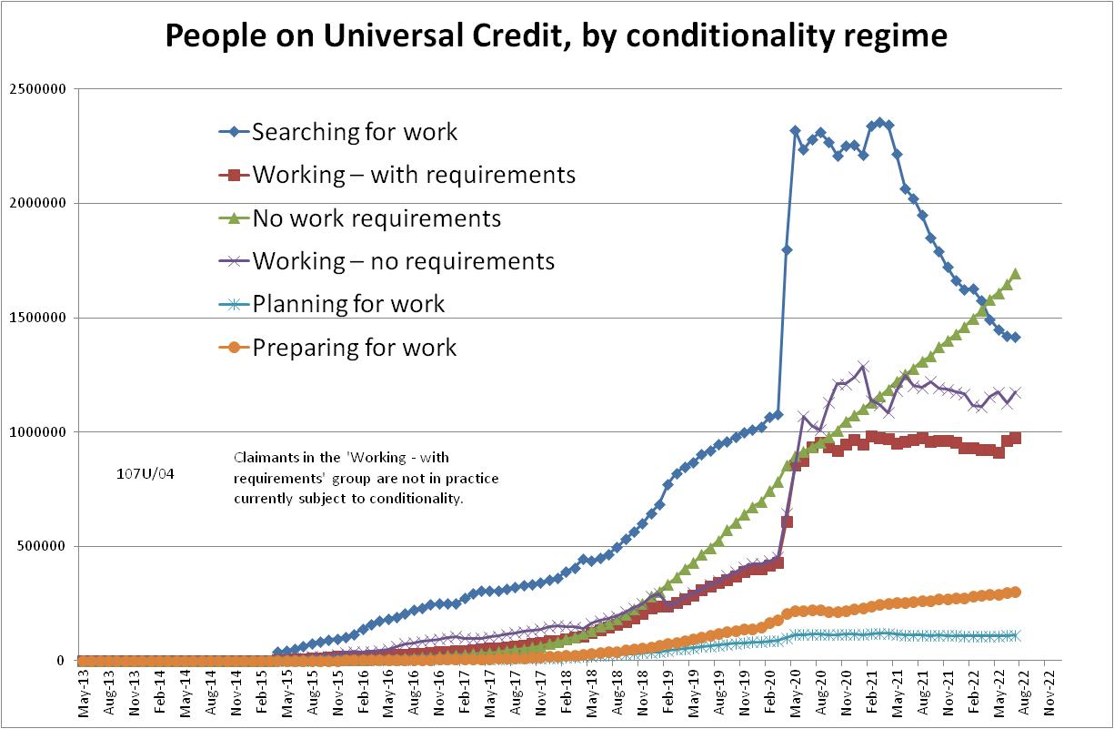

Figure 2
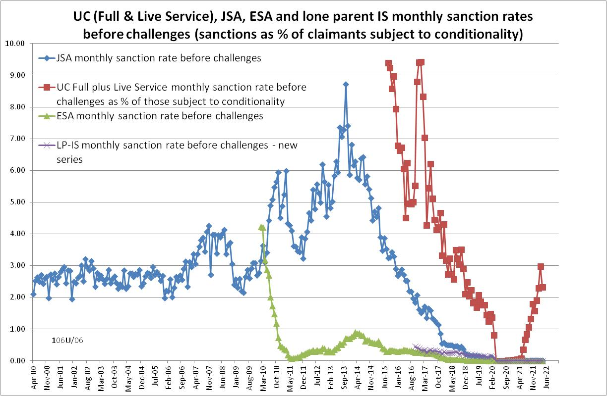

Figure 3
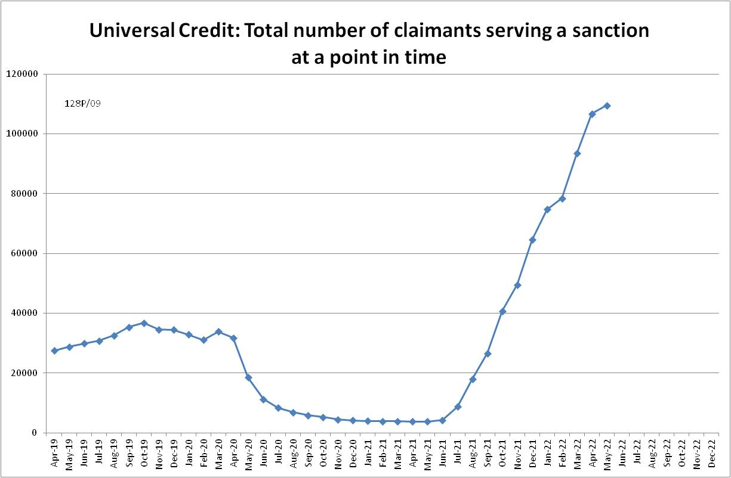

Figure 4
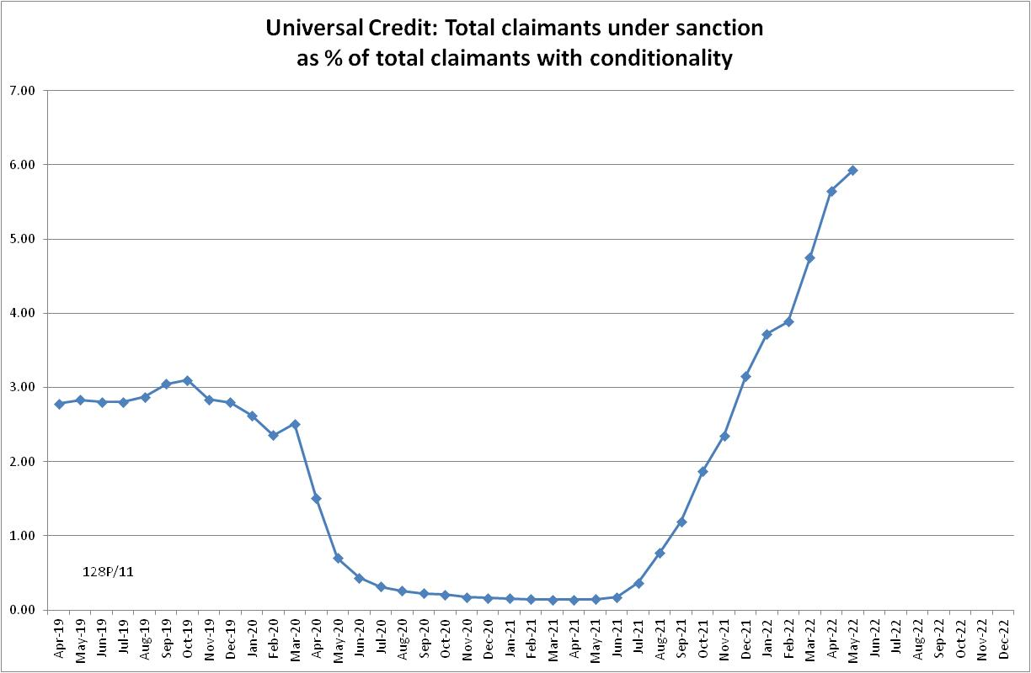
Figure 5
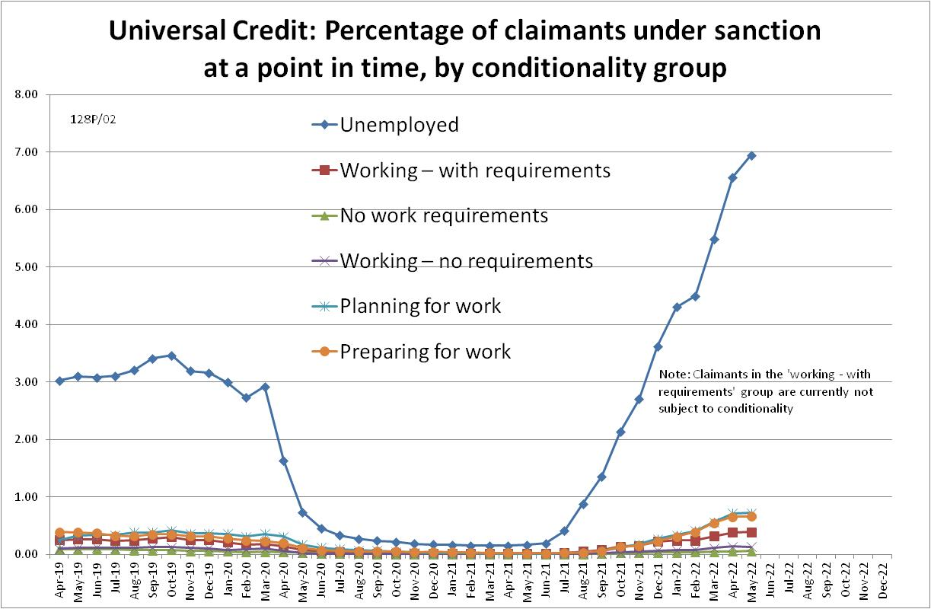

Figure 6
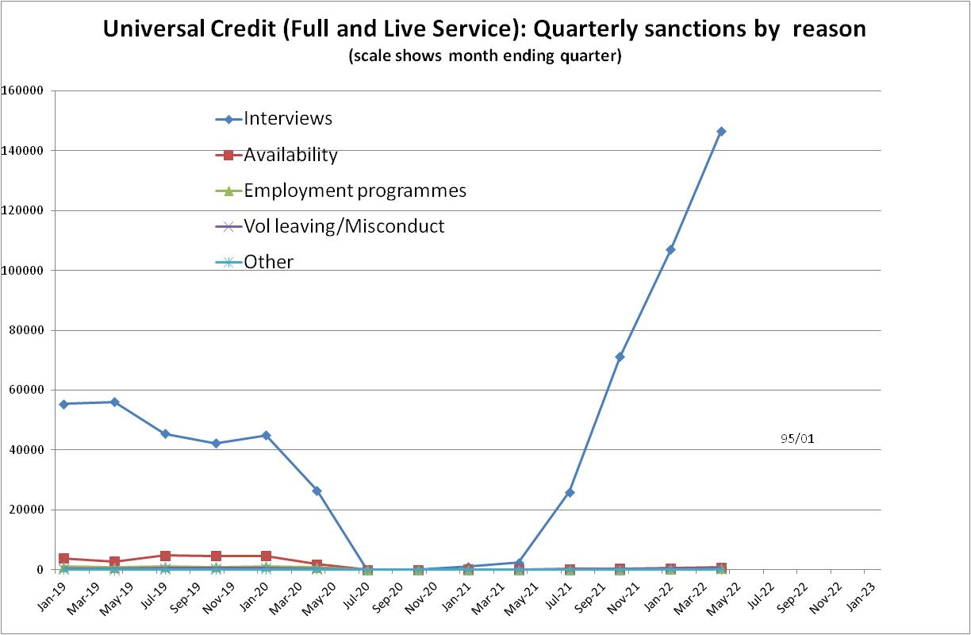

Figure 7
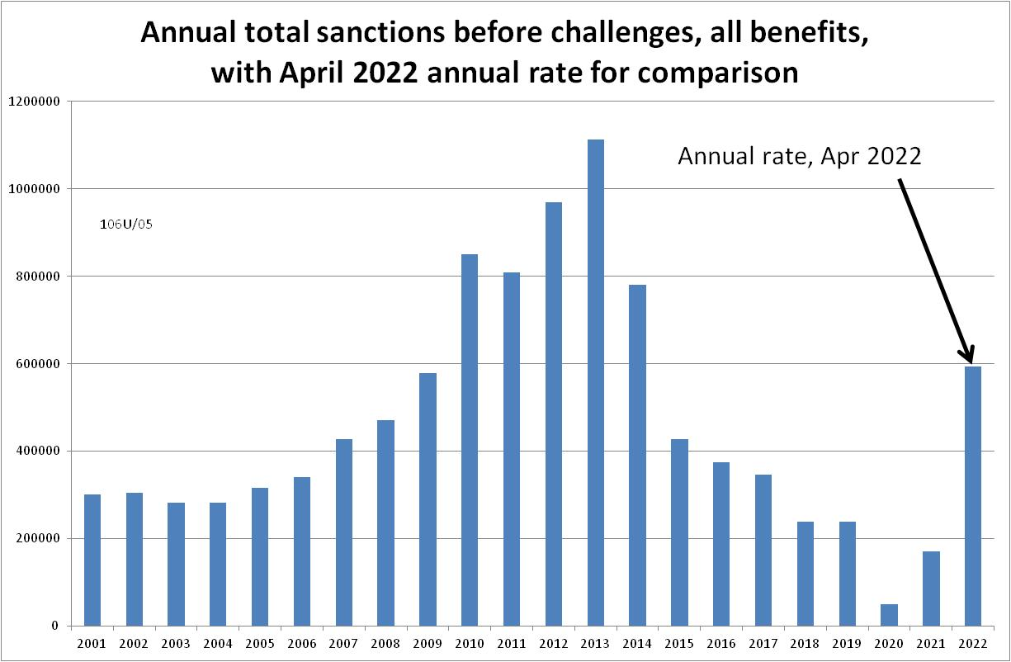
Figure 8
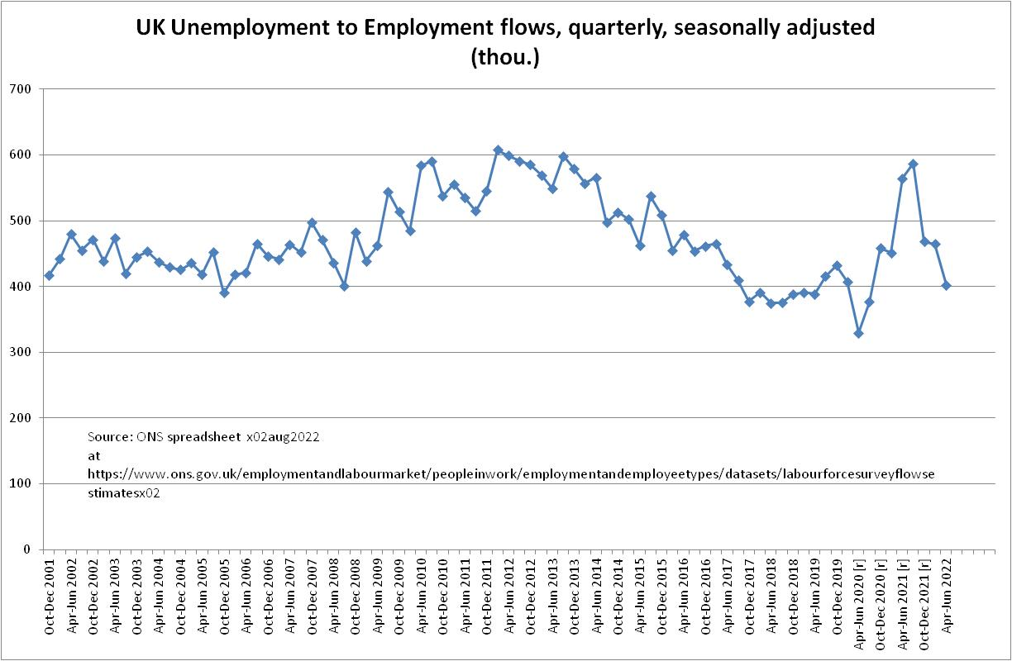

NOTES

Previous Briefings include many analyses that are not repeated here but remain valid. However it should be remembered that the DWP may have made subsequent revisions to the data reported in earlier Briefings. These revisions will generally not be major although there are exceptions. There may also often be substantial changes in some figures for the most recent few months.
https://www.gov.uk/government/news/managed-move-of-claimants-to-universal-credit-set-to-restart
Throughout the Briefing, the term ‘claimants subject to conditionality’ refers only to those actually subject to conditionality, i.e. it excludes UC claimants in the ‘working-with requirements’ group, who according to the legislation are subject to conditionality but in practice are currently not. In its published statistics, DWP is now following the same practice.
As already noted, a similar estimation method used in the February 2022 Briefing (p.4) proved quite accurate. It suggested about 30,000 new UC sanctions for November 2021; the actual figure is now shown to have been 37,701.
The drawbacks of the ‘claimants under sanction at a point in time’ measure were discussed in the November 2017 issue of the Briefing, pp.6-10. In November 2020, DWP withdrew the UC ‘rate’ data for all months prior to April 2019, pending revision of the figures for the former ‘Live Service’. These figures remain withdrawn. In addition, in the February 2021 release DWP made significant revisions to the figures for April 2019 onwards (which are for Full Service only, there being no one left on the former Live Service). These were fully discussed in the February 2021 Briefing.
Currently available figures for this measure only go back to April 2019 as DWP has withdrawn the figures for earlier dates. It is likely that a fuller run of figures would show a higher peak at an earlier date.
ONS Coronavirus (COVID-19) Infection Survey, at www.ons.gov.uk A rigorous comparison of the prevalence of Covid and of UC sanctions would have to make allowance for differences in the age groups covered by the statistics, variations in the prevalence of Covid by area and social group, etc. This has not been done here.

