BRIEFING

Benefit Sanctions Statistics

February 2021

11 March 2021

Dr David Webster
Honorary Senior Research Fellow
Urban Studies
University of Glasgow

Email david.webster@glasgow.ac.uk

Webpages: http://www.gla.ac.uk/schools/socialpolitical/staff/davidwebster/
http://www.cpag.org.uk/david-webster

SUMMARY
This Briefing covers the statistics released by DWP on 23 February, giving sanction decisions up to the end of October 2020.
Almost all new sanctions were officially suspended from March until 1 July due to the coronavirus pandemic. Since the suspension began, and up to the end of October, there have been no new sanctions on Jobseeker’s Allowance (JSA), Employment and Support Allowance (ESA) or Income Support (IS). The picture for Universal Credit (UC) is only slightly different. After falling to single figures in May, June and July, UC sanctions before challenges have risen only slightly, to 18 in August, 47 in September and 102 in October.

Sanctions have continued at these very low levels even after the ending of the suspension for two main reasons: first, DWP has decided that where a claimant commitment is involved, claimants can only be sanctioned if it has been put in place or updated since the pandemic, and it is taking time to work round the whole population of claimants; and second, DWP has introduced new procedures which make it much more difficult and time-consuming for a sanction to be imposed. These procedures are summarised in the Appendix to this Briefing.

The Briefing has always had reservations about the DWP’s statistics on the number of UC claimants under sanction at a point in time. DWP has now issued very significant revisions to these figures, suggesting that they have been overstating the number of claimants under sanction. The impact is greatest for the latest month available, i.e. August 2020. Whereas the DWP’s November release said there were 12,643 UC claimants under sanction in that month, the February release cuts this to 6,949, a reduction of 45%. This means that all the figures for numbers of UC claimants under sanction at a point in time previously published in this Briefing now require revision.

It is concerning that in November 2020 there were still said to be 4,628 UC claimants under sanction. These claimants must have been continuously under sanction for over 7 months. This is a result of the feature of UC that second and subsequent sanctions are served consecutively, rather than concurrently as is the case for JSA and ESA.

Data on the duration of UC Full and Live Service sanctions remain suspended while DWP addresses problems with the methodology.

In a reversal of what had been the position since the mid-1990s, the UK’s official measure of unemployment, based on the Labour Force Survey (LFS), is now showing a much lower number of unemployed people than is the claimant count based on benefit claims. It appears that the official measure may be currently understating unemployment, although the discrepancy does not currently seem to be well understood.

A news section reports other recent developments relating to benefit sanctions. These include important new evidence on public attitudes to sanctions and two new reviews of the international evidence on the impacts of sanctions and of benefit changes more broadly.

BRIEFING: Benefit Sanctions Statistics
February 2021

The DWP released its latest quarterly benefit sanctions statistics on 23 February, taking sanctions data up to the end of October 2020.The new data are summarised by DWP in the publication Benefit Sanctions Statistics, available along with methodological notes at https://www.gov.uk/government/collections/jobseekers-allowance-sanctions together with a spreadsheet with summary tables. The full figures for most aspects of the data are on the DWP’s Stat-Xplore database at https://stat-xplore.dwp.gov.uk/webapi/jsf/login.xhtml All statistics presented here relate to Great Britain.

There is little new information and therefore this issue of the Briefing is short. Fuller information is in previous Briefings, available at http://www.cpag.org.uk/david-webster .

The sanctions moratorium is being ended very gradually

Almost all new sanctions were officially suspended from March until 1 July due to the coronavirus pandemic. Full details of the sanctions suspension, including exact dates, legal basis etc. were given in the June 2020 Briefing, pp.7-8. DWP guidance on the resumption of sanctions was reported in the November 2020 Briefing, pp.3-4.

Since the suspension began, and up to the end of October, there have been no new sanctions or sanction referrals on Jobseeker’s Allowance (JSA), Employment and Support Allowance (ESA) or Income Support (IS), apart from 34 JSA referrals in April and 50 in August, all of which were cancelled. The picture for Universal Credit (UC) is slightly different. As previously reported, UC sanctions fell to single figures in May, June and July 2020. Since then they have risen slightly, to 18 in August, 47 in September and 102 in October. These numbers are too small to project any trend. They are for sanctions before any challenges. DWP is not currently reporting the number of UC sanction referrals, so we do not know how many UC sanction proceedings have been initiated since the end of the suspension.

Sanctions have continued at these very low levels even after the pandemic suspension for two main reasons:

- DWP has decided that where a claimant commitment is involved (which applies to almost all cases), claimants can only be sanctioned if it has been put in place or updated since the pandemic, and it is or has been taking time to work round the whole population of claimants (no information is available on the progress of the updates).
- DWP has introduced new procedures which make it much more difficult and time-consuming for a sanction to be imposed. These procedures are summarised in the Appendix to this Briefing.

Number and proportion of Universal Credit claimants under sanction at a point in time

The DWP’s preferred measure of the scale of sanctions is the proportion of claimants serving a sanction at a point in time (what it calls the ‘rate’). The Briefing has always expressed reservations about this measure, which were explained in the November 2017 issue, pp.6-10. In November 2020, DWP withdrew the UC ‘rate’ data for all months prior to April 2019, pending revision of the figures for Live Service. These figures remain withdrawn, and in addition DWP has now made significant revisions to the figures for April 2019 onwards (which are for Full Service only, there being no one left on Live Service).

The actual numbers of UC claimants under sanction as shown in the pre-revision figures published in November 2020 and in the post-revision figures published in February 2021 are compared in Figures 1 to 4.

The impact of the revisions is greatest in both absolute and proportional terms for the latest month available, i.e. August 2020. Whereas the DWP’s November release said there were a total of 12,643 UC claimants under sanction in that month, the February release cuts this to 6,949, a reduction of 5,694 or 45%. Most of this reduction was in the unemployed or ‘searching for work’ group (3,245 claimants), but although the reductions in the non-conditionality and ‘other’ groups were smaller in absolute terms, they were very large in proportional terms. The stated number of non-conditionality claimants under sanction in August 2020 has been cut by 82.5% and the number in the other groups by 65.7%.

Please note that all the figures for numbers of UC claimants under sanction at a point in time which have been previously published in this Briefing now require revision. However, revisions for dates earlier than April 2019 are currently not available.

Although the numbers of UC claimants stated to be under sanction have been so drastically cut, it is concerning that in November 2020, according to the revised figures, there were still 4,628 UC claimants under sanction. Since there had been virtually no new sanctions since March 2020, these claimants must have been continuously under sanction for over 7 months. This is a result of the feature of UC sanctions that second and subsequent sanctions are served consecutively, rather than concurrently as is the case for JSA and ESA. The most recent figures for these latter two benefits are for June 2020, when there were respectively 11 and 32 claimants under sanction.

Suspension of Universal Credit sanctions duration statistics

Data on the duration of UC Full and Live Service sanctions remain suspended while DWP addresses problems with the methodology.

Groups of claimants exposed to sanctions:
Universal Credit, JSA, ESA and Income Support

Changes to the numbers of people claiming the different benefits have been relatively small since the previous Briefing. At January 2021 there were almost six million (5.969m) claimants of UC, up by 293,000 from 5.676m in October 2020. JSA claimants have fallen slightly from 307,000 in October to 294,000 in January, while the total of claimant unemployed (whether on JSA or UC) has barely changed, from 2.506m in October to 2.516m in January. For claimants in the Work Related Activity Group of ESA, and of IS, the latest available figures are for August 2020. In that month there were 225,000 in the ESA WRAG and 244,000 claimants of IS normally subject to conditionality.

In a reversal of what had been the position since the mid-1990s, the UK’s official measure of unemployment, based on the Labour Force Survey (LFS), is now showing a much lower number of unemployed people than is the claimant count based on benefit claims. Some of the reasons for this are discussed in a paper from the Alliance for Full Employment (AFFE 2021). It appears that the official measure may be currently understating unemployment. One of the reasons for this may be the difficulties created by the large drop in response rates caused by the LFS having to move entirely on-line in the pandemic. Another may be the effect of the LFS requirement that to be unemployed a person must be available for work. So, for instance, unemployed parents (usually mothers), in both couple and lone parent households, with children off from school due to the pandemic but no alternative childcare arrangements, are likely to say they are not available for work, because they are needed for supervision and home schooling, but there will not have been any change in the reality of their unemployment.The USA is also having problems with its official measure of unemployment.

APPENDIX

NEW DWP PROCEDURES AND STAFF GUIDANCE
ON SANCTIONS

There has been no announcement, but via Freedom of Information it has been revealed that DWP has issued a whole series of guidance documents to staff which drastically change sanctions procedures and effectively implement several of the key reforms which commentators have been pressing for.

Sanctions Assurance Framework

The most important of these documents is the Sanctions Assurance Framework, which can be accessed at https://www.whatdotheyknow.com/request/covid19_benefit_sanctions_and_co#incoming-1684665

DWP always used to say that sanctions were a last resort, when they were not, since there were no procedures in place to ensure that they would be. But the new procedures do go some way to making it a reality. In particular:

- The work coach must have a case conference with their team leader before making any referral to a decision maker.The case conference should only be delegated to a deputy if the team leader is unavailable.The team leader must be satisfied that the agreed requirement was appropriate at the time of the ‘failure’ and that all safeguards (including the additional local and national public health guidelines) have been taken into account.
- Before considering a case conference, the work coach must have a discussion with the claimant to identify and understand any barriers or circumstances that may have had an impact on their work-related activities.
- When considering a possible sanction referral, the work coach must gather evidence and review any changes in the claimant’s circumstances, taking into account: complex needs; vulnerabilities; health conditions; and the pandemic. If the work coach feels that the claimant has not taken reasonable steps to search for work, they must gather information about what the claimant has done, and why they have not done more. This information must then be taken into the team leader case conference.
- If, following a referral to a decision maker, the decision maker considers that a sanction is appropriate, then they themselves must hold a case conference between the decision maker and their team leader.

Other useful changes are:

- Work coaches will not be allowed to make local decisions to impose sanctions. This has sometimes been the practice.
- In all cases, subsequent appointments must only be booked by the work coach if contact is established with the claimant. There have been frequent complaints that claimants have been sanctioned for not attending appointments they did not know about.
- The work coach must routinely check their caseload to identify claimants with an open-ended sanction, and make at least monthly attempts to re-engage with them by phone or journal. If contact is made, they must ensure the claimant understands why they have been sanctioned as well as how to bring the sanction to an end, and must advise the claimant on the availability of a Recoverable Hardship Payment.

The requirement for the work coach and their case conference to consider claimants' personal circumstances before making a referral in effect implements the proposals of the Benefit Claimants Sanctions (Required Assessment) Bill unsuccessfully promoted in 2016 by Mhairi Black MP. The double requirement for case conferences must of itself reduce the number of sanctions, simply because of the increased staff time involved. More careful consideration of circumstances will also reduce sanctions.

The requirement for monthly contact with claimants under open-ended sanction is important because it has frequently happened that people, particularly on ESA, have been left on open-ended sanctions for long periods simply due to communication difficulties.

These changes are very welcome but it will be necessary to monitor their impact. It should be borne in mind that they are purely administrative changes, not statutory, and therefore could be reversed as easily as they have been introduced. And for claimants who are sanctioned in spite of the changes, the harshness of the Duncan Smith/Grayling/Freud regime introduced for Universal Credit in 2012 remains unsoftened, apart from the limitation of any individual sanction to 6 months by Amber Rudd in November 2019.

Core Visits - ESA Guidance

DWP has also produced what appears to be much more detailed guidance on safeguards in relation to sanctions or disallowance decisions for ESA claimants. This is available at
https://www.whatdotheyknow.com/request/679640/response/1693401/attach/html/5/Annex%20C.pdf.html It is not clear whether these safeguards also apply to UC or JSA claimants who have had a vulnerability identified.

Further Guidance

A further package of 23 documents containing updated guidance on a whole range of conditionality–related topics is available at
https://www.whatdotheyknow.com/request/work_coach_guidance_and_spotligh#incoming-1716241

There is also a package of 24 documents containing Work Coach training materials at
https://www.whatdotheyknow.com/request/work_coach_new_entrant_learning#incoming-1679940

SANCTIONS - OTHER DEVELOPMENTS

THE SPRING 2021 BUDGET

The £20 per week uplift to Universal Credit will be continued until September. ‘Legacy’ Working Tax Credit claimants will get a one-off £500 tax-free payment. Neither the uplift nor the one-off payment is being extended to claimants on out-of-work ‘legacy’ benefits.

Previously, it was planned that from October 2021, the period over which Universal Credit advances are recovered was to increase from 12 to 24 months, and the maximum rate at which deductions can be made from a Universal Credit award was to be reduced from 30% to 25% of the standard allowance. These changes will now be brought forward to April 2021.

Local Housing Allowance is being frozen again from April, after only a year when a link with rent levels has been restored.

DWP study on the effectiveness of sanctions

There appears to be still no sign of publication of this study, first promised for Spring 2019 and last reported on in the Briefing August 2020 Briefing, p.10.

Deductions from benefit and food bank use

The importance of deductions from benefit, including repayments of sanction ‘hardship’ payments, has been underlined by a Trussell Trust study (Trussell Trust 2020) which showed that almost half (47%) of people using food banks in the last week of June and into July 2020 were in debt to the DWP, while three quarters (73%) of those users who were receiving UC were repaying an Advance Payment at the time they visited a food bank. The news story is at
https://www.trusselltrust.org/2020/12/01/almost-half-of-people-at-food-banks-have-money-taken-by-government-from-benefit-payments-during-economic-crisis/

Gingerbread and StepChange – single parents, debt and food bank use
Underlining the problem of indebtness in the particular case of lone parents is a report from the charities Gingerbread and StepChange (Richardson & Butler 2021). This was based on a voluntary sample of 1,676 single parents between November 2019 and January 2020, and two surveys of representative samples of 500 each of single parents and couple parents, conducted by Savant ComRes, the second of which was in November 2020. Prior to the pandemic, 13% of single parents were in severe problem debt compared to 5% of couple parents. The study found that the main causes of problem debt were a combination of poverty, income insecurity and ‘lumpy’ expenses; financial problems following relationship transitions; economic abuse by a former partner; life shocks; and Covid-19. It found that 66% of single parents had to cut back on food for themselves and 20% on food for their children as a result of making debt repayments; 19% of single parents in problem debt had recently used a foodbank, compared to 12% of those not in problem debt; and 69% of those in problem debt suffered from a mental health issue, compared to 53% for those not in problem debt.

Low income women workers and food bank use

A case study from Sheffield Hallam University (Beatty et al. 2021), undertaken in the period before the coronavirus crisis, takes a multidisciplinary approach to three key questions: are working women resorting to food bank use in times of financial hardship?; to what extent is this a function of non-standard working practices?; and is welfare reform a contributing factor? A three-strand approach is taken: a synthesis of literature, an analysis of national data and in-depth interviews with stakeholders involved with referrals to or delivery of emergency food provision within northern Britain. The findings highlight a growth in precarious employment models since the 2008/09 recession and how this intersects with increasing conditionality in welfare policy. The paper argues that ideological driven policy fails to acknowledge structural deficiencies in labour market demand and misattributes responsibility for managing precarious working patterns on to individuals who are already struggling to get by.

Local Welfare Assistance Provision (Review) Bill

The Conservative MP Paul Maynard, a former member of the Work and Pensions Committee, has introduced a private member’s Bill, the Local Welfare Assistance Provision (Review) Bill, to require the Government to undertake a review of the adequacy of local welfare assistance schemes provided by local authorities in England. One of the issues with these schemes has been whether they extend assistance to claimants under sanction. Details are at https://bills.parliament.uk/bills/2825 The Bill has cross-party support and sponsors include Iain Duncan Smith, Stephen Timms and Caroline Lucas.

Strong public support for suspension of sanctions during the pandemic
The mental health charity Rethink on 19 November published the results of new online research by YouGov into public attitudes to sanctions during the pandemic, at https://www.rethink.org/news-and-stories/news/2020/11/new-polling-reveals-scale-of-public-support-for-suspending-benefit-sanctions-during-the-pandemic/
The research shows that a majority of 6 in 10 UK adults (59%) support Rethink’s call for the government to suspend sanctions on claimants of Universal Credit for the next six months. Only 13% of UK adults opposed the move. More than twice as many UK adults who voted Conservative in 2019 (49%) support a pause to sanctions compared to those who oppose it (22%). Labour and Lib Dem voters were much more likely to support a pause (73% and 79% respectively), but there was little difference in attitudes by gender, age, social grade, region or EU referendum vote.
The full breakdown of the survey results is at
https://docs.cdn.yougov.com/ml9p82h68w/Rethink_UniversalCredit_201105.pdf

Attitudes to inequality during the pandemic

Light has been thrown on public attitudes relevant to benefit sanctions by a survey by the Policy Institute at King’s College London, in collaboration with the UK in a Changing Europe, to inform the Institute for Fiscal Studies Deaton Review of Inequalities (Duffy et al. 2021). The findings are based on an achieved sample of 2,226 adults in Britain which was surveyed during the second Covid lockdown, on 11 and 12 November 2020, using the YouGov GB online volunteer panel. The response rate is not stated, but figures have been weighted to be representative of GB adults (aged 18+) with respect to vote in the 2019 general election and EU referendum, age, gender, education level, attention paid to politics and region. The sample is not representative of the population with respect to ethnic composition.
The survey found that despite the exceptional circumstances of the pandemic, Britons are more likely to think that job losses caused by the crisis are the result of personal failure than chance. Nearly half – 47% – say that an individual’s performance at work is important in determining whether they lost their job at this time, compared with 31% who say luck is an important factor. By 57% to 39%, Conservative voters are much more likely than Labour voters to attribute these job losses to poor performance at work.

Scoping review of the international evidence on impacts of benefit sanctions

A team at the Universities of Glasgow and Edinburgh have produced a comprehensive review (Pattaro et al. 2021) of the quantitative international research evidence on the impacts of benefit sanctions, both on the labour market and more widely, drawing on 94 studies. They find that labour market studies, covering two thirds of the sample, consistently report positive impacts for employment but negative impacts for job quality and stability in the longer term, along with increased transitions to non-employment or economic inactivity. Although largely relying on non-experimental designs, wider-outcome studies reported significant associations with increased material hardship and health problems. There was also some evidence that sanctions were associated with increased child maltreatment and poorer child wellbeing.

Effects of social security policy reforms on mental health and inequalities:
A systematic review
A new paper (Simpson et al. 2021) reports a systematic review of quantitative observational studies of specific national and regional social security policy changes in high-income countries, undertaken since 1979. It found that policies that improve social security benefit eligibility/generosity are associated with improvements in mental health, as reported by fourteen of the included studies. Social security policies that reduce eligibility/generosity were related to worse mental health, as reported by eleven studies. Ten studies found no effect for either policies contracting or expanding welfare support. Fourteen studies also evaluated the impact on mental health inequalities and found that contractionary policies tend to increase inequalities whereas expansionary policies have the opposite effect. The paper concludes that changes in social security policies can have significant effects on mental health and health inequalities across different recipient groups, and that such health effects should be taken into account when designing future social policy reforms.
REFERENCES

Alliance for Full Employment (2021) The Ongoing Wave: The Failure of the UK Government to Measure Unemployment, and the Urgent Need for New Measures to Create Jobs, 24 January, at https://affe.co.uk/the-ongoing-wave/

Beatty, Christina, Cinnamon Bennett and Anna Hawkins (2021) ‘Managing precarity: Food bank use by low-income women workers in a changing welfare regime’, Social Policy and Administration 2021: 1–20, at
https://onlinelibrary.wiley.com/doi/epdf/10.1111/spol.12707

Duffy, Bobby, Kirstie Hewlett, Rachel Hesketh, Rebecca Benson & Alan Wager (2021) Unequal Britain: Attitudes to inequalities after Covid-19, February, at
https://www.kcl.ac.uk/news/unequal-britain-attitudes-to-inequality-in-light-of-covid

Pattaro, Serena, Nick Bailey, Evan Williams, Marcia Gibson, Valerie Wells, Mark
Tranmer and Chris Dibben (2021) The impacts of benefit sanctions: a scoping review of the quantitative research evidence, 18 February, at
https://osf.io/preprints/socarxiv/gmw9v/

Richardson, Joe and Adam Butler (2021) The single parent debt trap, London, 8 February, at
https://www.gingerbread.org.uk/policy-campaigns/publications-index/the-single-parent-debt-trap/

Simpson, J., Albani, V., Bell, Z., Bambra, C., Brown, H. (2021) ‘Effects of social security policy reforms on mental health and inequalities: A systematic review of observational studies in high-income countries’, Social Science & Medicine, at https://doi.org/10.1016/j.socscimed.2021.113717

Trussell Trust (2020) Lift the burden: Tackling the government debts facing people at food banks, December, at
https://www.trusselltrust.org/wp-content/uploads/sites/2/2020/12/Lift-the-burden-Dec-20.pdf

All the above publications are free to view except for Simpson et al.

Figure 1
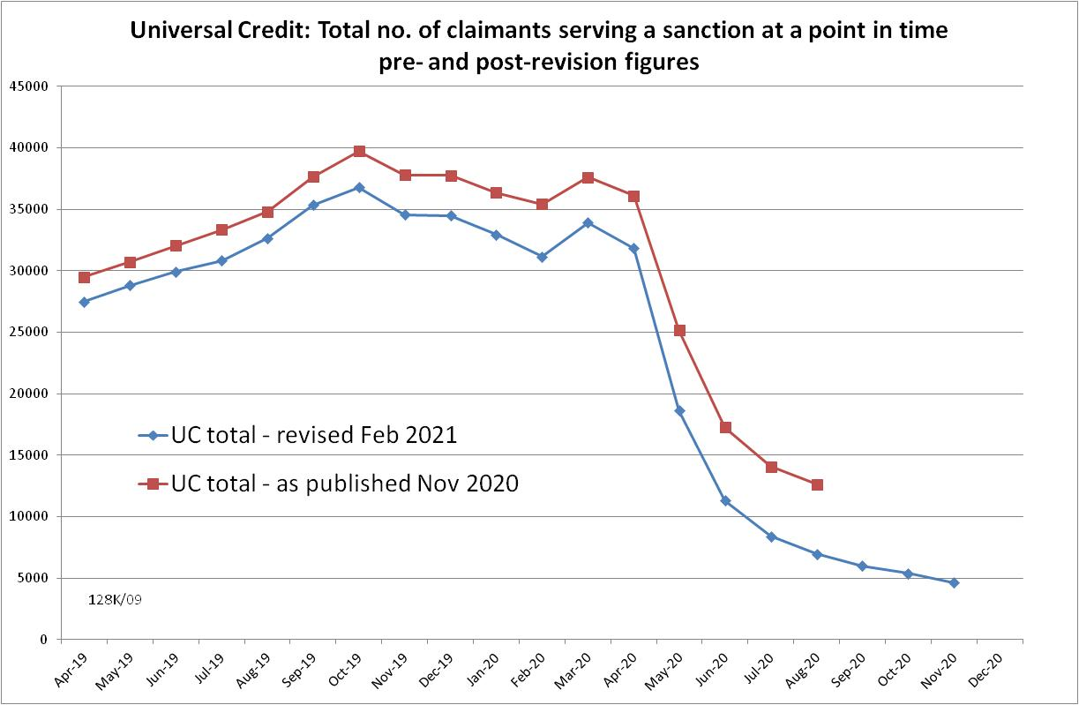

Figure 2
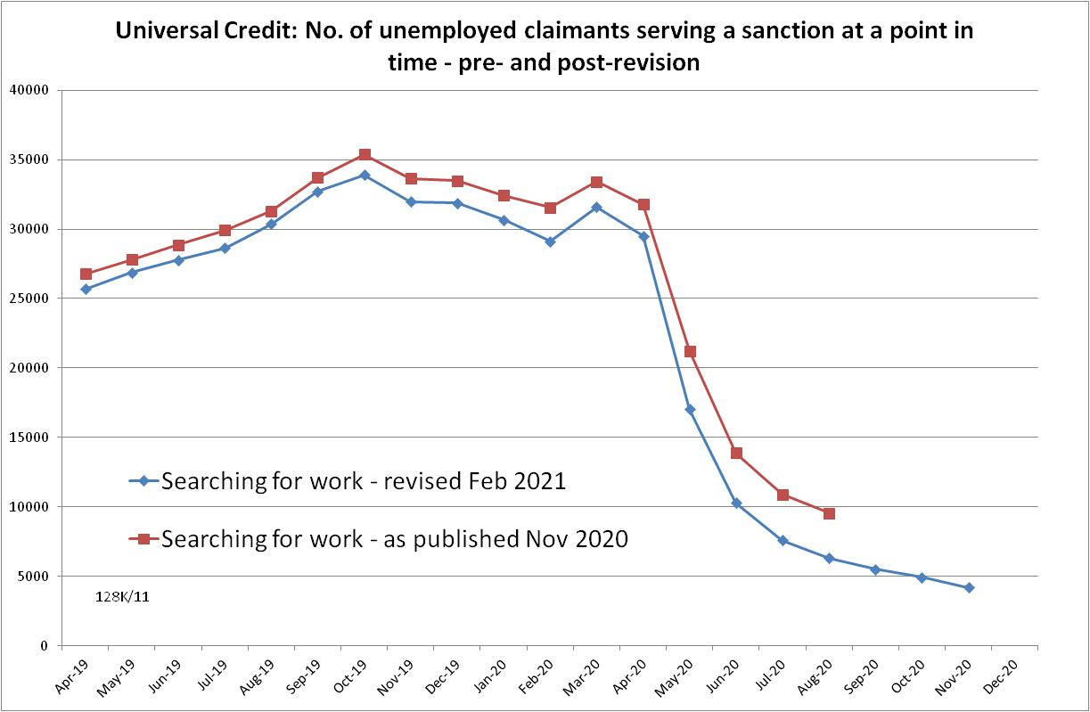

Figure 3
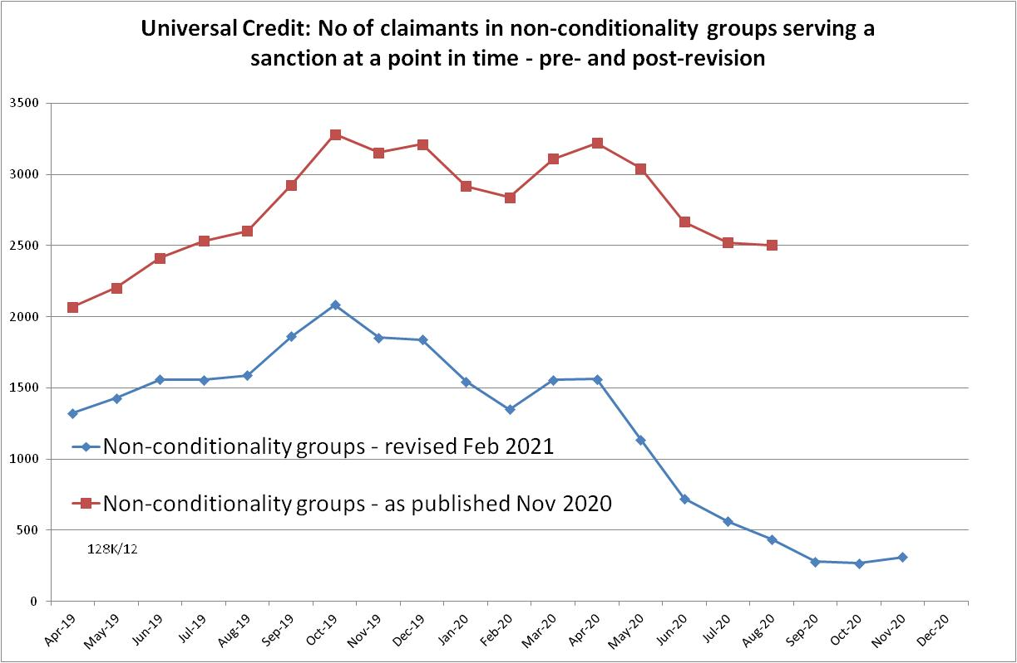

Figure 4
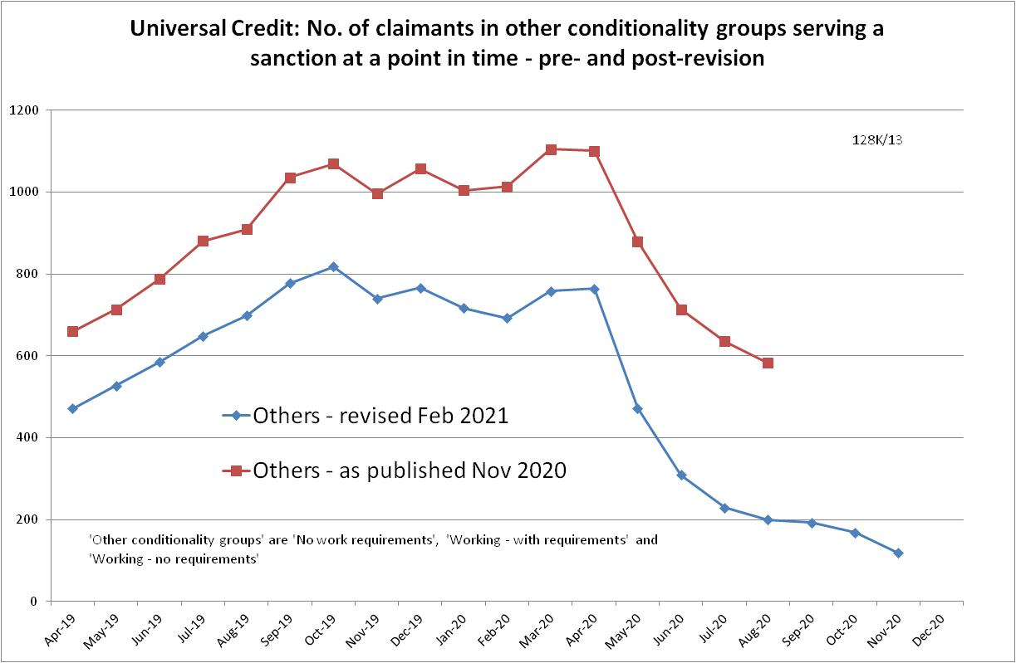

NOTES

Previous briefings include many analyses that are not repeated here but remain valid. However it should be remembered that the DWP may have made subsequent revisions to the data reported in earlier briefings. These revisions will generally not be major although there are exceptions, as for instance with the Universal Credit ‘sanctions rate’ figures reported in this issue. There may also often be substantial changes in some figures for the most recent few months.
Benefit Sanctions Statistics explains that the August 2020 JSA decisions resulted from processing backlogs relating to referrals made under the reason of “failure to attend a place on a training scheme or employment programme without good reason”.
There was an error on pp.2 and 8 of the November 2020 Briefing. It said that, according to the DWP statistics, there were 12,643 UC claimants under sanction in July. This should have read ‘August’. DWP has now revised the August figure to 6,949.

