BRIEFING

Benefit Sanctions Statistics

November 2020

24 November 2020

Dr David Webster
Honorary Senior Research Fellow
Urban Studies
University of Glasgow

Email david.webster@glasgow.ac.uk

Webpages: http://www.gla.ac.uk/schools/socialpolitical/staff/davidwebster/
http://www.cpag.org.uk/david-webster
SUMMARY
This Briefing covers the statistics released by DWP on 10 November, giving sanction decisions up to the end of July 2020, with other data for various dates.
Almost all new sanctions were officially suspended from March until 1 July due to the coronavirus pandemic. During the three complete months of the moratorium, i.e. April, May and June, there were only 33 new sanctions, 28 of them on Universal Credit (UC) and 5 on Jobseeker’s Allowance (JSA). In July there were only 7 new sanctions, all on UC. In practice, therefore, the sanctions suspension has continued at least to the end of July. However, a gradual reintroduction of conditionality did start in July and numbers of sanctions can be expected to increase in subsequent months. The intention is that sanctions related to claimants’ behaviour will only be imposed on the basis of claimant commitments that take account of the more difficult conditions of the pandemic, and these will take some time to roll out.

In spite of virtually no new sanctions being imposed during the moratorium, there were still 12,643 UC claimants under sanction in July, of whom 2,523 were not currently in a conditionality group subject to sanctions. This is because many sanctions are very lengthy, repeat UC sanctions are now served consecutively rather than concurrently, and UC sanctions continue even if the claimant moves into a no-conditionality group.

The DWP statisticians continue to have methodological difficulties, and have withdrawn two sets of statistics pending revision: all data on the duration of UC Full and Live Service sanctions; and figures for the proportion of claimants serving a sanction at a point in time (what DWP calls the ‘rate’) for all months prior to April 2019. It hopes to publish revised duration figures on 15 December.

In contrast to experience earlier in the pandemic, there have been no very dramatic changes in the numbers of UC claimants in the months of August to October. There were five and three-quarter millions (5.73m) UC claimants in October.

A Freedom of Information request has shown that as the number of sanctions has fallen since their peak in 2013/14, so also has the number of assaults on Jobcentre staff, and the correspondence is remarkably close. In 2013/14, when there were 1,110,940 sanctions (on all benefits), there were 639 assaults. By 2019/20 the number of sanctions had fallen to 226,720 and assaults had fallen to 252. The figures also show that as sanctions increased from 2008/09 to 2012/13, so also did assaults. Actual assaults are the most extreme manifestation of hostility and are therefore the tip of a larger iceberg. The figures imply that the ending of the Coalition government’s sanctions drive will have led to a welcome general improvement in relations between claimants and staff.

The news section of the Briefing includes analyses of several new studies, and also a response to a claim in a tweet by Neil Couling of DWP that the experience of the 1980s provides support for the efficacy of sanctions. Publication of the DWP’s own study on the efficacy of sanctions is now almost 18 months overdue.

BRIEFING: Benefit Sanctions Statistics
November 2020

INTRODUCTION

This Briefing discusses the latest quarterly DWP benefit sanctions statistics which were released on 10 November. The new data are summarised by DWP in the publication Benefit Sanctions Statistics, available along with methodological notes at https://www.gov.uk/government/collections/jobseekers-allowance-sanctions together with a spreadsheet with summary tables. The full figures for most aspects of the data are on the DWP’s Stat-Xplore database at https://stat-xplore.dwp.gov.uk/webapi/jsf/login.xhtml

The new release shows what happened to sanction decisions up to and including July. Some other figures are more up-to-date, and others less. All previous Briefings are available at http://www.cpag.org.uk/david-webster . All statistics presented here relate to Great Britain.

The sanctions moratorium: effectively continued through July but being ended gradually

Almost all new sanctions were officially suspended from March until 1 July due to the coronavirus pandemic. Full details of the sanctions suspension, including exact dates, legal basis etc. were given in the June Briefing, pp.7-8. The data show that during the three complete months of the moratorium, i.e. April, May and June, there were only 33 new sanctions, 28 of them on Universal Credit (UC) and 5 on Jobseeker’s Allowance (JSA). In July there were only 7 new sanctions, all on UC. In practice, therefore, the sanctions suspension has continued at least to the end of July. However, a gradual reintroduction of conditionality did start in July and numbers of sanctions can be expected to increase in subsequent months, although DWP states that requirements imposed on claimants will reflect the more difficult conditions of the pandemic.

By far the most detailed explanation of the process of reintroduction of conditionality and sanctions is given in a DWP paper Equality Analysis for Reinstatement of Universal Credit, New Style and Legacy JSA and ESA Conditionality (review of The Coronavirus Regulations
2020 and Legacy JSA and New-Style (NS) JSA Regulations 2020), dated 26 June 2020, at https://www.whatdotheyknow.com/request/691073/response/1648002/attach/html/3/Equality%20Analysis%20for%20Reinstatement%20of%20Conditionality.pdf.html

To summarise:

- From 1 July, claimants will not be sanctioned until they have accepted a new or revised claimant commitment.
- In the interim they will be expected to do what they reasonably can to search for and be available for work.
- Claimants in the Intensive work search regime were to receive alerts to advise them of the reinstatement of conditionality and activities they could undertake to look for work.
- The reintroduction of the claimant commitment requirement for UC claimants was to be tested first in only three jobcentres.
- New UC claimants were to be required to accept a claimant commitment from 8th July onwards, and new claimants for the other benefits from 22nd July onwards (though ‘Benefit Sanction Statistics’ gives this latter date as 3 August for Legacy JSA).
- Claimants who started their claim during the moratorium will not usually have a claimant commitment, and those who started it before the moratorium will require to have their commitment reviewed. To deal with these cases, from 30th June, as work coach resources allow, interviews were to be conducted over the phone to develop new or review existing claimant commitments to ensure that these are tailored to the claimant’s personal circumstances and in line with any Covid-19 guidelines whilst these exist.

The SSAC (2020, pp.15-16) adds the information that ‘the initial claimant interview with a work coach to agree the claimant commitment will be reduced from 50 to 30 minutes’, and ‘We understand that the DWP has a developed a Discretion Framework that is available to DWP staff.’ This however is not published.

There is what appears to be more detailed guidance on the claimant commitment interview at https://www.whatdotheyknow.com/request/681475/response/1625493/attach/4/FOI2020%2042056%20Spotlight%20on%20First%20commitments%20by%20phone%20appointment.pdf?cookie_passthrough=1 and on work search interviews at https://www.whatdotheyknow.com/request/690964/response/1647998/attach/html/5/Spotlight%20on%20Fortnightly%20work%20search%20reviews.pdf.html , although it is not clear whether this is fully up to date.

The Department for Communities in Northern Ireland has taken an independent line, saying:
‘For new claims made from 8 July 2020, DfC will instigate “light-touch” discussions without the threat or potential of a sanction, in recognition of the challenging circumstances people still find themselves in.’ (SSAC 2020, p.13)

The position in relation to Income Support (IS) is left unclear. IS claimants do not have to complete a claimant commitment, but do have to attend work-focused interviews, and IS sanctions were running at around 200 per month before the coronavirus. It may be that DWP has not prioritised interviews with these claimants as it deals with the various additional tasks created by the pandemic.

Suspension of Universal Credit sanctions duration statistics

DWP has suspended publication of data on the duration of UC Full and Live Service sanctions due to unspecified doubts about the methodology. It hopes to publish revised data on 15 December. Data on JSA and ESA sanction durations are not affected. The Briefing has always had reservations about these statistics, which were explained in the November 2017 issue, pp.6-8.

Withdrawal of UC ‘rate’ data for dates earlier than April 2019

The DWP’s preferred measure of the scale of sanctions is the proportion of claimants serving a sanction at a point in time (what it calls the ‘rate’). The Briefing has always expressed reservations about this measure, which were explained in the November 2017 issue, pp.6-10. For UC, the published data on this ‘rate’ have always included both Live and Full Service. Benefit Sanctions Statistics now states that the UC Live Service data on this ‘rate’ always suffered from the defect that they only included claimants whose sanctions had been completed at the time of the calculation. People with ‘open’ sanctions were omitted. All UC Live Service claimants had been transferred to UC Full Service by March 2019, so this problem affects data for that month and earlier. DWP has therefore withdrawn the UC ‘rate’ data for all months prior to April 2019. The published ‘rates’ for JSA and ESA are not affected by this particular problem.

The error introduced into the UC ‘rate’ figures previously shown in the Briefing by this fault in the Live Service data will of course have declined over time, as Live Service claimants fell as a share of total UC claimants. The November 2018 Briefing (p.6 and Figure 2) presented estimates showing how this share fell month by month for UC as a whole. But the problem will have affected some claimant groups more than others, in particular the unemployed ‘searching for work’ group, who were particularly likely to be on Live Service.

Reinstatement of corrected UC Live Service figures, when it occurs, will only affect past figures and will not affect reporting of the current level of sanctions.

Groups of claimants exposed to sanctions:
Universal Credit, JSA, ESA and Income Support

As a result of the coronavirus there was a large increase in the number of claimants normally subject to conditionality between March and April, from approximately 2.0m to approximately 2.87m. There was a further large increase in May, and by July there were approximately 3.40m in groups normally subject to conditionality – a 70% increase over March. These figures exclude in-work UC claimants, for whom conditionality was not being implemented even before the pandemic. Claimants subject to sanctions are split between UC, JSA, ESA and IS. The increase in claimants normally subject to conditionality between March and July was almost entirely due to increases in unemployed claimants, of 1.23m claiming UC and 0.15m claiming JSA (Figure 1).

A report from the Welfare – at a Social Distance project (Edmiston et al. 2020), based on survey data collected online from 7,601 new and existing claimants by YouGov between 21st May and 15th June 2020, finds that the characteristics of new benefit claimants during the pandemic, taking all benefits together, have been substantially different from those of existing claimants. The new claimants are younger; more likely to be male or from ethnic minorities; much more likely to be university graduates or from a higher ‘social grade’; and much less likely to have a health condition or disability, or to be social renters.

Numbers of claimants of the four benefits

There were huge increases in the number of claimants of UC in April and May, but since then increases have been continuing at more normal levels. Total UC claimants reached five and three-quarter millions (5.73m) in October.

Figure 2 shows that there has been no further material increase in unemployed UC claimants between May and October. UC claimants ‘preparing for work’ and ‘planning for work’ have also levelled off. Working UC claimants however have continued to increase, as have those with ‘no work requirements’ (i.e. limited capability for work or certain caring responsibilities), albeit the latter at a slower rate than before the pandemic. There are now 1.25m more working claimants of UC than before the pandemic.

Unemployed claimants

The UC count of those ‘searching for work’ does not contain everyone claiming benefits as a result of unemployment, because there are also people claiming ‘legacy’ JSA (i.e. unemployed claimants who have not had a change of circumstances which would have made them transfer to UC), and people who are claiming ‘New Style JSA’, i.e. the non-means tested benefit available for 6 months to newly unemployed people with a qualifying National Insurance contribution record.

Between March and May the total unemployed claimant count more than doubled, increasing by 1.238m to reach 2.597m, far surpassing the peak of the 2008 recession (these are slightly revised figures). But Figure 3 shows that there has been little further change since then. Claims for New Style JSA went on increasing until September, but there has been a downturn in October. One factor contributing to this downturn could be people starting to exhaust their entitlement. People coming to the end of New Style JSA can carry on claiming National Insurance credits, which count towards their state pension, but it seems likely that many will choose not to do so because of the conditionality requirements for job search etc. if they do.

The percentage of unemployed claimants who are on UC rather than JSA has remained at 88%.

Further analysis of the labour market under coronavirus is published by the Learning and Work Institute at https://learningandwork.org.uk/what-we-do/employment-and-social-security/labour-market-analysis/ and by the Institute for Employment Studies at https://www.employment-studies.co.uk/resource/labour-market-statistics-november-2020

Sickness and disability

The number of people claiming UC on grounds of sickness or disability and in normal times subject to conditionality is not published by DWP. UC claimants ‘preparing for work’ (216,626 at October 2020) include these people but they also include some people who are not sick or disabled and would previously have claimed IS. The number of ESA claimants subject to conditionality, i.e. those in the Work Related Activity Group (WRAG) however is known. They are all subject to conditionality. Their number peaked at 562,685 in August 2013 but had declined to 238,295 in April 2020 and an estimated 225,000 in July 2020.

During the coronavirus emergency, New Style ESA is available to additional groups such as people who are self-isolating due to vulnerability or are in quarantine. To date, this has not shown up in a slowing or reversal of the declining trend in the ESA WRAG. Instead, it has appeared in a reversal of the declining trend in numbers in the ESA Assessment Phase. There had been a decline in the numbers in the Assessment Phase every quarter since November 2016, but in May 2020 there was a rise to 60,374 from 46,070 in February. In contrast to the position under UC, claimants in the ESA Assessment Phase are not subject to conditionality.

Income Support

The number of IS claimants is falling quite fast due to movement of new claimants on to UC. At April 2020 there were an estimated 253,000 claimants on IS who would have been subject to sanctions but for the suspension. The largest group among these was an estimated 132,000 lone parents with a youngest child aged between one and five. There were also an estimated 118,000 carers and 3,000 other IS claimants.

The Universal Credit sanctions regime

A full description of the UC sanctions regime was given in the February 2019 issue of the Briefing, pp.5-6.

Universal Credit ‘Full Service’ and ‘Live Service’

On its introduction, Universal Credit was delivered via ‘Live Service’. A programme to transfer Jobcentres to the more sophisticated ‘Full Service’ was started in May 2016 and completed in December 2018. For many months therefore, Live Service and Full Service were operating in parallel. However, all Live Service claimants had transferred to Full Service by April 2019, and the systems used to administer Live Service were shut down at the end of March 2019. DWP is still not publishing comprehensive sanctions data on Full Service. Most data on Stat-Xplore still relate only to Live Service. Within Stat-Xplore, the only topic covered for Full Service sanctions is the number and proportion of claimants under sanction at a point in time. Benefit Sanctions Statistics and the accompanying spreadsheet add the number of adverse sanction decisions, duration of completed sanctions (currently suspended as noted above), repeat adverse sanction decisions in the past year, reasons for sanctions, and demographics, though not necessarily all of them in every release.

Sanctions before and after reviews, reconsiderations and appeals

Except for the new UC Full Service data first published in May 2019, the DWP’s Benefit Sanctions Statistics publication and Stat-Xplore database only show sanctions after any reviews, reconsiderations and appeals that have taken place by the time the data are published. But numbers of sanctions before the results of these challenges are important since they show all the cases in which claimants have had their money stopped. Although a successful challenge should result in a refund, this is only paid after weeks or months by which time serious damage is often done. Estimates of sanctions before challenges are therefore given here but although reliable for longer time periods, they are not fully accurate for individual months. For JSA and ESA, figures for sanctions before challenges have typically been higher than the ‘after challenge’ figures by very large amounts, namely about 20%. and 40% respectively. For UC Live Service (the only figures currently available for the UC appeal process) and for IS, the proportion of sanctions overturned has been much smaller at around 5% and 1% respectively. So for these types of sanction there is much less difference between the pre-and post-challenge figures. Wherever possible, this Briefing shows estimated pre-challenge sanctions figures. DWP now says that it aims to change this system for Universal Credit sanctions at some point in the future in order to show all decisions at each stage.
MONTHLY NUMBERS AND RATES OF SANCTIONS BEFORE CHALLENGES FOR THE FOUR BENEFITS

As noted earlier, the coronavirus moratorium on sanctions has effectively lasted through July and no later sanctions figures are yet available. There is therefore no point in updating this analysis. Readers are referred to the August 2020 and earlier Briefings for sanctions figures up to and including the first month of the moratorium.

UNIVERSAL CREDIT: CLAIMANTS UNDER SANCTION
AT A POINT IN TIME

The DWP’s preferred measure of sanctions ‘rate’ is the proportion of claimants who are serving a sanction at a point in time. There are various methodological problems with this measure, which were discussed in the November 2017 Briefing (pp.6-10). A further issue was discussed in the February 2020 Briefing, p.7. This measure also understates the impact of sanctions, since the number of people experiencing a sanction over a period such as a year is much greater than the number actually serving one at a point in time, and the effects of a sanction often last a long time. This is evidently why DWP likes this measure, and prioritised its development; it is constantly used to understate the impact of sanctions. But in spite of the limitations the figures can be of some value.

The figures for JSA and ESA have fallen too low to be of much interest even in normal times, and they currently only run to March 2020 so do not tell us about the sanctions moratorium. But the UC data run to August 2020. It is pointless to look at the proportion under sanction, because this will obviously have fallen simply because of the combined effect of the sanctions moratorium and the large increase in the number of claimants. Figure 4 therefore shows the absolute number of UC claimants under sanction on the second Thursday of each month, separating the unemployed, those in groups not subject to conditionality, and the rest. As noted above, this information is currently available only for months since April 2019, because of the problems with the Live Service data.

What is striking about Figure 4 is how many UC claimants were serving sanctions throughout the moratorium. There were 37,621 in March, before the moratorium. The number then fell month by month, but there were still 12,643 in July. The great majority of these were unemployed people, but even in July there were 2,523 UC claimants under sanction who were not currently in a conditionality group subject to sanctions. This is because UC sanctions continue even if the claimant moves into a no-conditionality group.

The other reasons why substantial numbers of UC claimants have remained under sanction during the coronavirus suspension are that many sanctions are very lengthy, and repeat UC sanctions are now served consecutively rather than concurrently as was the case with ‘legacy’ benefits.

ASSAULTS ON JOBCENTRE STAFF

No data have been published on assaults on Jobcentre staff since a Parliamentary Written Answer on 18 November 2014. Because of the obvious likelihood that a harsh sanctions regime will provoke more assaults, the present author requested updated figures from DWP using the Freedom of Information Act. The results are shown in Figure 5.

This shows that as the number of sanctions has fallen since their peak in 2013/14, so also has the number of assaults, and the correspondence is remarkably close. In 2013/14, when there were 1,110,940 sanctions (on all benefits), there were 639 assaults. By 2019/20 the number of sanctions had fallen to 226,720 and assaults had fallen to 252.

Figure 5 also shows that as sanctions increased from 2008/09 to 2012/13, so also did assaults. The Parliamentary Answer from 2014 did not explicitly give figures for total assaults, so those in the chart have been obtained by adding together the figures for individual categories of assault. It is not clear that the resulting totals are exactly comparable to those for 2013/14 to 2019/20. However it is clear that there was a rising trend in assaults in this period corresponding to the rising trend in sanctions.

Actual assaults are the most extreme manifestation of hostility and are therefore the tip of a larger iceberg. The figures imply that the ending of the Coalition government’s sanctions drive will have led to a welcome general improvement in relations between claimants and staff.

ANALYSES NOT INCLUDED IN THIS ISSUE

The coronavirus suspension makes it not worthwhile to update many of the analyses at present. Readers are referred to earlier numbers of the Briefing for analyses of matters not discussed in the present issue. Monthly numbers and rates of sanctions are in every previous issue. Repeat sanctions and duration of sanctions were discussed in August 2020; reasons for sanctions in June 2020; demographics in February 2020; claimants with earnings following a sanction were covered in November 2018; ethnicity and gender in July 2018; benefit destinations in February 2018; challenges to sanctions in February 2018 and May 2017; JSA benefit suspensions not followed by sanction, and ESA sanctions by medical condition in August 2017; and hardship payments for UC in August 2019 and for JSA and ESA in February 2019 and November 2015. Longer period analyses were included in the author’s written evidence to the Work and Pensions Committee (Webster 2018a) and in a presentation to the Welfare Conditionality conference at York in June 2018 (Webster 2018b). These analyses will be updated in future issues.
SANCTIONS - OTHER DEVELOPMENTS

SSAC review of the Covid-10 temporary measures

The Social Security Advisory Committee on 18 November published a review (SSAC 2020) of the arrangements within the social security system for coping with the Covid-19 pandemic.
It recommends that DWP should publish a strategic policy on easements and discretion in current circumstances, along with guidance to claimants, advice organisations and work coaches on how they can be delivered, together with a more rigorous approach to monitoring their delivery. It recommends clarification of the extent to which claimant concerns about working in unsafe environments would constitute ‘good cause’ for refusal to work. It also recommends a more proactive approach to identifying claimant circumstances and vulnerabilities, and publication of guidance on how claimant ‘vulnerability’ can be determined in relation to Covid-19.

Work & Pensions Committee report on wait for first UC payment, 19 October

The August Briefing (p.13) reported on the NAO’s fourth major report on UC (NAO 2020), published on 10 July, which was focused on the 5-week wait for first payment. On 19 October the House of Commons Work and Pensions Committe published its own report on Universal Credit: the wait for a first payment (House of Commons 2020). The report covers more ground than just the 5-week wait, including treatment of debt, support for claimants, timeliness of payments, backdating, payment frequency, and the relationship between the UC assessment period and people’s actual wage/salary payment periods. It makes three recommendations directly related to sanctions. The first is that all deductions, including sanctions, should be included within the current 30% cap (25% from October 2021) on deductions from a claimant’s UC entitlement, and that the cap should be reduced to 10% (para.110-11). It is assumed that this refers to repayments of ‘hardship payments’, since if it referred to sanctions themselves this would surely have received explicit discussion in the report. The second relevant recommendation is that DWP should formalise how it identifies and defines vulnerable claimants, as part of its overall approach to safeguarding vulnerable people (para.139). Finally, the Work Capability Assessment (WCA) process should be speeded up; at present it takes four months on average (para.158). The Committee discusses this in relation to payment of claimants’ full entitlement but another important issue is that pending their WCA, new UC claimants with a health condition or disability are subject to conditionality entirely at the discretion of their ‘work coach’.

DWP report on the variation in UC sanction rate between Jobcentres

On 8 October DWP published a research report (DWP 2020b) on the variation in the UC sanction ‘rate’ between Jobcentres and DWP Regions over the period August 2017 to August 2019, ‘rate’ being the DWP’s preferred measure of the proportion of claimants under sanction at a point in time. The report uses data published on 12 November 2019; unfortunately, as noted earlier in this Briefing, these data for months before April 2019 have since been withdrawn by DWP because ‘Live Service’ figures were underestimated. This presumably means that the findings of this study will be subject to revision, although it would be surprising if the revisions were to change them very much.

The key finding of the report is that as sanction rates fell from March 2018 to August 2019, the range of variation between Jobcentres also fell. This is what would be expected. The report also finds that variation in sanction rates between regions was relatively small, and that no region came consistently high or low in the distribution. The report does not consider whether there are some individual Jobcentres which are consistently harsher or more lenient than others, though other investigations at the University of Glasgow and by the present author have not found consistent differences.

It has long been clear that the DWP sanctions system is tightly controlled and monitored from the centre. The Social Security Act 1998 abolished independent adjudication, and since then ministers have had absolute control over sanction decisions. When ministers want sanctions to go up, they go up everywhere, and similarly when they want them to go down. Any emerging differences in harshness between Jobcentres appear to be quickly stamped out. However, there are some consistent differences in sanction rates for individual reasons, due to the interaction of benefit system rules with local labour market conditions. These were considered in a paper by the author (Webster 2014).

Neil Couling of DWP – tweet on conditionality and unemployment in the 1980s

On 18 September 2020, Neil Couling, DWP’s Change Director General and Senior Responsible Owner for Universal Credit, tweeted at https://twitter.com/NeilCouling/status/1306987961653899267:
‘I’ve challenged Dr Webster before, notably at the Scottish Parliament committee hearing. Noticeable difference in duration of unemployment in 80s recession (pre Restart) - it’s much longer (than) 90s and 2008/9 recessions. Makes the case for conditionality every time.’

The Scottish Parliament hearing referred to was of the Welfare Reform Committee on 29 April 2014, col.1465, at https://www.parliament.scot/parliamentarybusiness/report.aspx?r=9133&mode=pdf
when Neil Couling said:
‘When Dr Webster spoke to the committee, he gave some information on the history of the system, but he did not take the committee through the experience of the 1980s. During the big recession in the 1980s, my predecessors—under pressure—abandoned the sanctions and conditionality regime. The unemployment figure grew to 3 million—it was probably going to do that because of the nature of the economy—but it is interesting that it stayed at 3 million until 1986 and started to downturn only when we reintroduced into the system such a regime—the programme was called Restart then. The counterfactual that proves that sanctions work is that, after the 1990s recession, when we worked hard—as we did in the 2008 recession—to hang on to the conditionality regime, the unemployment rate fell very fast.’

This type of assertion really needs to be backed up by a research paper, since a tweet cannot possibly present or evaluate the evidence satisfactorily. But here are a few observations.

Neil Couling’s 2020 statement refers to unemployment ‘duration’, while the 2014 statement refers to the speed at which unemployment fell. It appears that in the 2020 statement he did not mean to refer to the duration of unemployment of individuals, but to the length of time that aggregate unemployment stayed high. In other words the two statements are actually the same. I proceed on that assumption.

There was a major new factor in the 1990s recession that did not apply in the 1980s recession. This is that large numbers of unemployed people moved off unemployment benefits and on to sickness benefits, because they were encouraged to do so. Conditionality did not get them into work. In calculations of ‘real’ unemployment (as defined in the series of papers by Beatty & Fothergill, e.g. Beatty at al. 2000) which I made for the late Wynne Godley, the real rate of unemployment is actually shown to have been higher, and to have fallen less steeply, in the 1990s than in the 1980s.

To the extent that conditionality affects unemployment, it is through the supply side of the labour market. But demand for labour is also important, determined by such factors as export demand, the exchange rate, indebtedness, government expenditure etc. Neil Couling appears to accept this for the rise of 1980s unemployment to 3 million (‘it was probably going to do that because of the nature of the economy’), but not for the subsequent reduction. This is inconsistent and the role of labour demand needs specific consideration.

Neil Couling mentions that Restart was introduced in 1986, but not the other major change in conditionality of that year, namely the increase in the maximum length of sanction (disqualification) from 6 to 13 weeks. The Department of Social Security’s own analysis (DSS 1989) showed that this had hardly any effect.

Finally, it should be noted that prior to 1986 there had been no regularly published statistical data on unemployment benefit disqualifications since 1939. So actually finding out what was the level of conditionality in the 1980s recession prior to 1986 is difficult if not impossible.

Publication of the DWP’s own study on the efficacy of sanctions is now almost 18 months overdue.

Gingerbread report on the impact of UC requirement for lone parent job search when youngest child is 3

On 29 September the charity Gingerbread published research on the impact on lone parents in London of the requirement under UC for job search when their youngest child reaches 3, which was introduced by the Welfare and Work Act 2016. This important report (Dewar & Clery 2020) is based on analysis of the Labour Force Survey, a focus group with 7 lone parents, telephone interviews with a further 9 lone parents, and discussions with relevant DWP staff. The research found that this group have distinctly different requirements from other lone parents, which are not currently being well met. Particular findings were that JCP support does not take sufficient account of individual circumstances, and that parents were not being told about available opportunities for training. Childcare, as so often, emerges as a key problem, exacerbated by the UC practice of paying for childcare costs in arrears.

Health Foundation and University of Glasgow report on mental health, welfare conditionality & employment support

A report from the Health Foundation and University of Glasgow (Wright 2020) looks at the treatment of people with mental health or alcohol addiction problems within the British social security and employment support systems. It is based on a re-analysis of 144 interviews conducted within the earlier Welfare Conditionality project (see Briefing, July 2018 p.17), analysis of 15 of the most recent UK policy documents related to mental health and problematic alcohol use, and a series of workshops and interviews in 2020 with 28 stakeholders working in the fields of social security and mental health. It recommends reform of conditionality as applied to people with mental health issues (no conditionality pending WCA, better information on ‘easements’, a bigger say for claimants on their ‘claimant commitment’, monitoring of ‘claimant commitments’), personalised support, and investment in evidence-based employability interventions, specifically that Individual Placement and Support (IPS) services should be fully integrated into UK and Scottish employability provision. There is an associated working paper (Stewart 2020).

New study shows adverse health effects of sanctions in Sweden

A new study from the Bonn IZA institute (Caliendo et al. 2020) reports that in Sweden in 2006 to 2008, unemployment benefit sanctions were found to have two adverse health effects. First, in the month before the sanction was imposed, but after the job seeker would have received a warning of an impending sanction, the proportion of jobseekers receiving a prescription for a mental health problem increased by about 37% relative to the control group. This was statistically significant at the 1% level. No increase was observed subsequently to the imposition of the sanction. The authors suggest that the threat of a benefit reduction increases the level of stress which in turn affects mental health. Second, after a sanction was imposed and during the unemployment spell, there was a substantial increase in the number of days on sickness benefit, and in the likelihood of reporting sick for at least seven days in a row; no evidence was available on whether this effect continued into employment, if gained. Both of these latter effects were particularly pronounced in the first months after the sanction. The authors conclude that there was no clear evidence for longer lasting health effects. The finding on prescriptions is compatible with those of Williams (2019) and Williams (2020) reported respectively in the November 2019 Briefing, p.15, and in the June 2020 Briefing, p.14. Williams looked at the association between sanctions and health effects but not at the precise timing.

It is a common problem with this type of academic article that not enough information is provided about the sanctions regime under study to enable the reader to judge the degree of applicability of the findings to their own country. This article is no exception. However, there is sufficient information to show that the Swedish regime at the time of the study was much milder than the UK regime. The authors comment (p.9) ‘The rate of sanctioned job seekers in Sweden was rather low before 2013 .......... because caseworkers generally considered the system as harsh and were reluctant to use this policy instrument.’ The authors’ data (p.10) show that of 368,487 unemployment spells included in the study, only 2,898 or 0.8% attracted a sanction. On the assumption that a Swedish unemployment spell was of similar length to one in the UK, i.e. about 5 months, this would equate to a monthly sanction rate of 0.16%. This compares with UK unemployed sanction rates which in 2006-08 were between 2% and 4% per month, and during the last decade have ranged up to over 9%. The lower the sanction rate, the less likely it is that vulnerable claimants will be sanctioned. Moreover, the authors state (pp.7 & 18) that for about 58% of those sanctioned, the reduction in benefit (from a much higher level than in the UK) was of only 25% for 40 days, compared with 100% in the UK, and for about a further 5% was of 50%. For the remainder, the reduction of benefit was 100% for an indeterminate period but the authors do not say what this period typically was.

Channel 4 TV series The Yorkshire Jobcentre continued: the case of the dyslexic piano tuner

This TV series has now concluded but is still available to view at https://www.channel4.com/programmes/the-yorkshire-jobcentre. The August 2020 Briefing (pp.14-15) discussed the series and highlighted a sanctions related case depicted in Episode 1. Sanctions cropped up again in Episode 6, in the case of Ray, a 63-year-old from East Leeds who had been a piano tuner all his life but was now finding it difficult to get enough work. He had been coming to the Jobcentre for two years. The first interview with his Work Coach Shelley that we see is quite amiable, but on the way home he tells the camera that he is very dyslexic and is scared of IT. The next interview is of quite a different character. It emerges that in the intervening fortnight Ray has done no job searching. Shelley asks him whether his circumstances have changed, and he says not. Then Shelley: ‘So my next question is, why is there no job search?’ Ray: ‘Because I haven’t done anything.’ S: ‘Why haven’t you done anything? Do you think it’s OK for me to accept that?’ R: ‘Not really’. S: You know you’ve got to look for work. You signed up to do 35 hours a week job search. Failure to provide evidence on a jobseeker’s sign-in, it can potentially affect your claim for Jobseekers Allowance. Your case can go to the decision makers, and the fact that you’ve said that to me, you know, and they base it on that decision, what do you think the outcome will be?’ (this accompanied by aggressive body language, e.g. chin jutting forward) R: ‘Well, suspense.’ S: ‘Which effectively can close your claim for Jobseekers Allowance.’ R: ‘Right.’ S: ‘Coming to the Jobcentre and saying to me “I’ve not done any job search” is not acceptable.’ R: ‘That’s right. That’s why I need to go on a computer course so I can learn how to do it properly.’ S: ‘So that’s been the main barrier, has it?’ R: ‘Well IT, for some reason I seem to freeze.’ S: ‘Right, well if you’re not really confident on computers, come and have a practice on our computers. If you want to sit with me for the next appointment on the computers, I’ll work around whatever you want to do.’ At their next meeting four weeks later we see Shelley sitting with Ray and explaining some of the basics. It emerges that Ray has not used a mouse since 1990. Shelley then offers to put Ray on a Digital Inclusion Programme, involving attendance from 10.0 to 4.0 for two weeks on five days a week. Later, we see Ray on his course with a one-to-one tutor who is pleased with his progress. At the next meeting with Shelley, Ray tells her that he still has difficulty filling in forms because he has dyslexia, to which Shelley replies ‘Thank you for being honest with me’, and suggests he talks to his GP. To the camera she comments that ‘You’d expect him to tell me from the word go’, while he separately says how stressed he felt at the earlier interviews.

From one point of view this story puts Shelley and the Jobcentre in a favourable light. Ray’s disability was eventually discovered, he was not sanctioned, and he was sent on a free course to give him the computer skills needed for job search. But the threat to sanction him was clearly inappropriate. As Shelley said, Ray might have been expected to reveal his dyslexia at the outset. But multiple case histories reported by the voluntary sector show that people commonly do not reveal this type of key information about themselves. A sanctions regime which makes sanctions a first or early resort, before there has been a serious effort to assess the claimant’s situation, is bound to penalise claimants inappropriately.

REFERENCES

Beatty, C., Fothergill, S. & Macmillan, R. (2000) ‘A Theory of Employment, Unemployment and Sickness’, Regional Studies, Vol. 34.7, pp.617-630

DWP (2020a) Equality Analysis for Reinstatement of Universal Credit, new style and legacy JSA and ESA Conditionality (review of The Coronavirus Regulations 2020 and Legacy JSA and New-Style (NS) JSA Regulations 2020), at
https://www.whatdotheyknow.com/request/691073/response/1648002/attach/html/3/Equality%20Analysis%20for%20Reinstatement%20of%20Conditionality.pdf.html

DWP (2020b) Variation in the Universal Credit sanction rate between jobcentres from August 2017 to August 2019 (HTML only), at
https://www.gov.uk/government/publications/variation-in-the-universal-credit-sanction-rate-between-jobcentres-from-august-2017-to-august-2019/variation-in-the-universal-credit-sanction-rate-between-jobcentres-from-august-2017-to-august-2019

Caliendo, Marco, Robert Mahlstedt, Gerard J. van den Berg & Johan Vikström (2020) Side Effects of Labor Market Policies, IZA Institute of Labor Economics Discussion Paper No. 13846, Bonn, November, at
https://www.iza.org/publications/dp/13846/side-effects-of-labor-market-policies

Department of Social Security (1989) An Analysis of Voluntary Unemployed Claimants, Analytical Services Division, November

Dewar, Laura & Elizabeth Clery (2020) Left behind: Single parents with pre-school
aged children and job-seeking under Universal Credit in London, London, Gingerbread, September, at
https://www.gingerbread.org.uk/policy-campaigns/publications-index/left-behind/

Edmiston, D; Geiger, BG; De Vries, R; Scullion, L; Summers, K; Ingold, J; Robertshaw, D; and Gibbons, A; and Karagiannaki, E. (2020) Who are the new COVID-19 cohort of benefit claimants? Welfare at a (Social) Distance Rapid Report #2. The Welfare at a (Social) Distance project; http://hub.salford.ac.uk/welfare-at-a-social-distance/

House of Commons Work and Pensions Committee (2020) Universal Credit: the wait for a first payment, Third Report of Session 2019-12, HC 204, 19 October, at
https://committees.parliament.uk/committee/164/work-and-pensions-committee/news/120137/mps-call-for-starter-payments-to-provide-financial-support-during-wait-for-first-universal-credit-payment/

National Audit Office (2020) Universal Credit: getting to first payment, Report by the Comptroller and Auditor General, HC 376 Session 2019–2021 10 July, at
https://www.nao.org.uk/report/universal-credit-getting-to-first-payment/

Social Security Advisory Committee (2020) A review of the Covid-19 temporary measures: A study by the Social Security Advisory Committee, Occasional Paper No. 24, November, at
https://www.gov.uk/government/publications/a-review-of-the-covid-19-temporary-measures

Stewart, A. B.R., Gawlewicz, A., Bailey, N., Katikireddi, S. V. and Wright, S. (2020) Lived Experiences of Mental Health Problems and Welfare Conditionality, Working Paper, University of Glasgow, Glasgow, at http://eprints.gla.ac.uk/223638/

Webster, D. (2014) 'Geographical Variations in JSA Sanctions and Disallowances', Supplementary evidence submitted to the House of Commons Work and Pensions Committee Inquiry into the Role of Jobcentre Plus in the reformed welfare system, Second Report of Session 2013-14, HC 479, Vol. II, pp. Ev w101-w111, at http://eprints.gla.ac.uk/90148/

Webster, David (2018a) Written evidence to the House of Commons Work and Pensions Committee inquiry into Benefit Sanctions, at
http://data.parliament.uk/writtenevidence/committeeevidence.svc/evidencedocument/work-and-pensions-committee/benefit-sanctions/written/82601.pdf
Webster, David (2018b) The great benefit sanctions drive 2010-16 in historical perspective, presentation to the conference Welfare Conditionality: Principles, Practice and Perspectives, University of York, Wednesday 27 June 2018, at http://eprints.gla.ac.uk/183161/

Williams, Evan (2019) ‘Unemployment, sanctions and mental health: the relationship between benefit sanctions and antidepressant prescribing’, Journal of Social Policy
doi:10.1017/S0047279419000783

Williams, Evan (2020) ‘Punitive welfare reform and claimant mental health: The impact of benefit sanctions on anxiety and depression, Social Policy and Administration, DOI: 10.1111/spol.12628, at https://onlinelibrary.wiley.com/doi/full/10.1111/spol.12628

Wright, Sharon (ed.) (2020) Mental health, welfare conditionality & employment support:
Policy recommendations & key findings, Health Foundation and University of Glasgow, October, at http://eprints.gla.ac.uk/224227/1/224227.pdf

Figure 1
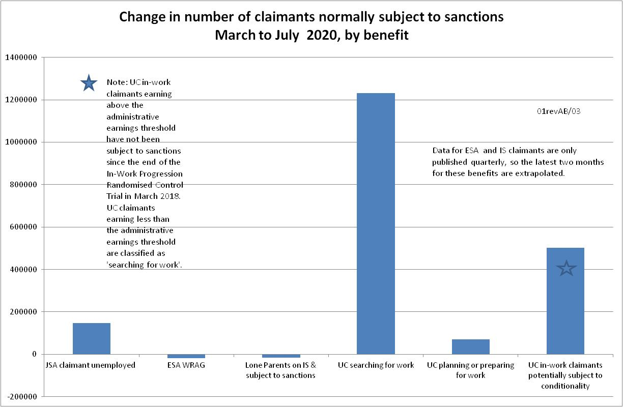

Figure 2
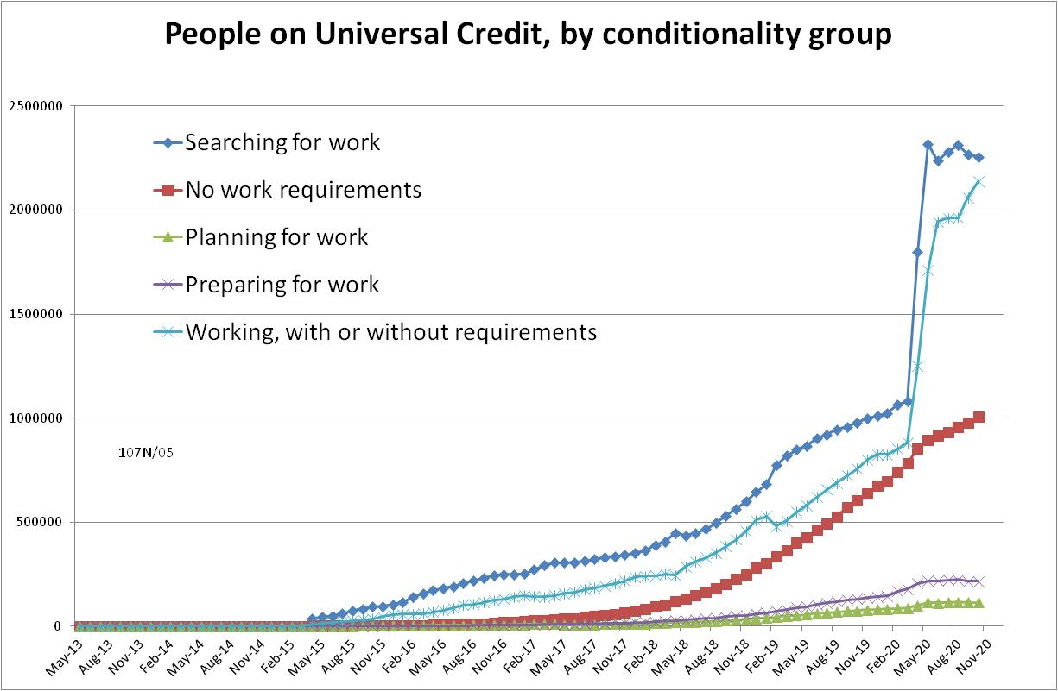

Figure 3
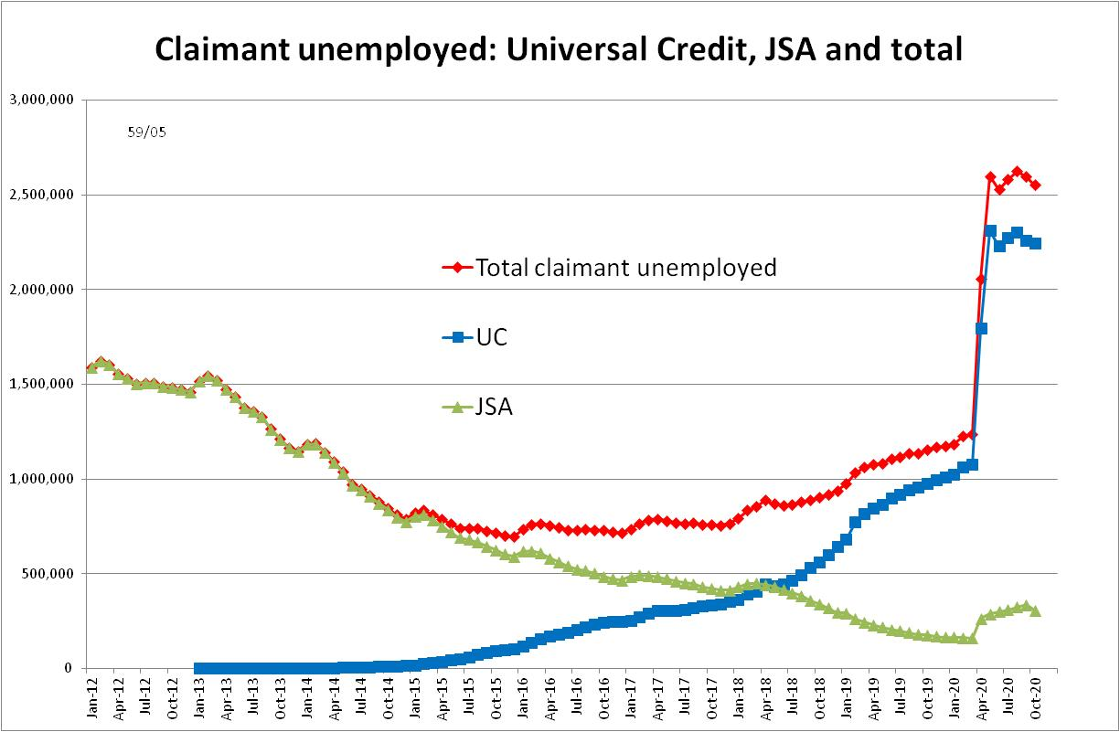

Figure 4
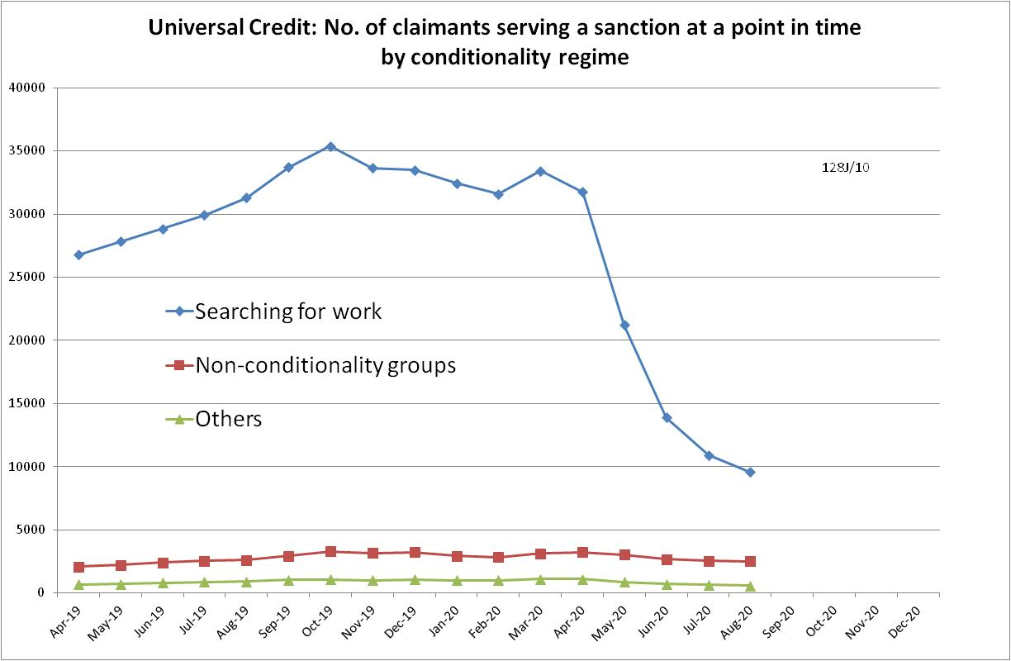

Figure 5
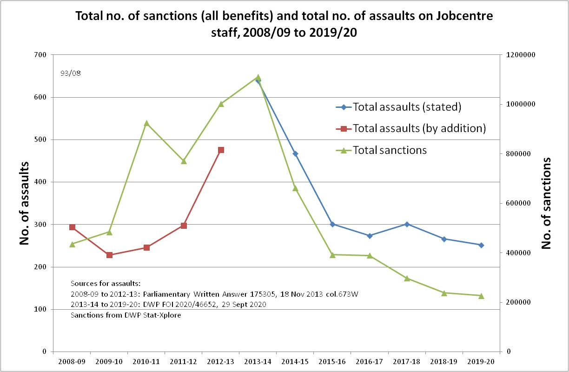

NOTES

Previous briefings include many analyses that are not repeated here but remain valid. However it should be remembered that the DWP may have made subsequent revisions to the data reported in earlier briefings. These revisions will generally not be major although there are exceptions and there may often be substantial changes in some figures for the most recent few months.
The total number of people subject to sanctions cannot be stated exactly, because there are some categories of Income Support claimants other than lone parents with a child under one who are not subject to sanctions, and there are no data on their numbers. However, they are likely to number in the low tens of thousands.
Lone parents with youngest child aged one to five have been estimated simply as four fifths of the total with youngest child aged 0 to five.
The basic concept of the DWP’s sanctions database (except for the new Full Service data) is that each sanction case appears only once, and is given its latest status and attributed to the month of the latest decision on the case. So, for instance, if a decision is made in January 2014 to sanction someone, this decision is reviewed in March 2014 with an outcome unfavourable to the claimant, reconsidered in a ‘mandatory reconsideration’ in May 2014 again with an unfavourable outcome, and is heard on appeal by a Tribunal in October 2014 with a decision favourable to the claimant, - it appears in the statistics for the first time in January 2014 as an adverse ‘original’ decision - in March 2014 it changes its status to a ‘reviewed’ adverse decision and moves month to be with all the other cases where the latest decision has been made in March 2014 - in May 2014 it changes its status to a ‘reconsidered’ adverse decision and moves month to be with all the other cases where the latest decision has been made in May 2014 - in October 2014 it changes its status again to an appealed non-adverse decision, and moves month again to be with all the other cases where the latest decision has been made in October 2014. DWP now says that it aims to change this system for Universal Credit sanctions at some point in the future in order to show all decisions at each stage.
The estimates of sanctions before challenges have been derived by adding the monthly total of ‘non-adverse’, ‘reserved’ and ‘cancelled’ decisions shown as being the result of reviews, mandatory reconsiderations and tribunal appeals, to the monthly total of adverse ‘original’ decisions. This produces only an approximate estimate for each individual month, since decisions altered following challenge are not attributed to the correct month. It will be particularly unreliable for months affected by a DWP catch-up of a backlog of decisions. But the estimates are reliable for longer periods.
A footnote to the Parliamentary Answer of 18 November 2014 states: ‘Please note that a more detailed online system was set up in September 2011 which has improved the quality of our reported incidents.’

