BRIEFING

Benefit Sanctions Statistics

February 2019

19 March 2019

Dr David Webster
Honorary Senior Research Fellow
Urban Studies
University of Glasgow

Email david.webster@glasgow.ac.uk

Webpages: http://www.gla.ac.uk/schools/socialpolitical/staff/davidwebster/
http://www.cpag.org.uk/david-webster
SUMMARY

This Briefing reports on the quarterly benefit sanctions statistics published by DWP on 19 February, giving figures to October or November 2019. The number of claimants on Universal Credit (UC) reached 1.64m in January 2019, when the number of UC claimants subject to conditionality passed one million for the first time, at 1.03m, leaving 0.6m not subject to conditionality. Of the 979,600 unemployed claimants at January 2019, 70.2% were on UC rather than JSA. Altogether almost 2m people are subject to conditionality.

The work search requirements of UC add more people to the count of unemployed claimants (‘additionals’). DWP is now publishing estimates of what the claimant count would have been if UC had been fully rolled out since 2013. It estimates that at November 2018 there would have been 366,000 ‘additionals’, comprising 232,000 (63.3%) who would previously have been claiming Housing Benefit only, 115,700 (31.6%) whose household would have been receiving Child Tax Credits, 14,600 (4.0%) with a partner on ESA, 1,800 (0.5%) with a partner on Income Support, and 1,800 (0.5%) ‘others’. In the event there were an estimated 82,000 ‘additionals’ actually in the claimant count at November 2018. More claimants will result from the change to treatment of mixed-age couples from 15 May 2019.

For most topics, DWP has still not published any statistics for sanctions on the estimated 94% of UC claimants (October 2018) using its UC ‘full service’. The published UC statistics on sanction numbers, numbers of claimants sanctioned, repeat sanctions, reasons for sanctions, Mandatory Reconsiderations and appeals, sanction levels and demographic profile of those sanctioned are based only on the estimated 48,000 claimants still on ‘live service’ at October 2018. Consequently they are now almost worthless. That said, while before-challenge monthly sanction rates on JSA, ESA and IS have bottomed out at low levels, the UC live service rate remains very high. There were about 156,000 sanctions on all benefits other than UC full service in the 12 months to October 2018. The number of UC full service sanctions cannot be estimated.

DWP’s UC figures for the proportion of claimants under sanction at a point in time, and the duration of sanctions, do cover all UC claimants, although they have other methodological weaknesses. As before, they show unemployed UC claimants being treated much more harshly than other UC groups, with about 4% under sanction. Sick and disabled people have always had a higher prevalence of sanctions under UC than under ESA.

Mean completed sanction durations (on DWP definitions) range between 6 and 14 weeks. ESA claimants have always had the longest durations, with over a fifth lasting more than 6 months. This is disturbing given that they are by definition sick or disabled. Durations for both JSA and ESA claimants have been rising. Durations for UC sanctions rose steeply up to Spring 2018, probably because of the DWP’s UC sanction catch-up blitz of 2016-17, but have since fallen back to around the same length as JSA sanctions.

DWP has confirmed that the reduction in recovery rate from 40% to 30% announced in the Budget 2018 will apply to UC hardship payment repayments. This means that in principle some sanctions could now effectively last for 9 years.

A news section reports other sanctions developments and a commentary on the government’s response (11 February) to the Work and Pensions Committee will be circulated separately.
BRIEFING: Benefit Sanctions Statistics
February 2019

INTRODUCTION

The latest quarterly benefit sanctions statistics were released by DWP on 19 February, giving data to the end of October or November 2018. The new data are summarised by DWP in the publication Benefit Sanctions Statistics, available at https://www.gov.uk/government/statistics/benefit-sanctions-statistics-to-october-2018 with an associated spreadsheet with summary tables. The full figures for most aspects of the data are on the DWP’s Stat-Xplore database at https://stat-xplore.dwp.gov.uk/webapi/jsf/login.xhtml

All statistics presented here relate to Great Britain.

Groups of claimants exposed to sanctions:
Universal Credit, JSA, ESA and Income Support

At October 2018, a total of almost two million (1.99m) claimants were exposed to the risk of sanctions, with varying frequency and severity. They were split between Universal Credit (UC), Jobseekers Allowance (JSA), Employment and Support Allowance (ESA) and Income Support (IS).

With the rollout of UC ‘full service’, the number of claimants on UC has been increasing rapidly and by January 2019 had reached 1.64m. Figure 1 shows how the numbers of claimants on UC have increased, by conditionality regime. Of the 1,638,189 UC claimants (provisional) at January 2019, over one third (605,897 or 37.0%) were not subject to conditionality. Of the 1,032,236 UC claimants subject to conditionality, 688,157 were unemployed and 239,859 were working, with 104,220 neither working nor unemployed but required to plan or prepare for work.

Unemployed claimants (i.e. looking for work)

At January 2019 the number of JSA claimants had fallen to 292,406. The combined total of unemployed people on UC or JSA in January 2019 was 979,600, so that over two-thirds (70.2%) of unemployed claimants are now on UC.

The November 2018 Briefing (p.3) explained that UC increases the number of unemployed claimants, by imposing work search requirements on people who would not previously have been subject to them (‘additionals’). On 22 January DWP published for the first time an ‘Alternative Claimant Count’ series back to January 2013 which shows what it estimates the claimant count would have been if UC had been fully rolled out since that date. This is available at
https://www.gov.uk/government/collections/alternative-claimant-count-statistics, together with a paper on Background Information and Methodology.

Figure 2 shows the different available measures of unemployment. The official (ILO) measure of unemployment gives the highest figures. It has been falling. Many unemployed people do not claim benefit, so claimant unemployment, combining unemployed claimants on JSA and UC (the green line in the chart) is lower. But this measure has been rising. The rise is at least partly due to the UC ‘additionals’.

The DWP’s ‘alternative claimant count’ is also shown in Figure 2. This is a hypothetical figure. DWP estimates that at November 2018 there would have been 366,000 ‘additionals’ claiming UC if UC had been fully rolled out, comprising 232,000 (63.3%) who would previously have been claiming Housing Benefit only, 115,700 (31.6%) whose household would have been receiving Child Tax Credits, 14,600 (4.0%) with a partner on ESA, 1,800 (0.5%) with a partner on Income Support, and 1,800 (0.5%) ‘others’. This is the first time that estimates of the numbers of ‘additionals’ have been available by previous benefit status.

However, UC has not yet been fully rolled out and therefore the actual number of ‘additionals’ included within the actual unemployed claimant count is smaller. Figure 3 shows how the composition of the actual total unemployed claimant count has been changing. As at November 2018, the actual unemployed claimant count of 916,910 was composed of 318,219 claimants of JSA, approximately 518,000 UC claimants ‘searching for work’ who were not ‘additionals’, and approximately 82,000 ‘additionals’ who were actually claiming UC. No breakdown by previous benefit status is available for these 82,000 actual ‘additionals’.

The DWP’s estimates of ‘additionals’ are inevitably speculative, and the actual number of additionals who join the claimant count in the future will depend on labour market conditions at the time as well as on benefit entitlements, administrative procedures and claimants’ own decisions. Nevertheless, the fact that only about 82,000 ‘additionals’ were actually claiming UC at November 2018, compared to a hypothesised 366,000 if UC had been fully rolled out, indicates how much further the implementation of the extended conditionality of UC still has to go.

Another change in benefit entitlement, not related to UC, will further add to the unemployed claimant count from 15 May 2019 onwards. The government announced on 14 January that from this date, for couples where one partner is above and the other below the state pension age, entitlement to pension age benefits will depend on the age of the younger partner, instead of the older partner as at present. This means that if they need to claim benefits, both partners will have to apply for working age benefits, which means Universal Credit. The working age partner (though not the retirement age partner) will be subject to conditionality, according to the standard conditionality categories. More information is at https://benefitsinthefuture.com/the-mixed-age-pension-credit-cut-what-does-it-really-mean/
No estimates appear to be available of the numbers of people involved.

Others subject to conditionality

The number of claimants on grounds of sickness and disability who are subject to sanctions can no longer be stated with complete certainty. This is because to the total of claimants in the ESA Work Related Activity Group (WRAG) there needs to be added the number of UC claimants claiming on grounds of sickness or disability. This is not published by DWP. The 65,295 UC claimants ‘preparing for work’ at January 2019 include these people but they also include some people who are not sick or disabled and would previously have claimed IS. The number of ESA WRAG claimants however is known. Their number peaked at 562,620 in August 2013 and has fallen since. There is a continuing gentle decline, with 385,450 at August 2018 and an estimated 379,000 at October 2018.

The number in the ESA Assessment Phase (which has no conditionality) is falling very sharply, to 153,760 in August 2018 from a peak of 546,030 in August 2014. This is presumably mainly because an increasing proportion of new claimants (and 100% from December 2018) are being put on to UC. UC does not have an assessment phase; the ‘Job Coach’ has discretion on what conditions to impose pending the Work Capability Assessment. This provision was criticised by the Work and Pensions Committee (2018, Ch.3). In response (Work & Pensions Committee 2019) DWP has now agreed to ‘explore the possibility’ of producing by summer 2019 a ‘Proof of Concept’ for a general policy of not imposing conditionality on those with a ‘fit note’ awaiting a WCA, although the ‘work coach’ would retain discretion to impose conditions if they choose.

There were an estimated 441,000 claimants on IS and subject to sanctions at October 2018. The largest group among these was an estimated 262,000 lone parents with a youngest child aged between one and five. DWP reports sanctions for these separately. There were also an estimated 165,000 carers and 14,000 other IS claimants. DWP only reports sanctions for the whole of this latter group of 179,000 claimants.

Universal Credit sanctions

Details of the UC sanction regime are given in the DWP’s Sanctions Statistics methodology document at https://www.gov.uk/government/uploads/system/uploads/attachment_data/file/637862/universal-credit-sanctions-statistics-background-information-and-methodology.pdf , in the claimant’s guide at https://www.gov.uk/government/publications/universal-credit-and-you/universal-credit-and-you-a and by OBR (2018, Chapter 3). The UC regime has similar lengths of sanction to those of the previous benefits for the various ‘failures’, but there are some critical differences. Sanctions are lengthened by being made consecutive, not concurrent. Hardship payments become repayable. Given that repayments are made at the rate of 40% of benefit – the same as the amount by which a hardship payment is lower than the benefit – this means that for claimants receiving hardship payments, UC sanctions are in effect 2½ times as long as their nominal length. This will change slightly when the recovery rate is reduced to 30% in October 2019 (Work & Pensions Committee 2019, para.91). From October 2019 effective sanctions for those claiming hardship payments will be three times as long as their stated length but a little less harsh in their later stages. This is a little-noticed consequence of the Budget announcement of 29 October 2018 and means that in principle, some sanctions could effectively last as long as nine years.

All sanctioned UC claimants must also demonstrate ‘compliance’ for 7 days before applying for hardship payments, and must reapply for each 4-week period. The 80% hardship rate for ‘vulnerable’ claimants is abolished. There is a new ‘lowest’ category of sanction which applies to claimants who would previously have been subject to the milder IS sanction regime. But now lone parents with a child aged between 2 and 5 lose their whole Standard Allowance, and those with a child aged 1 lose 40% of it, whereas previously both groups would have lost 20%.

Under UC, the sanction is applied to the amount of the Standard Allowance which is calculated to be due. In the case of in-work UC sanctions, the calculated amount may be less than the full amount, in which case the sanction may also be less. But conversely, where there are deductions from the Standard Allowance for various types of debt, UC sanctions are deducted from the Housing and Child elements to the extent necessary to ensure that the full amount of the sanction is exacted (usually 100% of the Standard Allowance) – making children suffer and creating the risk of eviction. This could not happen under the previous regime of entirely separate benefits. This provision has been criticised by the Work and Pensions Committee (2018, pp.41-42). In response, DWP (Work & Pensions Committee 2019) has said it will ‘explore options for capping overall deductions in relation to sanctions in circumstances where claimants have last resort deductions’ and will write back to the Committee by the end of 2019.

Under UC, a sanction imposed on a claimant in a particular conditionality group remains in place even if the claimant moves to a different group with no conditionality. Under the previous benefit regime the sanction would have ceased. This feature has also been criticised by the Work and Pensions Committee (2018, pp. 40-41). DWP has refused to change this.

Sanctions before and after reviews, reconsiderations and appeals

The DWP’s Benefit Sanctions Statistics publication and Stat-Xplore database only show sanctions after any reviews, reconsiderations and appeals that have taken place by the time the data are published. But numbers of sanctions before the results of these challenges are important since they show all the cases in which claimants have had their money stopped. Although a successful challenge should result in a refund, this is only paid after weeks or months by which time serious damage is often done. Estimates of sanctions before challenges are therefore given here but although reliable for longer time periods, they are not fully accurate for individual months. For JSA and ESA, figures for sanctions before challenges are typically higher than the ‘after challenge’ figures by very large amounts, namely about 20%. and 40% respectively. For UC ‘live service’ (the only figures currently available for the UC appeal process) and for IS, the proportion of sanctions overturned is much smaller at around 5% and 1% respectively. So for these types of sanction there is much less difference between the pre-and post-challenge figures. Wherever possible, this Briefing shows estimated pre-challenge sanctions figures
.

MONTHLY RATES OF SANCTIONS
FOR THE FOUR BENEFITS

On its introduction, Universal Credit was delivered via ‘Live Service’. A programme to transfer Jobcentres to the more sophisticated ‘Full Service’ was started in May 2016 and completed in December 2019. Figure 2 of the November 2018 Briefing presented estimates of how the numbers of UC claimants on each of Live Service and Full Service have changed over time. It is estimated that by October 2018, 94% of UC claimants subject to conditionality were on full service. Yet for UC sanctions, DWP is still publishing only figures for ‘live service’, and even for them gives no breakdown by conditionality group. Not only do the live service figures now relate to only about 48,000 (one in twenty) UC claimants, at October 2018; in addition, those remaining on live service will be untypical, in that they will disproportionately be long term unemployed single people. This makes it impossible to make an accurate estimate of the total numbers of UC sanctions being imposed. Here we present the live service figures as they are. The question of what might be happening to total UC sanctions is taken up later in this Briefing, after considering the DWP’s figures on people serving a sanction at a point in time and on durations of sanctions.

Rates of sanction on the four benefits, before challenges

DWP argues that comparisons between sanction rates on UC and on ‘legacy’ benefits cannot be validly made because of differences in policy. This argument was considered and rejected in Appendix 1 to the November 2018 Briefing.

Figure 4 gives the monthly rates of sanction before challenges for all four benefits for the four years or so for which any data on numbers of UC sanctions are available. For UC it shows only the rate for live service claimants subject to conditionality. Despite fluctuations (sometimes due to administrative backlogs), the UC live service sanction rate before challenges overall has remained extremely high, at 7%-8% of claimants per month. This is way above the rates for the other benefits. The JSA sanction rate has bottomed out at about 0.5% per month and the ESA rate at 0.04%. The rate for lone parents on Income Support is about 0.25% and that for other IS claimants about 0.02%.

Figure 5 presents the available figures on monthly sanction rates back to April 2000. This confirms how extremely high is the UC live service sanction rate - as high as the JSA rate was at the peak of the great sanctions drive of 2010-15 by the Coalition government.

The high monthly rate of UC live service sanctions is the product of a consistently high referral rate, at between 10% and 20% of claimants subject to conditionality per month, and a consistently high proportion of referrals which result in sanction, at about 80% when reserved and cancelled decisions are excluded (see Figure 4 of the November 2018 Briefing).

PROPORTION OF CLAIMANTS UNDER SANCTION AT A POINT IN TIME

The DWP’s preferred measure of sanctions ‘rate’ is the number and proportion of claimants who are serving a sanction at a point in time. These figures cover both live and full service, but there are various problems with this measure, which were discussed in the November 2017 Briefing (pp.6-10). In particular, it does not show people who stop claiming because of the sanction, or people who resume a sanction on returning to benefit, or those on UC who still have reduced benefits as a result of repaying hardship payments. This measure also gives no idea of the total number of people who have been subjected to sanctions over a given period such as a year, which is a serious weakness given that the effects of a sanction often last a long time. There are also particular problems with the JSA estimates, which do not appear credible at all. However, the figures do have the advantage that in respect of UC, they show the differing prevalence of sanctions for the different conditionality groups, and any trends will at least to some extent reflect similar trends in the numbers of sanctions being imposed.

Figures allowing calculation of the percentage of UC claimants under sanction at a point in time by conditionality group were first published by DWP in May 2018. Figure 6 updates these figures. After a downward trend, there is now a levelling off in all the groups. The unemployed are treated much more harshly than the other groups, with about 4% under sanction in the latest quarter, whereas the others are all below 1%. The in-work group previously came second, but they have now been overtaken by the ‘preparing for work’ group of mainly sick and disabled people. This is presumably due to the ending of the DWP’s large-scale trials of in-work conditionality.

Figure 7 compares the proportion of ESA Work Related Activity Group (WRAG) claimants who are under sanction at a point in time with the same proportion for UC claimants in the ‘no work requirements’ and ‘preparing for work’ conditionality groups. These are the groups containing sick and disabled people, though they also contain a minority of other people – lone parents and carers. The chart shows that sick and disabled people have always had a higher prevalence of sanctions under UC than under ESA. The difference for those in the ‘preparing for work’ group, the equivalent of the ESA’s WRAG, is about 0.75% of claimants. The only reason that anyone in the ‘no work requirements’ UC group is under sanction is that, as noted earlier, under UC a claimant must serve out their sanction even if they move into a no-conditionality group. At October 2018 there were 668 claimants in this position in the ‘no work requirements’ group and 604 in the ‘working – no requirements’ group.

DURATION OF COMPLETED SANCTIONS

The DWP’s ‘experimental’ statistics on the duration of completed UC, JSA and ESA sanctions were discussed in the November 2017 and August 2018 Briefings. They are not included in Stat-Xplore, but only in the spreadsheet accompanying Benefit Sanctions Statistics. A full set of these statistics is now available, going back to August 2015, October 2012 and November 2012 respectively for UC, JSA and ESA, and the opportunity is taken here to make a full comparative analysis.

The UC duration figures cover both live and full service, but there are various problems with this measure, which were discussed in the November 2017 Briefing (pp.6-8). As in the case of the proportions of people under sanction at a point in time, all the durations are understated. They show not the durations imposed, but the actual durations including the shorter durations of people who leave benefit before the sanction is fully served (often because of the sanction) and of those with successful challenges. They do not include the unserved portions of sanctions which claimants who leave before the sanction is completed are made to serve if they later reclaim. They also do not reflect the effect of repayment of UC hardship payments. They therefore do not show anything like the full impact of sanctions in lowering claimants’ incomes.

Benefit Sanctions Statistics prints only the median length of sanctions, i.e. the length which is longer than half of all sanctions and shorter than the other half. This is a useful measure for some purposes, but does not tell the whole story. In particular it does not show what is happening to the numbers of very lengthy sanctions. Because sanctions are for discrete lengths (4 weeks, 13 weeks etc.) the median also has a tendency to make big jumps in response to what are actually minor changes. The data provided by DWP have therefore been used here to make what will be a very accurate estimate of the mean length of sanctions, using alternative assumptions that the average duration for cases in the open ‘27 weeks or more’ class interval is either 30 or 40 weeks.

Figure 8 shows the mean and median durations of completed UC sanctions. When these figures were last examined, in the August 2018 Briefing, it looked as though there was a consistently rising trend. However the latest figures show that after peaking at 13-14 weeks in April 2018, the mean duration has fallen back to 6-7 weeks in November 2018. The most likely reason for this appears to be the ‘blitz’ which DWP mounted to clear a backlog of sanctions cases in the winter of 2016-17. If many of these were repeat sanctions on the same individuals, the rule that UC sanctions are consecutive rather than concurrent, together with the inability of the DWP’s methodology to distinguish between a single long sanction and two or more shorter ones served consecutively, will have produced a clutch of apparently very long sanctions. As these worked their way out of the system, the apparent average duration would fall back.

The median length of UC sanction in Figure 8 shows less movement than the mean, being mainly around 4 weeks except for a couple of spikes in May/June 2017 and April 2018.

Figure 9 shows the mean and median duration of completed JSA sanctions. There has been a very gently rising trend from 5 weeks to 6 weeks since 2014, which accelerated a little to over 7 weeks in 2017/18. This latter acceleration probably reflects the increasing preponderance in the stock of JSA claimants of longer term unemployed people who are more likely to have repeat sanctions. The marked spike in June 2018 is based on very few cases – only 114, compared to around 17,000 per month during 2013. Again, the median is of very little interest.

Figure 10 shows the mean and median durations of completed ESA sanctions. Here there has been a steady and markedly rising trend, from 8 weeks in 2014 to around 12 weeks in 2018. Again the spike in June 2018 is based on only 122 cases, compared to over 2,000 per month in 2013/14. The median shows no movement for most of the time, obscuring the upward trend which is obvious in the figures for the mean.

Figure 11 compares the mean durations for UC, JSA and ESA, using the 40-week assumption for the top class interval. Given that all ESA WRAG claimants are by definition sick or have disabilities, it is disturbing that they have had the longest sanction durations – mostly 10 weeks or more, compared to 6 weeks for JSA. This is probably due partly to the fact that, being typically dependent on benefits over long periods, fewer of them have the option of leaving benefit because of the sanction, and also partly because ESA sanctions last ‘until compliance’, with a further penalty added on; ‘compliance’ can be difficult to demonstrate, particularly if a contractor is involved. The UC mean sanction length has behaved too erratically for much to be said about it. The fluctuations partly reflect the changing composition of the stock of UC claimants in terms of conditionality groups, partly the methodological issue discussed earlier, and partly the (unknown) volume of sanctions.

Figure 12 compares the durations for UC, JSA and ESA in terms of the proportion of sanctions which are of each stated length, for the latest available quarter in each case. Compared with the figures shown in the August 2018 Briefing, the proportions of UC sanctions in the longest duration categories have fallen markedly, although 14.2% (one in seven) are lasting over three months. Again, the striking feature is the very high proportions of ESA sanctions which are in the longest categories – more than one fifth (21.4%) lasted over 6 months, and over one third (35.5%) lasted over three months.

NUMBERS OF SANCTIONS ON ALL BENEFITS BEFORE CHALLENGES IN THE YEAR TO 31 OCTOBER 2018

Because of non-publication of statistics on numbers of UC full service sanctions, it is no longer possible to produce any sensible estimate of the total number of sanctions on all benefits before challenges. In the 12 months to October 2018 there were 119,000 UC live service sanctions, 26,000 JSA, 3,000 ESA and 9,000 IS sanctions giving a partial total of approximately 156,000 sanctions before challenges in these 12 months. On a simple pro rata basis, the number of UC full service sanctions could be estimated at over 400,000. But this would be a guess and there is insufficient information to justify it.

It is also not possible to say what is the trend in the overall rate of UC sanctions. Figure 4 indicates that there is no overall trend in the rate for live service. Figure 6 on the proportion under sanction at a point in time might suggest a downward trend in the rate of sanctions. But the fall in recent months could simply be due to the working out of the system of the increased numbers of lengthy sanctions (on the DWP’s methodology) created by the blitz of 2016-17.

The reality is that we urgently need publication of statistics on numbers of UC full service sanctions. There is no substitute for them.

REPAYMENT OF HARDSHIP PAYMENTS

DWP has yet to publish any data on numbers of UC hardship payments. However, the government response to the Work & Pensions Committee report on Benefit Sanctions (2019, para.93), offers the first, fragmentary, information on repayments of UC hardship payments. The text states that ‘For eligible Universal Credit Full Service claims paid in September 2018, 5,300 (less than 1 per cent) have repayments taken for a RHP (Repayable Hardship Payment) (rounded to the nearest hundred).’

The total of Full Service claimants subject to conditionality at September 2018 was approximately 713,000, which matches with the ‘less than 1%’. The total of UC claimants in groups subject to conditionality who were serving a sanction at the same date was 20,883. These figures give some idea of the scale involved, but because of the varying lengths of sanctions and of repayment periods, no simple conclusion can be drawn about what proportion of sanctioned UC claimants are getting hardship payments. It would not be correct to conclude that about one quarter of sanctioned UC claimants are getting hardship payments.

Para.93 of the DWP response goes on to say that only 12% of those repaying hardship payments in September 2018 had a recovery rate at the maximum of 40% of Standard Allowance. It should be borne in mind that people repaying at a lower rate may still have been getting only 60% or less of their benefit, if they were making other repayments. And of course a lower recovery rate means that benefit will be reduced for a longer period.

ANALYSES NOT INCLUDED IN THIS ISSUE

Non-publication of data on numbers of UC full service sanctions means that in turn, the published figures on matters such as numbers of claimants sanctioned, repeat sanctions, reasons for sanctions, Mandatory Reconsiderations and appeals, sanction levels and the demographic profile of those sanctioned are now almost worthless. This is therefore not a good time to update these other analyses.

Readers are referred to earlier numbers of the Briefing for analyses of issues not discussed in the present issue. Figures on claimants with earnings following a sanction were covered in November 2018; ethnicity and gender in July 2018; benefit destinations in February 2018; challenges to sanctions in February 2018 and May 2017; JSA benefit suspensions not followed by sanction, and ESA sanctions by medical condition in August 2017; and reasons for sanctions in May 2017. Longer period analyses were included in the author’s written evidence to the Work and Pensions Committee (Webster 2018). These analyses will be updated in future numbers. Obviously it is hoped that it will soon be possible to produce a full range of updated analyses for UC covering ‘full’ as well as ‘live’ service.

SANCTIONS - OTHER DEVELOPMENTS

Government Response to the House of Commons Work and Pensions Committee report on Benefit Sanctions

The government response to the important Work and Pensions Committee report on Benefit Sanctions of November 2018 was published on 11 February. A separate briefing note is being circulated on this and will appear on the webpage www.cpag.org.uk/david.webster

Social Security Advisory Committee – research on the Claimant Commitment

The SSAC has announced that it is conducting research into the Claimant Commitment. Details are at
https://www.gov.uk/government/consultations/claimant-commitment/call-for-evidence-on-the-claimant-commitment and evidence submissions are invited by 16 April.

Social Mobility Commission report on falling investment in adult training

This report (Social Mobility Commission 2019), published on 29 January, underlines how far the UK has tipped over into a ‘work first’, punishment-oriented approach to non-employment, neglecting positive incentives and workforce development. This contrasts with the more positive, ‘human capital’ oriented approaches followed in many other countries. The report found:
- As a proportion of GDP, public expenditure on training in Great Britain was among the lowest of the G7 countries between 2004-2011 (the latest figures available) with only Japan at comparably low levels; spending in France was some 30 times higher
- Government funding for the Adult Skills Budget fell by 34% in real terms between 2010/11 and 2015/16.
- International comparisons of employer skills training suggest that it is the quality of
training which is relatively low in the UK.
- Disadvantaged adults with the lowest qualifications are the least likely to access adult training despite being the group who would benefit most.
- Graduates are 3 times more likely to receive training than those with no qualifications, while professionals and managers are about twice as likely to receive training as lower-skilled workers.

Inquiry into the effects of the Welfare Reform and Work Act 2016

Debbie Abrahams MP, chair of the All-Party Parliamentary Group (APPG) for Health in All Policies, and her colleagues have launched an inquiry into the effects of the Welfare Reform and Work Act 2016, focusing on impacts on children and disabled people. Details are at http://debbieabrahams.org.uk/debbie-launches-inquiry/ Topics considered will include the changes in conditionality for responsible carers under Universal Credit. Submissions are invited to appg@publicmatters.org.uk by Friday 22nd March 2019.

Centre for Welfare Reform – Call for a cumulative impact assessment

The Centre for Welfare Reform has pointed out that the government has never carried out any comprehensive analysis of the total impact on disabled people of the spending cuts and changes to social security since 2010. In response to pressure, the Secretary of State on 30 November 2018 produced a statement of reasons why it claims it cannot do this. The Centre has now published a paper, by Simon Duffy, refuting the government’s arguments, at
https://www.centreforwelfarereform.org/library/by-az/cumulative-impact-assessment-cia.html The report was followed by a debate in the House of Commons on 19 December, organised by Debbie Abrahams MP and Kate Green MP, reported at
https://hansard.parliament.uk/Commons/2018-12-19/debates/785092AB-6594-423B-A48E-41714F822FED/DisabilitySupport#

New study on reduced hours working and stress

A new study of the impact of reduced working hours on stress (Chandola et al. 2019) has found that in a large representative study of UK adults, male and female employees who made use of reduced hours working arrangements had lower levels of allostatic load (an index of chronic stress-related biomarkers). Among women caring for two or more children aged under 15, there was a difference of almost one unit of the allostatic load index (an additional biomarker risk) between women who used reduced hours flexible work and those without such arrangements. Reduced hours flexible work arrangements could enable women who combine work and family roles to reduce their levels of chronic stress. The DWP’s conditionality regime is of course designed to put pressure on claimants to work more.

UK compliance with the European Social Charter

The UK is a signatory to the European Social Charter (ESC), which is a sister to the European Charter on Human Rights (EHCR). It comes under the aegis of the Council of Europe and is not affected by Brexit. However, although the UK has undertaken obligations under the ESC, they are not enforceable in the UK courts. A new article by Mark Simpson (2018) assesses the UK’s compliance with the ESC and argues that social benefit levels and conditionality, including sanctions, are at best in questionable conformity with various core Articles of the Charter. It also suggests that there is scope for the ESC to influence UK judicial interpretations of the EHCR.

Universal Credit Essentials – Self-help advice for claimants

A new Facebook group, ‘Universal Credit Essentials’ is at https://en-gb.facebook.com/groups/UCEssentials/ It enables claimants to swap advice about navigating issues around Universal Credit, including sanctions. It already has almost 25,000 members.

NAO investigation into healthcare penalty charge notices

The November 2017 and August 2018 editions of the Briefing reported on the problems being caused by the English NHS system of fines on patients alleged to have wrongly claimed free dental treatment. The NHS in England also fines people for allegedly claiming free prescriptions when not entitled. According to the Guardian on https://www.theguardian.com/society/2018/mar/10/nhs-falsely-accuses-thousands-patients-prescription-fraud, 1,052,403 prescription fines were issued in 2017, of which 342,882 (32.6%) were wrongly issued and subsequently withdrawn. A further article in the Observer, 3 February 2019 expanded on the problems and also highlighted the fact that many fines have been issued because the NHS has not updated prescription forms to include Universal Credit.

The National Audit Office has now decided to conduct an investigation into this system. The notice is at https://www.nao.org.uk/work-in-progress/investigation-into-healthcare-penalty-charge-notices/ See also https://www.bbc.co.uk/news/education-47072903 and
https://www.theparliamentaryreview.co.uk/news/national-audit-office-to-investigate-unfair-nhs-penalty-charges

SCOTLAND

Scottish Parliament Social Security Committee report on
Social Security and In-Work Poverty

The report on this inquiry was published on 6 February, at
https://digitalpublications.parliament.scot/Committees/Report/SC/2019/2/6/Social-Security-and-In-Work-Poverty# In-work conditionality was the second most often raised concern in written submissions (para.112-34). The report concludes ‘Given the DWP has no evidence to support the development of in-work conditionality and, more fundamentally, that the Committee is opposed in principle to attaching punitive conditions to those already in work, the Committee does not support any extension of in-work conditionality.’ (para.133) It goes on to say ‘Furthermore, as tax credits, administered by HMRC, are not subject to conditionality or sanction, there is a strong case to be made for not only halting further migration of people in receipt of tax credits to Universal Credit but also to considering the removal of tax credit support from Universal Credit altogether and continuing to use HMRC unless the threat of conditionality and sanctions are removed.’ (para.134)

Scottish Government 2018 annual report on Welfare Reform

Every year since 2012, the Scottish Government has published a report on the impacts of the Welfare Reform Act 2012 and associated measures. The latest annual report was published on 1 October at https://www.gov.scot/publications/2018-annual-report-welfare-reform/

Scottish Social Security Charter

The draft Scottish Social Security Charter was laid before the Scottish Parliament on 10 January and is available at https://www.alliance-scotland.org.uk/blog/news/social-security-charter-presented-to-the-scottish-parliament/ One of the key points is that payments should continue while any negative decision is appealed.

Sanctions and mental health – A new report from Scotland

The Scottish Association for Mental Health has published a report (SAMH 2019) on the damaging effects of UC on people with mental health conditions, with sanctions a particular concern. It is based on a combination of literature review, first-hand claimant accounts and the experience of advisers. It says ‘it is clear that Work Coaches do not currently have the necessary skills or time to make accurate assessments of someone’s health to set appropriate conditions’. It recommends that sanctions should end for people with mental health problems.

Street begging in Edinburgh

A new report (Shelter Scotland 2019) profiles people who were begging in Edinburgh over the last couple of years, using information provided by three voluntary organizations. Information was gathered on a total of 420 individuals, with a core dataset of 139 and survey responses for 54. Within the core dataset, 31.8% had been sanctioned. Struggling to keep benefits appointments was mentioned specifically by a handful of people as the cause of the sanctions and this issue was borne out by the fact that one third of survey respondents regularly found it difficult to keep appointments.

Universal Credit promotes revival of loan sharks in Scotland

The Glasgow Herald on 31 December at
https://www.heraldscotland.com/news/17328439.universal-credit-rules-are-forcing-scots-to-use-loan-sharks/
reported that a study by the Illegal Money Lending Unit (Nick Hopkins Consulting 2018) has found that ‘aspects of UC – including the “waiting period” before payments commence and sanctions that stop the income of those deemed to have broken the rules – are among the reasons people are being driven to turn to illegal lending’. Repayments to the sharks are often enforced through actual or threatened violence.

INTERNATIONAL

Sanctions: Developments in Germany

The November 2018 Briefing highlighted a Financial Times report on the role played in the electoral decline of the German Social Democratic Party by its attachment to benefit sanctions. On the weekend of 10 February the Party decided to end ‘senseless and degrading’ sanctions (‘sinnwidrige und unwürdige Sanktionen’) altogether. This is less than a commitment to abolish all sanctions, as it goes on to say that the harsher sanctions on under-25s (a feature of the German but not UK system) ‘are manifestly counterproductive’; that no one should fear homelessness as the result of a sanction, so that housing support payments should not be touched (loss of these is also a feature of the UK system); and that there should no longer be a complete loss of benefits (which is also a feature of the UK system). The full policy paper Arbeit – Solidarität - Menschlichkeit: Ein Neuer Sozialstaat für Eine Neue Zeit is available at
https://www.spd.de/aktuelles/ein-neuer-sozialstaat-fuer-eine-neue-zeit/. Google will provide a (somewhat garbled) translation.

A challenge to benefit sanctions has been taken to the German Constitutional Court. It ruled on 23 January that the case was inadmissible as it was not of fundamental constitutional significance: https://www.bundesverfassungsgericht.de/SharedDocs/Entscheidungen/DE/2019/01/rk20190123_1bvr297513.html
However the case has generated much survey and other evidence against sanctions, which can be seen at
https://tacheles-sozialhilfe.de/startseite/tickerarchiv/d/n/2462/
https://tacheles-sozialhilfe.de/startseite/aktuelles/d/n/2461/
and https://tacheles-sozialhilfe.de/startseite/aktuelles/d/n/2207/

Official German sanctions statistics can be found at
https://statistik.arbeitsagentur.de/nn_1021952/SiteGlobals/Forms/Rubrikensuche/Rubrikensuche_Form.html?view=processForm&resourceId=210368&input_=&pageLocale=de&topicId=1023376&year_month=201809&year_month.GROUP=1&search=Suchen

Finally, a German NGO Sanktionsfrei has had a bright idea for action research. Over the next three years a sample of claimants will have any sanctions immediately and unconditionally reimbursed by Sanktionsfrei, and their outcomes will be compared with those of a control group. Results of a small pilot were very satisfactory. Details are at
https://www.dw.com/en/germanys-welfare-experiment-sanction-free-basic-security/a-46629933

Conditionality for the unemployed in France

Following legislation last September, conditionality and sanctions against unemployed people have been made harsher with effect from 3 January. Some details are at
https://www.bastamag.net/Cela-va-vraiment-etre-tres-violent-des-agents-de-Pole-emploi-reagissent-aux

Trump administration increases work requirements for SNAP

Just before Christmas, the Trump administration announced increased restrictions on the availability of food stamps for unemployed people. As it is, the Supplemental Nutrition Assistance Program (SNAP) requires able-bodied adults without dependent children to work or engage in job training, and restricts them to three months of benefits every three years if they cannot do so. But states can exempt adults in areas with high unemployment rates from that three-in-three rule. The proposed change would bar states from offering that exemption unless the local unemployment rate is more than 7 percent, which would cut an estimated 800,000 people from the programme. Further details are at
https://www.theatlantic.com/ideas/archive/2018/12/trump-adds-work-requirements-snap/578746/

Work requirements for healthcare – disastrous experience in Arkansas

The February 2018 Briefing (p.13) reported how the Trump administration has allowed states to make Medicaid conditional on work or training. Now the Economist (16 February 2019) at https://www.economist.com/leaders/2019/02/16/dont-put-work-requirements-on-medicaid has reported on the disastrous experience of this experiment in Arkansas and analysed how the Administration has misunderstood the problem.

US Financial Diaries

It seems usually to be assumed by British policymakers that low income people are bad at budgeting. Hence the recurrent attempts to ‘train’ claimants in managing their money by not allowing direct payment of housing assistance to the landlord, and by the elongation of payment periods as in UC. An American study by Morduch & Schneider (2017) challenges this view by using the novel method of studying a sample of intensive financial diaries. This shows that people do in fact display a lot of initiative and ingenuity in coping with what are difficult financial circumstances. Details are at https://www.usfinancialdiaries.org/ The study is being replicated in Britain by researchers at the Yunus Centre for Social Business and Health, Glasgow Caledonian University.

REFERENCES

Chandola, Tarani, Cara Booker, Meena Kumari & Michaela Benzeval (2019) ‘Are flexible work arrangements associated with lower levels of chronic stress related biomarkers? A study of 6,025 employees in the UK Household Longitudinal Study’, Sociology, 28 February

House of Commons Work and Pensions Committee (2018) Benefit Sanctions, Nineteenth Report of Session 2017-19, HC 955, 6 November, at
https://publications.parliament.uk/pa/cm201719/cmselect/cmworpen/955/955.pdf

House of Commons Work and Pensions Committee (2019) Benefit Sanctions: Government Response to the Committee’s Nineteenth Report of Session 2017-19, HC 1949, 11 February,, at https://publications.parliament.uk/pa/cm201719/cmselect/cmworpen/1949/1949.pdf

Morduch, Jonathan & Rachel Schneider (2017) The Financial Diaries: How American Families Cope in a World of Uncertainty, Princeton University Press

Nick Hopkins Consulting with Craigforth (2018) Illegal Moneylending in Scotland: Exploring the experience of customers, and organisations working with them, November,
at http://www.tsscot.co.uk/news/illegal-money-lending-research

Office for Budget Responsibility (2018) Welfare trends report, Cm 9562, January 2018, at
http://obr.uk/docs/dlm_uploads/WelfareTrends2018cm9562.pdf

Scottish Association for Mental Health (2019) ‘It was a confusion’: Universal Credit and Mental Health: Recommendations for Change, Glasgow, March, at
https://www.samh.org.uk/about-us/news-and-blogs/new-report-finds-that-universal-credit-is-not-working-for-people-with-menta

Shelter Scotland (2019) Street Begging in Edinburgh: A comprehensive evaluation of data available November 2016 to October 2018, Edinburgh, January, available at
https://scotland.shelter.org.uk/professional_resources/policy_library/policy_library_folder/shelter_scotland_street_begging_research_edinburgh_2019

Simpson, Mark (2018) ‘Assessing the Compliance of the United Kingdom’s Social Security System with its Obligations under the European Social Charter’, Human Rights Law Review, December, 18: 745–769 doi: 10.1093/hrlr/ngy030

Social Mobility Commission (2019) The adult skills gap: is falling investment in UK
adults stalling social mobility?, January, at https://www.gov.uk/government/publications/low-skilled-adults-are-missing-out-on-training-the-skills-gap

Webster, David (2018) Written evidence to the House of Commons Work and Pensions Committee inquiry into Benefit Sanctions, at
http://data.parliament.uk/writtenevidence/committeeevidence.svc/evidencedocument/work-and-pensions-committee/benefit-sanctions/written/82601.pdf

Figure 1
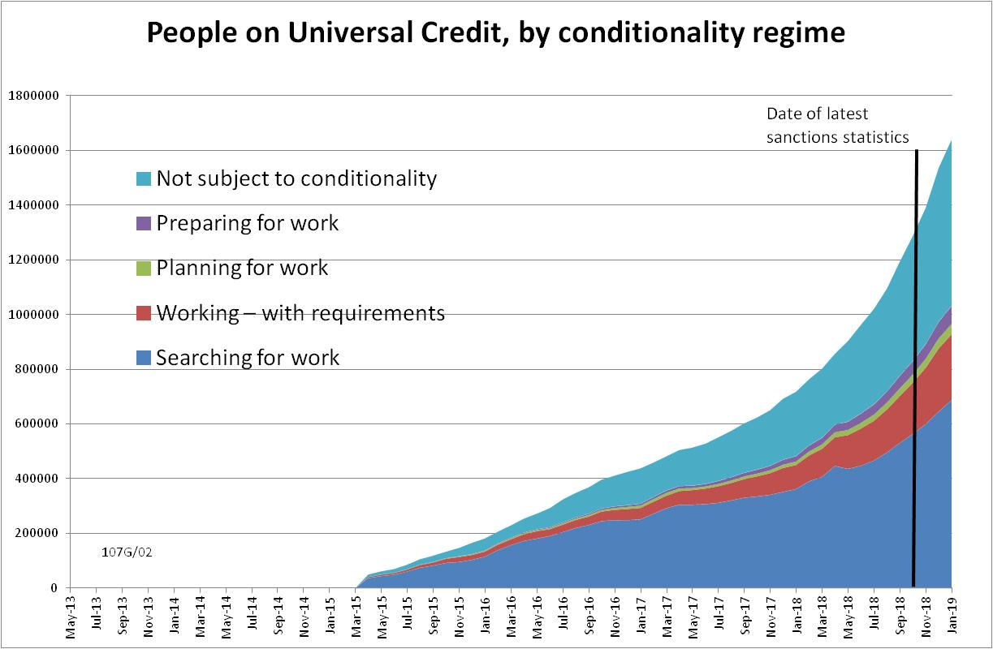

Figure 2
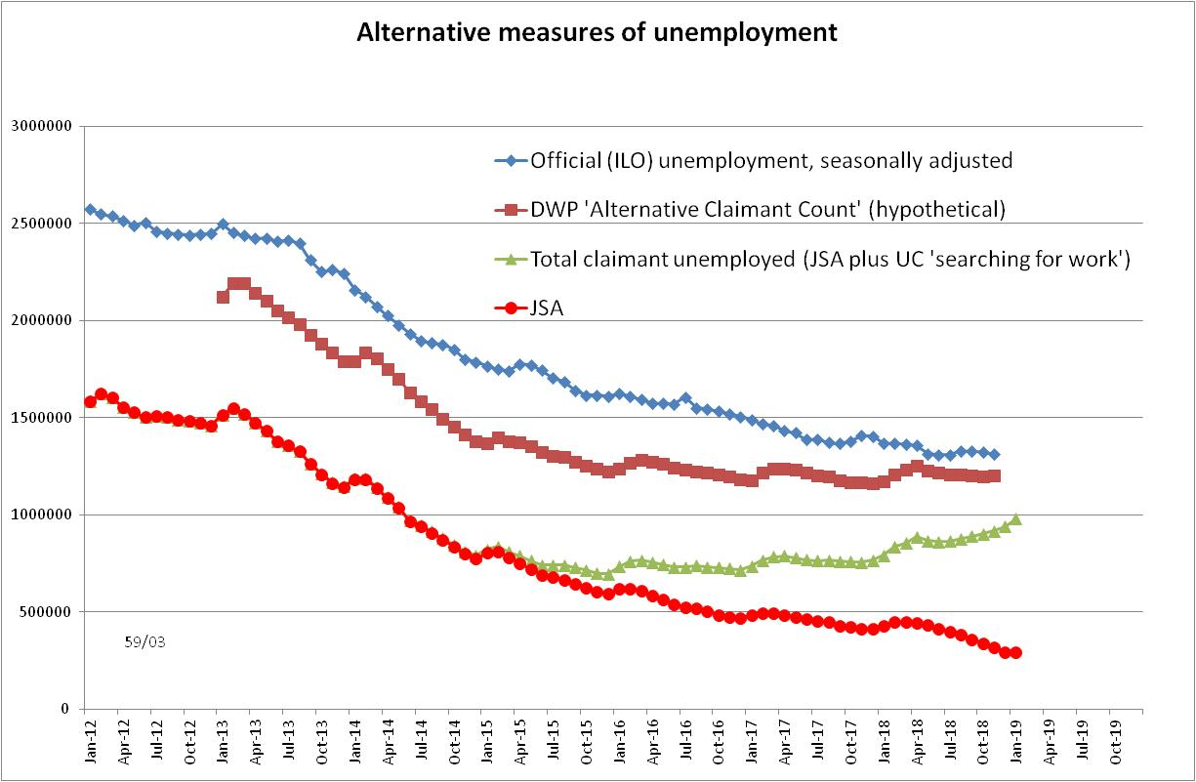
Figure 3
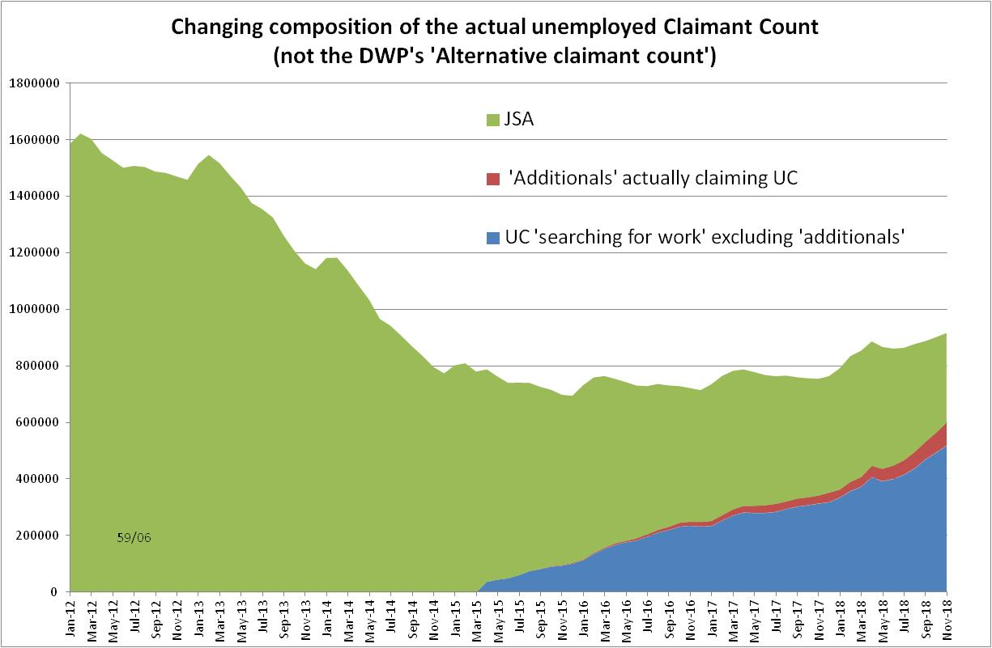

Figure 4
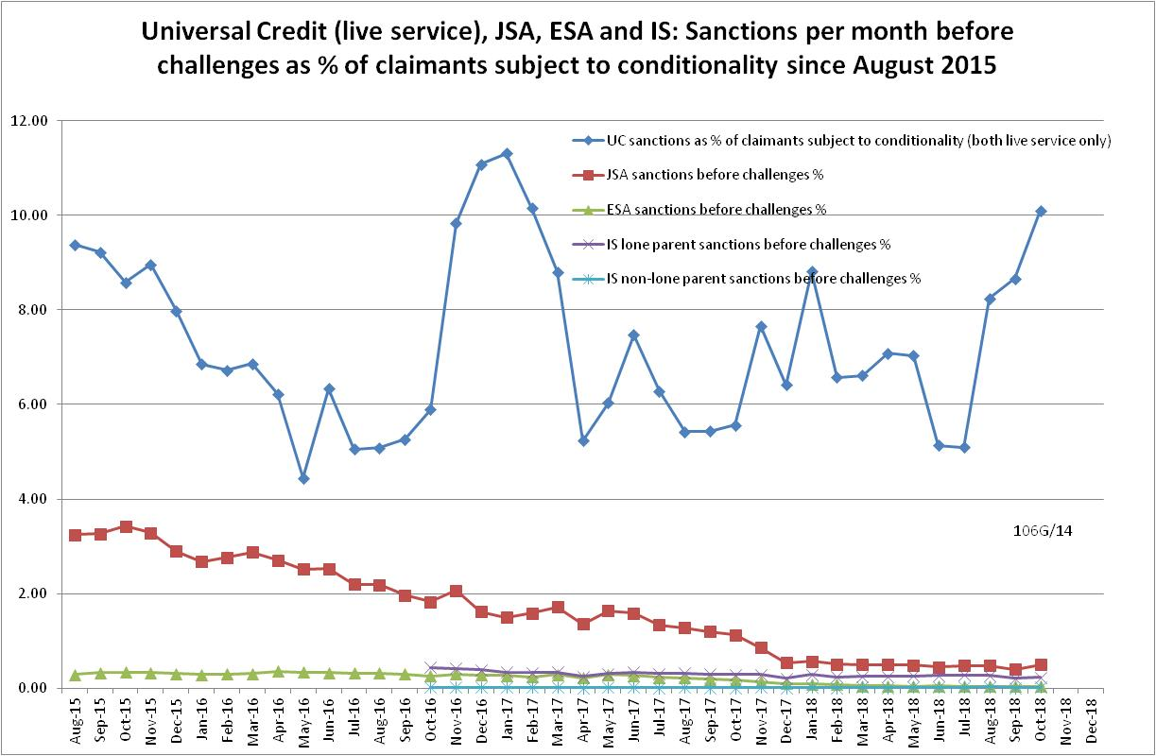

Figure 5
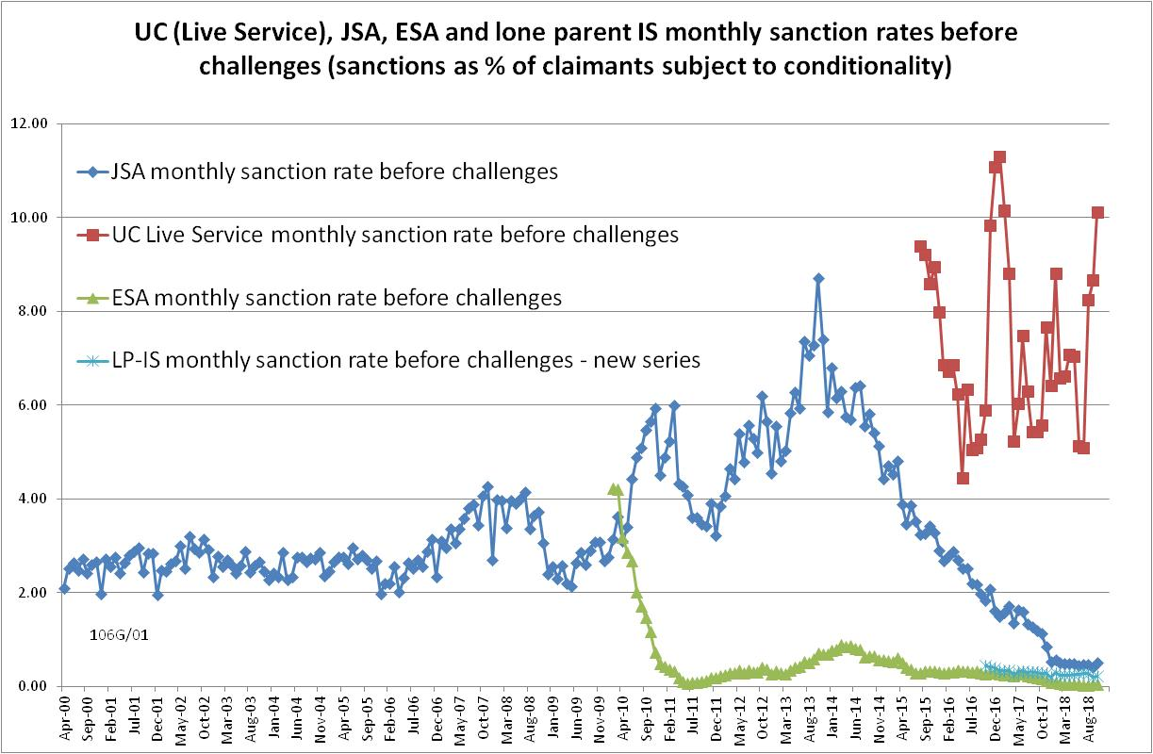

Figure 6
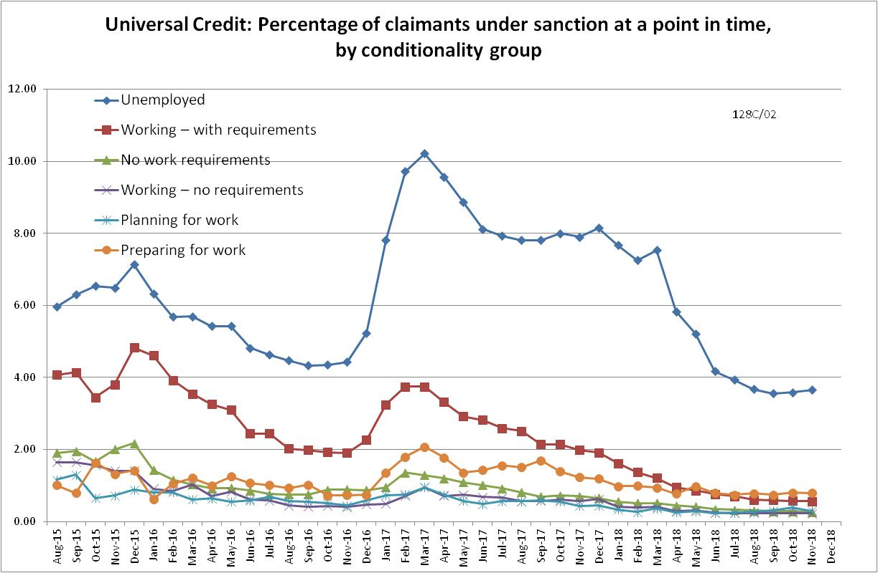

Figure 7
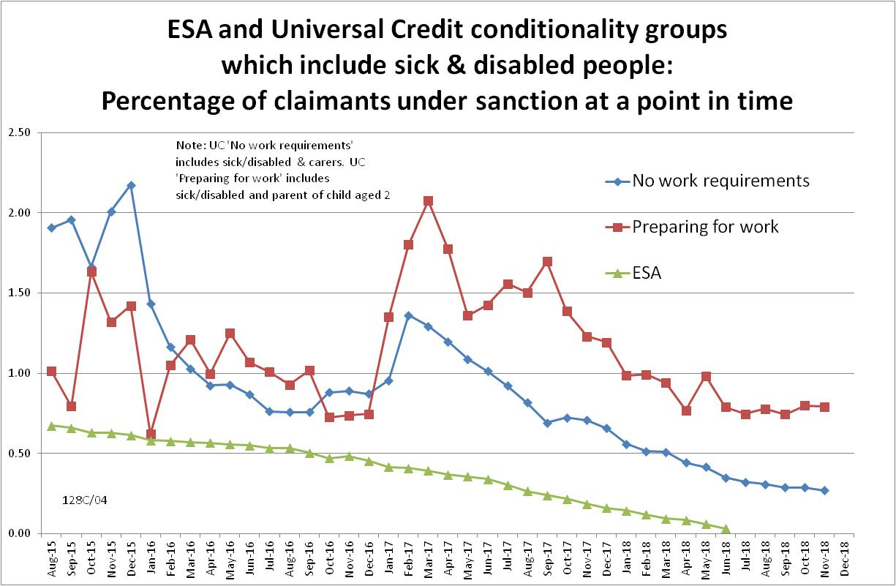

Figure 8
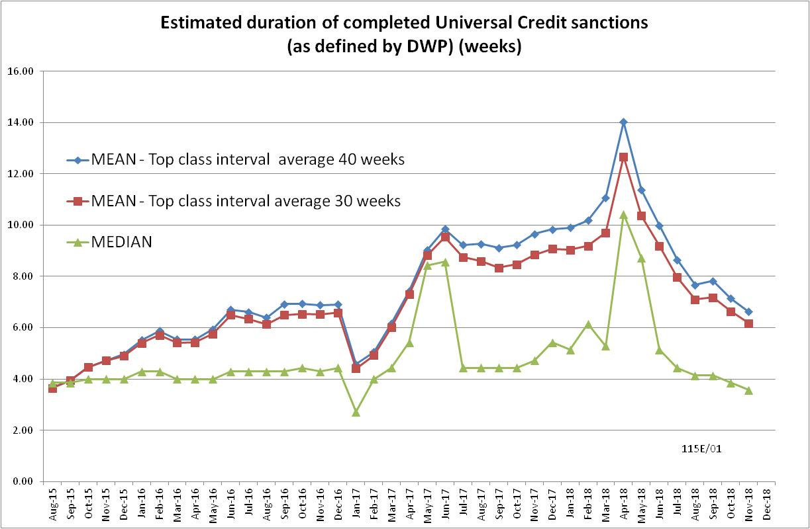

Figure 9
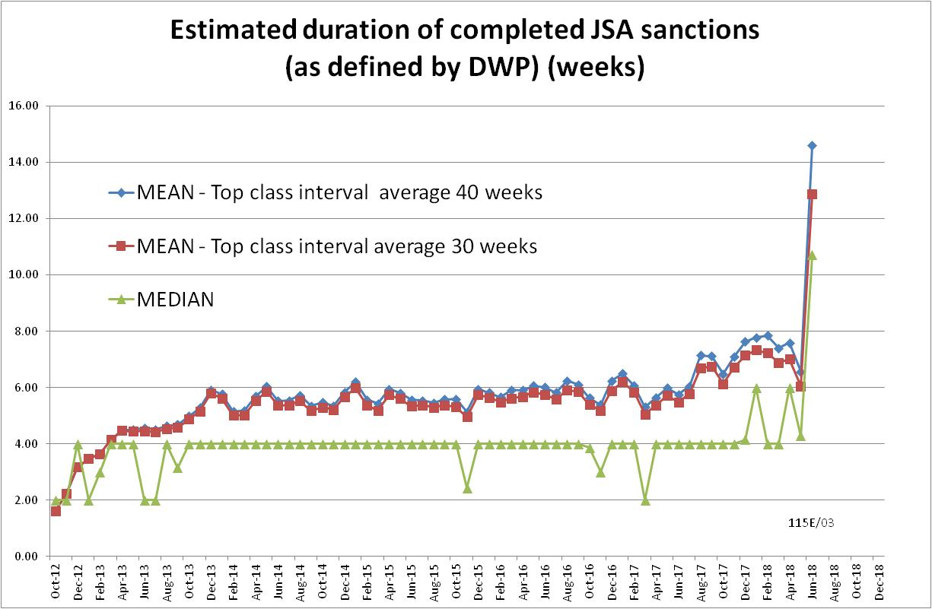

Figure 10
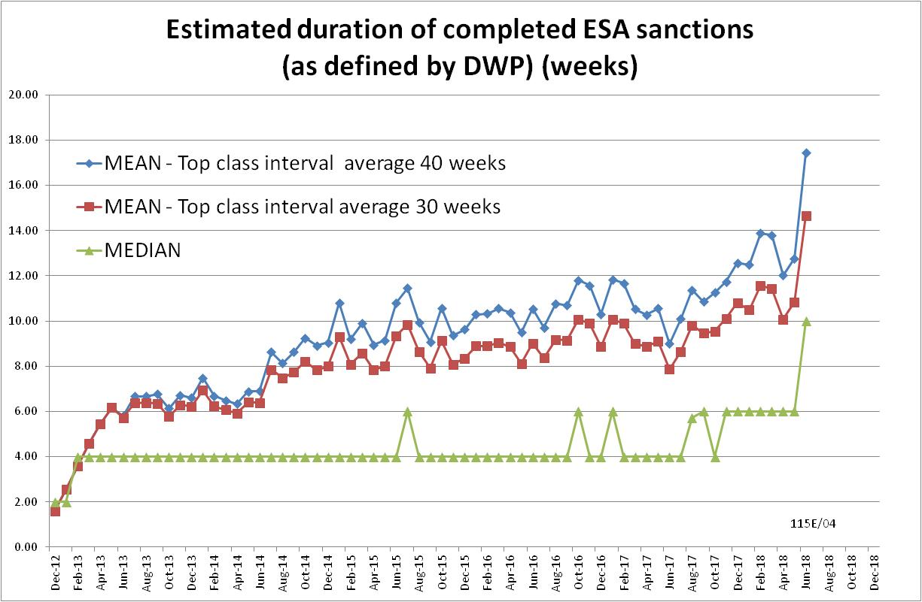

Figure 11
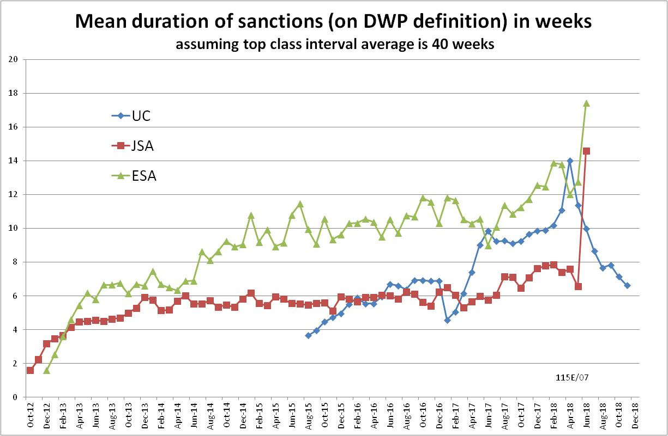

Figure 12
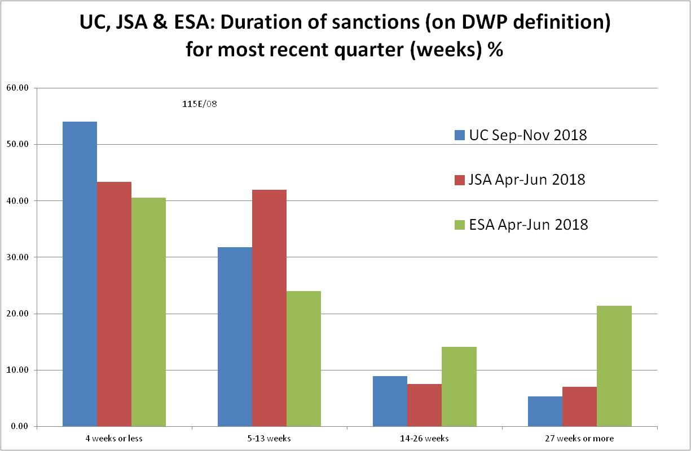

NOTES

Previous briefings are available at http://www.cpag.org.uk/david-webster. They include many analyses that are not repeated here but remain valid. However it should be remembered that the DWP may have made subsequent revisions to the data reported in earlier briefings. These revisions will generally not be major although there may be substantial changes in some figures for the most recent few months.
The total number of people subject to sanctions cannot be stated exactly, because there are some categories of Income Support claimants other than lone parents with a child under one who are not subject to sanctions, and there are no data on their numbers. However, they are likely to number in the low tens of thousands.
The in-work UC claimants subject to conditionality are low paid or part-time workers who prior to UC would not have been subject to sanctions at all. Those ‘planning for work’ are mainly lone parents with a child aged 1, while those ‘preparing for work’ are people who would have been in the ESA Work Related Activity Group, and lone parents with a child aged 2 but under 5. The statistical categories for conditionality regime used in Stat-Xplore are explained in the ‘i’ feature next to the variable name in Stat-Xplore and also in the Universal Credit Statistics methodology document at https://www.gov.uk/government/publications/universal-credit-statistics-background-information-and-methodology
Lone parents with youngest child aged one to five have been estimated simply as four fifths of the total with youngest child aged 0 to five.
The Work and Pensions Committee report (2018, p.59) has a useful chart showing the effect of repayable hardship payments on the effective length of sanctions. A qualification is that repayment is suspended for any month when the claimant earns more than their threshold, and any remaining debt is written off if the earnings threshold has been met for 26 weeks, whether continuous or not. This is only of any use to someone who has a realistic chance of earning.
UC hardship payments are 60% of the benefit. Repaying them at 30% of benefit will take twice as long as the original sanction length, making the total duration of the reduction in benefit three times as long as the original sanction length.
The Standard Allowance is the basic living amount for a single adult, before the addition of other amounts for housing costs, children etc.
The rules for recovery of debts were explained in Appendix 2 of the November 2018 Briefing.
The basic concept of the DWP’s sanctions database is that each sanction case appears only once, and is given its latest status and attributed to the month of the latest decision on the case. So, for instance, if a decision is made in January 2014 to sanction someone, this decision is reviewed in March 2014 with an outcome unfavourable to the claimant, reconsidered in a ‘mandatory reconsideration’ in May 2014 again with an unfavourable outcome, and is heard on appeal by a Tribunal in October 2014 with a decision favourable to the claimant, then: - it appears in the statistics for the first time in January 2014 as an adverse ‘original’ decision - in March 2014 it changes its status to a ‘reviewed’ adverse decision and moves month to be with all the other cases where the latest decision has been made in March 2014 - in May 2014 it changes its status to a ‘reconsidered’ adverse decision and moves month to be with all the other cases where the latest decision has been made in May 2014 - in October 2014 it changes its status again to an appealed non-adverse decision, and moves month again to be with all the other cases where the latest decision has been made in October 2014.
The estimates of sanctions before challenges have been derived by adding the monthly total of ‘non-adverse’, ‘reserved’ and ‘cancelled’ decisions shown as being the result of reviews, mandatory reconsiderations and tribunal appeals, to the monthly total of adverse ‘original’ decisions. This produces only an approximate estimate for each individual month, since decisions altered following challenge are not attributed to the correct month. It will be particularly unreliable for months affected by a DWP catch-up of a backlog of decisions. But the estimates are reliable for longer periods.
Using the March 2018 edition of the DWP’s Universal Credit Transition Rollout Schedule, which shows when each Jobcentre was to transfer to Full Service. DWP kindly supplied dates (October 2018 and October 2017 respectively) for Leeds Eastgate and Manchester Longsight which are missing from the Schedule. DWP has published revisions to the Jobcentre level figures for people on UC back to January 2016, and the numbers on full and live service have been recalculated for the purposes of this Briefing. The recalculation shows that the revisions are small and make little difference to the GB estimates of numbers on live and full service. It is assumed that when each Jobcentre transferred to Full Service, all existing UC claimants moved on to Full Service by the middle of the following month. Varying this assumption would be unlikely to make much difference to the estimates.

