BRIEFING

Benefit Sanctions Statistics

July 2018

24 July 2018

Dr David Webster
Honorary Senior Research Fellow
Urban Studies
University of Glasgow

Email david.webster@glasgow.ac.uk

Webpages: http://www.gla.ac.uk/schools/socialpolitical/staff/davidwebster/
http://www.cpag.org.uk/david-webster

SUMMARY

Of the 920,000 claimants on Universal Credit at May 2018, two-thirds (67.3%) were subject to conditionality. For the first time, a majority (50.7%) of all unemployed claimants were on UC rather than JSA. UC is now significantly boosting the number of people recorded as claimant unemployed, by making people look for work who would previously not have done.

In the 12 months ended January 2018 there were a total of approximately 355,000 sanctions before challenges on all the four benefits subject to conditionality (UC, JSA, ESA and IS). This compares to 383,000 in the 12 months to October 2017. Of the 355,000 sanctions, approximately 264,000 or almost three-quarters (74.4%) were on UC.

The overall rate of sanction under UC is typically around 5% per month, and the unemployed sanction rate within UC will be considerably higher. Only for relatively short periods in 2010-11 and 2012-14 has the JSA rate ever been as high as 5%.

Further backlogs in UC sanction decisions developed during 2017 and DWP’s response was to increase cancellations, which shot up in August to November 2017. If these referrals had gone to a decision the UC sanction rate in these months would have been some 1.5 percentage points higher.

The DWP’s new statistics on the proportion of claimants under sanction at a point in time are problematic, but the breakdown of the UC figures by conditionality group now available in Stat-Xplore will approximately show the relative treatment of the different groups. UC has become harsher towards unemployed claimants: 8% were shown as under sanction in the latest three quarters compared to about 6% in 2015. At January 2018 there were also 1,108 people serving sanctions who were in groups which are not supposed to be subject to conditionality at all. This is because they will have received a sanction when they were in a different group which was subject to conditionality. Previously the sanctions would have lapsed when people moved to another benefit. Numbers of people in this position will grow.

Among unemployed UC claimants, young men aged 16-24 are treated the most harshly, with no less than one in seven (14%) under sanction over the most recent year, a huge increase from the 8% at the start of UC. Men aged 25-39 are the next most likely to be under sanction (about 10%), followed by women aged 16-24 (8%).

Ethnic group analysis of JSA and ESA shows that people of mixed ethnicity and black/black British are consistently the most likely to be sanctioned. There is prima facie racial discrimination in the case of ESA, where ethnic minority claimants are almost always more likely to be sanctioned than whites. Within JSA since 2000, men have always been more likely to be sanctioned than women, except in the case of ‘voluntary leaving’ since 2000 and ‘availability’ since 2006. These two reasons are particularly likely to affect women because of caring responsibilities.

The DWP’s survey of UC ‘full service’ claimants shows that less than two-thirds (63%) thought their Claimant Commitment was achievable and just under two-thirds (64%) of those sanctioned thought the sanction was unfair.

At the end of the Briefing there is news of various significant developments in relation to the sanctions regime.
BRIEFING: Benefit Sanctions Statistics
July 2018

INTRODUCTION

Owing to other commitments, this quarterly Briefing is being produced later than usual. It reports on the most recent quarterly benefit sanctions statistics which were released by DWP on 15 May, giving data mainly to the end of January 2018. Important new information has been published on Universal Credit sanctions, and accordingly they are the focus here. The new data are summarised by DWP in the publication Benefit Sanctions Statistics, available at https://www.gov.uk/government/statistics/benefit-sanctions-statistics-to-january-2018 with an associated spreadsheet with summary tables. The full figures for most aspects of the data are on the DWP’s Stat-Xplore database at https://stat-xplore.dwp.gov.uk/webapi/jsf/login.xhtml

In June the DWP published the report of a survey of Universal Credit ‘full service’ claimants (DWP 2018f). The sample was of people who started their claim in November/December 2016. Approximately 1,000 claimants were interviewed in each of two ‘waves’ about 4 months and about 8 months after the start of their claim, with 589 of these being interviewed in both waves. This survey provides a useful supplement to the main official statistics and findings from it are presented as appropriate in this Briefing.

All statistics relate to Great Britain.

Groups of claimants exposed to sanctions

The number of claimants on Universal Credit (UC) reached 918,000 at May 2018 and by now will be over one million. Figure 1 shows how the numbers of claimants on UC have increased, by conditionality regime. Of the 918,790 UC claimants at May 2018, 300,257 (one third or 32.7%) were not subject to conditionality. Of the 618,438 UC claimants subject to conditionality, 444,532 were unemployed and 125,094 were working, with 48,812 neither working nor unemployed but required to plan or prepare for work.

UC is currently delivered through two different systems, ‘live service’ and ‘full service’, the latter being the full digital service intended to replace the former. As at 12 April 2018, ‘full service’ had been rolled out to 258 Jobcentres. ‘Full service’ rollout is planned to be completed in December 2018, when it will be available to new claimants in all 638 Jobcentres planned to be operational at that time. Published data on UC sanctions (other than some problematic special statistics on duration and related issues) currently only include ‘live service’ claimants and consequently their coverage is falling month by month. ‘Live service’ will be decommissioned in July 2019. Migration of existing claimants to UC is currently planned to begin in the same month. On 7 June the DWP announced that the planned completion of migration will be further delayed, to March 2023. At the same time it announced changes to transitional protection for people on existing benefits who will be made worse off by UC.

Unemployed people are the largest single group exposed to sanctions. In May 2017 there were 875,805 unemployed benefit claimants, of whom 50.7% were on UC and 49.3% on Jobseekers Allowance (JSA). This is the first time that a majority of unemployed claimants have been on UC rather than JSA.

Universal Credit sanctions

Details of the UC sanction regime are given in DWP (2018a) and OBR (2018, Chapter 3). The UC regime has similar lengths of sanction to those of the previous benefits for the various ‘failures’, but there are some critical differences. Sanctions are lengthened by being made consecutive, not concurrent. Hardship payments become repayable. Given that repayments are made at the rate of 40% of benefit – the same as the amount by which a hardship payment is lower than the benefit – this means that for claimants receiving hardship payments, UC sanctions are in effect 2½ times as long as their nominal length. All sanctioned UC claimants must also demonstrate ‘compliance’ for 7 days before applying for hardship payments, and must reapply for each 4-week period. The 80% hardship rate for ‘vulnerable’ claimants is abolished. There is a new ‘lowest’ category of sanction which applies to claimants who would previously have been subject to the milder IS sanction regime. But now lone parents with a child aged between 2 and 5 lose their whole standard allowance, and those with a child aged 1 lose 40% of it, whereas previously both groups would have lost 20%. Under UC, the sanction is applied to the amount of the Standard Allowance which is calculated to be due. In the case of in-work UC sanctions, the calculated amount may be less than the full amount, in which case the sanction may also be less.

Sanctions before and after reviews, reconsiderations and appeals

The DWP’s Benefit Sanctions Statistics publication and Stat-Xplore database only show sanctions after any reviews, reconsiderations and appeals that have taken place by the time the data are published. But numbers of sanctions before the results of these challenges are important since they show all the cases in which claimants have had their money stopped. Although a successful challenge should result in a refund, this is only after weeks or months by which time serious damage is often done. Estimates of sanctions before challenges are therefore given here but although reliable for longer time periods, they are not fully accurate for individual months. For JSA and ESA, figures for sanctions before challenges are currently higher than the ‘after challenge’ figures by very large amounts, namely about 20%. and 40% respectively. But to date, under 5% of UC sanctions have been overturned following challenge and for IS sanctions only 1%, so for these types of sanction there is much less difference between the pre-and post-challenge figures. This Briefing has a mixture of pre- and post-challenge sanctions figures.

DWP CONSULTATION ON THE FUTURE OF
CLAIMANT COUNT STATISTICS ON UNEMPLOYMENT

The unemployed claimant count has long been an important indicator, even though it has been replaced as the official national measure of unemployment since 2003 by a survey-based measure. Since Universal Credit started being rolled out, the claimant count has been a mix of people on JSA and people in the ‘searching for work’ category of UC. But UC includes in this category people who do not actually want a job. This has affected comparability within the series, with particularly marked effects on local areas according to how far UC has been rolled out. Consequently, the Office for National Statistics removed the ‘official statistics’ designation from the claimant count in June 2015 and stopped mainstream publication in March 2017, as it explains at
https://www.ons.gov.uk/news/statementsandletters/publicationarrangementsfortheclaimantcount In response, DWP has been consulting on two options for creating a consistent series (DWP 2018e). In the view of this author, neither option as set out by DWP is satisfactory. There is nothing new about changes to eligibility for benefits changing the recorded numbers of claimant unemployed. The key requirement is to explain clearly and accurately exactly what difference the administrative and policy changes have made to the figures.

This problem does not affect the analyses in these Briefings.

NUMBERS AND RATES OF SANCTIONS

Numbers of sanctions

As noted above, DWP’s published figures on numbers of UC sanctions cover only ‘live service’. As the number of Jobcentres which have switched to ‘full service’ increases, the figures become a greater and greater underestimate. To compensate for this, numbers of UC sanctions are estimated here by grossing up the figures for ‘live service’ pro rata to the total number of Jobcentres offering each type of service. The total number of Jobcentres and the number of Jobcentres offering ‘full service’ have both been changing. This Briefing uses the total number of Jobcentres for each month shown in the Jobcentre Register at https://jobcentre.register.gov.uk and the number of Jobcentres offering ‘full service’ in each month shown in the February 2018 issue of the rollout schedule at https://assets.publishing.service.gov.uk/government/uploads/system/uploads/attachment_data/file/693928/universal-credit-transition-rollout-schedule.pdf Figures for sanctions before challenges are estimated in the usual way as noted above.

In the 12 months ended January 2018 there were am estimated total of approximately 355,000 sanctions before challenges on all the four benefits subject to conditionality (UC, JSA, ESA and IS). This compares with over 1.1m sanctions before challenges in the peak year 2013, and is a fall compared to the previous quarterly estimate of 383,000 in the 12 months to October 2017. Of the 355,000 sanctions, approximately 264,000 or almost three-quarters (74.4%) were UC sanctions.

Monthly rates of sanctions

Since the number of sanctions depends on the changing number of claimants, for many purposes a more important measure is the rate of sanctions, which is most easily expressed as the estimated number of sanctions before challenges per month as a proportion of the number of claimants of the relevant benefit on the measurement day in each month. This is a measure of what medical statisticians would call incidence of sanctions. This measure understates the likelihood of a person being sanctioned at some time during their claim. But it quickly shows up changes in the level and trends of sanctioning.

Figure 2 updates the monthly before-challenge sanction rates for UC, JSA, ESA and IS since August 2015, when UC sanctions data start. The UC rate includes all types of claimant, since DWP does not publish separate figures for sanctions on the unemployed, working, sick etc. Rates have been calculated as a percentage of claimants subject to conditionality. For JSA this means all claimants; for UC, it is those ‘searching for work’, ‘working with requirements’, ‘planning for work’ and ‘preparing for work’; for ESA it is those in the Work Related Activity Group; for lone parents on IS, it is those with youngest child aged between 1 and 5 (all lone parent claimants with a youngest child aged 5+ have been taken off IS and transferred to JSA); and for other IS claimants, it is the great majority of claimants.

The rate of sanction under Universal Credit continues to be strikingly high. It is typically around 5% per month, far higher than the rate for JSA. In fact only for relatively short periods in 2010-11 and 2012-14 has the JSA rate ever been as high as this. It also needs to be remembered that this overall UC rate includes sanctions on groups with much lower sanction rates than the unemployed. The unemployed accounted for under three-quarters of the UC claimants subject to conditionality in the three months to January 2018. The unemployed sanction rate within UC will therefore be considerably higher than the overall rate shown in Figure 2.

Recurring backlogs are causing fluctuations in the UC sanctions rate and making it difficult to discern underlying trends. Backlogs in making decisions on UC sanction referrals developed during 2016, and DWP mounted a blitz to catch up at the end of that year. This can be seen in the surge in sanctions in November 2016 to March 2017 shown in Figure 2. Benefit Sanctions Statistics (May 2018, p.4) states that further backlogs developed during 2017 and the response this time was to cancel some referrals, for instance if they had not had a decision after more than three months. Figure 3 shows how the proportion of referrals which were cancelled shot up in August to November 2017. On a rough calculation, if these cancelled referrals had gone to a decision there would have been some 25,000 more UC sanctions in these months, increasing the sanction rate by some 1.5 percentage points each month.

DWP has further elaborated its attempt to deny that sanctions are higher under UC than under ‘legacy’ benefits. In reply to a PQ by Stephen Timms MP on 29 March, the Employment Minister Alok Sharma responded: ‘There are differences between sanctions policy in Universal Credit and other benefits. It is for this reason that a comparative assessment cannot be made. For instance, a Jobseeker’s Allowance claimant would have their claim closed if they fail to attend a Work Coach meeting and do not make contact within 5 days. This does not register as a sanction. Under Universal Credit, these same claimants would be referred for a sanction, but to ensure that they continue to receive other elements that they are entitled to, which might cover payment for children and housing costs, their claims are not closed. Accordingly, the numbers of sanctions will appear (emphasis added) higher in Universal Credit, as actions which would have previously resulted in a closed claim now appear as a sanction against part of the individual’s allowance. This does not reflect a tougher approach on sanctions, rather that Universal Credit is designed to provide continuous support to our claimants and, unlike other benefits, to ensure that all payment is not stopped while we investigate the reasons for the loss of contact with the claimant, and work to re-establish our relationship with them.’ The problem with this is that sanctions don’t just ‘appear’ higher in UC; they are higher. Moreover, it is incorrect to claim that UC is better than ‘other benefits’ in ensuring that some payment continues while a claimant is sanctioned. Under the existing JSA, ESA and IS benefits, a sanctioned claimant should continue to receive the equivalent housing or child-related benefits.

The proportion of UC claimants under sanction at a point in time

In its Benefit Sanctions Statistics, DWP now gives pride of place to estimates of the proportion of claimants who are experiencing a drop in benefit at a point in time as the result of a sanction. This is what medical statisticians would call a measure of prevalence. There was an extensive discussion of this new measure in the November 2017 Briefing, which pointed out many problems with it. One of the problems is that where people stop claiming after receiving a sanction but then have the sanction resumed later when they return to benefit, the resumed sanction is not captured in the published figures. People who leave benefit as a result of the sanction are also not included. There are other problems too, particularly for ESA and most of all for JSA. The overall conclusion is that, at best, this new statistic is not ready for publication.

However, there is value in the fact that DWP has now (on Stat-Xplore) broken down its figures for the proportion of UC claimants under sanction by conditionality group. Figure 4 shows the new figures. Since summer 2017 about 8 % or 1 in 12 of all unemployed UC claimants has been serving a sanction at any one time, this proportion having reached a peak of over 10% in March 2017. The proportion under sanction for unemployed claimants is now higher than it was when the statistics began in August 2015 – about 8% compared to about 6%, whereas for all other groups it is similar or lower. Evidently the administration of UC has become harsher towards unemployed claimants as the system has bedded in. Moreover it must be remembered that if 8% of claimants are under sanction at any one time, the proportion sanctioned at some point during, say, a year, will be much higher.

The second highest proportion under sanction is found among in-work claimants, running at around 2% except at the time of the backlog drive in early 2017. Rates for the other groups are around 1%. A striking feature of the figures is that there are people serving sanctions who are in the groups which are not supposed to be subject to conditionality at all: ‘no working requirements’ and ‘working – no requirements’. At January 2018 there were a total of 1,108 people in this position. This is because they will have received a sanction when they were in a different group which was subject to conditionality. One of the many problematic consequences of the ‘simplification’ of benefits by combining them into UC is that sanctions follow claimants into no-conditionality groups even though there is no longer any point to them. Previously the sanctions would have lapsed when people moved to another benefit. The number of people in this position will grow as UC expands.

Universal Credit:
Proportions under sanction by gender and age group

With the appropriate reservations, the DWP’s new figures on the proportion of claimants under sanction also enable an analysis of the treatment under UC of claimants of different gender and age group.

Gender – unemployed and in-work ‘with requirements’ UC claimants

Figure 5 shows the gender split for the ‘searching for work’ group, which accounted for 91.5% of those serving a UC sanction at February 2018. This shows the pattern familiar from JSA: male claimants are substantially more likely to be sanctioned than female. But strikingly, the gap between male and female has increased. At the start in 2015 it was about 2 percentage points but it has now widened to four percentage points, with the male proportion now 9%. Figure 6 gives the gender breakdown for the next largest group, ‘Working – with requirements’, which accounted for 4.2% of those under sanction at February 2018. Here once again men are more likely to be sanctioned than women, with a gap usually of about one percentage point.

Age group – unemployed and in-work ‘with requirements’ UC claimants

Figures 7 and 8 repeat this analysis for age group. The picture for unemployed UC claimants (Figure 7) is very clear: the younger the claimant, the more harshly they are being treated, and moreover the relative harshness of treatment of the young has greatly increased as UC has bedded in. A young person is now 50% more likely to be serving a sanction than they were at the start of the system (12% compared to 8%). One in eight is now serving a sanction at any given time, and the proportion sanctioned over a period of say a year will be much higher. The position for in-work UC claimants (Figure 8) shows the same pattern, that the younger the claimant the harsher the treatment. But in this case the relative harshness towards the young has not increased over time.

Combined age-sex groups – unemployed UC claimants

Figure 9 takes the analysis further by showing the proportion of unemployed claimants under sanction at a point in time for combined age-sex groups: males 16-24, females 16-24 etc. The picture becomes even starker. No less than one in seven (14%) of unemployed young men aged 16-24 are under sanction, a huge increase from the early days of the system when the proportion was 8%. Men aged 25-39 are the next most likely to be under sanction, at 10%, followed by young women aged 16-24 at 8%. Treatment of all three of these groups is now much harsher than in 2015 and 2016. The remaining groups have much smaller proportions under sanction, at 2%-4%, and the proportions are the same now as in 2015.

The proportion of claimants sanctioned during a period of time

Yet another way of measuring how often sanctions are applied is to take the proportion of all those making a claim during a period of time who were sanctioned during that period. The NAO (2017) found that of all the people who claimed JSA at any time over the six years 2010 to 2015, 24% were sanctioned before challenges. Figures have also been produced via Freedom of Information requests on the proportion of claimants within each financial year who were sanctioned, after challenges (see Briefing, February 2016, pp.6-7). For JSA these showed a peak percentage of 18.4% in 2013/14, falling to 12.9% in 2014/15.

The UC ‘full service’ survey report (DWP 2018f, p.51) states that eight months after the start of their claim, 11% of claimants who were either still claiming or had only closed their claim after 5 months or more had been sanctioned. This is an understatement because the sample included people who were not subject to conditionality at all or were subject to it for only part of the time. These people accounted for 12% of the total at the start of the claim and 20% at the time of survey. The sample also included people in conditionality categories with low rates of sanction; only 57% of the sample claiming UC at the time of interview were in the ‘intensive work search’ category, i.e. unemployed or earning below the ‘administrative earnings threshold’. For unemployed UC claimants, it appears that the proportion sanctioned over an 8-month period will have been in the mid-teens %. This is obviously a high figure, though it cannot be compared directly with the figures of 18.4% and 12.9% for JSA mentioned in the previous paragraph.

Findings from the DWP Universal Credit ‘full service’ survey

Some other key findings from this survey of UC claimants relevant to issues of conditionality are:

- Fewer than two-thirds (63%) of claimants thought their Claimant Commitment was achievable, and only 54% and 55% respectively thought that it took account of their personal circumstances and would help them to obtain or increase employment (p.41)
- Around 40% of claimants found it difficult to complete the hours of work search or preparation required by their Claimant Commitment, and almost half (47%) had completed fewer hours. (p.59)
- For around one third of those finding it difficult to meet the Claimant Commitment, the main reason was a lack of jobs available in their area. Suitability of the claimant’s skills, childcare responsibilities, and health problems were other common factors. (p.60)
- Meetings with the Work Coach and the online Journal were generally favourably regarded, with around three-quarters taking a positive view (pp.50-51)
- Claimants in the intensive work search conditionality group (i.e. unemployed or earning below the administrative threshold) were the most likely to have a long-term health condition (55 per cent). This suggests a serious mismatch between requirements and capabilities. (p.28)
- Claimants were asked to identify circumstances that could lead to a sanction. The circumstance which was least often correctly identified (by 80% of claimants) was failing to apply for a job when required by the Work Coach. This is serious as this carries the heaviest penalty, a ‘higher level’ sanction of three months for a first ‘failure’. (p.43)
- Two thirds (64%) of those sanctioned considered their sanction to have been unfair (p.52)
- 10% of those sanctioned did not know or understand the reason, while 7% believed that the sanction was due to an error made by the Jobcentre (p.52)

Statistics on deductions from Universal Credit

No regular statistics are published on deductions from UC to recover benefit overpayments (which DWP defines to include UC advances and sanction ‘hardship’ payments), and also to recover other debts including rent arrears. But the Labour MP Ruth George obtained some information via Parliamentary written answers on 7 March (130757) and 8 March (130822).

The answer of 7 March stated that there were 40,521 Universal Credit claimants who had a deduction from their Universal Credit as a recovery against a benefit overpayment (which related to their legacy benefits) within the last 31 days, i.e. since 4 February. In January 2018 the Universal Credit caseload was 732,000, so that the proportion of claimants with a deduction was approximately 6%. The mean value of the outstanding balances was £1,082.50 and the median was £332.55.

The answer of 8 March stated that of all UC Full Service awards in January 2018:
(a) 6% had a total deduction amount (either to a third party, for an advance, or for a fraud penalty) which equalled 40 per cent of the standard allowance
(b) Less than 0.5% had a total deduction amount which exceeded 40 per cent of the standard allowance. In these cases, a priority order is applied so that deductions for rent or fuel costs are applied first, in order to protect claimant welfare.

Not enough information was provided to be sure exactly what these two answers mean. However, they provoked considerable discussion, for instance at
https://www.huffingtonpost.co.uk/entry/thousands-of-universal-credit-claimants-suffer-40-cuts-to-pay-debts_uk_5acb133ee4b09d0a119541ae?guccounter=1

Also arousing controversy was the issue of recovery from UC of overpayments under the ‘legacy’ Tax Credit system. A Freedom of Information response (which I have been unable to trace) apparently stated that between April 2016 and October 2017, 95,620 Universal Credit claimants had deductions made from their payments due to such debt. The average monthly deduction in October was £50.85. There is a discussion at
http://www.politics.co.uk/comment-analysis/2018/01/09/tax-credit-debt-the-universal-credit-problem-nobody-is-talki

JSA and ESA: Sanctions by ethnicity and gender

An analysis of JSA sanction rates by ethnicity was included in this author’s evidence to a House of Commons Work and Pensions Committee inquiry in September 2014, para.16, at
http://eprints.gla.ac.uk/90147/1/90147.pdf Figures 10-18 update and extend this analysis.

JSA - ethnic groups

For JSA, data go back to 2005. Figure 10 shows that there is a fairly consistent hierarchy in JSA referrals for sanction, with mixed ethnic group claimants the most likely to be referred, followed by black or black British, then white and Asian/Asian British with similar rates, and ‘Chinese or other’ with the lowest rates. Figure 11 shows the likelihood that a JSA referral will lead to a sanction. Here there was consistent prima facie racial discrimination between 2005 and 2014, with whites substantially and consistently less likely to end up with a sanction. But the position appears to have changed in the last 4 years, with now no apparent differences between ethnic groups. Figure 12 shows the actual rates of JSA sanction, which are the outcome of both the referral and decisions processes. Mixed group claimants have always and black/black British claimants have almost always had sanction rates higher than whites. The picture for the other two minority groups is not consistent, although there was a period from the start of the Work Programme in summer 2011, through the great sanctions drive to 2015, when all the minority groups had higher rates than whites. There appears to be a general tendency for sanctions drives to increase the relative rates of sanction of all groups with a vulnerability, because they are the easiest to sanction.

ESA – ethnic groups

Figures 13-15 repeat the analysis for ESA claimants, for which data go back to 2010. Figure 13 shows that white claimants have almost always had a lower rate of referral for sanction than the minority groups, and once again the mixed ethnicity and black/black British groups have had the highest rates of referral. Figure 14 shows that no group is treated consistently better or worse than any other group at the decision stage. The net result however, shown in Figure 15, is that the minority ethnic groups have almost always had higher rates of sanction than white claimants, with the hierarchy being similar to that for JSA: mixed ethnicity with the highest rates, black/black British next, and in this case ‘Chinese or other’ and Asian/Asian British having similar rates. It is not possible at present to see whether these differences in ESA sanction rates are related to differences in the pattern of sickness or disability in each group, because having added ICD condition to Stat-Xplore (see Briefing, August 2017 p.12), DWP has now removed it again.

JSA – gender analysis

Figure 16 shows the quarterly rate of JSA disallowances and sanctions for breach of ‘active’ conditions separately for men and women since 2000 (no gender split is available in the regular statistics prior to 2000). It will be seen that on this overall measure, men have had consistently higher sanction rates than women. But analysis of the different reasons for sanction separately discloses that there are two exceptions to this, namely availability for work (Figure 17) and voluntarily leaving a job (Figure 18). For voluntary leaving, the picture is entirely consistent, with women always being sanctioned at a higher rate than men. For availability, there was a crossover in autumn 2006. Before that date, men were sanctioned at a higher rate than women, but since then the position has been reversed. The progressive transfer of lone parents from Income Support to JSA began in November 2008, so this cannot explain the crossover point, although it has probably worked to maintain women’s higher rate of sanction. It is likely that the crossover is related to the sanctions drive initiated by John Hutton, who became Secretary of State in November 2005 with a remit from Tony Blair to ‘toughen up’ the system. Be that as it may, it is significant that the only two reasons for which women are sanctioned more than men are issues which are obviously related to childcare and other caring responsibilities – women often have to give up a job or refuse to entertain particular hours or travelling time because of incompatibility with caring. This suggests that the system does not make sufficient allowance for these issues. These figures also raise the question why men are otherwise so consistently at greater likelihood of sanction.

ANALYSES NOT INCLUDED IN THIS ISSUE

Readers are referred to earlier numbers of the Briefing for analyses of issues not discussed in the present issue. These analyses will be updated in future numbers.

SANCTIONS - OTHER DEVELOPMENTS

Public Accounts Committee recommendations: Further DWP response

The November 2017 Briefing, pp.12-13, reported on the DWP’s response to the Public Accounts Committee report on Benefit Sanctions (House of Commons PAC 2017). The DWP has given a further update via the Treasury Minutes Progress Report for January 2018 (HM Treasury 2018, pp.139-42). On the five original PAC recommendations, DWP now states as follows:

1.Undertake a trial of warnings (rather than sanctions) for first sanctionable offences DWP said that this would require legislation which there is no time for. However, it now says it will ‘keep the spirit of the recommendation in mind in its future thinking on sanctions policy’. It now seems to have decided that it can do such a trial after all: see below for the minister’s announcement to the Work and Pensions Committee on 27 June.

2a.Monitor and assess the reasons for variations in sanction referrals across jobcentres DWP says it has established a ‘dashboard’ overseen by a senior steering group to monitor variations. It is also carrying out research on the reasons for variations across Jobcentres which was due to have been completed by March 2018 and will be published

2b.Monitor the use and take-up of protections for vulnerable groups DWP says it ‘is still considering the best way to qualitatively assess the use and effectiveness of protections for vulnerable claimants, which are applied against a backdrop of dynamic and changing
claimant circumstances. Protections are applied, but the Department’s systems do not support the central collection of this data. Ensuring protections are applied appropriately is a local management responsibility, which is underpinned in work coach quality standards and other supporting products.’ The NAO (2018, para.2.5-2.7) gives more up-to-date information on this topic.

3. The Department should report back to the Committee by the end of 2017 on its progress in
improving data systems, including on linking earnings outcomes to sanctions data, and
addressing recommendations for better information made by the UK Statistics Authority and
NAO DWP points to the various innovations it has made, particularly the sanctions prevalence and duration data which this Briefing has pointed out are highly problematic. It says that earnings data should be linked to sanctions data by Q4 2017. But to date nothing has appeared on this.

4. Work with the rest of Government to estimate the impacts of sanctions on claimants and their wider costs to government The DWP previously said it would do this but it has now backtracked. It says it has held discussions with other government departments and made no robust findings. But it has apparently made no effort to assess the abundant evidence from the voluntary sector or from the various studies such as those of the Oxford University Sociology Department. DWP also states that available information shows only a small financial impact, citing evidence that ‘only 0.2% of Scottish Welfare Fund applications were from claimants indicating they were undergoing a benefit sanction’. But Scottish Government reporting on the Welfare Fund does not have a category for benefit sanctions, so the number of people applying due to their effect cannot be judged from those who happened to mention them. A much more reliable source is the Rowntree study which found that 30% of destitute service users had experienced a sanction in the past year (Fitzpatrick et al. 2016, Table 4 p.29). DWP also argues that it does not have the resources and expertise need to carry out cross-departmental research. But of course it could easily fund and facilitate outside researchers, who would be eager to do this work.

5a. Work to better understand the relationship between sanctions and the housing-related barriers to employment that some people face The DWP says it ‘has refreshed guidance to Work Coaches on supporting claimants with complex needs including when and how to apply the homelessness easement’.

5b.The DWP should set out what more it will do to assure itself that Housing Benefit is not being stopped in error due to sanctions At last DWP has acknowledged that there is a specific problem with JSA so-called ‘intermediate’ sanctions, as frequently pointed out by this author, for instance in the Guide to the Oakley Report (Webster 2014, pp.8 & 17-18). DWP still proposes to do nothing about it, but to continue to put responsibility on the claimant. It says that it audits local authority administration of Housing Benefit and that ‘no audit has identified any example of JSA claimants having their Housing Benefit
claim suspended inappropriately following a sanction’. But of course this is not the same as saying that no JSA claimant has had their Housing Benefit stopped following a sanction.

House of Commons Work and Pensions Committee Inquiry into Benefit Sanctions

The new inquiry by the Work and Pensions Committee (their third into Benefit Sanctions in four years) was launched on 12 April. Written evidence was requested by 25 May and at the time of writing, 81 submissions are available on the Committee’s website. The Committee has held oral hearings on 16 May, 20 June and 27 June, with academics, claimants, the voluntary sector, the employment services providers, the Employment Minister Alok Sharma, and DWP officials. Transcripts of these hearings are also on the Committee’s website.

The written submissions and oral transcripts are at
https://www.parliament.uk/business/committees/committees-a-z/commons-select/work-and-pensions-committee/inquiries/parliament-2017/benefit-sanctions-inquiry-17-19/publications/
NB To see all the items it is necessary to click on the ‘+View all’ buttons.

Some key new points emerged at the hearing with the Minister on 27 June:

New sanctions trial Following the failure of the so-called ‘yellow card’/’early warning’ trial, the Minister has now announced another trial, in relation to interviews only. ‘We are saying let’s trial out a system where the first time somebody does not turn up for an interview, that does not lead to a sanctions referral if they have a good reason for not attending.’ The trial would be ‘certainly by the beginning of next year’ and would be in a couple of areas (Alok Sharma MP, Work & Pensions Committee 27 June 2018 Q.238-39 & Q.307-09). It is not yet clear whether this will be a genuine ‘yellow card’ system.

Randomised control trials on in-work progression within Universal Credit The Minister said ‘We did a randomised control trial in March of this year. The aim is to publish the results of that in September or October, and we had another £8 million awarded to us by the Treasury to do further trials over the coming period’ (Work & Pensions Committee 27 June Q.311-15).

Repayability of Universal Credit hardship payments: Rationale During the hearing on 27 June, the Minister and the Universal Credit Programme Director Neil Couling (who was in charge of benefit sanctions during the worst of the Coalition government’s sanctions campaign) both voiced what appears to be a new rationale for making hardship payments repayable under Universal Credit. In reply to a question (Q.278) the Minister said ‘I think the policy rationale for this was that if somebody was facing a sanction and they did receive a hardship payment ..... it should also then be fair to those who did not get a hardship payment. Therefore effectively those who do get a hardship payment will eventually be required to pay it back.’ At Q.282 Neil Couling added ‘It was not a savings motivation driving the policy. It was about equality between people who were sanctioned who got hardship awards and people who were sanctioned who did not — to leave people in exactly the same financial situation.’ As far as the present author is aware, this is the first time this rather odd argument has been put forward, at least in public. Couling’s claim that this procedure leaves people in exactly the same financial situation is obviously not correct.

An exchange between the Labour MP Ruth George and the minister Alok Sharma illustrates how readily the DWP’s new prevalence measure of sanctions can be misused. At Q.284 Ms George said ‘The (‘full service’) survey from the DWP of 1,000 claimants of Universal Credit showed around 11% of them had been sanctioned’. Alok Sharma replied that ‘the percentage of people who are facing sanctions on Universal Credit, is obviously coming down. The figure now is just over 4%’. The problem is that the two figures are measuring different things, as discussed earlier in this Briefing. George’s figure is the proportion of people starting UC at a given date who were sanctioned at some time over the following 8 months. Sharma’s figure is the proportion of those receiving UC at a given date who were under sanction at that date. So the two figures cannot be juxtaposed to infer that UC sanctions are coming down. The position is as shown in Figure 2 of this Briefing.

Mr Sharma also said at Q.279 that ‘we do have a clear policy whereby at any one time you will only face deductions up to 40% of your standard allowance’. The DWP’s Benefit Overpayment Recovery Guide (DWP 2018b, p.72) states that there are two exceptions to this, namely ( i) Deductions for normal consumption of utilities do not count towards the 40% maximum, and (ii) If a sanction or penalty is being applied, or if an advance is being recovered, priority deductions i.e. housing and fuel costs, are still taken even if the total amount of deductions is higher than the 40%.

Early warning trial final reports

Earlier Briefings (February 2017 p.10 and November 2017 p.13) reported on the DWP’s so-called ‘yellow card’ early warning trial, which has been a failure. DWP has at last published the long-promised final report and indeed there are two reports: a short main report (ad hoc research report no.63, DWP 2018c) and a much longer and more interesting ‘qualitative’ research report (Research Report 955, DWP 2018d). The qualitative report is worth reading for the light it throws on the experiences of both claimants and staff. There does not appear to have been enough consultation with staff before deciding on the nature of the trial. The claimants’ views give many illustrations of the difficulty of running what is in effect a penal system sensibly where the ‘offenders’ have as many problems and difficulties as they do.

National Audit Office report on Rolling out Universal Credit

The NAO on 11 June published a highly critical report on Universal Credit (NAO 2018), recounting the negative impacts on claimants and concluding that it is not value for money now, that its future value for money is unproven, and that it will never be possible to establish whether it actually gets more people into work. The only government response to date has been the misrepresentation of the report’s contents by the Secretary of State Esther McVey, for which she had to apologise to the House of Commons on 4 July (col.321). The report is an invaluable guide to the working of UC, alongside the previously published 2018 Welfare Trends report by the Office for Budget Responsibility (OBR 2018, Chapter 3).

DWP ad hoc statistical reports on Universal Credit

In September 2017 DWP published three ad hoc statistical reports on aspects of UC delivery: payment advances, payment timeliness and waiting days (DWP 2017a, 2017b & 2017c). The recent NAO report (NAO 2018) contains more up-to-date figures on payment advances and timeliness within ‘full service’, while waiting days have been abolished. By December 2017 the percentage of UC claimants paid in full on time was still only 81%, and by February 2018 60% of all new UC claimants were having to claim an advance payment.

Scotland Chief Medical Officer Annual Report

Scotland’s Chief Medical Officer has expressed concern about the impact of benefit sanctions on the mental health of the poor. The Annual Report published on 20 April comments:
‘Since 2008, the Scottish Health Survey has collected data on the prevalence of anxiety among the adult population in Scotland. Examination of these data before and after the new welfare sanctions regime (was) introduced indicate a potential adverse impact on mental health....... Among adults living in households in receipt of Job Seeker’s Allowance (JSA) or Income Support (IS) in 2008-11 (before the change), 19% had moderate to severe anxiety symptoms. Among those in a similar position in 2012-15 (after the change), the proportion was 28%. Adults living in households not receiving JSA/IS, who were unlikely to be affected by these changes, showed only a minimal increase in anxiety symptoms over the same period.’ (NHS Scotland 2018, p.55)

Increased jobseeking obligations for lone parents adversely affect their mental health

Glasgow University research reported at https://www.gla.ac.uk/news/headline_595120_en.html on 3 July has shown that the transfer of lone parents to the JSA/UC jobseeking conditionality regime through the ‘Lone Parent Obligation’ has damaged their mental health. The research is reported in full in Katikireddi et al. (2018), with accompanying reflections on its implications by Webb & Lorant (2018).

Gingerbread report on the impact of lone parent sanctions

A critical report, Unhelpful and unfair? The impact of single parent sanctions, was published on 17 April (Rabindrakumar & Dewar 2018)

Final outputs from the ESRC Welfare Conditionality project

The 5-year research project on Welfare Conditionality funded by the ESRC has now been completed. The final report is at
http://www.welfareconditionality.ac.uk/wp-content/uploads/2018/06/40475_Welfare-Conditionality_Report_complete-v3.pdf
The project wound up with an international conference at York on 26-28 June. The presentations from the conference are available at
http://www.welfareconditionality.ac.uk/2018/07/international-conference-presentations/
The project website at http://www.welfareconditionality.ac.uk/ features a host of other valuable resources.

Employers’ attitudes to conditionality

Employer experience of benefit conditionality is not often studied. A research project by Jo Ingold and colleagues at the University of Leeds comparing the UK and Denmark has filled this gap. Among the findings in their final report (Ingold et al. 2017) are the following:

- Employers in both countries were positively disposed towards unemployed candidates but were critical of ALMPs (‘active labour market programmes’), which they considered unsuited to their needs.
- Employers felt that benefit conditionality and ALMPs could ‘tarnish’ candidates and were dissatisfied about receiving large numbers of job applications as a result of conditionality and entitlement conditions, particularly in the UK.
- Danish employers had greater institutional trust in government policy and programmes. This translated into stronger inter-organisational trust (between employers and providers).
- By contrast, in the UK institutional trust was extremely weak, leaving more ‘gaps’ to be filled by providers through the development of inter-personal relationships with employers.

Earlier reports from the project are at
https://business.leeds.ac.uk/research-and-innovation/research-projects/how-do-inter-organisational-relations-affect-employer-engagement-uk-and-denmark/

DWP staff subject to ‘in-work’ conditionality

In a Westminster Hall debate on public sector pay on 5 June, Chris Stephens MP (Glasgow SW) pointed out the issues created by the fact that a substantial and increasing proportion of DWP’s own staff will have to engage in interviews with DWP’s own ‘work coaches’ with a view to increasing earnings which are below the ‘administrative earnings threshold’ or ‘household conditionality earnings threshold’. ‘With the introduction of universal credit, the point has been made that civil servants who will be in receipt of universal credit due to low pay or being a part-time worker will be under scrutiny by their own Department to increase their income to comply with those rules. That is important, because 18 months ago I secured an Adjournment debate on low pay in the Department for Work and Pensions, which pushed the Department to act. At that time, incredibly, 40% of civil servants employed in the Department for Work and Pensions were in receipt of tax credits....... Will the Minister publish the percentage of employees in each UK Government Department who are in receipt of tax credits?’ (col.68WH-69WH)
Two new books on Benefit Conditionality and Sanctions

Two new books have been published on benefit conditionality and sanctions, both from academics based in Edinburgh.

Michael Adler (University of Edinburgh) Cruel, Inhuman or Degrading Treatment? Benefit Sanctions in the UK, Palgrave Macmillan. Details at
https://www.palgrave.com/gb/book/9783319903552

This book, written from a primarily socio-legal perspective, subjects the largely hidden phenomenon of benefit sanctions in the UK to sustained examination and critique. It comprises twelve chapters dealing with the terms ‘cruel’, ‘inhuman’ and ‘degrading’ that are used as a benchmark for assessing benefit sanctions; benefit sanctions as a matter of public concern; the historical development of benefit sanctions in the UK; changes in the scope and severity of benefit sanctions; conditionality and the changing relationship between the citizen and the state; the impact and effectiveness of benefit sanctions; benefit sanctions and administrative justice; the role of law in protecting the right to a social minimum; a comparison of benefit sanctions with court fines; benefit sanctions and the rule of law; and what, if anything, can be done about benefit sanctions. Each chapter ends with a paragraph that attempts to highlight the most salient points in that chapter, and the book ends with a short conclusion in which benefit sanctions are assessed against the chosen benchmark.

Beth Watts & Suzanne Fitzpatrick (Heriot-Watt University) Welfare Conditionality, Routledge. Details at
https://www.routledge.com/Welfare-Conditionality/Watts-Fitzpatrick/p/book/9781138119918

This book by two of the researchers involved in the ESRC Welfare Conditionality project takes a primarily social policy perspective and is a comprehensive guide to the political and academic debates. It charts the rise of behavioural conditionality in welfare systems across a wide range of countries, its appeal to politicians of Right and Left, and its application to a growing range of social problems including housing and homelessness as well labour market issues. It considers both the efficacy and the ethics of welfare conditionality.

Mo Stewart’s new website

Mo Stewart is a longstanding campaigner over the treatment of claimants with disabilities, who has conducted a lot of research, particularly on the influence of American corporations on the UK disability benefits system. She has now launched her own website at https://www.mostewartresearch.co.uk/ It is valuable resource which carries a wide range of relevant material including work by many other authors as well as by Mo herself.

Updated Rowntree report on Destitution in the UK

The updated Rowntree report on destitution was published on 7 June (Fitzpatrick et al. 2018).
It found that the role of sanctions in contributing to destitution has fallen in line with the national trend of reduced sanctions. But it notes that this underlines their importance as a cause of destitution and also that experience of sanctions in the last year was particularly common among destitute people who had complex needs (35% of them had experienced a sanction).

Treatment of a JSA claimant with epilepsy

Disturbing individual cases of sanctions continue to occur. The case of Luke O’Donnell has attracted a lot of attention. He is a JSA claimant who has epilepsy and was sanctioned for missing an appointment when he had an episode of continuous seizures. This sort of case illustrates why Geiger (2017) found that JSA claimants with a disability were more likely to be sanctioned than others. Details are at
https://inews.co.uk/news/health/universal-credit-claimant-sanctioned-after-missing-appointment-due-to-seizure-slams-callous-system/ This webpage very usefully carries a facsimile of the Mandatory Reconsideration Notice issued to Mr O’Donnell by DWP on 17 March, with Mr O’Donnell’s annotations; normally it is difficult to get to see this sort of documentation. Mr O’Donnell was subsequently invited to give evidence to the House of Commons Work and Pensions Committee on 16 May, when he commented (Q.80-81) ‘I was that disgusted by their letter (of 17 March) because, in my opinion, it shows a culture of sanction by any means necessary and for as much as you can possibly get away with. It is almost as though these people are working to a commission. Honestly, you should read this letter, and please do, because it is absolutely astonishing ...... I put it online, and it went viral—it went absolutely mad. The press got hold of it. I have had people asking me to send it to them in the House of Lords as well ..... On 28 March, from nowhere, I get a second reconsideration telling me, “Oh, perhaps we may have got it wrong.” Rather than a shining beacon of their generosity, I suspect that was more a case of them scurrying away with their tails between their legs, because they pushed it too far.’

School attendance sanctions

The BBC reported on 10 May at http://www.bbc.co.uk/news/uk-wales-44054574 that a Welsh Government study found that fining parents for taking children out of school in term time has had no effect on overall absence rates.

REFERENCES

DWP (2017a) Universal Credit Statistical Ad Hoc: Payment Advances Data for May 2016 to June 2017 (updated in October 2017 with UC Full Service data to July 2017), September, updated October, at
https://assets.publishing.service.gov.uk/government/uploads/system/uploads/attachment_data/file/648831/universal-credit-payment-advances-statistical-ad-hoc.pdf

DWP (2017b) Universal Credit Statistical Ad Hoc: Payment Timeliness Data for Jan 2017 to June 2017 (updated in October 2017 with UC Full Service data to September 2017), September, updated October, at
https://assets.publishing.service.gov.uk/government/uploads/system/uploads/attachment_data/file/648800/universal-credit-payment-timeliness-statistical-ad-hoc.pdf

DWP (2017c) Universal Credit Statistical Ad Hoc: Waiting Days Data for May 2016 to June 2017, September, at
https://assets.publishing.service.gov.uk/government/uploads/system/uploads/attachment_data/file/645063/universal-credit-waiting-days-statistical-ad-hoc.pdf

DWP (2018a) Universal Credit Sanctions Experimental Official Statistics: Background information and methodology, February, at
https://www.gov.uk/government/uploads/system/uploads/attachment_data/file/637862/universal-credit-sanctions-statistics-background-information-and-methodology.pdf

DWP (2018b) Benefit overpayment recovery guide: A reference guide to the recovery of overpaid DWP administered Social Security benefits and penalties, including recovery of advances and hardship payments, Version 2.20, February, at
https://assets.publishing.service.gov.uk/government/uploads/system/uploads/attachment_data/file/683470/benefit-overpayment-recovery-guide.pdf

DWP (2018c) JSA Sanctions Early Warning Trial Evaluation – Final report, ad hoc research report no.63, May, at
https://www.gov.uk/government/publications/jobseekers-allowance-sanctions-early-warning-trial-evaluation-final-report

DWP (2018d) Jobseeker’s Allowance: Sanctions Early Warning Trial, Research Report 955, May, at
https://www.gov.uk/government/publications/jobseekers-allowance-sanctions-early-warning-trial-evaluation-qualitative-report

DWP (2018e) Proposals for a new statistical series to count the number of unemployed claimants: Research and Options Document, 21 May, at
https://www.gov.uk/government/consultations/proposals-for-a-new-statistical-series-to-count-unemployed-claimants

DWP (2018f) Universal Credit Full Service Survey, Research Report 958, June, at
https://www.gov.uk/government/publications/universal-credit-full-service-claimant-survey

Fitzpatrick, Suzanne et.al. (2016) Destitution in the UK, Joseph Rowntree Foundation, April, at https://www.jrf.org.uk/report/destitution-uk
Fitzpatrick, Suzanne et al. (2018) Destitution in the UK, York, Joseph Rowntree Foundation, 27 April, at https://www.jrf.org.uk/report/destitution-uk-2018

Geiger, Ben Baumberg (2017) ‘Benefits conditionality for disabled people: stylised facts from a review of international evidence and practice’, Journal of Poverty and Social Justice, 25:2, 107–28, with web appendix at
http://www.benbgeiger.co.uk/files/2017%20JPSJ%20conditionality%20web%20appendices.pdf

HM Treasury (2018) Treasury Minutes Progress Report: Government responses to the Committee of Public Accounts: Sessions 2010-12, 2012-13, 2013-14, 2014-15, 2015-16 and 2016-17 and progress on Government Cash Management, Cm 9566, January, at
https://assets.publishing.service.gov.uk/government/uploads/system/uploads/attachment_data/file/676345/CCS207_CCS0118804018-1_TM_2010-12_to_2016-17_Jan18_Accessible.pdf

House of Commons Public Accounts Committee (2017) Benefit sanctions, Forty-second Report of Session 2016–17, HC 775, 21 February, at
https://publications.parliament.uk/pa/cm201617/cmselect/cmpubacc/775/775.pdf

Ingold, Jo, Meenakshi Sarkar, Danat Valizade, Reece Garcia & Frederike Scholz (2017) Employer Engagement in Active Labour Market Programmes in the UK and Denmark:
Final Report, University of Leeds Centre for Employment Relations, Innovation and Change, Policy Report No.8

Katikireddi, S. V., Oarabile R Molaodi, Marcia Gibson, Ruth Dundas & Peter Craig (2018) ‘Evaluating the impacts of restrictions to Income Support for lone parents on health: A natural experiment study’, The Lancet Public Health 2018 (3): e333–40

National Audit Office (2018) Rolling out Universal Credit, HC 1123, 11 June, available at
https://www.nao.org.uk/report/rolling-out-universal-credit/

NHS Scotland (2018) Practising Realistic Medicine: Chief Medical Officer’s
Annual Report 2016-17, 20 April, at
https://beta.gov.scot/publications/practising-realistic-medicine/pages/10/

Office for Budget Responsibility (2018) Welfare trends report, Cm 9562, January 2018, at
http://obr.uk/docs/dlm_uploads/WelfareTrends2018cm9562.pdf

Rabindrakumar, Sumi & Laura Dewar (2018) Unhelpful and unfair? The impact of single parent sanctions, London, Gingerbread, March, at
https://www.gingerbread.org.uk/policy-campaigns/publications-index/unhelpful-unfair-impact-single-parent-sanctions/

Webb, Roger T. & Vincent Lorant (2018) Comment: ‘Neoliberal welfare reform and single parents’ mental health’, The Lancet Public Health 2018 (3): e307–08

Webster, David (2014) JSA Sanctions: A Guide to the Oakley Report and the Government’s Response, updated 14 September, available at
http://www.cpag.org.uk/sites/default/files/uploads/CPAG-Oakley-Report-Guide-DW-rev-14-Sept-2014.pdf

Figure 1
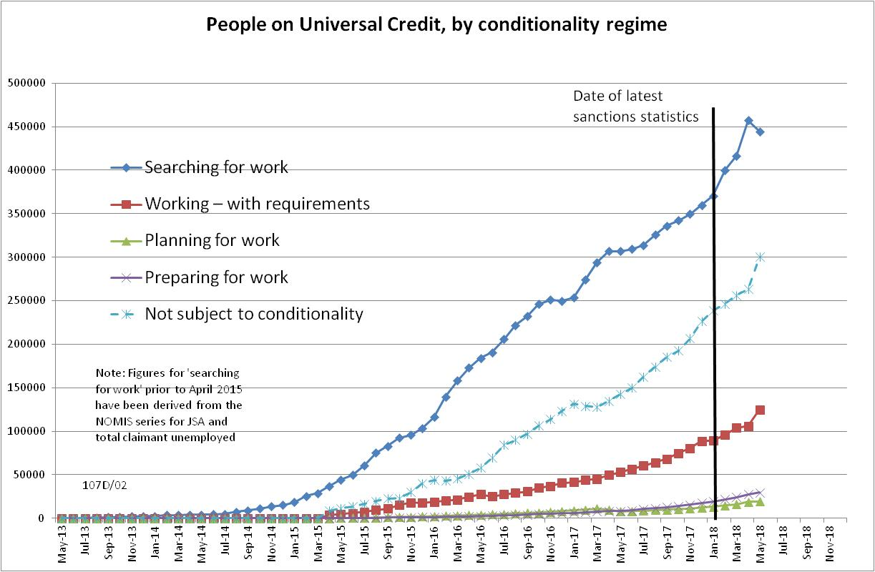

Figure 2
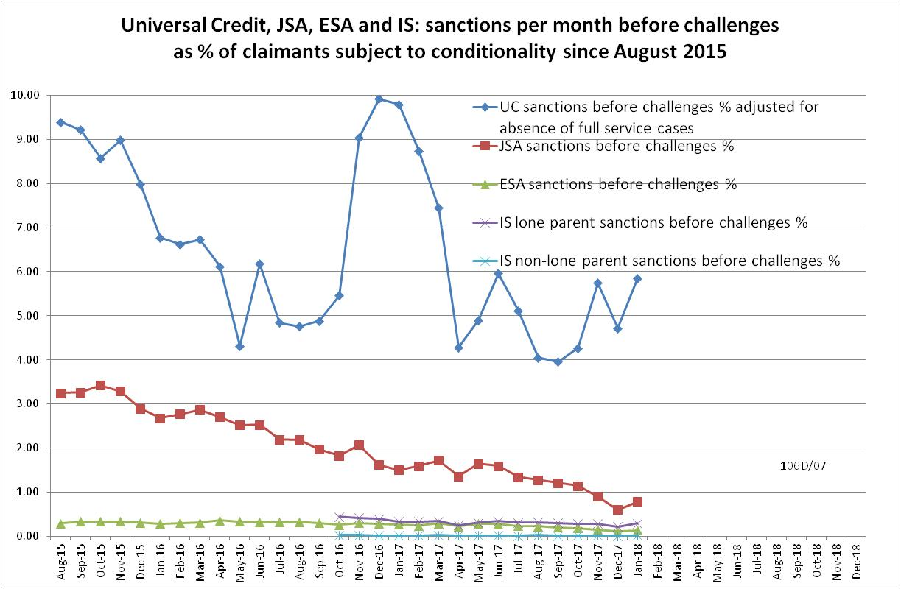

Figure 3
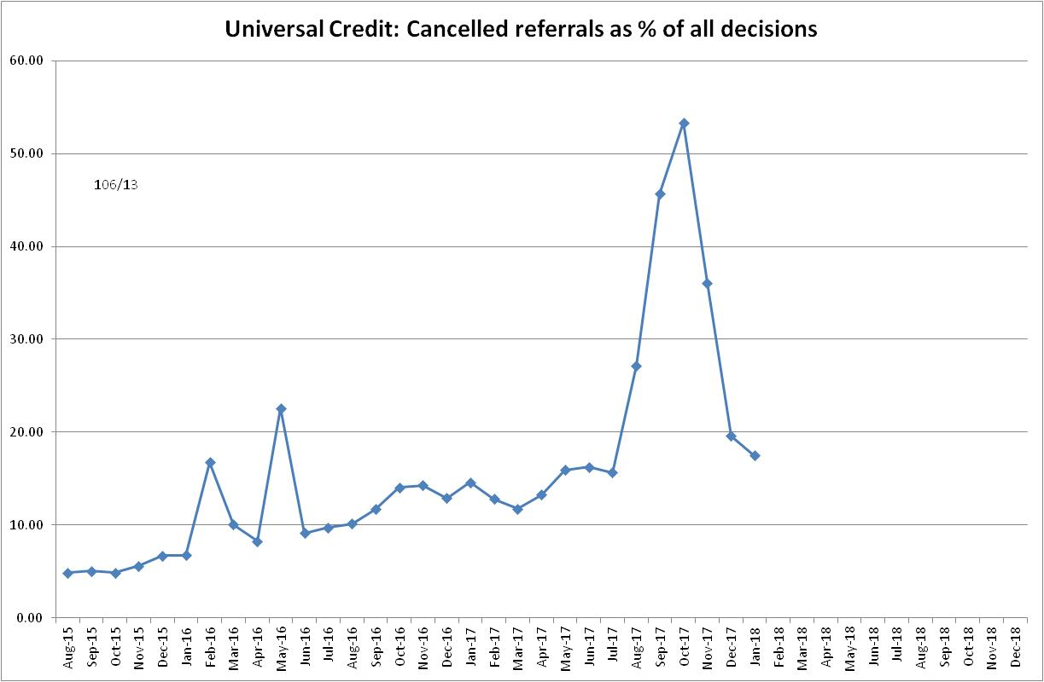
Figure 4
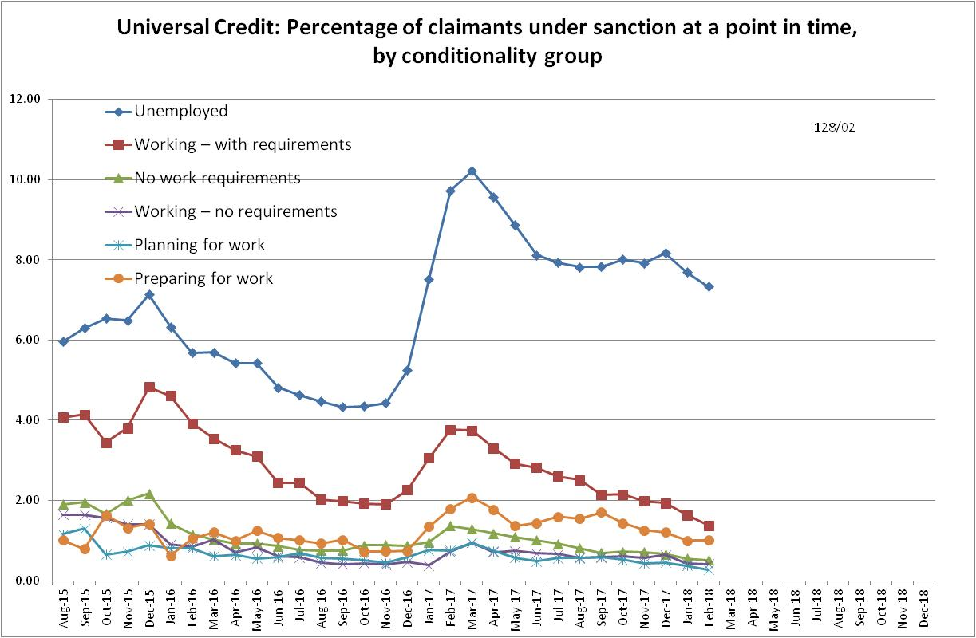
Figure 5
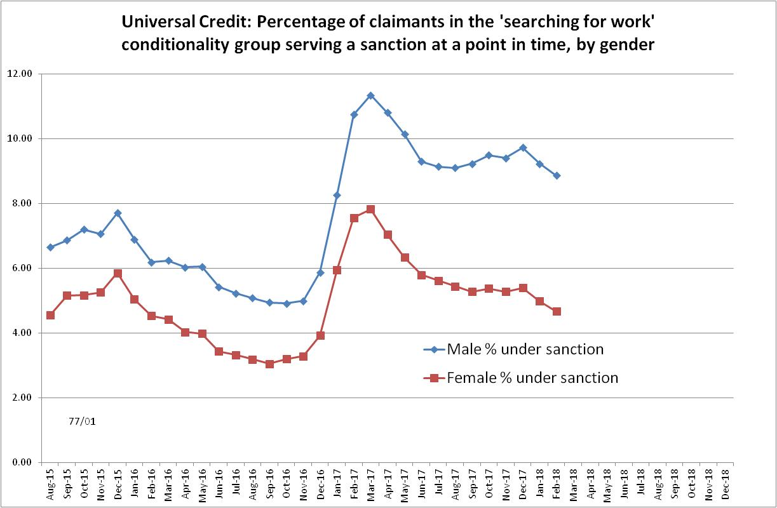

Figure 6
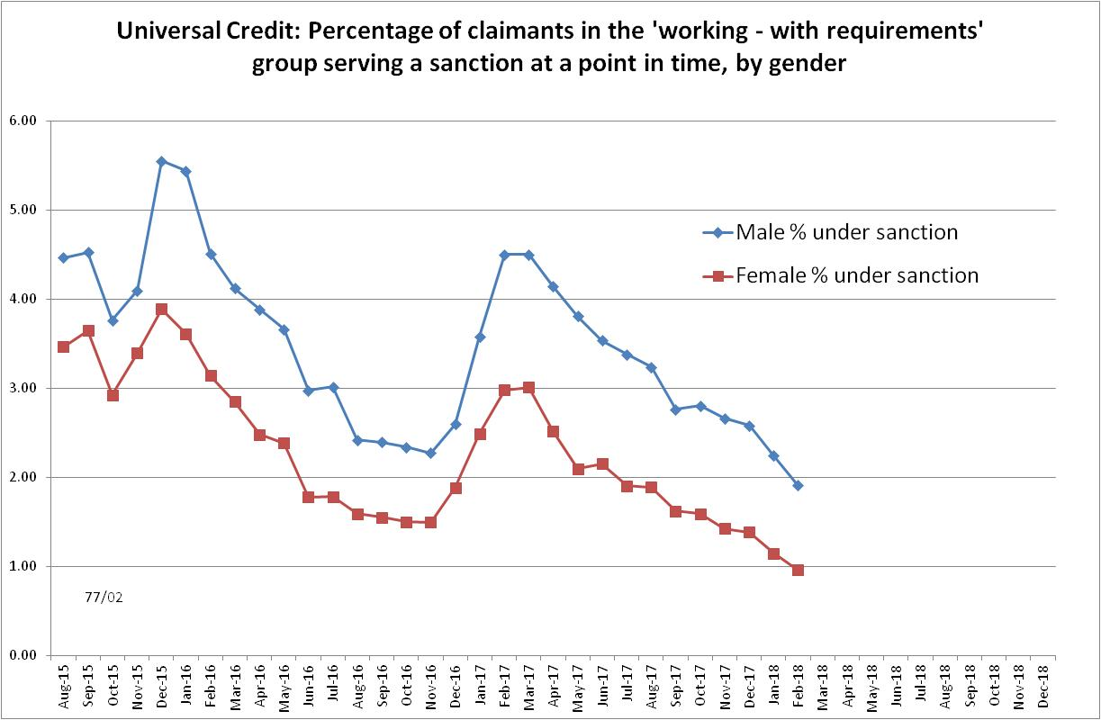
Figure 7
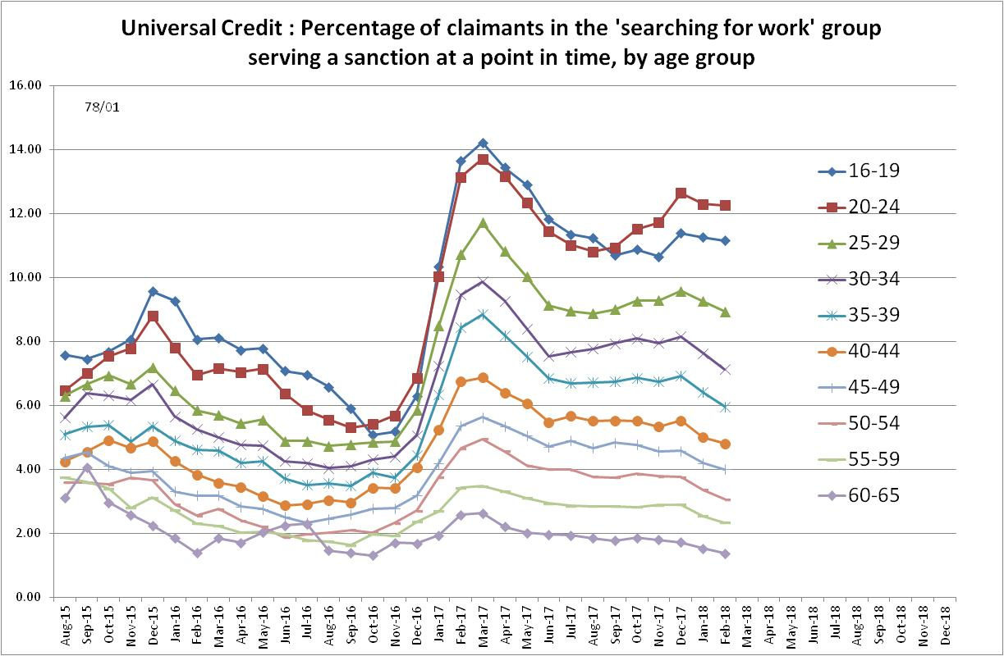
Figure 8
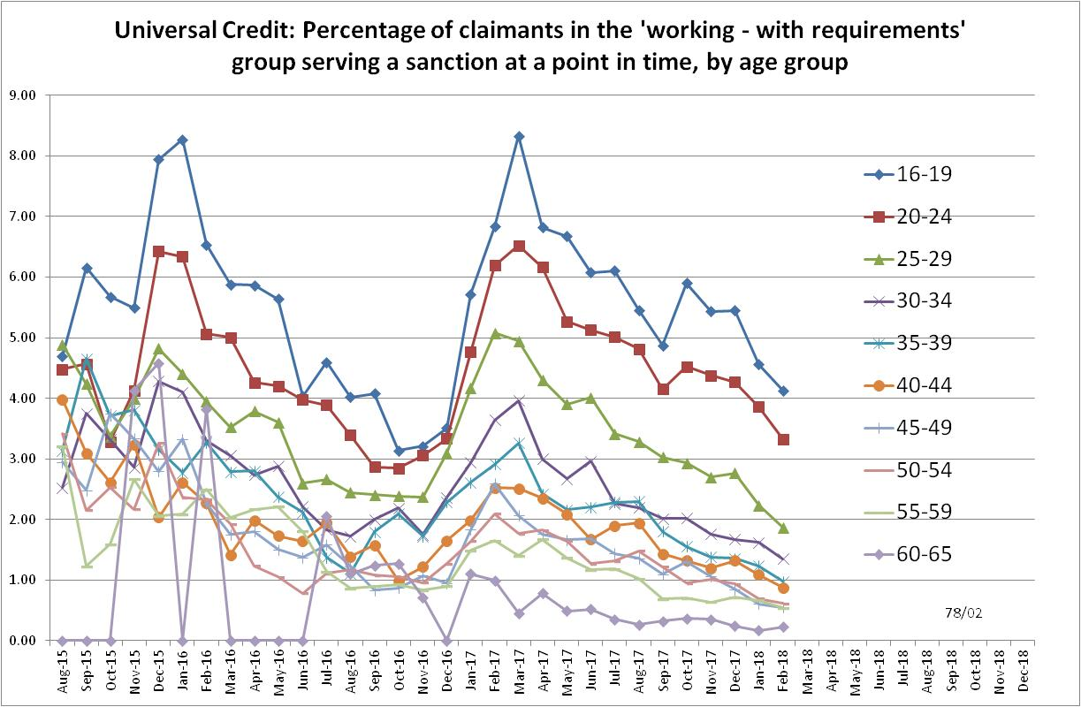
Figure 9
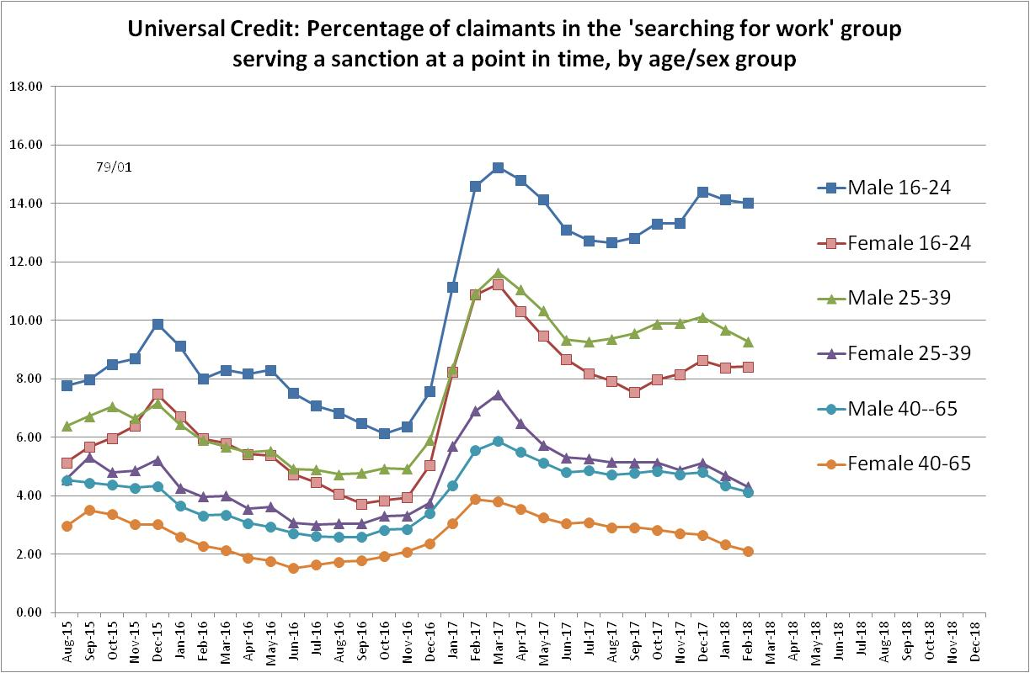
Figure 10
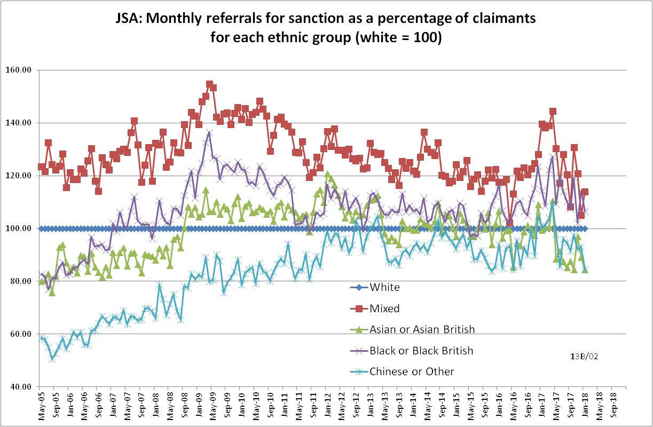
Figure 11
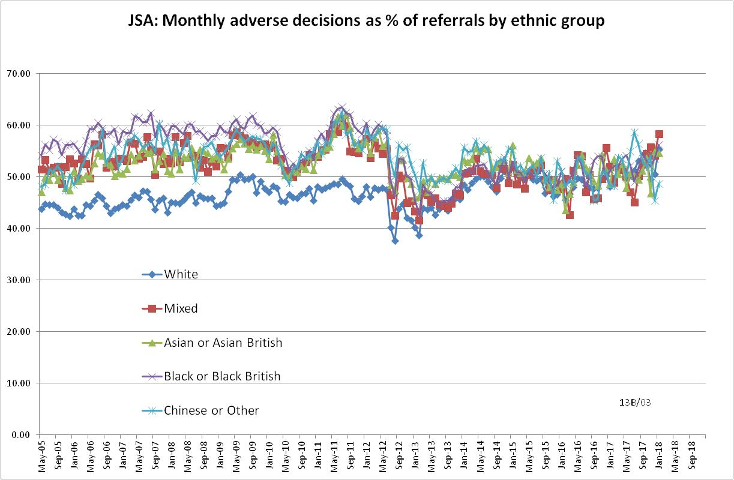
Figure 12
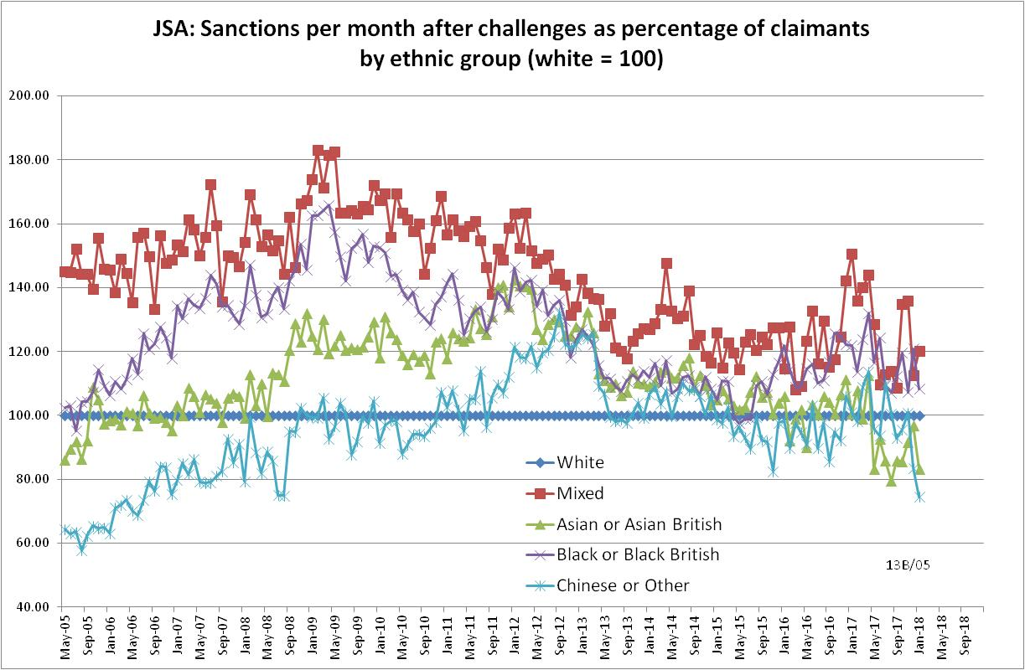

Figure 13
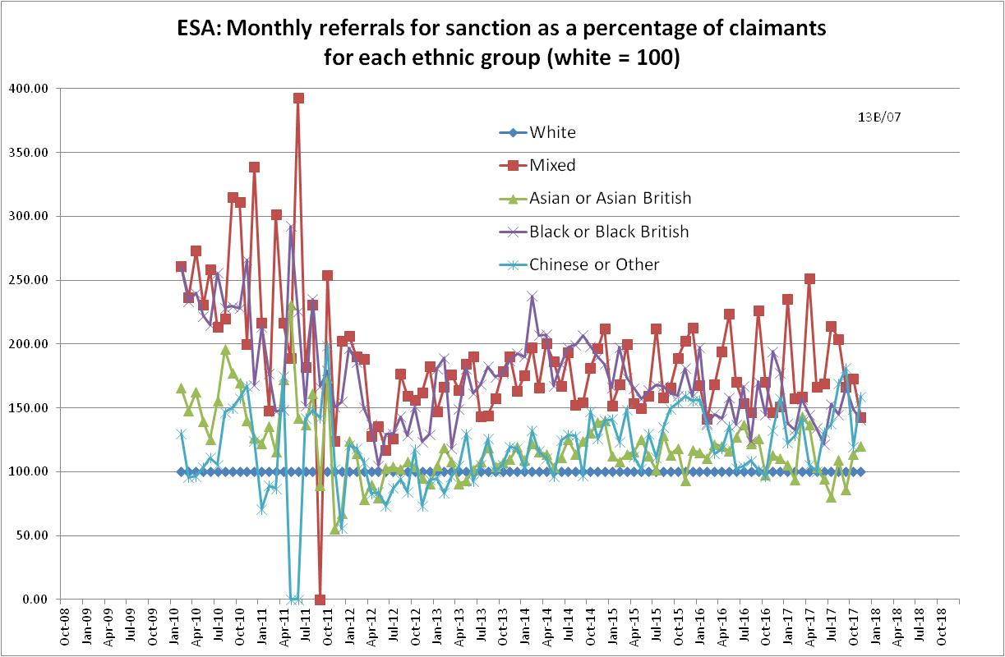
Figure 14
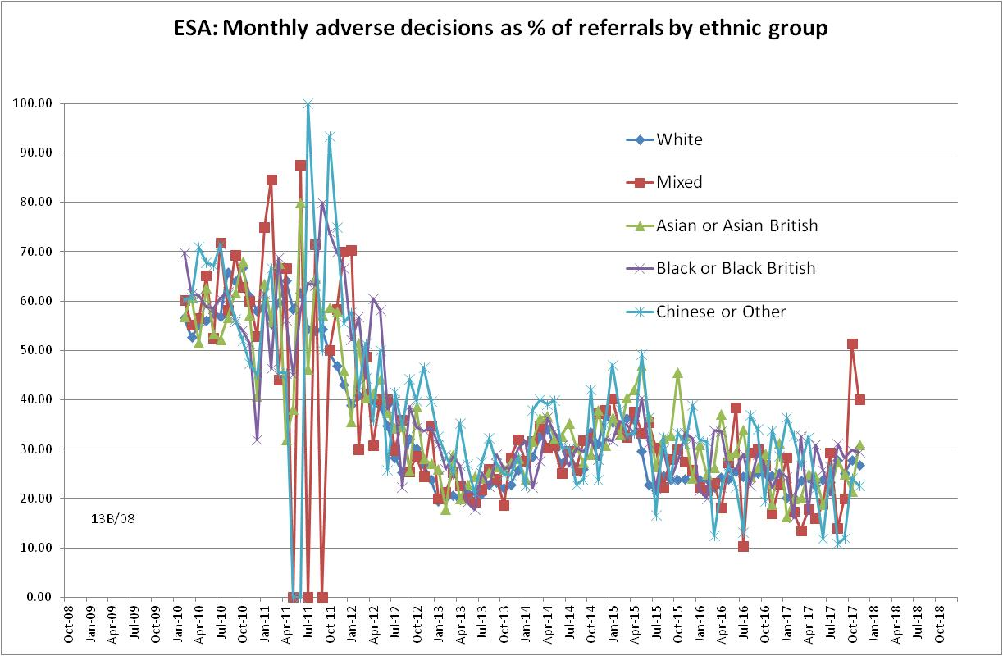

Figure 15
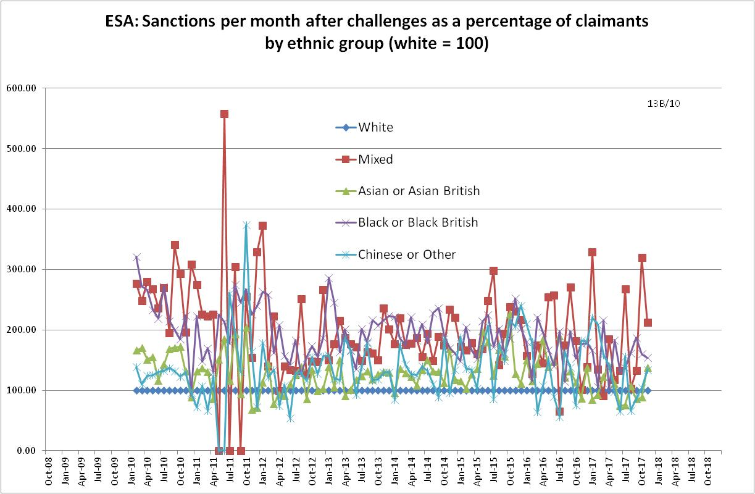

Figure 16
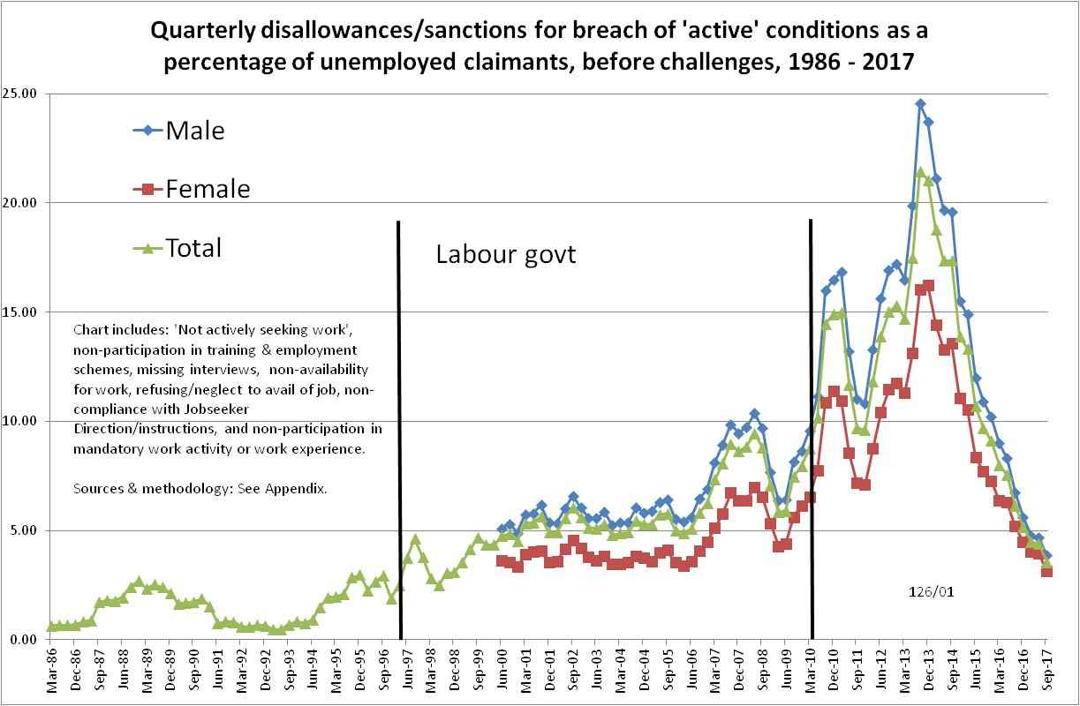

Figure 17
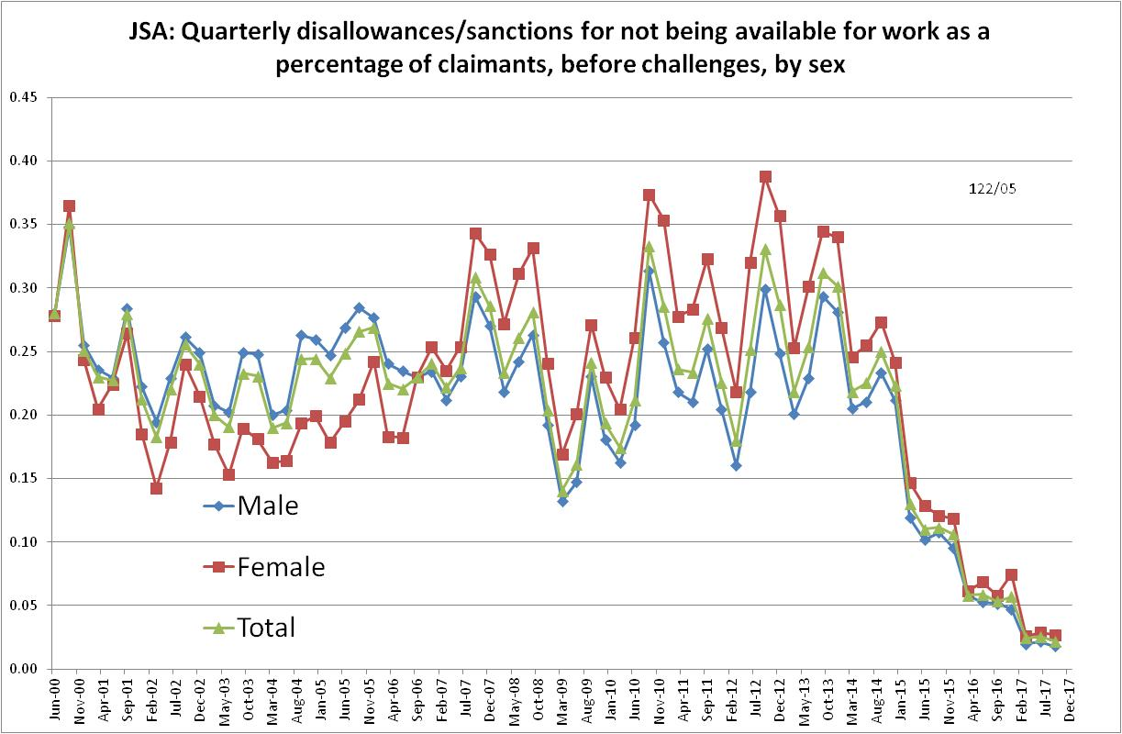
Figure 18
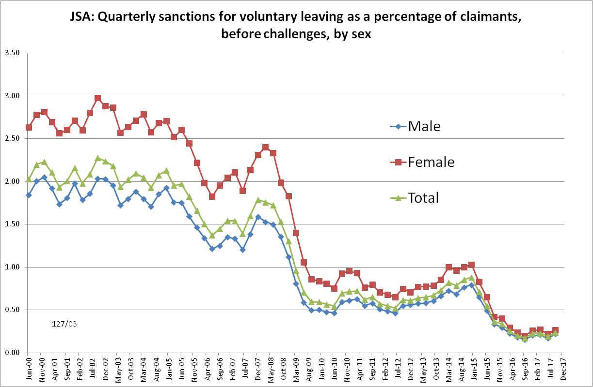

NOTES

Previous briefings are available at http://www.cpag.org.uk/david-webster. They include many analyses that remain valid. However it should be remembered that the DWP may have made subsequent revisions to the data reported in earlier briefings.
Repayment is suspended for any month when the claimant earns more than their threshold, and any remaining debt is written off if the earnings threshold has been met for 26 weeks, whether continuous or not.
The Standard Allowance is the basic living amount for a single adult, before the addition of other amounts for housing costs, children etc.
The basic concept of the DWP’s sanctions database is that each sanction case appears only once, and is given its latest status and attributed to the month of the latest decision on the case. So, for instance, if a decision is made in January 2014 to sanction someone, this decision is reviewed in March 2014 with an outcome unfavourable to the claimant, reconsidered in a ‘mandatory reconsideration’ in May 2014 again with an unfavourable outcome, and is heard on appeal by a Tribunal in October 2014 with a decision favourable to the claimant, then: - it appears in the statistics for the first time in January 2014 as an adverse ‘original’ decision - in March 2014 it changes its status to a ‘reviewed’ adverse decision and moves month to be with all the other cases where the latest decision has been made in March 2014 - in May 2014 it changes its status to a ‘reconsidered’ adverse decision and moves month to be with all the other cases where the latest decision has been made in May 2014 - in October 2014 it changes its status again to an appealed non-adverse decision, and moves month again to be with all the other cases where the latest decision has been made in October 2014.
The estimates of sanctions before challenges have been derived by adding the monthly total of ‘non-adverse’, ‘reserved’ and ‘cancelled’ decisions shown as being the result of reviews, mandatory reconsiderations and tribunal appeals, to the monthly total of adverse ‘original’ decisions. This produces only an approximate estimate for each individual month, since decisions altered following challenge are not attributed to the correct month. It will be particularly unreliable for months affected by a DWP catch-up of a backlog of decisions. But the estimates are reliable for longer periods.

