BRIEFING:

The DWP’s JSA/ESA Sanctions Statistics Release, 17 February 2016

29 February 2016

Dr David Webster
Honorary Senior Research Fellow
Urban Studies
University of Glasgow

Email david.webster@glasgow.ac.uk

Webpages: http://www.gla.ac.uk/schools/socialpolitical/staff/davidwebster/
http://www.cpag.org.uk/david-webster

SUMMARY

There has been a sustained fall since November 2013 in the monthly rate of JSA sanctions before and after challenges as a percentage of claimants, to 4.28% and 3.67% respectively in the year to September 2015. The monthly rate of JSA sanctions before challenges is now stabilising at about 3.7%, which is approximately the same level as the peak under the Labour government, although still well above the average from 2000 to 2010 of 2.81%. No statistics are available for sanctions against claimants who have been put on to Universal Credit (UC) instead of JSA, but the best estimate is that there will have been a total of about 414,000 sanctions on unemployed claimants (JSA plus UC) before challenges, in the year to September 2015. The rate of ESA sanctions has also fallen, to 0.50% per month before challenges and 0.40% after in the year to September 2015, and is also stabilising. Total ESA sanctions were 29,000 before challenges and 22,251 after in the year to September 2015.

The proportions of JSA and ESA claimants sanctioned during the year 2014/15 (July to June), after challenges, were 12.9% and 2.9% respectively. The JSA figure is a fall from 18.4% in 2013/14, though it remains higher than the 10.8% inherited by the Coalition. This is the first time a figure has been published for ESA.

Claimants are more likely to be sanctioned repeatedly on ESA than on JSA. During 2014/15, one quarter of sanctioned JSA claimants were sanctioned more than once, and just under one in ten was sanctioned three times or more. 1,042 JSA claimants were sanctioned ten times or more during the year. Of the sanctioned ESA claimants, over one quarter (27.8%) were sanctioned more than once, and just over one in eight (13.1%) three times or more.

Although there has been some modest improvement, cancelled (i.e. defective) referrals in the Work Programme, ‘other’ employment programmes and Mandatory Work Activity remain a major source of waste, with 100,108 cancelled referrals in these three schemes in the year to September 2015 compared to 29,836 for all other referrals.

The proportion of sanction challenges which are successful is now over 70% for JSA and about 50% for ESA, but because of low rates of challenge (particularly for JSA), overall only about 16% of JSA and 26% of ESA sanctions are overturned. There has never been clearer evidence that far more JSA claimants ought to challenge their sanctions. Not only are their chances of success better than 70%, but they are unlikely to have to bother to go beyond the informal review stage to get a positive result.

The Coalition/Conservative governments have pushed up the overall proportion of JSA referrals which result in a sanction by about 19 percentage points, from 62% to 81%. Further investigation shows that this is mainly due to an astonishing rise in the proportion of referrals for ‘not actively seeking employment’ (ASE) which result in a sanction, to 96%, compared to about 50% for all other sanctions. It appears that the DWP’s decision makers are now doing little more than rubber-stamping ASE sanction referrals. The impact on claimants is compounded by the fact that the proportion of ASE sanctions overturned is currently a tiny 6%, compared to about 17% for all other sanctions.

A news section at the end of the Briefing gives information about other developments relating to sanctions.
BRIEFING: The DWP’s JSA/ESA Sanctions
Statistics Release, 17 Feb 2016

Introduction

This briefing deals with the regular quarterly Jobseekers Allowance (JSA) and Employment and Support Allowance (ESA) sanctions data released on 17 February, which include figures for the further three months July to Sept 2015. Excel spreadsheet summaries of these statistics are available at https://www.gov.uk/government/collections/jobseekers-allowance-sanctions and the full dataset is in the Stat-Xplore database at https://stat-xplore.dwp.gov.uk/default.aspx.

All statistics relate to Great Britain.

Sanctions before and after reviews, reconsiderations and appeals

The DWP’s database only shows sanctions after any reviews, reconsiderations and appeals that have taken place by the time the data are published., But numbers of sanctions before the results of these challenges are important since they show all the cases in which claimants have had their money stopped. Although a successful challenge should result in a refund, this is only after weeks or months by which time serious damage is often done. Estimates of sanctions before challenges are therefore given here but although reliable for longer time periods, they are not fully accurate for individual months, as explained in earlier Briefings.

Universal Credit and Universal Credit sanctions

The DWP has been transferring new single claimants of unemployment benefits on to Universal Credit (UC) instead of JSA. But no statistics have been published on UC sanctions, and no date has been given for them. This is starting to have a significant distorting effect on the analysis of JSA sanctions, because the number of claimants at risk of JSA sanctions is being reduced. The distortion is amplified because single claimants are disproportionately young, and young people are sanctioned at double the rate of other people.

A full assessment of the distortion was contained in the November 2015 Briefing, and will be updated in a future Briefing. The present briefing includes approximate estimates of the scale of the distortion. The figures for ESA sanctions are unaffected since no ESA claimants have been transferred to UC.

The UC regime has similar lengths of sanction to those of JSA for the various ‘failures’, but there are some critical differences. Sanctions are lengthened by being made consecutive, not concurrent. Under Universal Credit hardship payments become repayable. Given that repayments are made at the rate of 40% of benefit – the same as the amount by which a hardship payment is lower than the benefit – this means that for claimants receiving hardship payments, UC sanctions are in effect 3½ times as long as their nominal length. All sanctioned UC claimants must also demonstrate ‘compliance’ for 7 days before applying for hardship payments, and must reapply for each 4-week period. The 80% hardship rate for ‘vulnerable’ claimants is abolished.

Impact of declining numbers of claimants

A fall in the number of claimants means a fall in the number of sanctions, other things being equal. The November 2015 Briefing (Figure 1) showed the numbers of JSA and unemployed UC claimants to October 2015. Between June and September 2015 the number of JSA claimants fell by another 47,173 to 644,308, while the number of unemployed claimants of UC rose by 34,193 to 82,737, giving a rather small net fall in unemployed claimants of 12,980.

The number of ESA claimants exposed to sanctions – those in the Work Related Activity Group (WRAG) – also continues to fall. The WRAG peaked at 0.563m in August 2013 but has since fallen every quarter until reaching 0.466m in August 2015 and an estimated 0.462m in September 2015. The fall is mainly because an increasing proportion of ESA claimants are being put into the Support Group rather than the WRAG.

UK Statistics Authority recommendations to DWP on sanctions statistics

As explained in previous briefings, the UK Statistics Authority in August made recommendations to the DWP for improvements to the sanctions statistics, as follows:

- Provide users with benefit sanction statistics based on the actual number of sanctions applied, making clear the numbers of reviews, reconsiderations and appeals.
- Make clear the limitations associated with the statistics.
- Include in the quarterly benefit statistics bulletin a statement of the proportion of JSA claims subject to a sanction, as well as the proportions of claimants who have been sanctioned during the most recent one-year and five-year periods, and the numbers on which these proportions are based.
- Ensure all statements made using the official statistics are objective and impartial and appropriately apply the definitions of the variables underpinning the data, including ‘actively seeking work’.
- Extend the range of benefit sanction data available by addressing the gaps in information on repeat sanctions and hardship payments, alongside the development of sanction data from the Universal Credit system.

Of this list, the only recommendation which has been implemented to date is the publication of the hardship payment statistics discussed in this briefing. The DWP has also issued, seven months late, a Freedom of Information response giving updated figures on the proportion of claimants sanctioned and on repeat sanctions. This is reported later in the briefing.

Numbers and rates of JSA sanctions

The estimated total number of JSA sanctions before challenges in the 12 months to end-September 2015 was 388,000. This is a big fall from the peak of 1,037,000 before challenges in the 12 months ending October 2013. If Universal Credit sanctions are running at the same rate as for JSA, they would add approximately a further 26,000, making a total of 414,000 for the 12 months to September 2015. This compares with only 331,806 sanctions after challenges reported for the same period in Stat-Xplore.

The main reason for the fall in JSA sanctions is the fall in JSA claimants, by 40.0% between October 2013 and September 2015. But there has also been a large fall in JSA sanctions as a percentage of unemployed claimants. On an annual basis, the rate of JSA sanctions has fallen from peaks of 6.77% per month before challenges and 5.83% after in the 12 months to March 2014, to 4.28% and 3.67% respectively in the 12 months to September 2015 (Figure 1). The monthly data (Figure 2) suggest that the monthly rate of JSA sanctions before challenges is stabilising at about 3.72%. As Figure 2 shows, this is approximately the same level as the peak (3.81%) reached during the sanctions drive initiated by John Hutton as Secretary of State as part of the JSA ‘relaunch’ of April 2006. Sanctions have usually run at well below this rate; the average for the whole period from 2000 to 2010 under the Labour government was 2.81%. Since 2012, sanctions are of course much more severe and so cannot be directly compared to earlier sanctions.

The decline in the monthly rate of JSA sanctions dates from approximately the time of the Call for Evidence for the Oakley Review of sanctions in November 2013. It appears possible that the greater public scrutiny of sanctions policy brought about by the review has influenced the behaviour of DWP ministers and officials.

Reasons for JSA sanctions

An analysis of reasons for JSA sanctions for the first half of 2015 and for earlier years was included in the November 2015 Briefing. This showed that the three main reasons for sanction are currently non-participation in the Work Programme, ‘not actively seeking work’ (which actually means not seeking work in the way instructed by Jobcentre Plus), and not attending an interview, in that order. Figures for the whole of 2015 will be in the next Briefing.

Numbers, rates and reasons for ESA sanctions

ESA sanctions are not affected by any of the estimation problems relating to Universal Credit, since no ESA claimants have been transferred to UC. Total ESA sanctions have now also fallen, to 29,000 before challenges and 22,251 after in the 12 months to September 2015 (Figure 3). This compares with peaks of 49,400 before challenges in the 12 months to August 2014 and 35,570 after challenges in the 12 months to September 2014. The fall partly reflects the continuing decline in the WRAG, but as a percentage of ESA WRAG claimants, sanctions before challenges have also declined modestly, both before and after challenges (Figure 4). These figures peaked at 0.76% in August to October 2014 and 0.55% in September to December 2014. In the year to September 2015 the monthly rate was 0.50% before challenges and 0.40% after. However, the fall appears to be coming to an end as the rates are now stabilising at these levels.

Figure 5 updates the reasons for ESA sanctions, after challenges. The big rise and subsequent fall in ESA sanctions since the spring of 2013 have been due to changes in sanctions for ‘failure to participate in work related activity’, while sanctions for not attending work-focused interviews have been gently and steadily declining. ‘Failure to participate in work related activity’ now accounts for just over four-fifths of ESA sanctions.

Sanctions overturned following challenge

An estimated 55,800 JSA sanctions and 6,800 ESA sanctions were overturned in the 12 months to September 2015 via reviews, reconsiderations or appeals. This is a total of 62,600 cases where the claimant’s payments will have been stopped for weeks or months only to be refunded later. This figure peaked at 153,600 in the year to March 2014.

The proportion of JSA and ESA claimants who are sanctioned

The overdue Freedom of Information response 2015-2187 was produced by DWP on 16 February 2016, giving updated figures on the proportion of claimants sanctioned, for the 12 months 1 July 2014 to 30 June 2015. For JSA, excluding sanctions successfully challenged, 284,436 individuals were sanctioned out of 2,206,160 individuals who claimed JSA at any time during the year. This is 12.9% and represents a fall from the 18.4% for the financial year 2013/14, though it remains higher than the proportion inherited by the Coalition in 2010.

The series for the proportion of JSA claimants sanctioned, after challenges, is now as follows (all figures are for financial years, except 2014/15):

2007/08 – 11.8 %
2008/09 – 9.8 %
2009/10 – 10.8 %
2010/11 – 15.1 %
2011/12 – 13.2 %
2012/13 – 16.0 %
2013/14 – 18.4%
2014/15 (1 July – 30 June) – 12.9%

If sanctions imposed but subsequently overturned were included, all these figures would be higher.

Over a five year period, the percentage of JSA claimants sanctioned (after challenges) is even greater. No update is available for the figure of 22.3% for 2009/10 to 2013/14 inclusive published in FoI response 2014-4972.

For the first time, FoI response 2015-2187 also reveals the proportion of ESA claimants sanctioned, again for the 12 months 1 July 2014 to 30 June 2015. During this period, the number of individual ESA claimants sanctioned, after challenges, was 15,949, out of 544,770 individuals who were in the WRAG at any point during the year. This is 2.9%, much lower than for JSA. But again, the figure before challenges would be higher.

Repeat sanctions

FoI response 2015-2187 also gives figures for the numbers of individuals subjected to repeated sanctions during 2014/15 (1 July to 30 June). Of the 284,436 JSA claimants sanctioned, one quarter (24.4%) were sanctioned more than once during the year, and just under one in ten (9.0%) was sanctioned three times or more. 1,042 JSA claimants were sanctioned ten or more times.

Of the 15,949 ESA claimants sanctioned, over one quarter (27.8%) were sanctioned more than once during the year, and just over one in eight (13.1%) was sanctioned three times or more.

It might be thought that because ESA WRAG claimants are agreed to be too ill to work, DWP might be more reluctant to subject them to repeated sanctions. Figure 6 shows that this is not the case. ESA claimants are in fact more likely than JSA claimants to be sanctioned repeatedly.

These figures understate the numbers of repeat sanctions on the same individuals because they exclude sanctions implemented but overturned following challenge, and because many claimants’ claims, particularly those for ESA, last longer than a year.

Adverse decisions as a proportion of referrals

The number of claimants who end up being sanctioned depends first of all on the number who are referred to decision makers, and then on the proportion of referrals which result in a sanction. In discussions of the sanctions system, most attention has been focused on the rate of referrals, and abundant evidence has been produced, by whistleblowers and others, of the pressure which has been put on Jobcentre Plus advisers to make more referrals. But the behaviour of decision makers also merits attention. Figure 7 shows, for both JSA and ESA, the estimated proportion of sanction referrals which resulted in a sanction being imposed.

For JSA, there was a striking rise under the Coalition of about 19 percentage points between 2011 and 2014 in the proportion of referrals which were given an adverse decision, from around 62% to around 81%. Comparison with Figure 1 shows that this coincided with the period when the Coalition was driving up sanctions. A separate analysis below shows that the increase in adverse decisions has been due to the rise of ‘Not actively seeking work’ as one of the two main reasons for sanction.

For ESA, Figure 7 shows that the proportion of referrals given an adverse decision actually fell by around 20 percentage points, from about 85% to about 65%, during 2011. The reason for this will have been that, as shown in Figure 5, it was at this time that ESA sanctions came to be dominated by those for not participating in work related activity, rather than not attending interviews. It may be that the issues involved in the former are more complicated and this would explain why there were fewer adverse decisions.
Cancelled Referrals

The August 2015 Briefing (pp.7-8) contained an analysis of ‘Reserved’ sanction decisions, showing that the data published by DWP convey no meaningful information about them. However, the data about ‘cancelled’ referrals do produce meaningful information. ‘Cancelled’ referrals are those which are mistaken or where information is missing. Figure 8 shows that there was a huge hike in the proportion of JSA referrals cancelled between summer 2011 and summer 2012, from under 10% to around 25%, with only a modest fall since then to around 17%. Figure 9 shows that the increase was mainly caused by just three types of referral: those for the Work Programme, ‘other’ employment schemes, and Mandatory Work Activity. These all involve external contractors supplying paperwork to DWP. These abortive referrals are one of the many wasteful features of the sanctions regime. In 12 months to September 2015, there were 72,924 Work Programme cancelled referrals, 19,904 for ‘other’ schemes, and 7,280 for MWA. All other reasons for sanction accounted for only 29,836 cancelled referrals between them.

From their inception, there has always been a higher proportion of cancelled referrals for ESA than for JSA. Figure 10 shows that after initial teething trouble, the proportion settled down at around 20%-30% in 2009. When the Work Programme started in summer 2011, it then had a similar hike to that seen for JSA. While fluctuating, it remains generally above 40%. The absolute number of cancelled referrals is smaller for ESA than for JSA: 25,800 in the year to September 2015.

JSA and ESA hardship payments

The ad hoc statistics on hardship payments released by DWP on 18 November 2015 were fully analysed in the November 2015 Briefing. No further information is available.

JSA and ESA Sanction Challenges

Figures 11 and 12 update earlier summaries of the changing performance of the appeal system.

JSA challenges As noted in earlier Briefings, the impact of Mandatory Reconsideration, introduced from 28 October 2013, has been to reduce the proportion of JSA sanctions that are challenged, but to increase the proportion of challenges which are successful, leaving the overall proportion of sanctions which are overturned more or less unchanged. The latest figures (Figure 11) show that the proportion of sanctions challenged remains unchanged at its new lower level of about 20%. But the proportion of challenges which are successful has continued to rise and is now over 70%. As a result there has been a very slight rise in the proportion of sanctions overturned, and it is now about 16%.

There continue to be hardly any JSA sanction Tribunal appeals - only 298 in the latest quarter, compared to a peak of 12,709 in the three months ending August 2013. The success rate of Tribunal appeals remains historically high at 49%, although still lower than the success rate in internal reviews and reconsiderations.

JSA ‘decision reviews’ continue to far outstrip formal ‘mandatory reconsiderations’, with 11,009 and 3,735 respectively in the quarter to September.

There has never been clearer evidence that far more JSA claimants ought to challenge their sanctions. Not only are their chances of success better than 70%, but they are unlikely to have to bother to go beyond the informal review stage to get a positive result.

ESA challenges The impact of Mandatory Reconsideration on ESA sanctions has been that what was a rise in the proportion of sanctions challenged has been halted, while the proportion of challenges which are successful has fallen sharply, the net effect being to lower the proportion of sanctions which are overturned. The latest data show a recent fall in the proportion of sanctions challenged, to about 50%. But this has been offset by a rise in the proportion of challenges which are successful, also to about 50%. The proportion of sanctions overturned remains at about the same level it has been since the introduction of Mandatory Reconsideration, at about 26% (Figure 12).

No ESA sanction appeal cases went to Tribunals in the quarter to September 2015. For ESA, like JSA, decision reviews continue to far outstrip formal mandatory reconsiderations, with 2,707 and 89 respectively in the quarter to September.

‘Not actively seeking employment’ (ASE): astonishing rise in proportion of referrals resulting in sanction

An updated separate analysis of JSA sanctions for ‘not actively seeking employment’ (ASE) has produced disturbing results. As noted earlier, ‘not actively seeking employment’ is not an honest description. Sanctions are not applied because claimants are not actively seeking work, but because they are not carrying out their job search in the exact way instructed by Jobcentre Plus. In other words the State presumes to substitute its view on the best way to look for work for that of the citizen.

While Figure 7 showed the proportion of all JSA referrals resulting in an actual sanction, Figure 13 gives the same information separately for referrals for ASE and for all other referrals. This produces the astonishing finding that the proportion of ASE referrals resulting in a sanction has now risen to 96%. In other words a claimant’s chance of escaping a sanction once referred for ASE is only one in 25. In my evidence to the House of Commons Work and Pensions Committee inquiry in 2013 (Webster 2013, para.11 and Figure 6), I drew attention to the 20 percentage point rise in the proportion of adverse decisions for ASE which had taken place under John Hutton as Secretary of State in 2006-07. At that time the published DWP statistics only went to October 2012, by which time the Coalition had pushed the proportion up further, to about 86%. We can now see that subsequently to this, ministers have pushed up the proportion by yet another ten percentage points. It appears that the DWP’s decision makers are now doing little more than rubber-stamping referrals for ASE sanctions without giving them proper consideration. Figure 13 shows that this situation is specific to ASE: the percentage of all other referrals resulting in sanction, despite some fluctuations, has stayed at around 50% for the last decade.

This is part of a larger campaign by the government to put more pressure on unemployed people, which also includes the ‘claimant commitment’ rolled out between 14 October 2013 and April 2014, and the increased sanction lengths introduced from 22 October 2012. The ‘claimant commitment’ – recently compared by Frank Field to a ‘prison manual’ (Field & Forsey 2016, see later in this Briefing) is a one-sided exercise which, according to the DWP’s own research, about half the time requires claimants to do things which do not take account of their personal circumstances, do not genuinely increase their chances of finding work, and are not achievable (Webster 2015, pp.5-6). Since 22 October 2012, the penalty for ‘not actively seeking work’ has been hugely increased. Previously, it was a ‘disentitlement’ only. This meant that the claimant could re-apply for JSA straight away and suffer the loss of benefit only for the then three ‘waiting days’ plus any time lost in re-applying. Since 2012, the disentitlement has been accompanied by a fixed penalty of 4 weeks’ loss of benefit (13 weeks for a second or subsequent ‘failure’ within 12 months), with the length of disentitlement and length of sanction adjusted so as to sum to the 4 or 13 weeks.

The extraordinarily high proportion of ASE referrals resulting in sanction is not offset by any greater propensity on the part of claimants to challenge these sanctions. In fact Figure 14 shows that there has always been a lower rate of challenge to ASE than to other sanctions. Currently the rate of challenge is some 8 percentage points lower, at 14% compared to about 22%. For both ASE and other sanctions, Figure 14 indicates that the increased penalties of October 2012 were followed by an increase in the propensity of claimants to mount a challenge, although this has not been sustained. But there is no indication in the chart that the increased penalty has led the DWP decision makers to take more care over their decisions; in fact, the reverse.

Figure 15 shows that challenges to ASE sanctions have also always had a lower success rate than other challenges, currently by over 30 percentage points, at about 43% compared to 75%. As a result, the proportion of ASE sanctions overturned (Figure 16) is currently a tiny 6%, compared to about 17% for all other sanctions.

SANCTIONS - OTHER DEVELOPMENTS

Government Response to the House of Commons Work and Pensions Committee report Benefit Sanctions Policy beyond the Oakley Review

Iain Duncan Smith has written a further letter to the Chair of the Work and Pensions following up various issues arising from the Committee’s report on benefit sanctions of March 2015. It is at http://www.parliament.uk/documents/commons-committees/work-and-pensions/Letter%20to%20Chair%20from%20Iain%20Duncan%20Smith%20re%20benefit%20sanctions%20.pdf It states that automated JSA and ESA sanction notifications were introduced on Monday 23 November 2015. In relation to the Committee’s call for DWP staff to initiate hardship payment claims for vulnerable claimants, it states that from 11 January 2016 Work Coaches will ‘do more’ to identify those claimants who are likely to require, and be eligible for, hardship payments. The Work Coach will be informed of a sanction and will ‘attempt’ to contact the claimant if they have previously been identified as likely to require and be eligible for a hardship payment.

The letter also attaches ‘supplementary guidance’ on the treatment of vulnerable claimants in relation to the ‘claimant commitment’. The DWP's main Vulnerability Guidance was published in response to a Freedom of Information request in May 2015. It is at https://www.whatdotheyknow.com/request/259586/response/635763/attach/4/Vulnerability%20guidance.pdf

Ahmed-Sheikh Bill – 2nd reading 11 March

Information about the Benefit Sanctions Regime (Entitlement to Automatic Hardship Payments) Bill providing for automatic payment of hardship payments was given in the November 2015 Briefing. The Bill has now been published on the House of Commons website at http://services.parliament.uk/bills/2015-16/benefitsanctionsregimeentitlementtoautomatichardshippayments.html It is now expected to have its second reading on 11 March.

The Bill provides that it must be assumed at the outset of any sanction that the claimant is eligible for hardship payments at 60% of benefit, and those payments must be made unless or until an actual assessment determines that they are not eligible. The Secretary of State is given the duty to ensure assessment within a reasonable period. Payments made cannot be reclaimed by DWP even if the claimant is found to be ineligible for them.

Westminster Hall sanctions debate 2 December

The House of Commons held a short Westminster Hall debate on benefit sanctions on 2 December (col.165WH). It is available at http://www.publications.parliament.uk/pa/cm201516/cmhansrd/cm151202/halltext/151202h0002.htm

House of Lords debate on sanctions, Monday 14 December

The House of Lords held a debate on benefit sanctions on 14 December (col. 1868-84) on an amendment to the Welfare Reform and Work Bill providing for a comprehensive review of sanctions.
Prime Minister’s Questions – 3 February 2015

Benefit sanctions were raised for what appears to be the first time at PMQs on 3 February (col. 917). Anne McLaughlin (Glasgow NE) (SNP) mentioned a constituent who works for the DWP who told her that staff have “aspirations” set for the number of sanction referrals they should make. David Cameron in response claimed that the purpose of sanctions is to prevent people opting for worklessness as a ‘lifestyle choice’ and that they are ‘fairly applied’.

House of Commons Work and Pensions Committee report on Benefit Delivery

This report was published on 21 December. It criticises (para.79-80) the quality of DWP decision-making in the benefit sanctions process, on the basis of the high proportion of sanctions overturned at Mandatory Reconsideration. It concludes ‘The statistics available expose flaws in the sanctioning process. DWP must address the quality of original decisions in order to maintain a downward trend in the number that are overturned at MR stage.’

Local Welfare in England and Wales – reports by the House of Commons Work and Pensions Committee and National Audit Office

In April 2013 the Coalition government scrapped the national Council Tax Rebate scheme and the former systems of DWP Crisis Loans and Community Care Grants, passing out responsibility to local authorities with reduced budgets. Discretionary Housing Payments are a local supplement to Housing Benefit dating from 2001. The Work & Pensions Committee and NAO both published reports on aspects of this local social security system on 12 January.
The Committee report on The Local Welfare Safety Net, which covers Council Tax support, Discretionary Housing Payments and local welfare assistance, is at http://www.publications.parliament.uk/pa/cm201516/cmselect/cmworpen/373/373.pdf The NAO report on Local Welfare Provision, which covers local welfare assistance only, is at https://www.nao.org.uk/wp-content/uploads/2016/01/Local-welfare-provision.pdf The reports only deal with England and Wales; arrangements in Scotland are different.

The Committee report does not deal with sanctions. However the NAO report does. It expresses concern (p.9) that ‘council-provided welfare support risked reducing benefit recipients’ incentive to find work by weakening the effect of benefit sanctions applied’. I have pointed out to the NAO that there is no evidence that reducing claimants to the degree of destitution required to qualify them for local welfare assistance has any positive effect on their likelihood of finding work, and much evidence to the contrary. The NAO has replied that ‘The question of whether or not sanctions are an effective mechanism for incentivising benefit recipients to comply with benefit conditions, or whether they are successful in encouraging affected individuals to find work was beyond the scope of the local welfare provision study.’

House of Commons Work and Pensions Committee Inquiry into In-work progression in Universal Credit

This inquiry is under way, with details at
http://www.parliament.uk/business/committees/committees-a-z/commons-select/work-and-pensions-committee/inquiries/parliament-2015/universal-credit-15-16/

One of the hottest issues concerns the proposed extension of sanctions to some 1.3m people already in part-time work, if they are considered not to be doing enough to increase their hours. In relation to this, the written evidence submitted by ERSA (Employment Related Services Association – the main welfare-to-work contractors’ organization) is significant. It states ‘ERSA believes that the application of conditionality might be limited to requiring an individual to engage initially with the in-work service, with individuals with disabilities and complex health conditions who are known to be working at full capacity to be exempt from conditionality requirements altogether.’

Interaction of the new Criminal Courts Charge with Benefit Sanctions in England and Wales

The August and November 2015 Briefings reported concern about the effects of the mandatory Criminal Courts Charge introduced by Chris Grayling in England and Wales on 13 April before he was transferred out of the Ministry of Justice. In a rare piece of good news, the new Justice Minister Michael Gove has scrapped it, with effect from Christmas Eve 2015.

Sheffield Hallam University report on Homeless people’s experiences of welfare conditionality and benefit sanctions

The Sheffield Hallam University report on Homeless people’s experiences of welfare conditionality and benefit sanctions, commissioned by CRISIS, was published on 10 December and is available at http://www.crisis.org.uk/data/files/publications/sanctions_report_FINAL.pdf

The study used the largest sample survey of this group to date – 1,013 homeless respondents, of whom 548 were claimants subject to conditionality and 213 had been sanctioned in the previous year, of whom 130 were on JSA and 85 on ESA. The main fieldwork was between February and April 2015, so that the ‘previous year’ was a period when ESA sanction rates were at their highest, but JSA rates were declining. The minor ‘easement’ of the Jobseeker’s Allowance (Homeless Claimants) Amendment Regulations 2014 came into force on 21 July 2014.

Among the study’s striking findings are that 21% of sanctioned respondents said they had become homeless, and 16% that they had had to sleep rough, as a result of the sanction; slightly more (38% compared to 36%) had committed a ‘survival crime’ than had received a hardship payment; 60% said being sanctioned had a negative effect on their ability to look for work; 75% said being sanctioned had a negative effect on their mental health; and 77% had gone hungry or skipped meals as a result of the sanction. Individual case histories show that while claimants sometimes received good employment services from Jobcentre Plus or Work Programme contractors, much of the time the services were very bad and in particular Universal Jobmatch was completely useless for everyone.

Quarriers report Compounding Disadvantage: Exploring the impact of benefit sanctions on young homeless people, 15 October 2015

In October, the Scottish charity Quarriers published a report on the damaging impact of benefit sanctions on homeless young people, which is available at
https://quarriers.org.uk/policy/compounding-disadvantage/ , together with a separate account of its launch at the SNP conference in Aberdeen. It is based on responses from 64 young people using four of Quarriers’ housing services in Glasgow. The report’s findings are similar to those of the Sheffield Hallam report and it concludes that ‘Sanctions compound young homeless people’s disadvantage. They make no contribution to positive outcomes for young people and make the job of supporting them more difficult.’

CRISIS Homelessness Monitors

CRISIS is publishing reports on the state of homelessness policies and services in the four countries of the UK as part of its project ‘The Homelessness Monitor’, jointly funded with the Joseph Rowntree Foundation (http://www.crisis.org.uk/pages/homelessnessmonitor.html).
The report for England 2016 (January 2016) is available at http://www.crisis.org.uk/data/files/publications/Homelessness_Monitor_England_2016_FINAL_%28V12%29.pdf
Scotland 2015 (December 2015) is available at http://www.crisis.org.uk/data/files/publications/HomelessnessMonitorScotland_FINAL.pdf
Wales 2015 (August 2015) at
http://www.crisis.org.uk/data/files/publications/HomelessnessMonitorWales2015_final.pdf
and Northern Ireland 2013 (May 2014) at
http://www.crisis.org.uk/data/files/publications/HomelessnessMonitor_NorthernIreland_web.pdf

All the reports except that for Northern Ireland deal with the impact of benefit sanctions (Northern Ireland never joined in the sanctions drive promoted by the Coalition government). For instance, the England report comments (p.xx) ‘The impact of benefit sanctions on homeless people and those at risk of homelessness has become a core concern of local authorities’ and notes (p.44) that one third of northern local authorities report that benefit sanctions are the primary welfare reform measure driving homelessness in their area. The Scotland report comments (p.xiii) ‘one of the most striking changes since the 2012 Homelessness Monitor in Scotland is the extent to which the fallout from benefit sanctions has come to dominate the day-to-day lives of many homelessness service users and providers in Scotland. There are major concerns associated with the organisational as well as personal impacts of sanctioned residents being unable to pay service charges in temporary and supported accommodation. Sanctions are reported to be so sudden in their impact that they are much more difficult for support agencies to manage than, say, the ‘Bedroom Tax’, and sanctioned clients are now routinely referred to food banks by homelessness agencies.’

Frank Field: Civitas review of welfare reform

The think-tank Civitas in January published a report by Frank Field, chair of the House of Commons Work & Pensions Committee, and Andrew Forsey, entitled Fixing Broken Britain?An audit of working-age welfare reform since 2010. It is available at http://www.civitas.org.uk/publications/fixing-broken-britain-an-audit-of-working-age-welfare-reform-since-2010/

Chapter 3 on conditionality comments ‘our concern with the current Claimant Commitment is that the duties, while clearly spelled out, are not buttressed by a counterbalancing series of
safeguards or rights. Indeed, the words ‘safeguards’ and ‘rights’ are missing completely from the contract...... The contract is so dominated by phrases such as ‘you must’ that it reads as though it has fallen from a prison manual...... The sanctions policy as initiated by Iain Duncan Smith appears from the reports published by voluntary organisations, to whom some might refer as the Big Society, to be causing havoc and despair amongst a growing number of claimants..... these sanctions sentences cut incomes to a far higher degree than any magistrates court is empowered to do, and then can only do after exercising its independent judgment based on the ‘facts’ presented in open court...... We believe the sanctions regime as it stands has become too rigid, too complex, too harsh, and is applied under conditions that appear to be unfavourable to claimants. All too many claimants appear to be subjected to a
disproportionately arbitrary punishment for a simple and genuine mistake, or a piece of sheer misfortune..... Although the department does not collect data on the impact of its sanctions policy, it is clear from information and research that has been published that a number of claimants – we know not how large a number – are being pushed permanently outside the
benefits system, leading to some being totally disconnected from both work and welfare. This group is left to the protection of their parents, often elderly, and often poor themselves, or to the charity of friends, should such friends exist, and should they be able to help. Such a state of affairs has not been seen since the abolition of the Poor Law in 1948...... Sanctions are therefore being applied at a scale unknown since the Second World War, and the operation of sanctions on this scale makes for the most significant change in the social security system
as it has existed in the post-war period.’ The Postscript comments ‘Justice..... calls for a major survey of what happens to the hundreds of thousands of people thrown off the welfare rolls each year through the sanctioning process. It is unacceptable, not only for this government but for its predecessor and those who will follow, to take away benefit from a mass of people each year and not trouble themselves with how this army of people survive. For that is what is happening under the government’s sanctions policy. The ability to track the wellbeing of the whole population is now a part of being a grown up government’.

‘Jobs miracle’ comes at cost of dire output and weak wages

This was the Financial Times’ headline to a story by its employment correspondent Sarah O’Connor on 19 February reporting the latest economic data from ONS. ‘Britain’s productivity has fallen even further behind its peers, resulting in a record shortfall, official figures show. The data highlight the fact that the UK’s “jobs miracle” has come at the cost of dire productivity and weak wage growth. Output per hour in the UK – a measure of productivity – was 18 percentage points lower than the average in the rest of the G7 group of major economies in 2014, the Office for National Statistics said. This is the widest gap since comparable records began in 1991. .....All G7 countries have suffered a productivity slowdown following the financial crisis in 2008 but only Japan has done worse than the UK.’ These findings are clearly related to the UK government’s policy of sanctions, which in so far as they raise employment at all, drive people into poor-quality, unsuitable and low paid jobs, as shown e.g. by Arni et al. (2009).

Scottish Public Health Observatory report on the impact of ‘welfare reform’ on public health

A new report from the Scottish NHS (Taulbut et al. 2016) looks at the impact of ‘welfare reform’ on public health in Scotland. Looking at data from 2003 to 2013, it notes (p.36) that periods where a stricter use of sanctions operated (more referrals/adverse decisions and/or tougher penalties) were associated with periods of worsening mental health among low-income, working-age adults in Scotland.

Standard form Conservative Party response to constituents’ complaints about the benefit sanctions regime

Trawling the web has revealed that a standard form response has been prepared for use by Conservative MPs who receive complaints from constituents about the damage done by the government’s benefit sanctions regime. The following MPs (and no doubt others) have posted the response (usually slightly edited) on their websites:

Harriett Baldwin MP (West Worcestershire) http://www.harriettbaldwin.com/faqs
Maria Caulfield MP (Lewes) http://www.mariacaulfield.co.uk/benefit-sanctions
Ben Howlett MP (Bath) http://www.ben4bath.co.uk/benefits-sanctions
Julian Smith MP (Skipton and Ripon) http://www.juliansmith.org.uk/benefit-sanctions

The response contains a number of misrepresentations, in particular:

‘The Government spends £94bn every year on working-age benefits’ – in fact the cost of JSA is only about £4bn per year and ESA WRAG about £2.5bn.
‘Over 70 per cent of claimants say they are more likely to follow the rules if they know they risk having their benefits stopped’ – The research report from which this is taken states, on the same page, that ‘there was no evidence from the survey that knowledge of JSA conditions led to actual movement into work’.
‘I can assure you that sanctions are used as a last resort’ – The DWP’s staff manuals are available on the web and they show that there are no procedures which would ensure that sanctions are a last resort. This claim is a simple invention.
‘May I reassure you that there are no targets for sanctions – It is true that there are no targets (which would be illegal), but there clearly are management processes designed to force JCP staff into imposing more sanctions than they think they should.
‘94 per cent of Jobseekers Allowance claimants stick to their commitments and are not sanctioned, and less than 1 per cent of Employment and Support Allowance claimants’ – This is a misuse of the monthly rate of sanctions as if it was an annual figure. As noted earlier in this briefing, a new FoI response shows that 12.9% of JSA claimants and 2.9% of ESA claimants were sanctioned, after any successful challenges, in the latest year for which information is available, and that the true proportions before challenges are higher.

Freedom of Information response: ESA sanctions by medical condition

The DWP’s FoI response 2015-4599 published on 14 January breaks down ESA sanction decisions by medical condition (International Classification of Diseases) for 2013/14 and 2014/15. It is available at
https://www.gov.uk/government/publications/individual-esa-sanctions-by-icd-apr-2013-to-mar-2014-and-apr-2014-to-mar-2015

Autumn Statement – Abolition of Mandatory Work Activity and Community Work Placements

The previous Briefing should have pointed out that abolition of Mandatory Work Activity and Community Work Placements was announced in the Autumn Statement (HM Treasury 2015, para.2.52). In the 12 months to September 2015, Mandatory Work Experience accounted for 6,756 sanctions after challenges. Separate figures are not available for Community Work Placement sanctions.

On MWA, Jonathan Portes of NIESR wrote a blog on 12 June 2012 criticising the fact that the government was expanding the programme in spite of its own research showing that it was completely ineffective:
http://www.niesr.ac.uk/blog/dwp-analysis-shows-mandatory-work-activity-largely-ineffective-government-therefore-extending#.U1-Bc1dQGzk

On CWP, UNISON Community e-news reported on 16 February that ‘Originally designed to create 125,000 placements, at a cost to the taxpayer of £125m, by end of September 2015 only 35,390 people had begun a placement, according to official DWP figures. It would seem that more than double that number had been referred to a placement which then did not materialise. In no small measure this failure to find placements is down to the Keep Volunteering Voluntary campaign. Nearly 650 voluntary groups have signed the pledge to forswear workfare and the associated publicity has persuaded many more to avoid involvement with the scheme.’

REFERENCES

Arni, Patrick, Lalivea, Rafael and Van Ours, Jan (2012) ‘How effective are unemployment benefit sanctions? Looking Beyond Unemployment Exit’, Journal of Applied Econometrics, DOI: 10.1002/jae.2289

Batty, Elaine, Christina Beatty, Rionach Casey, Mike Foden, Lindsey McCarthy & Kesia Reeve (2015) Homeless people’s experiences of welfare conditionality and benefit sanctions, Centre for Regional Economic and Social Research, Sheffield Hallam University, December, available at http://www.crisis.org.uk/data/files/publications/sanctions_report_FINAL.pdf

DWP (2013) The Jobcentre Plus Offer: Final evaluation report, November, available at https://www.gov.uk/government/publications/the-jobcentre-plus-offer-final-evaluation-report

Field, Frank & Andrew Forsey (2016) Fixing Broken Britain?An audit of working-age welfare reform since 2010, London, Civitas, available at http://www.civitas.org.uk/publications/fixing-broken-britain-an-audit-of-working-age-welfare-reform-since-2010/

HM Treasury (2015) Spending Review and Autumn Statement 2015, Cm 9162, November, at https://www.gov.uk/government/publications/spending-review-and-autumn-statement-2015-documents

House of Commons Work and Pensions Committee (2015) Benefit delivery, Fourth Report of Session 2015–16, HC 372, 21 December, available at http://www.publications.parliament.uk/pa/cm201516/cmselect/cmworpen/372/372.pdf

House of Commons Work and Pensions Committee (2015a) Benefit sanctions policy beyond the Oakley Review, Fifth Report of Session 2014–15, HC 814, 24 March, at http://www.publications.parliament.uk/pa/cm201415/cmselect/cmworpen/814/814.pdf

House of Commons Work and Pensions Committee (2015b) Benefit sanctions: Beyond the Oakley Review: Government Response to the Committee’s Fifth Report of Session 2014-15, HC 557, October, available at http://www.publications.parliament.uk/pa/cm201516/cmselect/cmworpen/557/557.pdf

Quarriers (2015) Compounding Disadvantage: Exploring the impact of benefit sanctions on young homeless people, Bridge of Weir, October, available at https://quarriers.org.uk/policy/compounding-disadvantage/

Taulbut M., W. Hearty, F. Myers, N. Craig, & McCartney G. (2016) Pulling in different directions? The impact of economic recovery and continued changes to social security on health and health inequalities in Scotland, Edinburgh, NHS Health Scotland, available at http://www.scotpho.org.uk/publications/reports-and-papers/1802-pulling-in-different-directions

Webster, D. (2013) ‘JSA Sanctions and Disallowances’, Written Evidence submitted to the House of Commons Work and Pensions Committee Inquiry into The Role of Jobcentre Plus in the reformed welfare system, 22 May, revised and corrected 8 August, Second Report of Session 2013-14, HC 479, pp. Ev w90ff., available at
http://www.publications.parliament.uk/pa/cm201314/cmselect/cmworpen/479/479vw.pdf

Webster, D. (2015) House of Commons Work and Pensions Committee report: Benefit Sanctions Policy beyond the Oakley Review (24 March 2015): Briefing on the Government’s Response, 4 November, available at
www.cpag.org.uk/david-webster

Figure 1

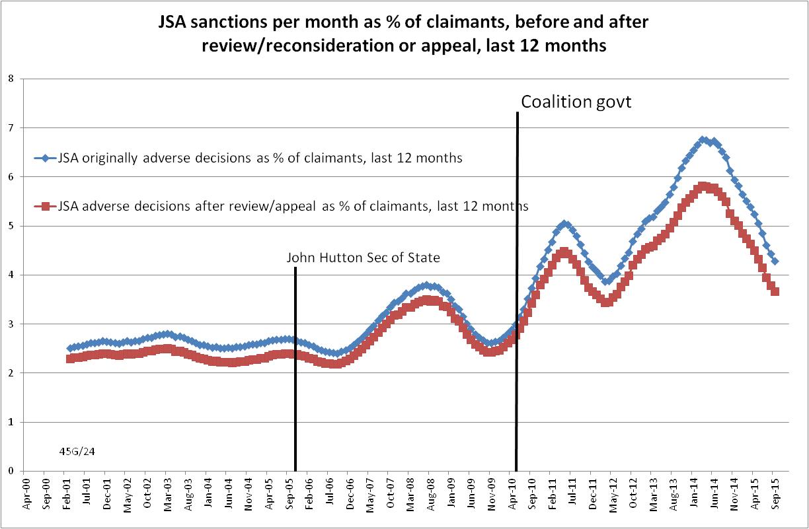

Figure 2
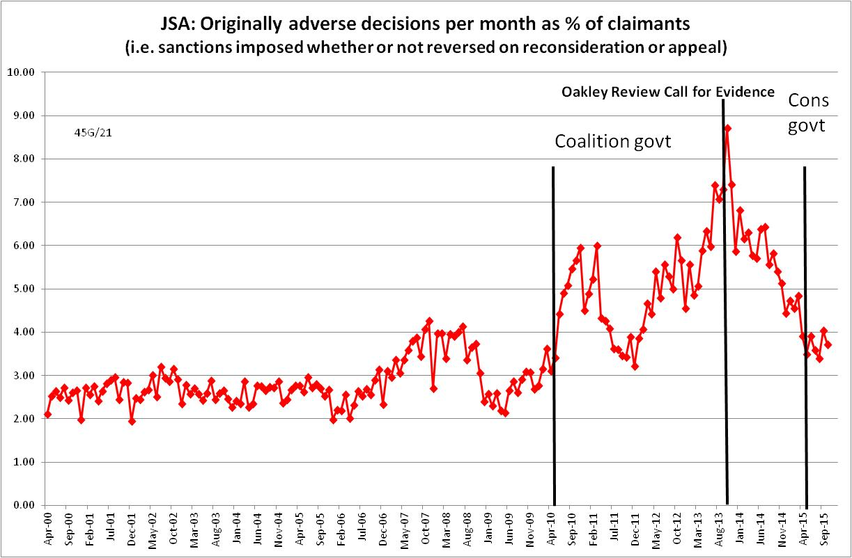
Figure 3
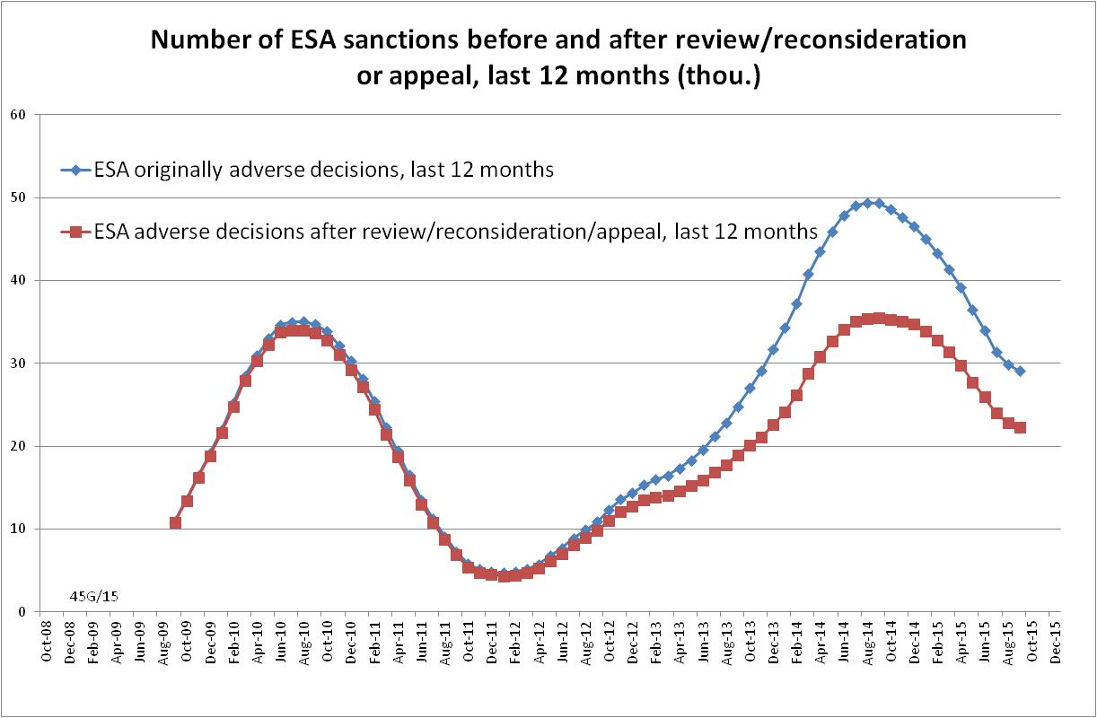

Figure 4
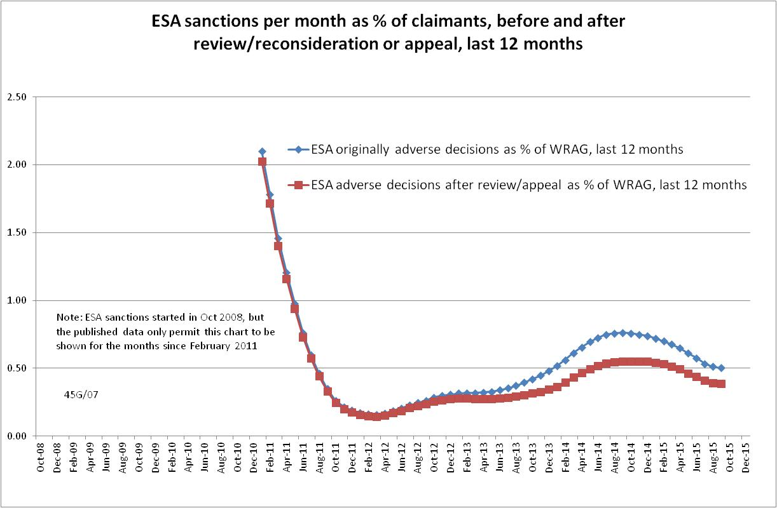

Figure 5
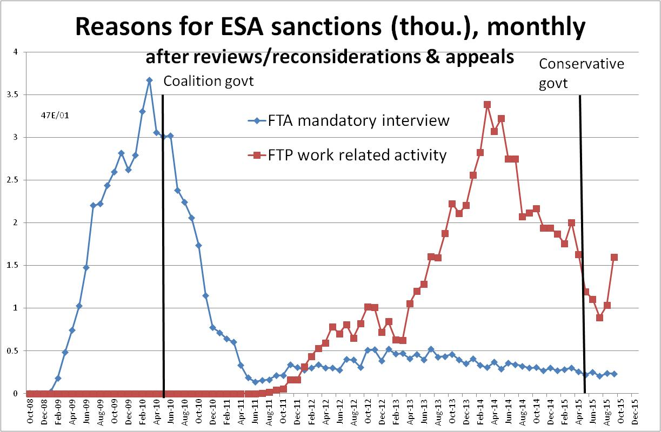

Figure 6
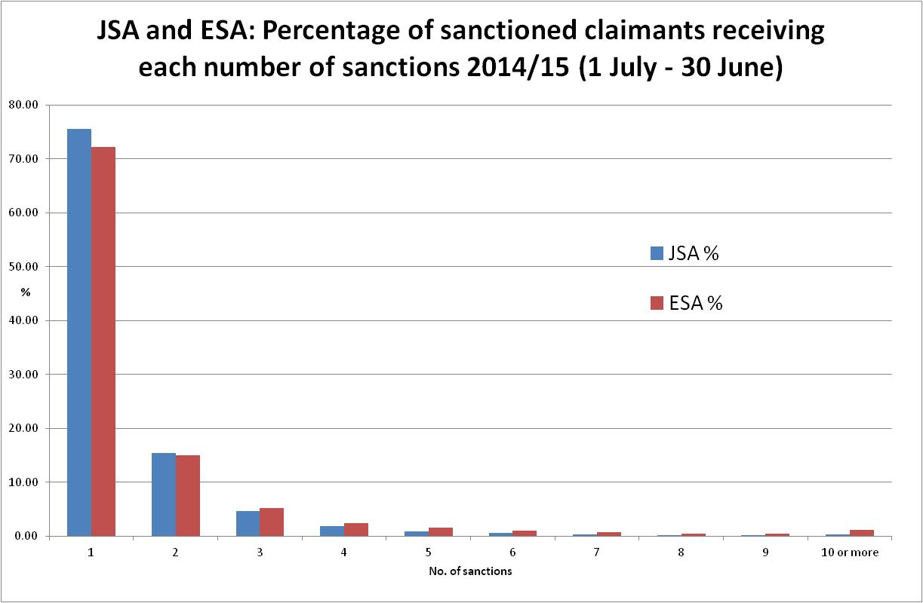

Figure 7
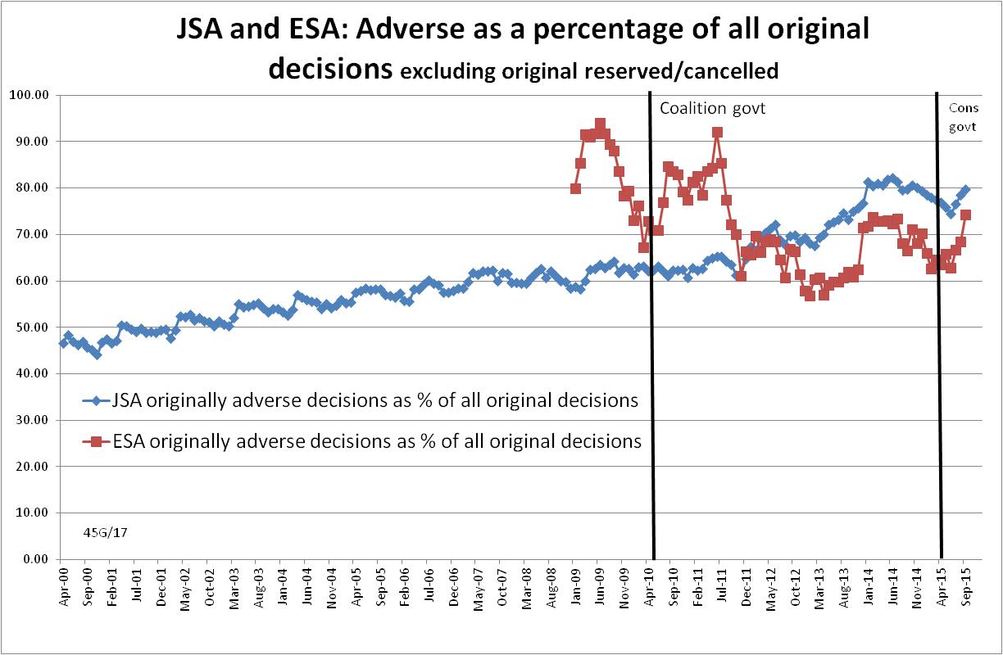

Figure 8
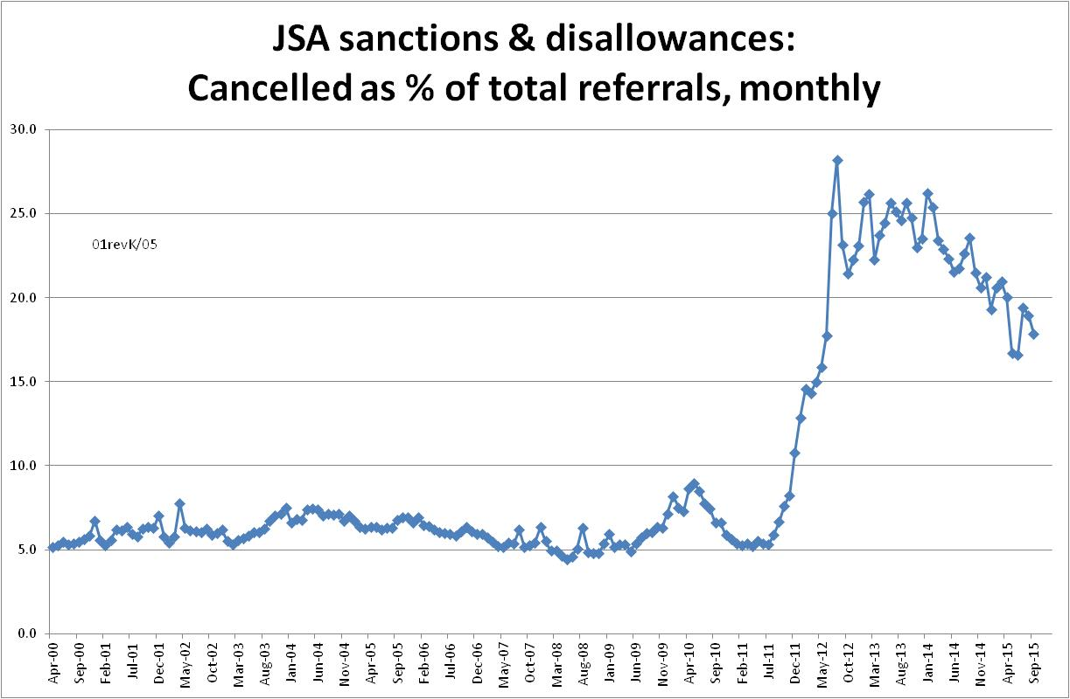

Figure 9
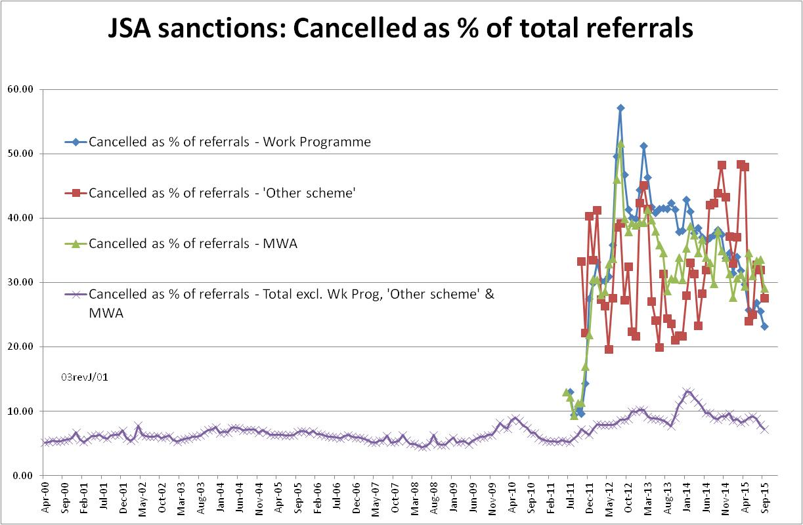

Figure 10
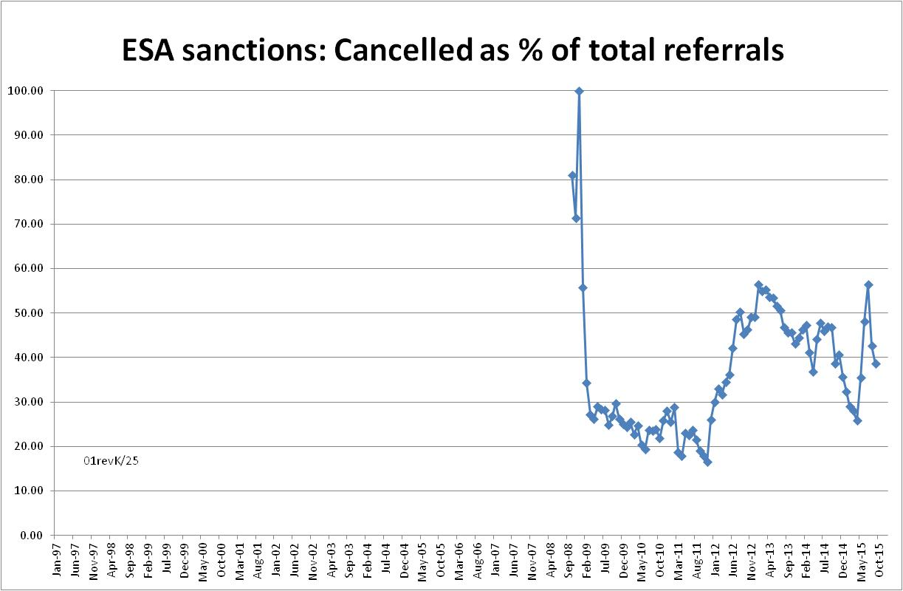

Figure 11
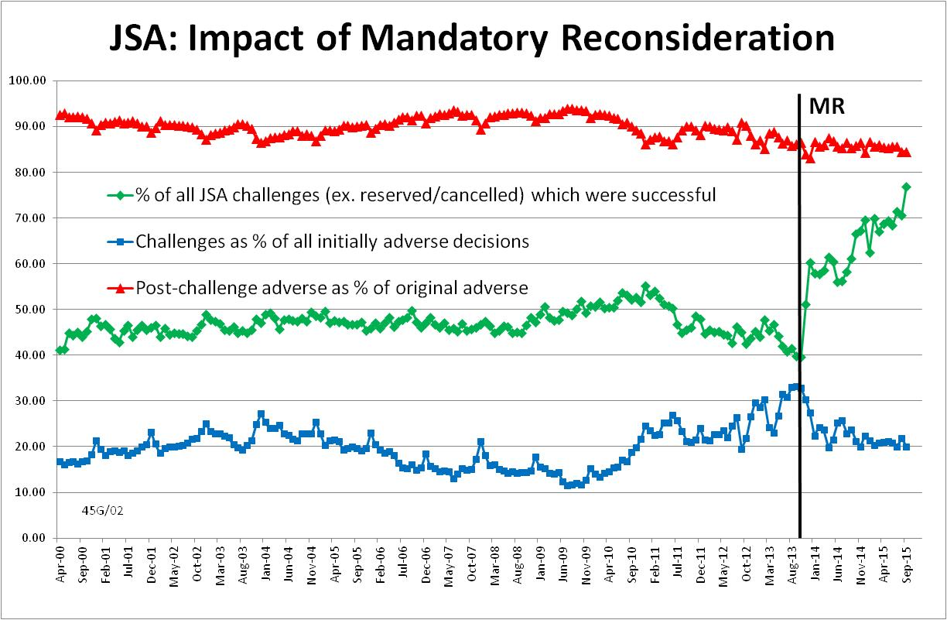

Figure 12
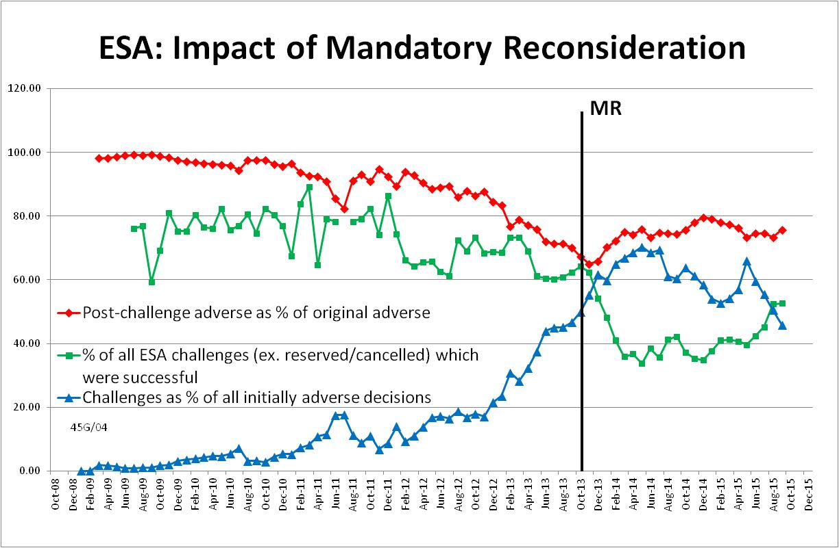

Figure 13
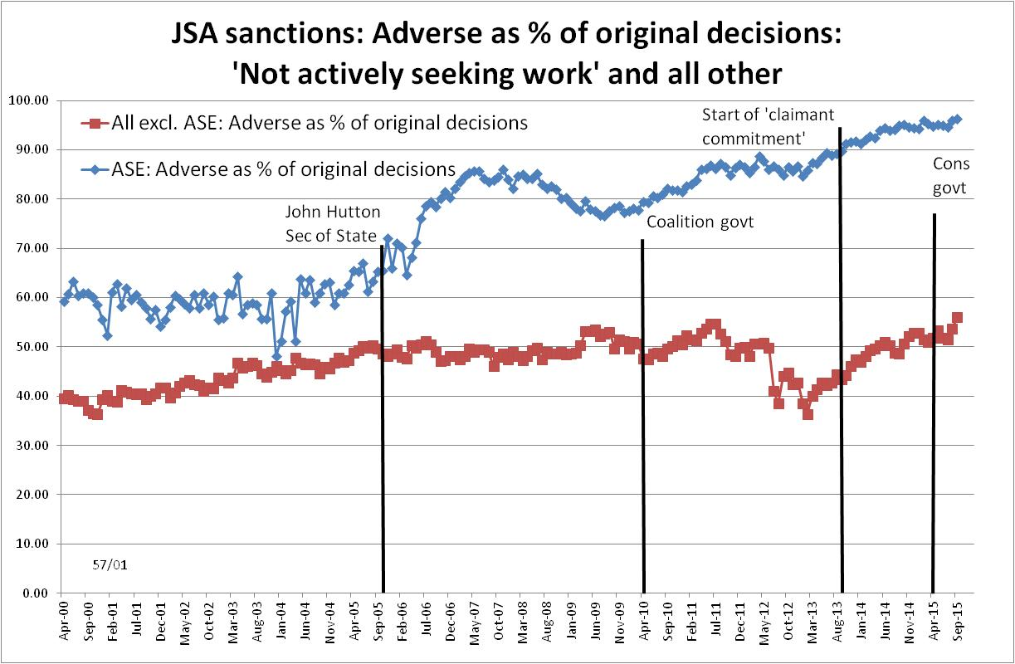

Figure 14
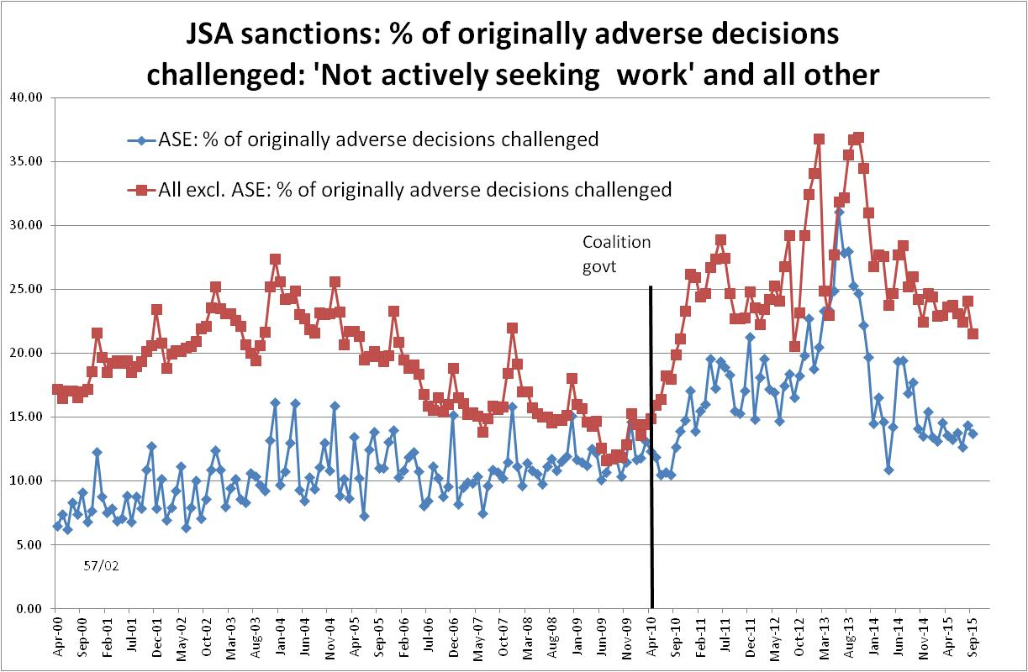

Figure 15
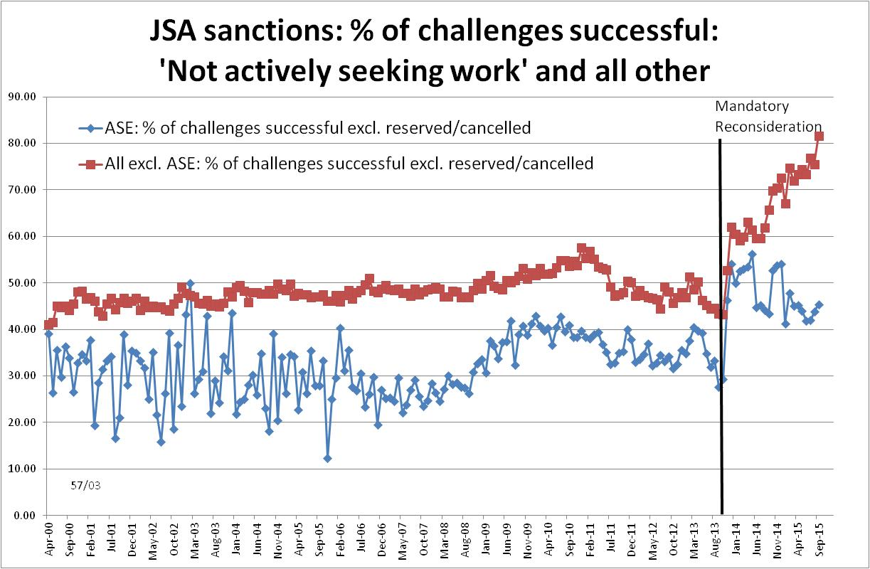

Figure 16
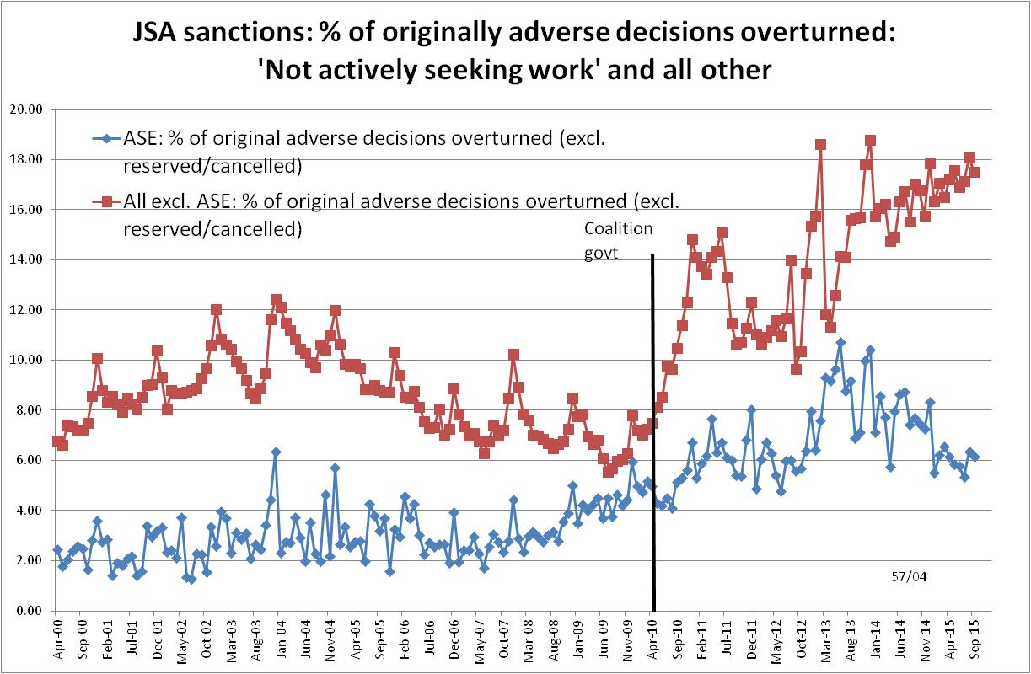

NOTES

This is the tenth in a series of briefings on the DWP’s statistics on Jobseeker’s Allowance (JSA) and Employment and Support Allowance (ESA) sanctions. All the briefings are available at http://www.cpag.org.uk/david-webster. Earlier briefings should be read in the light of the DWP’s statistical revisions, because some of their conclusions are no longer valid. However, much of the data and discussion remains useful, particularly because different briefings deal with different topics.
Stat-Xplore can now be accessed by registered users using an application programme interface (API).
The basic concept of the DWP’s sanctions database is that each sanction case appears only once, and is given its latest status and attributed to the month of the latest decision on the case. So, for instance, if a decision is made in January 2014 to sanction someone, this decision is reviewed in March 2014 with an outcome unfavourable to the claimant, reconsidered in a ‘mandatory reconsideration’ in May 2014 again with an unfavourable outcome, and is heard on appeal by a Tribunal in October 2014 with a decision favourable to the claimant, then: - it appears in the statistics for the first time in January 2014 as an adverse decision - in March 2014 it changes its status to a reviewed adverse decision and moves month to be with all the other cases where the latest decision has been made in March 2014 - in May 2014 it changes its status to a reconsidered adverse decision and moves month to be with all the other cases where the latest decision has been made in May 2014 - in October 2014 it changes its status again to an appealed non-adverse decision, and moves month again to be with all the other cases where the latest decision has been made in October 2014.
The terms used here in relation to reviews, reconsiderations and appeals are as follows: Mandatory Reconsideration, with initial capitals, and its abbreviation MR, means the whole new appeal system introduced on 28 October 2013 ‘mandatory reconsideration’, without initial capitals, and never abbreviated, means the formal reconsideration of a sanction decision undertaken by the DWP’s Disputes Resolution Team. ‘decision review’ means the informal process of reconsideration now undertaken by the original Decision Maker (but previously undertaken by a different Decision Maker) when a claimant first challenges a sanction ‘internal review’ is a term embracing both ‘decision review’ and ‘mandatory reconsideration’ ‘appeal’ means a formal appeal to a Tribunal ‘challenge’ means any challenge to a sanction decision, i.e. it embraces ‘decision reviews’, ‘mandatory reconsiderations’ and Tribunal appeals.
DWP published an updated version of its UC statistics release strategy on 17 February at https://www.gov.uk/government/publications/universal-credit-statistics-background-information/universal-credit-statistics-background-information It still says nothing about statistics on Universal Credit sanctions.
The documentation is in correspondence between Jonathan Portes (NIESR) and myself and the UKSA Chair Sir Andrew Dilnot, on the UKSA website at http://www.statisticsauthority.gov.uk/reports---correspondence/correspondence
Universal Credit sanctions have been estimated by assuming that their monthly rate is the same as for JSA, and increasing the resulting number by 37.7% in line with the result of the detailed calculation using age-specific JSA sanction rates reported in the November 2015 Briefing.
The estimate of sanctions before challenges has been derived by adding the monthly total of ‘non-adverse’, ‘reserved’ and ‘cancelled’ decisions shown as being the result of reviews, mandatory reconsiderations and tribunal appeals, to the monthly total of adverse ‘original’ decisions.
In FoI response 2015-2187, DWP has supplied a denominator, namely the number of individuals who claimed ESA at any point in the year, which is not quite correct as it is for 1 June 2014 to 31 May 2015. This does not make a significant difference.
http://www.publications.parliament.uk/pa/cm201314/cmselect/cmworpen/479/479vw.pdf pp. Ev w90-w101
DWP 2013, Table 6.2, p.157

