DWP Ad Hoc Statistical Release, 18 November 2015

JSA and ESA hardship applications and awards: Apr 2012 to Jun 2015

EARLY BRIEFING

1. Sanctions remove all of claimants’ JSA and all of the personal allowance component of ESA. Hardship payments are discretionary payments which can be claimed by sanctioned JSA and ESA claimants. If successful, arbitrarily defined ‘vulnerable’ people (which does not include, for instance, people who are mentally ill or homeless) get 80% of their sanctioned benefit. Others get 60%. Only the ‘vulnerable’ can apply immediately. Everyone else has to wait two weeks.

2. Today the DWP published monthly statistics on JSA and ESA hardship payment applications and awards for April 2012 to June 2015.

3. The DWP has never previously published statistics on ESA hardship payments and has not published regular statistics on JSA hardship payments since 2005.

JSA hardship payments: What the new figures show

4. Figure 1 compares the number of JSA hardship payment awards month by month with the estimated number of JSA sanctions before challenges, i.e. reviews, reconsiderations or appeals. This is the correct comparison since sanctioned claimants lose their money immediately and even if successful in their challenge, will only receive a refund weeks or months later.

5. The most striking feature is the huge increase in the number of hardship payments immediately upon Iain Duncan Smith’s introduction of the more severe sanctions regime, with longer sanctions, on 22 October 2012. Since then the gap between the number of sanctions and the number of hardship awards has continued to narrow. This is shown more clearly in Figure 2. Before the October 2012 changes, JSA hardship awards were running at less than 10% of sanctions. But they then rose steeply, to 30% by February 2013, and they have since risen further, to over 40%. The criteria for ‘hardship’ are specific to the sanctions regime and are particularly harsh – for instance, a person with cash in hand equal to their ‘applicable amount’ will be refused even if the money is owed to a payday lender (Decision Maker’s Guide para. 35198). If you get a hardship payment, it means that you have been completely cleaned out of resources, and exhausted all possibility of help from family and friends. The figures therefore show that the Duncan Smith regime is creating destitution on a horrifying scale.

6. Also, as with any discretionary benefit, the complicated application process and lack of information given to claimants mean that many claimants never even apply for the ‘hardship payments’ they ought to receive, and even when an application is made, there are often delays in payment.

7. The former minister Esther McVey told the Work and Pensions Committee on 4 February that ‘the vast, vast majority of people applying for hardship payments get them’. Figure 3 shows that this is true. Just under 90% of JSA applicants are successful. However it is disturbing that this percentage has risen from only about two-thirds prior to the Duncan Smith regime. A higher proportion of a larger number of applicants are completely destitute.

ESA hardship payments

8. Sanctioned ESA claimants are not quite as badly off in that they currently retain the ‘work related activity component’ of about £25.75 per week, although this is being abolished from April 2017 by George Osborne. They are also generally a less disadvantaged group than JSA claimants, in that long term sickness and disability are less concentrated among economically disadvantaged people than is unemployment. These factors probably explain why, although ESA hardship awards rose sharply after the Duncan Smith changes (for ESA, these were from 3 December 2012), the proportion of sanctioned claimants receiving hardship payments has never risen as high as for JSA. They have risen from under 10% during 2012 to around 20% since then, with the proportion declining slightly in later months (Figures 2 and 4). The proportion of ESA applicants claiming hardship payments who receive them is very high, and similar to that for JSA (Figure 3).

Overall scale of destitution

9. Altogether, there have been 749,900 JSA and 18,650 ESA hardship payment awards over the three and a quarter years covered by these statistics, a total of 768,550. Some of these will have been repeat awards to the same people, but on the other hand these figures do not include people who should have applied but did not. This does therefore give an idea of the scale of destitution being wrought by Duncan Smith’s sanction policies.

18 November 2015

Dr David Webster
Honorary Senior Research Fellow
Urban Studies
University of Glasgow

Email david.webster@glasgow.ac.uk

Webpages: http://www.gla.ac.uk/schools/socialpolitical/staff/davidwebster/
http://www.cpag.org.uk/david-webster

Figure 1
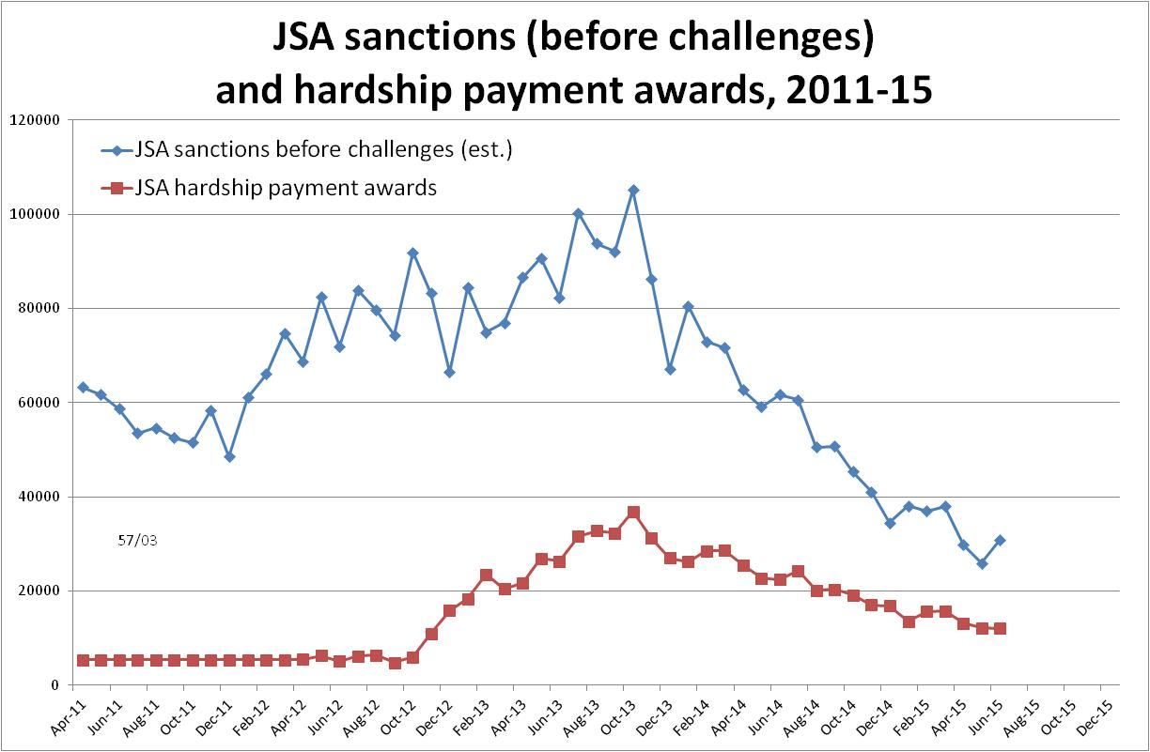

Figure 2
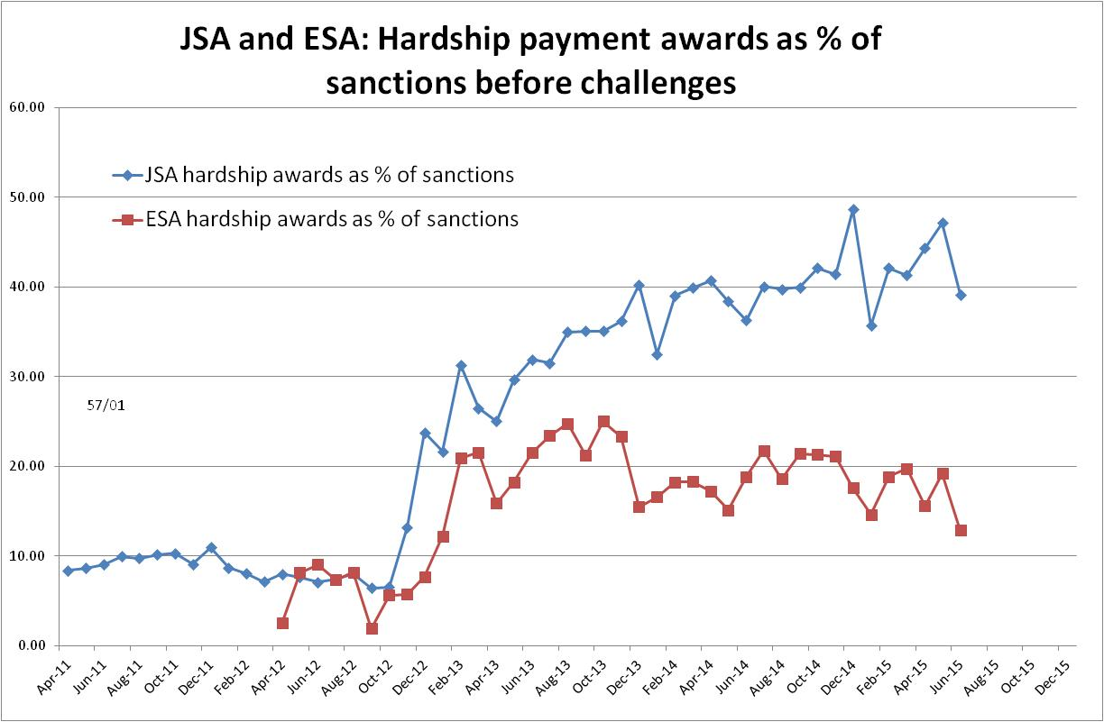

Figure 3
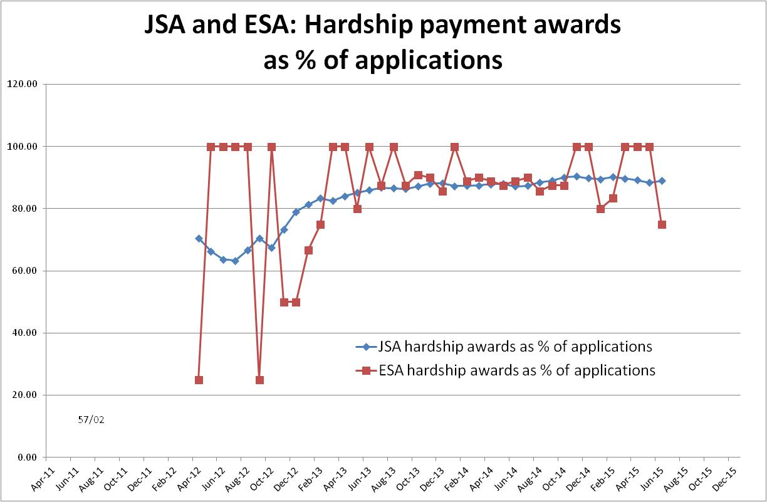

Figure 4
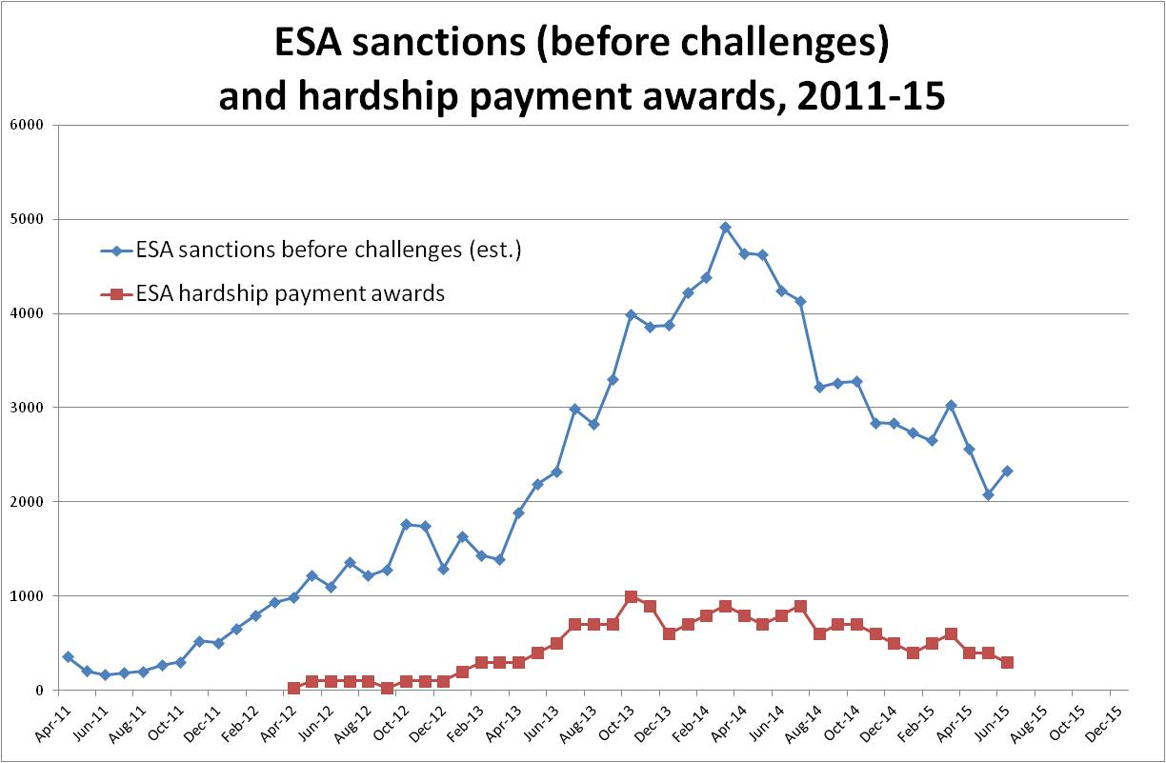

There was an ad hoc release in September 2012 giving the single figure of 64,000 JSA hardship payment awards in 2011-12, and a Freedom of Information response 2013-1443 in April 2013 giving figures for JSA hardship assistance for February 2005 to August 2012 on the different basis of number of claimants in receipt of hardship payments.
The figures for hardship payment show the actual month of the award. The estimated figures for sanctions before challenges are as given in the author’s regular quarterly statistical briefings. They are approximate because of the way the DWP database records cases. However this does not affect any substantial trends in the data.
The government told the Work and Pensions Committee (Report, 24 March 2015, para. 146) that it had ‘sped up’ the hardship payment process as from 14 July 2014 to ensure that claimants receive payment within three days.
I am awaiting clarification from DWP on the legal basis on which ESA hardship payments were made prior to the Employment and Support Allowance (Sanctions) (Amendment) Regulations 2012, which came into force on 3 December 2012.

