BRIEFING

Benefit Sanctions Statistics

November 2022

29 November 2022

Dr David Webster
Honorary Senior Research Fellow
Urban Studies
University of Glasgow

Email david.webster@glasgow.ac.uk

Webpages: http://www.gla.ac.uk/schools/socialpolitical/staff/davidwebster/
http://www.cpag.org.uk/david-webster

SUMMARY

This Briefing reports on the latest quarterly benefit sanctions statistics released on 15 November. There has been no improvement in the coverage of the Universal Credit (UC) sanctions statistics and none of the suspended data have been reinstated. However, some figures on UC Work Capability Assessments were released in a parliamentary answer as a one-off on 11 October.

The total number of people on UC was a provisional 5.78m in October 2022, of whom 1.81m (31.3%) were subject to conditionality.

Monthly UC sanctions reached a peak of 58,548 in March but since then have fallen, to an average of 45,100 in the latest quarter. This is over two-and-a-half times the average in the three months before the pandemic. It equates to a rate of over half a million (541,000) per year. Sanctions have also stabilised as a percentage of UC claimants subject to conditionality, at 2.5% per month. In the three months before the pandemic it was 1.4% per month. The monthly rate of sanction on unemployed UC claimants in July 2022 was higher at approximately 2.8%, or 1 in 36 claimants, while for those ‘planning for work’ and ‘preparing for work’it was much lower, at 0.28% and 0.27% respectively.

The number of UC claimants who were serving a sanction in August was 115,274, after peaking at 117,999 in July, This is more than three times the pre-pandemic peak of 36,771 in October 2019. The percentage of UC claimants subject to conditionality serving a sanction was 6.37% in August, more than double the pre-pandemic peak of 3.1% in October 2019 and equating to one in 16 of UC claimants subject to conditionality. One in 13 (7.65%) of those in the ‘searching for work’ group were under sanction in August 2022.

DWP is not currently publishing statistics on the duration of UC sanctions, but from the published data it can be estimated that the average must be around 11 weeks.

According to DWP, almost all UC sanctions (98.2% in the latest quarter to July 2022) are now for ‘Failure to attend or participate in a Work-Focused Interview’. As mentioned in the previous Briefing, this does not seem to reflect what is happening on the ground. However, there is now a steady trend for reported reasons other than interviews to increase slightly.

DWP has ceased publishing updates to statistics on sanctions for Jobseekers Allowance (JSA), Employment and Support Allowance (ESA) and Income Support (IS). Although
sanctions on these benefits had fallen to nil or negligible levels since the pandemic, there were still 423,600 people on these benefits and legally liable to sanction in July 2022.

The government has announced further increases in conditionality: a further raising of the UC ‘Administrative Earnings Threshold’ from January 2023; introduction of the postponed ‘in-work conditionality’ from September 2023; and general strengthening of the sanctions regime. These changes are clearly a response to widespread labour shortages but do not address the main issue of the recent rise of 630,000 in economic inactivity, particularly as related to ill health. The rises in the AET will only have a trivial effect on the labour market (although potentially a serious impact on claimants), and the government’s own trial of in-work conditionality produced only mediocre results. It is welcome therefore that the Autumn Statement announced a DWP review of inactivity, to report early in 2023. The Briefing has the usual summary of other sanctions-related developments.

BRIEFING: Benefit Sanctions Statistics
November 2022

The DWP released its latest quarterly benefit sanctions statistics on 15 November. The newly published data are summarised by DWP in the online publication Benefit Sanctions Statistics, available along with methodological notes at https://www.gov.uk/government/collections/jobseekers-allowance-sanctions together with a spreadsheet with summary tables. Some data are on Stat-Xplore at https://stat-xplore.dwp.gov.uk/webapi/jsf/login.xhtml . All statistics presented here relate to Great Britain. All previous Briefings are available at http://www.cpag.org.uk/david-webster .

DWP has ceased publishing updates to statistics on sanctions for Jobseekers Allowance (JSA), Employment and Support Allowance (ESA) and Income Support (IS). The latest statistics on sanctions on these benefits are those covered in the previous Briefing, in August 2022, giving data up to the end of April 2022. Historic data on these benefits will continue to be shown in the Briefing where appropriate.

As reported in previous Briefings, sanctions on JSA, ESA and IS had fallen to nil or negligible levels and no doubt this will continue. However there must be some discomfort about the fact that any revival of sanctions on these benefits would go unreported. At July 2022 there were still 423,600 people on these benefits and legally liable to sanction, comprising 94,670 on JSA, an estimated 173,100 on ESA (in the Work-Related Activity Group), and an estimated 155,800 on IS including 65,300 lone parents. Moreover, whereas all IS claimants are scheduled to be transferred to UC by March 2025, new claims to ‘new-style’ JSA and ESA will continue indefinitely. A reasonable solution would appear to be to ask DWP for data on sanctions on these benefits periodically, say once a year, via FoI or PQ, although such questions are not guaranteed to be answered.

As discussed in the previous Briefing (August 2022), the coverage of the different aspects of UC sanctions in the published statistics remains very poor. There has been no improvement in the coverage of the statistics since August and none of the suspended data have been reinstated.

One aspect specifically mentioned in the August Briefing was statistics on Work Capability Assessments (WCAs), which determine which conditionality group a claimant citing sickness or disability is put into. While a good set of statistics has always been published on WCAs for ESA, nothing has to date been included in the regular UC statistics. The Office for Statistics Regulation has been pursuing this issue and the latest exchange of letters is at https://osr.statisticsauthority.gov.uk/correspondence/siobhan-tuohy-smith-to-steve-ellerd-elliot-universal-credit-work-capability-assessment-statistics/ and
https://osr.statisticsauthority.gov.uk/correspondence/steve-ellerd-elliot-to-siobhan-tuohy-smith-universal-credit-work-capability-assessment-statistics/ . DWP has now included UC WCA statistics in its Statistical Work Programme, but has not committed to actually producing the statistics. It says this depends on availability of resources. The latest edition of the Statistical Work Programme (27 October) is at https://www.gov.uk/government/publications/dwp-statistical-work-programme/statistical-work-programme

Some figures on UC WCAs were finally released in a parliamentary answer as a one-off (UIN 53261, 11 October), at https://questions-statements.parliament.uk/written-questions/detail/2022-09-21/53261. They are discussed by the Disability News Service at https://www.disabilitynewsservice.com/dwp-finally-releases-universal-credit-fitness-for-work-figures/ They show that over the 12 months to end-June 2022, 609,900 UC WCAs were recorded, of which an average of 19.5% resulted in an assessment of fitness for work, 62.3% of limited capability for work related activities, and only 18.3% of limited capability for work (i.e. exemption from all requirements).

Number of people on Universal Credit (UC) and number subject to conditionality

The total number of people on UC was a provisional 5.78m in October 2022. Within this, the number of claimants subject to conditionality was 1.81m, or 31.3%. The proportion of UC claimants who are subject to conditionality has been declining and continues to do so.

The largest group of UC claimants subject to conditionality is those ‘searching for work’, i.e. unemployed. They were 1.38m in October 2022 (Figure 1), accounting for 93.8% of all claimant unemployed; the other 6.2% of the claimant unemployed were the 94,670 claimants on JSA mentioned above. The number in the ‘searching for work’ group has been declining but has levelled off in the latest few months. The rise in the Administrative Earnings Threshold (AET) from 26 September which was discussed on pp.8-9 of the August Briefing will probably have contributed to this in a small way in relation to the October figure, although the full effect will probably not be seen until later. The effect of the rise in AET is to shift some claimants from the ‘working –with requirements’ group to the ‘searching for work’ group. DWP estimates their numbers at 114,000 (DWP 2022) and they should be appearing in the statistics over the next few months, as will the 120,000 to be added by the further raising of the AET in January 2023 (see below).

The other two UC groups subject to conditionality are those ‘preparing for work’, who are mainly the UC equivalent of the ESA Work-Related Activity Group (WRAG), accounting for 0.32m claimants in October 2022, and those ‘planning for work’, 0.11m.

Of the 3.97m UC claimants not subject to conditionality, the ‘no work requirements’ group, i.e. sick, disabled and some carers, was 1.80m in October 2022. It is continuing to rise strongly, partly due to ‘managed migration’ from legacy benefits, which restarted on 9 May. The remaining groups not subject to conditionality are the ‘working – no requirements’ group, 1.21m at October 2022, and the ‘working – with requirements’ group, 0.96m. In spite of its name, in practice people in this latter group are currently not subject to conditionality. However, the government has indicated an intention to introduce ‘in-work conditionality’ for them from September 2023.This is discussed later in this Briefing.

Universal Credit sanctions appear to have peaked

UC sanctions appear to have peaked, at least for the time being, both in total numbers and as a percentage of UC claimants subject to sanctions – but at a comparatively high level (Figures 2 and 3).

Number of UC sanctions being imposed per month

Monthly UC sanctions reached a peak of 58,548 in March but since then have fallen back, to an average of 45,100 in the latest quarter (Figure 2). This is over two-and-a-half times the average in the last full three months before the pandemic (to February 2020), which was 17,295. It equates to a rate of over half a million (541,000) per year.

Monthly UC sanctions as a percentage of UC claimants subject to conditionality

UC sanctions have also stabilised as a percentage of UC claimants subject to conditionality (Figure 3). The monthly average of 45,100 for the latest quarter equates to 2.5% per month of UC claimants subject to conditionality, the same as in the previous quarter. In the three months immediately preceding the pandemic, i.e. December 2019 to February 2020, it was 1.4% per month.

The overall rate for UC puts together different categories of claimant with very different rates of sanctioning – unemployed, sick/disabled and those with caring responsibilities. The rate for unemployed claimants (‘searching for work’) is higher than for the other conditionality groups, which have quite low rates of sanctioning. From the figures for the proportion of claimants serving a sanction at a point in time (see below), and on the assumption that the duration of sanctions is similar for the different categories, the monthly rate of sanction on unemployed claimants in July 2022 would be approximately 2.8%, or 1 in 36 claimants. For those ‘planning for work’ it would be 0.28% and for those ‘preparing for work’, 0.27%.

Universal Credit claimants serving a sanction at a point in time

Number of UC claimants serving a sanction at a point in time

The number of UC claimants who were serving a sanction at a point in time has continued to rise but fell a little in August 2022, the last month of the latest quarter, when it was 115,274, after peaking at 117,999 in July (Figure 4). This is still more than three times the pre-pandemic peak of 36,771 in October 2019.

Percentage of UC claimants subject to conditionality who were serving a sanction at a point in time

Figure 5 shows the same data as a percentage of UC claimants subject to conditionality. Again, this measure has continued to rise but fell a little in August 2022, when it was 6.37% compared to 6.53% in July. This percentage is more than double the pre-pandemic peak of 3.1% in October 2019 and equates to one in 16 of UC claimants subject to conditionality. The difference between pre- and post-pandemic levels is less spectacular than for the simple numbers because there are now many more UC claimants subject to conditionality.

UC claimants serving a sanction at a point in time by conditionality group

Figure 6 shows the percentage of UC claimants subject to each individual conditionality regime who were serving a sanction at the measurement date in each month. As usual, unemployed (‘searching for work’) claimants were far more likely to be sanctioned than the other two groups subject to conditionality, with 106,474 or 7.65% under sanction in August 2022 compared to 0.77% for ‘planning for work’ and 0.74% for ‘preparing for work’. One in 13 unemployed UC claimants was under sanction in August 2022, up from one in 14 in May. In August, about 2% or one in 45 of the GB population had Covid, so, roughly speaking, an unemployed UC claimant was about three times as likely to be serving a benefit sanction as to have Covid.

There are also people in the groups not subject to conditionality who are serving sanctions. That is because under UC, sanctioned claimants are made to serve out the whole of their sanction even if they move into a no-conditionality group, for instance because of illness. There were 5,668 of them in August 2022, mainly (3,284) in the ‘working – with requirements’ group. They are the most likely to have recently been unemployed and therefore to have been sanctioned.

Duration of Universal Credit sanctions

DWP is not currently publishing statistics on the duration of UC sanctions. But given that the proportion of UC claimants under sanction was 6.53% in July 2022, and the proportion being given a sanction each month was approximately 2.5% in the quarter to July, it follows that the average duration of a UC sanction must be around 2.6 months or 11 weeks. This is obviously a very long time for a claimant to be without benefit income. This is only an approximate calculation because although the flow of sanctions has levelled off, it has not reached a steady state.

Reasons for UC sanctions

According to DWP, almost all UC sanctions (98.2% in the latest quarter to July 2022) are now for ‘Failure to attend or participate in a Work-Focused Interview’. This contrasts with 87.5% in November 2019-January 2020 (the last full quarter before the pandemic).
As mentioned in the previous Briefing (August 2022, p.6), this does not seem to accurately reflect what is happening on the ground, and it seems likely that the reason ‘Failure to attend or participate in a Work-Focused Interview’ is now being used to include cases where claimants have not done the work search or other activities required by their Work Coach. However, a trend has now emerged for the categories of reason other than interviews to increase slightly but steadily. Between July 2021 and July 2022, the quarterly number of sanctions for (non-)‘availability’ increased from 230 to 870, ‘non-participation in employment programmes’ from 10 to 850, ‘voluntary leaving/misconduct’ from 50 to 610, and ‘other’ from 20 to 100. This indicator may therefore be becoming more realistic.

Forthcoming further increases in conditionality

The previous Briefing (August 2022, pp. 8-9) discussed the increase in the UC Administrative Earnings Threshold (AET) from the equivalent of 9 hours a week for an individual on the National Minimum Wage to 12 hours a week. This took effect on 26 September. What this means is that an estimated 114,000 claimants at any one time, with earnings below the threshold, are being moved from the ‘working – no requirements’ conditionality group to ‘searching for work’, which currently means a move from no conditionality to full conditionality. A press release by DWP on 26 September at https://www.gov.uk/government/news/administrative-earnings-threshold-to-rise-for-universal-credit-jobseekers gives some further information.

Over the summer, leading Conservative politicians have been talking about increasing conditionality. During his leadership campaign, Rishi Sunak said he would be ‘much tougher’ on benefit claimants (https://www.telegraph.co.uk/politics/2022/08/17/liz-truss-rishi-sunak-tory-leadership-race-hustings-northern/ ), and also on 26 July he issued a press release saying that he would further raise the 12 hours’ a week AET to 18 hours. At the Conservative Party conference, Suella Braverman said the benefit system needs ‘a bit more stick’ (https://www.thetimes.co.uk/article/liz-truss-faces-questions-on-45p-tax-rate-uturn-conservative-tory-conference-follow-live-g55pw3hvr ). Reflecting these attitudes, three further increases in conditionality have been announced: a further raising of the AET; introduction of the postponed ‘in-work conditionality’; and general strengthening of the sanctions regime. There have also been a couple of announcements of increased employment support, for over-50s and people with mental health issues.

Further raising of the AET to 15 hours a week in January 2023

Kwasi Kwarteng in his abortive Growth Plan of 23 September (HM Treasury 2022a, para. 4.30) stated ‘The government is increasing support and incentives for those on Universal Credit (UC) across Great Britain by increasing the Administrative Earnings Threshold to 15 hours a week at National Living Wage for an individual claimant (and 24 hours a week for couples) from January 2023. This builds on the increase due to come into effect from 26 September 2022 which will raise the threshold from 9 hours a week to 12 hours a week for an individual (and 19 hours a week for couples). This latest change means that around 120,000 more UC claimants who are in work on low earnings will be moved from the Light Touch labour market regime to the Intensive Work Search labour market regime. They will be expected to actively search for work and attend weekly or fortnightly appointments at a jobcentre in order to secure more or better paid work, or they could have their benefits reduced.’ This commitment survived the reversal of most of the rest of Kwarteng’s package, and was reaffirmed in Jeremy Hunt’s Autumn Statement of 17 November (HM Treasury 2022b, para. 3.7).

Some of the problems likely to result from the 15-hour AET were discussed in an article by Julia Kollewe in the Guardian at https://www.theguardian.com/society/2022/sep/23/part-time-workers-dismay-benefits-rule-changes-kwasi-kwarteng

If we assume that every one of the estimated 234,000 claimants shifted from the 9-hour to the 15-hour threshold were to achieve the full 6 hours’ additional work per week this would be equivalent to getting 40,000 wholly unemployed people into full-time work (234,000 x 6/35). But of course this is extremely over-optimistic. Perhaps the equivalent of one third of these claimants might achieve the 6 hours. This would equate to 13,000 wholly unemployed people moving into full-time work. Therefore it can be seen that despite the heavy publicity given to it, this policy is trivial in relation to the scale of economy-wide labour shortages and the 630,000 increase in economic inactivity, though potentially serious in its impact on claimants.

Introduction of ‘in-work conditionality’

Jeremy Hunt’s Autumn Statement of 17 November (HM Treasury 2022b, para. 3.7) also stated: ‘To help tackle the barriers to progression faced by individuals on lower earnings, the government will bring forward the nationwide rollout of the In-Work Progression offer, starting with a phased rollout from September 2023. This will mean that over 600,000 Universal Credit claimants that are in work will be required to meet with a dedicated work coach so that they have support to increase their hours or earnings.’ This is the ‘in-work conditionality’ which caused so much controversy when UC was being introduced. Currently, in spite of its name, the ‘working – with requirements’ group is not subject to conditionality.

The DWP ran an ‘in-work progression trial’ from April 2015 to March 2018. The evaluation (DWP 2019) produced very mediocre results (summarised in the November 2019 Briefing, p.10), suggesting that the programme produced only marginal benefits and casting doubt on its value for money, even before considering the problems it will create for claimants. Much will depend on how the programme is administered – the more voluntary it is, the more successful it seems likely to be.

The estimate of ‘over 600,000’ UC claimants being drawn into in-work conditionality has presumably been derived in the first instance by taking the 964,000 claimants in the ‘working – with requirements’ group at October 2022 and deducting the 114,000 and 120,000 claimants respectively who are estimated to move into ‘intensive work search’ in the two rounds of raising of the AET. This produces the rather higher estimate of 730,000, but DWP may be making an adjustment for other factors such as raising of the minimum wage.

General strengthening of the sanctions regime

Kwarteng’s Growth Plan (HM Treasury 2022a, para. 4.31) stated ‘Alongside (the changes to the AET), the government will be strengthening the (UC) sanctions regime to set clear work expectations – including applying for jobs, attending interviews or increasing the hours – in return for receiving UC. Claimants who do not fulfil their job-search commitment without good reason could have their benefits reduced.’ This can only mean a further increase in sanctions beyond the over half a million per year being imposed already. This statement was not repeated in Hunt’s Autumn Statement, so it is unclear how much should be read into it.

Expansion of employment support for older workers and those with mental health issues

Kwarteng’s Growth Plan (HM Treasury 2022a, para. 4.32) stated ‘To help older workers to find work, the government will provide additional work coach support to new, eligible over 50s claimants and – for the first time – to over 50s that are long-term unemployed. This will mean more jobseekers across Great Britain receive intensive, tailored support at jobcentres to help them get into and progress in work, boosting their earnings ahead of retirement.’ More detail is at https://www.gov.uk/government/news/government-drive-to-help-those-aged-50-and-over-re-join-the-jobs-market On 10 October the government also announced at https://www.gov.uk/government/news/122-million-employment-boost-for-people-receiving-mental-health-support national rollout of an NHS England service to provide those who receive mental health support with employment advice to help them stay in work or return to the job market quicker. There has been no mention of compulsion in connection with these programmes.

The fall in economic activity and review by DWP

The withdrawal of large numbers of people from the labour force since the pandemic was discussed in the previous Briefing (August 2022, p.10). Chloe Smith’s only significant speech during her short spell as Secretary of State for Work and Pensions focused on this issue: https://www.gov.uk/government/news/dwp-secretary-of-state-outlines-plans-to-boost-labour-market and the media have continued to reflect increasing concern about it.

A series of articles in the Financial Times have presented the evidence for thinking that the decline in economic activity is very largely due to the excessive pressure on the NHS resulting in a failure to deliver adequate healthcare: Camilla Cavendish (17 September, p.12), Sarah O’Connor (27 September p.23) and John Burn-Murdoch (7 October p.22 and 4 November p.22). Similar articles appeared in the Observer, 23 October, at https://www.theguardian.com/business/2022/oct/22/the-long-battle-to-get-britains-lost-employees-back-to-work, in the Guardian, 11 October at https://www.theguardian.com/business/2022/oct/11/uk-unemployment-long-term-sick-jobless-level-pay-inflation , and on the BBC News website at https://www.bbc.co.uk/news/business-63204333 on 11 October and at https://www.bbc.co.uk/news/health-63625989 on 23 November. The Bank of England has espoused this view in its latest Monetary Policy Report (Bank of England 2022, pp.86-7): ‘It is likely that Covid and associated delays in treatment for other conditions have played a significant role in the increase in inactivity due to long-term sickness. Just under two million people reported to the ONS that they have long Covid as of 4 June. Around 20% of those people report that this reduces their ability to undertake day-to-day activities a lot. Those with existing health conditions may have also left the labour force in order to shield from Covid. In addition, participation may be lower due to the effects of other long-term health conditions, which may have been more difficult to treat than before the pandemic given capacity pressures in the healthcare sector.’ Reuschke & Houston (2022) estimate the number of withdrawals from the labour force specifically due to ‘long covid’ at 80,000.
The most thorough consideration of these issues is to be found in the transcript of the oral evidence session held on 26 October as part of the House of Commons Work and Pensions Committee’s Inquiry Plan for Jobs and Employment Support (House of Commons 2022). An earlier session of the Committee on 5 January considered the government’s Plan for Jobs and a further session on 16 November focused on employment support for young people and people with disabilities.
The oral evidence session on 26 October focused on the rise in economic inactivity and what to do about it. The expert witnesses were in agreement with each other. In summary, the points they made were:
- There is no large group of long-term unemployed people who are receiving Universal Credit and not looking for work – this is the group that conditionality is aimed at
- Three-quarters of the increase in inactivity since the pandemic has been among the over-50s
- There has been an increase in sickness among the already retired as well as among the newly inactive
- Some of the out of work sick are likely to be people who were previously sick but were in a job which they lost due to the pandemic and who have subsequently found it impossible to get back into work
- Vacancies are highest in the public sector, and this is related to a growing gap in pay compared to the private sector
- Given the importance of sickness in the rise of inactivity, flexibility by employers in making adjustments to assist sick employees is key
- It is only good quality work which is good for people’s health
- Only one in 10 out of work disabled people or out of work over-50s are currently getting some form of employment support each year from the DWP
- The DWP’s employment programmes such as Kickstart and Restart need to be redesigned to support both young and older people who are economically inactive, and in particular to reach those who are not benefit claimants
- Besides Jobcentre Plus, other agencies and groups should be enabled to deliver employment support and there needs to be effective local level co-ordination of employment services provided by different agencies
- The state does not engage effectively with employers; fewer than one in five of them have used Jobcentre Plus at all. There is no employment ministry and contacts with employers by different departments are not co-ordinated.
- Use of compulsion in trying to increase people’s working hours is not only unlikely to achieve very much, but may also have negative impacts on an individual’s wellbeing and work prospects
- The European Social Fund provision of employment skills support is being wound down before its replacement, the Shared Prosperity Fund, comes on stream in 2024-25. As a result there are projects now that are starting to hand out redundancy notices to employment advisers who help over-50s and sick and disabled people into work and then in a year’s time when the commissioning starts again, they will all be trying to recruit them and hoping they haven’t gone to do something else.
Eleanor Carter of Oxford University commented ‘capacity, conditionality and connectivity (are) the three Cs’ that are preventing Jobcentre Plus employment support from working effectively: capacity - job coach caseloads are too large; conditionality – sanctions cause harms and are out of line with international best practice; connectivity – Jobcentre Plus work is not sufficiently connected to that of other agencies.
Tony Wilson of the Institute for Employment Studies commented ‘we have built a bureaucratic compliance regime that is largely around job search monitoring with small volumes, highly technology-enabled to manage ..... very large caseloads, and largely checking compliance and whether people are meeting their conditions of benefit receipt. (It) will be a massive pivot to then deliver this support for economically inactive groups, many of whom aren’t in touch....... We have pretty much one of the strictest conditionality regimes in the developed world...... a compliance and monitoring regime that is somewhat out of hand...... I just can’t believe that the system has gone wrong to the extent that about one in 12 people are currently under sanction ..... It is a phenomenally large number of people who currently have had their benefits reduced for not doing what they were meant to do and I just can’t believe that either we, the state, or the public employment service or the individuals have this so spectacularly wrong on so many occasions that so many people are under sanction. Something isn’t right. I think sanctions have become an end in themselves rather than the thing that happens when stuff goes wrong.’
Stephen Evans of the Learning and Work Institute commented: ‘There is no evidence that Way to Work made a difference. In my view, it is the wrong answer to the wrong question. The right answer is how we extend employment support to those who are out of work, particularly the over-50s, particularly people with sickness and disability. We can do this, the resource is there and the willingness is there, but it is not just about DWP, it is about a much more joined up and localised approach.’ (Way to Work was discussed in the August 2022 Briefing, pp.7-8.)
The DWP’s ramping up of conditionality outlined above is obviously a reaction to the shrinking of the labour force. But it is questionable whether it is evidence-based, not least because most of the people missing from the labour force are not on benefits and therefore will not be reached by conditionality. So it is welcome to read in Jeremy Hunt’s Autumn Statement (HM Treasury 2022b, para. 3.6) that DWP will now be undertaking a full review of the rise in inactivity: ‘Since the 2008 Global Financial Crisis, much of the UK’s growth has been driven by an increase in the number of hours worked. This was partly due to falling unemployment – which is now close to its lowest rate in 50 years – and increased labour market participation after 2008, particularly amongst women. However, since the COVID-19 pandemic the trend in participation has reversed, seen particularly acutely within those aged over 50. There are now 630,000 more working age inactive individuals than there were pre-pandemic. The Department for Work and Pensions will thoroughly review workforce participation. This work will conclude in early 2023.’

SANCTIONS - OTHER DEVELOPMENTS

Third-party deductions must not be automatic

Following the court ruling that DWP does have discretion to waive the repayment of UC Recoverable Hardship Payments, which was reported in the November 2021 Briefing, p.7, the High Court has now ruled that DWP must not apply third party deductions automatically but must assess whether they are in the claimant’s best interests. The case was reported at https://www.theguardian.com/society/2022/sep/23/disabled-woman-wins-legal-challenge-against-dwp-over-automatic-benefit-deduction and the judgment is given in full at https://caselaw.nationalarchives.gov.uk/ewhc/admin/2022/2392/data.pdf

The Guardian on 28 November at https://www.theguardian.com/society/2022/nov/28/dwp-deducting-scotland-families-univeral-credit-debt reported that UC claimants in Scotland have on average been having deductions equating to 10% of their benefit entitlement.

Two-fifths of UC claimants already suffering hunger

A publication by the Trussell Trust (2022) reports that a YouGov survey of a representative sample of 1,846 people in receipt of Universal Credit (UC) during August 2022 found that 38% said they had gone a whole day with no food at all, or just one meal, in the last month because there wasn’t enough money for food, compared to 11% in the general population.

The TUC on how to replace Universal Credit

Over the last decade there have been quite a few reports proposing changes, improvement or replacement to deal with the problems in the UC system. The TUC has now provided the latest of these (TUC 2022). It has the advantage of being based on the longest experience of the system to date. The report recommends that punitive sanctions should be scrapped and that proposals to introduce in-work conditionality (now to be revived from September 2023) should be dropped.

Comprehensive book from the Welfare Conditionality project

The Welfare Conditionality project, funded by ESRC and delivered collaboratively by six universities, ran from 2013 to 2018. It has already produced various reports, available at http://www.welfareconditionality.ac.uk/publications/ . The lead researchers have now published a comprehensive book (Dwyer et al. 2023) drawing on the qualitative longitudinal data from the project. Repeat interviews with people in the UK subject to compulsion and sanction enable them to analyse the effectiveness and ethicality of welfare conditionality in promoting and sustaining behaviour change. They find that welfare conditionality routinely triggers negative outcomes, and they therefore call for the abandonment of these sanctions, reiterating the importance of genuinely supportive policies that promote social security and wider equality. Within the UK literature, this book will now stand alongside Watts & Fitzpatrick (2018) and Adler (2018) as one of the key references for anyone seeking to understand the working and effects of the British sanctions system. Watts & Fitzpatrick focus primarily on concepts, Adler primarily on legal aspects, and Dwyer et al. on empirical effects. All three have thorough discussions of the ethics of conditionality.

The case for a statutory duty to prevent destitution

A new article (Simpson et al. 2022) reviews the inadequacy of the present legal provisions aimed at preventing destitution in the UK, and makes the case for a specific statutory duty to address this failure of rights protection.

Need to shift from labour market coercion to improving the quality of jobs

In a new book, Katy Jones and Ashwin Kumar (Jones and Kumar 2022) question the mantra that “work is the best way out of poverty”. They show that the state’s engagement with people out of work ignores the needs of lone parents and disabled people, and has little concern for skills and career progression. They argue that unemployment should not be treated as a behavioural problem to be corrected by coercive labour market policies but that policy should address the obstacles to better paid, good quality jobs.

Mandatory Work Activity: Precedents from the 1930s

Mandatory Work Activity (MWA) was a feature of the sanctions regime from 2011 to 2015 (https://en.wikipedia.org/wiki/Mandatory_Work_Activity) Matthew Cooper’s new article (Cooper 2022) compares MWA with enforced work regimes from the last days of the Poor Law in the 1930s. It highlights similarities between both regimes but also significant differences: in the 1930s different claimant groups were subject to different coercions, whereas in the MWA regime, claimants were treated as a homogenous category in need of discipline.

Unconditional cash payments - Rory Stewart takes over at GiveDirectly

The February 2020 Briefing, p.16, reported on the New York based charity GiveDirectly, which has an evidence-based commitment to giving cash directly and unconditionally to people living in poverty. The former UK International Development Secretary and Conservative leadership candidate Rory Stewart is showing his commitment to this approach by taking over as the organization’s President. Details are at
https://www.givedirectly.org/aug29-announcement/

Discontinuation of the ‘Alternative Claimant Count’ unemployment series

By requiring some people to look for work who would not previously have done so, UC has increased measured claimant unemployment. To show how much difference this would have made if UC had been fully implemented from the date it was introduced, DWP created an ‘Alternative Claimant Count’ unemployment series, which was first published in January 2019, giving figures back to January 2013. The February 2019 Briefing, pp.3-4, discussed this ‘Alternative Claimant Count’ series. Now that UC has been more or less fully implemented, at least in relation to unemployed people, the alternative series has now converged to the main series. DWP is therefore discontinuing publication. The last release in the series was on 11 October and is at
https://www.gov.uk/government/statistics/alternative-claimant-count-statistics-january-2013-to-august-2022/alternative-claimant-count-statistics-january-2013-to-august-2022

REFERENCES

Adler, Michael (2018) Cruel, Inhuman or Degrading Treatment? Benefit Sanctions in the UK, Palgrave Macmillan

Bank of England (2022) Monetary Policy Report, August, at https://www.bankofengland.co.uk/monetary-policy-report/2022/august-2022

Cooper, Matthew (2022) ‘The return of forced labour in the workfare state: enforced work for benefits in the UK in the 1930s and since 2010’, Journal of Poverty and Social Justice, 30:3, 193–209, 19 August, at
https://bristoluniversitypressdigital.com/view/journals/jpsj/30/3/article-p193.xml
DOI: https://doi.org/10.1332/175982721X16588487048928

DWP (2019) In-Work Progression Trial: Further Impact Assessment and Cost Benefit Analysis, Ad hoc Report 75, October, at https://www.gov.uk/government/publications/universal-credit-in-work-progression-randomised-controlled-trial

DWP (2022) Numbers moved to Universal Credit’s Intensive Work Search Regime because of the increase in the Administrative Earnings Threshold, Ad hoc statistical release, 5 August, at https://www.gov.uk/government/publications/numbers-moved-to-universal-credits-intensive-work-search-regime-because-of-the-increase-in-the-administrative-earnings-threshold

Dwyer, Peter, Lisa Scullion, Katy Jones, Jenny McNeill and Alasdair B. R. Stewart (2023) The Impacts of Welfare Conditionality: Sanctions Support and Behaviour Change, Bristol, Policy Press

HM Treasury (2022a) The Growth Plan 2022, presented to Parliament by the Chancellor of the Exchequer by Command of His Majesty, CP 743, September, at
https://www.gov.uk/government/publications/the-growth-plan-2022-documents

HM Treasury (2022b) Autumn Statement 2022, presented to Parliament
by the Chancellor of the Exchequer by Command of His Majesty, CP 751, November, at
https://www.gov.uk/government/publications/autumn-statement-2022-documents

House of Commons Work and Pensions Committee (2022) Oral evidence: Plan for Jobs and employment support, HC 971, Wednesday 26 October, at
https://committees.parliament.uk/event/14715/formal-meeting-oral-evidence-session/

Jones, Katy and Ashwin Kumar (2022) Idleness, Newcastle-upon-Tyne, Agenda Publishing, December, details at https://cup.columbia.edu/book/idleness/9781788214544

Reuschke, Darja and Donald Houston (2022) ‘The impact of Long COVID on the UK workforce’, Applied Economics Letters, 6 July at
https://www.tandfonline.com/doi/full/10.1080/13504851.2022.2098239

Simpson, Mark, Gráinne McKeever and Ciara Fitzpatrick (2022) ‘Legal protection against destitution in the UK: the case for a right to a subsistence minimum’, Modern Law Review, 14 November, free to view at https://onlinelibrary.wiley.com/doi/10.1111/1468-2230.12773

Trades Union Congress (2022) A replacement for Universal Credit, London, 6 September, at
https://www.tuc.org.uk/sites/default/files/2022-09/UC%20Report_1.pdf

Trussell Trust (2022) Tackling the True Cost of Living by Strengthening Our Social Security System, September, at https://www.trusselltrust.org/wp-content/uploads/sites/2/2022/09/Cost-of-Living-campaign-policy-briefing-Sep-2022.pdf

Watts, Beth & Suzanne Fitzpatrick (2018) Welfare Conditionality, Abingdon, Routledge

Figure 1
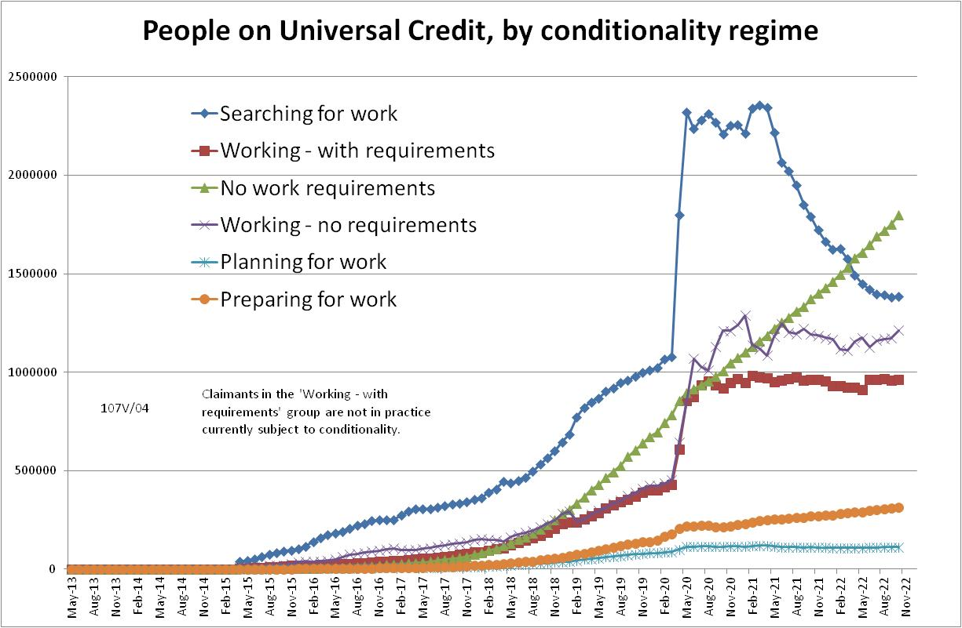

Figure 2
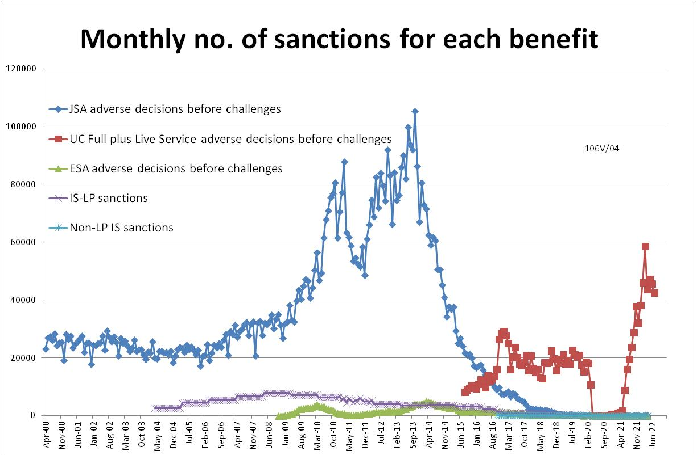

Figure 3
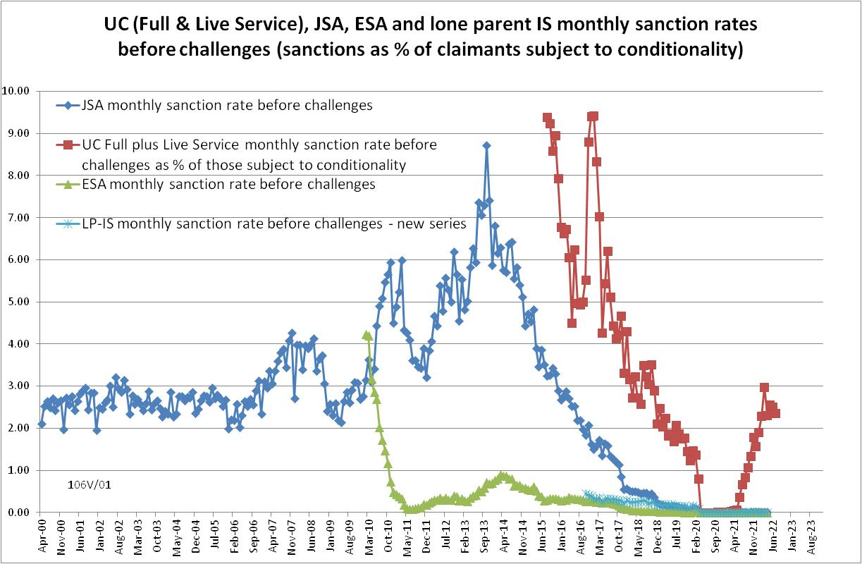
Figure 4
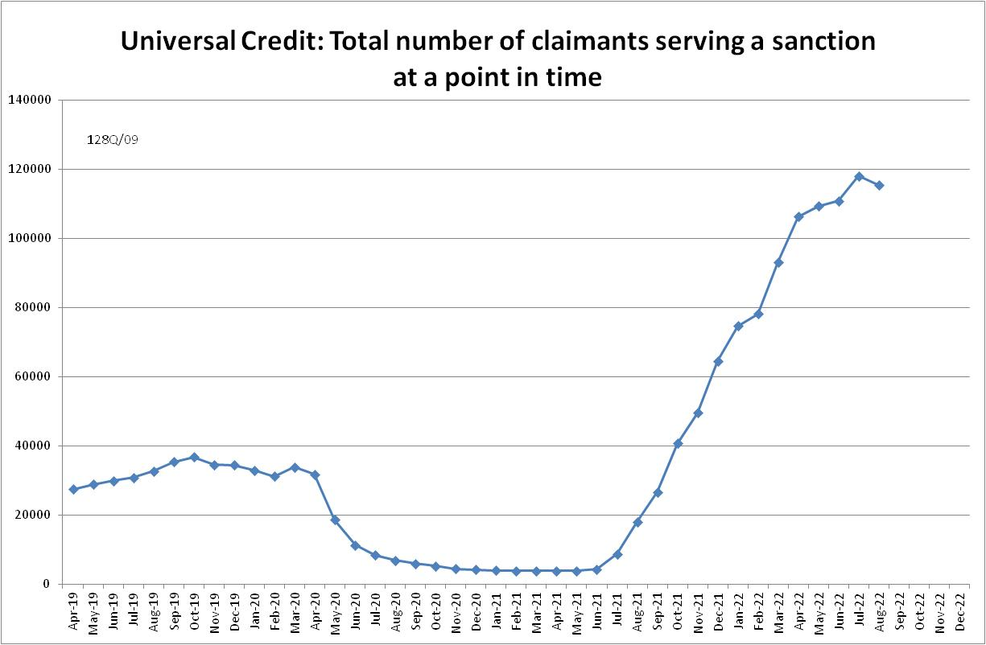

Figure 5
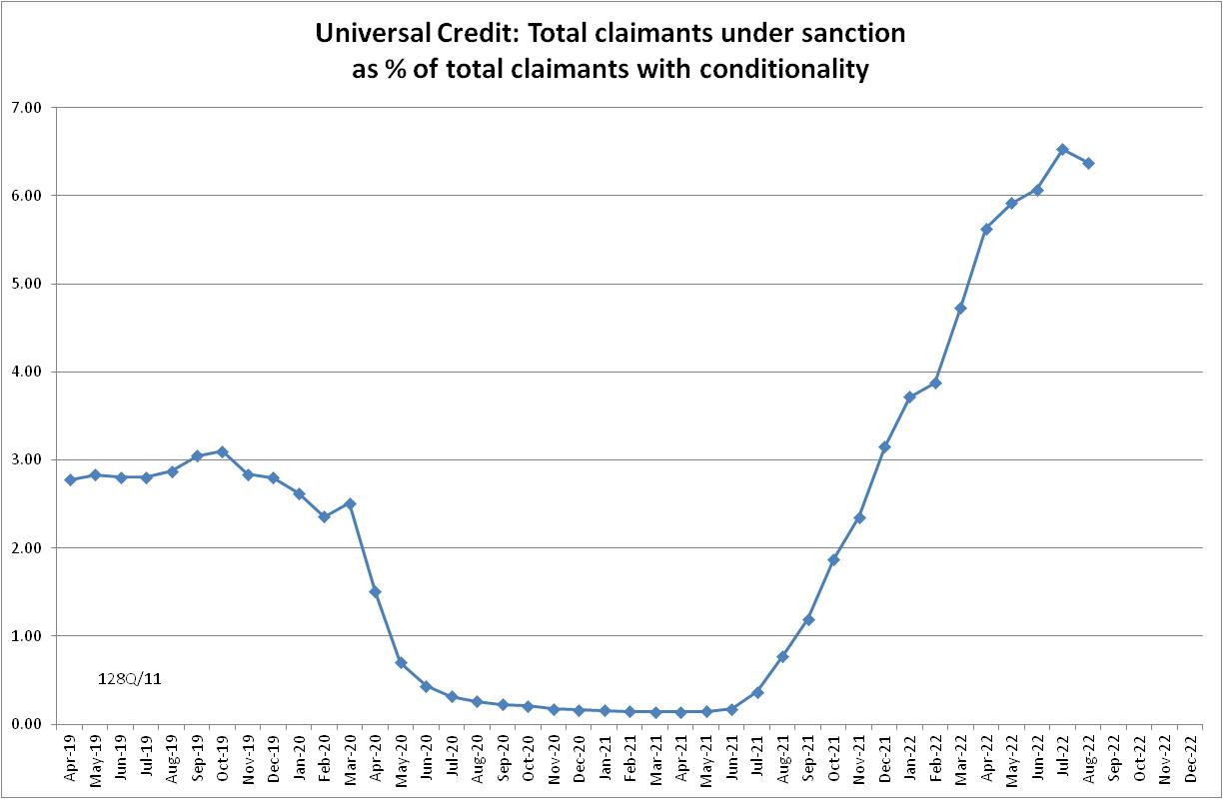

Figure 6
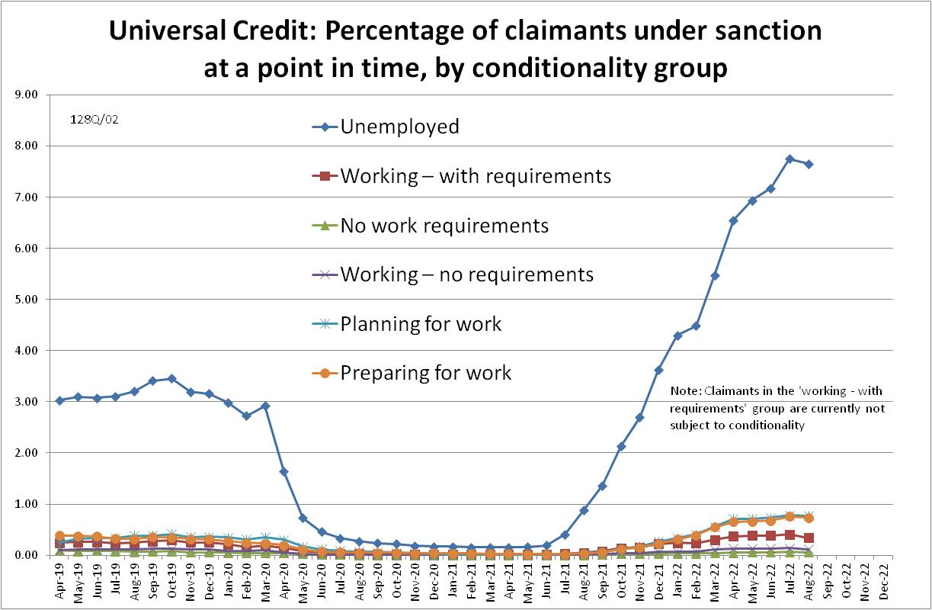

NOTES

Previous Briefings include many analyses that are not repeated here but remain valid. However it should be remembered that the DWP may have made subsequent revisions to the data reported in earlier Briefings. These revisions will generally not be major although there are exceptions. There may also often be substantial changes in some figures for the most recent few months.
Throughout the Briefing, the term ‘claimants subject to conditionality’ refers only to those actually subject to conditionality, i.e. it excludes UC claimants in the ‘working-with requirements’ group, who according to the legislation are subject to conditionality but in practice are currently not. In its published statistics, DWP is now following the same practice. This position will change when ‘in-work conditionality’ is introduced from September 2023.
A similar estimation method used in the February 2022 Briefing (p.4) proved quite accurate. It suggested about 30,000 new UC sanctions for November 2021; the actual figure is now shown to have been 37,701.
The drawbacks of the ‘claimants under sanction at a point in time’ measure were discussed in the November 2017 issue of the Briefing, pp.6-10. In November 2020, DWP withdrew the UC ‘rate’ data for all months prior to April 2019, pending revision of the figures for the former ‘Live Service’. These figures remain withdrawn. In addition, in the February 2021 release DWP made significant revisions to the figures for April 2019 onwards (which are for Full Service only, there being no one left on the former Live Service). These were fully discussed in the February 2021 Briefing.
Currently available figures for this measure only go back to April 2019 as DWP has withdrawn the figures for earlier dates. It is likely that a fuller run of figures would show a higher peak at an earlier date.
ONS Coronavirus (COVID-19) Infection Survey, at www.ons.gov.uk A rigorous comparison of the prevalence of Covid and of UC sanctions would have to make allowance for differences in the age groups covered by the statistics, variations in the prevalence of Covid by area and social group, etc. This has not been done here.
The Guardian on 26 July at https://www.theguardian.com/politics/2022/jul/26/sunak-promises-scrap-vat-on-fuel-bills-pm-dramatic-u-turn-leadership-truss reported the then Secretary of State Therese Coffey as claiming that DWP were blocked by Sunak when they wanted to increase the AET to 12 hours earlier this year. This does not seem to hve been reported by any other source. Sunak proposed in July (https://www.bbc.co.uk/news/uk-politics-62366197 ) to introduce £10 fines for patients who repeatedly miss NHS appointments. He later withdrew this proposal (https://www.bbc.co.uk/news/uk-63429244 ).
Additional findings from the ‘in-work progression trial’ were discussed in the November 2018 Briefing, pp.11-12.

