BRIEFING

Benefit Sanctions Statistics

May 2022

20 June 2022

Dr David Webster
Honorary Senior Research Fellow
Urban Studies
University of Glasgow

Email david.webster@glasgow.ac.uk

Webpages: http://www.gla.ac.uk/schools/socialpolitical/staff/davidwebster/
http://www.cpag.org.uk/david-webster

SUMMARY

This Briefing reports on the benefit sanctions statistics released by DWP on 17 May.

The monthly number of Universal Credit (UC) sanctions has continued to rise rapidly from its lows during the pandemic. The highest previously published monthly figure since the pandemic was 15,938, for July 2021, but this has risen to 37,701 in November 2021, with 32,107 in December 2021 and a further rise to 38,244 in January 2022.

Monthly UC sanctions have also continued to rise as a percentage of all UC claimants subject to conditionality, to 1.9% in January 2022, or 1.75% for the latest quarter as a whole. This is higher than the 1.4% per month in the three months immediately preceding the pandemic, i.e. December 2019 to February 2020. It can be estimated that the monthly rate of sanctions on unemployed UC claimants in January 2022 was approximately 2.2%.

The percentage of UC claimants subject to conditionality under sanction at a point in time has also risen well above the pre-pandemic level, to 3.9% in February 2022 compared to 3.1% in October 2019. For unemployed claimants this percentage was 4.52% in February 2022 compared to 0.41% for those ‘planning for work’ and 0.39% for those ‘preparing for work’.

Almost all UC sanctions (99%) are now for ‘Failure to attend or participate in a Work-Focused Interview’. This contrasts with 87.5% in November 2019-January 2020 (the last full quarter before the pandemic). A Freedom of Information (FoI) response gives an average of 174,498 missed UC appointments per week for the period 29 November 2021 to 18 February 2022, and it can be calculated that DWP is sanctioning 4.1% of the number of missed interviews, not far off the 3% calculated by the National Audit Office in 2016.

From the beginning of the pandemic and up to the end of January 2021, there continue to be very few sanctions on claimants of JSA (39 in the latest quarter), with none at all on claimants of ESA or on non-lone parent claimants of Income Support. There were 13 sanctions on lone parent claimants of IS in the latest quarter. The total number of sanctions on all benefits during 2021, at 171,067, remained well below previous annual totals back to 2000. However the 38,251 sanctions in January 2022 equate to an annual rate of 459,000, which would be higher than the number in 14 of the last 21 years.

A recent FoI response has revealed that the proportion of UC sanctions followed by a repayable Hardship Payment has risen, to 50% or over just before the pandemic. This is similar to that seen under JSA. Another shows that in April to December 2019 an average of 15,200 UC claimants (1.36% of those subject to conditionality) were having benefit deducted to repay a Hardship Payment. More than half of these claimants (55.5%) were losing 15% or more of their Standard Allowance, and over a quarter (27.8%) were losing 25% or more.

The Briefing considers in detail the controversy over the ‘Way to Work’ campaign, which has focused on the Secretary of State’s breaches of procedure in enacting a statutory instrument (SI) without the required 21 days’ notice, and failing to consult the Social Security Advisory Committee. The SI has brought about a serious worsening of claimants’ job search conditions, in reducing the period during which they can confine their job search to areas of previous experience or pay levels from 13 weeks to four. It concludes that this worsening appears likely to become permanent, without having had normal policy justification or scrutiny. Other sanctions-related developments are considered in the news section.
BRIEFING: Benefit Sanctions Statistics
May 2022

The DWP released its latest quarterly benefit sanctions statistics on 17 May.The important figures dropped from the February 2022 release have been included this time, namely the number of Universal Credit (UC) sanctions imposed, and the other figures relating to them: reasons for UC sanctions, the demographic profile of sanctioned UC claimants and repeat UC sanctions on the same individuals. However the published statistics for Universal Credit sanctions remain highly inadequate. Figures on the duration of UC sanctions remain suspended due to methodological problems, and apart from the odd Freedom of Information response DWP has never published any data at all on mandatory reconsiderations and appeals for UC Full Service, which has handled all UC claims since April 2019. Most data on UC sanctions are still being published in the form of ad hoc tables, rather than being available on Stat-Xplore at https://stat-xplore.dwp.gov.uk/webapi/jsf/login.xhtml . This means that analyses such as cross tabulations are not possible.

Figures on other benefits have been published as normal, but the numbers of people claiming them are now relatively small. Of the total of 2.479m claimants subject to conditionality at January 2022, 2.008m (four fifths or 81%) were on UC and only 0.472m on JSA, ESA or IS. Moreover there are currently hardly any sanctions on any benefits other than UC.

The newly published data are summarised by DWP in the online publication Benefit Sanctions Statistics, available along with methodological notes at https://www.gov.uk/government/collections/jobseekers-allowance-sanctions together with a spreadsheet with summary tables. All statistics presented here relate to Great Britain.

All previous Briefings are available at http://www.cpag.org.uk/david-webster .

The rapid rise in Universal Credit (UC) sanctions which was first noted in the November 2021 Briefing has continued

Number of UC sanctions being imposed per month

UC sanctions have continued to rise rapidly from their lows during the pandemic. The highest previously published monthly figure since the pandemic was 15,938, for July 2021, and the February 2022 Briefing estimated that this would have risen to about 30,000 in November 2021. In fact the November 2021 figure is now shown to have been 37,701, with 32,107 in December 2021 and a further rise to 38,244 in January 2022.

Monthly UC sanctions as a percentage of UC claimants subject to conditionality

UC sanctions have also continued to rise as a percentage of UC claimants subject to conditionality (Figure 1). The 38,244 UC sanctions imposed in January 2022 equate to 1.9% of UC claimants subject to conditionality – the highest monthly rate since July 2019. Taking the latest quarter as a whole, new UC sanctions per month as a percentage of claimants subject to conditionality were 1.75%. This is higher than in the three months immediately preceding the pandemic, i.e. December 2019 to February 2020, when it was 1.4% per month.

However the overall rate for UC puts together different categories of claimant with very different rates of sanctioning – unemployed, sick/disabled and those with caring responsibilities. The rate for unemployed claimants (‘searching for work’) is higher than for the other conditionality groups. From the figures for the proportion of claimants serving a sanction at a point in time (see below), and on the assumption that the duration of sanctions is similar for the different categories, the monthly rate of sanction on unemployed claimants in January 2022 would be approximately 2.2%.

UC claimants serving a sanction at a point in time

Number of UC claimants serving a sanction at a point in time

The number of UC claimants who were serving a sanction at a point in time has also risen rapidly. Figure 2 shows the number of UC claimants who were serving a sanction at the measurement date in each month. In February 2022 it reached 78,672 (1.41% of all claimants), over double the pre-pandemic peak of 36,785 in October 2019 and way above the low point of 3,829 (0.06% of all claimants) in May 2021. There is a slight indication of slackening in the pace of increase in January but this probably only reflects the dip in new sanctions in December and the trend appears to be firmly upwards.

Percentage of UC claimants subject to conditionality who were serving a sanction at a point in time

Figure 3 shows the same data as a percentage of UC claimants subject to conditionality. This percentage is also well above the pre-pandemic level, at 3.9% in February 2022 compared to 3.1% in October 2019, though the difference is less spectacular than for the simple numbers because there are now many more UC claimants subject to conditionality. Erratum: Please note that Figure 2 in the February 2022 briefing, and the accompanying text on p.4, presented the wrong figures. They showed claimants under sanction as a percentage of all UC claimants, rather than of UC claimants subject to conditionality.

UC claimants serving a sanction at a point in time by conditionality group

Figure 4 shows the percentage of UC claimants subject to each individual conditionality regime who were serving a sanction at the measurement date in each month. As usual, unemployed (‘searching for work’) claimants were far more likely to be sanctioned than the other two groups subject to conditionality, with 73,428 or 4.52% under sanction in February 2022 compared to 0.41% for ‘planning for work’ and 0.39% for ‘preparing for work’. However, all three groups show an increase since July 2021.

As noted in earlier Briefings, there are also people in the groups not subject to conditionality who are serving sanctions. That is because of the much-criticised feature of UC that sanctioned claimants are made to serve out the whole of their sanction even if they move into a no-conditionality group, for instance because of illness. Their numbers remain low but are increasing, to a total of 3,684 in February 2022, mainly (2,262) in the ‘working – with requirements’ group, who are the most likely to have recently been unemployed and therefore to have been sanctioned.

Reasons for UC sanctions

Although the overall rate of UC sanctioning has returned to roughly the pre-pandemic level, almost all UC sanctions (99%) are now for ‘Failure to attend or participate in a Work-Focused Interview’. This contrasts with 87.5% in November 2019-January 2020 (the last full quarter before the pandemic). Figure 5 shows how other reasons have all but disappeared. Not enough information is currently available from DWP to assess the significance of this development.

The February 2022 Briefing, pp.5-6, had a discussion of missed appointments. FoI response 2022/11705 of 11 March has since given the number of missed UC appointments per week for the period 29 November 2021 to 18 February 2022. This was an average of 174,498 per week, which is lower than the 240,000 quoted by the DWP’s Neil Couling in his tweet of 11 February. In the two months December 2021 and January 2022 there were approximately 1,708,590 missed interviews and DWP imposed 70,351 UC sanctions of which approximately 99% or 69,647 were for missed interviews. DWP therefore sanctioned 4.1% of the number of missed interviews, not far off the 3% calculated by the National Audit Office in its report of 2016 (NAO 2016) and mentioned in Neil Couling’s tweet.

FoI response 2022/19965 of 23 March gives a breakdown of missed appointments by channel, showing that 82.1% were to be in person, 17.7% by phone and 0.1% by video. It does not show the proportion of appointments missed for each channel.

Sanctions – Other benefits

From the beginning of the pandemic and up to the end of January 2021, there continue to be very few sanctions on claimants of JSA, with a total of 39 in the latest quarter. There continue to be none at all on claimants of ESA or on non-lone parent claimants of Income Support. There were 13 sanctions on lone parent claimants of IS in the latest quarter.

Sanctions – All benefits

Figure 6 shows that the total number of sanctions on all benefits during 2021, at 171,067, remained well below previous annual totals back to 2000. However it also shows that the 38,251 sanctions in January 2022 equate to an annual rate of 459,000, which would be higher than the number in 14 of the last 21 years.

Universal Credit Recoverable Hardship Payments

Hardship Payments are available on a discretionary basis (not as of right) to sanctioned claimants facing utter destitution. The conditions under UC are much harsher than for ‘legacy’ benefits. The payments are now loans, not grants as previously. Only four ‘immediate and most basic and essential needs’ can be met, namely for accommodation, heating, food and hygiene. The claimant has to demonstrate that they have sought alternative sources of support, and ceased any expenditure not relating to the four needs. They also have to demonstrate compliance with all requirements for a period of seven days before being allowed to apply. Originally, the maximum deduction limit for repayments was 40% of the Standard Allowance. On 16th October 2019 it was reduced to 30% and on 12th April 2021 to 25%.

The Briefing last reported on Hardship Payments in August 2019 (pp.7-9), when figures for the percentage of UC Full Service sanctions followed by a Hardship Payment were presented.
A FoI response 2021/68680 of 22 September 2021 (https://www.whatdotheyknow.com/request/785069/response/1882423/attach/4/Response20FOI20212068680.pdf) has since provided figures for new UC hardship payments, whether for Full or Live Service, recorded on the DM system since UC started. These are shown in Figure 7, which also shows the number of new UC sanctions. It will be seen that hardship payment awards lag a little behind the number of sanctions. During the pandemic, new awards fell away almost completely, due to the absence of new sanctions, but by August 2021 (the latest month shown) they had begun to rise again.

Figure 7 suggests a long-term trend for the proportion of sanctions leading to a hardship payment to rise. This is seen more clearly in Figure 8, which shows a rise from around 10% in 2015-16 to 50% or over just before the pandemic. This may partly be accounted for by the increase in the proportion of sanctioned claimants with dependants associated with the shift from Live to Full Service. However it may also reflect increasing levels of poverty resulting from the progressive dismantling of the social security safety net since 2010 (Harris 2022).

Comparison with the figures presented in the August 2019 Briefing (pp. 7-8 and Figure 7) shows that the proportion of sanctioned UC claimants receiving a Hardship Payment is now similar to the proportion which was seen under JSA.

Rates of deduction to repay Hardship Payments

A further FoI response 2021/68681 of 3 September 2021 (https://www.whatdotheyknow.com/request/no_of_uc_claimants_receiving_har ) has provided information on the actual rates of deduction from UC claimants’ benefits to repay repayable Hardship Payments. The data cover January 2018 to December 2019 but are complete only for April to December 2019, just before the pandemic. Over these 9 months an average of 15,200 UC claimants (1.36% of those subject to conditionality) were having benefit deducted to repay a hardship payment. Figure 9 shows that more than half of these claimants (55.5%) were losing 15% or more of their Standard Allowance, and over a quarter (27.8%) were losing 25% or more. These figures will not have been affected by the reductions in maximum deductions of October 2019 and April 2021.

The Universal Credit appeal system

There is still almost no information available about the operation of the appeal system under UC Full Service, which since April 2019 has accounted for all UC claimants. However, FoI response 2019/33126 of 20 September 2019 (https://www.whatdotheyknow.com/request/596535/response/1435036/attach/2/FOI2019 2033126 20Reply.pdf) has contributed the information that of the 8,430 UC Full Service Mandatory Reconsideration requests cleared in August 2019, three-quarters (74.7%) had been cleared within one month, while one in 12 (7.9%) had taken over 3 months.

The ‘Way to Work’ campaign: Potentially permanent worsening of job search conditions
The February 2022 Briefing (pp. 6-7) discussed the DWP’s ‘Way to Work’ campaign announced on 27 January at https://jobhelp.campaign.gov.uk/way-to-work/. This is said to be using the threat of sanctions to force jobseekers on UC and JSA to look for work outside their own field or level of pay after a maximum of four weeks instead of the previous 13 weeks. No data will be available on sanctions arising from this campaign until the August release, which will have data for the first three months of Way to Work. Nor is any useful performance data available, or it seems ever likely to be.
However there have been developments at political level.
The existing provision was set out in the Universal Credit Regulations 2013, Reg.97, para. (4): ‘Where a claimant has previously carried out work of a particular nature, or at a particular level of remuneration, a work search requirement and a work availability requirement must be limited to work of a similar nature, or level of remuneration, for such period as the Secretary of State considers appropriate, but only if the Secretary of State is satisfied that the claimant will have reasonable prospects of obtaining paid work in spite of such limitation.’ Para. 5 specified that this limitation should apply for a maximum of 3 months.

It is evident from this wording that no amendment was required in order to implement ‘Way to Work’. But on 7 February the Secretary of State laid a statutory instrument The Universal Credit and Jobseeker’s Allowance (Work Search and Work Availability Requirements - limitations) (Amendment) Regulations 2022 No.108, https://www.legislation.gov.uk/uksi/2022/108/contents/made ,which reduces the maximum period to four weeks. It was specified to come into force on the day after, on 8 February. Two breaches of normal procedure were involved: first, there is a rule that this type of Regulation should only come into force after 21 days, in order to allow those affected by it to make necessary arrangements; second, all new social security regulations should be referred in draft to the Social Security Advisory Committee. Therese Coffey wrote to the SSAC chair Stephen Brien on 3 February https://www.gov.uk/government/publications/way-to-work-amendments-to-regulations/secretary-of-state-for-work-and-pensions-to-ssac-way-to-work-regulations advising him of these two breaches but claiming ‘urgency’ on the basis that ‘Any delay could have a negative impact on my Department’s ability to achieve the target of getting half a million people into jobs by June’.

The SSAC chair replied on 8 February https://assets.publishing.service.gov.uk/government/uploads/system/uploads/attachment_data/file/1053839/way-to-work-ssac-letter-to-dwp.pdf saying ‘it is not currently clear to us why it is necessary to amend existing legislation to deliver the Way to Work campaign. Our understanding is that existing regulations already provide adequate space for the implementation of the campaign through the provision of Secretary of State discretion on limitations on work-related requirements, without needing a general rule...... the compelling need for urgency in this specific case is not apparent’. The SSAC does not yet seem to have commented further.

The House of Commons Second Delegated Legislation Committee considered the Regulations on 20 April 2022 at a meeting in which the junior DWP minister Mims Davies took part. A video of the meeting is at https://parliamentlive.tv/event/index/89a75749-3927-4042-9ae4-ecc68d8697c4 . Many criticisms were made of the Regulations and of the manner of their introduction, but with a government majority on the Committee they were supported 10-4.

Following unsatisfactory replies by DWP to written questions, the House of Lords Secondary Legislation Scrutiny Committee held a hearing to take evidence on the Regulations on 8 March 2022, which was attended by the junior DWP minister Baroness Stedman-Scott and a senior DWP official. The transcript is at https://committees.parliament.uk/event/13102/formal-meeting-oral-evidence-session/ . The mainly Conservative members of the Committee were highly critical of the Regulations, the manner of their introduction, and the Way to Work campaign itself. On 17 April they followed up with a scathing set of comments in their Weekly Report at https://publications.parliament.uk/pa/ld5802/ldselect/ldsecleg/176/17604.htm , and took the step of drawing the Regulations to the special attention of the House. They commented ‘Although the policy objective of matching jobseekers to job vacancies as quickly as possible is clear and important, we were not satisfied that these Regulations met the normal criteria for emergency legislation or that the DWP had a feasible plan for achieving its stated target
of getting 500,000 people into work by the end of June...... Extensive additional evidence still left us with the view that the target is aspirational, its delivery not yet fully thought through, and the Department’s ability to say whether it has been achieved somewhat uncertain...... We asked why, if these Regulations were intended to meet a deadline, they did not include a sunset clause to revert to a three month permitted period from 1 July. The Minister said the Secretary of State was committed to keeping the Regulations under review and did not want a sunset clause. This appears to us to indicate that the legislation may be intended to be a longer-term measure than the purported deadline of 30 June and suggests that the target date was adopted simply to gain publicity. Getting jobseekers into work as soon as possible is, of course, an important objective. It appears, however, that the end of June deadline has no specific significance, and the claimed “urgency” is self-imposed.’

The absence of a provision to revert to the 3-month period after 30 June is of key importance. Although Therese Coffey said in her letter to Stephen Brien that ‘I will undertake an evaluation of the regulations at the end of June to assess their effectiveness and whether they should be retained’, it is all too likely that the four week period will become permanent by default. Despite Coffey’s claim, it is evident from the House of Lords hearing (Q.5) that the DWP does not in fact have any way of evaluating the effectiveness of the Regulations. Moreover, reverting to 3 months would require the active step of a further statutory instrument with further parliamentary scrutiny, in which the Secretary of State would in effect be saying ‘We introduced this change in a hurry and it hasn’t worked so please agree to change it back’. Since the Regulations were in any case not needed, it appears that the intention has been to make a permanent change without normal policy justification or scrutiny.

This is a serious worsening of unemployed people’s rights and is unprecendented in the history of the British National Insurance system, apart from the period of direction of labour during the second world war. There has never previously been such a short time limit on claimants’ right to search for a job similar to the one they have lost. In fact up until the 13-week limit was introduced by the Social Security Act 1989, there was no maximum at all; the policy approach was to resolve the issue through discussion, with claimants having a right of appeal to an independent body. It should be remembered that the new limit will operate in conjunction with the requirement to take a ‘suitable’ job if offered; under the 2012 provisions failure to do this attracts a ‘higher level’ sanction lasting 3 months for a first and 6 months for a subsequent ‘failure’.

Ministers’ justifications for the 4 week maximum

Ministers have offered very little indeed in the way of justification for the 4-week maximum. The following is a summary of everything they have said, in date order (repetitions are not quoted here).

Two justifications were given by the Explanatory Memorandum to the Regulations (para.7.4):

1.‘This change will enable jobcentres to promote wider employment opportunities for claimants, working with employers to fill local vacancies, supporting people back into work more quickly.’ Comment: There was already nothing to stop ‘job coaches’ from promoting a wider range of vacancies. The difference is that they will now be able to coerce claimants in cases where the claimant considers these vacancies detrimental.

2. ‘This could reduce the time claimants spend out of work, thus preventing them from moving further away from the labour market – a factor that makes it increasingly difficult to get a job.’ Comment: The idea that being unemployed makes people less employable is a longstanding myth based on poor analysis of the historical data, which has long been exploded (Webster 2005). Even if there was truth in it, it is implausible to suggest that movement away from the labour market occurs as early as week 5 of an unemployment spell.

In the House of Lords on 8 March Baroness Stedman-Scott added the following (Q.1):

3. ‘We considered that we needed to use every measure possible to enhance our ability to support claimants into work.’ Comment: As already noted, the change actually replaces support by coercion.

In the House of Commons on 20 April (at 14.58.36 and 15.04.09) Mims Davies mounted two other arguments:

4. Recalling that the 13-week maximum period dated from the Social Security Act 1989, she argued that this period was considered reasonable in the context of the labour market at that time, but that circumstances are now different in that there are more vacancies in relation to the pool of unemployed people. Comment: There has never been any obstacle to Jobcentre staff drawing claimants’ attention to any job opportunities.The only difference the new policy makes is that claimants can now be compelled to take jobs which they consider detrimental. But in any case the existing Regulations would have allowed the Secretary of State to take the level of vacancies into account. Prior to 1989 there was never considered to be a need for any maximum period in spite of the wide variety of labour market conditions over the decades, including the booming 1950s.

5. ‘Once you are in a job it is much easier to get that better job.’ (This point was made by Mims Davies in response to prompting by a Tory MP on the Committee, not on her own initiative.) Comment: As John McDonnell MP pointed out in reply to Mims Davies, this can sometimes be true but often is not.

In the House of Commons on 20 April (at 14.57.58) Alison McGovern MP asked the minister Mims Davies to place in the House of Commons Library the analysis on which the new policy is based. In response, Davies said she would write to her. It is not known whether such a letter has been sent.
A Parliamentary Answer 4709 on 18 May (https://questions-statements.parliament.uk/written-questions/detail/2022-05-18/4709) stated that as of 15 May, DWP estimated that at least 317,800 unemployed UC claimants had moved into work during the Way to Work Campaign between 31 January and 15 May 2022. This was said to comprise over 192,600 shown by the DWP’s ‘into work’ measure to the end of March, 91,800 by internal management information for April and 33,400 by unspecified data up to 15 May (figures rounded to the nearest 100). At 99,800, into work movements in March were said to be a record for that month. This leaves unanswered the question how many of these movements were a result of Way to Work, as opposed to just happening during it.
Alison McGovern MP on 20 May asked (UIN 5651, https://questions-statements.parliament.uk/written-questions/detail/2022-05-20/5651 ) what targets DWP had put in place for the Way to Work campaign; how it is measuring the performance of the campaign, and what was the evidential basis for its design. The answer on 25 May said:

‘On the 26 January 2022, the Secretary of State for Work and Pensions launched ‘Way to Work’, a campaign across Great Britain to help 500,000 people into employment by the end of June 2022.We are building on the infrastructure established through our Kickstart Scheme to work more closely with employers, to bring them into Jobcentres and move claimants into work more quickly. We are providing more time for new claimants with their Work Coach and delivering a renewed focus on moving claimants into work through more rigorously applying agreements made in claimant commitments (emphasis added). We are also using data to ensure that we are flexible and adaptable in our delivery. This means that we are collecting data that is relevant, effective and that allows us to monitor performance in a timely way so as to assess what is working. Our ambition for 500,000 movements into work was developed in recognition of the 1.2 million vacancies in the wider economy (now 1.3 million vacancies), as well as the 1.6 million people searching for work within the Universal Credit caseload. It was based on historical performance in previous years over the same period covered by the Way to Work campaign (February to June) and included modelling based on enhanced delivery once Way to Work improvements have been applied.’

This does not explain how performance will be measured. In relation to conditionality, the most significant statement is that claimant commitments are being more rigorously enforced, which implies additional sanctions.

Potential legal challenge

The Public Law Project runs a Welfare Rights Public Law Specialist Support Hub offering free second-tier legal advice to frontline organisations (NGOs, advice organisations, charities and law centres) on complex public law issues in welfare rights cases. They think that the new Regulations are open to legal challenge and would like to bring a test case if a suitable individual complainant can be found. If you are an organisation supporting someone who you think is impacted by the four week rule, they would be interested to hear from you. You can contact them by emailing welfarehub@publiclawproject.org.uk or completing this Survey Monkey questionnaire: https://www.surveymonkey.co.uk/r/X6YZH5Y

SANCTIONS - OTHER DEVELOPMENTS

Yellow card warning system

DWP has many times been urged to introduce a system whereby a first ‘failure’ would attract a warning rather than a sanction. It appears that some modest progress is now being made. Replying on 10 February to a parliamentary question (UIN 119672) by Chris Stephens MP, the junior DWP minister Mims Davies said (https://questions-statements.parliament.uk/written-questions/detail/2022-02-07/119672) ‘The Department committed to look at processes to give claimants a written warning, instead of a sanction, for a first sanctionable failure to attend a Work-Search Review. We have completed one small proof of concept, and we plan to run another proof of concept this year.’

DWP blocking of information on the effects of benefit sanctions

The February 2022 Briefing (p.8) reported on the DWP’s refusal to permit access to the findings of its much-publicised study on the effectiveness of benefit sanctions, and on my intention to appeal the refusal to the Information Commissioner. The appeal was lodged on 24 March. The Commissioner has responded that it will be allocated to a case officer as soon as possible but that most cases are currently being allocated nine months from the date of receipt. Developments will be reported here.

The importance of debt and in particular of debts to government

A recent report from the Trussell Trust (Bennett-Clemmow et al., 2022) underlines the key importance of debts owed to government in producing destitution and food insecurity. Nearly half of people referred to food banks in the Trussell Trust network are in debt to the DWP alone. The Trust makes four key recommendations: Government must tackle the design features in the social security system which create debt; Government debt collection practices should embed the principles of clarity, flexibility and respect at their core – learning from best practice in the private sector; wider efforts are needed to increase resilience and protect people from destitution, by strengthening the social security system, uprating payments in line with the actual rate of inflation; and policymaking should be with and alongside people with lived experience.

On 22 March the Trussell Trust went on to publish findings from an online survey by YouGov of 1,506 adults (18+) currently claiming UC, carried out between 24 January and 15 February 2022. The figures have been weighted to be representative of UC claimants. The research found that two in five (40%) of UC claimants have been forced into debt this winter just to eat and pay bills; one in six (17%) needed to visit a food bank at least once since the start of December; one in three (33%) had more than one day in the last month where they didn’t eat at all or had only one meal; and one in three (33%) could not afford to heat their home for more than four days across the last month. Fuller details are at
https://www.trusselltrust.org/2022/03/17/two-in-five-brits-receiving-universal-credit-forced-into-debt-this-winter-as-payments-failed-to-cover-soaring-cost-of-living-says-the-trussell-trust/

Health-Justice Partnerships

Health-Justice Partnerships are collaborations between health services and organisations specialising in welfare rights. The partnerships allow people to access legal advice and assistance through the health service where they are receiving care, helping people to defend their rights and secure their legal entitlements and thus addressing social and economic issues that are harmful to health and are root causes of health inequality. A new report by the National Institute for Health and Care Research (NIHR 2022) summarises the findings of recent research, exploring how health justice partnerships can be implemented successfully. The report describes how these partnerships can operate, identifies factors which contribute to positive service outcomes, and provides evidence-based recommendations to support good practice. More information is available at
https://www.ucl.ac.uk/health-of-public/research/ucl-health-public-communities/law-health/health-justice-partnerships

Health-Justice Partnerships are a development of the work of the Low Commission on the Future of Advice and Legal Support, which was established to develop a strategy for access to advice and support on Social Welfare Law in England and Wales. Information about the Low Commission is available at https://www.lag.org.uk/about-us/policy/the-low-commission-200551

Youth Worklessness: Overall decline but increase in worklessness due to ill-health

A new report from the Resolution Foundation (Murphy 2022), funded by the Health Foundation, has considerable signficance for policies on worklessness among young people aged 18-24. Since 1995 worklessness has fallen, almost entirely due to declining fertility among young women, but while unemployment has fallen for both young men and young women, economic inactivity has risen for young men while falling for young women. For both young men and young women, long-term ill health has risen, with mental health issues rising particularly sharply while still being in a minority.

Decline in UK healthy life expectancy since 2011

A paper from Glasgow (Walsh et al. 2022) examines trends in healthy life expectancy in the UK. It finds that overall, male and female HLE increased markedly between 1995 and 2009, but then decreased by approximately 2 years between 2011 and 2019. A decline was observed for both the most and least deprived groups, but it was larger for those living in the 20% most deprived areas, where the decrease was 3.5 years. The authors point out that an increasing body of UK and international evidence has attributed these changes to UK Government austerity policies. They argue that there is an urgent need to reverse cuts to social security and protect the income and health of the poorest across all of the UK.

Dismantling of the social security safety net since 2010

John Harris in the Guardian of 1 June (Harris 2022) has provided a useful overview of the many changes since 2010 which have undermined the social security safety net in the UK.

Work intensity in the United Kingdom

The November 2018 Briefing (p.14) reported on the increased pressure on workers in the UK, a phenomenon which is related to benefit conditionality, which pushes people into unsuitable jobs and enables employers to treat staff badly. A new paper (Hunt &Pickard 2022) presents new evidence on the relationship between work intensity and job insecurity and on the negative effects of high work intensity for health and well-being. Its findings should help to inform debates about‘good work’.

Absence of employers from development in-work conditionality policy

A new article (Jones 2022) reflects on the absence of employers from both research and policy debates on the development of in-work conditionality policy and why this is a problem for the development of effective in-work support.

An Irish perspective on conditionality

A new book (Whelan 2022) draws on qualitative interviews with 19 people receiving various working age welfare payments in Ireland to explore stigma, social reciprocity and the notions of the deserving and undeserving poor, and to analyse welfare conditionality in the Irish context.

Work and Health Programme Statistics

New statistics on this government programme were published on 26 May at https://www.gov.uk/government/collections/work-and-health-programme-statistics

REFERENCES

Bennett-Clemmow, Alex, Joanne Oguntimehin, Gail Steeden, and Sinead Jefferies (2022) Debt to Government, Deductions and Destitution: Qualitative Research Report, February, Trussell Trust, at
https://www.trusselltrust.org/wp-content/uploads/sites/2/2022/02/Debt-to-government-deductions-and-destitution-qualitative-research-report.pdf

Harris, John (2022) ‘The decade that broke Britain: the disastrous decisions that left millions in a cost of living crisis’, Guardian, 1 June, at
https://www.theguardian.com/politics/2022/jun/01/the-decade-that-broke-britain-the-disastrous-decisions-that-left-millions-in-a-cost-of-living-crisis

House of Commons Work and Pensions Committee (2018) Benefit Sanctions, Nineteenth Report of Session 2017-19, HC 955, 6 November, at
https://publications.parliament.uk/pa/cm201719/cmselect/cmworpen/955/955.pdf

Hunt, Tom and Harry Pickard (2022) ‘Harder, better, faster, stronger? Work intensity and ‘good work’ in the United Kingdom’, Industrial Relations Journal, 53:3, 189-206, available free at https://eprints.whiterose.ac.uk/185784/7/Industrial Relations Journal

Jones, Katy (2022) ‘Heads in the Sand: the Absence of Employers in New Developments in UK Active Labour Market Policy’, Political Quarterly, 14 April, free to view at
https://doi.org/10.1111/1467-923X.13130

Murphy, Louise (2022) Not working: Exploring changing trends in youth worklessness in
the UK, from the 1990s to the Covid-19 pandemic, Resolution Foundation, June, at
https://www.resolutionfoundation.org/publications/not-working/

National Audit Office (2016) Benefit Sanctions, HC 628, 30 November, at
https://www.nao.org.uk/report/benefit-sanctions/

National Institute for Health and Care Research (NIHR) (2022) Health Justice Partnerships in England: A study of implementation success, School for Public Health Research, May, at
https://www.ucl.ac.uk/health-of-public/sites/health_of_public/files/ucl_research_hjps_in_england_report_recommendations.pdf

Morris, Sir H. (chair) (1929) Report of the Committee on Procedure and Evidence for the determination of Claims for Unemployment Insurance Benefit, Cmd. 3415, October

Walsh, David, Grant M. A. Wyper and Gerry McCartney (2022) ‘Trends in healthy life expectancy in the age of austerity’, Journal of Epidemiology and Community Health, 6 June, doi:10.1136/jech-2022-219011, free to view at
https://jech.bmj.com/content/jech/early/2022/06/08/jech-2022-219011.full.pdf

Webster, David (2005) ‘Long-Term Unemployment, the Invention of “Hysteresis” and the Misdiagnosis of Structural Unemployment in the UK’, Cambridge Journal of Economics, Vol.29 No.6, November, pp.975-95

Whelan, Joe (2022) Hidden Voices: Lived Experiences in the Irish Welfare Space, Bristol, Policy Press

Figure 1
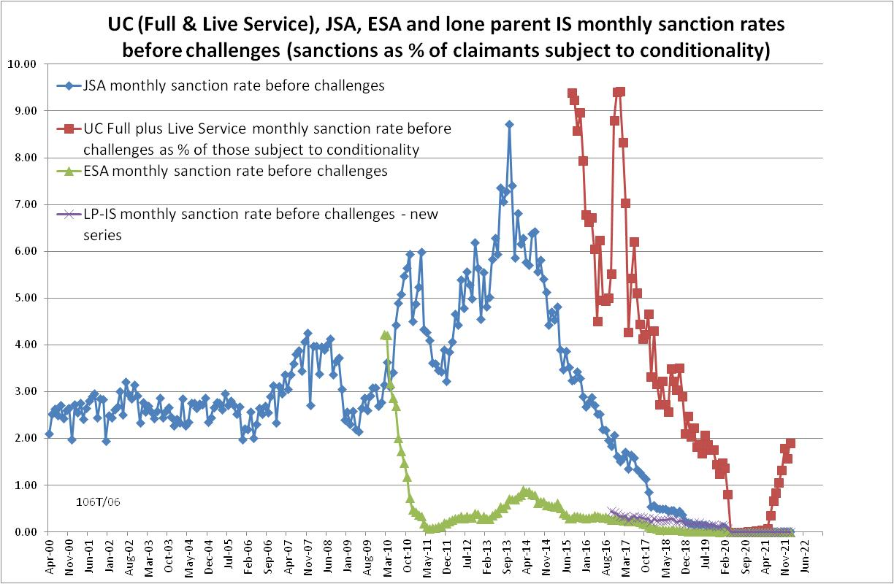

Figure 2
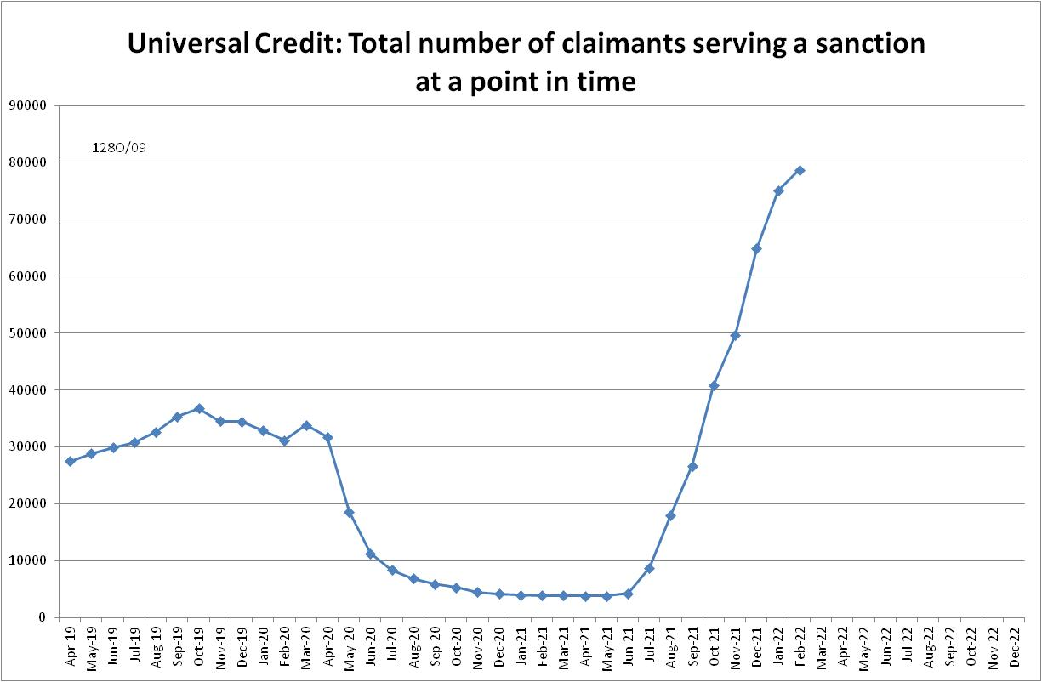

Figure 3
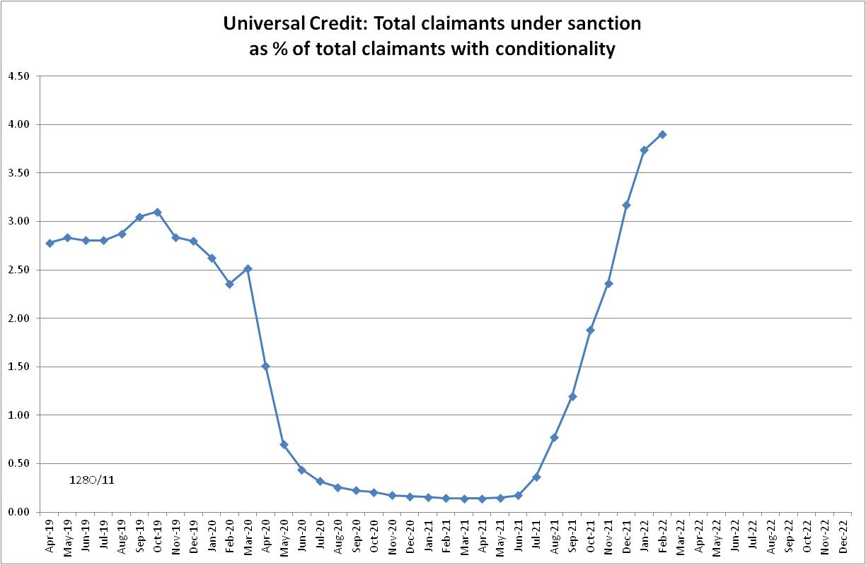
Figure 4
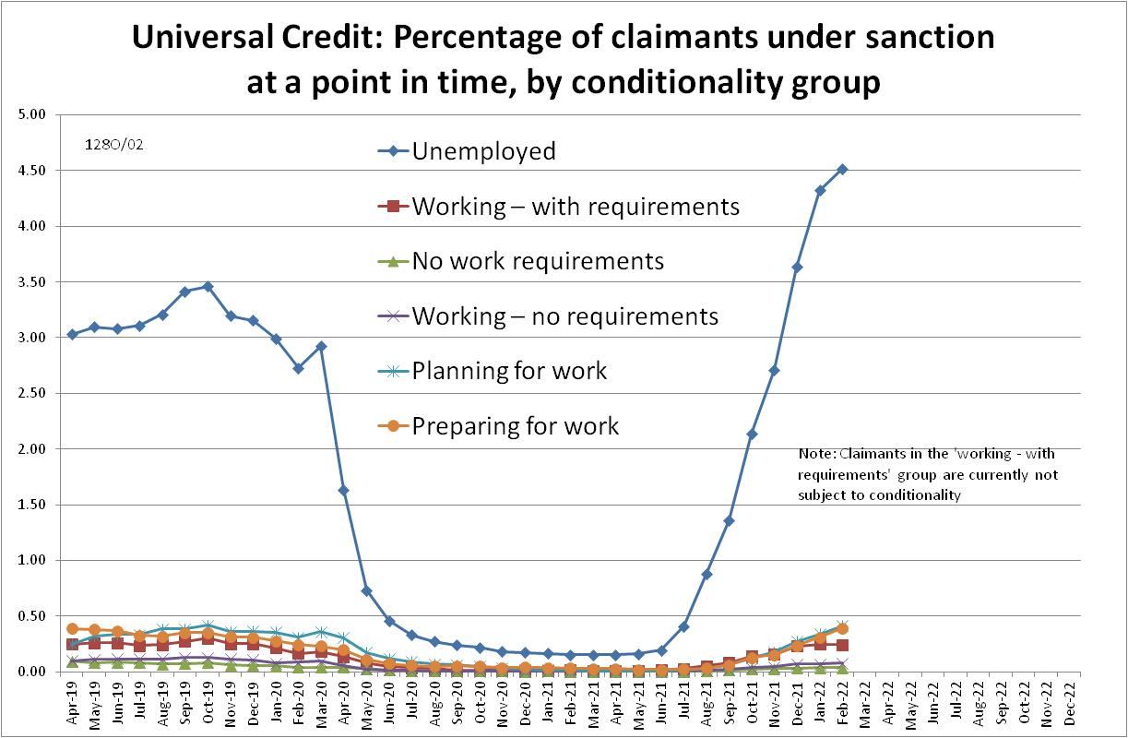

Figure 5
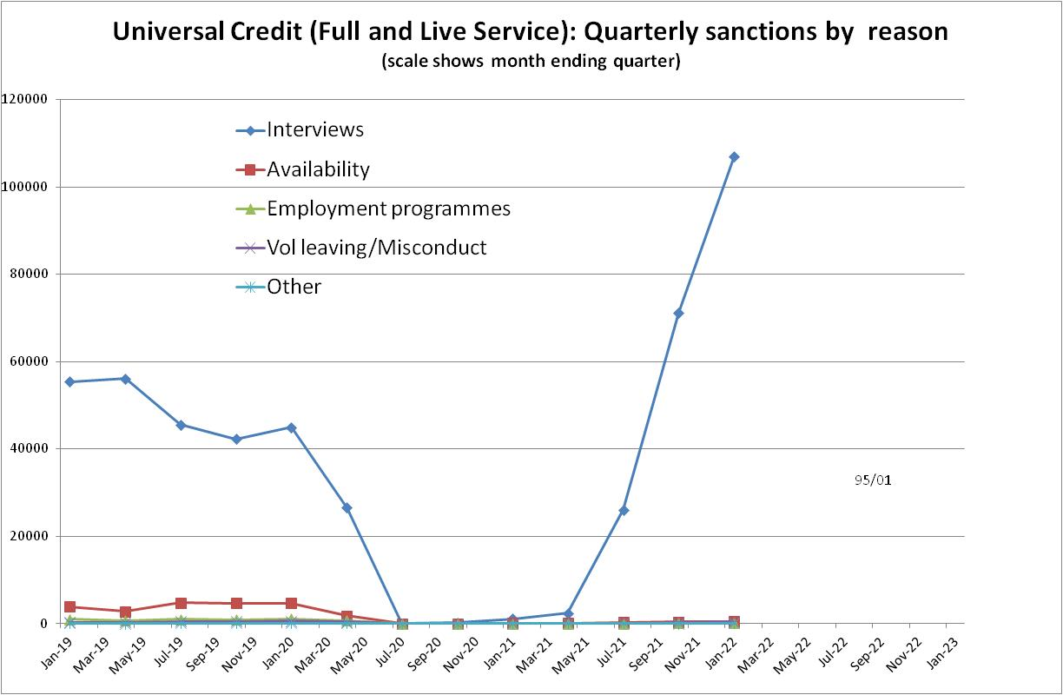

Figure 6
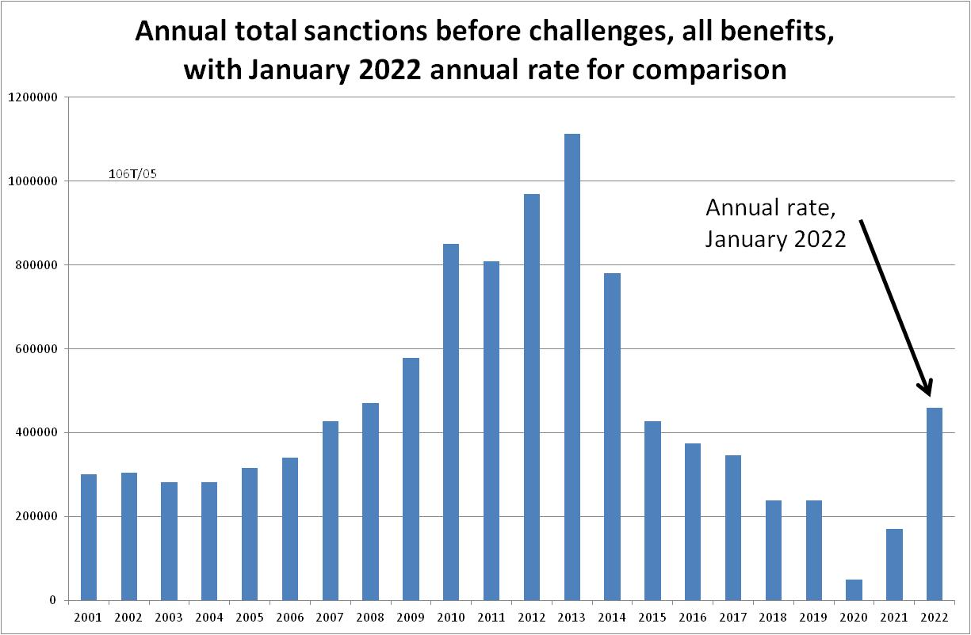

Figure 7
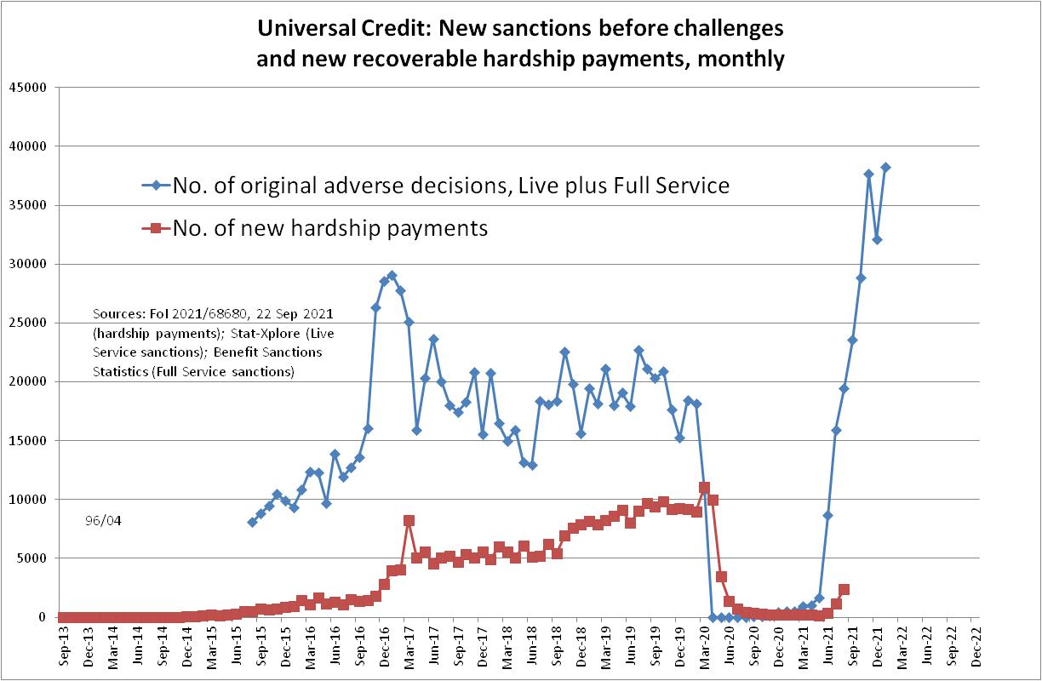
Figure 8
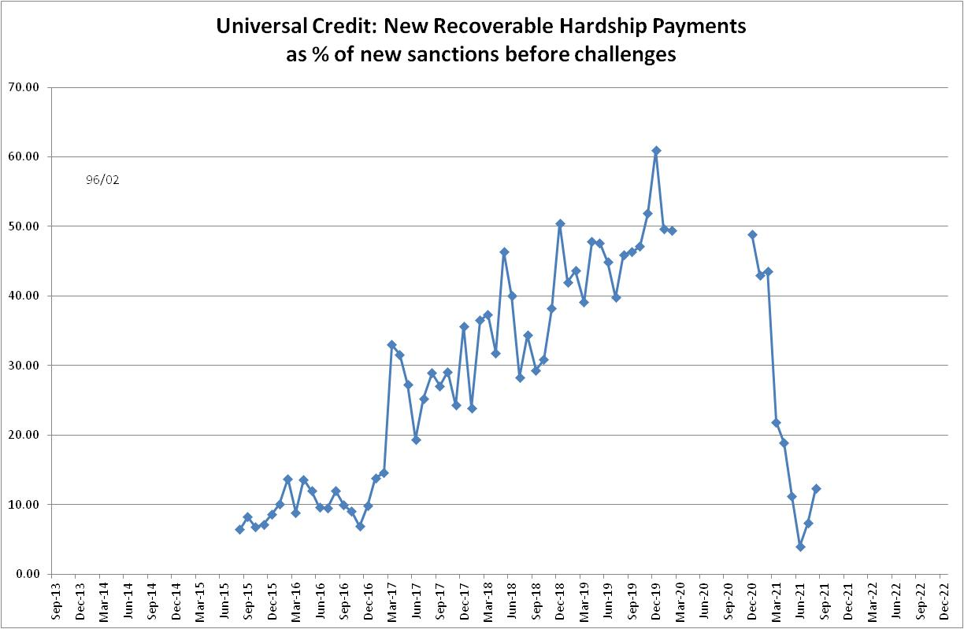

Figure 9
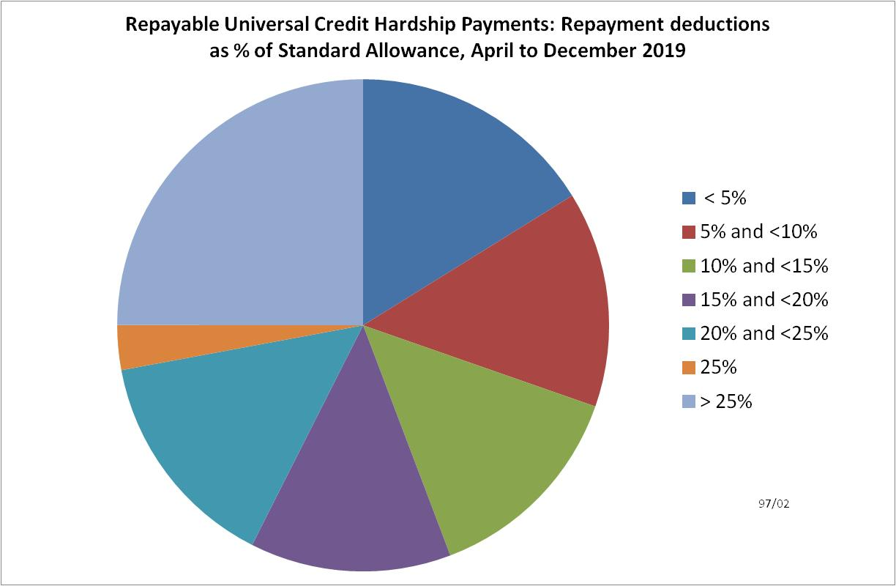

NOTES

Previous Briefings include many analyses that are not repeated here but remain valid. However it should be remembered that the DWP may have made subsequent revisions to the data reported in earlier Briefings. These revisions will generally not be major although there are exceptions. There may also often be substantial changes in some figures for the most recent few months.
As already noted, a similar estimation method used in the February 2022 Briefing (p.4) proved quite accurate. It suggested about 30,000 new UC sanctions for November 2021; the actual figure is now shown to have been 37,701.
The drawbacks of the ‘claimants under sanction at a point in time’ measure were discussed in the November 2017 issue of the Briefing, pp.6-10. In November 2020, DWP withdrew the UC ‘rate’ data for all months prior to April 2019, pending revision of the figures for the former ‘Live Service’. These figures remain withdrawn. In addition, in the February 2021 release DWP made significant revisions to the figures for April 2019 onwards (which are for Full Service only, there being no one left on the former Live Service). These were fully discussed in the February 2021 Briefing.
E.g. Morris (1929), para. 41(a): ‘In determining what work is suitable, we are of opinion that when a reasonable time has elapsed since the claimant was last employed and he is asked to look for work outside his usual occupation, the question of what is suitable for him should be a matter for frank and full discussion between the officer at the Exchange and the claimant. Before a claimant is required to seek work outside his own trade, a written notice to that effect should be given to him. In case of dispute the matter can be referred to a Court of Referees for decision.’

