BRIEFING

Benefit Sanctions Statistics

November 2019

2 December 2019

Dr David Webster
Honorary Senior Research Fellow
Urban Studies
University of Glasgow

Email david.webster@glasgow.ac.uk

Webpages: http://www.gla.ac.uk/schools/socialpolitical/staff/davidwebster/
http://www.cpag.org.uk/david-webster
SUMMARY

This Briefing reports the latest quarterly benefit sanctions statistics, which were released by DWP on 12 November, giving data on sanctions to the end of July 2019 and on numbers of claimants to October 2019.

The general picture is of continuing decline in the use of sanctions. This has been accentuated by revisions to the figures for Universal Credit (UC) sanctions before challenge. They have been revised downwards by approximately 20% to 25% for the months since July 2018, with smaller revisions to some earlier months. In the 12 months to July 2019 there were a total of approximately 210,000 sanctions before challenges on all benefits taken together, comprising 195,000 UC sanctions, 9,000 JSA, 800 ESA and 5,700 IS sanctions. This is a fall from the total of 246,000 in the 12 months to April 2019, and is well below the peak of 1,113,000 in 2013. The picture remains dominated by UC, which accounts for 92.5% of all sanctions. The long term decline in monthly UC sanctions as a proportion of claimants subject to conditionality has been from around 9% in 2015 to just under 2%.

The overall proportion of UC claimants subject to conditionality who are under sanction at a point in time is 3.07% in the latest quarter. The unemployed are treated much more harshly than the other groups, with about 3.29% under sanction, with the others all below 1%. In August 2019 there were a total of 2,653 claimants in UC no-conditionality groups who were under sanction because they had been sanctioned previously when in a conditionality group.

Although use of sanctions has fallen, there has been negligible reform to the system. On 27 November the reduction to six months in the maximum sanction for ‘higher level’ UC or JSA ‘failures’ came into effect. But this will only affect a very small number of people. The total number of people receiving 3-year ‘higher level’ sanctions since they were introduced in 2012 can only have been in the hundreds. By contrast, the number of people having their benefits removed for more than 6 months, and who will not be helped by this reform, is much larger. There were 26,574 for UC between November 2016 and August 2019; 6,197 for JSA over the six years from April 2013 to March 2019; and 6,740 for ESA from June 2013 to March 2019. The peak figure was 13,355 for UC in the 12 months to July 2018 alone. This occurs because under ESA, sanctions apply ‘until compliance’ and are followed by a fixed period sanction, while under UC, (a) all sanctions run consecutively not concurrently (i.e. a second sanction starts as soon as the first one ends, rather than overlapping) and (b) ‘low level’ and ‘lowest level’ sanctions apply ‘until compliance’ and are followed by a fixed period sanction. For 73 years from 1913 to 1986, the maximum length of a disqualification or sanction was 6 weeks.

The number of claimants on UC continues to increase rapidly and by October 2019 it was over two and a half million (2.57m). Under half of UC claimants (46.5%) were in practice subject to conditionality, and over half (53.4%) were not. The number of JSA claimants had fallen to 177,043, but the combined total of unemployed people on UC or JSA had risen to 1,163,740. The rise in total unemployed claimants is due to UC imposing work search and availability requirements on previously exempt people.

The news section at the end of the Briefing offers among other things a critical review of the DWP’s recently published Further Impact Assessment and Cost Benefit Analysis of in-work conditionality, and a report on the main political parties’ general election manifesto positions on benefit sanctions.
BRIEFING: Benefit Sanctions Statistics
November 2019

INTRODUCTION

The latest quarterly sanctions statistics were released by DWP on 12 November, giving data on sanctions to the end of July 2019 and on numbers of claimants to October 2019. The new data are summarised by DWP in the publication Benefit Sanctions Statistics, available along with methodological notes at https://www.gov.uk/government/collections/jobseekers-allowance-sanctions together with a spreadsheet with summary tables. There are significant revisions to the previously published data for Universal Credit Full Service sanctions and the relevant methodological notes have been updated. The full figures for most aspects of the data are on the DWP’s Stat-Xplore database at
https://stat-xplore.dwp.gov.uk/webapi/jsf/login.xhtml All statistics presented here relate to Great Britain.

Groups of claimants exposed to sanctions:
Universal Credit, JSA, ESA and Income Support

At July 2019, a total of about 1.9m claimants were exposed to the risk of sanctions, with varying frequency and severity. They were split between Universal Credit (UC), Jobseekers Allowance (JSA), Employment and Support Allowance (ESA) and Income Support (IS).

The number of claimants on UC continues to increase rapidly and Figure 1 shows that by October 2019 it was over two and a half million (2.57m). Figure 1 also shows how the numbers of UC claimants have increased for each conditionality regime. At October 2019 there were 988,938 unemployed people in the full conditionality ‘searching for work’ group. There were 131,662 people ‘preparing for work’ and 76,074 ‘planning for work’. The DWP classifies the 371,568 people in the ‘working – with requirements’ group as being subject to conditionality, but since the end of the ‘In-Work Progression Randomised Control Trial’ on 31 March 2018, no conditionality has been applied to them in practice. Therefore in total, under half of UC claimants (1,196,674 or 46.5%) were in practice subject to conditionality at October 2019, and over half (1,373,175 or 53.4%) were not. Unemployed people now account for 82.6% of UC claimants who are in practice subject to conditionality.

Unemployed claimants (i.e. searching for work)

The total of people classified as unemployed in the ‘claimant count’ continues to rise. This is due not to a worsening labour market but to UC imposing work search and availability requirements on previously exempt people. At October 2019 the number of JSA claimants had fallen to 177,043, but the combined total of unemployed people on UC or JSA had risen to 1,163,740. Well over four-fifths (84.8%) of unemployed claimants are now on UC rather than JSA. A fuller analysis of unemployment was given in the February 2019 Briefing (pp.3-4), and an excellent monthly labour market analysis including UC issues is published by the Learning and Work Institute at https://www.learningandwork.org.uk/our-resources/statistical-analysis/ .

Others subject to conditionality

To establish the number of claimants on grounds of sickness and disability who are subject to sanctions it is necessary to add to the total of claimants in the ESA Work Related Activity Group (WRAG) the number of UC claimants claiming on grounds of sickness or disability and subject to ‘preparing for work’ requirements. The latter figure is not published by DWP. The 131,662 UC claimants ‘preparing for work’ at October 2019 include these people but they also include some people who are not sick or disabled and would previously have claimed IS. The number of ESA WRAG claimants however is known. Their number peaked at 562,620 in August 2013 but there is a continuing gentle decline, with the number falling below 400,000 in March 2018 and estimated to have fallen below 300,000 in July 2019, reaching an estimated 299,000 at that date.

The number in the ESA Assessment Phase (which has no conditionality) is falling very sharply, to 61,783 in May 2019 from a peak of 545,972 in August 2014. This is because new claimants are being put on to UC. UC does not have an assessment phase; the ‘Job Coach’ has discretion on what requirements to impose pending the Work Capability Assessment.

The number of IS claimants is also falling quite fast due to movement of new claimants on to UC.There were an estimated 332,000 claimants on IS and subject to sanctions at July 2019. The largest group among these was an estimated 187,000 lone parents with a youngest child aged between one and five. There were also an estimated 140,000 carers and 5,000 other IS claimants.

The Universal Credit sanctions regime

A full description of the UC sanctions regime was given in the February 2019 issue of the Briefing, pp.5-6.

Sanctions before and after reviews, reconsiderations and appeals

Except for the new UC Full Service data first published in May 2019, the DWP’s Benefit Sanctions Statistics publication and Stat-Xplore database only show sanctions after any reviews, reconsiderations and appeals that have taken place by the time the data are published. But numbers of sanctions before the results of these challenges are important since they show all the cases in which claimants have had their money stopped. Although a successful challenge should result in a refund, this is only paid after weeks or months by which time serious damage is often done. Estimates of sanctions before challenges are therefore given here but although reliable for longer time periods, they are not fully accurate for individual months. For JSA and ESA, figures for sanctions before challenges are typically higher than the ‘after challenge’ figures by very large amounts, namely about 20%. and 40% respectively. For UC Live Service (the only figures currently available for the UC appeal process) and for IS, the proportion of sanctions overturned is much smaller at around 5% and 1% respectively. So for these types of sanction there is much less difference between the pre-and post-challenge figures. Wherever possible, this Briefing shows estimated pre-challenge sanctions figures.

DWP now says that it aims to change this system for Universal Credit sanctions at some point in the future in order to show all decisions at each stage.
MONTHLY NUMBERS AND RATES OF SANCTIONS BEFORE CHALLENGES FOR THE FOUR BENEFITS

On its introduction, Universal Credit was delivered via ‘Live Service’. A programme to transfer Jobcentres to the more sophisticated ‘Full Service’ was started in May 2016 and completed in December 2018. For many months therefore, Live Service and Full Service were operating in parallel. However, 100% of Live Service claimants had transferred to Full Service by April 2019, and the systems used to administer Live Service were shut down at the end of March 2019.

Much more information has been published on Live Service than on Full Service. DWP is still not publishing comprehensive sanctions data on Full Service, but starting in May 2019 it is now publishing some basic data on Full Service sanctions, going back to August 2015. The Briefing can therefore now show figures for all UC sanctions. Separate analysis of Full and Live Service sanctions was given in the May 2019 Briefing but UC sanctions figures in this Briefing are now always for Full and Live Service combined. Unlike all the previously published DWP figures, the new Full Service sanctions figures are on a ‘before challenge’ basis. Here, Live Service figures are put on to this same basis as previously explained.

Total numbers of sanctions

In the 12 months to July 2019 there were a total of approximately 210,000 sanctions before challenges on all benefits taken together, comprising 195,000 UC sanctions, 9,000 JSA, 800 ESA and 5,700 IS sanctions. This is a fall from the total of 246,000 in the 12 months to April 2019, and is well below the peak of 1,113,000 in 2013. The picture remains dominated by UC, which accounts for 92.5% of all sanctions.

Monthly rates of sanctions

The DWP has revised its figures for UC Full Service sanctions. This is because the previously published figures wrongly included data for Northern Ireland and also sanctions which were ‘given in error’. DWP have confirmed to me that the sanctions given in error are unlikely to have resulted in any claimant losing money, even temporarily, although they have not been able completely to exclude the possibility. It is considered therefore that the ‘given in error’ cases should be excluded from the sanctions figures shown in this Briefing. Figure 2 shows both the revised figures for Full and Live Service sanctions and those previously published. The effect of the revisions is substantial. The previously published figures for June 2018 to April 2019 have been reduced by approximately 20% to 25%, and there are smaller reductions for some of the earlier months. The overall effect of the revisions is to show that the decline in UC sanctions since the launch of UC has been steeper than previously shown.

For UC, the exact number of claimants subject to conditionality is not available for the period April 2015 to March 2018, when a proportion of people in the ‘working – with requirements’ group were enrolled in the In-Work Progression Trial. Here, it has been assumed that everyone in this group was subject to conditionality for the whole period up to March 2018, but no one since then. This will produce an overestimate of the total number of UC claimants subject to conditionality for the period up to March 2018, which will slightly lower the resulting sanction rates for this period.

Taking account of the UC data revisions and the changes affecting the ‘Working – with requirements’ group, Figure 3 shows estimated monthly sanctions before challenges as a percentage of claimants subject to conditionality, for each benefit since August 2015 when UC sanction figures begin.

The picture is very similar to that shown in earlier Briefings. The overall monthly rate of UC sanctions before challenges as a proportion of claimants subject to conditionality has continued to fall, from around 6% per month at the end of the catch-up blitz in 2017, to between 1.5% and 2.0% in July 2019. If the fluctuation associated with the catch-up is disregarded, the longer term decline has been from around 9% in 2015 to just under 2%.

The DWP has not broken down its UC Full Service sanctions figures between conditionality groups. However, the estimates of the proportion of claimants under sanction at a point in time (see Figure 5 below) indicate that the rate of UC sanction is much higher for unemployed than for other claimants. On the assumption that the ratios of the monthly rates for the ‘planning for work’ and ‘preparing for work’ groups to the rate for the unemployed group are similar to those for the proportions under sanction at a point in time (see below), it can be crudely estimated that the monthly rate of UC sanctions on unemployed claimants before challenges would be about 1.9% in the latest quarter. This is below the JSA rate seen over most of the period of the Labour government prior to 2010, as shown in the longer period Figure 4, although sanctions are now of course harsher. The unemployed UC rate is very close to the overall UC rate because unemployed people account for over four-fifths of UC claimants in practice subject to conditionality.

The UC sanction rate remains far above those for the other three benefits, which are at low levels as shown in Figure 3. In the latest quarter the JSA monthly rate of sanctions before challenges was about 0.15%, IS lone parent 0.17%, and ESA amd IS non-lone parent 0.01%.

PROPORTION OF CLAIMANTS UNDER SANCTION AT A POINT IN TIME

The DWP’s preferred measure of sanctions ‘rate’ is the proportion of claimants who are serving a sanction at a point in time. Their published figures for this measure have always covered both Live and Full service, but there are various problems with it, which were discussed in the November 2017 Briefing (pp.6-10).

Figure 5 shows the latest figures. The picture remains unchanged from recent quarters. The proportions for all groups are levelling off. The overall proportion for all UC claimants subject to conditionality is 3.07% in the latest quarter, but the unemployed are treated much more harshly than the other groups, with about 3.29% under sanction, whereas the others are all below 1%.

One of the strongly criticised features of Universal Credit is that sanctions are continued even if the claimant moves into a different group which has no conditionality. The Work and Pensions Committee (2018) condemned this as pointless. Figure 6 shows the numbers (not proportions) of people in each no-conditionality group who have been under sanction in each quarter since August 2015. The number of people in this position is steadily increasing, no doubt due mainly to the increase in the number of claimants on UC. In August 2019 there were a total of 2,653 claimants in this position, comprising 1,027 in the ‘working – with requirements’ group (which currently has no conditionality), 1,094 ‘no work requirements’ and 532 ‘working – no requirements’.

DURATION OF SANCTIONS

As announced by Amber Rudd on 9 May, a statutory instrument The Jobseeker’s Allowance and Universal Credit (Higher-Level Sanctions) (Amendment) Regulations 2019 (No. 1357) was tabled in Parliament on 16 October which caps the maximum duration of any ‘higher level’ UC or JSA sanction at 6 months. It came into force on 27 November, at which date any individual ‘higher level’ sanction which had already lasted as long as this was to be terminated. This reform will be very welcome to those affected by it, but as noted in the May 2019 Briefing (p.10) they will not be very numerous. Only 2,907 JSA claimants have had three or more high level sanctions during the whole period since they were introduced in October 2012, and the trigger for a 3-year sanction is having three high level sanctionable ‘failures’ within a 12-month period. Therefore the number actually receiving a 3-year sanction can only have been in the hundreds. For UC, the corresponding number is 120, although this relates only to Live Service. Although the figure for all UC higher level sanctions would be somewhat higher, it would still be small.

It is important to realise that the number of people having their benefits removed for more than 6 months, and who will not be helped by this reform, is much larger. This occurs because under ESA, sanctions apply ‘until compliance’ and are followed by a fixed period sanction, while under UC, (a) all sanctions run consecutively not concurrently (i.e. a second sanction starts as soon as the first one ends, rather than overlapping) and (b) ‘low level’ and ‘lowest level’ sanctions apply ‘until compliance’ and are followed by a fixed period sanction. Figure 7 shows the monthly number of people completing a sanction period of more than 6 months for UC, JSA and ESA, as measured by the ‘duration’ statistics given in the spreadsheet accompanying the latest Benefit Sanctions Statistics. These numbers are relatively large: 26,574 for UC between November 2016 and August 2019; 6,197 for JSA over the six years from April 2013 to March 2019; and 6,740 for ESA from June 2013 to March 2019 (Note: The published figures for JSA and ESA are less up-to-date than those for UC.) The numbers for UC completely dwarf those for the other two benefits, with a peak figure of 13,355 in the 12 months to July 2018 alone. This spike was due to the DWP mounting a ‘catch-up’ blitz after falling behind in the processing of sanction referrals.

Amber Rudd’s reform will do nothing at all to help the great majority of these people. It should be remembered that for 73 years from the start of National Insurance in 1913 up to 1986, the maximum length of a disqualification/sanction was 6 weeks, only one quarter of the length now still applying.

Other aspects of sanctions durations were considered in the February 2019 Briefing.

ANALYSES NOT INCLUDED IN THIS ISSUE

The paucity of data available for UC Full Service sanctions makes it not worthwhile to update many of the analyses at present. Readers are referred to earlier numbers of the Briefing for analyses of matters not discussed in the present issue. Reasons for sanctions were comprehensively analysed in May 2019; durations of sanctions were discussed in detail in February 2019; claimants with earnings following a sanction were covered in November 2018; ethnicity and gender in July 2018; benefit destinations in February 2018; challenges to sanctions in February 2018 and May 2017; JSA benefit suspensions not followed by sanction, and ESA sanctions by medical condition in August 2017; and hardship payments for UC in August 2019 and for JSA and ESA in February 2019 and November 2015. Longer period analyses were included in the author’s written evidence to the Work and Pensions Committee (Webster 2018a) and in a presentation to the Welfare Conditionality conference at York in June 2018 (Webster 2018b). These analyses will be updated in future issues.
SANCTIONS - OTHER DEVELOPMENTS

Thérèse Coffey: Oral evidence to the Work and Pensions Committee

The oral evidence to the Work and Pensions Committee on 16 October by the new Secretary of State for Work and Pensions, Thérèse Coffey, gave some idea of the approach of a minister who is otherwise an unknown quantity. Many subjects were covered, including whether she thought further reform is required to UC (apparently not), the two child policy, the decline in local housing allowance rates in relation to rents and the large scale fraud resulting from the DWP’s procedures for UC advances which allowed claimants to draw money without ever having presented themselves physically at a Jobcentre (this was put right on 18 September).

On sanctions, she said ‘I just started looking at this very recently ....... I think it’s fair to say
that something like just under 2.5% of people have ...... had a reduction in their benefits due to sanctions. I think that’s one of the lowest rates that we have had since the whole system came into effect. We are not trying to trap people or do other elements, but we want to make sure that people who have signed up to a contract in order to get support through universal credit actually fulfil that contract, because they are receiving other taxpayers’ money. So I think it’s a reasonable approach, but I am conscious of what (Amber Rudd’s) journey has started, and I am waiting for further consideration that I will do in conjunction with Will Quince, the Minister for Welfare Delivery.’ This suggests some willingness to consider further reform. But it repeats the dominant narrative that claimants make a contract to receive benefits in exchange for state-mandated behaviours, rather than in exchange for their national insurance contributions. Depending on their personal history, they may be receiving some of other taxpayers’ money, but many will certainly be receiving their own money in the form of the tax and national insurance contributions which they have paid (Hills 2015). The reference to 2.5% of people is the usual mis-statement which comes out of DWP. Over the most recent 12 months, average monthly sanctions as a proportion of UC claimants subject to conditionality have been about 2.1%, and the proportion of UC claimants subject to conditionality who were serving a sanction at any one time was about 3.27%. But the proportion of UC claimants over, say, the past year who have been subject to sanctions at any time during their claim will have been much higher; this is the concept which Ms Coffey’s wording implies. The DWP has been asked to publish this figure by the UK Statistics Authority since August 2015 (see earlier Briefings) but has refused. It can only be obtained by means of a Freedom of Information request.

A transcript of the session is available at
http://data.parliament.uk/writtenevidence/committeeevidence.svc/evidencedocument/work-and-pensions-committee/the-work-of-the-secretary-of-state-for-work-and-pensions/oral/106392.pdf and the video is at
https://parliamentlive.tv/Event/Index/d8df2ad7-4c03-45be-a922-b077d4c0e537

DWP study on the effectiveness of sanctions

In its response of 11 February to the Work and Pensions Committee report on Benefit Sanctions, the DWP undertook to use administrative data in an internal study to look at the impact that UC sanctions have on claimants’ likelihood of entering work and on earnings, to report in ‘late Spring 2019’. Thérèse Coffey told the Committee on 16 October that it will now be published by the end of the year.

Universal Credit In-work progression: Further impact assessment and cost-benefit analysis

In October the DWP published a further evaluation paper on its in-work progression randomised controlled trial (DWP 2019). Here are some comments on the paper.

- The result of the cost-benefit analysis is quite unfavourable to in-work conditionality. A benefit-cost ratio (BCR) greater than 1 does not mean that the programme should be implemented. All it means is that the programme would not actually lose money. There are a lot of things public money could be spent on and many of them have much higher BCRs than 1. The BCR of 8.5 for the Moderate intervention based on the 78-week data is quite good, but the paper points out that it is not statistically significant. The 2.5 for the Frequent intervention is pretty poor and also not statistically significant. In commonsense terms, the increased earnings of around £3 per week are small for all the effort (about a 1% increase in weekly earnings for someone on the minimum wage for 35 hours). The essential message is that the evaluation does not show that in-work conditionality represents value for money.
- Moreover even this negative finding is overoptimistic. The paper itself points out (pp.19-20) that there is now a new baseline for comparison in that there are now no interviews and therefore no costs, and that this will worsen the cost-benefit analysis (CBA) results.
- In addition, the CBA (Table 3.1) leaves out some important costs. Two of these are acknowledged on p.22 (time cost to the worker of the additional hours and of travel to the interview) but additional obvious ones are the time cost of additional travel to work, the negative impact on children of having their parent available less of the time, and the damage done by the sanctions which are imposed for missing interviews.
- The CBA is also said to leave out some benefits. Non-monetary benefits of additional earnings and hours are mentioned on p.22 but this is not convincing. It is difficult to see what would be the benefits of additional hours at all, and non-monetary benefits of additional earnings are surely already captured by the value of the earnings.
- There is also the very important objection that in-work conditionality would bring an officially estimated 1.3m people into the scope of state interference with their labour market decisions. UC is supposed to improve the incentive to earn more anyway, because of the standard taper.
- The sample sizes were already very large so there is not going to be any further study which produces statistical significance.

Given these rather negative findings as well as the general controversy around Universal Credit, it seems unlikely to this author that in-work conditionality will ever be implemented.

Of course the DWP’s evaluation only considers the compulsory scheme set up by UC. It does not mean to say that a proper Employment Service should not give advice and support to employed claimants on a voluntary basis. The cost-benefit considerations here would be very different, particularly because participants would be self-selected and therefore highly motivated.

DWP statement on the future decision process for policy on UC in-work conditionality

A reply to a PQ on 28 October set out the government’s intentions on the future of in-work conditionality. ‘...... the Department wants to ensure everyone has a chance to move to higher paid work, which is why we ran this trial to learn more about what interventions could work. We will examine the outcomes as we develop our policies further to help boost their earnings. The evaluation of the trial showed small but sustained impacts for those receiving the most support, and it also shows these interventions may be cost effective. These results are promising, but there is still more work to do to increase our knowledge of What Works. The Department is currently in the second year of a four-year programme, announced in the Autumn Budget 2017, to deliver a programme of research and analysis, and run a suite of tests and trials, working in partnership with other Government Departments and external organisations. This includes research which seeks to understand the situations and support needs of our future in-work cohorts; a Rapid Evidence Assessment of international policies linked to in-work progression; and work which will support Jobcentre staff to help claimants to make good decisions around job-switching. The Department will be using the results of the trial, together with other research conducted in years 1 and 2 of this programme, to develop more targeted tests and trials to support the development of effective in-work services.’

Advertising Standards Authority ban on UC adverts

The May 2019 issue of the Briefing (pp.10-12) reported on the DWP’s public relations campaign to defend Universal Credit. There were 44 complaints to the Advertising Standards Authority (ASA) about the advertising element of the campaign, including from disability organizations. The ASA has now banned four of the adverts, and the linked webpage, in their current form. The complaints upheld related to the identifiability of the webpage as marketing material, and to the claims made in the print adverts that people move into work faster on UC than under the old system; that jobcentres will pay an advance to people who need it; and that rent can be paid directly to landlords under UC. Unfortunately it appears that no one complained about the claim that ‘Right now less than 3% of those who are on universal credit and under conditionality are getting a sanction’. As noted in the May Briefing and in the note above about Thérèse Coffey’s session with the Work & Pensions Committee, this understates the likelihood of a new claimant receiving a sanction at some point during their claim. The full ASA ruling is at
https://www.asa.org.uk/rulings/department-for-work-and-pensions-G19-1021769.html

Debt ‘Breathing Space’: further information

The August Briefing (p.10) had a short note on the planned ‘breathing space’ to help problem debtors, which will commence in early 2021. A reply to a PQ on 28 October gave more information. ‘...... It is the government’s intention to include Universal Credit advances and third-party deductions in Breathing Space, alongside other benefit deductions designed to recover debt ..... To ensure that the required IT changes align with the wider Universal Credit programme, Universal Credit advances and third-party deductions will be included in Breathing Space on a phased basis following the commencement of the wider scheme.’ It still remains unclear whether repayable hardship payments will be included in the Breathing Space. There has been no mention of the treatment of sanctions themselves.

Work and Pensions Committee on Universal Credit and ‘survival sex’

The House of Commons Work and Pensions Committee published the report of its inquiry into ‘survival sex’ on 25 October. The Committee’s definition of the term is ‘when people—overwhelmingly, but not exclusively, women—have to turn to sex work to meet their basic survival needs, including money, food and shelter’. Their report is extremely critical of DWP: ‘The Department’s first written response to our inquiry ..... displayed little interest in either the lived experience of claimants or the expertise of frontline support organisations. (It) was defensive, dismissive and trite..... In May 2019 ..... We heard in private from ..... four women who work or have worked in the sex industry due, in part, to problems with Universal Credit and the wider benefit system. Given our concerns about the Department’s grasp of the problem, we invited the Minister for Family Support, Housing and Child Maintenance ..... to sit in on our private session..... Afterwards, we asked the Department to submit a new response that properly engaged with our inquiry and the evidence available. Although the resulting resubmission was substantively similar to the original, the Minister also wrote to us with a fuller response. He also acknowledged that DWP had got it wrong on its first attempt. This is a welcome admission from the Minister..... DWP needs to improve the way that it systematically gathers, uses, and responds to frontline evidence and claimants’ lived experience of Universal Credit. DWP should publish a revised Evaluation Framework for Universal Credit. This should detail how it will systematically seek out and respond to evidence from frontline organisations, and claimants themselves, to help prevent desperate situations driving people into survival sex and other problems.’

Sanctions in the Party General Election Manifestos

Abolition of the current benefit sanctions regime features in four out of the main seven party manifestos. The following are the most direct references. This summary does not attempt to quote everything relating to social security.

The Conservative Party manifesto does not say anything about benefit conditionality.

The Labour Party states ‘Labour will scrap Universal Credit ...... We will immediately stop moving people onto it and design an alternative system that treats people with dignity and respect ...... we will ..... implement an emergency package of reforms to mitigate some of the worst features of UC while we develop our replacement system ..... We will immediately suspend the Tories’ vicious sanction regime and ensure that employment support is positive not punitive ..... The Tories’ rhetoric of ‘scroungers’ and ‘skivers’ has whipped up hatred of disabled people, with disability hate crime skyrocketing, up 37% in the last year alone. Labour will never demonise disabled people or the unemployed.’ Labour also says it will ‘completely change (the) culture, replacing the DWP on day one with a Department for Social Security, which will be there to help and support people, not punish and police them’. It is not proposing to separate employment support from benefits administration. Pollard (2018) provides a useful discussion of the likely problems in changing the culture of DWP.

The Liberal Democrats, who with the Conservatives were responsible for introducing the current sanctions regime, say ‘We will ..... Introduce an incentive-based scheme to replace the current sanctions system, which does not encourage people into work, penalises people with mental health issues and deters people from claiming support.’ They also say they would separate employment support from benefits administration (they were merged into Jobcentre Plus by Labour in 2002). The new Fabian Society report (see below) also calls for a separation of benefit administration from employment support.

The Green Party will introduce a condition-free Universal Basic Income, which will also ‘Replace Universal Credit and the cruel benefit sanctions regime, which have left hundreds of thousands of people facing destitution.’

The Brexit Party says nothing about benefit conditionality. It does however pledge to ‘undertake a 12-month review of UC and bring in reforms within two years’. It also makes an acknowledgment of the insurance principle in saying it will ‘Support those who have paid into the system with accelerated payment processes (five-week maximum)’, although it is not clear exactly what this means.

The SNP says ‘SNP MPs will demand an end to policies which are pushing people into poverty, debt and desperation including ending the two child cap on tax credits and associated rape clause, an end to the punitive benefit sanctions regime, and a halt to Universal
Credit...... The Tories punitive benefit sanction scheme has been shown to be ineffective in supporting people into work yet it has contributed to rising poverty across the UK. The recent changes that have been implemented do not go far enough. It is time for the whole scheme to be scrapped.’

Plaid Cymru implies support for continuation of the sanctions regime except for disabled people. ‘Whilst we believe that disabled people should be encouraged and supported into employment, we do not believe it is appropriate to require disabled people to face the same obligations and threats of sanctions in looking for employment. We will establish sheltered employment schemes for those people who need a more supportive environment to return to work, as a stepping stone towards full participation in employment, and will work with accredited employers to create such schemes.’ It wants devolution of UC and some individual benefits but does not say what it would do with them apart from scrapping the bedroom tax.

‘Welfare reform’ and worsening mortality

Two recent studies show that recent adverse trends in mortality hvave disproportionately affected the poor and are therefore likely to be the result of ‘austerity’. An English study (Taylor-Robinson et al. 2019) provides evidence that the unprecedented rise in infant mortality from 2014 to 2017 disproportionately affected the poorest areas of the country, leaving the more affluent areas unaffected. The analysis also suggests that about a third of the increase in infant mortality from 2014 to 2017 may be attributed to rising child poverty. This article is free to access.

Work by the Scottish Public Health Observatory at
https://www.scotpho.org.uk/population-dynamics/recent-mortality-trends/ concludes that the recent slowing improvement and actual falls in life expectancy are due to austerity and pressure on health and social care services, with influenza also playing a role and some other factors suggested but not yet properly investigated. Further information is at https://www.scotpho.org.uk/media/1886/lynda-fenton-phins-2019.pdf

Mothers’ employment rates at a historic high

A release by ONS (ONS 2019) reports that 75.1% of mothers with dependent children are now in employment. This is the highest proportion since the data series started in 1996, when the proportion was 61%. Of those with children under 2 years old, the proportion in employment is now 67.5%, compared to 46% in 1996. The majority (69.9%) of the 1.8m lone parents (male or female) with dependent children in the UK in 2019 were in employment.

Trussell Trust State of Hunger first year report

The Trussell Trust is carrying out a three-year research project on the scale and nature of food insecurity in the UK, to inform efforts to end the need for food banks. It is described at https://www.trusselltrust.org/state-of-hunger/ An introductory report (Trussell Trust 2019) focused primarily on questions of definition, leading to the decision to adopt the concept of ‘household food insecurity’ for the purposes of the study. This is an internationally recognised and measurable concept. The Trust has now published a report on the first year’s survey research on users of food banks, food bank managers, and staff of referral agencies (Sosenko et al. 2019). The fieldwork on users was carried out in October/November 2018, when the rate of sanctions on all benefits had fallen dramatically from earlier levels. Therefore not surprisingly, sanctions were found to be less important than waits for benefits in prompting food bank use: 7% of users were under sanction, compared to 22% who were waiting for benefits. But like earlier studies, this study did find that sanctions lead to increased food bank use, after controlling for other factors. One fifth (21%) of users reported receiving a sanction during the previous 12 months, and of these, 38% received more than one sanction in that period. For just over half of the respondents who reported at least one sanction, the length of the latest sanction was longer than one month. People who experienced a benefit sanction in the past 12 months reported more frequent food bank use, on average, than others. Furthermore, the average frequency of food bank use increased with the number of sanctions and with the length of the latest sanction.

Only slightly over a third (36%) of those who received a sanction in three months prior to the survey applied for a hardship payment. Of those who did apply, 56% received a hardship payment, 8% were waiting for a decision and 35% had their application refused – a figure which the researchers say is ‘obviously concerning’. On the assumption that the success rate for applications awaiting a decision would be the same as for those already decided, these figures imply that approximately 22% of sanctioned individuals received a hardship payment. This is close to the proportion (17.7%) reported in the August 2019 Briefing (pp.7-9) for UC as at August 2018; the fact that it is higher could be explained by the presence in the survey of claimants on JSA or ESA, which have higher rates of hardship payment award. Those who did not apply for hardship payments were more likely to be lone parents, private renters, those living in a hostel/bed and breakfast/emergency accommodation, and those who viewed their situation as a ‘short-term crisis’.

Fabian Society report on reforming social security

A new report from the Fabian Society (Harrop 2019) proposes comprehensive reforms to social security. Among its nine key points are the importance of co-design of the system in partnership with both users and non-users, and the need to re-emphasise universal and contribution-based benefits, reducing the dominance of means-testing which has grown up over the past 40 years. It calls for an end to sanctions except in extreme circumstances. ‘Harsh conditions and sanctions undermine users’ confidence in the entire social security system. Requirements should be reduced and refined to reflect real life for people with low incomes and the genuine barriers to complying that people face. There needs to be sympathetic enforcement of rules with more trust and leeway, with an end to sanctions apart from exceptional circumstances ....... Jobcentre Plus offices should be reimagined as employability support hubs not ‘sanctions centres’. This task will be far easier if conditions become more straightforward to comply with. Structural changes might also assist, such as creating a clearer separation between social security administration and personal employment support ..... The government’s focus should be on offering positive support and incentives to enable people to work, rather than imposing draconian conditions on people. The social security system has always included work-search requirements for unemployed people but today’s regime of conditions and sanctions is far harsher than ever before. There is little
evidence that very tough requirements promote better long-term employment outcomes and many feel that the system is simply intended to create a hostile environment to drive down the number of benefit recipients. Ministers should immediately suspend sanctions in all but exceptional cases. They should then pilot significantly reduced requirements – or even test
removing conditions altogether – to understand the extent that conditions really make a difference to sustainable employment outcomes.’ (Note: The reference to the history of work-search requirements is not quite correct. Between 1913 and 1919 and again between 1930 and 1989 there was no requirement to take any action to seek work other than to register as unemployed at an Employment Exchange/Jobcentre and therefore be able to be offered a job by employers or officials.)

Financial Resilience and the transition to Universal Credit

The think tank Policy in Practice, supported by the Joseph Rowntree Foundation, published a comprehensive report on this topic on 19 September. It points out that the families who will have difficulties moving on to UC can be identified in advance and argues that targeted support should be made available for them.

Child Poverty Action Group Project: Secure Futures for Children and Families

The Child Poverty Action Group has launched its own project to think afresh and come up with proposals for what a truly effective social security system might look like. Contributions are invited. Details of the project are at https://cpag.org.uk/policy-and-campaigns/secure-futures-children-and-families and there are introductory papers on the main webpage and at https://cpag.org.uk/policy-and-campaigns/briefing/social-security-%E2%80%93-where-have-we-been-and-where-are-we-going

Sanctions produce an increase in use of anti-depressants

A new article (Williams 2019) using quarterly local authority-level data on JSA sanctions and antidepressant prescriptions in England finds that during the period of very high sanction rates from Q4 2012 to Q4 2014 inclusive, every 10 additional sanctions were associated with 4.57 additional antidepressant prescribing items. This translates to approximately one additional person receiving treatment. This finding indicates that sanctions are associated with both adverse mental health impacts and wider public expenditure implications. The author comments that the results suggest the need to reassess the use of sanctions within the contemporary social security system.

Child development and poverty in lone parent families

A new paper (Harkness et al. 2019) finds that almost all of the deficit in cognitive outcomes between children of single mothers and those with two parents is now explained by single parent families’ reduced economic circumstances. Deficits associated with parenting having all but disappeared over the last 40 years. The findings indicate the importance of supporting the incomes of single-parent families, and in particular those with very young children. The article is free to access.

Gingerbread on Single Parents and In-Work Progression

On 4 November Gingerbread published a report on the obstacles to in-work progression for lone parents in London (Dewar and Cleary 2019). It is based on interviews with a sample of 11 self-selected members or supporters, and four participants in employability programmes. It identifies five interconnected barriers to progression: working part-time, lack of affordable childcare, lack of flexibility in hours of work, time out of the labour market, and either having few educational qualifications or being over-qualified for the lone parent’s current role. Key recommendations for national policy are that DWP should be cautious in the development of in-work progression requirements for single parents, developing a better evidence base of what works and moving away from a punitive approach including sanctions. The government should also introduce structural changes, including a day one right to flexible working, additional support for childcare and targeted career support for single parents when their youngest child begins primary or secondary school.

UN Special Rapporteur on the risks of a Digital Welfare Dystopia

The UN Special Rapporteur on Extreme Poverty and Human Rights in October produced a report warning of the dangers posed by the development of digital welfare systems: ‘the grave risk of stumbling, zombie-like, into a digital welfare dystopia is highlighted’. Increasingly, digital systems are used to ‘automate, predict, identify, surveil, detect, target and punish’. It is argued that big technology companies operate in an almost human rights-free zone, and that this is especially problematic when the private sector is taking a leading role in designing, constructing and even operating significant parts of the digital welfare state. In the UK, we know that digital systems are already used for surveillance of unemployed people’s job search activities through ‘Universal Jobmatch’, and the February 2018 issue of the Briefing (p.13) reported on the way claimants in the USA are being wrongly stripped of benefits through the use of faulty digital algorithms. The report is at https://undocs.org/A/74/493

REFERENCES

Dewar, Laura and Elizabeth Cleary (2019) Held back: Single parents and in-work progression in London, London, Gingerbread, November, at
https://www.gingerbread.org.uk/policy-campaigns/publications-index/held-back/

DWP (2019) In-Work Progression Trial: Further Impact Assessment and Cost Benefit Analysis, Ad hoc Report 75, October, at https://www.gov.uk/government/publications/universal-credit-in-work-progression-randomised-controlled-trial

Harkness, Susan, Paul Gregg and Mariña Fernández-Salgado (2019) ‘The Rise in Single-Mother Families and Children’s Cognitive Development: Evidence from Three British Birth Cohorts’, Child Development, available free to access at https://srcd.onlinelibrary.wiley.com/doi/full/10.1111/cdev.13342

Harrop, Andrew with Ben Cooper (2019) Where Next? Reforming social security over the next 10 years, London, Fabian Society supported by Age UK, the Children’s Society, Crisis, the Joseph Rowntree Foundation and the TUC, available at https://fabians.org.uk/publication/where-next/

Hills, John (2015) Good Times, Bad Times: The welfare myth of them and us, Bristol, Policy Press

House of Commons Work and Pensions Committee (2018) Benefit Sanctions, Nineteenth Report of Session 2017-19, HC 955, 6 November, at
https://publications.parliament.uk/pa/cm201719/cmselect/cmworpen/955/955.pdf

House of Commons Work and Pensions Committee (2019) Benefit Sanctions: Government Response to the Committee’s Nineteenth Report of Session 2017-19, HC 1949, 11 February, at https://publications.parliament.uk/pa/cm201719/cmselect/cmworpen/1949/1949.pdf

House of Commons Work and Pensions Committee (2019) Universal Credit and “survival sex”, Second Report of Session 2019–20, HC 83, 25 October, at
https://publications.parliament.uk/pa/cm201920/cmselect/cmworpen/83/83.pdf

ONS (2019) Families and the labour market, UK: 2019: The employment rates of men and women with dependent children in the UK, based on data from the Labour Force Survey and Annual Population Survey, 24 October, at
https://www.ons.gov.uk/employmentandlabourmarket/peopleinwork/employmentandemployeetypes/articles/familiesandthelabourmarketengland/2019

Policy in Practice (2019) Financial Resilience and the Transition to Universal Credit, London, 19 September, at
http://policyinpractice.co.uk/new-analysis-financial-resilience-and-the-transition-to-universal-credit/

Pollard, Tom (2018) Pathways from Poverty: A case for institutional reform, London, Demos at https://demos.co.uk/wp-content/uploads/2019/01/Pathways-from-Poverty-a-case-for-institutional-reform.pdf

Sosenko, Filip, Mandy Littlewood, Glen Bramley, Suzanne Fitzpatrick, Janice Blenkinsopp and Jenny Wood (2019) State of Hunger: A study of poverty and food insecurity in the UK, London, Trussell Trust, November, at
https://www.stateofhunger.org/wp-content/uploads/2019/11/State-of-Hunger-Report-November2019-Digital.pdf

Taylor-Robinson, David, Eric T C Lai, Sophie Wickham, Tanith Rose, Paul Norman, Clare Bambra, Margaret Whitehead and Ben Barr (2019) ‘Assessing the impact of rising child
poverty on the unprecedented rise in infant mortality in England, 2000–2017: time trend analysis’, BMJ Open doi:10.1136/bmjopen-2019-029424, at
https://bmjopen.bmj.com/content/9/10/e029424

Trussell Trust (2019) Introduction to a Study of Poverty and Food Insecurity in the UK, at
https://www.trusselltrust.org/wp-content/uploads/sites/2/2019/06/SoH-Interim-Report-Final-2.pdf

Webster, David (2018a) Written evidence to the House of Commons Work and Pensions Committee inquiry into Benefit Sanctions, at
http://data.parliament.uk/writtenevidence/committeeevidence.svc/evidencedocument/work-and-pensions-committee/benefit-sanctions/written/82601.pdf
Webster, David (2018b) The great benefit sanctions drive 2010-16 in historical perspective, presentation to the conference Welfare Conditionality: Principles, Practice and Perspectives, University of York, Wednesday 27 June 2018, at http://eprints.gla.ac.uk/183161/

Williams, Evan (2019) ‘Unemployment, sanctions and mental health: the relationship between benefit sanctions and antidepressant prescribing’, Journal of Social Policy
doi:10.1017/S0047279419000783

Figure 1
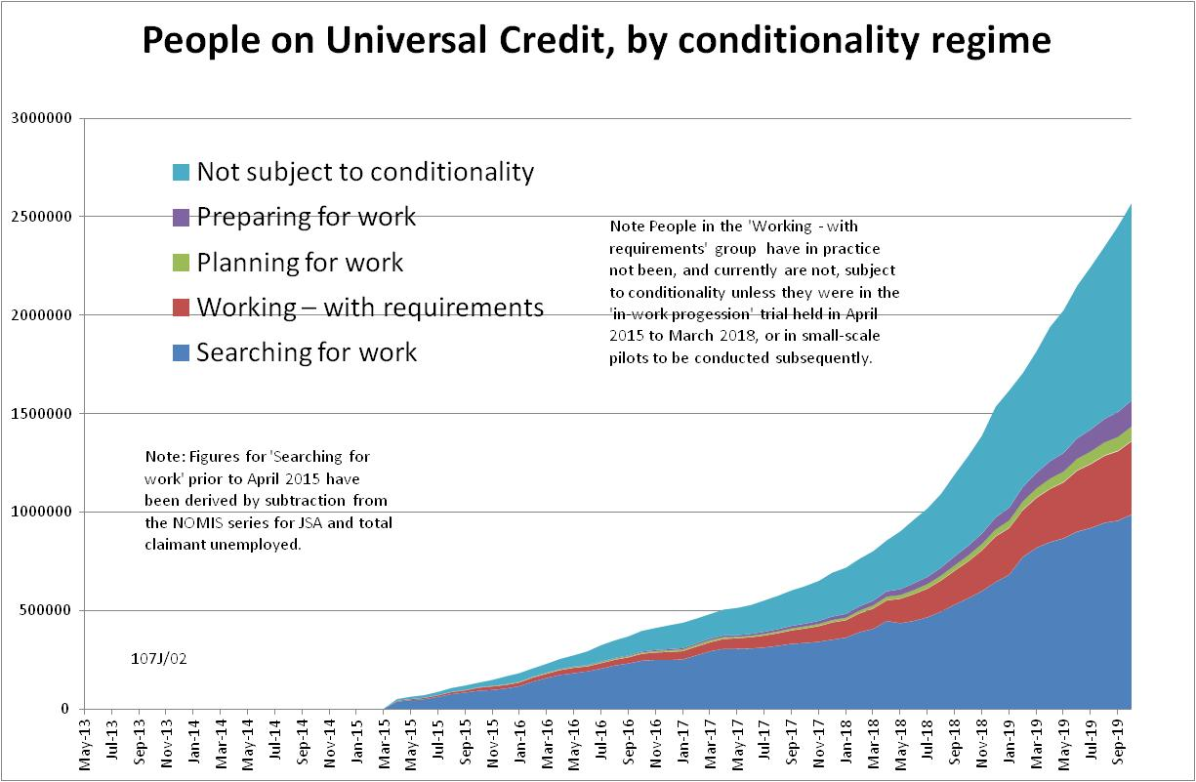

Figure 2
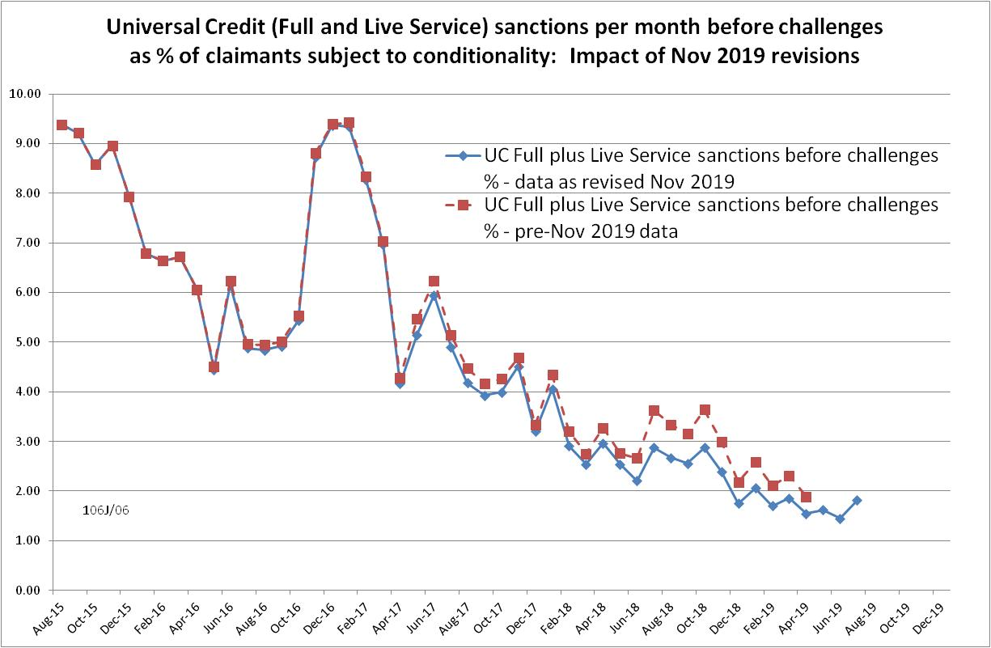

Figure 3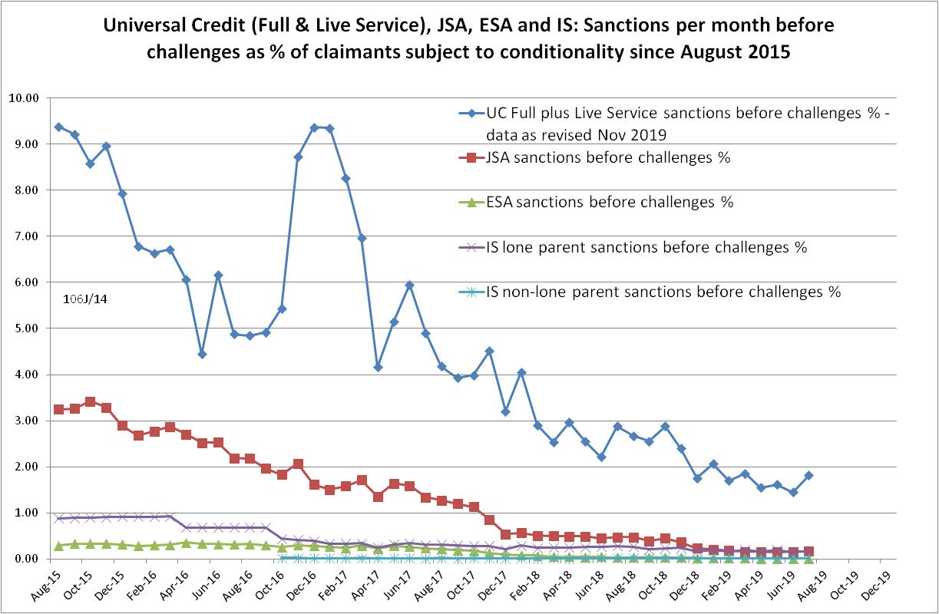

Figure 4
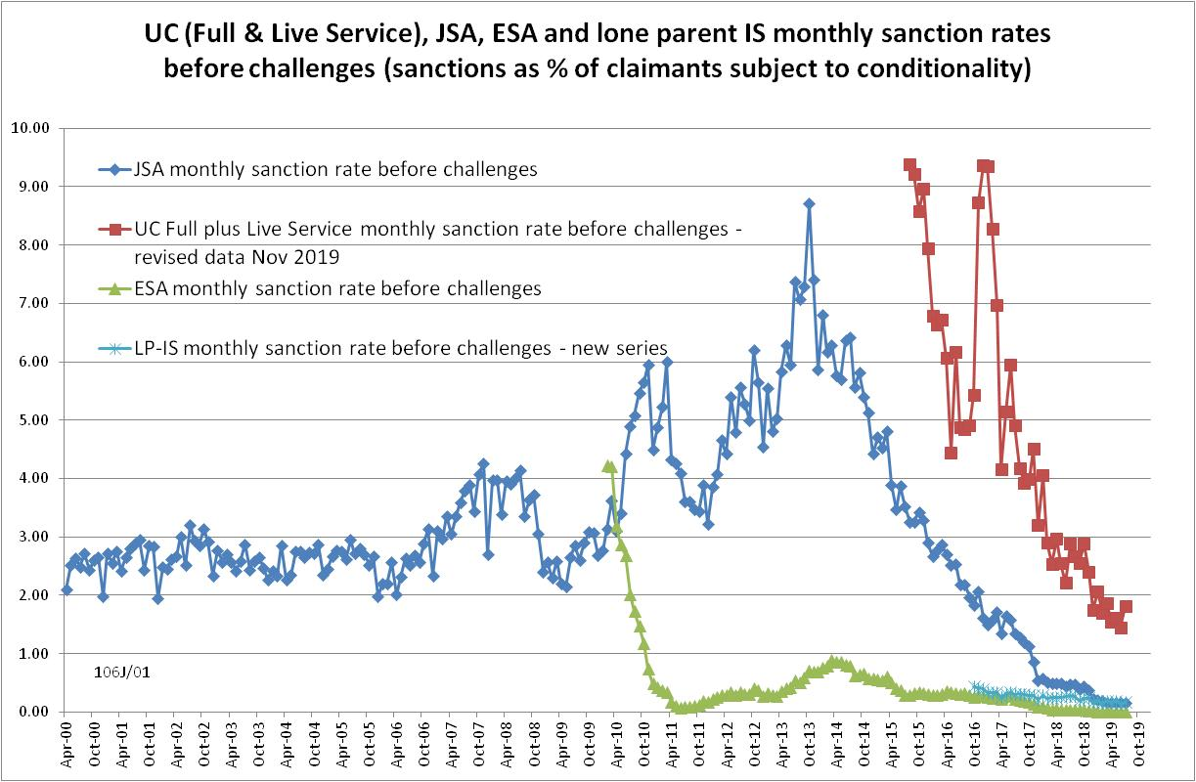
Figure 5
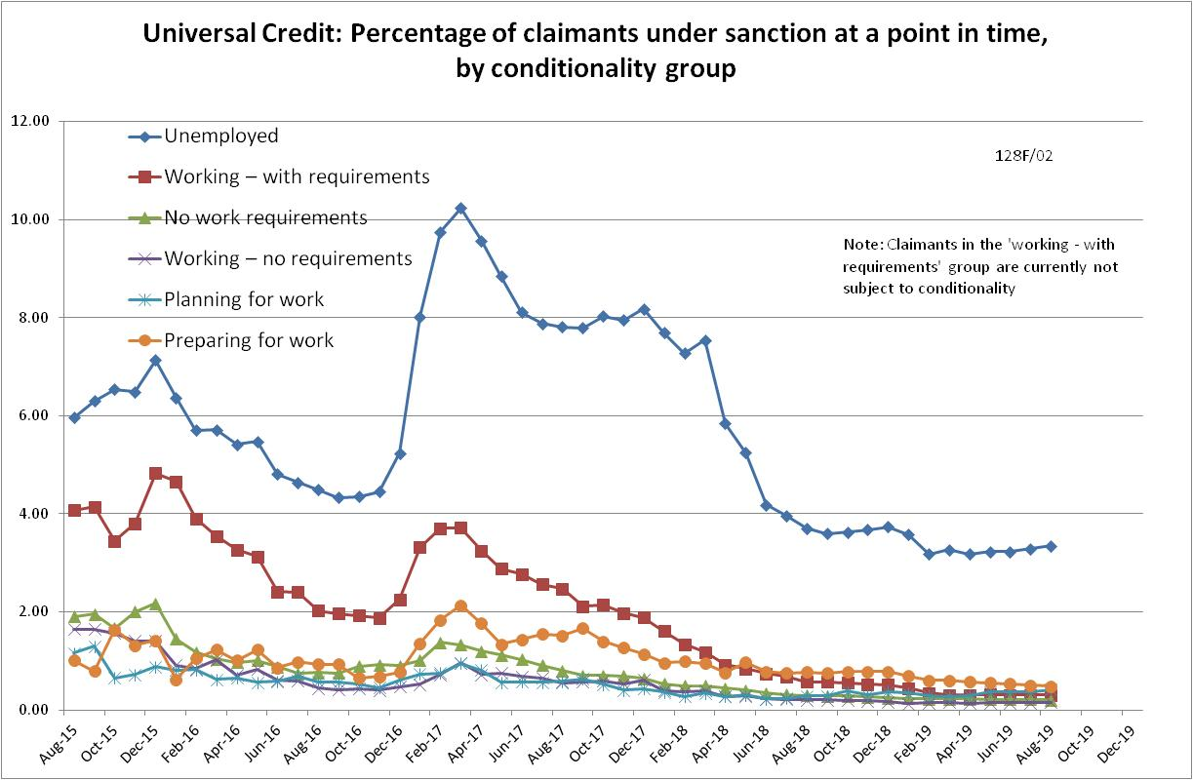
Figure 6
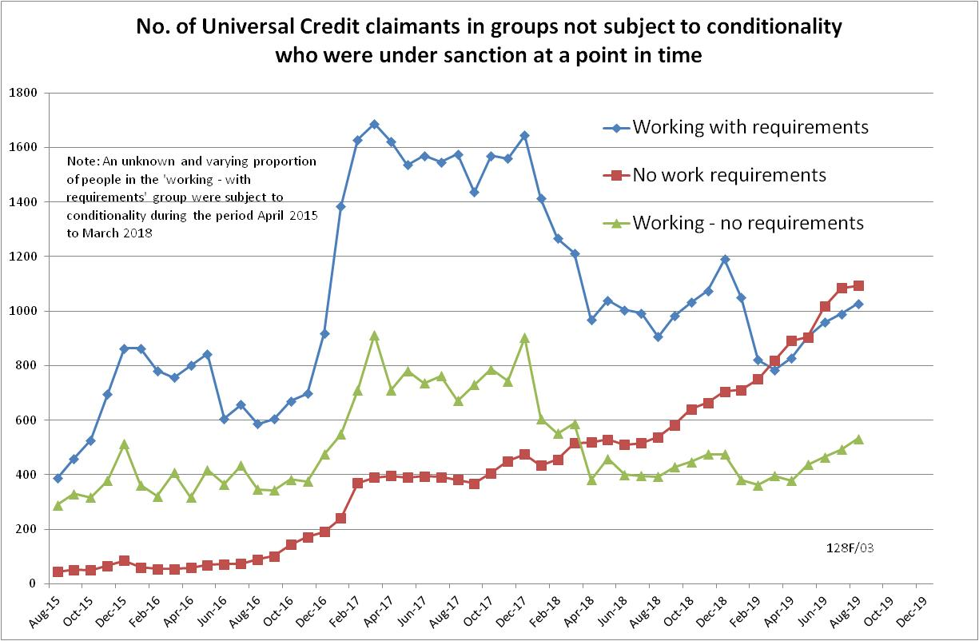

Figure 7
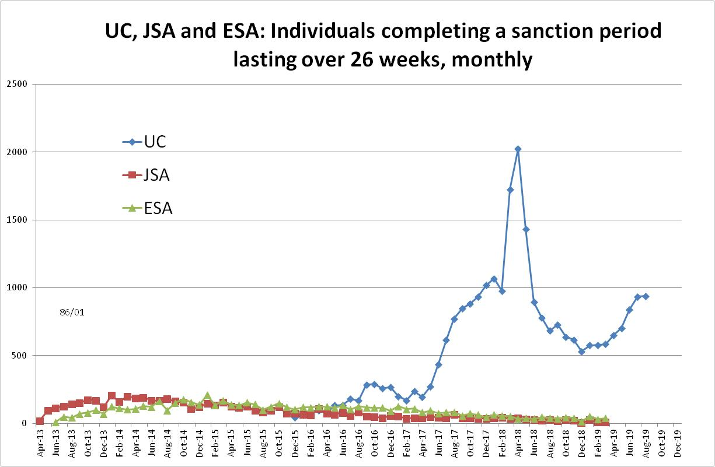

NOTES

Previous briefings are available at http://www.cpag.org.uk/david-webster. They include many analyses that are not repeated here but remain valid. However it should be remembered that the DWP may have made subsequent revisions to the data reported in earlier briefings. These revisions will generally not be major although there may be substantial changes in some figures for the most recent few months.
The total number of people subject to sanctions cannot be stated exactly, because there are some categories of Income Support claimants other than lone parents with a child under one who are not subject to sanctions, and there are no data on their numbers. However, they are likely to number in the low tens of thousands.
The UC claimants in the ‘working – with requirements’ group are low paid or part-time workers. Those ‘planning for work’ are mainly lone parents with a child aged 1, while those ‘preparing for work’ are people who would have been in the ESA Work Related Activity Group, and lone parents with a child aged 2 but under 5. The statistical categories for conditionality regime used in Stat-Xplore are explained in the ‘i’ feature next to the variable name in Stat-Xplore and also in the Universal Credit Statistics methodology document at https://www.gov.uk/government/publications/universal-credit-statistics-background-information-and-methodology
Lone parents with youngest child aged one to five have been estimated simply as four fifths of the total with youngest child aged 0 to five.
The basic concept of the DWP’s sanctions database(except for the new Full Service data) is that each sanction case appears only once, and is given its latest status and attributed to the month of the latest decision on the case. So, for instance, if a decision is made in January 2014 to sanction someone, this decision is reviewed in March 2014 with an outcome unfavourable to the claimant, reconsidered in a ‘mandatory reconsideration’ in May 2014 again with an unfavourable outcome, and is heard on appeal by a Tribunal in October 2014 with a decision favourable to the claimant, - it appears in the statistics for the first time in January 2014 as an adverse ‘original’ decision - in March 2014 it changes its status to a ‘reviewed’ adverse decision and moves month to be with all the other cases where the latest decision has been made in March 2014 - in May 2014 it changes its status to a ‘reconsidered’ adverse decision and moves month to be with all the other cases where the latest decision has been made in May 2014 - in October 2014 it changes its status again to an appealed non-adverse decision, and moves month again to be with all the other cases where the latest decision has been made in October 2014. DWP now says that it aims to change this system for Universal Credit sanctions at some point in the future in order to show all decisions at each stage.
The estimates of sanctions before challenges have been derived by adding the monthly total of ‘non-adverse’, ‘reserved’ and ‘cancelled’ decisions shown as being the result of reviews, mandatory reconsiderations and tribunal appeals, to the monthly total of adverse ‘original’ decisions. This produces only an approximate estimate for each individual month, since decisions altered following challenge are not attributed to the correct month. It will be particularly unreliable for months affected by a DWP catch-up of a backlog of decisions. But the estimates are reliable for longer periods.
See p.6 of the updated Universal Credit Sanctions Background Information and Methodology at https://www.gov.uk/government/publications/universal-credit-sanctions-statistics-background-information-and-methodology DWP have subsequently told me the following: ‘These errors occur for reasons such as an incorrect end date (or similar) being entered onto the system at the front-end, and the decision maker immediately realising this and correcting it. The error would be corrected well before it has any chance to impact the claimant’s payment. Although the incorrect sanction appears in our underlying data, it is completely removed from the front-end system used by claimants and work coaches/decision makers. It is not likely that these errors do affect a claimant’s payment; when a sanction decision is input onto the system (which is what provides our data for sanction counts), the claimant’s actual benefit payment doesn’t drop until the next assessment period, which could mean a time gap of several weeks between the date on which the sanction is entered into the system and the change in the claimant’s payment.’ DWP also point out that ‘cancelled’ cases refer to those which are stopped at the referral stage, whereas in the ‘error’ cases the sanction is stopped after an adverse decision has been made.
The In-work Progression conditionality trial started in 10 Jobcentres in April 2015 and began rollout across the whole country in December 2015, in both Full and Live Service. The trial finished on 31 March 2018. 30,709 claimants passed through the trial. About two-thirds ('frequent' & 'moderate' support) were in the trial for at least a year, the other one third for at least 2 months. The total number of people in the ‘working – with requirements’ group rose from 4,000 in April 2015 to 103,000 in March 2018. We therefore know that a substantial proportion of the group were in the trial at any one time, but we do not know how many.
Pre-October 2016 data for lone parents on IS are not comparable with the current data.
A methodology note at https://www.gov.uk/government/publications/sanctions-durations-and-rate-background-information-and-methodology explains these duration statistics and they were discussed in the February 2019 Briefing.

