BRIEFING

Benefit Sanctions Statistics

August 2019

25 September 2019

Dr David Webster
Honorary Senior Research Fellow
Urban Studies
University of Glasgow

Email david.webster@glasgow.ac.uk

Webpages: http://www.gla.ac.uk/schools/socialpolitical/staff/davidwebster/
http://www.cpag.org.uk/david-webster
SUMMARY

By July 2019 the number of claimants on UC had reached two and a quarter million (2.27m). People in the ‘working – with requirements’ category of UC are not in practice currently subject to conditionality. Therefore in total just under half of UC claimants (1,109,330 or 48.9%) were in practice subject to conditionality at July 2019, 84% of them unemployed people. When people on other benefits are added in, at April 2019 a total of about 1.77m claimants were exposed to the risk of sanctions, with varying frequency and severity.

Claimant unemployment continues to rise, due to UC imposing work search and availability requirements on previously exempt people. By July 2019 the combined total of unemployed people on UC or JSA had risen to 1,127,785. Over four-fifths (82.5%) of unemployed claimants are now on UC rather than JSA.

In the 12 months to April 2019 there were a total of approximately 246,000 sanctions before challenges on all benefits, comprising 224,000 UC sanctions, 14,000 JSA, 1,200 ESA and 7,000 IS sanctions. This is an increase over the total of 228,000 in the 12 months to January 2019, but remains well below the peak of 1,113,000 in 2013. UC accounts for 91% of all sanctions, and for all of the increase in the latest quarter.

There has been a decline in the overall monthly rate of UC sanctions before challenges as a proportion of claimants subject to conditionality from around 9% in 2015 to just over 2% by 2019. The corresponding rate for unemployed UC claimants can be crudely estimated at about 2.4% in the latest quarter. This is very similar to the JSA rate seen over most of the period of the Labour government prior to 2010. Monthly sanction rates before challenges for the other three benefits have also fallen since 2015. In the latest quarter the JSA rate was about 0.18%, IS lone parent 0.17%, and ESA and IS non-lone parent 0.01%.

The DWP’s preferred measure of sanctions ‘rate’ is the proportion of claimants who are serving a sanction at a point in time. For almost all conditionality groups within UC, the current proportion is lower than at any previous time, the exception being the ‘planning for work’ group (mainly lone parents) for whom the proportion had fallen to under 0.25% in summer 2018 but is now around 0.30%. However, all groups are now showing a levelling off in the latest quarter. The unemployed are treated much more harshly than the other UC groups, with about 3.25% under sanction, whereas the others are all below 1%. Under UC, sanctions are continued even if the claimant moves into a different group which has no conditionality. In May 2019 there were 2,291 claimants in this position.

New figures show that the proportion of sanctioned UC claimants getting hardship payments rose only from about 10% at spring 2017 to 17% by August 2018. This is much lower than the proportion for JSA at around 45% and for ESA at just under 20%. The low proportion will be mainly due to the fact that UC hardship payments are repayable, making claimants reluctant to take them, and to the need to reclaim every month. It means that many sanctioned claimants under UC are having to live on even lower incomes than they did under the previous sanctions regimes for JSA and ESA.

At the end of the Briefing there is a digest of news about sanctions. Many of the items this time are about the background of extreme poverty, debt and lack of financial resilience that most people starting a sanction now have to cope with.
BRIEFING: Benefit Sanctions Statistics
August 2019

INTRODUCTION

The latest quarterly statistics were released by DWP on 13 August, giving data on sanctions to the end of April or May 2019 and on numbers of claimants to July 2019. The new data are summarised by DWP in the publication Benefit Sanctions Statistics, available along with methodological notes at https://www.gov.uk/government/collections/jobseekers-allowance-sanctions together with a spreadsheet with summary tables. The full figures for most aspects of the data are on the DWP’s Stat-Xplore database at
https://stat-xplore.dwp.gov.uk/webapi/jsf/login.xhtml

All statistics presented here relate to Great Britain.

Groups of claimants exposed to sanctions:
Universal Credit, JSA, ESA and Income Support

At April 2019, a total of about 1.77m claimants were exposed to the risk of sanctions, with varying frequency and severity. They were split between Universal Credit (UC), Jobseekers Allowance (JSA), Employment and Support Allowance (ESA) and Income Support (IS).

Figure 1 shows that by July 2019 the number of claimants on UC had reached two and a quarter million (2.27m). Figure 1 also shows how the numbers of UC claimants have increased for each conditionality regime. At July 2019 there were 932,350 unemployed people in the full conditionality ‘searching for work’ group. There were 111,803 people ‘preparing for work’ and 65,177 ‘planning for work’. The DWP classifies the 327,599 people in the ‘working – with requirements’ group as being subject to conditionality, but since the end of the ‘In-Work Progression Randomised Control Trial’ on 31 March 2018, no conditionality has been applied to them in practice. Therefore in total just under half of UC claimants (1,109,330 or 48.9%) were in practice subject to conditionality at July 2019, and just over half (1,159,866 or 51.1%) were not. Unemployed people now account for 84% of UC claimants who are in practice subject to conditionality.

Unemployed claimants (i.e. searching for work)

The total of people classified as unemployed in the ‘claimant count’ continues to rise, due to UC imposing work search and availability requirements on previously exempt people. Figure 2 shows that at July 2019 the number of JSA claimants had fallen to 197,476, but the combined total of unemployed people on UC or JSA had risen to 1,127,785. Over four-fifths (82.5%) of unemployed claimants are now on UC rather than JSA. A fuller analysis of unemployment was given in the February 2019 Briefing (pp.3-4).

Others subject to conditionality

To establish the number of claimants on grounds of sickness and disability who are subject to sanctions it is necessary to add to the total of claimants in the ESA Work Related Activity Group (WRAG) the number of UC claimants claiming on grounds of sickness or disability and subject to ‘preparing for work’ requirements. The latter figure is not published by DWP. The 111,803 UC claimants ‘preparing for work’ at July 2019 include these people but they also include some people who are not sick or disabled and would previously have claimed IS. The number of ESA WRAG claimants however is known. Their number peaked at 562,620 in August 2013 but there is a continuing gentle decline, with the number falling below 400,000 in March 2018 and reaching an estimated 328,000 in April 2019.

The number in the ESA Assessment Phase (which has no conditionality) is falling very sharply, to 79,505 in February 2019 from a peak of 545,972 in August 2014. This is because new claimants are being put on to UC. UC does not have an assessment phase; the ‘Job Coach’ has discretion on what requirements to impose pending the Work Capability Assessment.

The number of IS claimants is also falling due to movement of new claimants on to UC.There were an estimated 369,000 claimants on IS and subject to sanctions at April 2019. The largest group among these was an estimated 213,000 lone parents with a youngest child aged between one and five. There were also an estimated 149,000 carers and 7,000 other IS claimants.

The Universal Credit sanctions regime

A full description of the UC sanctions regime was given in the February 2019 issue of the Briefing, pp.5-6.

Sanctions before and after reviews, reconsiderations and appeals

Except for the new UC Full Service data first published in May 2019, the DWP’s Benefit Sanctions Statistics publication and Stat-Xplore database only show sanctions after any reviews, reconsiderations and appeals that have taken place by the time the data are published. But numbers of sanctions before the results of these challenges are important since they show all the cases in which claimants have had their money stopped. Although a successful challenge should result in a refund, this is only paid after weeks or months by which time serious damage is often done. Estimates of sanctions before challenges are therefore given here but although reliable for longer time periods, they are not fully accurate for individual months. For JSA and ESA, figures for sanctions before challenges are typically higher than the ‘after challenge’ figures by very large amounts, namely about 20%. and 40% respectively. For UC Live Service (the only figures currently available for the UC appeal process) and for IS, the proportion of sanctions overturned is much smaller at around 5% and 1% respectively. So for these types of sanction there is much less difference between the pre-and post-challenge figures. Wherever possible, this Briefing shows estimated pre-challenge sanctions figures.

DWP now says that it aims to change this system for Universal Credit sanctions at some point in the future in order to show all decisions at each stage.

MONTHLY NUMBERS AND RATES OF SANCTIONS BEFORE CHALLENGES FOR THE FOUR BENEFITS

On its introduction, Universal Credit was delivered via ‘Live Service’. A programme to transfer Jobcentres to the more sophisticated ‘Full Service’ was started in May 2016 and completed in December 2018. For many months therefore, Live Service and Full Service were operating in parallel. However, the latest Benefits Sanctions Statistics (p.4) states that by April 2019, 100% of Live Service claimants had transferred to Full Service. It also states (p.5) that the systems used to administer Live Service cases were shut down at the end of March 2019.

Much more information has been published on Live Service than on Full Service. DWP is still not publishing comprehensive sanctions data on Full Service, but starting in May 2019 it is now publishing some basic data on Full Service sanctions, going back to August 2015. The Briefing can therefore now show figures for all UC sanctions. Separate analysis of Full and Live Service sanctions was given in the May 2019 Briefing but from now on, UC sanctions figures in this Briefing are always for Full and Live Service combined. Unlike all the previously published DWP figures, the newly published Full Service sanctions figures are on a ‘before challenge’ basis. Here, Live Service figures are put on to this same basis as previously explained.

Total numbers of sanctions

In the 12 months to April 2019 there were a total of approximately 246,000 sanctions before challenges on all benefits taken together, comprising 224,000 UC sanctions, 14,000 JSA, 1,200 ESA and 7,000 IS sanctions. This is an increase over the total of 228,000 in the 12 months to January 2019, but remains well below the peak of 1,113,000 in 2013. It is notable that the picture remains dominated by UC, which accounts for 91% of all sanctions, and for all of the increase.

Monthly rates of sanctions

Figure 3 shows estimated monthly sanctions before challenges as a percentage of claimants subject to conditionality, for each benefit since August 2015 when UC sanction figures begin.

For UC, the exact number of claimants subject to conditionality is not available for the period April 2015 to March 2018, when a proportion of people in the ‘working – with requirements’ group were enrolled in the In-Work Progression Trial. Here, it has been assumed that everyone in this group was subject to conditionality for the whole period up to March 2018, but no one since then. This will produce an overestimate of the total number of UC claimants subject to conditionality for the period up to March 2018, which will slightly lower the resulting sanction rates for this period.

There has been a fairly steady decline in the overall monthly rate of UC sanctions before challenges as a proportion of claimants subject to conditionality since the end of the catch-up blitz in 2017, from around 6% per month to just over 2%. If the fluctuation associated with the catch-up is disregarded, the longer term decline has been from around 9% in 2015 to just over 2% by 2019.

The DWP has not broken down its new UC Full Service sanctions figures between conditionality groups. However, the estimates of the proportion of claimants under sanction at a point in time (see Figure 5 below) indicate that the rate of UC sanction is much higher for unemployed than for other claimants.

Figure 3 shows that sanction rates before challenges for the other three benefits have also fallen since 2015. In the latest quarter the JSA rate was about 0.18%, IS lone parent 0.17%, and ESA amd IS non-lone parent 0.01%. The UC rate remains far above those for the other benefits.

Figure 4 shows sanction rates over the longer period since April 2000, to the extent that figures are available. The most notable feature is that the overall UC sanction rate is now similar to the lowest rate seen for JSA, at just over 2% in 2005 to 2006. However, this is not a fair comparison since all JSA claimants are unemployed, whereas UC claimants subject to conditionality include sick and disabled people, lone parents and carers, who have much lower sanction rates. On the assumption that the ratios of the monthly rates for the ‘planning for work’ and ‘preparing for work’ groups to the rate for the unemployed group are similar to those for the proportions under sanction at a point in time (see below), it can be crudely estimated that the monthly rate of UC sanctions on unemployed claimants would be about 2.4% in the latest quarter. This is very similar to the JSA rate seen over most of the period of the Labour government prior to 2010, as shown in Figure 4, although sanctions are now of course harsher.

PROPORTION OF CLAIMANTS UNDER SANCTION AT A POINT IN TIME

The DWP’s preferred measure of sanctions ‘rate’ is the proportion of claimants who are serving a sanction at a point in time. Their published figures for this measure have always covered both Live and Full service, but there are various problems with it, which were discussed in the November 2017 Briefing (pp.6-10).

Figures allowing calculation of the percentage of UC claimants under sanction at a point in time by conditionality group were first published by DWP in May 2018. Figure 5 updates these figures. For almost all groups, the current proportion is lower than at any previous time, the exception being the ‘planning for work’ group (mainly lone parents) for whom the proportion had fallen to under 0.25% in summer 2018 but is now around 0.30%. However, all groups are now showing a levelling off in the latest quarter. The unemployed are treated much more harshly than the other groups, with about 3.25% under sanction, whereas the others are all below 1%. The ‘working – with requirements’ group previously came second, but ending of the DWP’s in-work conditionality trial in March 2018 has meant that they have now been overtaken by the ‘preparing for work’ group of mainly sick and disabled people.

One of the strongly criticised features of Universal Credit is that sanctions are continued even if the claimant moves into a different group which has no conditionality. The Work and Pensions Committee (2018) condemned this as pointless. Figure 6 shows the numbers (not proportions) of people in each no-conditionality group who have been under sanction in each quarter since August 2015. In May 2019 there were a total of 2,291 claimants in this position, comprising 932 in the ‘working – with requirements’ group (which currently has no conditionality), 911 ‘no work requirements’ and 448 ‘working – no requirements’. The number in the ‘No work requirements’ group has been steadily rising, presumably because of the increase in UC claimants. These are people who have become sick or disabled, or been recognised as such, subsequently to having ‘failed’ some requirement when they were subject to conditionality.

PROPORTION OF SANCTIONED UNIVERSAL CREDIT CLAIMANTS RECEIVING A HARDSHIP PAYMENT

Note: This section has already been circulated as a special mailing to people on the Briefing mailing list on 8 July 2019 but will not have been seen otherwise. It has not been updated.

It is now possible to calculate what proportion of sanctioned Universal Credit claimants are receiving a ‘hardship payment’, i.e. a loan equal to 60% of the benefit otherwise due, paid if the claimant can show they are otherwise destitute. The figures, which relate to UC Full Service, are shown in the Table.

From about 10% at spring 2017 the percentage had risen only to 17% by August 2018. With unemployed claimants accounting for 80%-90% of UC claimants subject to conditionality (as shown by Stat-Xplore), it would be expected that the percentage of sanctioned UC claimants getting hardship payments would be close to that seen for JSA claimants. But it is much lower. According to the available figures, the percentage for JSA is around 45% and for ESA just under 20%.

Figure 7 compares the proportions for UC, JSA and ESA. It will be seen that the proportion of UC claimants getting hardship payments is far below that for JSA and even below the ESA percentage.

There are probably two main contributory factors. The most important is the fact that, unlike JSA or ESA, UC makes hardship payments repayable, currently at the rate of 40% of benefit otherwise payable (to be reduced to 30% in October 2019). UC already has a number of other features which put claimants into debt, in particular the 5-week wait for the first payment, the much higher rates at which other debts are deducted, increased penalties for lone parents of young children, and retrospective reimbursement of up-front payments for childcare. This accumulation of debt is likely to make claimants reluctant to claim hardship payments and to try to do without. The other factor is that under JSA and ESA, a hardship award once made applies for the rest of the sanction period, whereas under UC, the claim for a hardship payment has to be renewed for each month. The time, expense and uncertainty involved will act as a deterrent to claiming. This is well known from experience with other benefits.

Under UC (Universal Credit Regulations 2013, Reg.116), there are also more explicit restrictions on the award of hardship payments, and this may be having an effect. Only four ‘immediate and most basic and essential needs’ can be met through a UC hardship payment, namely for accommodation, heating, food and hygiene. The claimant also has to demonstrate that they have sought alternative sources of support, and ceased any expenditure not relating to the four needs. They also have to demonstrate compliance with all requirements for a period of seven days before being allowed to apply, and this can be difficult.

The upshot is that many sanctioned claimants (probably a majority) under UC are having to live on even lower (often zero) incomes than they did under the previous sanctions regimes for JSA and ESA.

The Work and Pensions Committee (2018) recommended that repayment of hardship payments should be reduced to an affordable level, with a default of 5%. The government response (February 2019) was intransigent. It stated (para.92) that ‘It is the Department’s view that if the rate of recoverability were lowered further to 5 per cent, the impact of sanctions on claimants’ behaviour could be reduced. Recoverability reinforces that meeting work-related requirements and working is always better – recovery of hardship payments is suspended and ultimately written off once claimants work at or above their Conditionality Earning Threshold for a certain period of time. Keeping a noticeable rate of recovery of RHPs ensures that this continues to act as an incentive to find work.’ A PQ by Stephen Timms (226487, 4 March 2019) revealed that the government does not know how many people have benefited from writing off.

The only rationale ever offered for making hardship payments repayable was given by the Employment Minister Alok Sharma and DWP Director of Universal Credit Neil Couling in the Work & Pensions Committee hearing of 27 June 2018 (Qu.278-283). It was that it was thought unfair that people who need hardship payments should get them when other people who do not need them do not get them. This rationale would appear to require all means-tested benefits (including UC itself) to be repayable.

ANALYSES NOT INCLUDED IN THIS ISSUE

Readers are referred to earlier numbers of the Briefing for analyses of matters not discussed in the present issue. Reasons for sanctions were comprehensively analysed in May 2019; durations of sanctions were discussed in detail in February 2019; claimants with earnings following a sanction were covered in November 2018; ethnicity and gender in July 2018; benefit destinations in February 2018; challenges to sanctions in February 2018 and May 2017; JSA benefit suspensions not followed by sanction, and ESA sanctions by medical condition in August 2017; and hardship payments for JSA and ESA in February 2019 and November 2015. Longer period analyses were included in the author’s written evidence to the Work and Pensions Committee (Webster 2018a) and in a presentation to the Welfare Conditionality conference at York in June 2018 (Webster 2018b). These analyses will be updated in future numbers.
TABLE: PERCENTAGE OF SANCTIONED FULL SERVICE UC CLAIMANTS RECEIVING A HARDSHIP PAYMENT

 | No. of UC Full Service Sanctions followed by a Hardship Payment |  |  |  | % of UC Full Service Sanctions followed by a Hardship Payment
 | Rounded no. | Upper bound | Lower bound | No. of UC Full Service Sanctions | Upper bound % | Lower bound %
Jan-17 | 100 | 150 | 50 | 731 | n.a. | n.a.
Feb-17 | 0 | 50 | 0 | 708 | n.a. | n.a.
Mar-17 | 0 | 50 | 0 | 664 | n.a. | n.a.
Apr-17 | 100 | 150 | 50 | 1441 | n.a. | n.a.
May-17 | 400 | 450 | 350 | 3934 | 11.4 | 8.9
Jun-17 | 300 | 350 | 250 | 3523 | 9.9 | 7.1
Jul-17 | 300 | 350 | 250 | 3178 | 11.0 | 7.9
Aug-17 | 400 | 450 | 350 | 4119 | 10.9 | 8.5
Sep-17 | 300 | 350 | 250 | 3349 | 10.4 | 7.5
Oct-17 | 400 | 450 | 350 | 3941 | 11.4 | 8.9
Nov-17 | 300 | 350 | 250 | 2564 | 13.6 | 9.7
Dec-17 | 200 | 250 | 150 | 1858 | 13.5 | 8.1
Jan-18 | 600 | 650 | 550 | 4597 | 14.1 | 12.0
Feb-18 | 500 | 550 | 450 | 4852 | 11.3 | 9.3
Mar-18 | 500 | 550 | 450 | 4074 | 13.5 | 11.0
Apr-18 | 700 | 750 | 650 | 5270 | 14.2 | 12.3
May-18 | 400 | 450 | 350 | 3743 | 12.0 | 9.3
Jun-18 | 1100 | 1150 | 1050 | 7625 | 15.1 | 13.8
Jul-18 | 2200 | 2250 | 2150 | 14603 | 15.4 | 14.7
Aug-18 | 2400 | 2450 | 2350 | 13868 | 17.7 | 16.9

Sources: House of Commons Written Parliamentary Answer 206209, 20 March 2019; Benefit Sanctions Statistics, May 2019
n.a. = Estimate too imprecise to be worth quoting. This is due to the published figures on hardship payments being rounded to the nearest 100.

SANCTIONS - OTHER DEVELOPMENTS

Amber Rudd resignation

Amber Rudd resigned as Secretary of State for Work and Pensions on 7 September. She had announced an intention to make some reforms of the sanctions system (Parliamentary Written Statement, 9 May, col.34WS, and speech on 10 May, at
https://www.gov.uk/government/speeches/the-future-of-the-labour-market with accompanying press release at
https://www.gov.uk/government/news/record-employment-is-not-enough-jobseekers-need-the-chance-of-better-work ). The proposals seem to have arisen from the review of the effectiveness of sanctions announced in the government response to the Work and Pensions Committee report (2019). There does not seem to have been any further announcement and the stance of her successor Thérèse Coffey is unknown.

‘Breathing Space’ scheme for problem debts

On 19 June the Treasury announced that the regulations for a ‘breathing space’ scheme for problem debtors will be put to Parliament before the end of 2019, for implementation in early 2021. For 60 days, interest payments and charges will be stopped from accruing and enforcement action from creditors will be halted, provided the debtor seeks professional advice. Those in mental health crisis will be protected during treatment by a NHS crisis team. The scheme will cover a wide range of debts, including local and central government debts, in particular council tax, income tax and benefit and tax credit overpayments. Mortgage and rent arrears will be ‘excludable’ but not necessarily excluded. However it is not clear how repayments and deductions within Universal Credit will be treated.
The government announcement is at
https://www.gov.uk/government/news/individuals-to-be-protected-from-devastating-impact-of-problem-debt
It follows an earlier consultation, whose updated details are at
https://www.gov.uk/government/consultations/breathing-space-scheme-consultation-on-a-policy-proposal/breathing-space-scheme-consultation-on-a-policy-proposal
A summary of the responses to the consultation is at
https://www.gov.uk/government/consultations/breathing-space-call-for-evidence

APPG Report on what needs to change in Universal Credit

The All-Party Parliamentary Group on Universal Credit on 18 July published a report succinctly setting out the problems with UC and how to deal with them. It is available at
https://appguniversalcredit.org.uk/updates/report-launch-what-needs-to-change-in-universal-credit/
On sanctions, it recommends in particular that sanctions should end when claimants have complied with their requirements, or if they become unable to comply for example due to ill health or childbirth.

More on bailiffs and council tax arrears

The Financial Times on 18 and 22 June carried further stories on the criticisms of bailiffs, the bulk of whose work is on collecting local authority debts including council tax. Sarah O’Connor on 18 June reported that much of the pressure on bailiffs to employ aggressive tactics arises from the fact that they are frequently self-employed and paid by results. Naomi Rovnick on 22 June reported on these tactics and on the huge increases in debt that result from bailiffs’ charges for letters and home visits. Additional pressures such as these are a key part of the context in which claimants are subjected to benefit sanctions.

The Institute for Fiscal Studies published a report in January on the working of the local council tax support schemes which replaced Council Tax Benefit in England in 2013 (Adam et al. 2019). (Scotland and Wales have their own national schemes.) It found that the impact of reductions in council tax support (CTS) on council tax arrears is entirely driven by households that would, in the absence of cuts, have been entitled to maximum CTS and hence would have had no council tax bill to pay at all. It also found that lone parents, renters, and claimants in councils that already had relatively low council tax collection rates are all more likely than average to fall into council tax arrears as a result of being required to pay a council tax bill that they would not have had in the absence of cuts.

Kerry Hudson on the sanctions regime

Kerry Hudson, author of Lowborn (2019), recently wrote about the sanctions regime, taking as her starting point a 229-day UC sanction (worth £2,381.60) imposed on Danielle John of Cardiff (Hudson 2019). Not enough information is in the public domain to understand exactly what happened in this case, but it illustrates some of the problems of the sanctions regime. More information is available on Twitter at https://twitter.com/dannnimj/status/1157649743352348672?lang=en
and also at
https://www.walesonline.co.uk/news/wales-news/universal-credit-payment-sanction-dwp-16736546
and at
https://www.mirror.co.uk/news/uk-news/dwp-cuts-womans-universal-credit-18908306
The latter two stories have a video interview with Danielle John.

Sanctions, Support & Service Leavers:
Social security and transitions from military to civilian life

The final report of this study of military veterans and their families, funded by the Forces in Mind Trust, was published in June (Scullion et al. 2019). The research was delivered through two waves of repeat qualitative longitudinal interviews with veterans and their families who were claiming social security benefits, and consultations with key national, regional and local policy and practice stakeholders. A total of 120 in-depth interviews were undertaken between June 2017 and January 2019: 68 at Wave A and 52 at Wave B. The report finds that although the guidance on Claimant Commitments suggests that they need to be personalised, realistic and achievable, the majority of respondents felt they had little choice about the content. The application and threat of benefit sanctions routinely had profoundly negative impacts. Although there were examples of good practice in the mandatory support offered by JCP and external employment support and training providers, there were significant differences, with much of the support on offer being experienced as inappropriate and/or inadequate. Overall, for many respondents the conditional ‘work first’ benefits system had been ineffective in moving them closer to or into paid employment. The report recommends that the DWP should review the sanctioning of members of the Armed Forces community to ensure that benefit sanctions are not applied to those experiencing mental and physical health impairments resulting from service in the Armed Forces, in line with the Armed Forces Covenant (2011) commitment of special consideration for those injured and bereaved.

Rise in in-work poverty – IFS

The Institute of Fiscal Studies has published a group of three papers exploring the reasons why in-work poverty has been increasing. Between 1994 and 2017 there was an increase from 13% to 18% in the proportion of people in working households living in relative poverty. By 2017, 8m people in working households in the UK were in relative poverty. The papers are available at https://www.ifs.org.uk/publications/14196

Young Women’s Trust: One in four young mums skips meals every day

On 27 June the Young Women’s Trust, a charity that supports young women on low or no pay, released the results of a survey in March 2019 by Survation of a representative sample of 520 young mothers aged 18 to 30. It found that
- One in four (28 per cent) skips meals every day to provide for their children;
- Half (50 per cent) skip meals at least once a week;
- 37 per cent of those on Universal Credit skip meals every day, compared to 24 per cent of other mothers; and
- Six in ten (61 per cent) skip meals regularly (at least once a month).
There is no report as such. The press release is at
https://www.youngwomenstrust.org/what_we_do/media_centre/press_releases/995_one_in_four_young_mums_skips_meals_every_day_to_make_cash_last

Impact of Universal Credit on claimants with complex needs in North East England

This study (Cheetham et al. 2019), published in the British Medical Journal, is specifically of UC claimants who are vulnerable. It used interviews and focus groups in Gateshead and Newcastle-upon-Tyne with 33 UC claimants with complex needs, disabilities and health conditions, and 37 staff from local government, housing, voluntary and community sector organisations. The experiences of staff supporting UC claimants concurred with those of the claimants themselves. The study found that UC negatively impacts on material wellbeing, physical and mental health, and social and family lives. UC claimants described the digital claims process as complicated, disorientating, impersonal, hostile and demeaning. Claimants reported being pushed into debt, rent arrears, housing insecurity, fuel and food poverty. System failures, indifference and delays in receipt of UC entitlements exacerbated the difficulties of managing on a low income. The threat of punitive sanctions for failing to meet the enhanced conditionality requirements under UC added to claimants’ vulnerabilities and distress. Staff reported concerns for claimants and additional pressures on health services, local government and voluntary and community sector organisations. The study suggests that UC is undermining vulnerable claimants’ mental health, and increasing the risk of poverty, hardship, destitution and suicidality.

Typically, staff anticipated a bleak outlook as the roll-out of UC gathers momentum, with increasing numbers of vulnerable claimants being found ‘fit for work’ and then sanctioned because they cannot cope with the mandatory requirements placed on claimants. The threat of sanctions for not meeting the mandatory job search requirements of UC, and heightened fears of eviction and homelessness combined to seriously destabilise claimants’ mental health and emotional wellbeing.

Sanctions and suicide – a report from 2018

Cheetham et al., reported above, draw attention to a study of the connection between financial difficulty and suicide which was published last year (Bond et al. 2018). The latter report comments that ‘Our qualitative evidence has identified problems with benefits – particularly sanctions, administrative errors and the fear of benefits being withdrawn – as common drivers of suicidality. People with lived experience of mental health problems report the power dynamic between state and individual can make them feel powerless, and that assessment and sanctions processes can make people feel they are a burden to society.’ They recommend that DWP should signpost claimants whose income is reduced due to a sanction or changes in circumstances to sources of both financial and mental health support.

Loss of financial resilience of low income families

A report from the Resolution Foundation (Pacini & Smith 2019) has found that nearly 60 per cent of those on low-to-middle incomes report have no savings at all, up from just over 40 per cent ahead of the financial crisis in 2007. There also appears to be less opportunity for lower-income households to respond to an income shock by cutting back on spending. Consumption spending dropped by £20 a week between 2009 and 2014 on average, but the retrenchment in the lowest quartile of the income distribution was £61 a week. And by 2017, the proportion of consumption allocated by that lower-income group to ‘essentials’ was 8 percentage points higher than prior to the financial crisis, a larger increase than for any other group. The value of benefits relative to average earnings has also declined markedly since the financial crisis, and is declining further. In particular, Jobseekers Allowance reaches its lowest value ever in 2019-20, at 14.5 per cent of average weekly earnings.

Citizens Advice: ‘Achieving income security for all’

On 2 September Citizens Advice published a special report on people receiving benefits that have been frozen since 2016. In the last 12 months:
- Half (49%) have struggled to meet essential costs such as rent, household bills and food
- Nearly a quarter (23%) have fallen behind on rent or mortgage payments
- Over a third (39%) have less than £100 left at the end of each month after covering essential costs
The report is available at https://www.citizensadvice.org.uk/about-us/policy/policy-research-topics/welfare-policy-research-surveys-and-consultation-responses/welfare-policy-research/achieving-income-security-for-all/

SCOTLAND

Scottish Government 2019 Annual Report on Welfare Reform

The latest comprehensive report on the impact of Welfare Reform was published by the Scottish Government on 13 September at https://www.gov.scot/publications/2019-annual-report-welfare-reform/ It finds that post-2015 changes reduce annual social security spending in Scotland by £500m per year, on top of the £3.7bn per year estimated by last year’s report to have resulted from previous changes since 2010. The report does not mention benefit sanctions but is a useful guide to changes in Universal Credit which apply across the UK.
Report on the Scottish Welfare Fund

The Scottish Welfare Fund was established to provide a national safety net for Scotland when the UK government handed over responsibility to local authorities in 2013. Unlike some English local authorities, it has a policy of not refusing assistance because people have been sanctioned. A new report by Menu for Change, a partnership between Oxfam Scotland, Child Poverty Action Group in Scotland, Nourish Scotland and The Poverty Alliance, undertakes a critical review of the working of the Fund (Hilber & MacLeod 2019). It is available at
https://menuforchange.org.uk/strengthening-the-safety-net/

The report finds that some local authorities do not advertise the Scottish Welfare Fund as much as they would wish because if it operated at full demand, they would not be able to cope. The Fund’s budget has remained static since it was introduced in 2013, representing a real-terms cut. It is administered by councils using funding from the Scottish Government and comprises a programme and an administration budget. Many local authorities are having to top up their administration allocation with money or wider resources just to continue distributing current grants.

The Scottish Government’s Annual Update of statistics on the Scottish Welfare Fund was published on 30 July at https://www2.gov.scot/Topics/Statistics/Browse/Social-Welfare/swf

NORTHERN IRELAND

Northern Ireland: Select Committees call for extension of Universal Credit mitigations

The House of Commons Work and Pensions and Northern Ireland Affairs Committees have published a joint report on Universal Credit in Northern Ireland. Among other proposals, they recommend that the current package of Mitigations should be extended for four years beyond March 2020, and that fortnightly payments of UC should be continued in Northern Ireland and extended to England and Wales.

REFERENCES

Adam, Stuart, Robert Joyce & Thomas Pope (2019) The impacts of localised council tax support schemes, London, Institute for Fiscal Studies, at https://www.ifs.org.uk/publications/13827

All-Party Parliamentary Group on Universal Credit (2019) What needs to change in Universa Credit? Priority Recommendations, July, at
https://appguniversalcredit.org.uk/updates/report-launch-what-needs-to-change-in-universal-credit/

Bond, Nikki & Merlyn Holkar (2018) A Silent Killer: Breaking the link between
financial difficulty and suicide, London, Money & Mental Health Policy Institute, September
https://www.moneyandmentalhealth.org/suicide-and-debt/

Cheetham, Mandy, Suzanne Moffatt, Michelle Addison & Alice Wiseman (2019) ‘Impact of Universal Credit in North East England: a qualitative study of claimants and support staff’, BMJ Open 9:e029611. doi:10.1136/bmjopen-2019-029611, at
https://bmjopen.bmj.com/content/bmjopen/9/7/e029611.full.pdf

DWP (2019) Universal Credit Sanctions Experimental Official Statistics: Background information and methodology, August, at
https://assets.publishing.service.gov.uk/government/uploads/system/uploads/attachment_data/file/824602/universal-credit-sanctions-statistics-background-information-and-methodology.pdf

Hilber, David & Mary Anne MacLeod (2019) The Scottish Welfare Fund: Strengthening the Safety Net. A Study of Best Practice, Glasgow, June, at
https://menuforchange.org.uk/strengthening-the-safety-net/

House of Commons Work and Pensions Committee (2018) Benefit Sanctions, Nineteenth Report of Session 2017-19, HC 955, 6 November, at
https://publications.parliament.uk/pa/cm201719/cmselect/cmworpen/955/955.pdf

House of Commons Work and Pensions Committee (2019) Benefit Sanctions: Government Response to the Committee’s Nineteenth Report of Session 2017-19, HC 1949, 11 February, at https://publications.parliament.uk/pa/cm201719/cmselect/cmworpen/1949/1949.pdf

House of Commons Work and Pensions and Northern Ireland Affairs Committees (2019) Welfare policy in Northern Ireland, First Joint Report, HC 2100, 9 September, at
https://publications.parliament.uk/pa/cm201719/cmselect/cmniaf/2100/2100.pdf

Hudson, Kerry (2019) ‘The system lifted me from poverty. Today, Danielle John is not so lucky’, Guardian, 10 August, at
https://www.theguardian.com/society/commentisfree/2019/aug/09/we-should-be-scared-about-how-horror-stories-of-austerity-will-end

Pacitti, Cara & James Smith (2019) A problem shared? What can we learn from past recessions about the impact of the next across the income distribution?, Resolution Foundation, August, at
https://www.resolutionfoundation.org/publications/a-problem-shared/

Scullion, Lisa, Peter Dwyer, Katy Jones, Philip Martin & Celia Hynes (2019) Sanctions, Support & Service Leavers: Social security and transitions from military to civilian life. Final Report, University of Salford, June, at
http://usir.salford.ac.uk/id/eprint/51812/1/FiMT%20Final%20Report%20WEB.pdf

Webster, David (2018a) Written evidence to the House of Commons Work and Pensions Committee inquiry into Benefit Sanctions, at
http://data.parliament.uk/writtenevidence/committeeevidence.svc/evidencedocument/work-and-pensions-committee/benefit-sanctions/written/82601.pdf
Webster, David (2018b) The great benefit sanctions drive 2010-16 in historical perspective, presentation to the conference Welfare Conditionality: Principles, Practice and Perspectives, University of York, Wednesday 27 June 2018, at http://eprints.gla.ac.uk/183161/

Figure 1
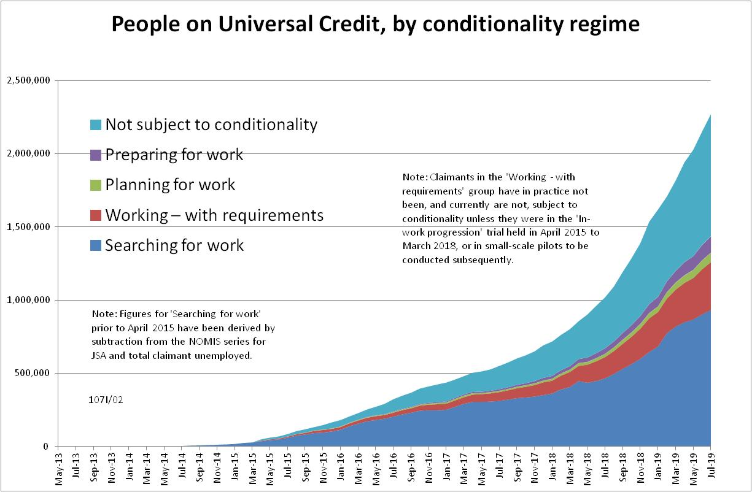

Figure 2
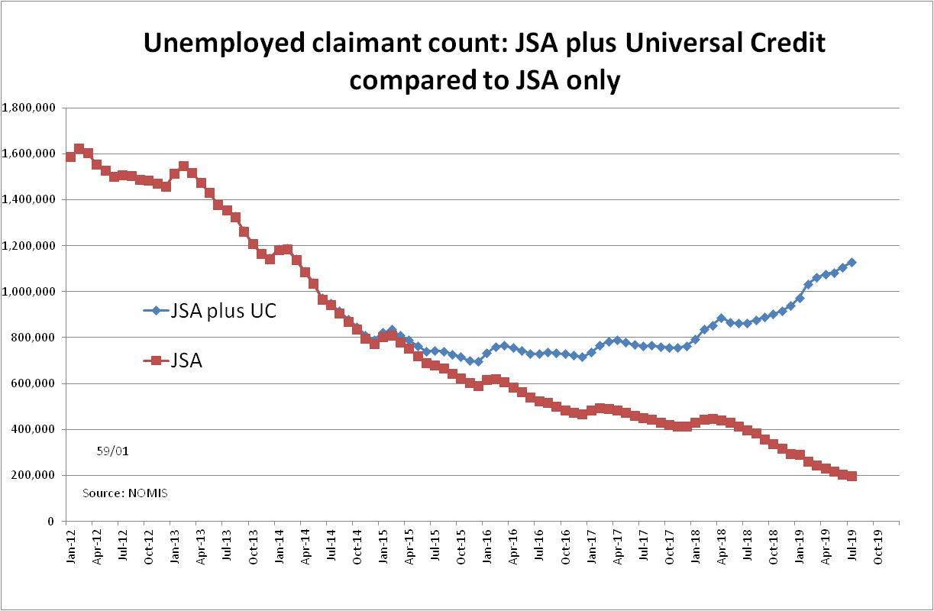
Figure 3
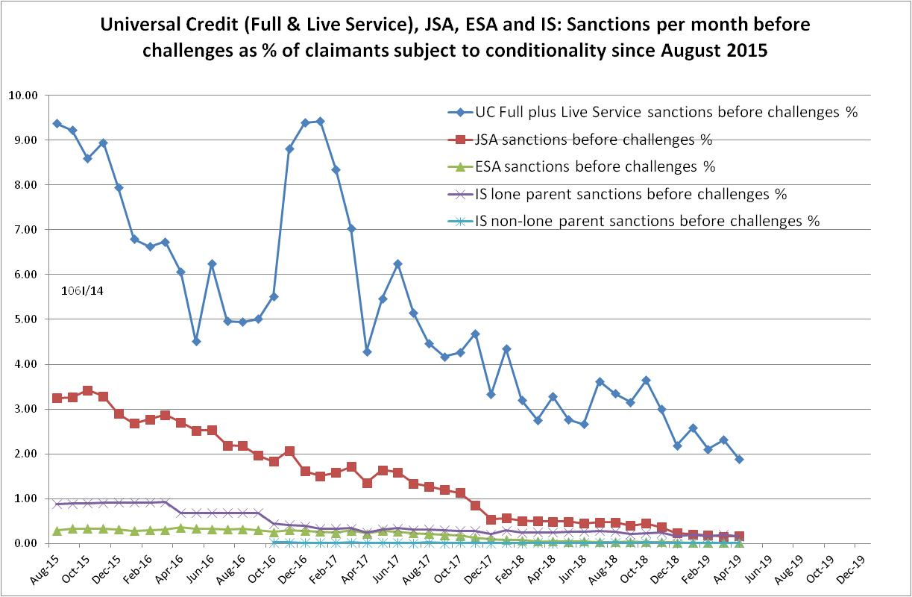

Figure 4
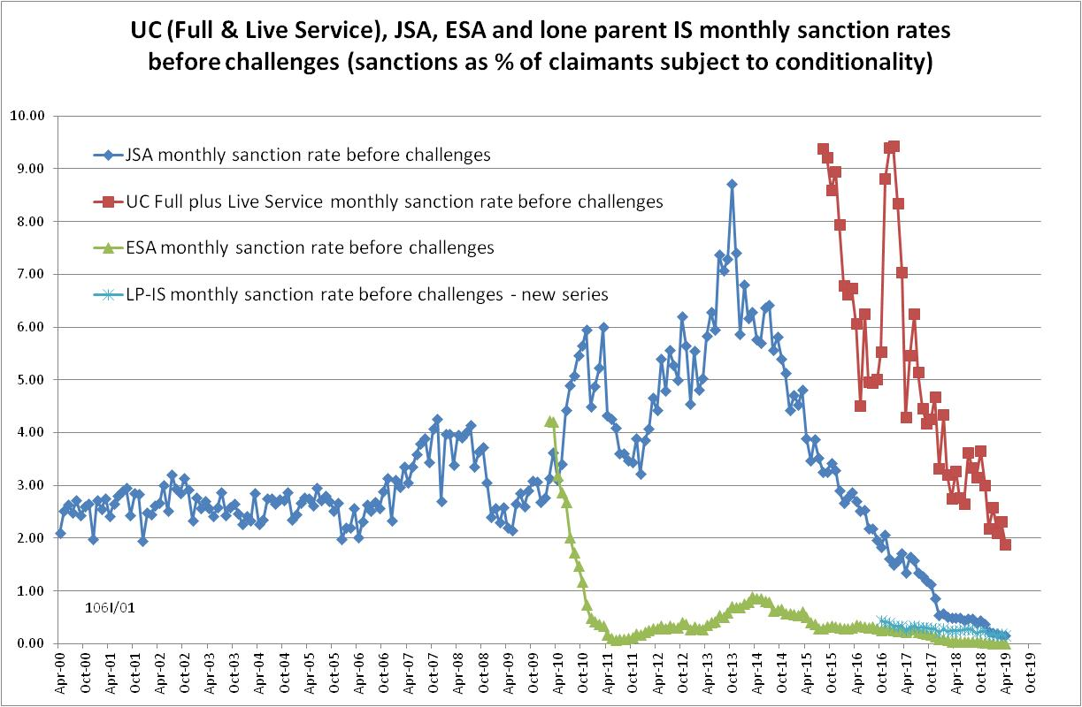
Figure 5
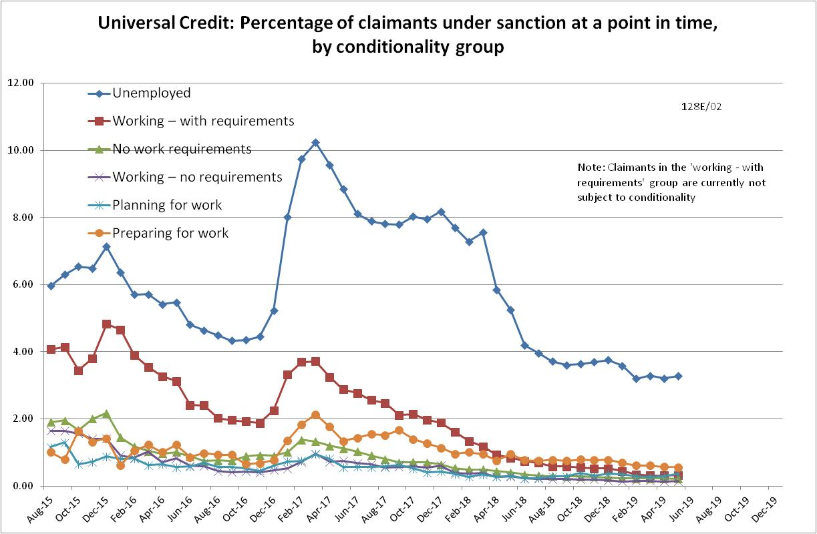
Figure 6
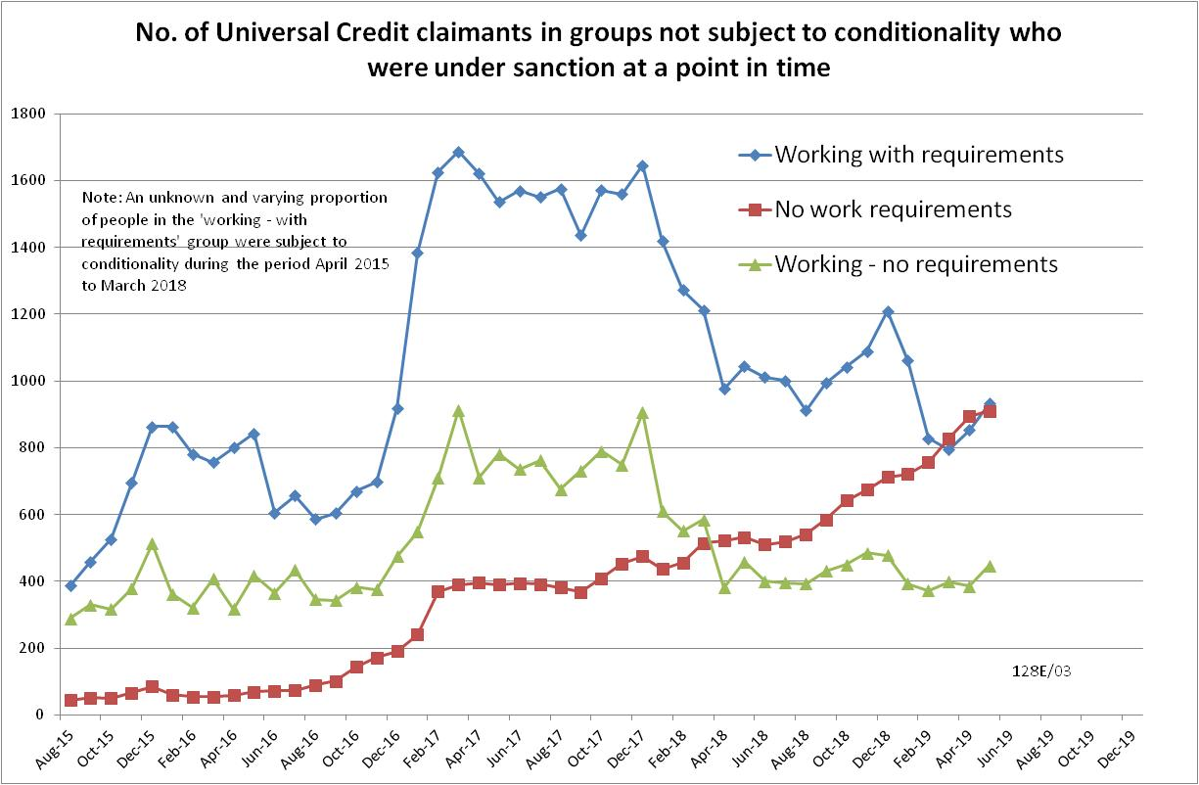

Figure 7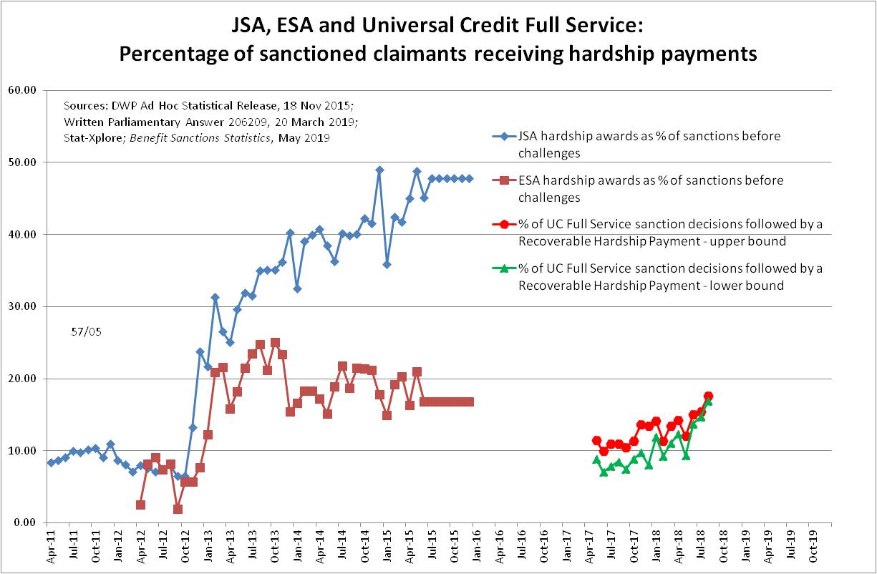

NOTES

Previous briefings are available at http://www.cpag.org.uk/david-webster. They include many analyses that are not repeated here but remain valid. However it should be remembered that the DWP may have made subsequent revisions to the data reported in earlier briefings. These revisions will generally not be major although there may be substantial changes in some figures for the most recent few months.
The total number of people subject to sanctions cannot be stated exactly, because there are some categories of Income Support claimants other than lone parents with a child under one who are not subject to sanctions, and there are no data on their numbers. However, they are likely to number in the low tens of thousands.
The UC claimants in the ‘working – with requirements’ group are low paid or part-time workers. Those ‘planning for work’ are mainly lone parents with a child aged 1, while those ‘preparing for work’ are people who would have been in the ESA Work Related Activity Group, and lone parents with a child aged 2 but under 5. The statistical categories for conditionality regime used in Stat-Xplore are explained in the ‘i’ feature next to the variable name in Stat-Xplore and also in the Universal Credit Statistics methodology document at https://www.gov.uk/government/publications/universal-credit-statistics-background-information-and-methodology
Lone parents with youngest child aged one to five have been estimated simply as four fifths of the total with youngest child aged 0 to five.
The basic concept of the DWP’s sanctions database(except for the new Full Service data) is that each sanction case appears only once, and is given its latest status and attributed to the month of the latest decision on the case. So, for instance, if a decision is made in January 2014 to sanction someone, this decision is reviewed in March 2014 with an outcome unfavourable to the claimant, reconsidered in a ‘mandatory reconsideration’ in May 2014 again with an unfavourable outcome, and is heard on appeal by a Tribunal in October 2014 with a decision favourable to the claimant, then: - it appears in the statistics for the first time in January 2014 as an adverse ‘original’ decision - in March 2014 it changes its status to a ‘reviewed’ adverse decision and moves month to be with all the other cases where the latest decision has been made in March 2014 - in May 2014 it changes its status to a ‘reconsidered’ adverse decision and moves month to be with all the other cases where the latest decision has been made in May 2014 - in October 2014 it changes its status again to an appealed non-adverse decision, and moves month again to be with all the other cases where the latest decision has been made in October 2014. DWP now says that it aims to change this system for Universal Credit sanctions at some point in the future in order to show all decisions at each stage.
The estimates of sanctions before challenges have been derived by adding the monthly total of ‘non-adverse’, ‘reserved’ and ‘cancelled’ decisions shown as being the result of reviews, mandatory reconsiderations and tribunal appeals, to the monthly total of adverse ‘original’ decisions. This produces only an approximate estimate for each individual month, since decisions altered following challenge are not attributed to the correct month. It will be particularly unreliable for months affected by a DWP catch-up of a backlog of decisions. But the estimates are reliable for longer periods.
The In-work Progression conditionality trial started in 10 Jobcentres in April 2015 and began rollout across the whole country in December 2015, in both Full and Live Service. The trial finished on 31 March 2018. 30,709 claimants passed through the trial. About two-thirds ('frequent' & 'moderate' support) were in the trial for at least a year, the other one third for at least 2 months. The total number of people in the ‘working – with requirements’ group rose from 4,000 in April 2015 to 103,000 in March 2018. We therefore know that a substantial proportion of the group were in the trial at any one time, but we do not know how many.
Pre-October 2016 data for lone parents on IS are not comparable with the current data.
The figures for the number of Universal Credit Full Service sanction decisions which were followed by a Recoverable Hardship Payment are from a Parliamentary Question by Stephen Timms MP (206209, 20 March 2019). Data on the actual numbers of Universal Credit Full Service sanction decisions (before challenges) were published by DWP in Benefit Sanctions Statistics on 13 May 2019. Full Service from the start has included all categories of applicant in the Jobcentre area and therefore the omission of Live Service cases should not have biased the figures.
Figures for JSA and ESA hardship payments were published by DWP in an Ad Hoc Statistical Release in November 2015 and slightly updated in a Parliamentary Written Answer, 12 Sept 2016. They were discussed in the November 2015 Briefing, at www.cpag.org.uk/david-webster

