BRIEFING

Benefit Sanctions Statistics:
Universal Credit, JSA, ESA and Income Support

February 2018

20 March 2018

Dr David Webster
Honorary Senior Research Fellow
Urban Studies
University of Glasgow

Email david.webster@glasgow.ac.uk

Webpages: http://www.gla.ac.uk/schools/socialpolitical/staff/davidwebster/
http://www.cpag.org.uk/david-webster

SUMMARY

This Briefing draws out the main points from the latest quarterly benefit sanctions statistics published by DWP on 21 February, containing data to end-October 2017.

The movement of people on to Universal Credit (UC) is accelerating, but to date under one third of claimants subject to sanctions are on UC. Despite this, the estimated 290,000 UC sanctions before challenges in the 12 months to October 2017 accounted for over two-thirds (71%) of all estimated sanctions in this period. There were also approximately 86,000 JSA, 13,000 ESA, 12,000 IS lone parent and 400 IS non-lone parent sanctions before challenges in the same period.

DWP wants commentators to use a new measure of the rate of sanctions, namely the proportion of claimants who are estimated to be experiencing a drop in benefit at a point in time as the result of a sanction. But its estimates suffer from many problems and in any case this measure understates the impact of sanctions. As the routine measure, this Briefing will continue to use the monthly number of sanctions as a proportion of total claimants subject to conditionality. This has its own limitations, but it quickly shows up changes in the level and trends of sanctioning, and enables long-period historical comparisons.

The most striking feature continues to be the high rate of sanction under Universal Credit. The monthly rate of UC sanctions has fluctuated wildly. But the overall average since August 2015 is an extremely high 6.7% per month before challenges. If fluctuations are disregarded, then it appears that the rate has fallen from an initial 9% per month to around 4%-4.5% before challenges. This is still very high by historical standards. The current UC rate is higher than for any benefit under the previous Labour government. It is currently not possible to explain with any confidence why the UC rate started so high and has fallen so much, but part of the explanation must lie in the remarkably high level of cancellations of referrals for UC sanction in the latest quarter, rising to over 50%.

After peaking at over 8% in 2013, the JSA sanction rate before challenges fell steadily and now appears to have stabilised at around 1.7% of claimants per month. Sanction rates on ESA WRAG and lone parent IS claimants are much lower, currently both around 0.3% per month before challenges, while on other IS claimants they are very low at around 0.01%.

The proportion of UC sanctions challenged has been only 16.0%. Of these challenges, only 29.1% have succeeded, with the result that only 4.7% of UC sanctions have been overturned. These are very low proportions compared to JSA and ESA. The success rate of UC sanction challenges at Tribunal has been a very high 80.2%, indicating that too few claimants are taking their cases to Tribunal. Out of 417,000 UC sanctions imposed to date, only 1,086 or 0.3% have reached a Tribunal.

New DWP figures show that only about 19% of sanctioned JSA claimants spent 30 days or less on a working age benefit in the 6 months following the sanction. This suggests that it is not in fact easy for many of these people simply to walk into a job if they try hard enough. Figures published recently by Ben Baumberg Geiger show that in 2010-14, the JSA sanction rate was 25-50% higher for disabled than for other claimants.

As usual there is a section at the end of the Briefing on developments in relation to sanctions in the UK and USA.
BRIEFING: Benefit Sanctions Statistics
February 2018

INTRODUCTION

The latest quarterly benefit sanctions statistics were released by DWP on 21 February. The figures now cover all four of the benefits Universal Credit (UC), Jobseekers Allowance (JSA), Employment and Support Allowance (ESA), and Income Support (IS) in largely the same format. There is a summary in the publication Benefit Sanctions Statistics, available at https://www.gov.uk/government/collections/jobseekers-allowance-sanctions#history with an associated spreadsheet with summary tables. The full figures for most aspects of the data are on the Stat-Xplore database at https://stat-xplore.dwp.gov.uk/webapi/jsf/login.xhtml

In a departure from traditional practice, DWP has published figures running to end-October 2018 rather than end-September. This means that the figures are more up-to-date, but the October data will be subject to particularly large revisions as the results of challenges to sanctions and other changes feed through. All statistics relate to Great Britain.

Groups of claimants exposed to sanctions:
Universal Credit, JSA, ESA and Income Support

At May 2017, a total of some 1.8m claimants of UC, JSA, ESA and IS were exposed to sanctions. Universal Credit merges six existing means-tested benefits: JSA, ESA, IS, Working Tax Credit, Child Tax Credit and Housing Benefit. Claimants of the first three of these are already subject to sanctions and under UC those claiming in-work UC (the equivalent of Working Tax Credit) also become liable to sanctions. But some claimants of UC are not liable to sanctions.

DWP is transferring claimants who would have been on the existing benefits on to UC but the process up to now has been slow and piecemeal. To date, less than one third of the claimants who are subject to sanctions are on UC. Over two thirds are still on JSA, ESA or IS.

Since 2013, DWP has been transferring new unemployed claimants of income-based (but not contribution-based) JSA on to UC. Until May 2016 this was only of single claimants without dependants. Since May 2016, DWP has been transferring to UC new claimants of all household types of all the types of benefit which are subsumed into UC, in successive groups of Jobcentres. The current schedule for transfer of Jobcentres to this ‘full service’ (including transfers already made in an Annex) is at https://www.gov.uk/government/uploads/system/uploads/attachment_data/file/680524/universal-credit-transition-rollout-schedule-feb18-dec18.pdf The rollout was initially slow but has accelerated since October 2017. By the end of that month, 147 out of 680 Jobcentres were operating ‘full service’ (22%). Because only new claimants are currently transferred, far fewer than 22% of the claimants of each benefit other than JSA have so far been transferred. Under the current schedule, rollout of UC to new claimants will be completed in December 2018. Moving existing claimants on to UC is currently scheduled to take until March 2022.

Figure 1 shows how the numbers of claimants on UC have increased, by conditionality regime. Of the 729,000 UC claimants at January 2018, 239,000 were not subject to conditionality. They comprise those working but earning more than the equivalent of 35 hours a week at the national minimum wage, people who would have been in the ESA Support Group, and lone parents with a child aged under 1. Of the 489,000 UC claimants subject to conditionality, 368,000 were unemployed and 89,000 were working, with 32,000 required to plan or prepare for work. The in-work UC claimants subject to sanctions are low paid or part-time workers who prior to UC would not have been subject to sanctions at all. Those ‘planning for work’ are mainly lone parents with a child aged 1, while those ‘preparing for work’ are people who would have been in the ESA Work Related Activity Group, and lone parents with a child aged 2 but under 5.

Unemployed people are the largest single group exposed to sanctions. All unemployed claimants are subject to sanctions and their number can be stated with certainty since it is separately published by ONS and NOMIS and the unemployed are the only category of UC claimants who are classed by DWP as ‘searching for work’. In October 2017 there were 797,525 unemployed benefit claimants, of whom 429,916 (53.9%) were on JSA and 367,609 (46.1%) on UC.

The number of claimants on grounds of sickness and disability who are subject to sanctions can no longer be stated with certainty. This is because to the total of claimants in the ESA Work Related Activity Group (WRAG) there needs to be added the number of UC claimants claiming on grounds of sickness or disability. This is not published by DWP. The 14,206 UC claimants ‘preparing for work’ at October 2017 include these people but they also include some claimants of IS. The number of ESA WRAG claimants however is known. The slight increase in the number of these claimants noted in the previous Briefing proved short-lived and numbers are again declining. There were 406,110 in August 2017 and an estimated 403,000 at October 2017. Their number peaked at 562,620 in August 2013.

There were an estimated 511,000 claimants on IS and subject to sanctions at October 2017. The largest group among these was an estimated 305,000 lone parents with a youngest child aged between one and five. DWP reports sanctions for these separately. There were also an estimated 176,000 carers and 30,000 other IS claimants. DWP only reports sanctions for the whole of this latter group of 206,000 claimants.

Universal Credit sanctions

Details of the UC sanction regime are given in DWP (2018). The UC regime has similar lengths of sanction to those of the previous benefits for the various ‘failures’, but there are some critical differences. Sanctions are lengthened by being made consecutive, not concurrent. Hardship payments become repayable. Given that repayments are made at the rate of 40% of benefit – the same as the amount by which a hardship payment is lower than the benefit – this means that for claimants receiving hardship payments, UC sanctions are in effect 2½ times as long as their nominal length. All sanctioned UC claimants must also demonstrate ‘compliance’ for 7 days before applying for hardship payments, and must reapply for each 4-week period. The 80% hardship rate for ‘vulnerable’ claimants is abolished. There is a new ‘lowest’ category of sanction which applies to claimants who would previously have been subject to the milder IS sanction regime and it is equivalent to it. Under UC, the sanction is the amount of the Standard Allowance which is calculated to be due. In the case of in-work UC sanctions, this may be less than the full amount of the Standard Allowance, in which case the sanction will also be less.

Sanctions before and after reviews, reconsiderations and appeals

The DWP’s Benefit Sanctions Statistics publication and Stat-Xplore database only show sanctions after any reviews, reconsiderations and appeals that have taken place by the time the data are published. But numbers of sanctions before the results of these challenges are important since they show all the cases in which claimants have had their money stopped. Although a successful challenge should result in a refund, this is only after weeks or months by which time serious damage is often done. Estimates of sanctions before challenges are therefore given here but although reliable for longer time periods, they are not fully accurate for individual months. For JSA and ESA, figures for sanctions before challenges are currently higher than the ‘after challenge’ figures by very large amounts, namely about 20%. and 40% respectively. But to date, under 5% of UC sanctions have been overturned following challenge and for IS sanctions only 1%, so for these types of sanction there is much less difference between the pre-and post-challenge figures. This Briefing has a mixture of pre- and post-challenge sanctions figures.

Further exchange between UK Statistics Authority and DWP

There has been a further exchange of letters between the DWP and the UK Statistics Authority, continuing the dialogue about the quality of the sanctions statistics since the original complaint of July/August 2015. A letter from Tom Davies, DWP Acting Chief Statistician, to Ed Humpherson, UKSA Director General for Regulation, and Ed Humpherson’s reply are at https://www.statisticsauthority.gov.uk/correspondence-list/
under 15 March 2018 and 16 March 2018 respectively.

DWP is refusing to publish the proportion of claimants over one and five years who experience a sanction. It claims that this is ‘to avoid confusing users with various measures’. However the single measure that it now publishes, namely the proportion of claimants under sanction at a point in time, is of no value for many purposes and as noted in the November 2017 Briefing, is a serious underestimate subject to multiple problems.

DWP is also failing to take any action to fill the gap represented by the lack of data on claimants suffering the longer sanctions for repeat ‘failures’ within a year. And it has not published any information on hardship payments since an ad hoc release of November 2015 (see the Briefing for November 2015).
NUMBERS AND RATES OF SANCTIONS
FOR THE FOUR BENEFITS

Numbers of sanctions

In the 12 months ended October 2017 there were a total of approximately 390,000 sanctions on all the four benefits (UC, JSA, ESA and IS) before challenges. This compares with over 1.1m sanctions before challenges in the peak year 2013. Of the 390,000 sanctions, approximately 279,000 or over two-thirds (71%) were UC sanctions; this high proportion was partly due to DWP catching up with a backlog of UC sanctions during this period. It contrasts with the relatively low proportion of claimants subject to sanctions who are on UC, namely under one third. There were approximately 86,000 JSA, 13,000 ESA, 12,000 IS lone parent and 400 IS non-lone parent sanctions before challenges in the 12 months ended October 2017.

Monthly rates of sanctions

Numbers of sanctions are influenced by the numbers of claimants of the benefits concerned, so that a measure of the rate of sanctions is required. In its Benefit Sanctions Statistics, DWP has started to present as a ‘rate’ the proportion of claimants who are estimated to be experiencing a drop in benefit at a point in time as the result of a sanction. There was an extensive discussion of this new measure in the November 2017 Briefing, which pointed out many problems with it. DWP has since conceded to me that one of the problems is that where people stop claiming after receiving a sanction but then have the sanction resumed later if they return to benefit, the resumed sanction is not captured in the published figures. DWP has also told me that 20% of sanctions are not followed by a reduction in benefit at all. But they do not know the reasons for this and are only investigating it, so it is too early to trust it as a finding. There are other problems too, particularly for ESA and most of all for JSA. The overall conclusion is that, at best, this new statistic is not ready for publication. Even if it was ready, it is not suitable for use as a sole measure. In particular, it understates the extent of the effects of sanctions. For instance, the Benefit Sanctions Statistics spreadsheet (1.9a) says that on the second Thursday of June 2017 there were 1,896 people experiencing a drop in JSA as the result of a sanction. But Stat-Xplore shows that 4,921 people actually received a JSA sanction in that month, after challenges – two and one half times as many, even before challenges. Over the full 12 months ending in June 2017, 46,567 people received a JSA sanction, after challenges. As the extensive literature makes clear, the effects of a sanction are not experienced only by those current deprived of income: many of them, such as debt and damage to health and relationships, last a long time.

The Briefing will return to this subject at a later date. Meanwhile, the Briefing will continue to routinely present the rate of sanctions as the estimated number of sanctions before challenges as a proportion of the number of claimants of the relevant benefit on the measurement day in that month. This can still be derived from Stat-Xplore. As a measure this has the disadvantage that it produces a rather low figure which understates the likelihood of a person being sanctioned at some time during their claim – though not nearly as low as the DWP’s figures on the number of people suffering a payment drop. But it has the crucial advantages that it quickly shows up changes in the level and trends of sanctioning, and enables long-period historical comparisons. When possible, the Briefing will also publish the proportion of claimants sanctioned over the longer periods of a year and five years.

Figure 2 compares the monthly before-challenge sanction rates for UC, JSA, ESA and IS for the period for which DWP has published UC sanctions data, namely since August 2015. The UC rate includes all types of claimant, since DWP does not publish separate figures for unemployed, working, sick etc. Rates have been calculated as a percentage of claimants subject to conditionality. For JSA this means all claimants; for UC, it is those ‘searching for work’, ‘working with requirements’, ‘planning for work’ and ‘preparing for work’; for ESA it is those in the Work Related Activity Group; for lone parents on IS, it is those with youngest child aged between 1 and 5 (all lone parent claimants with a youngest child aged 5+ have been taken off IS and transferred to JSA); and for other IS claimants, it is the great majority of claimants. UC sanctions have been increased pro rata to adjust for the omission by DWP of sanctions on claimants in ‘full service’ areas, using the DWP’s published schedule for transfer of Jobcentres to ‘full service’, and the listing of Jobcentre closures published in the Daily Mirror, 5 January 2018.

The most striking feature continues to be the high rate of sanction under Universal Credit. During 2016 DWP developed backlogs in making decisions on UC sanction referrals, and then mounted a blitz to catch up at the end of 2016. Consequently the monthly rate of UC sanctions has fluctuated wildly, making it difficult to discern the underlying rate. But the overall average since August 2015 is an extremely high 6.7% per month before challenges. If the fluctuations associated with the backlog and catch-up are disregarded, then it appears that the rate has fallen from an initial 9% per month to around 4%-4.5% before challenges. This is still very high by historical standards, as can be seen from Figure 3, which shows monthly rates of sanction for all the benefits back as far as the data are available on the web. The current UC rate is higher than seen for any benefit under the previous Labour government.

Because DWP has not published the necessary data, we do not know how the rate of sanctions varies between the different groups of UC claimants subject to conditionality. It might, for instance, be higher for unemployed than for employed claimants, or vice versa. We simply do not know.

After peaking at over 8% in 2013, the JSA sanction rate before challenges fell steadily and now appears to have stabilised at around 1.7% of claimants per month. The overall rate of sanction on unemployed people is likely to rise simply because of the continuing transfer of claimants to the high-sanctioning UC. Sanction rates on ESA WRAG and lone parent IS claimants are much lower, currently both around 0.3% per month before challenges, while on other IS claimants they are very low at around 0.01% (an exact figure cannot be given as the precise number of IS claimants subject to sanctions is not published). The series of lone parent IS sanctions data previously published in the former Income Support Lone Parents Regime: Official Statistics: Quarterly official statistics bulletin is also shown in Figure 3. DWP notes that the new Stat-Xplore series is not comparable to it, but does not offer an explanation of the large discrepancy between the old and new figures.

Explaining the high rate of Universal Credit sanctions, and its fall

To explain why the UC sanction rate is so high, the DWP (2018, p.4) states that under JSA, claimants not attending an interview will normally have their cases closed whereas under UC they are more often sanctioned. The reason for this is that UC claimants may be in receipt of other parts of UC, such as housing benefit and child credits, and therefore cannot have their cases closed. Another part of the explanation why the UC sanction rate is so much higher than JSA is that UC claimants tend to be younger, and younger people have a higher rate of sanction. But a chart in the August 2017 Briefing (Figure 5) showed that the mean monthly UC sanction rate after challenges is much higher than for JSA for every age group, so this explanation is only of limited value.

A different explanation is required for the overall fall in the rate of UC sanctions since August 2015. Figures 4 and 5 compare the rates of referral, proportions of referrals resulting in sanction, and rates of cancellation of referrals, for UC and JSA. They show that the fall in the JSA sanction rate has been mainly due to a continuous fall in the referral rate since 2013. But the UC referral rate has remained high at around 10% per month, and the fall in the UC sanction rate has been mainly due to an increase in the proportion of referrals which are cancelled, particularly in the latest three months, when it has risen to a remarkable 50%. The key question is what this is due to. Benefit Sanctions Statistics states (p.4) that ‘there were a large number of outstanding sanction referrals processed in September and October 2017. Some of these were cancelled.’ What this could mean is that the rate of new referrals actually fell in these months, and a high proportion of decisions were on backlog cases. This may possibly be an effect of the DWP’s new ‘guidance to work coaches in UC to support them to make decisions not to sanction a customer in specific straight-forward cases if good reason is shown for not attending an interview’ (DWP/Dept of Health 2017). Most UC sanctions are for missed interviews. Cancellation may have been particularly frequent for the backlog cases due to the lapse of time making checking of facts difficult. If this interpretation is correct, then the next set of statistics might see a fall in referrals, accompanied by an offsetting fall in cancellations, with the net result that the rate of UC sanctions might remain at a similar level to that of August-October 2017. However, this is speculation. Because of the backlogs and catch-ups it remains very difficult to identify any trend in the UC sanction rate and the outstanding fact remains that the UC sanction rate overall has been and still is extremely high.

Low rate of challenge to Universal Credit sanctions: compounding the impact

Over the two and one-quarter years for which statistics are available, the proportion of UC sanctions challenged has been only 16.0%. Of these challenges, only 29.1% have succeeded, with the result that only 4.7% of UC sanctions have been overturned. These are very low proportions compared to JSA and ESA and they compound the effect of the already high before-challenge rate of sanctions under UC. The success rate of UC sanction challenges at mandatory reconsideration stage has been only 28.3%, but at Tribunal it has been a very high 80.2%, indicating that too few claimants are taking their cases to Tribunal and many wrongful UC sanctions are being allowed to stand. Out of 417,000 UC sanctions imposed to date, only 1,086 or 0.3% have reached a Tribunal.

Over the same period since August 2015, 23.1% of JSA sanctions have been challenged, and 76.1% of the challenges have succeeded, so that 17.6% of the sanctions have been overturned. For ESA, over the same period, 62.1% of sanctions have been challenged, and 41.2% of the challenges have succeeded, so that 25.8% of the sanctions have been overturned. IS sanctions are relatively mild and a lower rate of challenge is to be expected. Over the period since October 2016, the rate of challenge to IS sanctions on lone parents has been very low at 1.4%, with however a relatively high success rate of challenges at 61.9%, resulting in 0.9% of sanctions overturned.

Over the year to October 2017 there have been no Tribunal cases at all for ESA or IS sanctions, and only 566 and 366 respectively for UC and JSA sanctions.

RATES OF SANCTION ON DISABLED AND NON-DISABLED JSA CLAIMANTS

Ben Baumberg Geiger has shown that over the period 2010-14, the sanctioning rate for disabled people on JSA was 25-50% higher than for non-disabled people on JSA. The data on sanctions come from Stat-Xplore, while the data on the numbers of disabled and non-disabled JSA claimants are from a DWP Freedom of Information request 2015-447. In both cases ‘disabled’ is a self-classification. Full details are in Geiger (2017) and in particular in the web annex to the paper at http://www.benbgeiger.co.uk/files/2017%20JPSJ%20conditionality%20web%20appendices.pdf
To update this analysis, a further FoI request would be required.

THE DURATION OF SANCTIONS

The DWP’s Benefit Sanctions Statistics and the accompanying summary spreadsheet also have new ‘experimental’ statistics on the duration of ‘ended’ UC, ESA and JSA (but not IS) sanctions. For UC, JSA and ESA there are month-by-month detailed frequency distributions of durations in the spreadsheet, JSA having been added in the latest (February) release.

Again, the November 2016 Briefing contained a full analysis of the new statistics, which is not repeated here. As in the case of the proportions of people under sanction at a point in time, all the durations are understated. They do not show the duration of sanctions of people who stay on benefit and serve their sanction fully; they do not include the periods of reduced income endured by people who remain eligible for benefit but stop claiming it; they do not include the unserved portions of sanctions which those claimants are made to serve if they later reclaim; and they do not reflect the effect of repayment of UC hardship payments. They therefore do not show anything like the full impact of sanctions in lowering claimants’ incomes.

BENEFIT DESTINATIONS OF CLAIMANTS RECEIVING A SANCTION

The November 2017 Briefing reported on new ‘experimental’ statistics on the benefit destinations of claimants during the 180 days following a benefit sanction decision, contained in Benefit Sanctions Statistics (but not in the associated spreadsheet or in Stat-Xplore). There is an explanation of methodology at https://www.gov.uk/government/publications/benefit-destinations-of-claimants-receiving-a-benefit-sanction-methodology

The Briefing commented that it was not clear whether people who continue their claim for the benefit but receive no money because of the sanction are counted as being ‘on the benefit’. DWP have subsequently clarified to me that they are counted as being ‘on benefit’.

The destination figures have now been updated to end-March 2017. They cover the whole period starting from the launch of the new regimes for JSA and ESA on 22 October and 3 December 2012 respectively, and from 1 August 2015 for UC ‘live service’. UC ‘full service’ figures are not included.

It is difficult to draw any firm conclusions from these figures. However, they do confirm that JSA claimants are the most likely to leave benefit and ESA the least likely. Only 27% of sanctioned JSA claimants spent the full 180 days ‘in receipt of benefit’, compared to 65% of sanctioned UC claimants and 86% of sanctioned ESA claimants.

Perhaps the most significant figure is that only about 19% of sanctioned JSA claimants spent 30 days or less on a working age benefit during the following six months. This fits with other evidence that it is not in fact easy for these people simply to walk into a job if they try hard enough. Moreover, the figures do not show whether people who stopped claiming benefits actually went into work. We know that many of them do not.

ANALYSES NOT INCLUDED IN THIS ISSUE

Readers are referred to earlier numbers of the Briefing for analyses of issues not discussed in the present issue. These analyses will be updated in future numbers.

SANCTIONS - OTHER DEVELOPMENTS

‘Improving Lives’ White Paper

Following the Green Paper of October 2016, the government published its White Paper on work, health and disability on 30 November (DWP/Dept of Health 2017). Some key points:

- Whereas the Green Paper trailed the possibility of extending sanctions to the ESA Support Group and its UC equivalent, the White Paper accepts the overwhelming view emerging from the consultation that employment support for this group should be voluntary. It says ‘Starting now and over the next two to three years we will test voluntary interventions for people in the ESA Support Group and its equivalent in UC.’ (p. 13)
- ‘We have now provided guidance to work coaches in UC to support them to make decisions not to sanction a customer in specific straight-forward cases if good reason is shown for not attending an interview.’ (p.57) This is of course welcome, though it is extraordinary that guidance should ever have said anything different.
- ‘Since the Green Paper [in October 2016] we have rolled out new training for work coaches as part of the Health and Work Conversation (HWC). This new training builds skills of empathy, active listening, and helping people respond resiliently to challenges and overcome fixed beliefs about their abilities.’ (p. 17) It may well be that this new training is at least partly responsible for what seems to have been a relatively sensible administration of the ‘claimant commitment’ compared to the excesses of the ‘actively seeking work’ sanctions drive of 2011-13.

Social Security (Scotland) Bill – right to be accompanied

The Scottish Government has made an amendment to its Social Security Bill currently going through the Scottish Parliament which guarantees the right of claimants to be accompanied by a person of their choice at meetings with officials concerning their claim. The DWP argues, for instance as quoted in the Scottish newspaper The National on 19 January, at
http://www.thenational.scot/news/15865535.Scotland_set_for_revolution_on_social_security
that claimants already have this right. However, experience shows that it is often not honoured by Jobcentres or contractors, as for instance is noted by the House of Commons Work and Pensions Committee (2018b, p.50).

The full amendment (39) reads:

‘Support during discussions and assessments: Right to support
(1) The Scottish Ministers must comply with an individual’s wish to have another person (“a supporter”) present during any discussion or assessment relating to the individual’s entitlement to a type of assistance described in Chapter 2, unless the wish is unreasonable.
(2) The Scottish Ministers’ duty under subsection (1) includes ensuring that any person acting on their behalf complies with such a wish, unless the wish is unreasonable.
(3) The role of a supporter is to support the individual in question during the discussion or (as the case may be) assessment, and includes making representations on the individual’s behalf.
(4) Nothing in this section is to be read as requiring the Scottish Ministers to provide or pay for a supporter.’

This still leaves quite a large loophole, since it would be difficult for a claimant to enforce their right if officials claimed it was being exercised unreasonably. They would have to go to court retrospectively. Nevertheless, the creation of a statutory right is very welcome. Of course it will not affect sanctions, since the Scottish social security benefits will not have any sanctions. But if a similar statutory right were extended to claimants of DWP benefits, it would undoubtedly help to prevent many mistaken and destructive sanctions.

House of Commons Work & Pensions Committee reports on ESA and PIP assessments

In February the House of Commons Work & Pensions Committee published two reports on ESA and PIP assessments, the first (2018a) on claimant experiences and the second (2018b) on the processes themselves. The claimant experience report links to a large volume of evidence. Among other things, the substantive report states (para.63) that the DWP dropped its ‘aspiration’ to uphold 80% of decisions at Mandatory Reconsideration stage in December 2017, in response to an enquiry from the Committee. This ‘aspiration’ was reported on in the May 2017 Briefing (p.12). The Work & Pensions report also calls for DWP to institute a proper process of learning from overturned decisions at appeal.

Demos report on improving the Work Capability Assessment

Also in February, Demos has published a major report by Ben Baumberg Geiger (Geiger 2018) which draws on research in several countries and on a specially-commissioned UK public opinion survey to propose improvements to the Work Capability Assessment and the conditionality regime for sick and disabled people. It has an extensive discussion of sanctions (Chapter 3). It notes that the only form of conditionality that any frontline welfare-to-work providers think might be effective for this group is to mandate an initial meeting. The opinion survey shows that while the public do support some sanctions on disabled people, the majority do not support penalties as severe as the present ESA/UC regime, and they support sanctions for minor non-compliance either only weakly or not at all.

The paper (pp.76-77) also has an explanation for the rise in the proportion of ESA claimants allocated to the Support Group between 2012 and 2015, in terms of the use of the exceptional circumstances safeguard to protect people from the then particularly harsh sanctioning regime within the Work Related Activity Group. It therefore appears that the toughening of conditionality during this period, associated with referrals to the Work Programme, was directly responsible for causing a shift of a large number of claimants out of conditionality altogether. This type of unintended consequence is often found in conditionality regimes.

A BBC sanctions case history – ESA/Universal Credit

On 31 January the BBC News website carried at
http://www.bbc.co.uk/news/stories-42789610
an appalling story of an ESA, later Universal Credit, claimant Tony Rice, for whom a sanction, coming on top of a pile of earlier mishaps and applied by DWP without inquiry into his circumstances, created a really severe crisis.

OBR report on Universal Credit

The 2018 Welfare Trends report by the Office for Budget Responsibility (OBR 2018) is entirely about Universal Credit and is a useful guide to its rules, issues and impacts, including the conditionality regime.

New online register of Jobcentres

Any researcher using labour market data will have found it frustrating that it has been difficult to find an authoritative up-to-date list of operational Jobcentres. DWP Client Statistics have been working with the Government Digital Service (GDS) to develop a register of DWP Jobcentres, as part of the Government Transformation Strategy to build authoritative lists that are held once across government. It is now available on line and will be updated on a monthly basis. It comprises three lists of:
- 695 individual Jobcentres with their Unique Property Reference Numbers (UPRNs): https://jobcentre.register.gov.uk/
- 26 Jobcentre Office Districts: https://jobcentre-district.register.gov.uk/
- 7 Jobcentre Groups: https://jobcentre-group.register.gov.uk/

Another NHS sanction system

The November 2017 Briefing briefly reported on the problems created by a NHS system in England for automatic £100 fines for people deemed not eligible for free dental treatment. Now, on 11 March 2018, the Observer has reported similar problems with another NHS system, operated by the NHS Business Services Authority, which issues penalty notices for £100 fines for people thought not to be entitled to free prescriptions. A Freedom of Information response has disclosed that 1,052,430 such penalty notices were issued in 2017, of which 342,882 (32.6%) were subsequently withdrawn because the patients concerned were in fact entitled to free prescriptions.

USA introduces work requirements as a condition of health care

The main US programme to provide medical care for low income people is Medicaid. Its scope was expanded under the Obama administration. On 11 January the Trump administration, via the Federal agency Centers for Medicare & Medicaid Services, issued guidance allowing individual states to make being in work or training a condition for the receipt of health care. Kentucky and Indiana have already implemented the policy and another eight states have requested approval to do so. Critics (Bernstein & Katchjan 2018; Huberfeld 2018) have pointed out that the policy will be counterproductive, since, not surprisingly, there is research evidence that health care makes people more likely to gain and hold employment (e.g. Ohio Dept of Medicaid 2017).

Use of IT systems in decision making in the USA

A new book (Eubanks 2018) investigates how data mining, policy algorithms, and predictive risk models are undermining the rights of poor people in the USA. In particular it shows how over a three year period one million applications for healthcare, foodstamps and cash benefits in the State of Indiana were wrongfully refused because a new computer system was programmed to interpret any mistake as ‘failure to cooperate’.
REFERENCES

Bernstein, Jared & Hannah Katchjan (2018) ‘Trump’s Medicaid Work Requirement Will Backfire’, New York Times, 11 January, at
https://www.nytimes.com/2018/01/11/opinion/trumps-medicaid-backfire.html

DWP (2018) Universal Credit Sanctions Experimental Official Statistics: Background information and methodology, February, at
https://www.gov.uk/government/uploads/system/uploads/attachment_data/file/637862/universal-credit-sanctions-statistics-background-information-and-methodology.pdf

DWP/Dept of Health (2017) Improving Lives: The Future of Work, Health and Disability, Cm9526, November, at
https://www.gov.uk/government/publications/improving-lives-the-future-of-work-health-and-disability

Eubanks, Virginia (2018) Automating Inequality: How High-Tech Tools Profile, Police and Punish the Poor, New York, St Martin’s Press

Geiger, Ben Baumberg (2017) ‘Benefits conditionality for disabled people: stylised facts from a review of international evidence and practice’, Journal of Poverty and Social Justice, 25:2, 107–28, with web appendix at
http://www.benbgeiger.co.uk/files/2017%20JPSJ%20conditionality%20web%20appendices.pdf

Geiger, Ben Baumberg (2018) A Better WCA is Possible: Disability Assessment, Public Opinion and the Benefits System, London, Demos, with separate online Appendix, at
https://www.demos.co.uk/project/a-better-work-capability-assessment/

House of Commons Work and Pensions Committee (2018a) PIP and ESA assessments: claimant experiences, Fourth Report of Session 2017–19, HC355, 9 February, at
https://publications.parliament.uk/pa/cm201719/cmselect/cmworpen/355/355.pdf

House of Commons Work and Pensions Committee (2018b) PIP and ESA assessments, Seventh Report of Session 2017–19, HC829, 14 February, at
https://publications.parliament.uk/pa/cm201719/cmselect/cmworpen/829/829.pdf

Huberfeld, Nicole (2018) ‘Can Work Be Required in the Medicaid Program?’, New England Journal of Medicine, 378:788-791, 1 March, at
http://www.nejm.org/doi/full/10.1056/NEJMp1800549

Office for Budget Responsibility (2018) Welfare trends report, Cm 9562, January 2018, at
http://obr.uk/docs/dlm_uploads/WelfareTrends2018cm9562.pdf

Ohio Department of Medicaid (2017) Ohio Medicaid Group VIII Assessment: A Report to the Ohio General Assembly, 1 January, at
http://medicaid.ohio.gov/portals/0/resources/reports/annual/group-viii-assessment.pdf

Figure 1
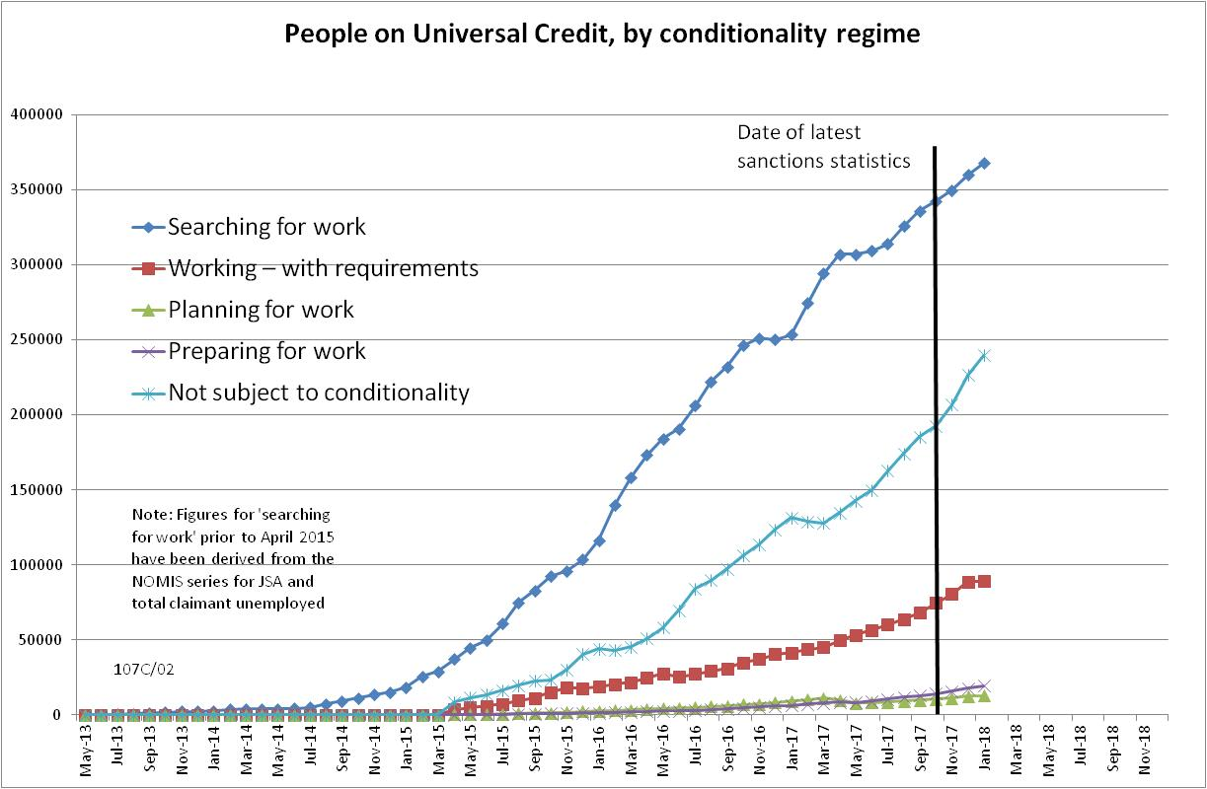

Figure 2
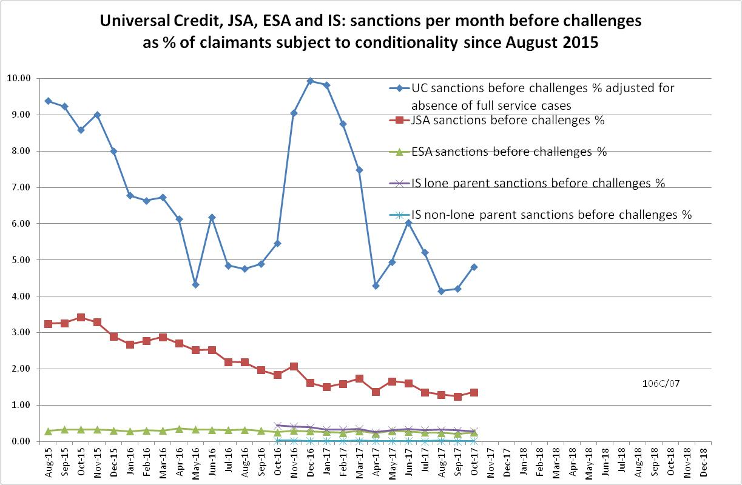

Figure 3
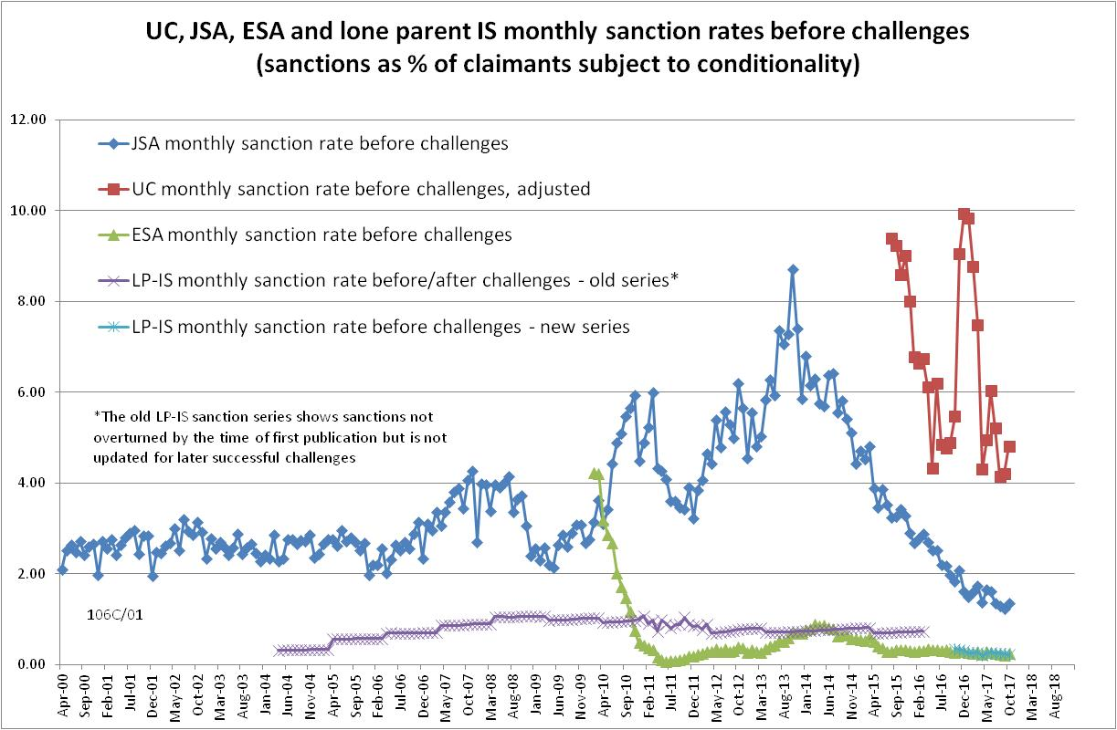
Figure 4
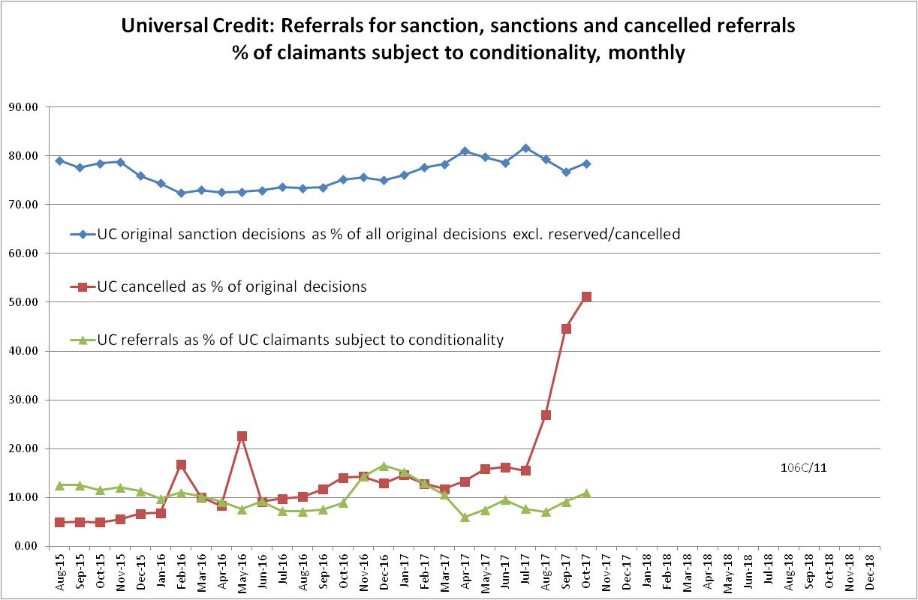
Figure 5
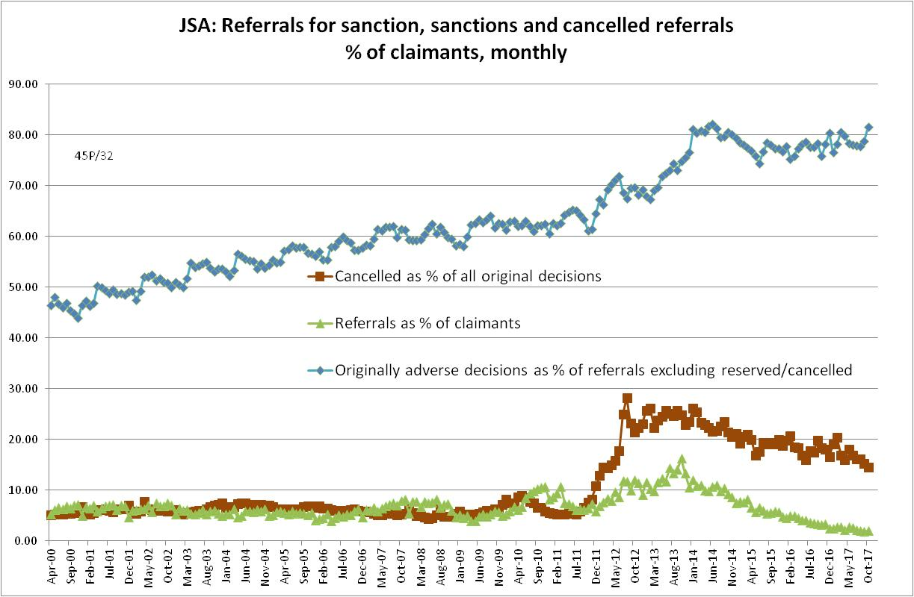

NOTES

Previous briefings are available at http://www.cpag.org.uk/david-webster. They include many analyses that remain valid. However it should be remembered that the DWP may have made subsequent revisions to the data reported in earlier briefings.
The total number of people subject to sanctions cannot be stated exactly, because there are some categories of Income Support claimants other than lone parents with a child under one who are not subject to sanctions, and there are no data on their numbers. However, they are likely to number in the low tens of thousands.
The statistical categories for conditionality regime used in Stat-Xplore are explained in the ‘i’ feature next to the variable name in Stat-Xplore and also in the Universal Credit Statistics methodology document at https://www.gov.uk/government/publications/universal-credit-statistics-background-information-and-methodology
Lone parents with youngest child aged one to five have been estimated simply as one fifth of the total with youngest child aged 0 to five.
Repayment is suspended for any month when the claimant earns more than their threshold, and any remaining debt is written off if the earnings threshold has been met for 26 weeks, whether continuous or not.
The Standard Allowance is the basic living amount for a single adult, before the addition of other amounts for housing costs, children etc.
The basic concept of the DWP’s sanctions database is that each sanction case appears only once, and is given its latest status and attributed to the month of the latest decision on the case. So, for instance, if a decision is made in January 2014 to sanction someone, this decision is reviewed in March 2014 with an outcome unfavourable to the claimant, reconsidered in a ‘mandatory reconsideration’ in May 2014 again with an unfavourable outcome, and is heard on appeal by a Tribunal in October 2014 with a decision favourable to the claimant, then: - it appears in the statistics for the first time in January 2014 as an adverse ‘original’ decision - in March 2014 it changes its status to a ‘reviewed’ adverse decision and moves month to be with all the other cases where the latest decision has been made in March 2014 - in May 2014 it changes its status to a ‘reconsidered’ adverse decision and moves month to be with all the other cases where the latest decision has been made in May 2014 - in October 2014 it changes its status again to an appealed non-adverse decision, and moves month again to be with all the other cases where the latest decision has been made in October 2014.
The estimates of sanctions before challenges have been derived by adding the monthly total of ‘non-adverse’, ‘reserved’ and ‘cancelled’ decisions shown as being the result of reviews, mandatory reconsiderations and tribunal appeals, to the monthly total of adverse ‘original’ decisions. This produces only an approximate estimate for each individual month, since decisions altered following challenge are not attributed to the correct month. It will be particularly unreliable for months affected by a DWP catch-up of a backlog of decisions. But the estimates are reliable for longer periods.
DWP have undertaken to me to add this point to their methodology document, but at the time of writing had not yet done so.
As noted in the news section of this Briefing, DWP has now started to publish an on-line authoritative listing of operational Jobcentres, but this came too late for use in this issue of the Briefing.
In this discussion, it needs to be borne in mind that Stat-Xplore shows the date of decision, not the date on which the original referral was made. Usually, the referral and the decision will be close together, but this may not apply where there is a backlog. The discussion here uses the terms ‘referral’ and ‘decision’ interchangeably but takes into account that this may not be appropriate to a backlog.
Publication of the more detailed frequency distribution for JSA sanction ‘durations’ does not necessitate any revision to what was said about these figures in the November 2017 Briefing.

