BRIEFING:

Benefit Sanctions Statistics:
JSA, ESA, Universal Credit and Income Support for Lone Parents

May 2017

7 June 2017

Dr David Webster
Honorary Senior Research Fellow
Urban Studies
University of Glasgow

Email david.webster@glasgow.ac.uk

Webpages: http://www.gla.ac.uk/schools/socialpolitical/staff/davidwebster/
http://www.cpag.org.uk/david-webster

SUMMARY

In the May 2017 statistical release, DWP has published statistics on Universal Credit (UC) sanctions for the first time, and it has put lone parent Income Support (LP-IS) sanctions on to the same basis as other sanctions.

In 2016 there were approximately 339,000 JSA or UC sanctions on unemployed people before challenges, of which 157,000 were JSA and 182,000 UC. After challenges, there were 127,409 JSA and 176,855 UC sanctions, a total of 304,264. Also after challenges, 83,898 JSA claimants were sanctioned, and 104,906 UC claimants, making a total of 188,804 sanctioned individuals.

The average monthly rate of sanctions under UC over the 17 months for which data are published was very high at 7.1% of claimants before challenge, compared with only 2.6% for JSA. This makes the overall monthly rate for unemployed claimants 3.75%, substantially higher than suggested by previously published DWP statistics. Reasons for the higher UC rate include the relative youth of UC claimants and the fact that under UC, more of those who miss interviews are sanctioned rather than have their cases closed.

In 2016, the mean number of sanctions per sanctioned individual was 1.69 for UC, 1.52 for JSA and 1.57 for ESA, indicating that under UC sanctions are more concentrated on a minority of individuals.

Reasons for UC sanctions are dominated by missed interviews, accounting for 70.1% of UC sanctions in 2016. This is far more than for JSA (21.2%). Work search penalties are significant at 17.2%, compared to 21.9% for JSA. Among JSA sanctions, failure to participate in the Work Programme has increased substantially in relative importance since 2013, from 29.6% to 47.4%, while work search has declined.

The ESA monthly sanction rate before challenges is stable or slightly rising at about 0.33% per month. The monthly rate of lone parent IS sanctions after challenges appears to have declined over the past year. For the quarter ended December 2016 it was 0.35%, compared to 0.52% for lone parents on JSA. Almost all the LP-IS sanctions (96%) were for missing an interview.

Rates of challenge are much lower for UC and LP-IS sanctions than for JSA or ESA. In the quarter ended December 2016 only just over 1% of LP-IS sanctions were challenged, while in the 17 months for which UC data are available, an average of only 14.5% of UC sanctions were challenged. These rates for UC and LP-IS compare with fairly stable figures of around 25% for JSA and 60% for ESA.

There is less difference in success rates for challenges. For JSA they are almost 80% and LP-IS about 70%, with ESA around 45% and UC the lowest at around 31%. Overall overturn rates (the proportion of sanctions rescinded after challenge) for JSA and ESA have converged at about 20% while for UC the rate is under 5% and for LP-IS under 1%.

The UK Statistics Authority is pursuing DWP on the question of improvements to the sanctions statistics. There is other news on sanctions developments at the end of the Briefing.
BRIEFING: Benefit Sanctions Statistics
May 2017

INTRODUCTION

This briefing continues the series of reports dealing with the quarterly benefit sanctions data released by DWP. The latest statistics were released on 17 May on Stat-Xplore at https://stat-xplore.dwp.gov.uk/webapi/jsf/login.xhtml (note change of URL), giving figures to December 2016.

With this release there has been a major change of coverage by Stat-Xplore. As before, Jobseekers Allowance (JSA) and Employment and Support Allowance (ESA) sanctions are reported, the former going back to April 2000 and the latter to their introduction in October 2008. Sanctions on claimants of Universal Credit (UC) are now reported for the first time, going back to August 2015, and sanctions on lone parent claimants of Income Support (IS), previously published separately, are now on Stat-Xplore, but going back only to October 2016. Some rudimentary statistics on in-work UC pilot sanctions were separately published on 23 March and are commented on in this Briefing.

DWP provides some commentary on the figures for all four types of sanction (other than in-work UC) in its substantially expanded May 2017 Quarterly Statistical Summary at https://www.gov.uk/government/statistics/dwp-statistical-summaries-2017 A new departure is that the Quarterly Summary now has a useful set of supporting data tables, in a separate file at https://www.gov.uk/government/statistics/dwp-statistical-summaries-2017. A guide to the new UC sanctions statistics is at https://www.gov.uk/government/uploads/system/uploads/attachment_data/file/613873/universal-credit-sanctions-statistics-background-information-and-methodology.pdf and the DWP (p.11) invites feedback.

As before, JSA and ESA sanctions are summarised in an Excel spreadsheet at https://www.gov.uk/government/collections/jobseekers-allowance-sanctions. Summary statistics on lone parent IS sanctions were previously published at https://www.gov.uk/government/collections/income-support-lone-parent-regime-figures-on-sanctions-and-work-focused-interviews--2 These are still available for periods up to March 2016 (not September 2016 as stated on the DWP website) but are not being updated. The DWP warns that the methodology for lone parent IS sanctions statistics has changed so that the earlier figures are not comparable.

All statistics relate to Great Britain.

Claimants exposed to sanctions: JSA, ESA, Universal Credit and Income Support

Since 2013, DWP has been transferring unemployed claimants from JSA to Universal Credit. In April 2017 there were 706,110 unemployed claimants, of whom 483,355 were on JSA and 312,755 on UC.

Within ESA, only those in the Work Related Activity Group (WRAG) are subject to sanctions. Their number peaked at 562,620 in August 2013 but has been continuously declining since then and has now fallen to an estimated 412,000 in December 2016.

The number of lone parents on Income Support has also been falling, to 401,630 in November 2016. Currently, only those with a youngest child aged under 1 are exempt from sanctions. Some other IS claimants are also subject to sanctions.

In April 2017 there were also 50,305 in-work UC claimants subject to sanctions in the DWP’s pilot areas (provisional figure).

The February 2017 Briefing had a chart (Figure 1) showing how the numbers of people subject to the different types of sanction have changed.

Universal Credit sanctions

The UC regime has similar lengths of sanction to those of JSA for the various ‘failures’, but there are some critical differences. Sanctions are lengthened by being made consecutive, not concurrent. Hardship payments become repayable. Given that repayments are made at the rate of 40% of benefit – the same as the amount by which a hardship payment is lower than the benefit – this means that for claimants receiving hardship payments, UC sanctions are in effect 2½ times as long as their nominal length. All sanctioned UC claimants must also demonstrate ‘compliance’ for 7 days before applying for hardship payments, and must reapply for each 4-week period. The 80% hardship rate for ‘vulnerable’ claimants is abolished. There are also some new ‘lowest’ categories of sanction (DWP 2017, pp.5 & 9).

Sanctions before and after reviews, reconsiderations and appeals

The DWP’s Stat-Xplore database only shows sanctions after any reviews, reconsiderations and appeals that have taken place by the time the data are published. But numbers of sanctions before the results of these challenges are important since they show all the cases in which claimants have had their money stopped. Although a successful challenge should result in a refund, this is only after weeks or months by which time serious damage is often done. Estimates of sanctions before challenges are therefore given here but although reliable for longer time periods, they are not fully accurate for individual months. Figures for sanctions before challenges are currently higher than the ‘after challenge’ figures by about 20% for JSA and 39% for ESA. To date, under 4% of UC sanctions have been overturned on challenge and for lone parent IS sanctions only 1%, so for these types of sanction there is much less difference between the pre-and post-challenge figures. This Briefing has a mixture of pre- and post-challenge sanctions figures, depending on the feasibility and difficulty of estimating the pre-challenge figures from the published data, and on the scale of the difference between the pre- and post-challenge figures.

UK STATISTICS AUTHORITY CRITICISMS OF SANCTIONS STATISTICS

Previous issues of this Briefing have reported the UK Statistics Authority’s criticisms of the DWP’s sanctions statistics, and have noted how little the DWP has done to meet them. The February 2017 issue of this Briefing contained an Appendix taking stock of the whole issue. The UKSA on 29 March has now written to DWP again and the letter is at

https://www.statisticsauthority.gov.uk/wp-content/uploads/2017/03/Letter-from-Ed-Humpherson-to-Neil-McIvor-290317.pdf

It states:

‘..... Our teams have been in contact in recent months regarding the steps that your department is taking to strengthen and extend the benefit sanction statistics. In particular, we welcome the greater consistency across the sanction statistics through the decision to adopt the same method for other benefit types, beginning with income support sanctions and to be followed by Universal Credit. We also welcome the extension of information about the start and end dates of sanctions, to support the measurement of their duration, as well as aid data linkage.

‘The introduction of the monthly sanction rate has provided some insight for interpreting the trends of sanctioning; however, as I noted in my earlier letter it is important to present the broader context, for example by considering how best to reflect all instances (including non-adverse sanctions) where benefit payments are stopped.

‘I would be grateful if you could update me on the ways that you are seeking to deliver the wider public value in the reporting about benefit sanctions.

‘I am keen also to hear your thoughts about addressing the recommendations of the recent reports from the Public Accounts Committee and National Audit Office on benefit sanctions.’

NUMBERS AND RATES OF SANCTIONS AGAINST UNEMPLOYED PEOPLE (JSA and Universal Credit)

For the first time since 2013 it is now possible to give a complete picture of sanctions on unemployed claimants. In 2016 there were approximately 339,000 JSA or UC sanctions on unemployed people before challenges, of which 157,000 were JSA and 182,000 UC., There were more UC than JSA sanctions in spite of there being on average less than half as many unemployed people on UC as on JSA. The number of UC sanctions is surprisingly high. The February 2017 Briefing estimated 300,000 JSA plus UC sanctions on unemployed people in the year to September 2016; the true figure is now shown to have been 321,000.

After challenges, in 2016 there were 127,409 JSA and 176,855 UC sanctions, a total of 304,264. After challenges, there were 83,898 claimants of JSA who were sanctioned, and 104,906 claimants of UC, making a total of 188,804. Figures for the number of individuals who were sanctioned before challenges are not available from Stat-Xplore.

Figure 1 shows the monthly absolute numbers of JSA and UC sanctions since April 2000, showing UC sanctions rapidly overtaking JSA during 2016. Figure 2 shows the monthly sanction rates (sanctions as a percentage of claimants) for JSA alone and for all unemployed claimants since April 2000. This shows that, as argued in earlier Briefings, the overall sanction rate on unemployed people has not been falling nearly as fast as the DWP’s published figures for JSA have suggested. It did apparently fall to 3% during 2016 but by the end of the year, while the JSA rate stood at 2%, the overall rate was over 5%.

Figure 3 shows the monthly before-challenge sanction rates for JSA and for UC separately since August 2015, showing that while the JSA rate has fallen from about 3.5% to about 2.0%, the UC rate has fluctuated between 4% and 10%.

These figures raise two questions. First of all, why is the UC sanction rate so much higher than the JSA rate? One obvious reason is that the demographic characteristics of UC claimants are different from those of JSA claimants. The great majority of unemployed claimants moved on to UC have been single people. They tend to be younger than others, and young people have long had a higher rate of sanction. Another reason why the UC sanction rate is higher is that, as explained by DWP (2017, p.4), claimants not attending an interview under UC are more often sanctioned rather than having their cases closed. This of course creates a harsher regime since when a case it closed a fresh claim can be made after the expiry of the seven ‘waiting days’ whereas a sanction is at least four weeks.

The second question is whether the sharp upturn in UC sanctions in November and December 2017 is real. Similar upturns are regularly seen in the latest few months of data for ESA sanctions, which subsequently disappear when all of the challenges have worked their way through. However, the rate of successful challenge to UC sanction decisions to date is very much lower than for ESA (under 4% compared to some 39%), so this cannot account for much of the upturn.

An alternative potential explanation is provided by the recent National Audit Office report (NAO, November 2016). It notes (para.2.26-27) that UC claimants have been experiencing long delays for a decision, and that a backlog of referrals grew during 2016. It said that DWP ‘expects to reduce the Universal Credit decision backlog to an acceptable level by December 2016’. Reducing the backlog with this timing would have the effect of increasing the monthly number of sanctions in the run-up to December 2016. The implication is that the rate of UC sanctions in November and December 2016 is misleadingly high, but also that the rate in earlier months since August 2015 is misleadingly low. The best guide to the true rate of UC sanctions before challenges is therefore probably the average for the whole period August 2015 to December 2016, which was 7.1% per month. This is still extremely high, and compares with 2.6% for JSA over the same period. It makes the overall rate 3.75% for these 17 months.

The proportion of JSA claimants who are sanctioned

No data are available for the proportion of UC claimants who are sanctioned over periods longer than a month. However the February 2017 Briefing reported important new evidence from both the NAO and the DWP on the proportion of JSA claimants who are sanctioned. The NAO report (para.1.10 and Figure 5) showed that of all the people who claimed JSA at any time over the six years 2010 to 2015, 24% were sanctioned before challenges.

As a result of information published in DWP Freedom of Information response 2017-965 of 6 April 2017, it is now possible to update the proportion of all JSA claimants in a given financial year who have been sanctioned. The results are in Figure 4. Not surprisingly, in view of the large fall in the proportion of claimants sanctioned each month, there has been a correspondingly large fall in the proportion sanctioned each year, from a peak of 17.99% in 2013/14 to 8.15% in 2015/16. This is lower than in any year since this measure became available, for 2007/08. Figure 4 also shows the proportion of claimants receiving two or more sanctions during the year. This has not fallen so much, and the 2015/16 rate of 1.84% is higher than the rate for 2008/09, 1.76%. This reinforces the conclusion noted in earlier Briefings that sanctions are tending to become more strongly concentrated on a minority of claimants.

Because all the above figures show sanctions after any successful challenges, they understate the proportion of claimants who have been sanctioned.

Sanctions and sanctioned individuals: repeat sanctions

In 2016, 83,898 claimants of JSA were sanctioned after challenges, 104,906 of UC, and 7,942 of ESA, making a total of 196,746. Figure 5 shows the difference between sanctions and sanctioned individuals, after challenges, for JSA, UC and ESA. In 2016, UC sanctions were more concentrated on particular individuals than were either JSA or ESA sanctions. The mean number of sanctions per sanctioned individual was 1.69 for UC, 1.52 for JSA and 1.57 for ESA. There has been a trend since 2010 for JSA and ESA sanctions to be more concentrated on a minority of individuals. This has now stabilised but has not been reversed.

Because all the above figures show sanctions after any successful challenges, they understate the number of sanctioned individuals and the number of sanctions they have received.

Reasons for JSA and UC sanctions

The UC regime has introduced some new reasons for sanctions. These generally apply to employed part-time or low paid workers, notably ‘lose pay voluntarily’ or ‘lose pay through misconduct’. There is also ‘failure to comply with requirement to report specified change in circumstances relevant to Work Related requirements’ and ‘failure to comply with requirement to provide evidence or confirm compliance’. However, all of these account for only small numbers of sanctions, under half of one per cent of all the UC sanctions from August 2015 to December 2016. It is assumed that ‘failure to comply with a work preparation requirement’ is effectively the same as the ‘Jobseeker Direction’ under JSA. Taking these points into account, the reasons for UC sanctions can be put into the same categories as previously used in these Briefings for JSA.

Figure 6 shows the monthly numbers of UC sanctions, after challenges, for each category of reason since August 2015. The picture is dominated by ‘failure to attend’ interviews. This reflects the point already mentioned that under UC those missing an interview are more likely to be sanctioned rather than to have their case closed. Second in importance, but a long way behind, are sanctions for the equivalent of ‘not actively seeking work’, i.e. ‘failure to undertake all reasonable work search action’ or ‘failure to undertake particular, specified work search action’. Third in importance is ‘failure to comply with a work preparation requirement’.

Figure 7 compares the percentage of UC sanctions after challenges in 2016 for each category of reason with the percentages for JSA in 2016 and in 2013, which was the peak year for JSA sanctions. This shows that under UC there is far more emphasis on not attending interviews, which accounted for 70.1% of UC sanctions in 2016, compared to 21.2% for JSA. There is also greater emphasis on ‘failure to comply with a work preparation requirement’ (the equivalent of Jobseeker Direction), although this is much less prevalent at 6.9%. All other reasons are less important than under JSA, although work search penalties are still significant at 17.2%, compared to 21.9% for JSA. Among JSA sanctions, failure to participate in the Work Programme has increased substantially in relative importance since 2013, from 29.6% to 47.4%. This is very likely because the referrals for this ‘failure’ are under the control of external contractors, and it is less easy for DWP to ease back as it appears to have done for other JSA sanctions. ‘Not actively seeking work’ has declined in relative importance, from 35.2% to 21.9%. Jobseeker Directions have also declined, from 3.3% to 1.1%.

ESA SANCTIONS: Numbers, rates and reasons

The ESA sanction rate is stable or slightly rising (Figure 8). Over the year to December 2016, the rate of sanction on ESA claimants in the WRAG, before challenges, averaged 0.33% per month. The total of ESA sanctions in the year to December 2016 was approximately 17,240 before challenges and 12,471 after challenges. Increases since 2012 have been entirely due to sanctions for not taking part in work related activity. These sanctions currently account for 80%-90% of all ESA sanctions (Figure 9).

As explained in the February 2017 Briefing (p.9), the upturn in ESA sanctions for ‘failure to participate in work related activity’ in the latest two months is probably not significant.

The Supplement to the August 2016 Briefing (Webster 2016) explained that the rise and fall in the ESA sanction rate between 2012 and 2016 is explained mainly by changing numbers of referrals to the Work Programme, and to a lesser extent by changes in the proportion of referrals for sanction which result in an actual sanction.

INCOME SUPPORT SANCTIONS – MAINLY LONE PARENTS

Sanctions on lone parents claiming Income Support for not attending work-focused interviews were phased in between April 2001 and April 2004. Statistics on them have been published since April 2004, and since April 2014 these have also included sanctions for not participating in work-related activity. DWP has now changed the methodology for these statistics and has moved them to Stat-Xplore, as from October 2016. It has also added statistics on the small number of IS sanctions on people other than lone parents. Both the new and the old statistics show sanctions after challenges, but for the new series the pre-challenge figures can now be approximately estimated, whereas this was not possible before.

The last publication on the previous basis took the figures up to March 2016. This means that there are six missing months. DWP is warning that the new figures are not comparable because of the change of methodology, but there is no way of assessing its impact. DWP should have overlapped the two series; perhaps they have done so privately.

IS sanctions are milder than JSA sanctions: a reduction in benefit equivalent to 20% of the IS personal allowance rate for a single person over the age of 25.

Between 2008 and 2012, lone parents on IS with a youngest child aged between 5 and 16 were progressively transferred to JSA and made subject to the full JSA conditionality and sanctions regime (the ‘Lone Parent Obligation’). Figure 10 shows that there has been a steady reduction in the number of lone parents on non-sickness out-of-work benefits since 1999. The proportion of these lone parent claimants who were on JSA peaked at 23.9% in February 2013 and has since been falling, to 13.7% in December 2016.

Reflecting the larger numbers on IS, Figure 11 shows that the monthly number of IS sanctions on lone parents has generally exceeded the number of JSA sanctions by a wide margin, an exception being at the peak of JSA sanctioning in 2013. However the picture for the rates of sanction is the reverse (Figure 12). The rate of JSA sanctions on lone parents has generally been much higher than the rate of IS sanctions. Whereas IS sanctions peaked at just over 1% per month in 2008, JSA sanctions peaked at over 4% in 2013. In the latest quarter ended December 2016, the two rates have been very close at around 0.5% per month. There appears to have been a substantial decline in the rate of lone parent IS sanctions in the past year, mirroring that for JSA, although this might be due to the change of methodology.

The published statistics now include reasons for sanction. For the quarter ended December 2016, 96% of lone parent sanctions were for missing an interview and the rest for not taking part in work related activity.

In the quarter ended December 2016, there were 135 sanctions on IS claimants other than lone parents, all for missing an interview.

THE APPEAL SYSTEM

The new statistics for the first time allow the performance of the appeal system to be compared for all four types of sanction – JSA, UC, ESA and lone parent IS. The findings for UC and LP-IS must be treated with particular caution, both because of the very short run of figures available, and because the Stat-Xplore database records successful reviews, reconsiderations and appeals against the month of the review, reconsideration or appeal decision and not against the month of the original decision. This means that percentages of sanctions challenged, percentages of appeals successful and percentages of sanctions overturned may be incorrect for individual months; only the averages for runs of several months give a reliable picture.

In contrast to the position for the other three types of sanction, under Universal Credit there is no ‘decision review’ stage. A claimant challenging a UC sanction must go straight to the Mandatory Reconsideration. It seems likely that this will make the process more adversarial. However, it does not affect the comparison of overall challenges made here.

Figure 13 shows the monthly percentage of sanctions which are challenged. Rates of challenge are clearly much lower for UC and lone parent IS sanctions than for JSA or ESA sanctions. In the quarter ended December 2016 only just over 1% of LP-IS sanctions were challenged, while in the 17 months for which UC data are available, an average of only 14.5% of UC sanctions were challenged. For the reason discussed earlier, this is probably the best guide to the true rate of challenge under UC. The very sharp decline in the apparent rate of challenge in November and December 2016 is probably due to DWP switching decision makers away from considering challenges to dealing with the backlog in original decisions. NAO (2016, para.2.27) commented that DWP would need more decision makers to deal with the backlog, but with current staffing cuts it is likely that these have not been provided.

The very low challenge rates for UC and LP-IS compare with fairly stable figures of around 25% for JSA and 60% for ESA.

Factors affecting the rate of challenge include the amount of money at stake, the degree of unreasonableness of the sanction and the ability of the claimant to make a challenge. For instance, UC claimants are disproportionately young and may lack confidence and know-how, while lone parents lose less money and are generally very short of time. ESA claimants are often on ESA for a long time, raising the amount of money potentially at stake.

Figure 14 shows the proportion of challenges which were successful. Here there is less difference between the different types of sanction. Success rates for JSA have risen markedly since 2013, from around 50% to almost 80% and success rates for LP-IS are almost as high at about 70%. Success rates for ESA have fallen markedly since 2013, from around 80% to around 45% and success rates for UC are the lowest at around 31%.

Figure 15 shows the proportion of sanctions which are overturned. This is the net result of the rate of challenge and of the success rate of challenges. Overturn rates for JSA and ESA have converged at about 20% while for UC the rate is under 5% and for LP-IS under 1%.

Given the relatively high success rates for the challenges that are made, it seems clear that not enough claimants are challenging their sanctions. An exception to this may be lone parents on IS, for whom the time, cost and stress of a challenge may not be outweighed by the relatively small amount of money at stake.

UNIVERSAL CREDIT IN-WORK SANCTIONS

DWP's In Work Progression Trial Progress Update

Data on in-work sanctions are included in the Stat-Xplore UC sanctions data, but they cannot be separated out. However, on 23 March DWP published a statistical update on the trial of alternative conditionality regimes for Universal Credit claimants who are in work, at
https://www.gov.uk/government/statistics/in-work-progression-trial-update-april-2015-to-october-2016
It covers the period April 2015 to October 2016.

The Update gives a figure of 2% sanctioned during the trial. However this is meaningless since a) DWP states that people were in the trial for varying periods of time during the study period, but no information is provided about how long these periods were, and b) around one third of the people included in the figures were not eligible for UC in the first place and therefore can't have been sanctioned anyway. DWP should not have highlighted the finding that '98% were not sanctioned'. The Update also reports that the overwhelming majority of the sanctions were 'low level'. This is probably reliable but not at all surprising.

The Update also gives information on earnings progression and employment sustainment. But it does not give comparative data on the present regime. In any case, a comparison is not worth doing at this stage when sample numbers are still so low.
SANCTIONS - OTHER DEVELOPMENTS

Rollout of Universal Credit full service

The DWP published the area-by-area rollout schedule for the full Universal Credit service on 16 November, at
https://www.gov.uk/government/publications/universal-credit-transition-to-full-service

Public Accounts Committee Inquiry on benefit sanctions

The government response to the PAC report was supposed to appear within two months of the PAC report, i.e. by 21 April, but has not yet been published. No doubt it is a temporary victim of the announcement on 18 April of the general election. When it does appear, it will be as a Treasury minute at https://www.gov.uk/government/collections/treasury-minutes.

Sir Henry Brooke on Mandatory Reconsideration

Henry Brooke is a retired Lord Justice of Appeal, son of the former Conservative Home Secretary of the same name. On 15 May he posted a blog at

https://sirhenrybrooke.me/2017/05/15/mandatory-reconsiderations-and-the-rule-of-law/ making severe criticisms of the DWP’s ‘mandatory reconsideration’ regime. He commented:

‘New statistics have shown that in 87% of ..... mandatory reconsiderations the original decision is upheld. Now we have learned, through the response to a Freedom of Information request, that one of the DWP’s Key Performance Indicators – a management device through which the relevant civil servants’ achievements and promotion prospects are measured – is that the decisions in at least 80% of these cases should be upheld in the department’s favour following mandatory reconsideration.

‘This appears to be an absolutely outrageous interference by the executive with the rule of law.

‘It is bad enough that applicants are compelled to go through this process, instead of merely having the opportunity to opt for it as a way of trying to avoid the cost and hassle of tribunal proceedings. But it is altogether unspeakable that DWP managers seek to incentivise those who turn these applications down – and what is more, they do not make this policy public.’

The FoI response referred to, also dated 15 May, is at https://www.whatdotheyknow.com/request/402400/response/978248/attach/2/FOI%201740%20response.pdf

Labour Party Manifesto commitment to scrap the punitive benefit sanctions system

The February 2017 Briefing reported on the Labour Party’s commitment to reform the sanctions system. The Labour Manifesto for the forthcoming General Election now states:
‘We will scrap the punitive sanctions regime’ and also ‘We will change the culture of the
social security system, from one that demonises people not in work to one that is supportive and enabling. As well as scrapping the Conservatives’ punitive sanctions regime, we will
change how Jobcentre Plus staff are performance-managed.’ It also states ‘We will scrap the Work Capability and Personal Independence Payment assessments and replace them with a personalised, holistic assessment process that provides each individual with a tailored plan, building on their strengths and addressing barriers. Labour will end the privatisation of
assessments.’

SNP Conference resolution and manifesto on benefit sanctions

The SNP Conference on 17 March called for the benefit sanctions regime to be scrapped. The resolution read: ‘Conference rejects the punitive Tory benefit sanction regime; commends the creators of I, Daniel Blake for bringing the public’s attention to the cruel and callous reality facing tens of thousands of disadvantaged people across the UK; further notes with the concern the shocking findings of the National Audit Office of the scale and ineffectiveness of the sanctions regime; is concerned that the most vulnerable including those at risk of homelessness, those with caring responsibilities and those with mental ill health are the most likely to be punished by the draconian regime, welcomes the decision of the Scottish Government to make sure that the new Employment Programme, effective from April 2017, does not facilitate the UK Government’s sanctions system, and calls for the UKG to move urgently to scrap the unfair sanctions regime.’ There is more detail at
http://www.welfareweekly.com/snp-conference-calls-to-scrap-draconian-benefit-sanctions-regime/

The SNP general election manifesto states: ‘Fighting against the cruel and punitive sanction regime: Mhairi Black has led opposition to the punitive benefit sanctions regime, and proposed a Private Member’s Bill to make the system fairer. SNP MPs will continue to press for change in the next Parliament’. It also has a section from Mhairi Black entitled ‘Ending the Callous Tory Benefit Sanctions Regime’.

Independent Food Aid Mapping Project

Most information about food banks in the UK has hitherto been provided by the Trussell Trust, which has the largest network. Now, the Independent Food Aid Project has carried out a project to map all other providers. Details are at http://www.foodaidnetwork.org.uk/ and there was a full report in the Guardian on 29 May at https://www.theguardian.com/society/2017/may/29/report-reveals-scale-of-food-bank-use-in-the-uk-ifan The study to date has found 651 independent food banks and these added to the 1,373 distribution centres operating out of the Trussell Trust’s 419 food banks make a total of at least 2,024 food banks in the UK.

One Parent Families Scotland:
Report on impact of conditionality on wellbeing of single parent families

One Parent Families Scotland has prepared a report Single Parent Families, Benefit Conditionality and Wellbeing: Necessary, Just, Effective? A summary is available at
http://www.opfs.org.uk/wp-content/uploads/OPFS-SP-conditionality-Summary-WEB23042017.pdf and the full report will be released after the general election.

Scottish Unemployed Workers’ Network book Righting Welfare Wrongs

The Scottish Unemployed Workers’ Network has published a book Righting Welfare Wrongs: Dispatches and Analysis from the Front Line of the Fight Against Austerity., published by Commonprint. It has a preface by Paul Laverty, scriptwriter for the acclaimed film I, Daniel Blake, and is full of information about the reality of sanctions in Scotland and of efforts to help their victims.

The book can be ordered for £10 or downloaded effectively free as an e-book at
https://scottishunemployedworkers.net/book-righting-welfare-wrongs/

Falling real wages

The Financial Times on 18 May (p.2) reported that wages have dropped in real terms for the first time in almost three years. Stephen Clarke of the Resolution Foundation commented: ‘this decade is set to be the worst in over 200 years for pay packets’. Forecasts suggest that the average worker will earn less in 2021 than they did in 2008. Inequality is also expected to increase in the next few years. Meanwhile, the employment rate has reached a new record high of 74.8 per cent and unemployment is the lowest since 1975. Normally, a tight labour market is associated with rising wages. Explaining the paradox, Martin Beck of Oxford Economics commented: ‘A shift towards less secure forms of employment, the tightening up of eligibility for benefits and the consequences of globalisation have all made workers less willing and able to push for higher wages’. Benefit conditionality is of course one of the major factors forcing people to accept bad jobs at low wages, and is intended to be.

Consequently it is not surprising that the Guardian reported on 23 May that a Cardiff University study has found that a record 60 per cent of British people in poverty live in a household where someone is in work. This follows a New Policy Institute study published in December 2016 which found that the proportion was 55 per cent.

The OECD on basic income

The idea of a ‘basic income’ or ‘citizen’s income’ is sometimes advocated as a way of abolishing benefit conditionality, but there is a vigorous debate about its feasibility and about its other likely positive and negative effects. The OECD has published a report on the subject (OECD 2017), with separate background notes, at http://www.oecd.org/employment/future-of-work.htm The OECD has a record of zealous advocacy of benefit sanctions based on ignoring any evidence on their effects not produced by academic economists, and its views need to be read critically. Nevertheless this is a useful review of the subject.

Death of Gordon Waddell

Professor Gordon Waddell, one half of the Waddell & Aylward team who promoted the ‘biopsychosocial model’ of sickness, died on 20 April. His death does not seem to have been widely noticed but there was an obituary in the Glasgow Herald at http://www.heraldscotland.com/opinion/15273116.Obituary___Gordon_Waddell__surgeon_who_transformed_the_treatment_of_back_pain/

Waddell’s work transformed the treatment of back pain by showing that people recovered more quickly if they stayed active. Many observers think that the huge reduction in musculoskeletal disorders as a reason for claiming ESA/Incapacity Benefit has been largely due to the resulting change of treatment of these conditions by doctors (see e.g. Cattrell et al. 2011).

After teaming up with Professor Mansel Aylward, most notably to produce their government-promoted book The Scientific and Conceptual Basis of Incapacity Benefits (2005), Waddell arguably over-generalised these favourable results to contend that all or most medical conditions would benefit from interventions to promote return to work. Although their book specifically warned against stiffer medical testing for sickness benefits, Waddell & Aylward’s work laid the foundations for the introduction of ESA in 2008 and in particular opened the door to the previously unheard-of application of benefit sanctions to sick people.

A comprehensive critique of the Waddell & Aylward work was recently published in Shakespeare et al. (2017).

ANOTHER SCOTTISH JOBSEEKER’S EXPERIENCE

The August 2015 issue of this Briefing (still available at www.cpag.org.uk/david-webster) reprinted a statement given to her Jobcentre by an unemployed claimant from Fife, explaining that she was signing off because the JSA regime was more of a hindrance than a help.

The Glasgow Herald on 9 May 2017 carried a letter from another jobseeker, this time in Dundee, recounting very much the same experience. He wrote:

‘ .... I had a highly-paid job as a senior manager with a hi-tech engineering company, owned by one of the largest FTSE-100 companies, then I was made redundant.

‘I attempted to claim Jobseekers Allowance, which was the most depressing and degrading experience. No one asked if I had enough money. I was treated as a scrounger with utter contempt and disdain and the only aim was to get me off Jobseekers Allowance as soon as possible, whatever the job and salary, with no regard to what I needed to live and pay my mortgage. I was threatened with sanctions if I did not follow everything they insisted I do, even before I received any money. In the end I cancelled my claim as I could spend my time more productively looking for the correct job, instead of jumping through the pointless hoops the JobCentre wanted me to do.

‘In the end I found a job through my contacts, although I had to become self-employed to do it – not through choice, but necessity, as there are very few well-paid jobs in Scotland......’

REFERENCES

Cattrell, A., E. C. Harris, K. T. Palmer, M. Kim, M. Aylward & D. Coggan (2011) ‘Regional trends in awards of incapacity benefit by cause’, Occupational Medicine 61: 148-151

DWP (2017) Universal Credit Sanctions Experimental Official Statistics: Background information and methodology, May, at
https://www.gov.uk/government/uploads/system/uploads/attachment_data/file/613873/universal-credit-sanctions-statistics-background-information-and-methodology.pdf

House of Commons Public Accounts Committee (2017) Benefit sanctions, Forty-second Report of Session 2016–17, HC 775, 21 February

National Audit Office (2016) Benefit Sanctions, HC 628, 30 November

OECD (2017) Basic income as a policy option: Can it add up?, Policy Brief on the Future of Work, May, with technical background note, at
http://www.oecd.org/employment/emp/Basic-Income-Policy-Option-2017.pdf

Shakespeare, Tom, Nicholas Watson & Ola Abu Alghaib (2017) ‘Blaming the victim, all over again: Waddell and Aylward’s biopsychosocial (BPS) model of disability’, Critical Social Policy, Volume 37, Issue 1, February

Webster, David (2016) Explaining the rise and fall of JSA and ESA sanctions 2010-16, Suppplement to the Briefing on the DWP’s JSA/ESA Sanctions Statistics Release, 17 August 2016, 3 October, at www.cpag.org.uk/david-webster

Figure 1
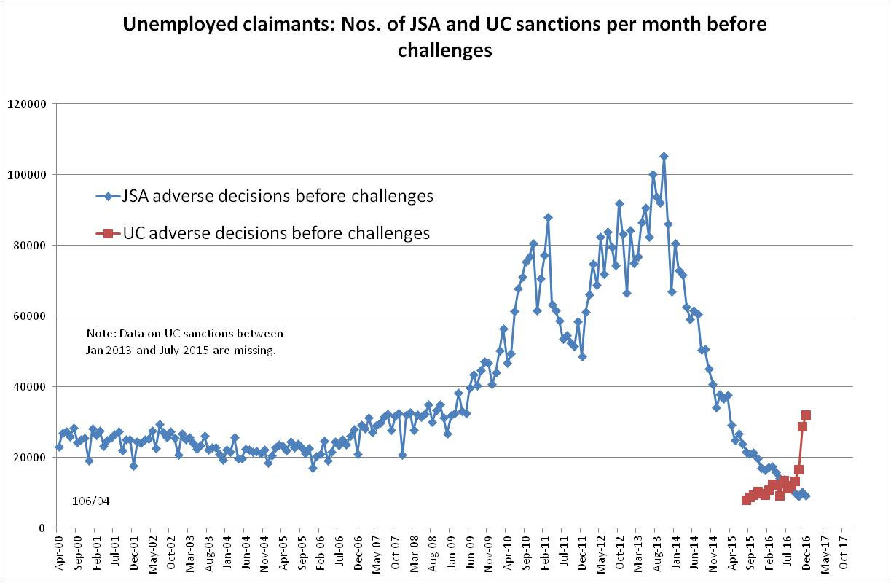

Figure 2
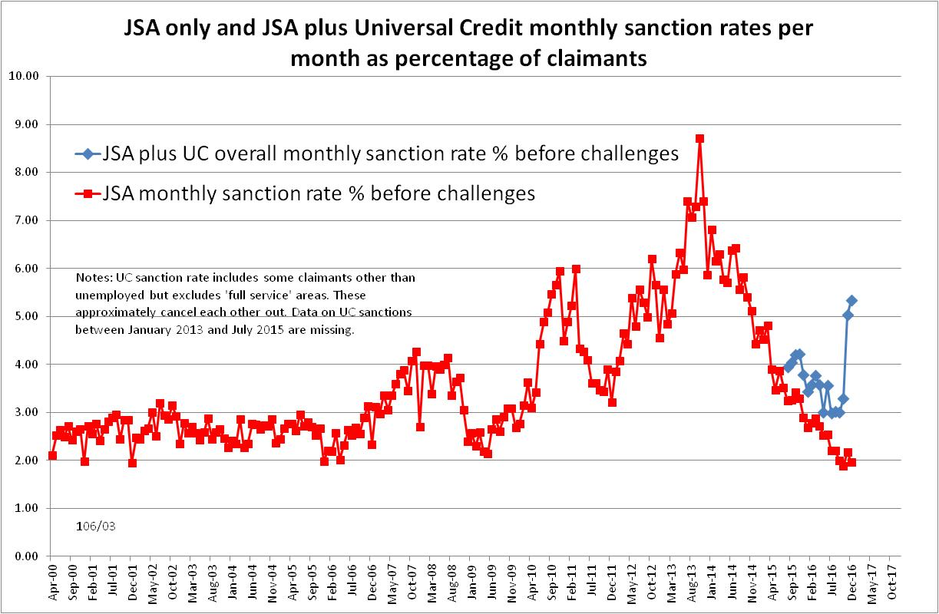

Figure 3
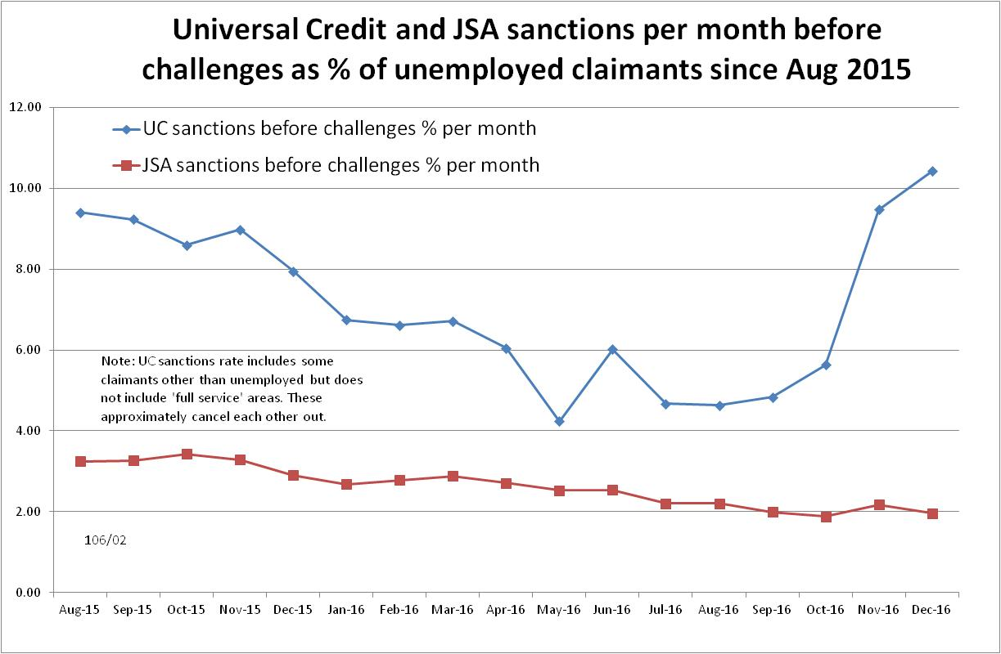
Figure 4
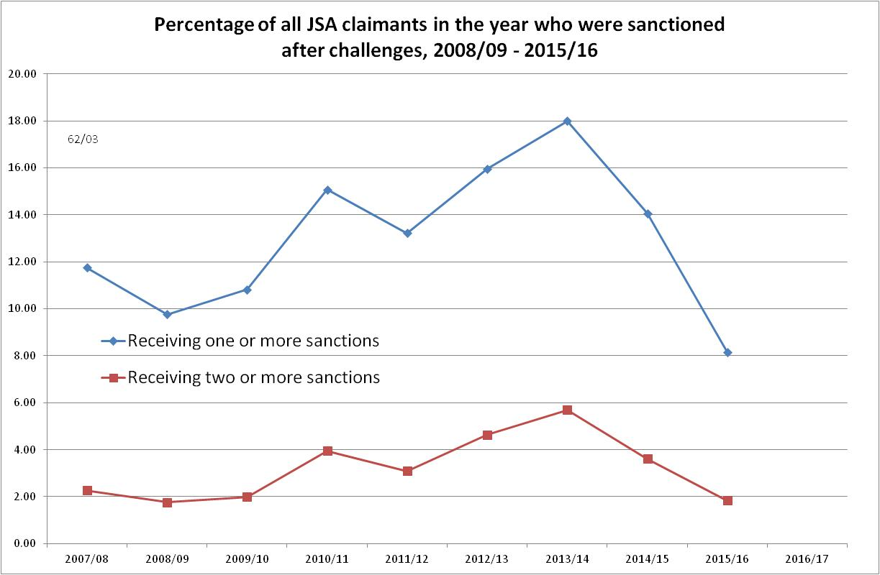

Figure 5
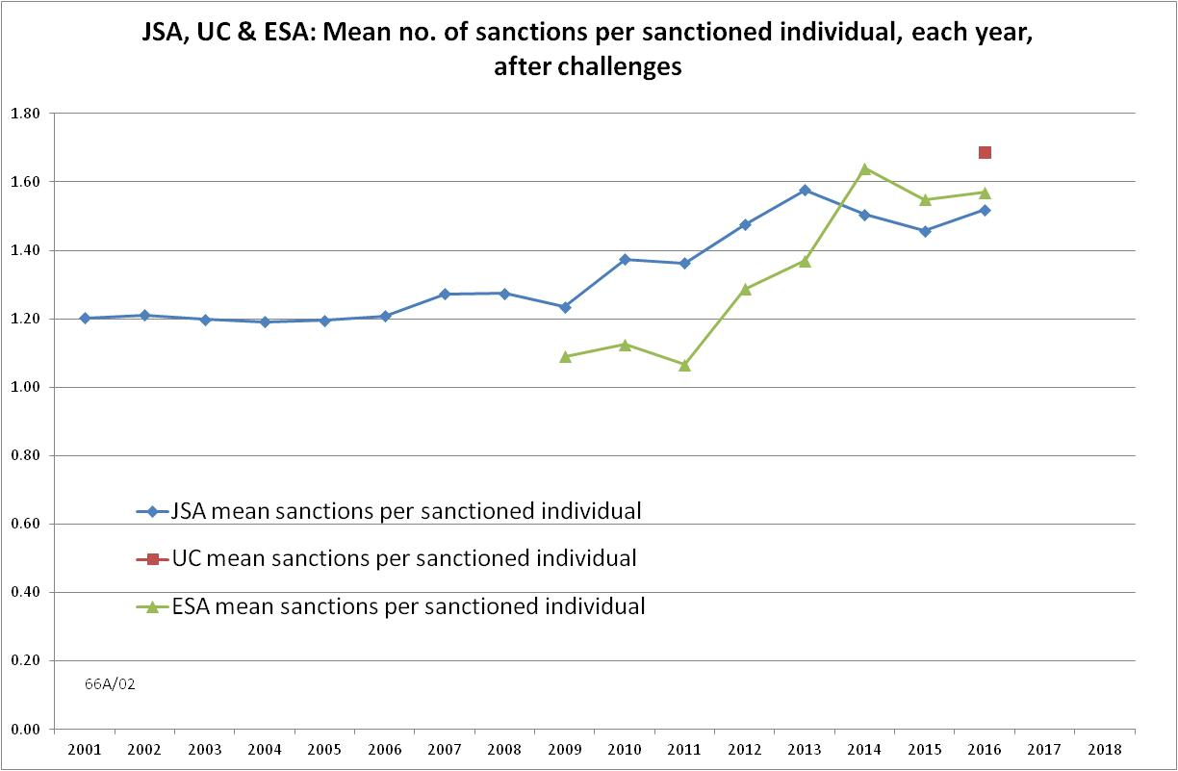
Figure 6
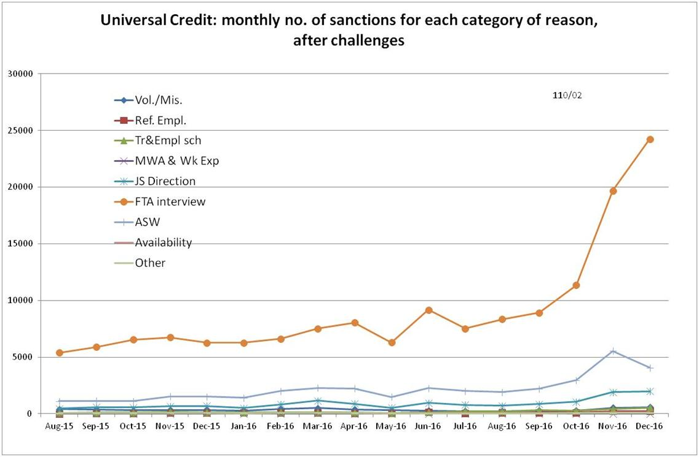
Figure 7

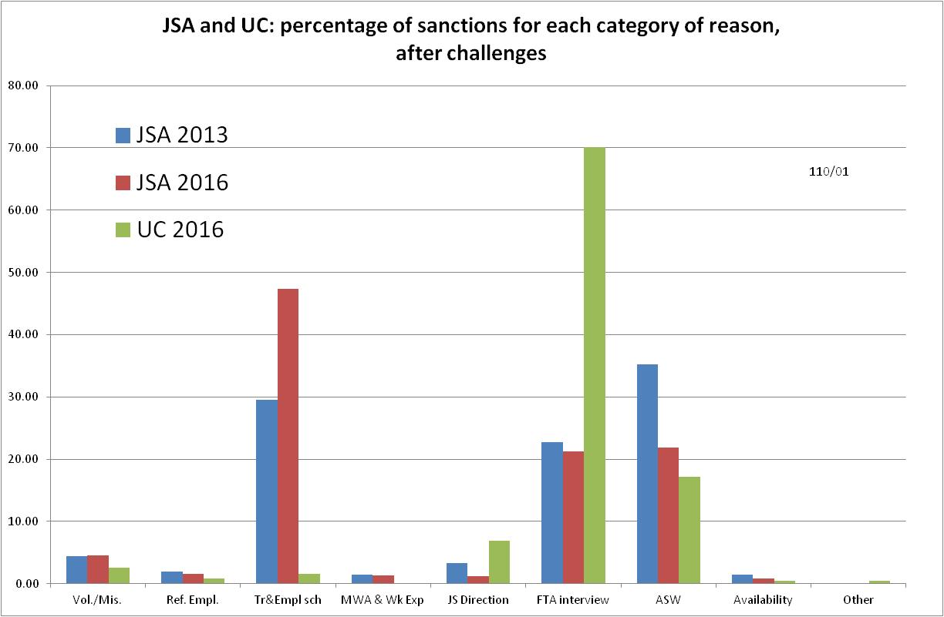
Figure 8
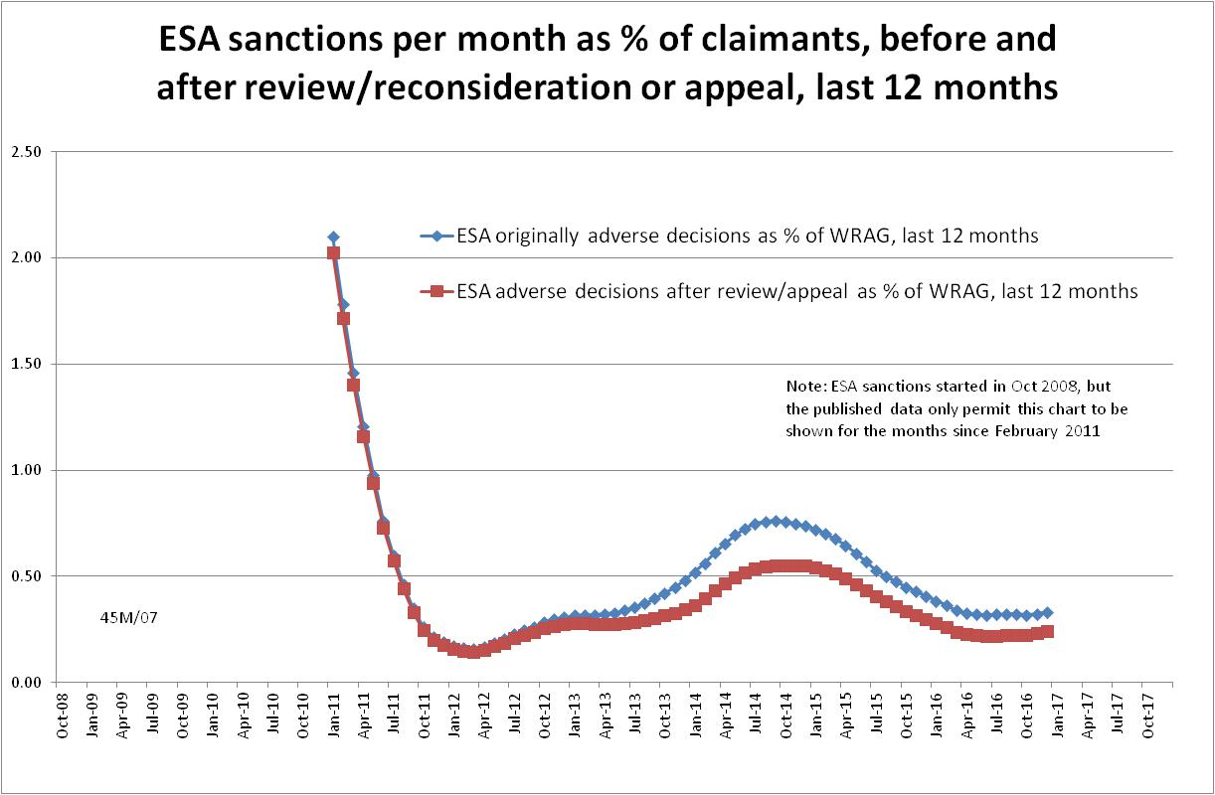
Figure 9
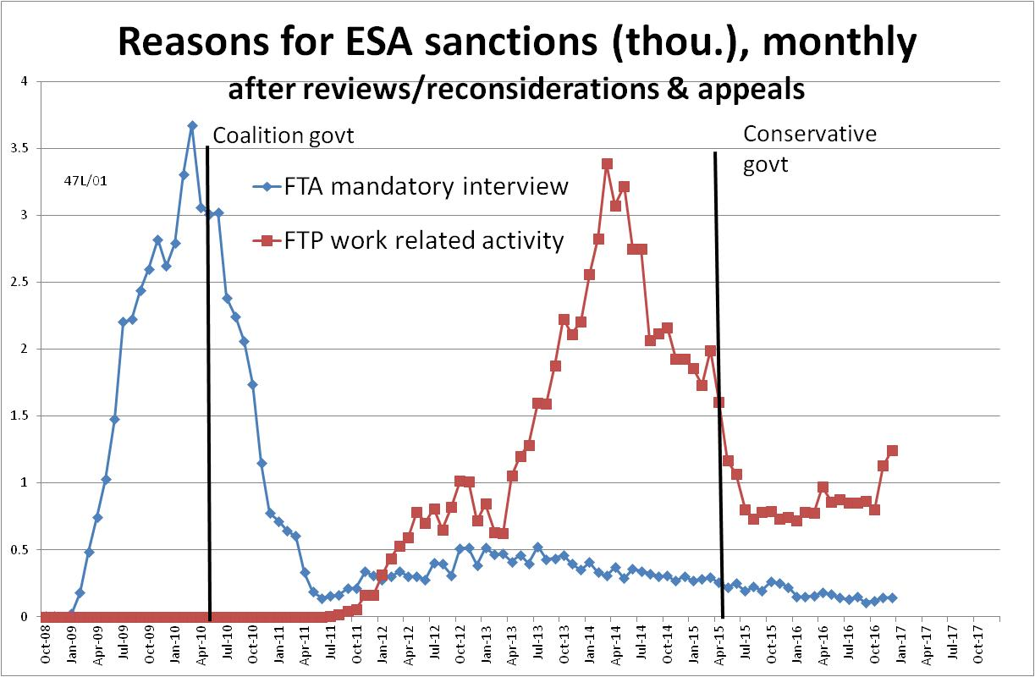
Figure 10
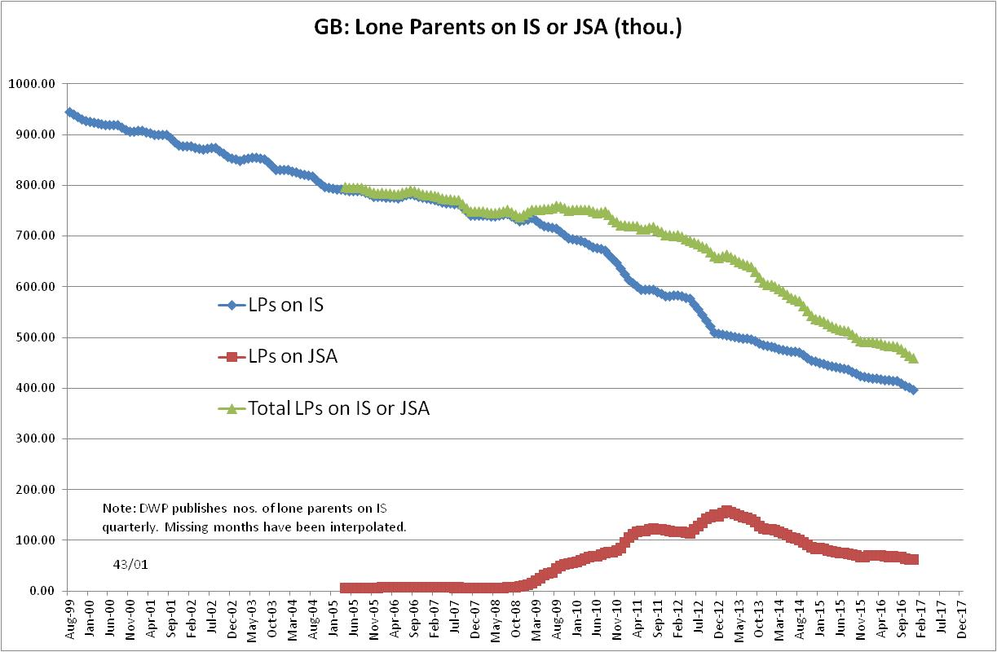
Figure 11
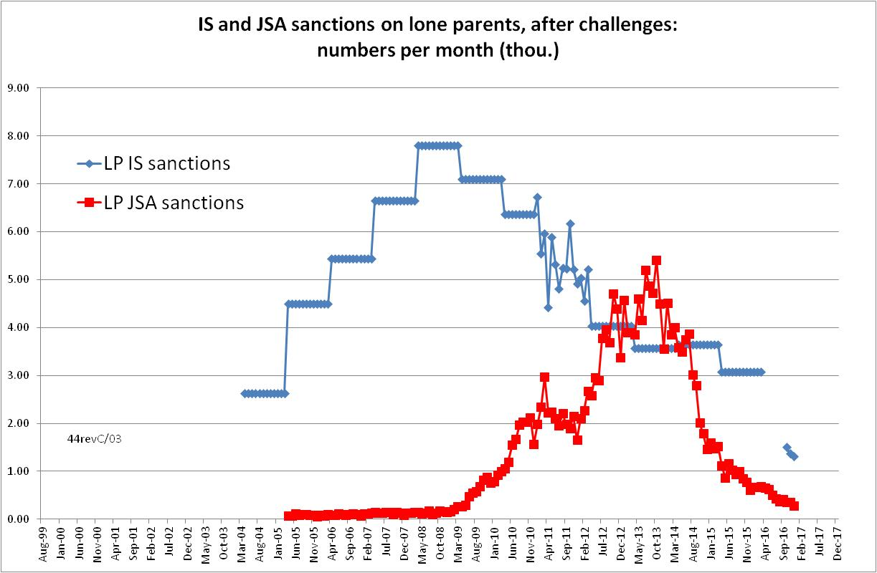
Figure 12
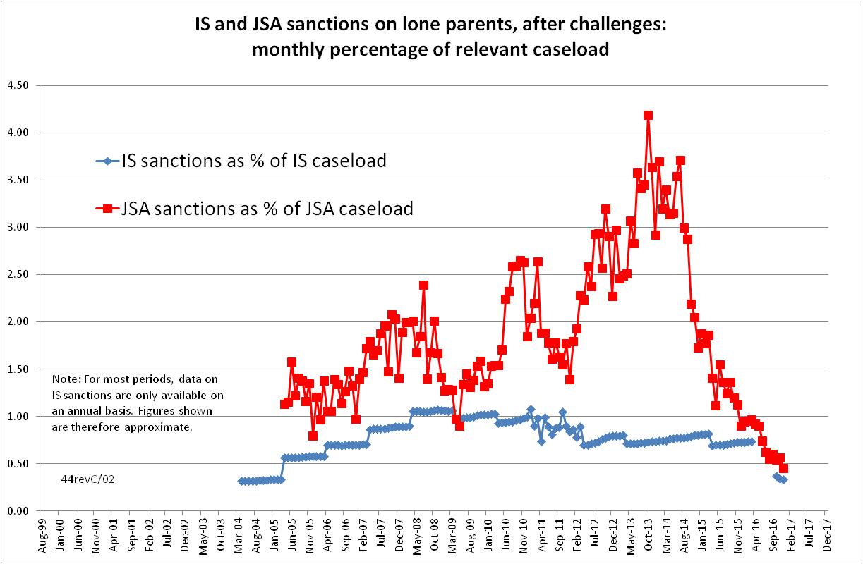
Figure 13
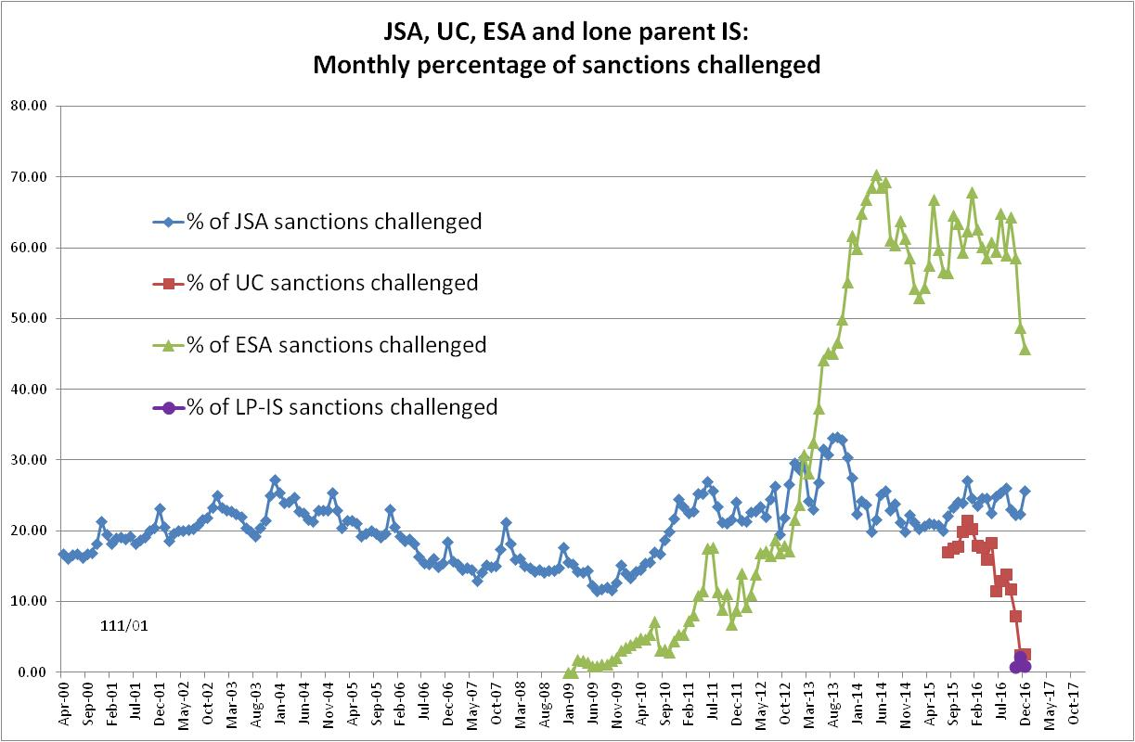

Figure 14
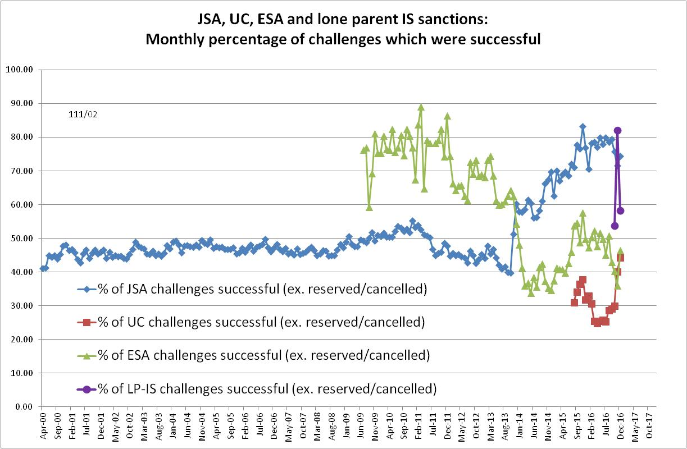
Figure 15
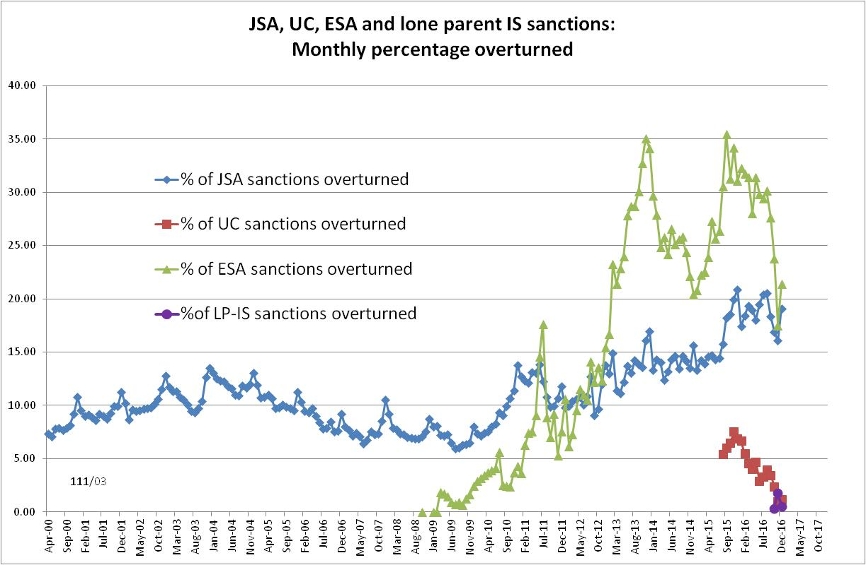

NOTES

This is the fourteenth in a series of briefings on the DWP’s statistics on Jobseeker’s Allowance (JSA) and Employment and Support Allowance (ESA) sanctions. All the briefings are available at http://www.cpag.org.uk/david-webster. Earlier issues contain various analyses not included in the present briefing. In reading earlier issues it should be remembered that the DWP may have made subsequent statistical revisions.
‘In-work’ conditionality has been taken to apply to claimants in the statistical category 'working - with requirements'.
Repayment is suspended for any month when the claimant earns more than their threshold, and any remaining debt is written off if the earnings threshold has been met for 26 weeks, whether continuous or not.
The basic concept of the DWP’s sanctions database is that each sanction case appears only once, and is given its latest status and attributed to the month of the latest decision on the case. So, for instance, if a decision is made in January 2014 to sanction someone, this decision is reviewed in March 2014 with an outcome unfavourable to the claimant, reconsidered in a ‘mandatory reconsideration’ in May 2014 again with an unfavourable outcome, and is heard on appeal by a Tribunal in October 2014 with a decision favourable to the claimant, then: - it appears in the statistics for the first time in January 2014 as an adverse ‘original’ decision - in March 2014 it changes its status to a ‘reviewed’ adverse decision and moves month to be with all the other cases where the latest decision has been made in March 2014 - in May 2014 it changes its status to a ‘reconsidered’ adverse decision and moves month to be with all the other cases where the latest decision has been made in May 2014 - in October 2014 it changes its status again to an appealed non-adverse decision, and moves month again to be with all the other cases where the latest decision has been made in October 2014.
The UC sanction data published by DWP on Stat-Xplore include some sanctions on claimants other than unemployed but exclude sanctions in 'full service' areas (44 out of 714 Jobcentre areas). These factors are assumed approximately to cancel each other out.
The estimate of sanctions before challenges has been derived by adding the monthly total of ‘non-adverse’, ‘reserved’ and ‘cancelled’ decisions shown as being the result of reviews, mandatory reconsiderations and tribunal appeals, to the monthly total of adverse ‘original’ decisions. This produces only an approximate estimate for each individual month, since decisions altered following challenge are not attributed to the correct month. But the estimates are reliable for longer periods.
The UC figure includes some claimants who were not unemployed but excludes others who were. See note 5.
The DWP Quarterly Statistical Summary (p.15) has an estimate of what the ESA sanction rate for the latest quarter is likely to be once challenges have fully worked through: 0.26% for the quarter ended December 2016.

