BRIEFING:

Benefit Sanctions Statistics:
JSA, ESA and Universal Credit

February 2017

22 February 2017

Dr David Webster
Honorary Senior Research Fellow
Urban Studies
University of Glasgow

Email david.webster@glasgow.ac.uk

Webpages: http://www.gla.ac.uk/schools/socialpolitical/staff/davidwebster/
http://www.cpag.org.uk/david-webster

SUMMARY

This Briefing updates the analysis of the DWP’s quarterly JSA and ESA sanctions data up to the end of September 2016, and draws on additional statistical material newly published by DWP and the National Audit Office (NAO). No quarterly Briefing was produced in November. The previous Briefing was published in August with a Supplement on 3 October.

One third of unemployed claimants are now on Universal Credit (UC) rather than JSA. The best estimate of the total number of sanctions before challenges on unemployed people claiming either JSA or UC in the year to September 2016 is 300,000. This is double the 153,528 JSA sanctions after challenges reported by the DWP. The rate of JSA sanctions before challenge as a percentage of unemployed claimants has continued to fall, to 2.73% per month in the year to September 2016. This is the lowest since February 2010. Since October 2012, sanctions are much more severe and so the total loss of benefits imposed on the unemployed remains much greater than is suggested by the numbers of sanctions alone.

The Supplement to the August 2016 Briefing showed that JSA sanctions rose and fell in 2010-16 because of decisions by ministers, changing referrals to the Work Programme, and an increase in the proportion of sanction referrals resulting in an actual sanction. In so far as they overlap with it, the NAO (Nov. 2016) and Public Accounts Committee (Feb. 2017) reports confirm this analysis, and they add useful evidence of their own.

Ad hoc data released by DWP on 13 December show that of people claiming JSA for between 1 and 2 years during 2010 to 2015, 37% were sanctioned, after challenges; of those claiming between 2 and 3 years, half (49%) were sanctioned; and of those claiming between 3 and 4 years, 85% were sanctioned. The pre-challenge proportions will have been higher.

The DWP says it will publish data on the ‘stock’ of people under sanction at any one time. However, it already has this data in an approximate form from surveys but does not publish it. At August 2013, 64,900 people were not receiving JSA due to a sanction or disallowance. This understates the number of people suffering the effects of a sanction at any one time.

The PAC hearing on 12 December exposed a misunderstanding about why JSA sanctions cause wrongful loss of Housing Benefit. It is because action taken by DWP on this issue following the Oakley report (July 2014) has dealt only with ‘higher’ and ‘lower’ sanctions and has not addressed the problem of so-called ‘intermediate’ sanctions.

Over the year to September 2016, the rate of sanction on ESA claimants in the WRAG, before challenges, averaged 0.34% per month, up from 0.32% in May to July 2016. The total of ESA sanctions in the year to September 2016 was approximately 18,100 before challenges and 12,854 after. The increase is due to sanctions for not taking part in work related activity.

A news section at the end of the Briefing gives information about other developments relating to sanctions, and an Appendix discusses developments in the DWP’s sanctions statistics. An important finding is that interim results of the Scottish so-called ‘Early Warning’ trial show that it is a failure. It is a weak substitute for the genuine warning system consistently recommended by all five independent reviews since 2007. The DWP’s current statistical proposals will also fail to meet the requirements of the UK Statistics Authority.

BRIEFING: Benefit Sanctions Statistics
February 2017

Introduction

This briefing continues the series of reports dealing with the quarterly Jobseekers Allowance (JSA) and Employment and Support Allowance (ESA) sanctions data released by DWP. The latest statistics were released on 15 February on Stat-Xplore at https://stat-xplore.dwp.gov.uk/default.aspx and in an Excel spreadsheet summary at https://www.gov.uk/government/collections/jobseekers-allowance-sanctions. These give sanctions figures to September 2016. DWP provides some commentary on the figures in its Quarterly Statistical Summary https://www.gov.uk/government/statistics/dwp-statistical-summaries-2017 This briefing also discusses sanctions on claimants of Universal Credit.

All statistics relate to Great Britain.

An Appendix discusses developments in the DWP’s sanctions statistics.

Claimants exposed to sanctions: JSA, ESA, Universal Credit and Income Support

The National Audit Office (2016, para.1.6) estimated that in 2015 an average of 1.395m people at any one time were subject to the possibility of sanctions. Figure 1 shows the numbers of claimants of each benefit who are subject to sanctions. The main group, and the one subject to the harshest sanctions, is the unemployed. Figure 2 shows that while their numbers have been flatlining since December 2014 at about three-quarters of a million, there has been a big shift from JSA to Universal Credit. At September 2016, almost a third of unemployed claimants were on UC: 233,641, compared to 501,044 on JSA. No statistics have yet been published on UC sanctions; they are now promised for the second quarter of 2017 (DWP 2016b). This means that the total of sanctions on unemployed people is being understated in the official statistics, and that the rate of sanctions on JSA claimants has not fallen as much as the number.

Within ESA, only those in the Work Related Activity Group are subject to sanctions. Their number has been continuously declining since August 2013 and has now fallen to an estimated 424,000 in August 2016.

The number of lone parents on Income Support has also been falling, to 414,000 in September 2016. Currently, only those with a youngest child aged under 1 are exempt from sanctions. For recent years, Figure 1 shows the total number of lone parents on IS rather than just those subject to sanctions. It is hoped to refine this in future issues of the Briefing.

In January 2017 there were also 42,570 in-work UC claimants subject to sanctions in the DWP’s pilot areas. Data on sanctions on them are not expected until early 2018.

Universal Credit sanctions

The UC regime has similar lengths of sanction to those of JSA for the various ‘failures’, but there are some critical differences. Sanctions are lengthened by being made consecutive, not concurrent. Hardship payments become repayable. Given that repayments are made at the rate of 40% of benefit – the same as the amount by which a hardship payment is lower than the benefit – this means that for claimants receiving hardship payments, UC sanctions are in effect 2½ times as long as their nominal length. All sanctioned UC claimants must also demonstrate ‘compliance’ for 7 days before applying for hardship payments, and must reapply for each 4-week period. The 80% hardship rate for ‘vulnerable’ claimants is abolished.

Sanctions before and after reviews, reconsiderations and appeals

The DWP’s database for JSA and ESA sanctions only shows sanctions after any reviews, reconsiderations and appeals that have taken place by the time the data are published. But numbers of sanctions before the results of these challenges are important since they show all the cases in which claimants have had their money stopped. Although a successful challenge should result in a refund, this is only after weeks or months by which time serious damage is often done. Estimates of sanctions before challenges are therefore given here but although reliable for longer time periods, they are not fully accurate for individual months. Figures for sanctions before challenges are currently higher than the ‘after challenge’ figures by about 20% for JSA and 39% for ESA.

Numbers and rates of sanctions against unemployed people
(JSA and Universal Credit)

The estimated total number of JSA sanctions before challenges in the 12 months to end-September 2016 was 189,300. To this must be added the total of Universal Credit sanctions, so far unpublished.

In these Briefings the assumption has previously been made that the rate of UC sanctions is the same as for JSA, adjusted upwards by 37.7% to allow for the younger age profile of UC claimants. But the NAO (2016, Figure 2 p.13) reported that the sanction referral rate for unemployed people on UC is 80% higher than for JSA. The NAO suggests that the reason for this is that under UC, DWP impose a sanction for missed interviews whereas under JSA they often simply close the case. It has also been suggested to me that JCP staff are spending less time sanctioning JSA claimants because they are focusing on UC claimants; this would be consistent with the DWP wanting to demonstrate how much better UC is than JSA.

The UC sanction rate is probably therefore 80% higher than the JSA rate, implying 110,000 UC sanctions before challenges in the 12 months to September 2017. The best estimate for the total of sanctions on unemployed claimants in the year to September 2016 is therefore 300,000. This compares with only 153,528 JSA sanctions after challenges reported for the same period in Stat-Xplore.

Figure 3 shows that the rate of JSA sanctions before challenges as a percentage of unemployed claimants has continued to fall, to 2.73% per month in the year to September 2016. This is the lowest on this measure since February 2010. The monthly data (Figure 4) also suggest a continuing decline. However, since October 2012, sanctions are of course much more severe and so the total loss of benefits imposed on unemployed people remains very much greater than is suggested by the numbers of sanctions alone.
Explaining the rise and fall of JSA sanctions 2010-2016

A full analysis of the reasons for the rise and fall of JSA sanctions in 2010-16 was produced as a Supplement to the August 2016 Briefing (Webster 2016) and is available at www.cpag.org.uk/david-webster. Since then, there has been further analysis by the NAO (2016, especially Appendix 3) and discussion at the Public Accounts Committee on 12 December 2016 (PAC 2016).

My analysis concluded that the reasons for the rise and fall were:

- There was an unannounced change of policy by ministers in May 2010 to pressurise DWP staff to make more referrals for JSA sanctions.
- Reductions in the rate of referrals for sanction for all reasons under the control of Jobcentre Plus, except for Workfare, account for most of the fall in JSA sanctions since October 2013.
- The increase and then decline in the Work Programme client group from June 2011 accounts for a major part of the rise and fall in JSA sanctions. Its effect was amplified by the ruling by the DWP that contractors must refer claimants for sanction if there is any breach of requirements, even where they know that the claimant is co-operating fully.
- Changes in the proportion of referrals for sanction on which there was a decision adverse to the claimant also contributed to the rise in JSA sanctions.
- ‘Workfare’ has made a small contribution to the rise in JSA sanctions.

The NAO report and PAC hearing did not consider all these points. However, where they did, they confirmed them. They also added some significant insights:

- The NAO report (Figure 10, p.25 and Figure 30, p.57), indicates that in January 2012 the DWP increased expectations for ‘actively seeking work’. Robert Devereux, the DWP Permanent Secretary, confirmed to the PAC (Qu.44 & Qu.96) that from that date the DWP changed its interpretation of S.7(1) of the Jobseekers Act 1995: ‘For the purposes of this Act, a person is actively seeking employment in employment in any week if he takes in that week such steps as he can reasonably be expected to have to take in order to have the best prospects of securing employment’. He claimed that ‘prior to 2012 we were running a system that basically looked for what we might call minimum standards. Indeed, in the regulations, it said that people needed to do two steps to look for work (Editorial note: this is not quite correct). That is how we were running it prior to 2012. The Act of Parliament says that claimants should do “all that is reasonable”, which is self-evidently not two steps. Progressively, from January 2012 onwards, we have been looking for people to do all that is reasonable’. Devereux in other words confirmed that the huge increase in penalties for ‘not actively seeking work’ was due to a change of policy. However, his statement is misleading in two respects. First, as shown in my own analysis, the increase in penalties occurred as soon as the Cameron government took office in May 2010. Second, the requirements put on claimants were in many if not most cases patently unreasonable, as has been demonstrated in a huge amount of evidence.
- It is clear that penalties for not actively seeking work have fallen since the Claimant Commitment has been rolled out. Devereux claimed (Qu.45-47) that this fall is due to the Commitment having produced better understanding of the requirements by the claimant. This is not credible. During the great sanctions campaign, the complaint of claimants sanctioned for not actively seeking work was not that the requirements were unclear, but that they were unreasonable, for instance in being required to document the undocumentable or to use a non-existent computer using IT skills the claimant didn’t have. The Conservative MP Nigel Mills commented at the PAC (Qu.63): ‘a cynic might think that you started off sanctioning far too many people for far too minor reasons in 2012 and 2013, got a lot of bad publicity, thought you’d gone a bit too far, called the dogs off a bit and sanctions have come back down. That might be a more plausible explanation than having slightly changed the complicated language of a claimant commitment from the previous agreements’.
- The NAO report (para.2.5 and Appendix 3 para.15) confirmed that management pressure on Jobcentre staff to make sanction referrals was reduced from 2013 onwards: ‘On our visits to jobcentres staff told us that managers’ focus on referral rates fell substantially from 2013 onwards, which may help explain falling referral rates’.

The proportion of JSA claimants who are sanctioned, and repeat sanctions

Important new evidence on the proportion of JSA claimants who are sanctioned has been published by both the NAO and the DWP.

The NAO report (para.1.10 and Figure 5) showed that of all the people who claimed JSA at any time over the six years 2010 to 2015, 24% were sanctioned before challenges. This is the first time an authoritative figure has been published for the proportion sanctioned before challenge. It confirms the estimates for 5-year periods previous given in these Briefings. Post-challenge proportions have been previously found through Freedom of Information requests and reported in earlier editions of this Briefing.

The NAO (Figure 5) also reported that approximately 14% of all claimants in 2010-15 received one sanction before challenges, 4.8% received two sanctions before challenges, and 5.3% received three or more sanctions before challenges.

The DWP appears to have been stung by the NAO’s decisive refutation of its repeated claims that ‘only a tiny minority of claimants are ever sanctioned’, on which it was pursued at the PAC by Philip Boswell MP (SNP) (Qu.151). On the day after the PAC hearing it put out an ad hoc statistical publication Jobseeker's Allowance: statistics on claim duration and sanctions, at
https://www.gov.uk/government/statistics/jobseekers-allowance-statistics-on-claim-duration-and-sanctions

This is inferior to the NAO’s work in quoting the lower post-challenge proportions, giving the percentage sanctioned in 2010-15 as 21% instead of 24%. However, it does show that, as already noted in this author’s evidence to the House of Commons Work and Pensions Committee (Webster 2014, para.16), the probability of sanction over the six years 2010-16 was more or less constant irrespective of the duration of claim, varying only between 4% and 5% per month. It then goes on to draw out the corollary that the proportion of claimants who are sanctioned will be smaller for those with short durations than for those with longer. Instead of quoting these figures in an even-handed way, the DWP has suppressed the proportions sanctioned among those with longer durations. But these can mostly be calculated from the information the DWP does give, and Table 1 of this Briefing (below) gives them. Of people claiming JSA for between 1 and 2 years, 37% were sanctioned, after challenges; of those claiming between 2 and 3 years, half (49%) were sanctioned; of those claiming between 3 and 4 years, 85% were sanctioned; and it follows that among those claiming for 4 years or more, close to 100% will have been sanctioned. The pre-challenge proportions will have been higher.

This presents three problems for DWP. First, it contradicts what Robert Devereux and his Work Services Director, Neil Couling, told the PAC on 11 March 2013, when they claimed that sanctions become more frequent the longer claimants go on claiming, because the DWP 'does more work' with longer standing claimants. Second, it undermines the DWP’s claims that sanctions are a ‘last resort’. This clearly cannot be true when Jobcentres start sanctioning people as soon as they come through the door at the same rate as longer-standing claimants. Third, it undermines the rationale for the cruelly lengthened sanctions for repeat ‘failures’. Clearly, claimants are likely in many cases to attract these simply through being longer on benefit rather than as a result of anything they do or don’t do.

The NAO report on 30 November commented (para.1.10) that ‘The Department does not know whether people who get more sanctions get them because they are less compliant than other claimants or because they claim for longer and have more opportunities not to comply with conditions’. However, it is clear from the subsequent ad hoc release of 13 December that the latter must be at least a large part of the explanation.

Reasons for JSA sanctions

The reasons for JSA sanctions were extensively considered in the NAO report and in the Supplement to the August 2016 Briefing (Webster 2016). The three main reasons are currently non-participation in the Work Programme, ‘not actively seeking work’ (which actually means not seeking work in the way instructed by Jobcentre Plus), and not attending an interview, in that order. Figures to the end of calendar 2016 will be in the next Briefing.

Number of claimants under JSA sanction at any one time

At the PAC on 12 December, Robert Devereux said (Qu.101) ‘The principal thing that we can’t do at the moment is talk about the stock of people who are currently sanctioned. All of the data in these Reports is basically trying to divide the new decisions to sanction this month by the total number of people on our books, which is one way of doing statistics. That is not the same answer to the question, “How many people today are currently being sanctioned?”, because they might have been sanctioned last month and are still sanctioned this month. Once you start to be able to get the date part of this straight, you can do a number of things. First, you can deduce how many people at any one time are being sanctioned, which is an interesting fact.......’. The subsequent DWP Written Evidence (DWP 2016b) gave a list of planned developments of sanctions statistics including the following:
‘C. Obtain start and end dates for sanctions to understand duration during Q3 2017, to
enable point-in-time sanctions rates’.

The DWP in fact already has approximate information on the number of JSA claimants under sanction at any one time, taken from their 5% sampling. Far from being a new development, this is a measure which was published regularly up to February 2005. Since then the results have been accessible only via Freedom of Information requests. The DWP’s FoI Response 2014-614 of 5 March 2014 (available at https://www.gov.uk/government/publications/statistics-on-claimants-not-getting-jsa-by-reason-may-1997-to-nov-2000-and-may-2005-to-aug-2013) gave the number of claimants not in receipt of JSA due to disallowance or sanction for most quarters from May 1997 to August 2013. This information can be linked to other already published sources to produce the long series going back to 1986 which is shown in Figure 5.

Because most sanctions last for only a few weeks, the numbers are naturally much smaller than the total number of sanctions imposed in a year. The figure has usually been around 20,000 to 30,000, but Figure 5 brings out how exceptional has been the most recent period from 2012 onwards, with numbers far outstripping even those of the previous Thatcher/Major sanctions drive of the early 1990s. The highest figure shown, of 64,900 at August 2013, will not have been the peak.

The DWP is probably prioritising more exact figures for this particular measure because these relatively small numbers can be presented as supporting its claims that sanctions only affect a small minority of claimants. But two key points need to be remembered:

- Because sanctions have long-lasting effects such as putting people into debt, undermining their health and losing them their homes, the numbers under sanction at any one time understate the numbers suffering their effects.
- Because hardship payments are repayable under Universal Credit, the true length of Universal Credit sanctions for people needing to claim hardship is actually two and a half times the stated length. This means that figures for the number of people under UC sanction at any one time will grossly understate the number of people currently suffering a punitive deduction.

JSA sanctions and Housing Benefit

The PAC hearing on 12 December 2016 (Qu.156-158) revealed an important misunderstanding about the vexed question of claimants wrongly losing their Housing Benefit as the result of a JSA sanction. ‘Chair: Okay. On the issue of JSA and housing benefit, you heard in the evidence—this is something a number of us have heard about in our
surgeries—about housing benefit being stopped when the sanction is applied and about the havoc that causes. You are shaking your head. Sir Robert Devereux: It shouldn’t happen.
Susan Park (DWP Director of Work Services): Absolutely not.’ The PAC report itself has gone on to recommend that the DWP ‘should set out what more it will do to assure itself that Housing Benefit is not being stopped in error due to sanctions’.

Devereux and Ms Park are apparently unaware that when the DWP took steps to resolve this issue after it was raised in the Oakley report (July 2014), they specifically did not do anything about so-called ‘intermediate sanctions’, which are technically disqualifications. In these cases, DWP continues to notify local authorities that JSA entitlement has ended and that the claimant’s ‘passporting’ to other benefits has therefore stopped. This is bound to result in some claimants wrongly losing Housing Benefit. Similarly, claimants receiving ‘intermediate sanctions’ have been left out of the Scottish Early Warning Trial (see the May 2016 Briefing, p.13). This issue was explained in the author’s briefing on the government response to the Work and Pensions Committee (Webster 2015, para.38-43). This problem can only be properly resolved by getting rid of the inappropriate use of disqualification, which essentially dates back to 1995 when Michael Portillo and Peter Lilley chose to try to make an ideological point through the drafting of the Jobseekers Act 1995 rather than to design legislation that would work.

Numbers, rates and reasons for ESA sanctions

In contrast to JSA, the ESA sanction rate is currently showing a slight rise (Figure 6). Over the year to September 2016, the rate of sanction on ESA claimants in the WRAG, before challenges, averaged 0.34% per month, up from 0.32% in May to July 2016. The total of ESA sanctions in the year to September 2016 was approximately 18,100 before challenges and 12,854 after challenges. The recent increase is entirely due to sanctions for not taking part in work related activity. These sanctions account for some 90% of all ESA sanctions (Figure 7).

As noted in previous Briefings, the upturn in sanctions for ‘failure to participate in work related activity’ in the latest two months is probably not significant. Challenges to sanctions for this reason appear to take a particularly long time to be settled, so that even though the most recent sanctions were imposed 5 months prior to publication of the statistics, there are still many cases included in the ‘adverse’ category for the most recent months which will appear as ‘non-adverse’ in the next set of statistics.

The Supplement to the August 2016 Briefing (Webster 2016) explained that the rise and fall in the ESA sanction rate between 2012 and 2016 is explained mainly by changing numbers of referrals to the Work Programme, and to a lesser extent by changes in the proportion of referrals for sanction which result in an actual sanction.

JSA and ESA sanction challenges

The working of the appeal system was analysed in the August 2016 Briefing. The position has not changed significantly since then.

Sanctioning process – Decision making in Jobcentres

An important disclosure in the NAO report (para.2.2-2.3, Figure 15, Figure 28 and Figure 29 as corrected) is that in January 2013 the DWP introduced a fast track process by which in ‘straightforward’ cases claimants can be sanctioned directly by Jobcentre staff, without the case going to one of the specialist decision maker teams. This was to deal with the surge of cases which the DWP itself had created through its sanctions drive, and the backlog arising from the Poundland case. The relevant guidance at
https://www.whatdotheyknow.com/request/192184/response/473959/attach/6/FTA%20Guidance.pdf states (para.62 or 71, depending on the version) ‘It is essential that the claimant is not made aware at any stage that some decisions are made locally’.
SANCTIONS - OTHER DEVELOPMENTS

Early Warning Trial interim evaluation report – a failed experiment

Interim results from the Scottish trial of the so-called 'early warning' system (sometimes incorrectly called ‘Yellow Card’) were published on 20 December at https://www.gov.uk/government/publications/jobseekers-allowance-sanctions-early-warning-trial-evaluation-interim-report The ‘early warning’ trial applies only to ‘high’ and ‘low’ but not to ‘intermediate’ sanctions. It involves sending a letter telling the claimant that a sanction will be imposed unless further evidence is provided within 14 days, rather than imposing the sanction immediately. The government has represented it as a response to the very different recommendation, made by the Freud Report (2007), Gregg Review (2008), Oakley Review (July 2014), Work and Pensions Committee (March 2015) and now by the PAC (February 2017) that a first ‘failure’ should attract only a warning, not a sanction.

The interim results show that only 13% of people who were sent the warning letters provided further information within the 14 days allowed, of whom only about half succeeded in preventing the sanction. This is actually a lot less than the proportion who eventually challenge the types of sanctions included in the trial, which is about 22%, of whom about about three-quarters succeed in overturning the sanction (16% of those sanctioned). The implication is that either 2 weeks is not long enough, or the letter is too vague (a facsimile is included in the report), or both. Interestingly, the report suggests that over a quarter of the additional evidence was received too soon to have been the result of the warning letter, which indicates that in a lot of cases the decision to sanction is being made prematurely on the basis of inadequate evidence. This reveals a separate problem that now urgently needs to be tackled. These findings strengthen this author’s view that no sanction should be imposed before a proper hearing at which the claimant is entitled to representation.

These interim results do not include any input from claimants themselves. The final report to be published in Spring 2017 will include this. However, it is not too soon to conclude that this experiment has been shown to be a failure. The obvious implication is that the DWP should stop ignoring the expert advice from Freud, Gregg, Oakley, Work & Pensions Committee and PAC and introduce a proper warning system without further delay.

National Audit Office study of the DWP's benefit sanctions regime and Public Accounts Committee Inquiry on benefit sanctions

The NAO report is one of the most important documents on benefit sanctions of the last 30 years. It was published on 30 November, at https://www.nao.org.uk/report/benefit-sanctions/, together with a technical appendix on the methodology of the NAO’s own sanctions studies at https://www.nao.org.uk/wp-content/uploads/2016/11/Benefit-sanctions-detailed-methodology.pdf NB The main report as first published on the web had errors, on p.17 and in Figures 21 and 29, of which the last is extremely important. If you downloaded it before mid-February, you will need to download the corrected version now on the NAO website. It has a corrected main text and an Erratum at the end.

The House of Commons Public Accounts Committee has held a linked inquiry. Their report was published on 21 February at http://www.parliament.uk/business/committees/committees-a-z/commons-select/public-accounts-committee/inquiries/parliament-2015/benefit-sanctions-16-17/publications/
together with written evidence submitted to the inquiry and the transcript of the public hearing held on 12 December (To see all the written evidence you have to click on ‘+View all’.)

The government response to the PAC will appear as a Treasury minute at https://www.gov.uk/government/collections/treasury-minutes. It is supposed to appear within two months of the PAC report, i.e. by 21 April.

In a notable piece of misreporting, the Daily Mail claimed on 30 November that the NAO’s finding that 24% of JSA claimants had been sanctioned over the period 2010 to 2015 meant that ‘A quarter of Jobseeker's Allowance claimants have been caught abusing the benefits system over the past five years’. The report is at
http://www.dailymail.co.uk/news/article-3985208/A-QUARTER-Jobseeker-s-Allowance-claimants-punished-abusing-benefits-watchdog-finds.html

Immediate eligibility for hardship payments for sanctioned JSA claimants extended to homeless/mentally ill people from 1 Apr 2017

The Secretary of State, Damian Green, announced on 16 November in a speech to the right-wing think tank ‘Reform’ that from the 2017/18 financial year, homeless people and those with a mental health condition will be added to the category of ‘vulnerable’ JSA claimants who are allowed to apply for hardship payments from day 1 of a sanction. All other JSA claimants – the great majority – have to wait 2 weeks before being allowed even to apply. Different rules apply to Universal Credit claimants, who have to demonstrate ‘compliance’ for a week before being allowed to apply. The change is expected to help around 10,000 people over 4 years from 2017/18 to 2020. Details are at

https://www.gov.uk/government/news/homelessness-and-mental-health-conditions-to-be-supported-by-hardship-fund

and at

http://www.reform.uk/publication/a-welfare-system-that-works-for-all-rt-hon-damian-green-mp-secretary-of-state-for-work-and-pensions/

This is a minor and belated response to the recommendation of the House of Commons Work and Pensions Committee in March 2015 (HC 814, para.150) that all sanctioned claimants should be able to apply for hardship payments from day 1. In its response to the Committee (23 October 2015), the government proposed three minor reforms: to reintroduce automated sanction notification letters; to trial a 2-week delay in applying sanctions to allow the claimant to submit further evidence ('early warning'); and to consider widening the definition of 'vulnerability' in relation to the general 2-week ban on applying for hardship payments so as to include homeless people or those with mental health conditions. Green has therefore now announced that the government has finished 'considering' whether to do this, and has decided to do it - but only from 1 April 2017, two years after the (more comprehensive) recommendation from the Work and Pensions Committee. The government has said nothing about any reform to the minimum one-week wait under Universal Credit.

WCA retesting to be scrapped for ESA claimants with severe lifelong conditions

On 1 October the media reported that the Secretary of State, Damian Green, would announce at the Conservative Party conference that under new guidelines to be drawn up, people with severe health conditions with no prospect of getting better will no longer have to undergo the present 6-monthly repeated Work Capability Assessments. The Green Paper Cm 9342 (para.150) also suggests a simpler initial assessment for these people. The DWP website does not seem to have any further information, but it appears that no timetable has been set for preparation of the criteria for allocation to this group nor for implementation of the reform.

Work, Health and Disability Green Paper raises possibility of extension of sanctions to the ESA Support Group

The government’s consultation paper Improving Lives: The Work, Health and Disability

Green Paper Cm 9342 was published on 31 October with a deadline for comments of 17 February. It discusses ways of getting more people with health conditions or disabilities into work, or keeping them in work.

Para.114 suggests introducing conditionality for ESA claimants in the Support Group, who are not currently subject to sanctions: ‘We could consider implementing a “keep-in-touch”

discussion with work coaches. This could provide an opportunity for work coaches to offer

appropriate support tailored to the individual’s current circumstances, reflecting any changes since their Work Capability Assessment. This light-touch intervention could be explored as a voluntary or mandatory (italics added) requirement and we would consider our approach carefully, utilising digital and telephone channels in addition to face-to-face contact, depending on which was more appropriate for the individual and their circumstances.” The proposal for mandation, if implemented, would add another 1.5m to the total of British citizens exposed to the DWP’s secret penal system at any one time, on top of the 1.3m already proposed to be added by the extension of sanctions to in-work claimants of Universal Credit, a total of 2.8m. This would mean approximately a tripling of the number currently subject to sanctions. This proposal has been criticised by the House of Commons Work and Pensions Committee in its report on the Disability Employment Gap (see below).

End of the Work Programme

Referrals to the Work Programme will cease in April 2017. The successor Work and Health programme is expected to commence in England and Wales in Autumn 2017, with a narrower scope; unemployed claimants will only be referred after 2 years, instead of the present 1 year. In Scotland, the successor programmes Work Ability and Work First will be devolved to the Scottish government and will commence in April 2017. A useful House of Commons Library briefing paper (Mirza-Davies & McGuinness 2016) is at

http://researchbriefings.parliament.uk/ResearchBriefing/Summary/CBP-7845#fullreport

House of Commons Work and Pensions Committee report:
The future of Jobcentre Plus

This report was published on 9 November, at http://www.parliament.uk/business/committees/committees-a-z/commons-select/work-and-pensions-committee/publications/
and the government’s response was published on 24 January at
http://www.publications.parliament.uk/pa/cm201617/cmselect/cmworpen/965/965.pdf

The Committee’s report contains critical discussion of sanctions throughout. Its key conclusions in relation to sanctions are:

21. ..... Work Coaches are tasked with referring claimants for possible sanctions at the same time as supporting them into and in work. This combined role may mean that many claimants see JCP staff as policemen rather than genuine coaches, potentially undermining claimant trust and confidence. Trustful, positive and personalised support is central to the Work Coach model working effectively, but currently the Department has little means of assessing how far this is being delivered.

22. We recommend the Department set out how it will support Work Coaches to strike the right balance between coaching and conditionality—potentially conflicting elements of their role. Work Coaches should be given more comprehensive guidance on how to adopt a flexible approach to conditionality for vulnerable groups of claimants, such as those with health conditions or housing problems. The guidance should include multiple examples illustrating the circumstances in which different levels of conditionality, including frequency of meetings, would be appropriate and effective.

23. We recommend that the Department monitor the extent to which claimants consider Claimant Commitments personalised. This should include adding a question on this topic to the annual Claimant Experience survey.

And in relation to the new Work and Health Programme (the successor to the Work Programme, starting in April 2017) it concludes:

66. There is a clear consensus that people with disabilities and work-limiting health conditions should not be mandated to take part in the Work and Health Programme. Indeed, mandation could be self-defeating, making poor use of limited space on the programme and undermining relationships with the specialist support organisations alongside which JCP needs to work. We are pleased that the Department has confirmed that participation in the Work and Health Programme will be voluntary for disabled people on ESA and those with limited capability for work on Universal Credit. We recommend the Department clarify whether and how mandation will apply to disabled people and those with health conditions on JSA or the Universal Credit equivalent. The Department should produce guidance for Work Coaches on making referral decisions, mandation and the eligibility criteria for the Programme. This should encompass the use of discretion in potentially complex situations such as where an individual with a health condition has been unemployed for more than two years but may stand to benefit from external provision, or is claiming JSA or the Universal Credit equivalent.

In its response (para.12), the government has agreed to add a question to the annual claimant experience survey, seeking the claimant’s views on the Claimant Commitment, starting in 2017/18. It undertakes (para.47) to produce guidance on mandation to the Work and Health Programme later this year, implying that mandation and sanctions will continue for many claimants. It makes no meaningful comment on the conflict between the sanctioning and support roles of Work Coaches.

House of Commons Work and Pensions Committee report:
Disability Employment Gap

This report, published on 3 February, criticises the application of sanctions to disabled people. It recommends:

7. ..... We are concerned .... about the (October 2016) green paper’s suggestion of applying conditionality to people in the ESA Support Group. We recommend that the Department does not immediately proceed with the idea of mandating contact between Support Group claimants and JCP. There is limited evidence to support this being a helpful approach, and some evidence that it is counter-productive. We recommend that any steps to engage the Support Group are introduced on a voluntary basis, and are led by the needs of individual claimants. We also re-iterate our previous recommendation, supported by Government, that participation by disabled people in contracted-out DWP employment support programmes should be voluntary and free from the risk of sanctions. This should extend to JCP programmes for the Support Group.

8. The Department must ensure that in attempting to ensure that disabled people comply with the conditions of their benefits, it is not inadvertently harming their work prospects. Sanctions, where applied, should be a means to an end rather than an end in themselves. We heard that inappropriate sanctions can cause significant hardship, which in turn can affect the health of disabled claimants and make a return to work less, not more likely. The Department must consider how it can enhance the protection that it offers to disabled claimants. Drawing on the outcome of the green paper consultation on the Support Group, and the Yellow Card trial, we recommend the Department develop a Code of Conduct for Work Coaches on applying sanctions to disabled people. This should incorporate existing safeguarding advice on protecting vulnerable ESA claimants. It should also include guidance on how to consider the impact on a disabled claimants’ mental and physical wellbeing when deciding whether to make a referral for a sanction.

The report also calls for a delay in implementing the abolition of the £29.05 per week Work Related Activity component of ESA, scheduled for 1 April, until it has set out how its promised extra financial support for people with unavoidably higher living costs related to their health conditions will be delivered.

A House of Commons Briefing Paper on abolition of the Work Related Activity component was published on 17 February at
http://researchbriefings.parliament.uk/ResearchBriefing/Summary/CBP-7649#fullreport

Retirement of David Freud

David Freud retired on 31 December, having been Parliamentary Under-Secretary and then Minister of State for Welfare Reform at the DWP since May 2010 and an adviser to the previous Labour government from 2006 onwards. He has been more consistently involved with the sanctions system, and for longer, than any other minister since Michael Portillo. His departure means that none of the ministers responsible for the great sanctions campaign of 2010-16 is any longer at the DWP. Freud has been replaced as Parliamentary Under Secretary by Lord Henley, a long-serving junior Tory minister. However, Henley does not appear to have been given any similar responsibility for benefit sanctions.

Freud gave evidence to the House of Commons Work and Pensions Committee on 8 February for their Universal Credit Update inquiry, transcript at

http://www.parliament.uk/business/committees/committees-a-z/commons-select/work-and-pensions-committee/inquiries/parliament-2015/universal-credit-progress-16-17/

At Qu.155, referring to unemployed claimants and ‘work coaches’, he said ‘As you move to full cyclical employment, more or less, you are now dealing with a totally different group of people who have barriers and problems and issues, and you are talking about a rather different type of intervention with people. You are trying to analyse their problems and sort out their barriers. The interesting thing is that with the claimant commitment, they (i.e. work coaches) are beginning to see those barriers and recognise them in a way that earlier they would not have done. I remember going to one Jobcentre and talking to the work coaches and I said to them, “You have got someone in front of you. How many of them that you see do you think have mental health issues?” They said probably about 20%, which is interesting because the statistic is 22% of people on JSA have mental health issues. But I don’t think a work coach would ever have been able to recognise that until we had this much more elaborate relationship with people.’

It is not true that people with barriers are a ‘totally different group’ – they have been in the claimant count throughout. The question that Freud’s comments raise is why, as a minister, did he promote the great campaign of sanctions against JSA claimants when he must have known that Jobcentre Plus did not have the capacity to avoid wrongfully sanctioning vulnerable people?

Mhairi Black MP - Benefit Claimants Sanctions (Required Assessment) Bill

This private member’s Bill promoted by Mhairi Black (SNP – Paisley & Renfrewshire S.) would prevent a claimant from being sanctioned unless two requirements have been met. First, the claimantʹs circumstances have to be assessed. Second, a number of conditions have to be met. These focus on the claimant’s situation, in particular any caring responsibilities, mental and physical health and well‐being and housing position and whether, in the light of the circumstances, the imposition of the sanction is justified. Where, following the assessment, a claimant is sanctioned, they must be assessed for hardship payments.

The Bill had a very substantial 5-hour second reading debate on Friday 2 December 2016. The debate is scheduled to resume on 24 February but the Bill is not expected to make further progress.

At the time of writing, a copy of the Bill was available at
http://services.parliament.uk/bills/2016-17/benefitclaimantssanctionsrequiredassessment.html

Labour Party commitment to scrap the punitive benefit sanctions system

For the first time, the Labour Party has given a commitment to reform the sanctions system. In her speech to the party’s Annual Conference on 26 September, Debbie Abrahams MP, shadow Work and Pensions secretary, said ‘I want to scrap the discredited Work Capability Assessment and replace it with a system based on personalised, holistic support, one that provides each individual with a tailored plan, building on their strengths and addressing barriers, whether skills, health, care, transport, or housing-related. This Government’s punitive sanctions system must go too, so Job Centre Plus and employment support providers’ performance will not just be assessed on how many people they get off their books.’ The Party leader Jeremy Corbyn endorsed this statement in his own conference speech on 28 September. Corbyn followed up in prime minister’s questions on 2 November (col.881), when he said ‘It is time that we ended this institutionalised barbarity (i.e. sanctions) against often very vulnerable people’. Theresa May sidestepped his call for a review of the sanctions regime.

Scottish Parliament Employment Support debate & resolution 6 October

On 6 October the Scottish Parliament agreed that the employment support programmes for people with disabilities and the longer term unemployed to be devolved from April this year should be voluntary, without sanctions. The 30 Conservatives voted against the SNP government resolution and Labour amendment. The debate is at
http://www.parliament.scot/parliamentarybusiness/report.aspx?r=10563&i=97221

Damian Green at the Scottish Parliament Social Security Committee, 3 November

The Secretary of State, Damian Green, attended the Scottish Parliament Social Security Committee for an evidence session on 3 November. The transcript is at
http://www.parliament.scot/parliamentarybusiness/report.aspx?r=10606

He appeared relaxed about the prospect of the Scottish Government operating purely voluntary employment support policies.

Alison Johnstone (Lothian) (Green): Thank you for joining us this morning. My first question relates to sanctions and devolved employment programmes. Your predecessor committed to referring benefit recipients to devolved employment programmes on a voluntary basis. Can you clarify for the committee that you intend to honour that commitment?
Damian Green: Yes. The interface between the sanctions regime and the work programmes is a practical one: it boils down to what happens if someone refuses to co-operate at all. We do not yet know what the Scottish Government will propose in respect of its employability programmes but, from talking to Jamie Hepburn (Scottish Government Employment Minister) and others, my impression is that it might well want to run a completely voluntary system. If the Scottish Government runs a completely voluntary system, the question is what happens with difficult cases. Your sister committee in Westminster—the Work and Pensions Committee—said in a 2015 report that it thought that sanctions are a key element of the mutual obligation that underpins the effectiveness and fairness of the social security system. I suspect that it will be interesting for this committee to see whether you can devise a realistic system that does not have that as a backstop—around the world, broadly speaking, people have come to that conclusion.
Alison Johnstone: Are you of the view that it is a matter for the Scottish Government?
Damian Green: The skills or employability part is a Scottish Government programme. As I say, I will be interested to see what it does.

West Cheshire Foodbank report #stillhungry: Who is hungry, for how long, and why?, published 20 July 2016

This is an important report on food bank use and the role of benefit sanctions in it, produced in collaboration by Oxford and Chester Universities and the Trussell Trust, among other organizations. It is the most detailed study of the usage of any food bank to appear to date. The report and material about it are at
https://westcheshire.foodbank.org.uk/about/ourresearch/stillhungry/
and at
http://www.ox.ac.uk/news/2016-07-20-one-three-foodbank-users-child

The report analyses quantitative data on food bank users for the period January 2013 to April 2016 (some 200 referrals per month), and qualitative data for May 2014 to April 2016. Overall, 41% of referrals to the food bank reflected benefit problems, and 7.4% were a direct result of sanctions (this is likely to be an underestimate of the total impact of sanctions since earlier sanctions will have contributed to the adverse situation of other users, for instance the 16% of users whose main reason for referral was debt). Reflecting the fall in sanction rates nationally, the number of people seeking help due to benefit sanctions halved between May 2014 and April 2016. Crises due to benefit changes and delays typically lasted one to four weeks, but the length of time in crisis for people experiencing a sanction was noticeably longer than for other referral reasons. Sanctions were more likely than any other reason for referral to result in an income crisis lasting 13 weeks or longer (13 per cent). Over one in five (21.9%) of those affected by sanctions was a child. The February 2015 Briefing, p.7, reported a rather different but compatible calculation that one dependant child is affected for approximately every six JSA claimants who are sanctioned.

Loopstra et al., Oxford University - further analysis of the relationship between sanctions and foodbank use

On 27 October the Oxford University Sociology Department team published a further study (Loopstra et al. 2016) of the relationship across areas between sanctions and Trussell Trust foodbank use. The paper is available at http://www.ox.ac.uk/news/2016-10-27-strong-link-between-increased-benefit-sanctions-and-higher-foodbank-use

This follows on from their earlier study (Loopstra et al. 2015), the difference being that the new study investigates whether there is a dynamic rather than simply cross-section relationship between sanctions and foodbank use. It is therefore more robust.

The paper finds that for every 10 additional sanctions applied in each quarter of the year, on average five more adults would be referred to foodbanks in the area. As sanctioning decreased, foodbank use also decreased. The availability of food distribution sites affected how tightly sanctioning and food bank usage were associated, so that in areas with few distribution sites, rising sanctions led to smaller increases in food bank usage. These findings imply that sanctioning is closely linked with rising need for emergency food assistance, but its impact is probably not fully reflected in available data.

This research has taken place in the context of persistent ministerial denials, totally unevidenced, that there is any relationship between sanctions and foodbank use.

Trussell Trust calls for a telephone hotline to the DWP for foodbank staff

The Trussell Trust released a statistical update on 8 November, showing that in the six months April-September 2016, over 500,000 three-day emergency food supplies were given out by Trussell Trust foodbanks, of which over 188,500 were for children. The Trust is proposing a phone hotline to the DWP as another measure to help people out of crisis. This would provide prompt trouble-shooting support for people referred to foodbanks because of problems with a welfare claim. A hotline would be a low cost solution allowing foodbank managers and volunteers to support those in serious crises more quickly and efficiently, reducing stress and negative impact on mental wellbeing. Evidence from the Trussell Trust network suggests foodbank managers, volunteers and welfare advisers spend a significant amount of time on hold to DWP phone lines on behalf of people in crisis. This was also a recommendation of A route map to ending hunger as we know it in the United Kingdom: Feeding Britain in 2015-16 (December 2015, recommendation 22), which was the follow-up to the report of the All-Party Parliamentary Group on Hunger of December 2014. The All-Party Group is continuing its work, which can be followed at https://feeding-britain.org/

Details of the hot line proposal are at
https://www.trusselltrust.org/2016/11/08/half-million-emergency-food-parcels-distributed-trussell-trust-foodbanks-six-months/
and at
http://www.frankfield.co.uk/upload/docs/437487_A%20route%20map%20to%20ending%20hunger%20as%20we%20know%20it%20in%20the%20United%20Kingdom_FULL.pdf

Glasgow Homelessness Network: Experiences of Begging in Glasgow

This survey of 67 people found begging in Glasgow in summer 2016 was conducted with the help of Heriot Watt University. It found that most people were UK residents entitled to claim benefits, with disability benefits the most common. But most were sleeping rough and half identified income from begging as their sole source of income, including Glasgow residents eligible for and in receipt of benefits, often as a result of sanctions meaning that, at the point of interview, they had no other income. Sanctions were the main reason for those eligible for benefits not receiving them, accounting for 10.3% of the whole sample. When people were asked what they would do if they were unable to get money from begging, the most common response was resort to crime, taking the form of shoplifting, theft, housebreaking or street robbery (although the one fifth of the sample who were Roma from Romania were less likely to view crime as an alternative to begging). The full report is at
http://www.ghn.org.uk/wp-content/uploads/2016/12/Report-_-Begging.pdf

Unemployed people more likely to be underweight than obese

A new study (Hughes & Kumari 2017) investigated associations of unemployment with underweight, overweight, and obesity in 10,737 working-age UK adults from Understanding Society (UKHLS) (the UK household longitudinal survey) in 2010–12. Current jobseekers were more likely to be underweight and less likely to be overweight after adjustment for gender, age, education, health, smoking and physical activity, while unemployed non-smokers had increased odds of obesity. Underweight and overweight associations were more apparent for longer-term jobseekers, men, and jobseekers from lower-income households. The implications for sanctions, which often involve attacking people’s diet, are obvious. More details at https://www.iser.essex.ac.uk/research/publications/524078

Joseph Rowntree Foundation report - We can solve poverty in the UK: A strategy for governments, communities, businesses and citizens, 6 September 2016

This report is available at
https://www.jrf.org.uk/report/we-can-solve-poverty-uk?utm_medium=email&utm_campaign=JRF%20weekly%20round-up%20wc%205%20September%202016&utm_content=JRF%20weekly%20round-up%20wc%205%20September%202016+CID_94165fa44638b3383c25ddda58f43839&utm_source=Email%20marketing%20software&utm_term=five-point%20plan%20to%20solve%20poverty%20by%202030

It includes a recommendation on benefit sanctions (p.24): ‘Reform the sanctions regime to a stepped approach with early warnings built in and clear communication, using non-financial sanctions first. Final sanctions should be less severe, and should not result in destitution.’

Universal Credit sanctions

In spite of the NAO’s finding (November) that the rate of referrals for sanction under Universal Credit is almost double that for JSA, very little is yet known about how the regime is working. The Hull Daily Mail however on 29 November reported a case where a UC claimant was sanctioned for missing a Jobcentre appointment because he had got a temporary job. Universal Credit is supposed to strengthen the incentives for people to move into work. The news story is at
http://www.hulldailymail.co.uk/ex-soldier-darren-veal-loses-universal-credit-after-failing-to-make-jobcentre-meeting/story-29939999-detail/story.html

Benefit sanctions in the Republic of Ireland:
Critical report by the Waterford Institute of Technology

On 24 November the Waterford Institute of Technology published a critical report on the Irish Republic’s sanctions regime, The Impact of Sanctions: Evidence from International Research & WUERC Primary Research, by Tom Boland and Ray Griffin. It explains that in 2012 the Republic copied the UK by introducing a sanctions system of the penal type. Previously, as in the early years of the UK system, there had only been disqualifications. Comparative figures in the report show that the scale of sanctions is much lower than in the UK, but it has been increasing. The report is available at
https://www.wit.ie/news/humanities/report-on-welfare-reforms-harming-our-economy-society
REFERENCES

DWP (2016a) Jobseeker’s Allowance claim duration and sanctions: Data for January 2010 to December 2015, Ad Hoc Statistical Release, 13 December, at
https://www.gov.uk/government/uploads/system/uploads/attachment_data/file/577194/jobseekers-allowance-santions-claim-duration-statistics.pdf (NB Note the typo ‘santions’)

DWP (2016b) Public Accounts Committee Inquiry into Benefit Sanctions: Written Evidence from the Department for Work and Pensions, 21 December, at
http://data.parliament.uk/writtenevidence/committeeevidence.svc/evidencedocument/public-accounts-committee/benefit-sanctions/written/44767.pdf

Freud, David (2007) Reducing dependency, increasing opportunity: options for the future of welfare to work, an independent report to the Department for Work and Pensions, Leeds, Corporate Document Services

Garratt, E., Spencer, A. & Ogden, C. (2016) #stillhungry: Who is hungry, for how long, and why?, Research Report by West Cheshire Foodbank, University of Oxford, University of Chester, Trussell Trust, Cheshire West Citizens Advice Bureau, DIAL West Cheshire (DIAL House), Chester Aid to the Homeless and the Debt Advice Network, July, available at
https://westcheshire.foodbank.org.uk/about/ourresearch/stillhungry/

Gregg, Paul (2008) Realising Potential: A Vision for Personalised Conditionality and Support. An independent report to the Department for Work and Pensions, TSO, December

House of Commons Public Accounts Committee (2017) Benefit sanctions, Forty-second Report of Session 2016–17, HC 775, 21 February

House of Commons Work and Pensions Committee (2016) The future of Jobcentre Plus,
Second Report of Session 2016–17, HC 57, 9 November

House of Commons Work and Pensions Committee (2017) Disability employment gap,
Seventh Report of Session 2016–17, HC 56, 3 February, available at
https://www.publications.parliament.uk/pa/cm201617/cmselect/cmworpen/56/56.pdf

Hughes, Amanda & Kumari, Meena (2017) ‘Unemployment, underweight, and obesity: findings from Understanding Society (UKHLS)’, Preventive Medicine, 97: 19 -25, April
DOI http://dx.doi.org/10.1016/j.ypmed.2016.12.045

Loopstra, Rachel, Aaron Reeves, David Taylor-Robinson, Ben Barr, Martin McKee & David Stuckler (2015) ‘Austerity, sanctions, and the rise of food banks in the UK’, British Medical Journal, 360:h1775, 8 April, at http://dx.doi.org/10.1136/bmj.h1775

Loopstra, Rachel, J. Fledderjohann, A. Reeves & D. Stuckler (2016) The impact of benefit sanctioning on food insecurity: a dynamic cross-area study of food bank usage in the UK,
University of Oxford, Department of Sociology Working Papers No. 2016-03, October, at
http://www.ox.ac.uk/news/2016-10-27-strong-link-between-increased-benefit-sanctions-and-higher-foodbank-use

Mirza-Davies, James & McGuinness, Feargal (2016) Work and Health Programme, House of Commons Library Briefing Paper No.7845, 22 December, available at
http://researchbriefings.parliament.uk/ResearchBriefing/Summary/CBP-7845#fullreport

National Audit Office (2016) Benefit Sanctions, HC 628, 30 November

Webster, David (2014) Evidence submitted to the House of Commons Work and Pensions Committee Inquiry into Benefit Sanctions Policy beyond the Oakley Review, 12 December, available at http://www.cpag.org.uk/sites/default/files/uploads/CPAG-HofC-Wk-Pens-Sanctions-DW-evidence-Dec-2014.pdf

Webster, D. (2015) House of Commons Work and Pensions Committee report: Benefit Sanctions Policy beyond the Oakley Review (24 March 2015): Briefing on the Government’s Response, 4 November, available at
www.cpag.org.uk/david-webster

Webster, David (2016) Explaining the rise and fall of JSA and ESA sanctions 2010-16, Suppplement to the Briefing on the DWP’s JSA/ESA Sanctions Statistics Release, 17 August 2016, 3 October, at www.cpag.org.uk/david-webster

APPENDIX:
Developments in the DWP’s sanctions statistics

In response to complaints from Jonathan Portes of NIESR and the present author, the UK Statistics Authority in August 2015 made recommendations to the DWP for improvement of its sanctions statistics, as follows:

- Provide users with benefit sanction statistics based on the actual number of sanctions applied, making clear the numbers of reviews, reconsiderations and appeals.
- Make clear the limitations associated with the statistics.
- Include in the quarterly benefit statistics bulletin a statement of the proportion of JSA claims subject to a sanction, as well as the proportions of claimants who have been sanctioned during the most recent one-year and five-year periods, and the numbers on which these proportions are based.
- Ensure all statements made using the official statistics are objective and impartial and appropriately apply the definitions of the variables underpinning the data, including ‘actively seeking work’.
- Extend the range of benefit sanction data available by addressing the gaps in information on repeat sanctions and hardship payments, alongside the development of sanction data from the Universal Credit system.

The DWP’s updated Benefit Sanction Statistics Publication Strategy published in April 2016 (now slightly further updated on 17 February 2017) did not show much interest in complying with these recommendations. The May 2016 Briefing contained an assessment of the publication strategy, which remains valid.

The UKSA has since pursued these issues with DWP, and the discussions were referred to by the DWP Permanent Secretary at the PAC on 12 December (Qu.42). The NAO report (2016, para.24(d)) added its weight to the UKSA by recommending that the DWP ‘should improve both internal management information and published statistics about sanction processes, variation and trends. It should demonstrate that it has satisfied the UK Statistics Authority that it has met all recommendations on its published statistics.’

This has now been further reinforced by the PAC (2017), which has recommended (5) that ‘The Department should report back to us by the end of 2017 on its progress in improving data systems, including on linking earnings outcomes to sanctions data, and addressing recommendations for better information made by the UK Statistics Authority and National Audit Office.’ It is particularly welcome that the PAC has insisted on a report back.

In response to the NAO report the DWP on 21 December produced new proposals (DWP 2016b) for future sanctions statistics, as follows (with my comments in italics):

A. Bringing published Income Support sanctions into line with the methodology used for JSA and ESA by Q2 2017 (this was already announced in the sanctions publications strategy of April 2016);
B. Publish Universal Credit sanctions by Q2 2017 (this is the first time a date has been given for UC sanctions data publication);
C. Obtain start and end dates for sanctions to understand duration during Q3 2017, to
enable point-in-time sanctions rates. (This is a new commitment. As noted earlier in this Briefing, point-in-time sanctions rates, i.e. the proportion of claimants under sanction at any one time, are already known from sample survey data though not published.)
D. Using C, track movement on and off benefit post-sanction, say by the end of Q3 2017;
E. Link start and end dates for sanctions to already available real-time information, to track movement into employment, and look at earnings. This could be possible for JSA and UC claimants by Q4 2017. (D and E are new commitments. Producing data on what happens to those sanctioned in terms of movement off benefit or into employment has been demanded from many quarters, particularly the House of Commons Work and Pensions Committee. This is a valuable innovation.)

Overall, these proposals are not going to meet the requirements of the UK Statistics Authority.

Contrary to Robert Devereux’ statement to the PAC (Qu.101), the biggest gap in the DWP’s information is arguably not the start and end dates of sanctions, but the date of decision. Because it does not know this, the DWP cannot say how many people are subject to the longer sanctions for repeat ‘failures’ and consequently cannot evaluate the harsh changes that were made in the 2012 JSA and ESA Regulations. There are currently no proposals to plug this gap.

The DWP is still inviting comments on its Benefit Sanction Statistics Publication Strategy, to be sent to Stats-consultation@dwp.gsi.gov.uk

Meanwhile, DWP’s compliance with the Freedom of Information Act has markedly worsened. It is taking much longer to respond to statistical requests – I recently experienced a delay of three months beyond the 20 working day deadline, and another researcher had an 8-month delay. It is also not updating its page of statistical FoI responses at https://www.gov.uk/government/collections/dwp-statistical-foi-releases Nothing has been added to this page since June last year. This means that even when information is released under FoI it is effectively still not in the public domain.

The NAO report (para.3.7) commented that the DWP ‘has ..... resisted working with academic researchers and third-party organisations to explore the effect of sanctions’, and recommended (para.24(a) that it ‘should adopt an open and collaborative approach to working with academic researchers and third‑party organisations.’

The DWP has stopped updating its Tabulation Tool, as explained at
https://www.gov.uk/government/publications/tabulation-tool-questionnaire-statistical-notice
As far as I have been able to tell, the information has been successfully transferred to NOMIS, as promised.

Table 1

ALL JSA CLAIMANTS 2010 TO 2015:
PROPORTION SANCTIONED (after challenges)
BY LENGTH OF TIME ON JSA
 | Total time on JSA 2010-2015: Cumulative (as shown by DWP)
 | 0-3 months | 0-6 months | 0-1 year | 0-2 years | 0-3 years | 0-4 years | 0-5 years
Cumulative % of individuals | 36 | 55 | 75 | 90 | 96 | 99 | 100
Cumulative % of these individuals sanctioned | 6 | 9 | 13 | 17 | 19 | 21 | 21
Total time on JSA 2010-2015:
Non-cumulative (calculated from the DWP data)
 | 0-3 months | 3-6 months | 6 months-1 year | 1-2 years | 2-3 years | 3-4 years | 4-5 years
% of individuals (non-cumulative) | 36 | 19 | 20 | 15 | 6 | 3 | 1
% of these individuals sanctioned (non-cumulative) | 6 | 15 | 24 | 37 | 49 | 85 | n.a.
Source: DWP (2016) Jobseeker’s Allowance claim duration and sanctions: Data for January 2010 to December 2015, Ad Hoc Statistical Release, 13 December
Notes:
1. The percentage of claimants on JSA for between 4 and 5 years who were sanctioned cannot be calculated due to DWP having rounded the data.
2. The proportion sanctioned will have been biased downwards by the DWP’s exclusion of claims which were not wholly within the 5 year period, as well as by use of the post-challenge figures.

Figure 1
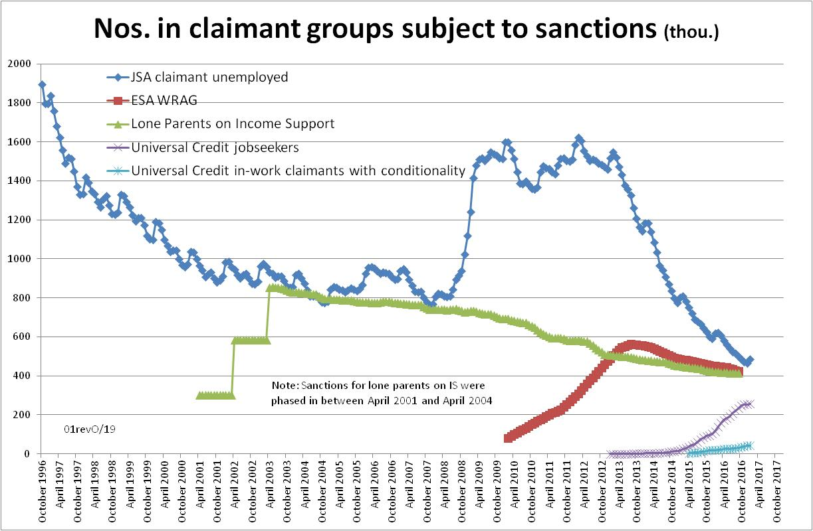

Figure 2
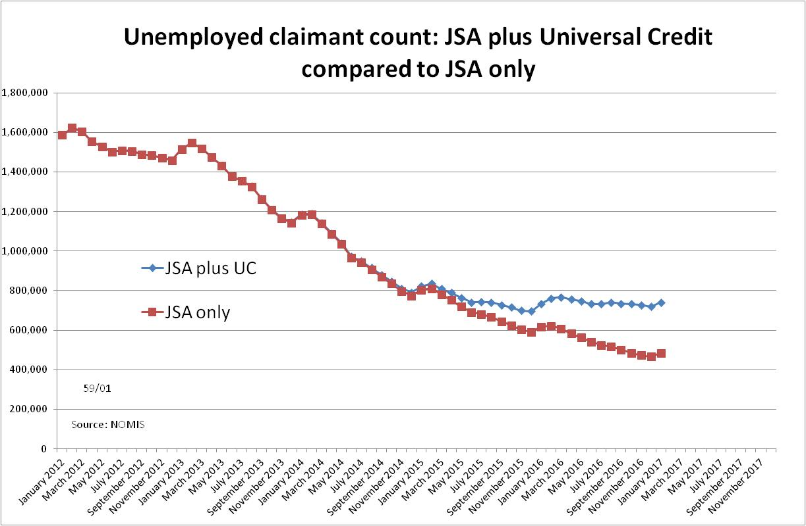

Figure 3
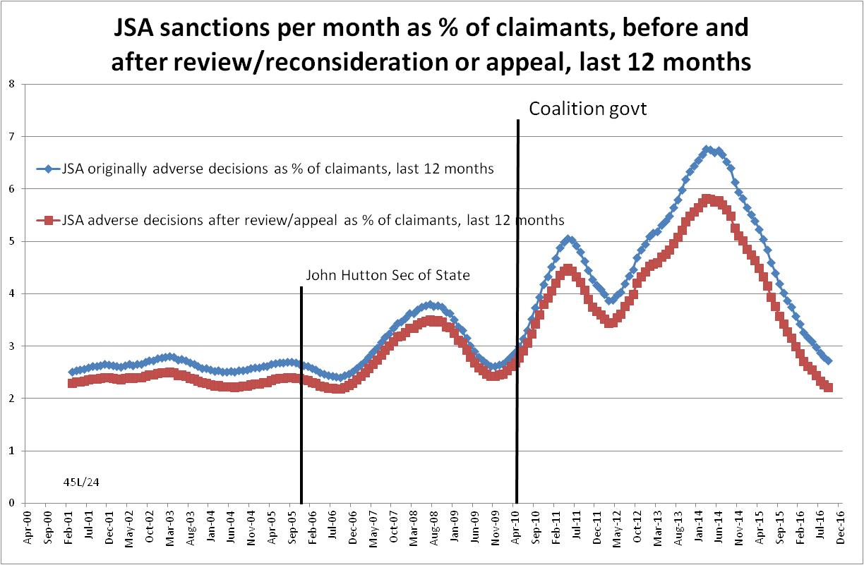

Figure 4
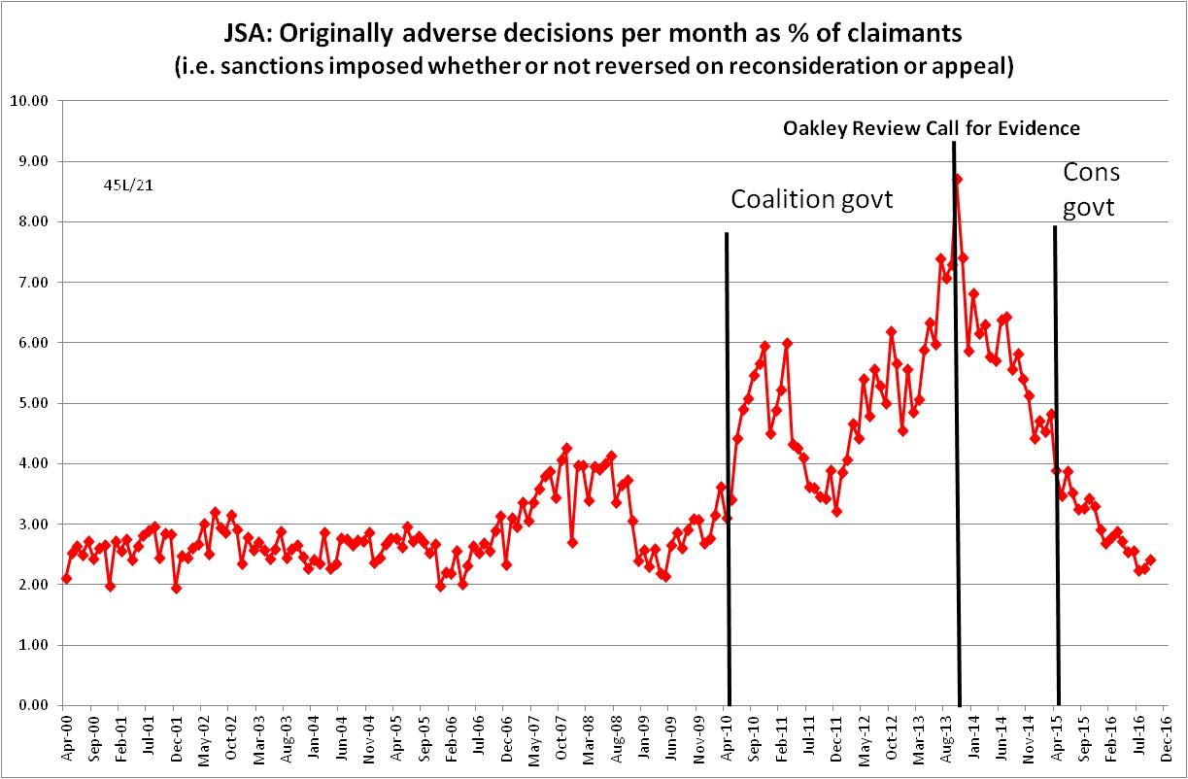
Figure 5
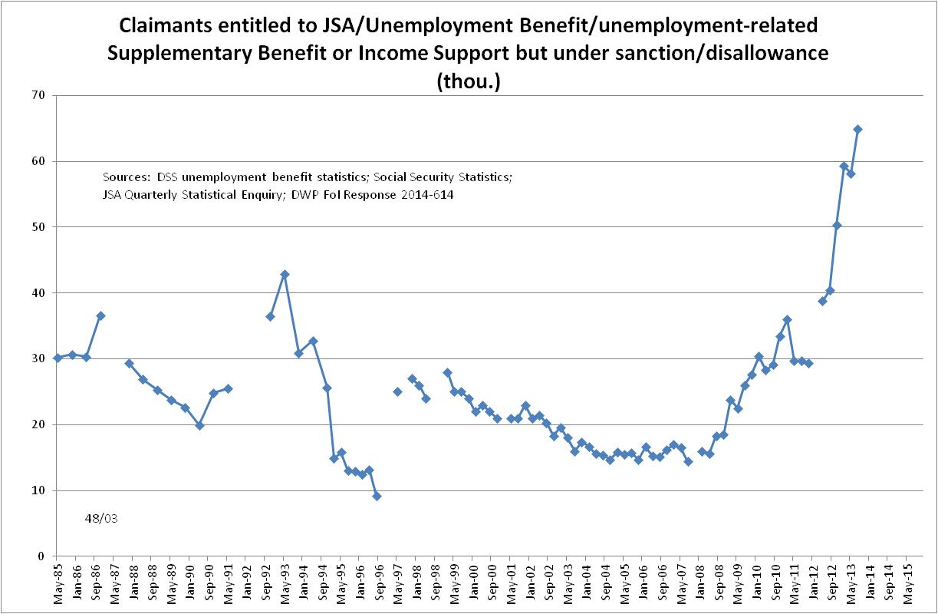
Figure 6
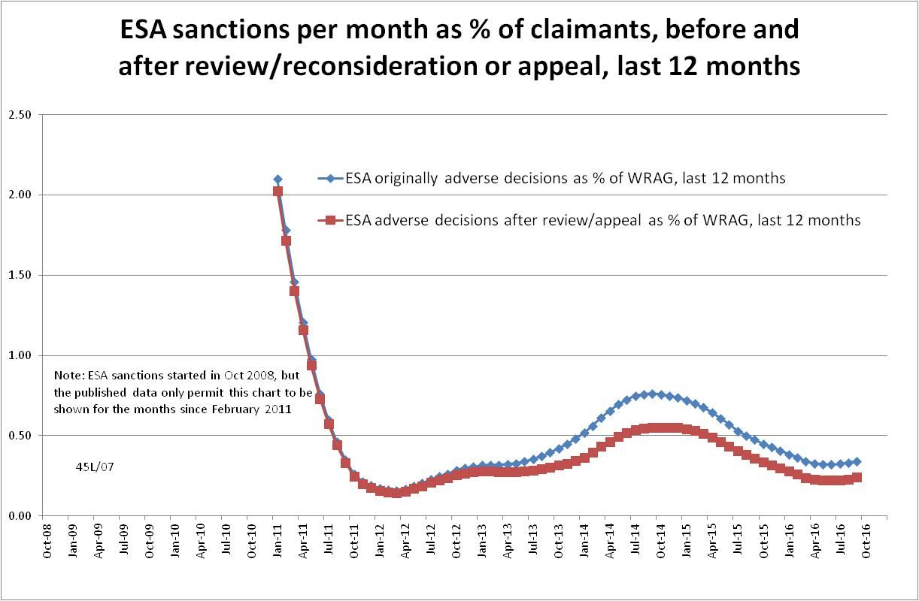
Figure 7
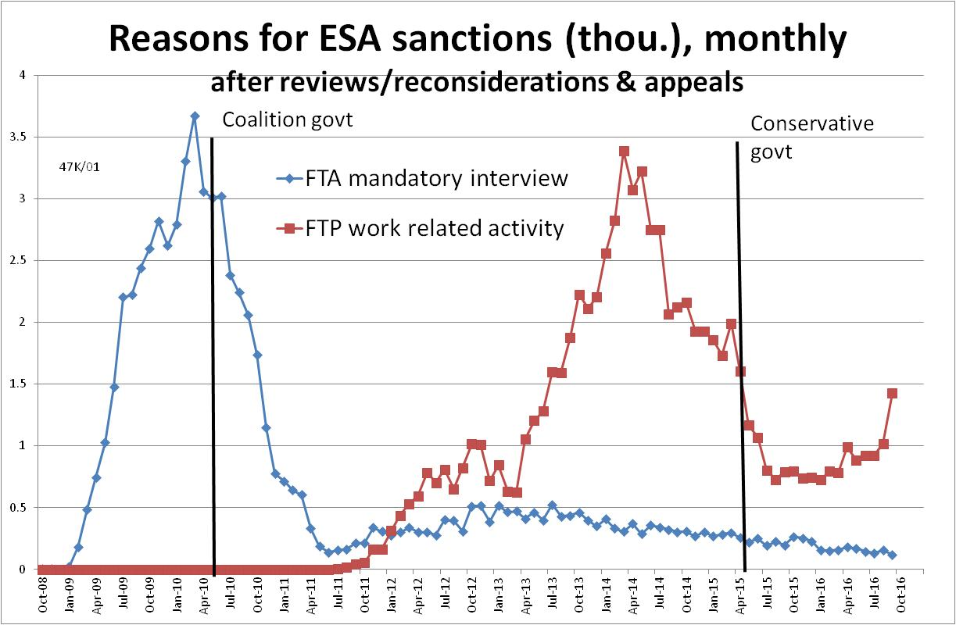

NOTES

This is the thirteenth in a series of briefings on the DWP’s statistics on Jobseeker’s Allowance (JSA) and Employment and Support Allowance (ESA) sanctions. All the briefings are available at http://www.cpag.org.uk/david-webster. No briefing was produced in November 2016. Earlier issues contain various analyses not included in the present briefing. In reading earlier issues it should be remembered that the DWP may have made subsequent statistical revisions.
‘In-work’ conditionality has been taken to apply to claimants in the statistical category 'working - with requirements'.
Repayment is suspended for any month when the claimant earns more than their threshold, and any remaining debt is written off if the earnings threshold has been met for 26 weeks, whether continuous or not.
The basic concept of the DWP’s sanctions database is that each sanction case appears only once, and is given its latest status and attributed to the month of the latest decision on the case. So, for instance, if a decision is made in January 2014 to sanction someone, this decision is reviewed in March 2014 with an outcome unfavourable to the claimant, reconsidered in a ‘mandatory reconsideration’ in May 2014 again with an unfavourable outcome, and is heard on appeal by a Tribunal in October 2014 with a decision favourable to the claimant, then: - it appears in the statistics for the first time in January 2014 as an adverse ‘original’ decision - in March 2014 it changes its status to a ‘reviewed’ adverse decision and moves month to be with all the other cases where the latest decision has been made in March 2014 - in May 2014 it changes its status to a ‘reconsidered’ adverse decision and moves month to be with all the other cases where the latest decision has been made in May 2014 - in October 2014 it changes its status again to an appealed non-adverse decision, and moves month again to be with all the other cases where the latest decision has been made in October 2014.
The estimate of sanctions before challenges has been derived by adding the monthly total of ‘non-adverse’, ‘reserved’ and ‘cancelled’ decisions shown as being the result of reviews, mandatory reconsiderations and tribunal appeals, to the monthly total of adverse ‘original’ decisions. This produces only an approximate estimate for each individual month, since decisions altered following challenge are not attributed to the correct month. But the estimates are reliable for longer periods.
DWP does not appear to have made any announcement about this change of practice and its rationale can only be guessed at. Presumably it is because the concept of UC is that many claimants will remain on the same benefit even if they move into work.
Public Accounts Committee, Fifth Report of Session 2013–14: Department for Work and Pensions: Responding to change in jobcentres, May 2013, Q131, Ev 18 and Q146, Ev20.
The documentation is in correspondence between Jonathan Portes (NIESR) and myself and the UKSA Chair Sir Andrew Dilnot, on the UKSA website at http://www.statisticsauthority.gov.uk/reports---correspondence/correspondence
Available at https://www.gov.uk/government/publications/benefit-sanction-statistics-publication-strategy/benefit-sanction-statistics-publication-strategy

